**This report about test task.**

**I created a working project on Visual Studio for Test Task work and I set the name of the project as kblog. Within the project, I created the python workfile and the html pages for the flask.**

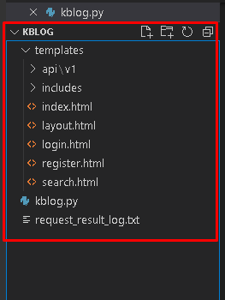

**I made app.route definitions for html pages and made page redirects.**

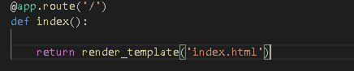

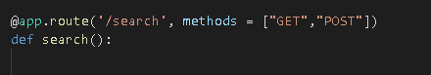

**I made a form class as an extra. I added it to the register and login pages.**

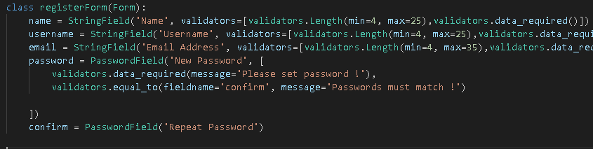

**I made mysql definition and connection for test operations.**

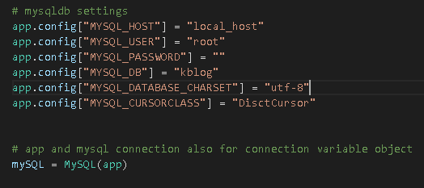

**I have inherited html pages from layout.html page.**

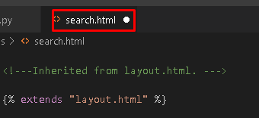

**I used bootstrap navbar.**

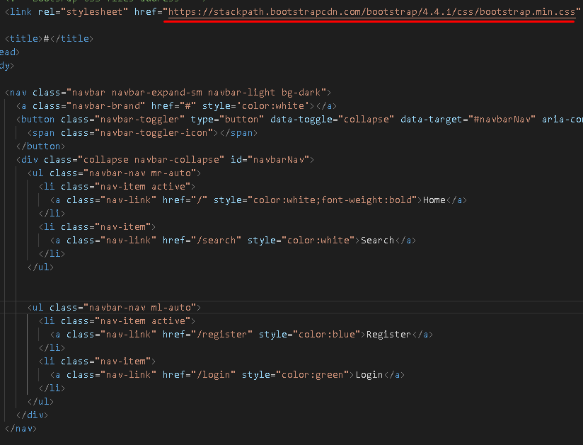

**I used yandex geocoder-maps service to access location information.**

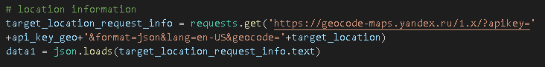

**I used yandex search-maps service to access location coordinates.**

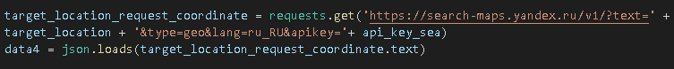

**I used a math function to calculate the distance between two locations.**

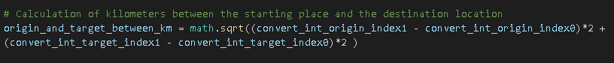

**I converted list values ​​to float values ​​for math calculation**

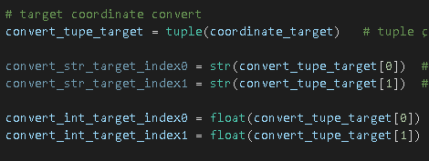

**Converting the response from request to json format**

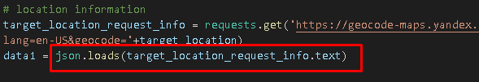

**To find out if an address is within the moscow ring road, I set the Moscow Kremlin coordinate as the center point.**

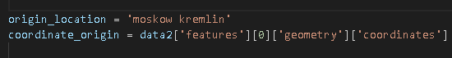



**I examined the coordinates of the moscow ring road.**

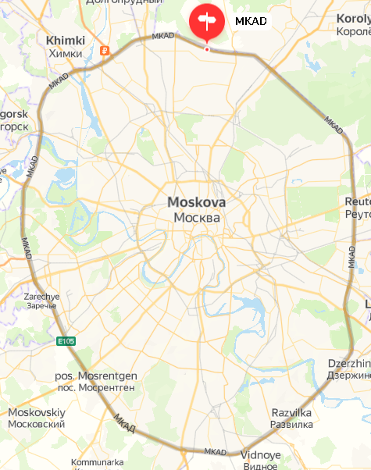

**I calculated the distance between two points with center point coordinate values ​​and moscow ring road coordinate values.**

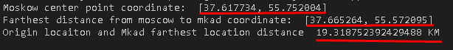

**I calculated the distance between two points with center point coordinate values ​​and target location coordinate values.**

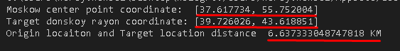

**If the distance between the central location and the target location is greater than the distance between the central location and the Moscow ring road, the target location is not within the Moscow ring road.**

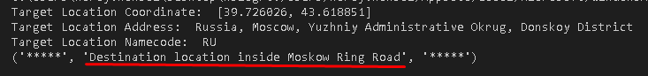

**I printed the results to a log file.**

