What I will show next is not meant to be a contradiction of what Bjarne Stroustrup wrote in the book, just a completion.
I used Visual C++ 2010, and fltk-1.3.x-r820, but I have tried also other versions of FLTK in the past (like fltk-1.3.x-r7725) and worked just fine.

- First you must test the program from page 1160 (Appendix D, section D.5) to see if the FLTK library is properly installed (if you followed exactly the steps from pages1158-1159, FLTK instalation was peace of cake …).
If it works then you should have something like this on your screen :
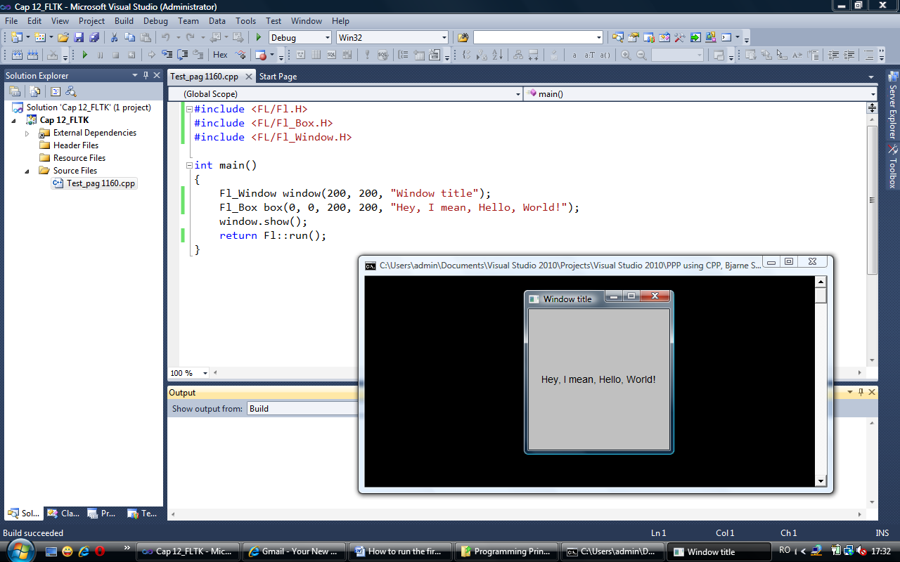

- Of course that after this you should be able to compile and run the first example from chapter 12 (section 12.3, page 411).
So the final result should look like the print-screen from the next page.

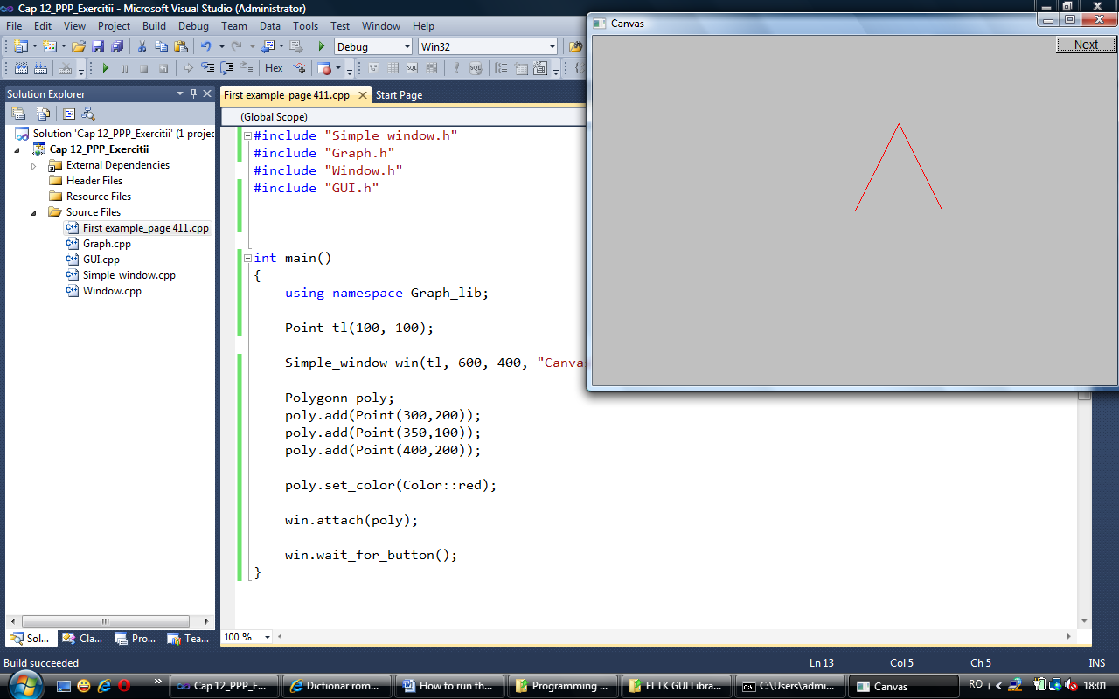

- It can be easily noticed that in the Solution Explorer view of the project there is the main file First example_page 411.cpp.
Also there are other 4 cpp files : Graph.cpp, GUI.cpp, Simple_window.cpp, and Window.cpp.

- All this 5 cpp files are in the project folder and can be added to Solution Explorer easily.
First you create with the command Ctrl+Shift+A a new cpp file (the main file) where you wright the code from page 411. Be carefull to change the class name in the main file from Polygon to Polygonn.
Then with the command Shift+Alt+A you open the folder of the current project, and select all the cpp files that you need to add to Source Files component of Solution Explorer. In this case the other 4 cpp files.
It can be seen bellow all the files that are in this project folder, and that I have selected the graphic cpp files (only for example, because I already have them added in Source Files).

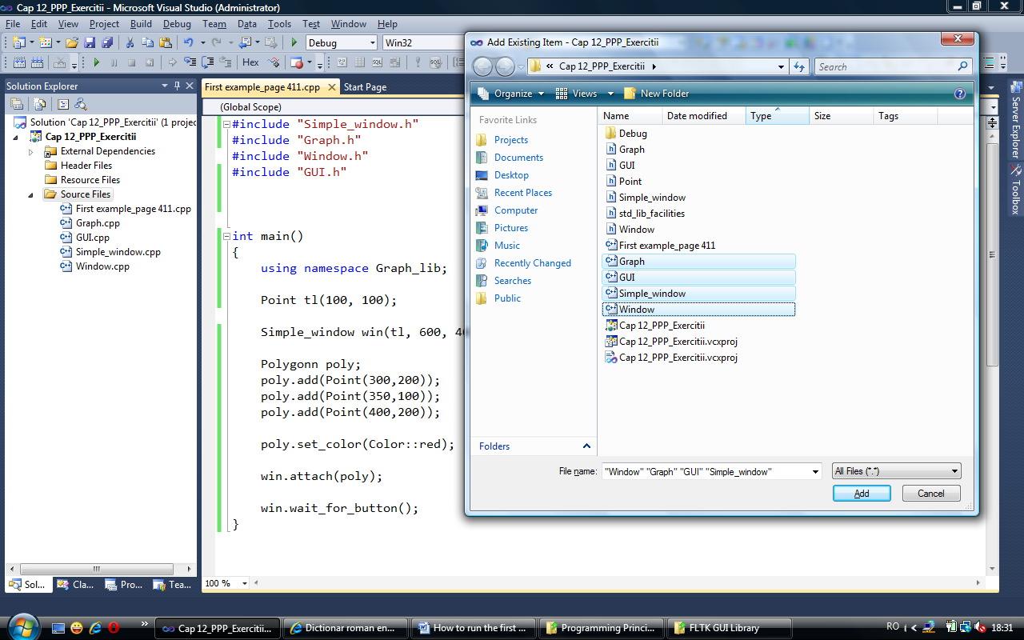

- It can be seen from this picture that in the main file I #included 4 headers : Simple_window.h, Graph.h, Window.h, GUI.h.
Also it can be seen in the window Add Existing Item, that these 4 headersare in the project folder, together with other 2 headers : Point.h and std_lib_facilites.h. This last 2 headers are not #included in the main cpp file, because they are indirectly #included by the first 4 headers. But is important that all 6 of them are in the project folder.

- Now you saw at point 4, that I requested for you to change the class name Polygon to Polygonn.
This is because I’ve had compiler errors whit class names Polygon, Rectangle amnd Ellipse. It said something about problems with Windows classes. So I changed them in Graph.h and Graph.cpp to Polygonn, Rectanglee and Ellipsee.
Of course that whenever you use them in main cpp files like I did for this first example they must be changed also there, otherwise the compiler would not know what are they.
Without this minor changes the error can be seen in the picture from bellow :
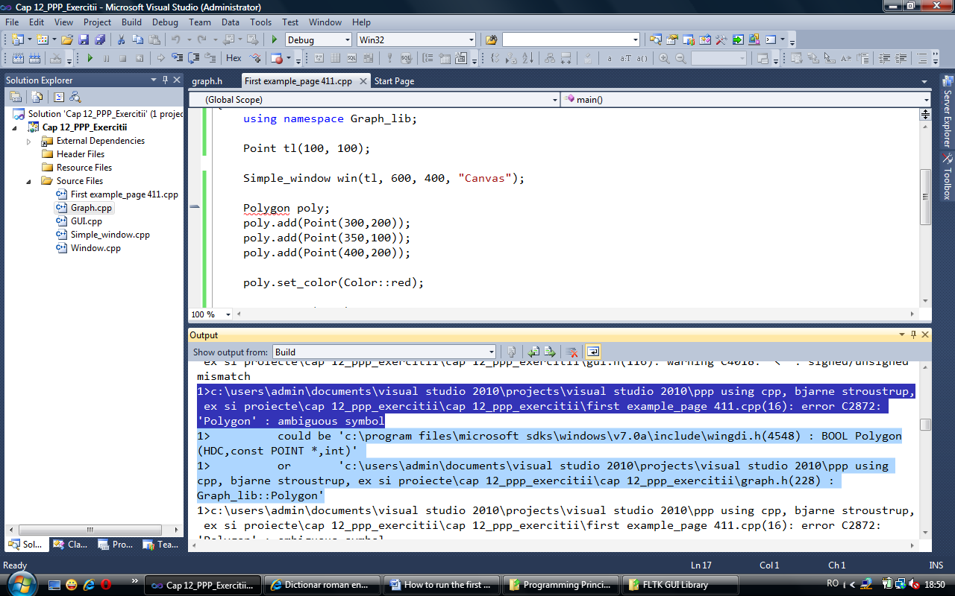

- To be much easy to use the graphic headers and cpp files I have made the necessary changes, and I will put all the headers and cpp graphic files together with this word file on the web to be downloaded.
But if someone whants to do it at home it is very very easy : the minor changes from Polygon to Polygonn, Rectangle to Rectanglee and Ellipse to Elipsee must be made only in Graph.h and Graph.cpp files (the other 8 headers and cpp files are OK). After this changes, do not forget to use this classes with their modified names (Polygonn, Rectanglee or Ellipsee) in the main cpp file.
- So for the moment with what I have showed untill now, the first example from page 411 will work.
But for the folowing more complicated examples from folowing sections untill section 12.7.10 (page 430) I get errors regarding class Vector.
You can see it on the print-screen from bellow.

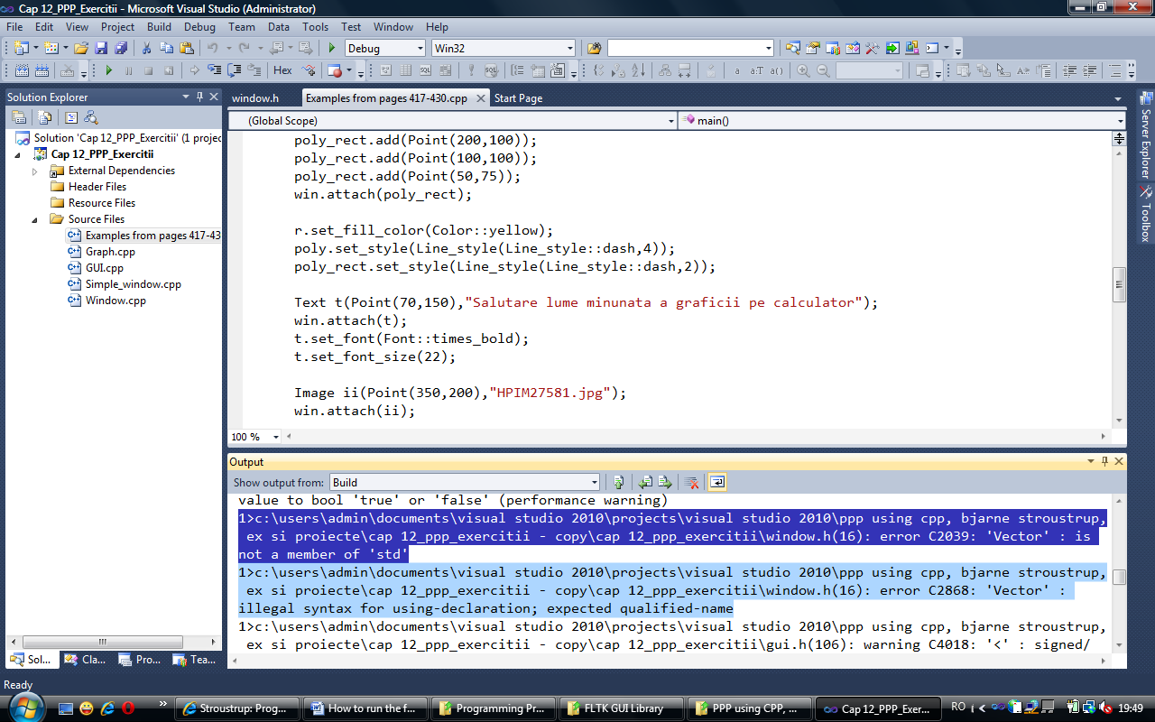

A final change must be made : std_lib_facilities.h file that is on the PPP using CPP site http://www.stroustrup.com/Programming/Graphics/std_lib_facilities.h
must be changed with another one that was added for a while on the suporting site for the book (at that one I added also the line #include <iostream>).
So the working std_lib_facilites.h is :
//
// This is a standard library support code to the chapters of the book
// "Programming -- Principles and Practice Using C++" by Bjarne Stroustrup
//

#ifndef STD_LIB_FACILITIES_GUARD
#define STD_LIB_FACILITIES_GUARD 1

#include <cmath>
#include <cstring>
#include <fstream>
#include <stdexcept>
#include <string>
#include <sstream>
#include <vector>
#include <iostream>

using namespace std;

//------------------------------------------------------------------------------

// Helper function to show an error message
inline void error(const string& errormessage)
{
throw runtime_error(errormessage);
}

//------------------------------------------------------------------------------

inline void error(string s1, string s2)
{
error(s1+s2);
}

//------------------------------------------------------------------------------

#endif // STD_LIB_FACILITIES_GUARD

