
Impress Guide
Chapter 1
Introducing Impress

Copyright
This document is Copyright © 2007–2014 by the LibreOffice Documentation Team. Contributors are listed below. You may distribute or modify it under the terms of either the GNU General Public License (http://www.gnu.org/licenses/gpl.html), version 3 or later, or the Creative Commons Attribution License (http://creativecommons.org/licenses/by/4.0/), version 4.0 or later.
このガイドのトレードマークは正式な所有者の所有物です。

コントリビューター
Peter Schofield Michele Zarri T. Elliot Turner
Jean Hollis Weber Hazel Russman Chad D. Lines
Low Song Chuan Jaimon Jacob Muhammad Sufyan Zainalabidin

Feedback
このドキュメントへのコメント提案は ドキュメントチームメーリングリスト: documentation@global.libreoffice.orgに投稿してください。
留意点: メーリングリストに投稿したものすべてにおいて、メッセージ内に記載されたアドレス、個人的な情報は誰でも見られる形で保存され、削除することはできません

Acknowledgments
This chapter is based on Chapter 1 of the OpenOffice.org 3.3 Impress Guide. The contributors to that chapter are:
Michele Zarri Jean Hollis Weber Dan Lewis
Agnes Belzunce Peter Hillier-Brook Gary Schnabl
Claire Wood Rachel Kartch Hazel Russman
Linda Worthington

このドキュメントの発行日と対応するソフトウェアのバージョン
Published 18 May 2014. Based on LibreOffice 4.2.2.

Note for Mac users
Some keystrokes and menu items are different on a Mac from those used in Windows and Linux. The table below gives some common substitutions for the instructions in this chapter. For a more detailed list, see the application Help.
Windows or Linux | Mac equivalent | Effect
Tools > Options menu selection | LibreOffice > Preferences | Access setup options
Right-click | Control+click and/or right-click depending on computer system | Open a context menu
Ctrl (Control) | ⌘ (Command) | Used with other keys
F5 | Shift+⌘+F5 | Open the Navigator
F11 | ⌘+T | Open the Styles and Formatting window

Contents
Copyright 2
コントリビューター 2
Feedback 2
Acknowledgments 2
このドキュメントの発行日と対応するソフトウェアのバージョン 2
Note for Mac users 2
What is Impress? 4
Starting Impress 4
Main Impress window 5
Slides pane 5
Sidebar 6
Workspace 7
Toolbars 7
Status bar 7
Navigator 8
Workspace views 9
Normal view 9
Outline view 9
Notes view 10
Handout view 10
Slide Sorter view 11
Customizing Slide Sorter view 11
Moving a slide using Slide Sorter 12
Selecting and moving groups of slides 12
Working in Slide Sorter view 12
Creating a new presentation 13
Formatting a presentation 16
Inserting slides 16
New slide 16
Duplicate slide 16
Selecting a slide layout 17
Selecting layout 17
Changing layout 18
Modifying slide elements 18
Adding text 19
Adding objects 19
Modifying slide appearance 19
Modifying a slide show 20
Custom animations 20
Slide transitions 20
Running a slide show 21
Presenter Console 21

What is Impress?
Impress is the presentation (slide show) program included in LibreOffice. You can create slides that contain many different elements, including text, bulleted and numbered lists, tables, charts, and a wide range of graphic objects such as clipart, drawings and photographs. Impress also includes a spelling checker, a thesaurus, text styles, and background styles.
This chapter introduces the Impress user interface and describes how to create a simple slide show using the Presentation Wizard. The other chapters in this guide explain all the features available in Impress that can be used to create more sophisticated slide shows.
To use Impress for more than very simple slide shows requires some knowledge of the elements which the slides contain. Slides containing text use styles to determine the appearance of that text. Creating drawings in Impress is similar to using the Draw program included in LibreOffice. See the Draw Guide for more details on how to use the drawing tools.

Starting Impress
You can start Impress in several ways:
- From the LibreOffice Start Center, if no component is open: click on the Impress Presentation icon to create a new presentation, or click on the Open File icon and navigate to the folder where there is an existing presentation.
- From the system menu, the standard menu from which most applications are started. On Windows, it is called the Start menu. On Linux with a Gnome desktop, it is called the Applications menu; on a KDE desktop, it is identified by the KDE logo. On Mac OS X, it is the Applications menu. Details vary with your operating system; see the Getting Started Guide Chapter 1 Introducing LibreOffice.
- On Windows, use the Presentation selection in the LibreOffice Quickstarter. Similar functions exist for Mac OS X and Linux; see the Getting Started Guide Chapter 1 Introducing LibreOffice.
- From any open component of LibreOffice. Click the triangle to the right of the New icon on the main menu bar and select Presentation from the drop-down menu or choose File > New > Presentation on the main menu bar.
Note | When LibreOffice was installed on your computer, in most cases a menu entry for each component was added to your system menu. The exact name and location of these menu entries depend on the operating system and graphical user interface.
When you start Impress for the first time, the Presentation Wizard is shown by default. Here you can choose from the following options:
- Empty presentation, which gives you a blank document
- From template, which is a presentation designed with a template of your choice
- Open existing presentation
- Click Create to open the main Impress window.
For detailed instructions about how to use the Presentation Wizard, see “Creating a new presentation” on page 13.
If you prefer not to use the Presentation Wizard, select the Do not show this wizard again option before clicking Create. You can enable the wizard again later under Tools > Options > LibreOffice Impress > General > New document on the main menu bar and select the Start with wizard option.

Main Impress window
The main Impress window (Figure 1) has three parts: the Slides pane, Workspace, and Sidebar. Additionally, several toolbars can be displayed or hidden during the creation of a presentation.
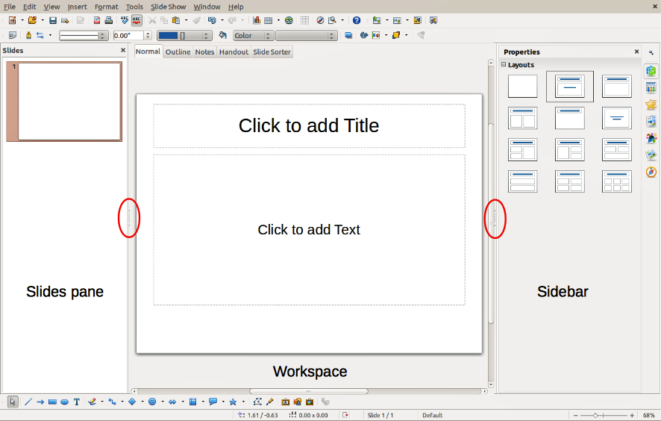
Figure 1: Main window of Impress; ovals indicate the Hide/Show markers
Tip | You can close the Slides pane or the Sidebar by clicking the X in the upper right corner of each pane or go to View > Slide Pane or View > Sidebar on the main menu bar to deselect the pane. To reopen a pane, go to View on the main menu bar and select Slide Pane or Sidebar again.  You can also maximize the Workspace area by clicking on the Hide/Show marker in the middle of the vertical separator line (indicated by ovals in Figure 1). Using the Hide/Show marker hides, but does not close, the Slides pane or Sidebar. To restore the pane, click again on its Hide/Show marker.

Slides pane
The Slides pane contains thumbnail pictures of the slides in your presentation, in the order the slides will be shown, unless you change the slide show order that is described in Chapter 9 Slide Shows. Clicking a slide in this pane selects it and places it in the Workspace. When a slide is in the Workspace, you can make any changes you like.
Several additional operations can be performed on one or more slides simultaneously in the Slides pane:
- Add new slides to the presentation.
- Mark a slide as hidden so that it will not be shown as part of the presentation.
- Delete a slide from the presentation if it is no longer needed.
- Rename a slide.
- Duplicate a slide (copy and paste) or move it to a different position in the presentation (cut and paste).
It is also possible to perform the following operations, although there are more efficient methods than using the Slides pane, as you will see later in this chapter:
- Change the slide transition following the selected slide or after each slide in a group of slides.
- Change the sequence of slides in the presentation.
- Change the slide design.
- Change slide layout for a group of slides simultaneously.

Sidebar
The Sidebar has seven sections. To expand a section you want to use, click on its icon or click on the small triangle at the top of the icons and select a section from the drop down list. Only one section at a time can be open.
Properties
Shows the layouts included within Impress. You can choose the one you want and use it as it is, or modify it to meet your own requirements. However, it is not possible to save customized layouts.
Master Pages
Here you define the page (slide) style for your presentation. Impress includes several designs of Master Pages (slide masters). One of them – Default – is blank, and the rest have background and styled text.
Custom Animation
A variety of animations can be used to emphasize or enhance different elements of each slide. The Custom Animation section provides an easy way to add, change, or remove animations.
Slide Transition
Provides a number of slide transition options. The default is set to No Transition, in which the following slide simply replaces the existing one. However, many additional transitions are available. You can also specify the transition speed (slow, medium, fast), choose between an automatic or manual transition, and choose how long the selected slide should be shown (automatic transition only).
Styles and Formatting
Here you can edit and apply graphics styles, but you can only edit presentation styles. When you edit a style, the changes are automatically applied to all of the elements formatted with this style in your presentation. If you want to ensure that the styles on a specific slide are not updated, create a new master page for the slide.
Tip | Go to Format > Styles and Formatting on the main menu bar or press the F11 key to open the Styles and Formatting dialog, where you can modify the styles used in any master page to suit your purpose. This can be done at any time.
Gallery
Opens the Impress gallery where you can insert an object into your presentation either as a copy or as a link. A copy of an object is independent of the original object. Changes to the original object have no effect on the copy. A link remains dependent on the original object. Changes to the original object are also reflected in the link.
Navigator
Opens the Impress navigator, in which you can quickly move to another slide or select an object on a slide. It is recommended to give slides and objects in your presentation meaningful names so that you can easily identify them when using the navigator.

Workspace
The Workspace (normally in the center) has five tabs: Normal, Outline, Notes, Handout, and Slide Sorter (Figure 2). These five tabs are called View buttons. The Workspace below the View buttons changes depending on the chosen view. The workspace views are described in detail “Workspace views” on page 9.
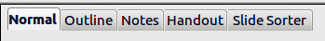
Figure 2: Workspace tabs

Toolbars
Many toolbars can be used during slide creation; they can be displayed or hidden by going to View > Toolbars on the main menu bar and selecting from the context menu.
You can also select the icons that you wish to appear on each toolbar. For more information, refer to Chapter 11 Setting Up and Customizing Impress.
Many of the toolbars in Impress are similar to the toolbars in Draw. Refer to the Draw Guide for details on the functions available and how to use them.

Status bar
The Status bar (Figure 3), located at the bottom of the Impress window, contains information that you may find useful when working on a presentation. You can hide the Status Bar by going to View on the main menu bar and deselecting Status Bar in the context menu.
Note | The sizes are given in the current measurement unit (not to be confused with the ruler units). This measurement unit is defined in Tools > Options > LibreOffice Impress > General.
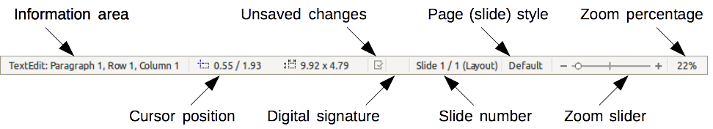
Figure 3: Status bar
From left to right, you will find:
- Information area – changes depending on the selection. For example:
Example selection | Examples of information shown
Text area | Text Edit: Paragraph x, Row y, Column z
Charts, spreadsheets | Embedded object (OLE) “ObjectName” selected
Graphics | Bitmap with transparency selected
- Cursor position – the position of the cursor or of the top left corner of the selection measured from the top left corner of the slide, followed by the width and height of the selection or text box where the cursor is located.
- Unsaved changes – a flag indicating that the file needs saving. Double-clicking on this flag opens the file save dialog.
- Digital signature – a flag indicating whether the document is digitally signed. After the file has been saved, double-clicking on this flag opens the digital signatures dialog.
- Slide number – the slide number currently displayed in the Workspace and the total number of slides in the presentation.
- Page (slide) style – the style associated with the slide, handout, or notes page currently in the Workspace. Double-clicking on the style name opens the slide design dialog.
- Zoom slider – adjusts the zoom percentage of the Workspace displayed.
- Zoom percentage – indicates the zoom percentage of the Workspace displayed. Double-clicking on zoom percentage opens the zoom and layout dialog.

Navigator
The Navigator displays all objects contained in a presentation. It provides another convenient way to move around a presentation and find items in it. To open the Navigator dialog (Figure 4), click the Navigator icon on the Standard toolbar, or go to View > Navigator on the main menu bar, or use the keyboard shortcut Ctrl+Shift+F5. Alternatively, click on the Sidebar Navigator icon to open a page that is similar to the Navigator dialog.
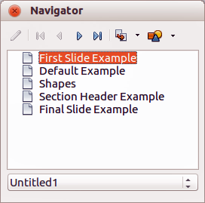
Figure 4: Navigator dialog
The Navigator is more useful if you give your slides and objects (pictures, spreadsheets, and so on) meaningful names, instead of leaving them with default names, such as “Slide 1” and “Shape 1” and so on.

Workspace views
Each of the Workspace views is designed to ease the completion of certain tasks; it is therefore useful to familiarize yourself with them to quickly accomplish those tasks.
Note | Each Workspace view displays a different set of toolbars when selected. These toolbar sets can be customized by going to View > Toolbars, then check or uncheck the toolbar you want to add or remove.

Normal view
Normal view is the main view for creating individual slides. Use this view to format and design slides and to add text, graphics, and animation effects.
To place a slide in the slide design area of the Normal view (Figure 1 on page 5), either click the slide thumbnail in the Slides pane or double-click it in the Navigator.

Outline view
Outline view (Figure 5) contains all of the slides of the presentation in their numbered sequence. It shows topic titles, bulleted lists, and numbered lists for each slide in outline format. Only the text contained in the default text boxes in each slide is shown. If you have added text boxes or graphic objects to the slides, then these objects are not displayed. Slide names are not included.
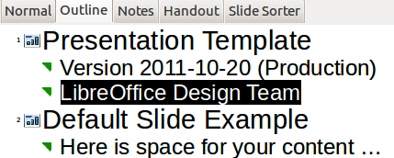
Figure 5: Outline view
Figure 6: Outline level and movement arrows in Text Formatting toolbar
Use Outline view for:
- Making changes in the text of a slide:
- Add or delete text in a slide just as in the Normal view.
- Move the paragraphs of text in the selected slide up or down by using the up and down arrow buttons (Move Up or Move Down) on the Text Formatting toolbar (highlighted in Figure 6).
- Change the outline level for any of the paragraphs in a slide using the left and right arrow buttons (Promote or Demote) on the Text Formatting toolbar.
- Simultaneously move a paragraph and change its outline level using a combination of these four arrow buttons.
- Comparing the slides with your outline (if you have prepared one in advance). If you notice from your outline that another slide is needed, you can create it directly in the Outline view, or you can return to the Normal view to create it.
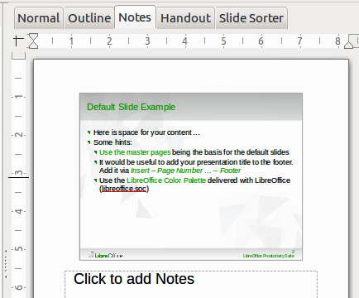
Figure 7: Notes view

Notes view
Use the Notes view (Figure 7) to add notes to a slide. These notes are not seen when the presentation is shown to an audience on an extra display monitor connected to your computer.
- Click the Notes tab in the Workspace.
- Select the slide to which you want to add notes.
- Click the slide in the Slide pane, or double-click the slide name in the Navigator.
- In the text box below the slide, click on the words Click to add notes and begin typing.
You can resize the Notes text box using the resizing handles which appear when you click on the edge of the box. You can also move the box by placing the pointer on the border, then clicking and dragging. To make changes in the text style, press the F11 key to open the Styles and Formatting dialog or click on the Styles and Formatting icon on the Sidebar.

Handout view
Handout view is for setting up the layout of your slide for a printed handout. Click the Handout tab in the workspace and the Layouts section opens on the Sidebar (Figure 8) where you can then choose to print 1, 2, 3, 4, 6, or 9 slides per page. If the Layouts section does not open, then click on the Properties icon at the side of the Sidebar.
You can also use this view to customize the information printed on the handout. Refer to Chapter 8 Adding and Formatting Slides, Notes, and Handouts for more information.
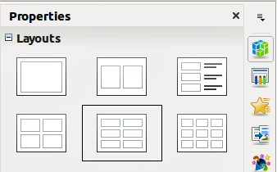
Figure 8: Handout layouts
Select from the main menu Insert > Page Number or Insert > Date and Time and the Header and Footer dialog opens. Click on the Notes and Handouts tab (Figure 9) and use this dialog to select the elements you want to appear on each handout page and their contents.
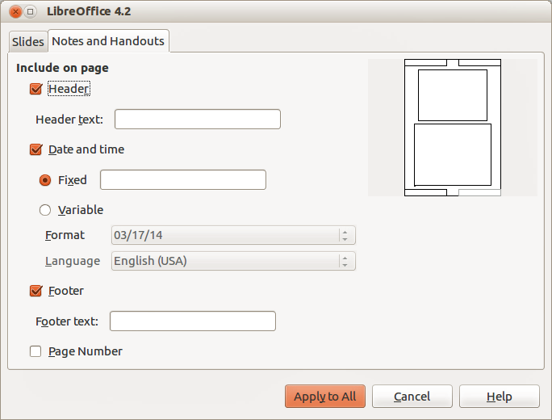
Figure 9: Header and Footer dialog – Notes and Handouts page

Slide Sorter view
The Slide Sorter view (Figure 10) contains all of the slide thumbnails. Use this view to work with a group of slides or with only one slide.
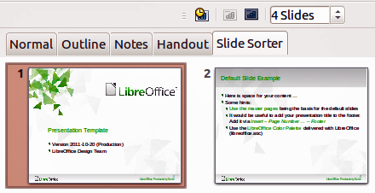
Figure 10: Slide Sorter view

Customizing Slide Sorter view
To change the number of slides per row:
- Check View > Toolbars > Slide Sorter and Slide View to show or hide the slide sorter and view toolbars (Figure 11).
- Adjust the number of slides (up to a maximum of 15).
Figure 11: Slide Sorter and Slide View toolbars

Moving a slide using Slide Sorter
To move a slide in a presentation using the Slide Sorter:
- Click the slide to highlight it (Figure 10).
- Drag and drop it to the location you want.

Selecting and moving groups of slides
To select a group of slides, use one of these methods:
- Using the Ctrl key – click on the first slide and, while pressing the Ctrl key, select the other desired slides.
- Using the Shift key – click on the first slide, and while pressing the Shift key, select the final slide in the group. This selects all of the other slides between the first and the last slide selected.
- Using the mouse – click slightly to one side (left or right) of the first slide to be selected. Hold down the left mouse button and drag the cursor until all of the slides you want selected are highlighted.
To move a group of slides:
- Select a group of slides.
- Drag and drop the group to their new location.

Working in Slide Sorter view
You can work with slides in the Slide Sorter view just as you can in the Slide pane. To make changes, right-click a slide and choose any of the following from the context menu:
- New Slide – adds a new slide after the selected slide.
- Duplicate Slide – creates a duplicate of the selected slide and places the new slide immediately after the selected slide (see “Duplicate slide” on page 16).
- Delete Slide – deletes the selected slide.
- Rename Slide – allows you to rename the selected slide.
- Slide Layout – allows you to change the layout of the selected slide.
- Slide Transition – allows you to change the transition of the selected slide.
- For one slide, select a slide and add the desired transition.
- For more than one slide, select a group of slides and add the desired transition.
- Hide Slide – any slides that are hidden are not shown in the slide show.
- Cut – removes the selected slide and saves it to the clipboard.
- Copy – copies the selected slide to the clipboard without removing it.
- Paste – inserts a slide from the clipboard after the selected slide.

Creating a new presentation
This section shows you how to create a new presentation using the Presentation Wizard.
Tip | The first thing to do is decide on the purpose of the presentation and plan the presentation. Although you can make changes as you go, having an idea of who the audience will be, the structure, the content, and how the presentation will be delivered, will save you a lot of time from the start.
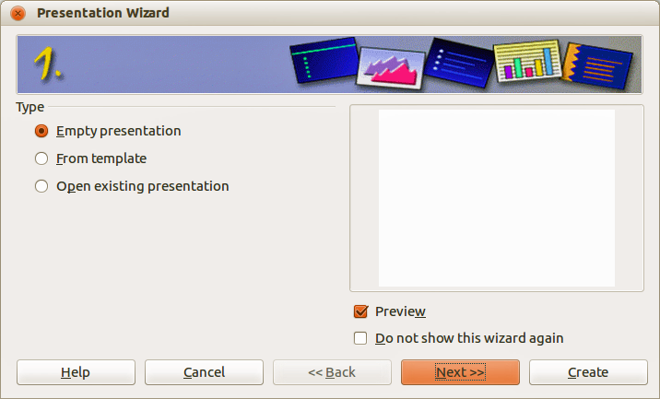
Figure 12: Presentation Wizard Step 1 – selecting presentation type
When you start Impress, the Presentation Wizard Step 1 (Figure 12) appears.
- Under Type, choose one of the options:
- Empty presentation creates a blank presentation.
- From template uses a template design already created as the basis for a new presentation. The wizard changes to show a list of available templates. Choose the template you want. More details can be found in Chapter 2, Using Slide Masters, Styles, and Templates.
- Open existing presentation continues work on a previously created presentation. The wizard changes to show a list of existing presentations. Choose the one you want.
- Click Next and the Presentation Wizard Step 2 opens. It appears as shown in Figure 13 if you selected Empty presentation at step 1. If you selected From template, an example slide is shown in the Preview box.
- Choose a design under Select a slide design. The slide design section gives Presentation Backgrounds with a list of choices for slide designs. If you want to use one of these other than <Original>, click it to select it.
The types of Presentation Backgrounds are shown in Figure 13. When you select a presentation background, you will see a preview of the slide design in the Preview window.
<Original> is for a blank presentation slide design.
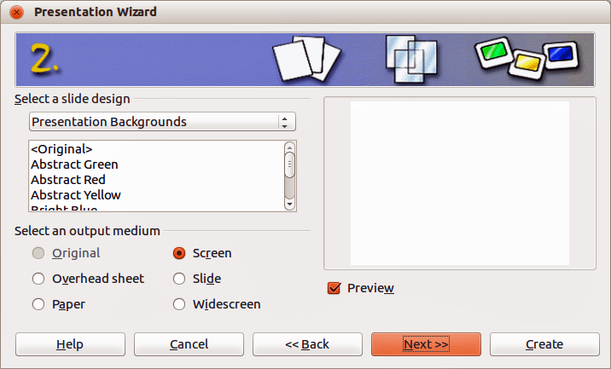
Figure 13: Presentation Wizard Step 2 – selecting slide design & output medium
- Select how the presentation will be used under Select an output medium. Most often, presentations are created for computer screen display, so you would select Screen. You can change the page format at any time.
Note | The default Screen page is for a 4:3 display (28cm x 21cm) which is not suitable for modern wide-screen displays. You can change the slide size at any time by switching to Normal view and selecting Format > Page.
- Click Next and the Presentation Wizard Step 3 (Figure 14) opens.
- Select the desired slide transition from the Effect drop-down menu.
- Select the desired speed for the transition between the different slides in the presentation from the Speed drop-down menu. Medium is a good choice for now.
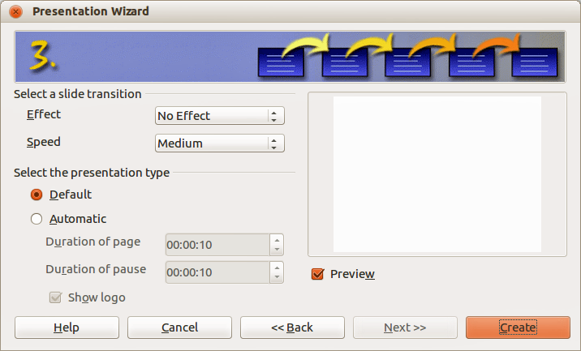
Figure 14: Presentation Wizard Step 3 – selecting transitions & presentation type
- Select the presentation type – Default or Automatic.
- Choosing Default displays the presentation as a full screen presentation with the specified speed you selected from the Speed drop down list.
- Choosing Automatic allows you to set the duration the slide is displayed and the duration of the pause between the end and restart of the presentation.
- If you did not select From template in Step 1 of the Presentation Wizard, click Create and your new presentation is created.
Tip | You can accept the default values for both Effect and Speed unless you are skilled at creating presentations. Both of these values can be changed later while working with Slide transitions and animations. These two features are explained in more detail in Chapter 9 Slide Shows.
Note | If you selected From template in Step 1 of the Presentation Wizard, then the Next button is active and, when clicked, Steps 4 and 5 become available. These extra steps when using a template are described below.
- Click Next and Step 4 of the Presentation Wizard (Figure 15) appears. Here you can enter the name of your company, your presentation topic, and the basic ideas you want to cover in the presentation you are creating.
- Click Next and step 5 of the Presentation Wizard (Figure 16) appears showing a preview of what each slide in your presentation will look like. If the preview does not appear, select Preview.
- If you want to create a summary of your presentation, select Create summary. This creates a new slide that contains a bulleted list from the titles of the slides that follow the selected slide. The summary slide is inserted behind the last slide of your presentation.
- Click Create and your new presentation is created.
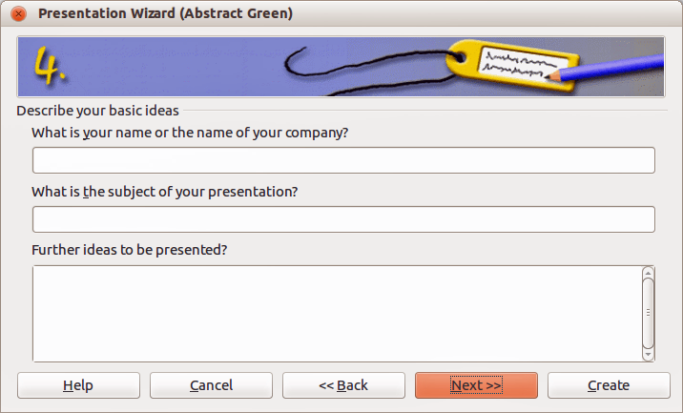
Figure 15: Presentation Wizard Step 4 – presentation information
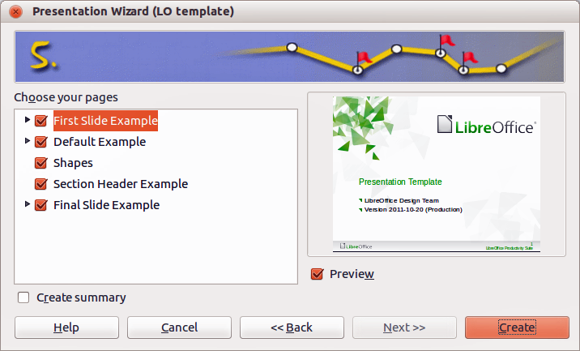
Figure 16: Presentation Wizard Step 5 – presentation preview

Formatting a presentation
A new presentation only contains one empty slide. In this section we will start adding new slides and preparing them for the intended contents.

Inserting slides

New slide
A new slide can be inserted into a presentation as follows:
- Go to Insert on the main menu bar and select Slide.
Or, right-click on a slide in the Workspace, Slides Pane, or Slide Sorter view and select Slide > New Slide from the context menu.
Or, click the Slide icon in the Presentation toolbar. If the Presentation toolbar is not visible, go to View > Toolbars on the main menu bar and select Presentation from the list.
- A new slide is inserted after the selected slide in the presentation.

Duplicate slide
Sometimes, rather than starting from a new slide you may want to duplicate a slide already included in your presentation. To duplicate a slide:
- Select the slide you want to duplicate from the Slides Pane.
- Right-click on the slide in the Slides Pane or Workspace and select Duplicate Slide from the context menu.
Or, go to Slide Sorter view, right-click on a slide and select Duplicate Slide from the context menu.
Or, go to Insert on the main menu bar and select Duplicate Slide.
Or, click on the triangle to the right of the Slide icon in the Presentation toolbar and select Duplicate Slide from the context menu. If the Presentation toolbar is not visible, go to View > Toolbars on the main menu bar and select Presentation from the list.
- A duplicate slide is inserted after the selected slide in the presentation.

Selecting a slide layout
Click on the Properties icon at the side of the Sidebar to open Layouts section and display the available layouts (Figure 17). The layouts included in Impress range from a blank slide to a slide with six contents boxes and a title.
The first slide in a presentation is normally a title slide. The Title Slide (which also contains a section for a subtitle) or Title Only are suitable layouts for the first slide, while for most of the remaining slides you will probably use the Title, Contents layout.
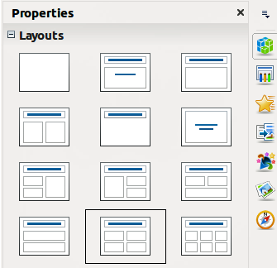
Figure 17: Available slide layouts

Selecting layout
Assuming that the Blank Slide layout was not selected:
- Click on Click to add title and then type the title text. To adjust the formatting of the title, modify the Title presentation style; see Chapter 2 Using Slide Masters, Styles, and Templates for instructions.
- If you are using the Title Slide layout, click on Click to add text to add a subtitle. To adjust the formatting of the subtitle, modify the Subtitle presentation style; see Chapter 2 Using Slide Masters, Styles, and Templates for instructions.
Note | Text and graphic elements can be readjusted at any time during the preparation of the presentation, but changing the layout of a slide that already contains some contents can have a dramatic effect. It is therefore recommended that you pay particular attention to the layout you select. If you do need to change the layout after contents have been added, the contents are not lost though they may need to be reformatted.
Tip | To view the names for the included layouts, use the Tooltip feature: position the cursor on an icon in the Layout section (or on any toolbar icon) and its name will be displayed in a small rectangle.
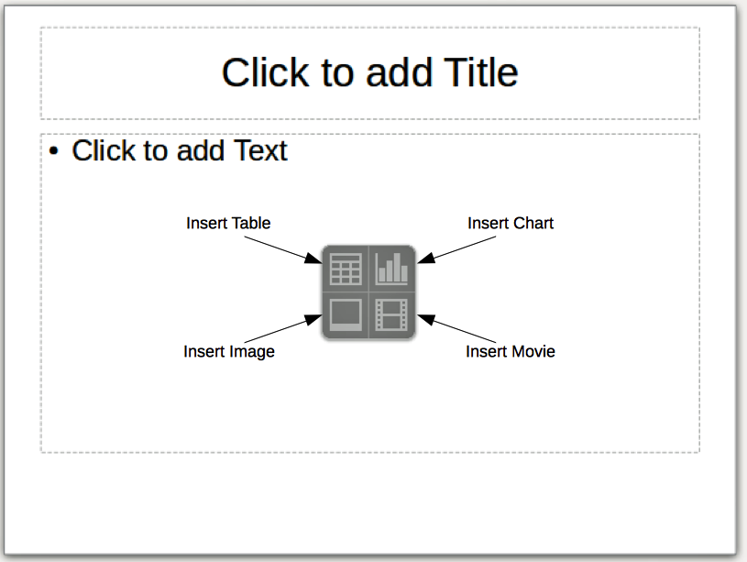
Figure 18: Selecting contents type

Changing layout
To select or change the layout:
- Place the slide in the work area and select the desired layout from the layout section in Sidebar Properties. Several layouts contain one or more content boxes. Each of these boxes can be configured to contain one of the following elements: Text, Movie, Image, Chart or Table.
- Select the type of contents by clicking on the icon that is displayed in the middle of the contents box as shown in Figure 18.
- If instead you intend to use the contents box for text, just click on the Click to add text and type your text.
Note | If you have selected a layout with one or more contents boxes, this is a good time to decide what type of contents you want to insert.

Modifying slide elements
A slide contains elements that were included in the slide master, as well those elements included in the selected slide layout. However, it is unlikely that the predefined layouts will suit all your needs for your presentation. You may want to remove elements that are not required or insert objects such as text and graphics.
Although Impress does not have the functionality to create new layouts, it allows you to resize and move the layout elements. It is also possible to add slide elements without being limited to the size and position of the layout boxes.
To resize a contents box, click on the outer frame so that the 8 resizing handles are displayed. To move it place the mouse cursor on the frame so that the cursor changes shape. You can now click the left mouse button and drag the contents box to its new position on the slide.
To remove any unwanted elements, click the element to highlight it and the resizing handles show it is highlighted. Press the Delete key to remove it.
Note | Changes to any of the layouts included in Impress can only be made using View > Normal, which is the default. Attempting any changes by modifying a slide master, although possible, may result in unpredictable results and requires extra care as well as a certain amount of trial and error.

Adding text
To add text to a slide that contains a text frame, click on Click to add text in the text frame and then type your text. The Outline styles are automatically applied to the text as you insert it. You can change the outline level of each paragraph as well as its position within the text by using the arrow buttons on the Text Formatting toolbar (see Figure 6 and “Outline view” on page 9). For more information on text, see Chapter 3 Adding and Formatting Text.

Adding objects
To add any pictures or objects to a slide, for example a picture, clipart, drawing, photograph, or spreadsheet, click on Insert then select from the drop down menu what type of insert you require. For more information, see the following chapters:
- For pictures, see Chapter 4 Adding and Formatting Images.
- For graphic objects, see Chapter 5 Managing Graphic Objects and Chapter 6 Formatting Graphic Objects.
- For OLE and other objects, see Chapter 7 Including Spreadsheets, Charts, and Other Objects.

Modifying slide appearance
To change the background and other characteristics of all slides in the presentation, you need to modify the master page or choose a different master page.
A Slide Master is a slide with a specified set of characteristics that acts as a template and is used as the starting point for creating other slides. These characteristics include the background, objects in the background, formatting of any text used, and any background graphics.
Note | LibreOffice uses three interchangeable terms for this one concept. Master slide, slide master, and master page. These terms all refer to a slide that is used to create other slides. This user guide, however, uses only the term slide master, except when describing the user interface.
Impress has included a range of slide masters, found in the Master Pages section of the Sidebar. You can also create and save additional slide masters or add more from other sources. See Chapter 2 Using Slide Masters, Styles, and Templates for information on creating and modifying slide masters.
If all you need to do is to change the background, you can use a shortcut:
- Select Format > Page and go to the Background tab on the Page Setup dialog that opens.
- Select the desired background between solid color, gradient, hatching and bitmap.
- Click OK to apply it. A dialog box opens, asking if the background should be applied to all the slides. If you click Yes, Impress automatically modifies the master page for you.
Note | Inserting and correctly formatting a background is beyond the scope of this chapter, but you can find all the information you need in the Chapter 6 Formatting Graphic Objects and the Draw Guide Chapter 4 Changing Object Attributes.

Modifying a slide show
By default the slide show will display all the slides in the same order as they appear in the slide sorter, using any transition between slides specified in the Presentation Wizard, and you need some keyboard or mouse interaction to move from one slide to the next.
Now is a good time to review the entire presentation and answer some questions. Run the slide show at least once (see “Running a slide show” on page 21) before answering them. You might want to add some questions of your own.
- Are the slides in the correct order? If not, some of them will need to be moved.
- Is the information well spaced and visible to members of an audience at the back of a large room? They may not be able to see information at the bottom of a slide, so you may need to design your presentation to fit the top three-quarters of the screen.
- Would an additional slide make a particular point clearer? If so, another slide needs to be created.
- Do some of the slides seem unnecessary? Hide or delete them.
- Would custom animations help some of the slides? (Advanced technique.)
- Should some of the slides have a different slide transition than others? The transition of those slides should be changed.
Tip | If one or more slides seem to be unnecessary, hide the slide or slides, and view the slide show a few more times to make sure they are not needed. To hide a slide, right-click the slide in the Slides pane and select Hide Slide from the context menu. Do not delete a slide until you have done this; otherwise you may have to create that slide again.
Once you have answered these and your own questions, make the necessary changes. This is done most easily in the Slide Sorter view (see “Slide Sorter view” page 11). Use the Slide Show menu to change the order of the slides, choose which ones are shown, automate moving from one slide to the next, and other settings. To change the slide transition, animate slides, and make other enhancements, use the various selections in the Task pane.

Custom animations
If you wish to add a custom animation to a slide, do it now. Custom animations are found in the Custom Animation section of the Sidebar. This is an advanced technique and is explained in Chapter 9 Slide Shows.

Slide transitions
Your first slide show will probably have the same slide transition for all slides. Setting Advance slide to On mouse click is the default. If you want each slide to be shown for a specific amount of time, click Automatically after and enter the number of seconds. Click Apply to all slides.
Transition choices are found under Slide Transition on the Sidebar. For more information about slide transitions see Chapter 9 Slide Shows.
Tip | The Slide Transition section has a very useful option: Automatic preview. With this option selected, when you make any changes in a slide transition, the new slide is previewed in the Slide Design area, including its transition effect.

Running a slide show
- To run the slide show, do one of the following:
- Click Slide Show > Slide Show on the main menu bar.
- Click the Slide Show icon on the Presentation toolbar or the Slide Sorter toolbar.
- Press F5 or F9. (F9 does not work on a Mac.)
- If the slide transition is Automatically after x seconds, let the slide show run by itself.
- If the slide transition is On mouse click, do one of the following to move from one slide to the next.
- Click the mouse button to advance to the next slide.
- Use the arrow keys on the keyboard to go to the next slide or back to the previous one.
- Press the Spacebar on the keyboard to advance to the next slide.
- Right-click anywhere on the screen to open a menu from which you can navigate the slides and set other options.
- When you advance past the last slide, the message Click to exit presentation... appears. Click the mouse or press any key to exit the presentation.
- To exit the slide show at any time including at the end, press the Esc key.

Presenter Console
LibreOffice Impress has a Presenter Console function that can be used when an extra display for presentation has been connected your computer. The Presenter Console (Figure 19) provides extra control over slide shows by using different views on your computer display and on the display that the audience sees. The view you see on your computer display includes the current slide, the upcoming slide, any slide notes, and a presentation timer.
For more information and details about using the Presenter Console, see Chapter 9 Slide Shows.
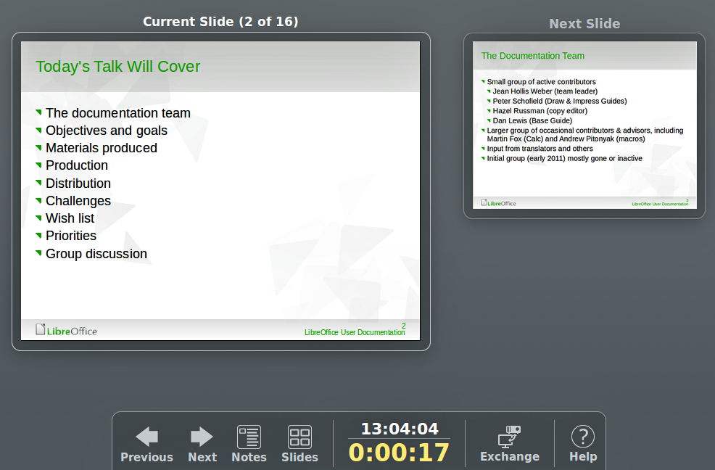
Figure 19: Impress Presenter Console

