
Impress Guide
Chapter 3
Adding and Formatting Text

Copyright
This document is Copyright © 2010–2014 by the LibreOffice Documentation Team. Contributors are listed below. You may distribute or modify it under the terms of either the GNU General Public License (http://www.gnu.org/licenses/gpl.html), version 3 or later, or the Creative Commons Attribution License (http://creativecommons.org/licenses/by/4.0/), version 4.0 or later.
このガイドのトレードマークは正式な所有者の所有物です。

コントリビューター
Peter Schofield Michele Zarri Jean Hollis Weber
T. Elliot Turner Low Song Chuan

Feedback
このドキュメントへのコメント提案は ドキュメントチームメーリングリスト: documentation@global.libreoffice.orgに投稿してください。
Note: Everything you send to a mailing list, including your email address and any other personal information that is written in the message, is publicly archived and cannot be deleted.

Acknowledgments
This chapter is based on Chapter 3 of the OpenOffice.org 3.3 Impress Guide. The contributors to that chapter are:
Nicole Cairns Martin J Fox Peter Hillier-Brook
Jean Hollis Weber Michele Zarri

このドキュメントの発行日と対応するソフトウェアのバージョン
Published 19 May 2014. Based on LibreOffice 4.2.3.

Note for Mac users
Some keystrokes and menu items are different on a Mac from those used in Windows and Linux. The table below gives some common substitutions for the instructions in this chapter. For a more detailed list, see the application Help.
Windows or Linux | Mac equivalent | Effect
Tools > Options menu selection | LibreOffice > Preferences | Access setup options
Right-click | Control+click and/or right-click depending on computer system | Open a context menu
Ctrl (Control) | ⌘ (Command) | Used with other keys
F5 | Shift+⌘+F5 | Open the Navigator
F11 | ⌘+T | Open the Styles and Formatting window

Contents
Copyright 2
コントリビューター 2
Feedback 2
Acknowledgments 2
このドキュメントの発行日と対応するソフトウェアのバージョン 2
Note for Mac users 2
Introduction 5
Working with text boxes 5
Entering text into AutoLayout text boxes 5
Entering text into text boxes 5
Moving text boxes 6
Resizing text boxes 7
Using Position and Size dialog 7
Deleting text boxes 9
Inserting text 9
Pasting text 9
Pasting text unformatted 9
Pasting text formatted 9
Inserting special characters 10
Inserting formatting marks 11
Formatting text 11
Introduction 11
Selecting text 12
Using styles to format text 13
Modifying presentation styles 13
Updating a style from a selection 14
Applying a presentation style 14
Formatting characters 14
Character dialog 14
Font page 15
Font Effects page 15
Position page 15
Sidebar Character subsection 16
Formatting paragraphs 17
Paragraph dialog 17
Indents and Spacing page 18
Alignment page 20
Tabs page 20
Asian Typography page 21
Sidebar Paragraph subsection 22
Creating bulleted and numbered lists 23
Creating lists in AutoLayout text boxes 23
Creating lists in other text boxes 24
Changing list appearance 24
Changing list type 25
Position page 25
Customize page 26
Using tables 28
Creating a table 28
Modifying a table 30
Sidebar options 30
Table toolbar 30
Position and size 33
Deleting tables 33
Using fields 34
Inserting a field 34
Formatting fields 34
Date and time fields 34
Page number fields 34
Using hyperlinks 34
Inserting hyperlinks 35
Formatting hyperlinks 36
Working with hyperlink buttons 36

Introduction
Any text used in slides is contained in text boxes. This chapter describes how to create, modify, use, and delete text boxes. It also discusses the various types of text that can be inserted and explains how to format the text. Finally, it provides information on how to insert special forms of text such as numbered or bulleted lists, tables, fields, and hyperlinks.

Working with text boxes
There are two ways of adding text boxes to slides:
- Choose a predefined layout from the Layouts section of the Tasks pane containing text elements as described in Chapter 1 Introducing Impress. These text boxes are called AutoLayout text boxes.
- Create a text box using the Horizontal text tool or Vertical text tool in the Drawing toolbar (Figure 1) or the Text toolbar (Figure 2).
Figure 1: Drawing Toolbar
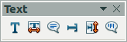
Figure 2: Text toolbar
Note | In addition to the normal text boxes where text is horizontally aligned, it is possible to insert text boxes where the text is aligned vertically. Click on the Vertical Text icon in the Drawing or Text toolbars (Figure 1 and Figure 2) to create a vertical text box. The Vertical Text tool is available only when Asian languages and Complex text layout (CTL) are enabled in Tools > Options > Language Settings > Languages on the main menu bar.

Entering text into AutoLayout text boxes
To enter text into an AutoLayout text box:
- Make sure Normal view is selected.
- Click in the text box that reads Click to add text.
- Type or paste your text into the AutoLayout text box.
For more information on AutoLayout text boxes, see “Creating bulleted and numbered lists” on page 23 for more information.

Entering text into text boxes
To enter text into a text box created using the text tool:
- Make sure Normal View is selected.
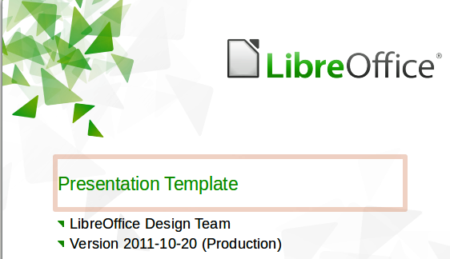
Figure 3: Entering text in a text box
- Click on the Text icon on the Drawing toolbar (Figure 1) or the Text toolbar (Figure 2). The default position of the drawing toolbar is towards the bottom of the screen. If the Drawing or Text toolbars with the text icon are not visible, got View > Toolbars > Drawing or Text on the main menu bar.
- Click in the slide and drag to draw a text box setting the width. Do not worry about the height because the text box will expand as you type.
- To reposition the text box to a different part of the slide, see “Moving text boxes” on page 6; to change the width, see “Resizing text boxes” on page 7.
- Release the mouse button when finished. The cursor appears in the text box, which is now in edit mode with the border highlighted (Figure 3).
- Type or paste your text in the text box.
- Click outside the text box to deselect it.

Moving text boxes
In Normal view, the cursor changes from an arrow to an I-beam (depending on your computer setup) as you move it over the text in a text box.
- Click when the pointer becomes an I-beam. The text box is now in edit mode. In this mode the border is visible around the text box edges (Figure 3).
- Move the cursor over the highlighted border and it changes shape, becoming the usual “move” symbol for your operating system (for example, a hand).
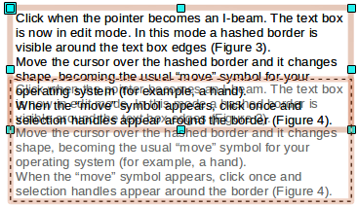
Figure 4: Moving text boxes
- When the “move” symbol appears, click once and selection handles appear around the border (Figure 4).
- Click anywhere on the border and drag to move the text box. A semi-transparent copy of the text box shows where your text box will be placed. Do not click on a selection handle as this will not move the text box, but resize the text box.
- Release the mouse button when the text box is in the desired position. To return to edit mode, click outside the text box area.

Resizing text boxes
In Normal view, the cursor changes from an arrow to an I-beam (depending on your computer setup) as you move it over the text in a text box.
- Click when the pointer becomes an I-beam. The text box is now in edit mode. In this mode the border is visible around the text box edges (Figure 3).
- Move the cursor over the border and it changes shape, becoming the usual “move” symbol for your operating system (for example, a hand).
- When the “move” symbol appears, click once and selection handles appear around the border (Figure 5).
- Move the pointer over any handle. The cursor changes shape, indicating in which direction the text box will be resized. The corner handles change the two dimensions of the text box simultaneously, while the four handles at the center of each side modify only one dimension.
- When the two-headed arrow is displayed, click and drag to resize the text box. As you resize the text box, a dashed outline appears indicating the new size of the text box.
- Release the mouse button when the text box is at the desired size. To return to edit mode, click outside the text box area.
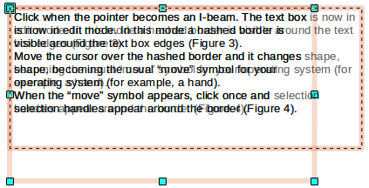
Figure 5: Resizing text boxes
Tip | To maintain the proportions of a text box while resizing, press and hold the Shift key, then click and drag. Make sure to release the mouse button before releasing the Shift key.

Using Position and Size dialog
For more accurate control over the size and position of a text box, use the Position and Size dialog instead of using the mouse.
- Select the text box, then click on the text box border to display the selection handles.
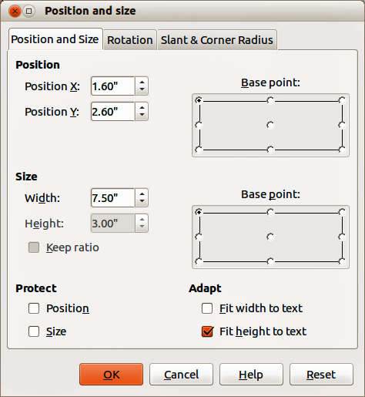
Figure 6: Position and Size dialog
- Press F4, or select Format > Position and Size from the main menu bar, or right-click and select Position and Size from the context menu to open the Position and Size dialog (Figure 6).
- Alternatively, click on the Properties icon on the Sidebar, then open the Position and Size subsection where you can change position, size, and rotation angle of the text box. To open the Position and Size dialog, click on the More Options icon at the top right of the Position and Size title bar.
- Use the Position to specify the X (horizontal) and Y (vertical) position of the text box. The values represent the distance of the base point relative to the top left corner of the slide.
- Use the Size section to specify the width and height of the text box. The values represent the distance of the base point relative to the top left corner of the slide. To maintain the ratio of width to height, select the Keep ratio option.
- Select one of nine base points that correspond to the selection handles on the text box and the center of the text box. The default selection is the top left corner of a text box.
- To prevent accidental modification of the position or size of the text box, select the Position and/or Size options in the Protect section of the dialog.
- To allow the text box to adjust its height and/or width as you enter text, select Fit width to text and/or Fit height to text in the Adapt section of the dialog.
- Click OK and the text box is moved or re-positioned on your slide.
Note | The unit of measurement for this dialog and other dialogs used in Impress is set in Tools > Options > LibreOffice Impress > General on the main menu bar.

Deleting text boxes
- Click the text once to display the text box border.
- Move the cursor to the border and click to display the selection handles, then press Delete.
Tip | Sometimes it is faster to to delete a text box by dragging a selection rectangle around the text box and then hitting the Delete key. Take care to avoid selecting and accidentally deleting other text boxes or shapes.

Inserting text

Pasting text
Text may be inserted into the text box by copying it from another document and pasting it into Impress. However, the pasted text will probably not match the formatting of the surrounding text or that of the other slides in the presentation. This may be what you want on some occasions; however, in most cases you may want to make sure that the presentation style is consistent. There are several ways to ensure consistency and these methods are explained below.

Pasting text unformatted
It is good practice to paste text without formatting and apply the formatting later. After highlighting and copying the text, use one of these methods to paste the text into your slide without formatting:
- Use the keyboard shortcut Control+Shift+V and select Unformatted text from the dialog that opens.
- Click on the small triangle to the right of the Paste icon on the Standard toolbar and select Unformatted text from the context menu that opens.
- Select Edit > Paste Special on the main menu bar and select Unformatted text from the dialog that opens.
The text will be pasted at the cursor position and formatted with the outline style in an AutoLayout text box or with the default graphic style in a normal text box.

Pasting text formatted
To paste text straight into an AutoLayout text box on your slide with its formatting retained, use one of these methods:
- Use the keyboard shortcut Control+V.
- Click on the Paste icon on the Standard toolbar.
- Select Edit > Paste on the main menu bar.
The text will be pasted into your slide at the cursor position. To give the pasted text the same appearance as the rest of your presentation, apply the appropriate outline style to the text:
- Select the text you have just pasted (see “Selecting text” on page 12 for more information).
- Select Format > Default formatting on the menu bar. This operation assigns one of the nine Presentation styles to the text. The style depends on where the text was pasted into your slide.
Figure 7: Text Formatting toolbar
- Use the four positioning arrows on the Text Formatting toolbar (Figure 7) to move the text to the appropriate position and give it the appropriate outline level. The left arrow promotes the list entry by one level (for example from Outline 3 to Outline 2), the right arrow demotes the list entry by one level, the up and down arrows move the list entry.
- Apply necessary manual formatting to the text changing font attributes, tabs, and so on.
If you are pasting text into a normal text box, you can still use styles to quickly format the text. Note that only one graphic style can be applied to the copied text.
- Paste the text in the desired position.
- Select the text you have just pasted (see “Selecting text” on page 12 for more information).
- Select the desired graphic style.
- Apply necessary manual formatting to the text changing font attributes, tabs, and so on.
Tip | Presentation styles are very different from Writer styles and are applied differently. Refer to “Using styles to format text“ on page 13 for details.

Inserting special characters
To insert special characters, such as copyright, math, geometric, or monetary symbols, or characters from another language.
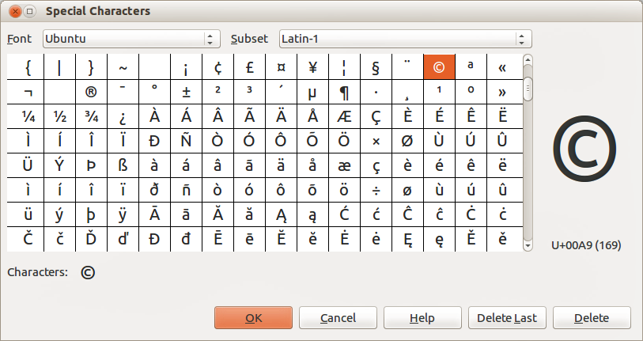
Figure 8: Special Characters dialog
- Click at the position where you want to insert the special character into the text.
- Select Insert > Special Character on the main menu bar to open the Special Characters dialog (Figure 8). Alternatively, and if the Text Formatting toolbar has been customized, click the Special Character icon to open the Special Characters dialog.
Tip | To show toolbar tools that are not visible on a toolbar, right-click in a blank area on the toolbar and select Visible Buttons from the context menu that opens. Click on the icon you wish to add to the toolbar.
- Choose the font and character subset from the Font and Subset drop-down menus.
- Select the special character you want to insert. You may have to scroll to find the one you want.
- Click OK to close the dialog and insert the special character at the cursor position in the text.
- Alternatively, double-click on the special character you want to insert. This closes the dialog and inserts the special character at the cursor position in the text.
Characters you selected will be inserted in the order they were selected, even if you accidentally click on the wrong character. Clicking on another character will only add it to the ones being inserted. Use one of the following methods to delete any unwanted characters:
- Click Delete Last to delete the last special character that you selected and then click on the correct character.
- Click Delete to delete all the characters selected and then click on the correct characters.
- Alternatively, you can insert all the selected characters and then delete any unwanted characters from the slide because special characters behave like any other character.

Inserting formatting marks
Formatting marks are a type of special character that you can insert into your text to correct the formatting. For example, it may not be desirable for words that are separated by a space or a hyphen to span over two lines, you can insert a non-breaking space or non-breaking hyphen. To access formatting marks, select Insert > Formatting marks on the main menu bar to open a context menu that lists the formatting marks that Impress supports, which are as follows:
- Non-breaking space – inserts a space that will keep bordering characters together on line breaks (keyboard shortcut Control+Shift+Space).
- Non-breaking hyphen – inserts a hyphen that will keep bordering characters together on line breaks.
- Optional hyphen – inserts an invisible hyphen within a word that will appear and create a line break once it becomes the last character in a line.
- No-width optional break – inserts an invisible space within a word that will insert a line break once it becomes the last character in a line. Only available when complex text layout (CTL) is enabled (keyboard shortcut Control+Slash).
- No-width no break – inserts an invisible space within a word that will keep the word together at the end of a line. Only available when complex text layout (CTL) is enabled.
- Left-to-right mark – inserts a text direction mark that affects the text direction of any text following the mark. Only available when complex text layout (CTL) is enabled.
- Right-to-left mark – inserts a text direction mark that affects the text direction of any text following the mark. Only available when complex text layout (CTL) is enabled.

Formatting text

Introduction
The appropriate use of text formatting can give a presentation a consistent look and a dynamic feel and it can even enhance the understanding of an audience by preventing any distracting elements in your message.
When you enter text, either in an AutoLayout text box or in a normal text box, it is formatted with a set of predefined attributes known as a style. The style used depends on the outline level of the point where the text was entered into a text box. For example, if you paste text at a level 2 position, Impress will format it either according to the Outline 2 presentation style for AutoLayout text boxes or the Default Graphic style for text boxes.
Tip | Sometimes, as seen in the “Pasting text” section on page 9, it is very useful to re-apply the baseline style to a selection of text eliminating any manual formatting applied to it, especially if you made a mistake and you do not know how to undo it. To use the baseline style, select the formatted text and then select Format > Default formatting on the main menu bar.
Formatting text may require some intervention in three areas:
- Character attributes (for example font color)
- Paragraph attributes (for example alignment)
- List attributes (for example type of bullet)
Sometimes it is quicker and more efficient to apply manual formatting. However, in situations where you need to perform the same modifications to many different parts of the presentation, the use of styles is recommended. Both these techniques are described here.
Note | Unlike LibreOffice Writer, where it is recommended to use styles whenever possible, in Impress manual formatting has to be used more often. This is because presentation styles are fixed in Impress. Therefore, it is not possible, for example, to have two different level 1s or different types of bullet points for the same outline level. Also, the lack of support for character styles forces the use of manual formatting to modify sections of the text.

Selecting text
Text must be selected before it can be formatted. Any formatting changes will apply only to the selected text.
- To format all the text in a text box, click once on the text, then click once on the border of the text box to display the selection handles. Now any formatting changes will apply to all the text in the text box.
- To format only part of the text and after clicking once on the text, you can select text using one of the following methods:
- Click and drag the cursor over the text to highlight the text.
- Double-click to select a complete word or triple click to select a whole paragraph.
- Press and hold the Shift key and then use the keyboard arrow keys to extend your selection.
Tip | To select text word by word, instead of character by character, press the Ctrl key and Shift key together. To speed up the selection even further, you can combine the Shift key with the Home key or the End key to extend the selection up to the start or end of the line in which the cursor is positioned, respectively.

Using styles to format text
Impress has two categories of styles: presentation styles and graphics styles. Presentation styles are used on text inserted into an AutoLayout text box, slide master backgrounds, and background objects. However, for text inserted in a text box or a graphic object, you need to apply a graphic style.
In this chapter we focus on Presentation styles. For information on graphic styles, see Chapter 6 Formatting Graphic Objects.

Modifying presentation styles
To modify a presentation style, follow these steps:
- Open the Styles and Formatting dialog (Figure 9) by pressing F11 or selecting Format > Styles and Formatting on the menu bar.
- Make sure the Presentation Styles icon is selected.
- Right-click on the style to be modified and select Modify from the context menu. The tabbed pages available in this dialog for modifying a presentation style are shown in Figure 10.
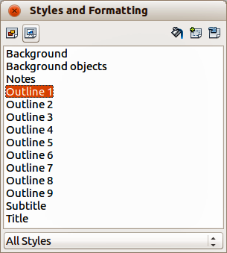
Figure 9: Presentation Styles and Formatting dialog
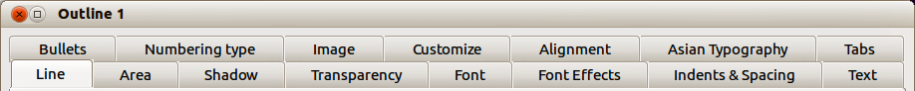
Figure 10: Dialog for modifying a presentation style
This modifying dialog consists of fifteen tabbed pages, which can be divided in two groups: pages that determine formatting of the text, and pages that determine the properties of slide master background and background objects.
There is no difference between attributes that determine a style and attributes used manually on portions of text. In fact the pages that open when manually applying formatting are the same that you use when configuring styles in the Styles and Formatting dialog. Therefore, once you master the formatting of text, you will know how to create and modify a style.
- For the Font and Font Effects style pages, refer to “Formatting characters” on page 14.
- For the Indents and Spacing, Alignment, and Tabs style pages, refer to “Formatting paragraphs” on page 17.
- For the Bullet and numbering type, Graphics, Customize style pages, refer to “Creating bulleted and numbered lists” on page 23.
The pages that relate to formatting background and background objects are described in detail in Chapter 6 Formatting Graphic Objects.

Updating a style from a selection
To update a style from a portion of text that you have just modified or would like to use:
- Select an item in a text box that has the format you want to adopt as a style.
- In the Styles and Formatting dialog (Figure 9), select the style you want to update and then click the Update Style icon .

Applying a presentation style
To apply a presentation style, move the paragraph to the appropriate outline level as described in “Creating bulleted and numbered lists” on page 23.This is different from Writer, where you select the desired style from the Styles and Formatting window.

Formatting characters

Character dialog
To view the character formatting options, select Format > Character on the main menu bar or click the Character icon on the Text Formatting toolbar (Figure 15 on page ) and the Character dialog opens (Figure 11). If Text Formatting toolbar is not visible, choose View > Toolbars > Text Formatting. Note that character styles do not exist in Impress.
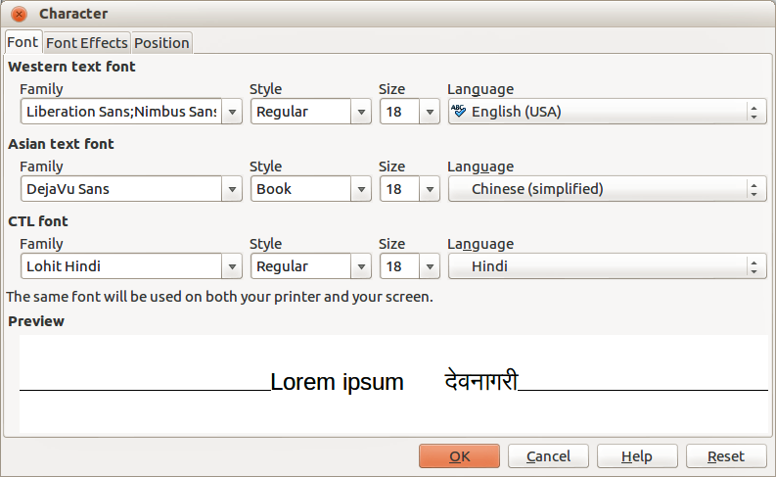
Figure 11: Font page in Character dialog with Asian and CTL fonts enabled

Font page
Use the Font page (Figure 11) to select the desired font type, its base attributes (Italic, Bold, etc.) as well as the size. A sample of the font is displayed in the lower part of the dialog. You can also specify the language of this style. This font page is also available when creating or modifying a presentation style or a graphics style.
Tip | When writing a presentation in multiple languages, you can use the language setting to create two styles that only differ in the language but are otherwise the same. This allows you to check the spelling of all of the contents without affecting appearance.
If support for Asian language and Complex Text Layout (CTL) font has been enabled (Tools > Options > Language Settings > Languages), then Asian text font and CTL text font are available in the Character dialog. Each part of the Character dialog has the same functionality, so you can specify the Asian and CTL text fonts and their attributes as well as Western text fonts.
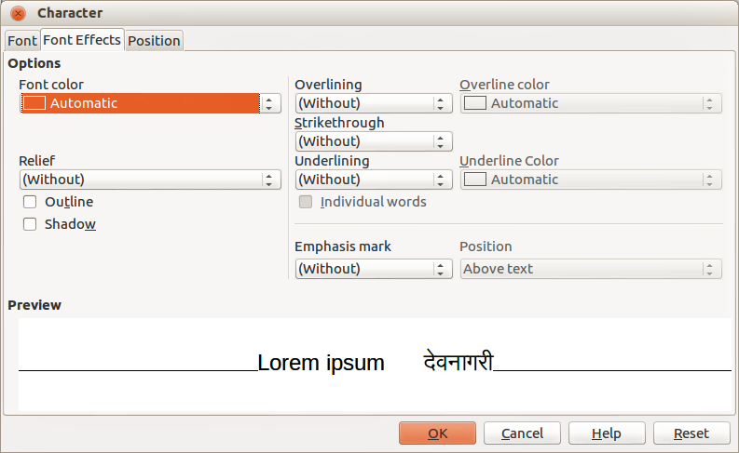
Figure 12: Font Effects page in Character dialog

Font Effects page
Use the Font Effects page (Figure 12) to apply special effects to the text, such as over lining and underlining, color, shadow, and so on. As for the Font page, a sample of the text is displayed in the lower part of the dialog, providing a quick visual check of the effects applied. This page is also available when creating or modifying a presentation style or a graphics style.

Position page
The Position page (Figure 13) has advanced options to customize text. Use this page to set the text position relative to the baseline when you need to insert subscripts or superscripts. This page is not available when creating or modifying a presentation style or a graphics style.
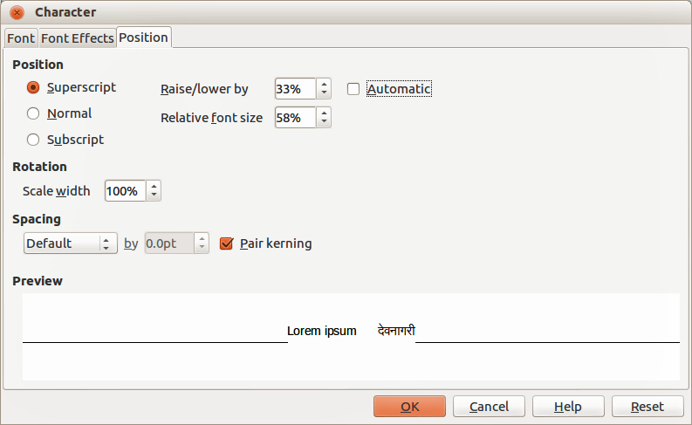
Figure 13: Position page in Character dialog
In Position, create a superscript or a subscript as follows:
- Select Superscript or Subscript as applicable.
- Specify the amount as a percentage by which the text should be raised (superscripts) or lowered (subscripts). If Automatic is selected, this option is not available.
- Specify the percentage of the character to be used relative to the baseline character size.
The other attributes that can be set on this page are as follows:
- Scale width in Rotation – specifies the percentage of the font width by which to horizontally stretch or compress the individual characters of the selected text.
- Spacing – specifies the spacing between the characters of the selected text. For expanded or condensed spacing, enter the amount that you want to expand or condense the text in the by box using the options from the drop-down list.
- Default – uses the character spacing specified in the font type
- Expanded – increases the character spacing
- Condensed – decreases the character spacing
- Pair kerning – automatically adjust the character spacing for specific letter combinations. Kerning is only available for certain font types and requires that your printer support this option.

Sidebar Character subsection
An alternative method of formatting characters is to use the Character subsection (Figure 14) on the Sidebar. Click on the Properties icon on the Sidebar, then open the Character subsection. If you require more character formatting, click on the More Options icon at the top right of the Character title bar to open the Character dialog.
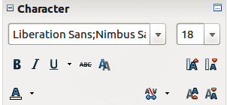
Figure 14: Sidebar Character Subsection
The character formatting options available in the Character subsection on the Sidebar are as follows:
- Font Name and Font Size – select the font name and size that you want to use from the drop-down lists. These options are also available on the Text Formatting toolbar.
- Bold; Italic; Underline – these options are also available on the Text Formatting toolbar. Click on the small triangle to the right of Underline and select the type of underlining you want to use from the drop-down list. Click More Options at the bottom of this drop-down list to open the Character dialog.
- Strikethrough – draws a line through the selected text.
- Shadow – adds a shadow to the selected text.
- Increase Font and Reduce Font – each click increases or reduces the size of the selected characters by the same amount. Actual size depends on your computer setup.
- Font Color and Highlighting – click on the small triangle to the right of these icons and select the color you want to use. These options are also available on the Text Formatting toolbar.
- Character Spacing – click on the small triangle to the right Character Spacing and select the type of spacing between characters that you require. Spacing between characters is also know as kerning.
- Superscript – reduces the font size of the selected text and raises the text above the baseline.
- Subscript – reduces the font size of the selected text and lowers the text below the baseline.

Formatting paragraphs

Paragraph dialog
To view the paragraph formatting options, select Format > Paragraph on the main menu bar or click the Paragraph icon on the Text Formatting toolbar (Figure 22 on page ) and the Paragraph dialog opens (Figure 15). If the Text Formatting toolbar is not visible, select View > Toolbars > Text Formatting on the main menu bar.
Normally the paragraph formatting dialog contains three pages: Indents and Spacing; Alignment and Tabs. However, if Asian language support has been enabled in Tools> Options > Language Settings > Languages, a page called Asian Typography is also becomes available.
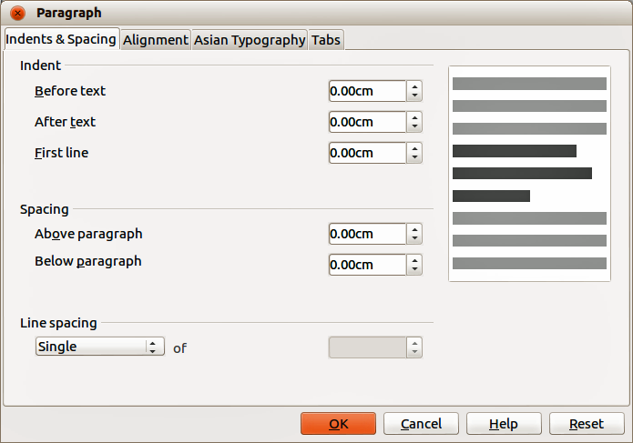
Figure 15: Indents and Spacing in Paragraph dialog

Indents and Spacing page
The Indents and Spacing page (Figure 15) has four sections and is also available in Presentation Styles dialog and Graphics Styles dialog.
- Indent – specifies the amount of space to leave between the left and the right page margins and the paragraph.
- Before text – enter the amount of space that you want to indent the paragraph from the page margin. If you want the paragraph to extend into the page margin, enter a negative number. In Left-to-Right languages, the left edge of the paragraph is indented with respect to the left page margin. In Right-to-Left languages, the right edge of the paragraph is indented with respect to the right page margin.
- After text – enter the amount of space that you want to indent the paragraph from the page margin. If you want the paragraph to extend into the page margin, enter a negative number. In Left-to-Right languages, the right edge of the paragraph is indented with respect to the right page margin. In Right-to-Left languages, the left edge of the paragraph is indented with respect to the left page margin.
- First line – indents the first line of a paragraph by the amount that you enter. To create a hanging indent enter a positive value for Before text and a negative value for First line.
- Spacing – specifies the amount of space to leave between selected paragraphs.
- Above paragraph – enter the amount of space that you want to leave above the selected paragraph(s).
- Below paragraph – enter the amount of space that you want to leave below the selected paragraph(s).
Note | If spacing is specified for both before and after a paragraph and Do not add space between paragraphs of the same style is selected, only the spacing below a paragraph is applied when the preceding and following paragraphs are of the same paragraph style.
- Line spacing – specifies the amount of space to leave between lines of text in a paragraph. The options available from the drop-down list are as follows:
- Single – applies single line spacing to the current paragraph. This is the default setting.
- 1.5 lines – sets the line spacing to 1.5 lines.
- Double – sets the line spacing to two lines.
- Proportional – select this option and then enter a percentage value in the box, where 100% corresponds to single line spacing.
- At Least – sets the minimum line spacing to the value that you enter in the box. If you use different font sizes within a paragraph, the line spacing is automatically adjusted to the largest font size. If you prefer to have identical spacing for all lines, specify a value in At Least that corresponds to the largest font size.
- Leading – sets the height of the vertical space that is inserted between two lines.
- Fixed – enter a fixed value to be used for line spacing.
Tip | Setting the line spacing to less than 100% is a good method to place a lot of text into a text box when space is limited. However, care must be taken as too small a value will make the text hard to read.
Tip | You can change the default unit of measurement, for example from inches to centimeters, in Tools > Options > LibreOffice Impress > General on the main menu bar.
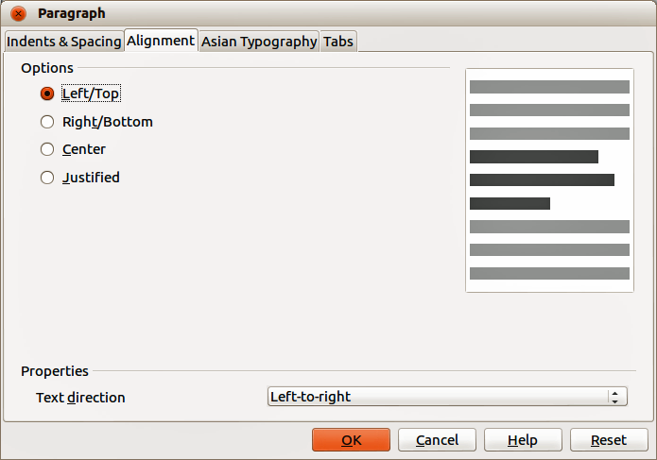
Figure 16: Alignment in Paragraph dialog

Alignment page
Use the Alignment page (Figure 16) to determine the paragraph alignment as follows. This page is also available in Presentation Styles dialog and Graphics Styles dialog.
- Left – aligns the paragraph to the left page margin. If Asian language support is enabled, this option is named Left/Top.
- Right – aligns the paragraph to the right page margin. If Asian language support is enabled, this option is named Right/Bottom.
- Centered – centers the contents of the paragraph on the page.
- Justify – aligns the paragraph to the left and to the right page margins.
- Text direction – specifies the text direction for a paragraph that uses complex text layout (CTL) and is only available if complex text layout support is enabled.
The paragraph alignment options can also be accessed using the paragraph alignment icons on the Text Formatting toolbar (Figure 22 on page ) or the Paragraph subsection (Figure 19) on the Sidebar.
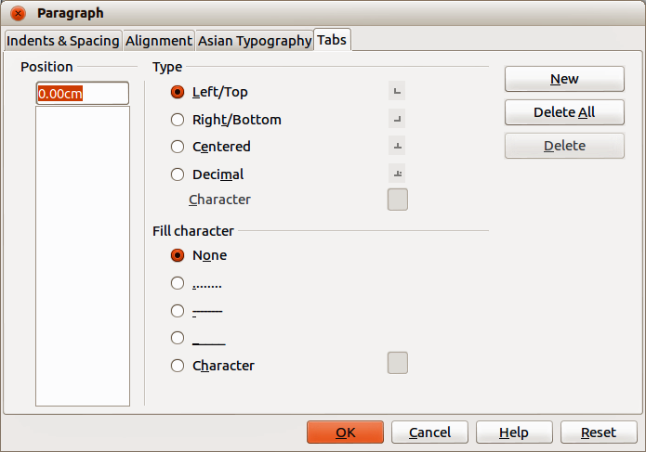
Figure 17: Tabs in Paragraph dialog

Tabs page
Use the Tabs page (Figure 17) to determine the tab stops. This page is also available in Presentation Styles dialog and Graphics Styles dialog.
You can create tabs within a paragraph as follows:
- Set the size of the tab stop in the Position text box.
- Select the type of tab in Type. If you set the type to Decimal, specify the character to be used as the decimal point In Character box.
- Left – aligns the left edge of the text to the tab stop and extends the text to the right. The name of this tab stop is Left/Top if Asian language support is enabled.
- Right – aligns the right edge of the text to the tab stop and extends the text to the left of the tab stop. This name of this tab stop is Right/Bottom if Asian language support is enabled.
- Center – aligns the center of the text to the tab stop.
- Decimal – aligns the decimal point of a number to the center of the tab stop and text to the left of the tab.
- Character – enter a character that you want the decimal tab to use as a decimal separator.
- Select a Fill character which will be drawn from the tab insertion point up to the tab stop.
- None – inserts no fill characters and removes any existing fill characters to the left of the tab stop.
- ....... – fills the empty space to the left of the tab stop with dots.
- ------ – fills the empty space to the left of the tab stop with dashes.
- ______ – draws a line to fill the empty space to the left of the tab stop.
- Character – specify a character to fill the empty space to the left of the tab stop.
- Click the New button to apply the new tab stop to the current paragraph.
- Click OK to save your changes and close the dialog.
You can edit tabs within paragraphs as follows:
- Select the tab you want to edit in the Position box.
- Select the Type and Fill character you want to use.
- Click OK to save your changes and close the dialog.
Note | To change the tab position, you have to delete the tab first, then create a new tab with the changes you require.
You can delete tabs within paragraphs as follows:
- Select the tab in the Position box.
- Click Delete to delete the selected tab.
- Click Delete All to delete all of the tab stops that are set for the current paragraph.
- Click OK to save your changes and close the dialog.

Asian Typography page
Use the Asian Typography page (Figure 18) to set the following properties relative to line changes. This page is also available in Presentation Styles dialog and Graphics Styles dialog.
- Apply list of forbidden characters to the beginning and end of lines – prevents the characters in the list from starting or ending a line. The characters are relocated to either the previous line or the next line. To edit the list of restricted characters that start or end a line, go to LibreOffice > Language Settings > Asian Layout.
- Allow hanging punctuation – prevents commas and periods from breaking the line. Instead, these characters are added to the end of the line, even in the page margin.
- Apply spacing between Asian, Latin and Complex text – inserts a space between Asian, Latin and complex characters.
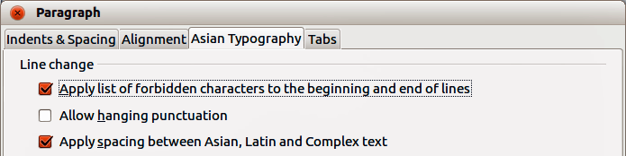
Figure 18: Asian Typography in Paragraph dialog

Sidebar Paragraph subsection
An alternative method of formatting paragraphs is to use the Paragraph subsection (Figure 19) on the Sidebar. Click on the Properties icon on the Sidebar, then open the Paragraph subsection. If you require more paragraph formatting, click on the More Options icon at the top right of the Paragraph title bar to open the Paragraph dialog.
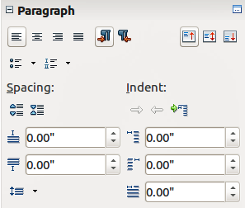
Figure 19: Sidebar Paragraph Subsection
The character formatting options available in the Paragraph subsection on the Sidebar are as follows:
- Align Left; Align Center, Alight Right, Align Justified – determines how a paragraph is aligned to the page margins. These icons are also available on the Text Formatting toolbar.
- Left-To-Right, Right-To-Left – only available when Asian and Complex text layout (CTL) options have been selected in Tools > Options > Language Settings > Languages.
- Align Top, Align Center Vertically, Align Bottom – aligns the selected paragraph to the top, center or bottom of the text box. This is similar to vertical alignment of data within a table cell.
- Bullets, Numbering – creates a bulleted or numbered list from selected paragraphs. Click on the small triangle to the right of the icon to select a bullet or numbering formatting option from a drop-down list. Click More Options at the bottom of these drop-down lists to open the Bullets and Numbering dialog.
- Increase Spacing , Decrease Spacing – increases or decreases the spacing above and below the selected paragraphs.
- Above Paragraph Spacing, Below Paragraph Spacing – increases or decreases the spacing either above or below the selected paragraph. Enter the amount of spacing you want to use in the text box.
- Line Spacing – adjust the spacing between the lines of a selected paragraph. Click on the small triangle to the right of the icon and select the type of line spacing you want to use from the drop-down list.
- Increase Indent – this tool is only active when a list item is selected. Each click demotes the outline level of the selected list paragraph. Works in the same way as the Demote icon on the Text Formatting toolbar.
- Decrease Indent – this tool is only active when a list item is selected. Each click promotes the outline level of the selected list paragraph. Works in the same way as the Promote icon on the Text Formatting toolbar.
- Switch to Hanging Indent – this tool is only active when a standard paragraph is selected and does not work on list items. Each click switches the hanging indent of the first line of a selected paragraph from a positive value to a negative value or from a negative value to a positive value.
- Left Indent, Right Indent, Hanging Indent – enter the value for each type of indent in the text boxes.

Creating bulleted and numbered lists
The procedure to create a bulleted or numbered list varies depending on the type of text box used, although the tools to manage the list and customize the appearance are the same. In AutoLayout text boxes created automatically by Impress, the outline styles available are, by default, bulleted lists. For normal text boxes an additional step is required to create a bulleted list.

Creating lists in AutoLayout text boxes
Every text box included in the available layouts is already formatted as a bulleted list, therefore to create a bulleted list the only necessary steps are as follows:
- From the Layout pane, choose a slide design that contains a text box. Those are easily recognizable from the thumbnail.
- Click on the text ●Click to add text in the text box and start typing your first item.
- Press Enter to start a new bulleted line.
- Press Shift+Enter to start a new line without creating a new bullet or number. The new line will have the same indentation as the previous line.
- Press Tab, or the Demote icon on the Text Formatting toolbar (Figure 7 on page ), or use the keyboard shortcut Alt+Shift+Right to demote or move your item down to the next outline level.
- Press Shift+Tab, or the Promote icon on the Text Formatting toolbar, or use the keyboard shortcut Alt+Shift+Left to promote or move your item up to the next outline level.
- Click the Bullets On/Off icon on the Text Formatting toolbar or Bullets in the Sidebar Paragraph subsection to create a list without bullet points or an item without a bullet point.
By default, the list created is a bulleted list. To customize the list appearance or to change from bulleted to numbered or numbered to bulleted, refer to “Changing list appearance” below.
In AutoLayout text boxes, promoting or demoting an item in the list corresponds to applying a different outline style. This means that the second outline level corresponds to Outline 2 style, the third to Outline 3 style, and so on. As a consequence, a change in the level also produces other changes (for example font size, bullet type, and so on).
Note | Do not try to change the outline level by selecting the text and then clicking the desired outline style as you would in Writer. Due to the way that presentation styles work in Impress it is not possible to apply outline levels in this way.

Creating lists in other text boxes
To create a list in a text box, follow these steps:
- Place the cursor in the text box.
- Click the Bullets On/Off icon in the Text Formatting toolbar, or Bullets or Numbering in the Sidebar Paragraph subsection.
- Type the text and press Enter to start a new bulleted line.
- Press Shift+Enter to start a new line without creating a new bullet or number. The new line will have the same indentation as the previous line.
- Press Tab to increase the indent level of your item.
- Press Shift+Tab to decrease the indent level of your item.
To customize the list appearance or to change from bulleted to numbered or numbered to bulleted, refer to “Changing list appearance” below.

Changing list appearance
You can customize the appearance of a list, change the bullet type or numbering for the entire list or for a single entry. All changes can be made using the Bullets and Numbering dialog (Figure 20), or the Bullets or Numbering tools in the Sidebar Paragraph subsection.
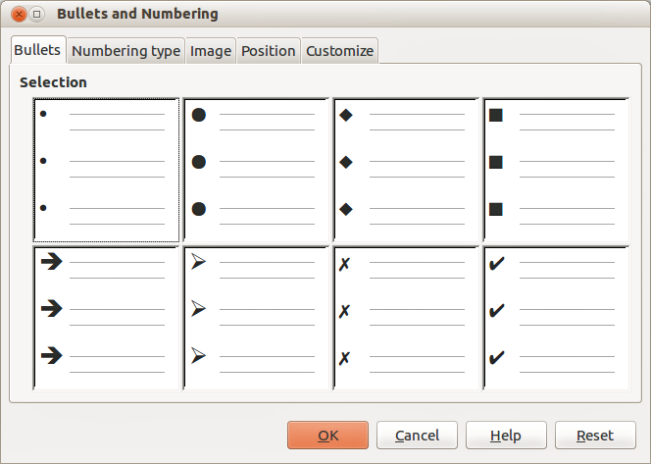
Figure 20: Bullets and Numbering dialog – Bullets page

Changing list type
- To change the type of list for all the items in an entire list, select the entire list by highlighting all the text in the text box or click on the border of the text box so that the selection handles are displayed.
- To change the appearance of a single item in a list, click anywhere in the list item to place the cursor in the line.
- Select Format > Bullets and Numbering on the main menu bar or click on the Bullets and Numbering icon on the Text Formatting toolbar to open the Bullets and Numbering dialog (Figure 20). This dialog contains five pages: Bullets, Numbering type, Image, Position, and Customize. Alternatively, click on Bullets or Numbering in the Sidebar Paragraph subsection.
- If a bulleted list is required, select the bullet style from the default styles available on the Bullets page of the Bullets and Numbering dialog. Alternatively, click on the small triangle to the right of the Bullets tool in the Sidebar Paragraph subsection and select a bullet type from the drop-down list.
- If a numbered list is needed, select a numbering style from the default numbering styles on the Numbering type page of the Bullets and Numbering dialog. Alternatively, click on the small triangle to the right of the Numbering tool in the Sidebar Paragraph subsection and select a numbering type from the drop-down list.
- If you want to use a graphics style, select a graphic style from the default styles available on the Image page of the Bullets and Numbering dialog.
- If you want to adjust the indentation and spacing of your list, see “Position page” below for more information.
- If you want to use a customized list, select Customize in the Bullets and Numbering dialog and use the available options to customize your list. See “Customize page” below for more information.
- If using the Bullets and Numbering dialog, click OK to save your changes and close the dialog. When using the Bullets or Numbering tool in the Sidebar Paragraph subsection, any changes to a list are immediate.
Note | To open the Bullets and Numbering dialog when using the Bullets or Numbering tool in the Sidebar Paragraph subsection, click on More Options at the bottom of the drop-down list that appears when click the small triangle to the right of the tool.
Note | If the list was created in an AutoLayout text box, then an alternative way to change the entire list is to modify the Outline styles. Changes made to the outline style will apply to all the slides using them, so be careful before using this command.

Position page
Use the Position page (Figure 21) to adjust the indentation and spacing of the bullet point and its text. This page is particularly effective when used in combination with the Customize page.
Set up an outline level as follows:
- Select the level from the list on the left hand side of the page. Select level 1 – 10 to modify all levels simultaneously.
- Set the Indent value to create spacing between the bullet or number and the text. If level 1 – 10 is selected, Indent is not available.
- Select the Relative option to measure the indent value relative to the previous level and not from the margin.
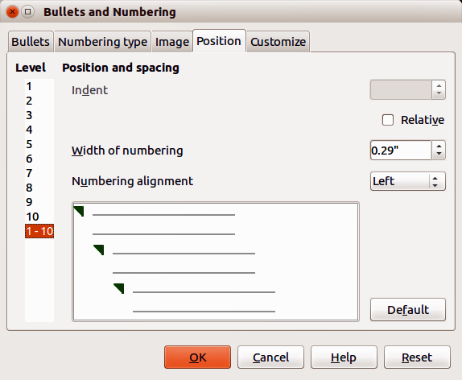
Figure 21: Bullets and Numbering – Position page
- Set Width of numbering to make sure there is enough room in a numbered list for numbers when they consist of two or more digits.
- Set Numbering alignment to specify the alignment of numbers when creating a numbered list. For example, you may want to align numbers to the right when your numbered list includes numbers with two or more digits.
- Click Default to set indent and spacing values to the Impress default values.
- Click OK to save your changes and close the dialog.
Note | The Position page is not available if you are modifying a presentation style or graphics style. However, the same effects can be obtained using the Indents and Spacing page of the Paragraph dialog (Figure 15 on page ) for creating or modifying a slide.

Customize page
Use the Customize page (Figure 22) to alter the style of outline levels. The options available on this page depend on the type of marker selected for the list. Using the Customize page, you can create complex structured layouts, for example a nested list with numbering followed by bullets.
- To modify each level independently, select each level you want to modify on the left hand side of the box. The right hand side of the screen shows a preview of the modifications made.
- To modify all levels at once, select 1 – 10 as the level. With these levels being arranged in a hierarchical structure, changing, for example, the font attribute of one of the levels ripples through all the lower levels.
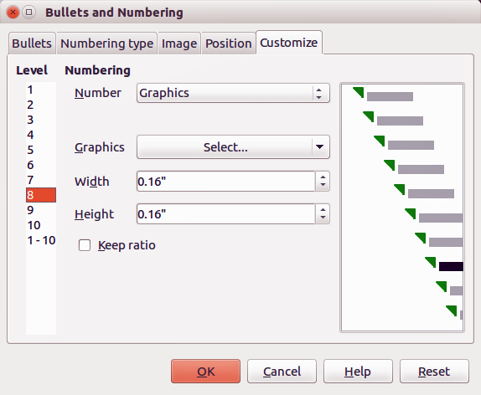
Figure 22: Bullets and Numbering – Customize page
- Select the options you want to use when customizing your list. The options available are described below.
- To revert to the default values used in Impress, click Reset.
- When you have finished customizing the list, click OK to save your changes and close the dialog.
Depending on the bullet or numbering style selected, some of the following options may not be available on the Customize page:
- Numbering – select the type of numbering you want to use in your list from the drop-down list.
- Before – enter any text or characters to appear before the number (for example, Step).
- After – enter any text or characters to appear after the number (for example, a punctuation mark).
- Color – select the color for the list marker (number or bullet character) from the drop-down list.
- Relative size – specify the size of the number relative to the size of the characters used in the paragraph for each item.
- Start at – enter the first value of the list (for example, you might want the list to start at 4 instead of 1).
- Character button – select a special character for the bullet.
- Graphics – select a graphic from the gallery of available graphics or a file on to be used as a marker.
- Width – specifies the width of the graphic used as a marker.
- Height – specifies the height of the graphic used as a marker.
- Keep ratio – if selected, the ratio between the width and the height of the graphic marker is maintained.

Using tables
Tables are a powerful mechanism to convey structured information quickly, so they represent an important tool when creating a presentation. You can create tables directly in Impress eliminating the need to embed a Calc spreadsheet or a Writer text table in your presentation. However, in some circumstances, it makes sense to embed a table into a presentation, especially when you require greater functionality in the table. The tables provided by Impress do have a limited functionality.
Several predefined table designs are available in the Table Design subsection of the Sidebar (Figure 23).
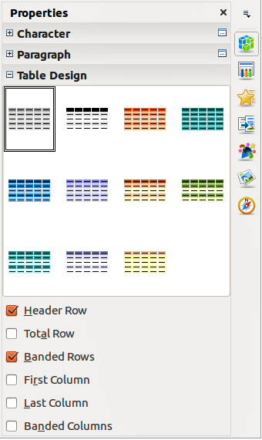
Figure 23: Sidebar Table Design subsection

Creating a table
When working with tables, it is useful to know the number of rows and columns needed as well as the appearance. The parameters can be adjusted later, but this is more laborious than setting the correct table dimensions from the beginning.
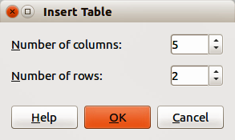
Figure 24: Insert Table dialog
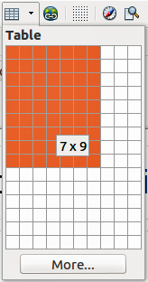
Figure 25: Table graphic insert tool
To insert a table into your slide, proceed as follows:
- Select the slide which will contain the table and, if necessary, modify the slide layout to create space for the table.
- Go to Insert > Table on the main menu bar or click on the Table icon on the Standard toolbar to open the Insert Table dialog (Figure 24).
- Specify the number of columns and number of rows you require for your table.
- Click OK to close the dialog and your table appears in the center of your slide.
Alternatively, click on the small triangle to the right of the Table icon to open the table graphic insert tool (Figure 25).
- Using the cursor, select the number of columns and rows required, then click the left mouse button. Your table appears in the center of your slide.
- Make sure the Table Design subsection (Figure 23) in the Sidebar is open.
- Select one of the predefined styles, which only differ in the color scheme. It is recommended that you select a color scheme similar to the one you want, but you can change table colors later on.
- Move the table by selecting it and dragging it to a new position, or use the method described in “Position and size” on page 33.
Note | When inserting tables into a slide, the table is inserted with the default style and settings already applied. This table can be modified to your requirements.  When tables are inserted into a slide, they are given a set of default attributes such as color scheme, banded rows, header row, and so on. Currently these defaults are hard coded in LibreOffice and cannot be changed.

Modifying a table
Once the table is added to the slide, you can control its appearance, size, position, and so on using a combination of the options in the Table Design subsection of the Sidebar, the Table toolbar, and the Table properties dialog.

Sidebar options
The following options are available in the Show section of Table Design on the Tasks pane:
- Header Row – selected by default and adds a first row with a different background from the rest of the table.
- Total Row – the opposite of Header Row. If selected, it changes the background of the last row to make it stand out from the other rows.
- Banded Rows – selected by default and option colors alternate rows with different backgrounds making it easier to read data presented in rows.
- First Column – highlights the first column of the table by allocating a darker background to it.
- Last Column – highlights the last column of the table by allocating a darker background to it.
- Banded Columns – when selected, alternate columns are colored differently.

Table toolbar
When a table is selected, eight selection handles appear around the edges and the Table toolbar (Figure 26) is displayed. If the Table toolbar is not displayed when a table is selected, go to View > Toolbars > Table on the main menu bar. The Table toolbar contains the majority of the tools you need to modify a table.
Table
Creates a new table in the selected slide. Opens the Insert Table dialog (Figure 24) where you can select the required number of rows and columns. Alternatively, click on the small triangle to the right of the Table icon to open a graphic tool for inserting tables (Figure 25). See “Creating a table” on page 28 for more information on inserting tables into your slide.
Line Style
Changes the style of the line of the selected cells. Opens a Border Style drop-down list where you can select from a range of predefined line styles.
Line Color (of the border)
Opens a Border Color drop-down menu where you can select the color of the borders around the selected cells.
Borders
Opens a Borders drop-down menu where you can select a predefined border configuration for the selected cells. If the desired border pattern is not available, you will need to use the Table properties dialog.
Area Style/Filling
In the drop-down menu, select how the selected cells should be filled: Invisible, Color, Gradient, Hatching, or Bitmap. Depending on the selection, the drop-down menu lists the available fillings for the option selected. Refer to Chapter 6 Formatting Graphic Objects for details on how to manage area filling styles.
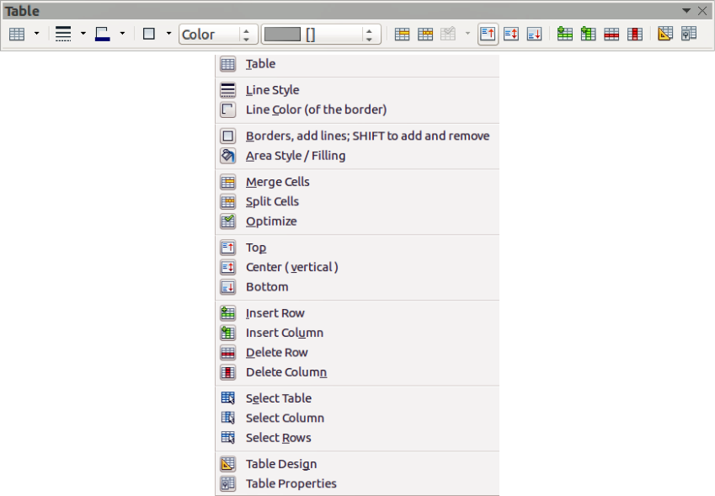
Figure 26: Table toolbar
Merge Cells
Merges the selected cells into one cell. Note that the contents of the merged cells are also merged. You can also right-click on the selected cells and select Cell > Merge from the context menu.
Split Cells
Make sure that the cursor is positioned on the cell you want to split, then click to open the Split Cells dialog (Figure 27). Select the number of cells required from the split as well as whether the cell should be split horizontally or vertically. When splitting horizontally, you can select the Into equal proportions option to get all cells of equal size. The contents of the split cell are kept in the original cell (the one on the left or top). You can also right-click on the selected cells and select Cell > Split from the context menu.
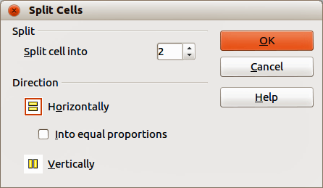
Figure 27: Split Cells dialog
Optimize
Evenly distributes the selected cells either horizontally or vertically. You can also right-click in the selected cells and select Row > Space Equally or Column > Space Equally from the context menu. If you want to optimize the whole table, you can evenly distribute rows or columns by right-clicking on the table border and select Row > Space Equally or Column > Space Equally from the context menu.
Top, Center (vertical), Bottom
You can select the vertical alignment of text in a cell by selecting the required cells and choosing the appropriate alignment. You can also right-click in the selected cells, then select Cell from the context menu and choose the appropriate alignment. To apply cell alignment to the whole table, right-click on the table border, then select Cell from the context menu and choose the appropriate alignment.
Insert Row, Insert Column
Clicking on Insert Row or Insert Column inserts a single row or column below and to the right of the selected cell. To insert more than one row or column, highlight cells across the number of rows or columns required, then click on Insert Row or Insert Column. You can also right-click in the selected cells and select Row > Insert or Column > Insert from the context menu. Select the required number of rows or columns in the dialog that opens and click OK.
To insert rows at the beginning of the table and columns at the left of the table, select the table, then right-click on the table border. Select the required number of rows or columns in the dialog that opens and click OK.
Delete Row, Delete Column
Clicking on Delete Row or Delete Column deletes a single row or column below where you have selected a cell. To delete more than one row or column, highlight cells across the number of rows or columns required, then click on Delete Row or Delete Column. You can also right-click in the selected cells and select Row > Delete or Column > Delete from the context menu.
Select Table, Select Column, Select Rows
These three icons select the complete table or the columns or rows where you have selected cells. By default these icons are not displayed on the Table toolbar. To display these icons, right-click in a blank area on the toolbar and select Visible Buttons from the context menu. Click on the icon you want displayed in the toolbar.
Table Design
This tool no longer functions with Table Design now as a subsection in the Sidebar.
Table Properties
Click the Table Properties icon on the Table toolbar, or right-click in the table and select Table from the context menu to open the Format Cells dialog (Figure 28), which contains the following pages.
- Font – use to select the desired font type, its base attributes (Italic, Bold, etc.) as well as the size. A sample of the font is displayed in the lower part of the dialog. You can also specify the language. See “Font page” on page 15 for more information on the available options.
- Font Effects – use to apply special effects to the text, such as over lining and underlining, color, shadow and so on. A sample of the text is displayed in the lower part of the dialog, providing a quick visual check of the effects applied. See “Font Effects page” on page 15 for more information on the available options.
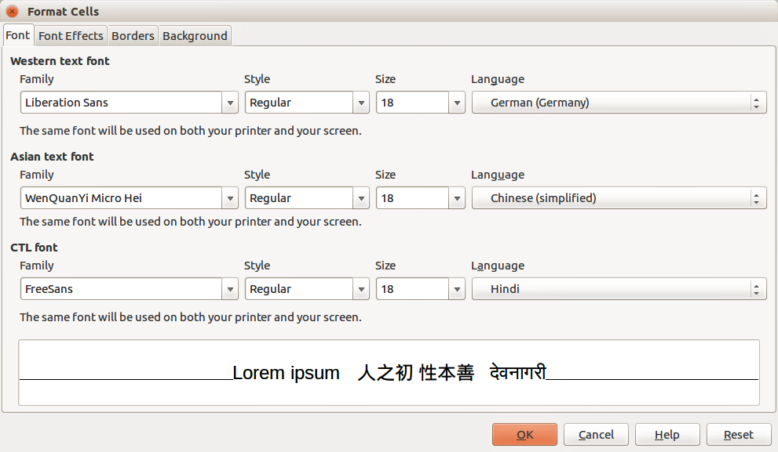
Figure 28: Format Cells dialog
- Borders – use to set advanced properties not available when using the Table toolbar, such as the spacing between the text and the border as well as setting the style of each individual border of the table separately. This page also provides the same options as the Line Style and Line Color on the Table toolbar.
Note | It is currently not possible to define diagonal borders for Impress tables.
- Background: changes the background of the selected cells and provides the same functions as Area Style/Filling on the Table toolbar.

Position and size
Impress treats tables just like any other graphic object. You can change table position and size on the slide by using the selection handles and the mouse.
For more accurate control with positioning and table sizing, open the Position and Size dialog (Figure 6 on page ). With the table is selected, right-click on the border of table and select Position and Size from the context menu or go to Format > Position and Size on the main menu bar, or press the F4 key.
Note | Only the Position and Size page in this dialog can be used for tables. For more information on this dialog see Chapter 6 Formatting Graphic Objects.

Deleting tables
To delete a table use one of the following methods:
- Click in the slide and drag a selection box over the table to select it, then press the Delete key.
- Click on the table border to select the table and press the Delete key.

Using fields
Fields allow the automatic insertion of text into the slide. You can think of a field as a kind of formula which is calculated when the document is loaded or printed and the result is written in the document. Fields are commonly used when creating templates and slide masters, as explained in Chapter 2 Using Slide Masters, Styles, and Templates.

Inserting a field
To insert a field into a slide, select the slide where the field will be and then select Insert > Fields on the main menu bar followed by one of these options:
- Date (fixed) – inserts the current date into your slide as a fixed field. The date is not automatically updated.
- Date (variable) – inserts the current date into your slide as a variable field. The date is automatically updated each time you open the file.
- Time (fixed) – inserts the current time into your slide as a fixed field. The time is not automatically updated.
- Time (variable) – inserts the current time into your slide as a variable field. The time is automatically updated each time you open the file.
- Author – inserts the first and last names of the author of the presentation. This information is derived from the value recorded in the LibreOffice user data. To modify this information go to Tools > Options > LibreOffice > User Data.
- Page Number – inserts the page number into the current slide. If you want to add a page number to every slide, go to View > Master > Slide Master on the main menu bar and insert the page number field.
- Page Count – inserts the total number of slides.
- File Name – inserts the name of the file. The file name only appears after you save the file.

Formatting fields

Date and time fields
To format a date or time field:
- Right-click on the field.
- Select the desired format from the context menu that opens. The available formats will depend on the language setting in Tools > Options > Language Settings > Language.

Page number fields
Formatting the page number fields can be done one of two ways:
- Select the page number field and apply the formatting manually.
- Go to Format > Page on the main menu bar and select a format from the list in Layout Settings in the Page Setup dialog.

Using hyperlinks
When inserting text (such as a website address or URL) that can be used as a hyperlink, Impress formats it automatically, creating the hyperlink and applying color and underlining. If you do not want Impress to use its default settings, then you have to insert a hyperlink manually.
Tips | To prevent LibreOffice from automatically turning website addresses (URLs) into hyperlinks, go to Tools > AutoCorrect Options > Options and deselect the URL Recognition checkbox.  To change the color of hyperlinks, go to Tools > Options > LibreOffice > Appearance, scroll to Unvisited links and/or Visited links, select the checkboxes, select new colors and click OK. Note that this will change the color for all hyperlinks in all components of LibreOffice which may not be what you want.

Inserting hyperlinks
To insert a hyperlink, or customize the appearance of a hyperlink:
- Select Insert > Hyperlinks on the main menu bar or use the keyboard shortcut Ctrl+K to open the Hyperlink dialog (Figure 29).
- On the left hand side, select one of the four types of hyperlinks. The top right part of the dialog changes according to the selection of hyperlink type. A full description of all the choices, and their interactions, is beyond the scope of this chapter. A summary of the most common choices used in a presentation is given below.
- Create your hyperlink using the dialog, then click Apply to insert into your slide.
- Click Close to close the dialog.
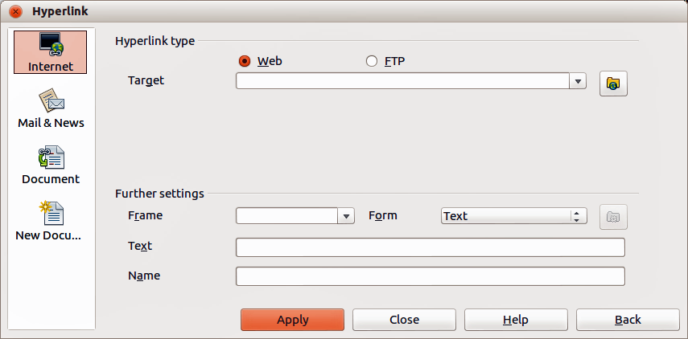
Figure 29: Hyperlink dialog
The options for Hyperlink type available are as follows:
- Internet – choose whether the link is Web or FTP. Enter the required web address in the Target text box.
- Mail & News – choose whether the link is an E-mail or news link. Enter the details of the Recipient and the Subject.
- Document – creates a hyperlink to another document or to another place in a document, commonly referred to as a bookmark.
- Enter the Path details in the text box, or click the Open File icon to open a file browser. Leave this blank if you want to link to a target in the same presentation.
- Optionally, you can specify a target (for example a specific slide). Click on the Target in Document icon to open a dialog where you can select the target. If you know the name of the target, you can type it into the Target text box.
- New Document: – creates a hyperlink to a new document. Select whether to edit the newly created document immediately (Edit now) or just create it to edit later (Edit later). Choose the type of document to create (text, spreadsheet, and so on). The Select path icon opens a file browser so that you can choose the directory for the new document.
Note | For navigation within a presentation, it is generally better to use the object interaction menu that you can find either in the Drawing toolbar or in the context menu that opens when right-clicking on an object.
The Further settings section on the Hyperlink dialog is common to all the hyperlink types, although some choices are more relevant to some types of links.
- Frame – set the value to determine how the hyperlink will open. This applies to documents that open in a web browser.
- Form – specifies if the link is to be presented as text or as a button. See “Working with hyperlink buttons” on page 36 for more information.
- Text – specifies the text that will be visible to the user.
- Name – applicable to HTML documents. It specifies text that will be added as a NAME attribute in the HTML code behind the hyperlink.

Formatting hyperlinks
To format a hyperlink:
- Select it by dragging a selection across the text. Do not click on the hyperlink because this will open the hyperlink.
- Right-click on the selected hyperlink.
- Select the type of formatting you want to change from the options available in the context menu.

Working with hyperlink buttons
A hyperlink button is inserted in the center of the current slide. In most cases, that is not where you want it to appear. To edit the text or size of a hyperlink button, or to move it to another place on the slide:
- Go to View > Toolbars > Form Controls on the main menu bar to open the Form Controls toolbar (Figure 30).
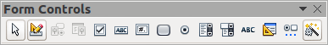
Figure 30: Form Controls toolbar
- Click the Design Mode On/Off icon . All the icons on the Form Controls toolbar become active.
- Select the hyperlink button you want to edit or move.
- Drag the hyperlink button to another position, or right-click to open a context menu where you can change the text on the button, the size of the button, and other properties.
- When you have finished editing the button, click the Design Mode On/Off icon again to make the icons inactive. For a detailed description of the properties and how to work with Form Controls, refer to the Writer Guide.

