CREATE TABLE PBLTWO (
TE_ONE VARCHAR(50),
TE_TWO VARCHAR(50),
TE_THREE VARCHAR(50)
);
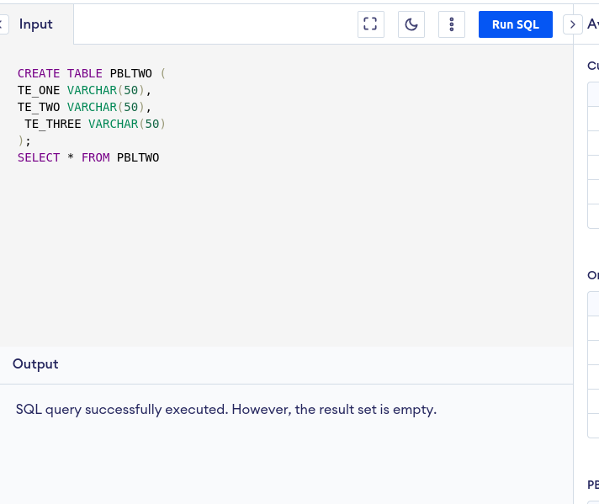

INSERT INTO PBLTWO(TE_ONE,TE_TWO,TE_THREE)
VALUES('VAIBHAV','ARYAN','ADITYA')
SELECT * FROM PBLTWO

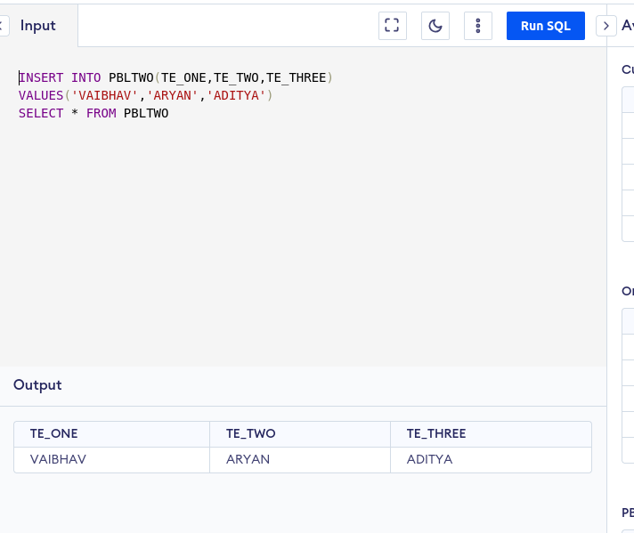

UPDATE PBLTWO
SET TE_TWO='VED'
SELECT * FROM PBLTWO
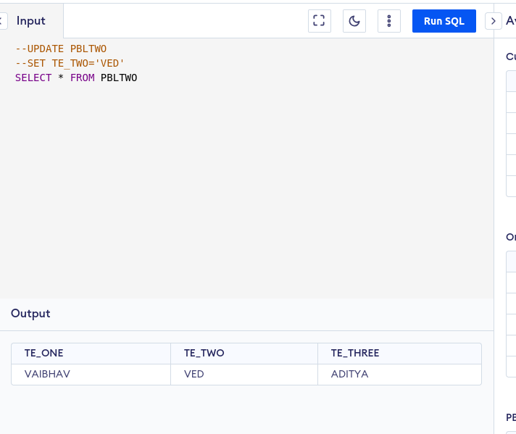

ALTER TABLE PBLTWO
ADD COLUMN CLASS_ID INT;
UPDATE PBLTWO SET CLASS_ID = 101
SELECT * FROM PBLTWO

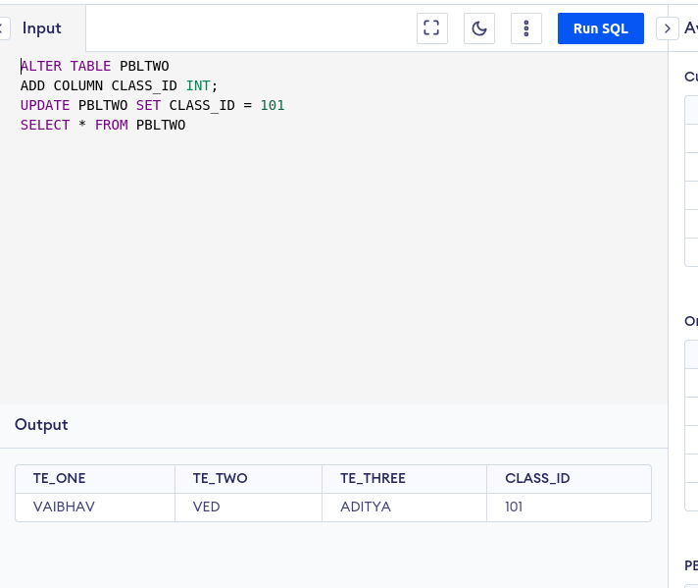

ALTER TABLE PBLTWO
DROP COLUMN CLASS_ID;
SELECT * FROM PBLTWO

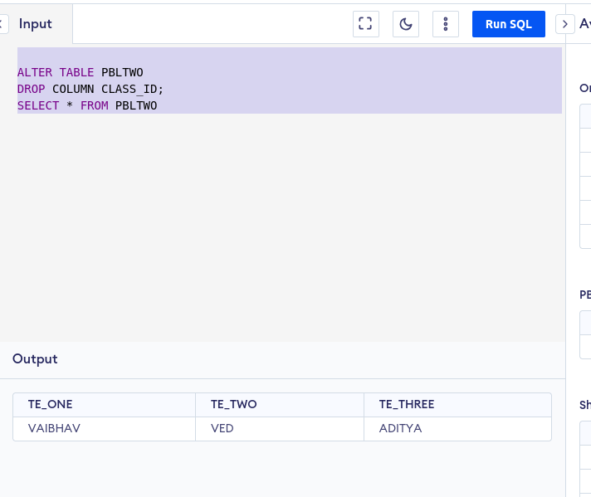

DROP TABLE PBLTWO;
SELECT * FROM PBLTWO

