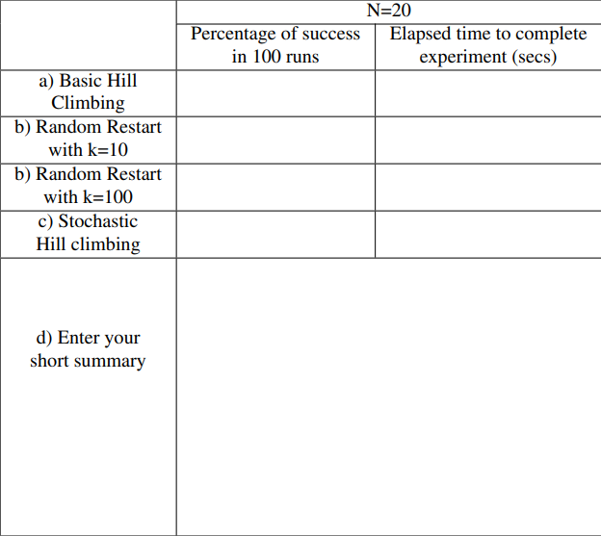
Random-restart hill climbing with k=100 achieved by far the highest success rate (92%) but also had the largest running time per experiment. Basic and stochastic hill climbing were very fast but almost always got stuck in local optima, while random restart with k=10 provided a moderate trade off between success rate and time.
1.12
1%
92%
0.18
4.24
23%
0.10
2%

Korhan Erdoğdu 30838

