1. **SIGNING UP.**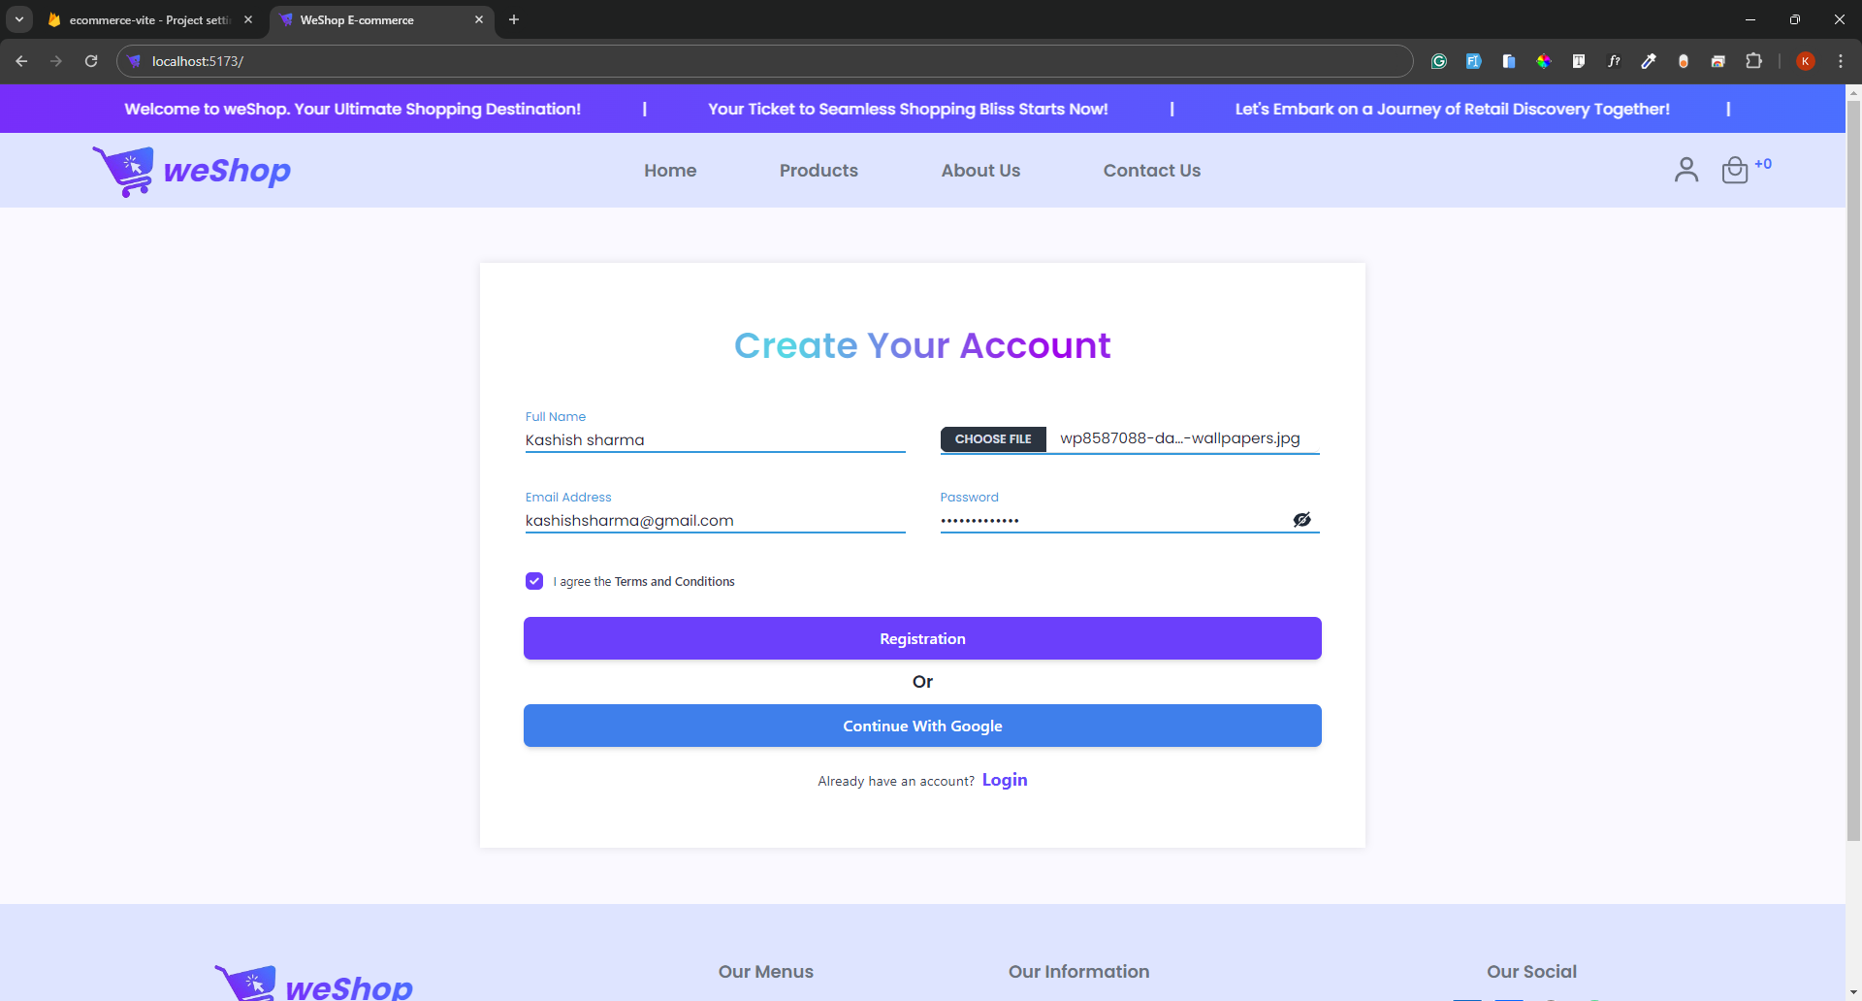
2. **LOGIN**A screenshot of a phone

   Description automatically generated
3. **SINGLE ITEM PRODUCT PAGE.**A screenshot of a computer

   Description automatically generated
4. **ADDING ITEM TO CART**A screenshot of a computer

   Description automatically generated
5. **TESTING CHECKOUT PAGE.(click “pay no” on the cart)**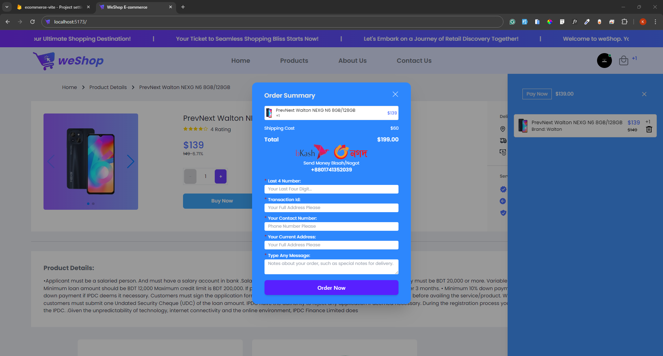
6. **SWITCHING BETWEEN NAVIGATIONS**
   1. **Home**A screenshot of a computer

      Description automatically generated
   2. Products  
      A screenshot of a computer

      Description automatically generated
   3. About Us.  
      A screenshot of a computer

      Description automatically generated
   4. Contact Us.  
      A screenshot of a computer

      Description automatically generated
7. **SENDING A MESSAGE(Contact us Page)**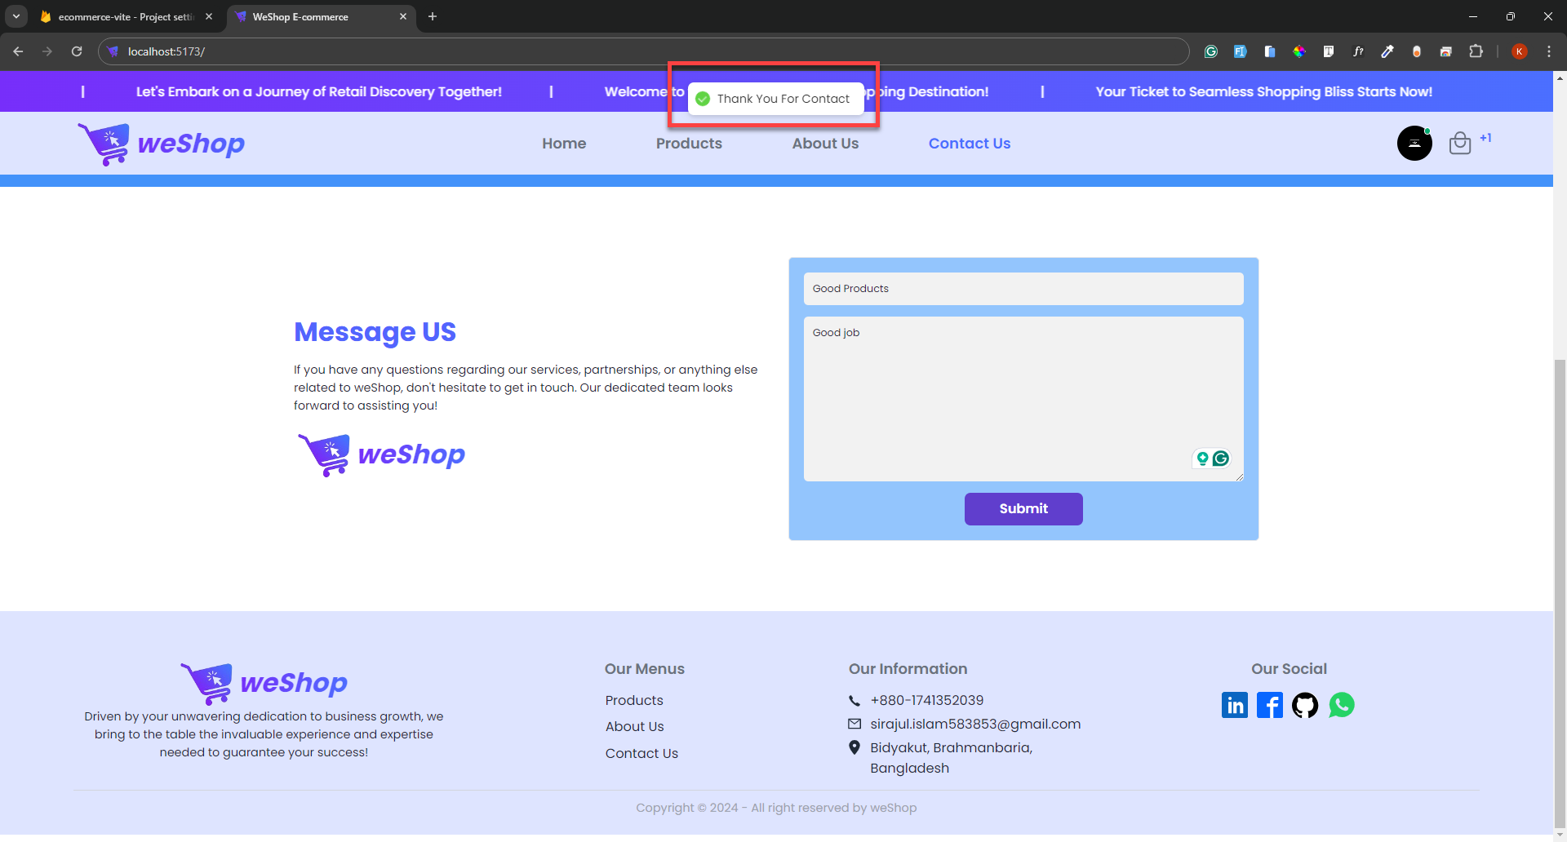
8. **LOGOUT**
   1. A screenshot of a computer

      Description automatically generated
   2. A screenshot of a computer

      Description automatically generated