**PHAM TIEN DUNG**

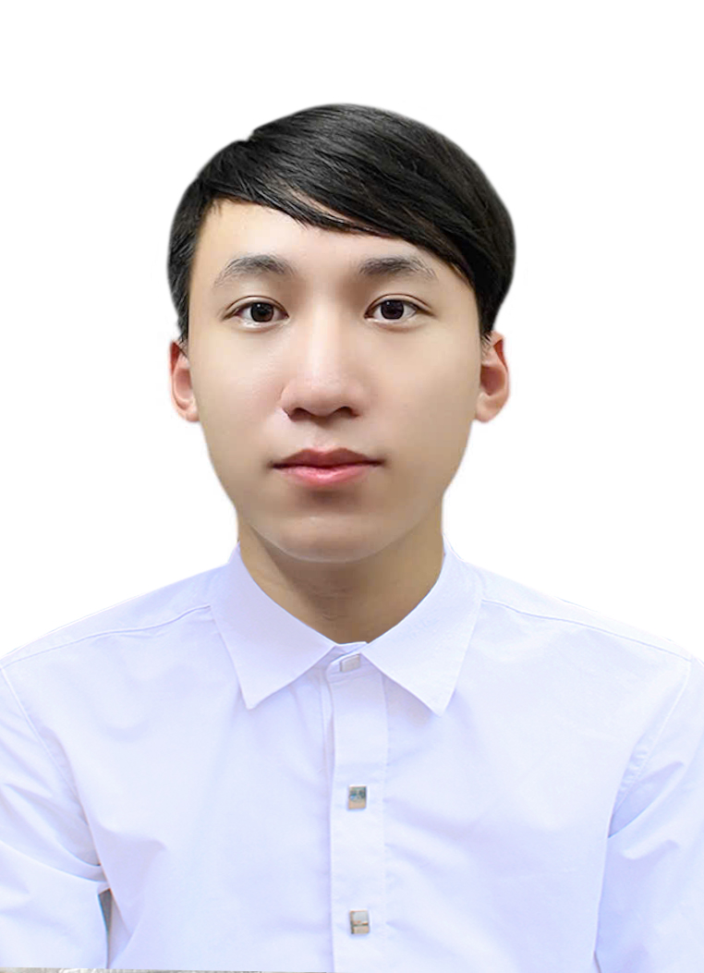

**Phone number: +84 868372403**

**Email address: dungpt2007@gmail.com**

**High School (recent):** Nguyen Hue High School for the Gifted

**GPA (grade 11 or 12):** 12

**SAT or ACT score (if applicable):** 1420 **TOEFL, IELTS Score (if applicable):** 6.5

|  |
| --- |
| EXPERIENCES |
| * 1 out of 20 students in Hanoi who have the honor to attend the Vietnamese Physics Olympiads. * Experience in some experimental project related to physics: * Water Rocket (third price) (2022-2023): We made water rockets for a shooting contest, writing reports about total cost, mechanisms, and statistical shooting distances at different angles. * Collision experiment (third prize) (2023-2024): We carried out experiments about collisions between model cars on an air track, measuring mass and velocities before and after the crash to validate the Conservation Laws in Physics. * Went through programming courses such as SIC programming course: As I took up a new hobby in coding, I soon had a liking for combining my code with my academic knowledge about physics. |
| REWARDS & SCHOLARSHIPS |
| Consolation Prize in National Physics Olympiads (VPhO) 2024-2025  First Prize in Hanoi Physics Olympiads 2024-2025  Second Prize in Hanoi Physics Olympiads 2023-2024 |

ABOUT YOURSELF

My name is Tien Dung. I love reading comics, physics, and programming. Realizing that an increasing number of students in Vietnam are passionate about physics, I applied to the Computer Science Department in VinUni to create a website for sharing materials and basic core concepts for competitive physics.

|  |
| --- |
| **Ability** |
| I am a gifted Physics student. During school, I usually search for materials in that field, so I believe myself to be quite skilled at Physics. |
| **Aspiration** |
| I have a strong desire to design a web aiming to provide students who have passion for Physics with useful knowledge despite my lack of background in code. |
| **Creativity** |
| In programming, I tend to write code defensively to avoid bugs. I am also prone to new fastidious details in experiments to lower the observational errors. |
| **Commitment** |
| I hardly had any extra classes, so during my time cramming for Physics test, I spent hours reading references, learning from peers and forums to bring my A-game at problem sets. |