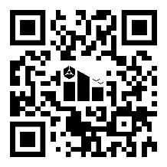
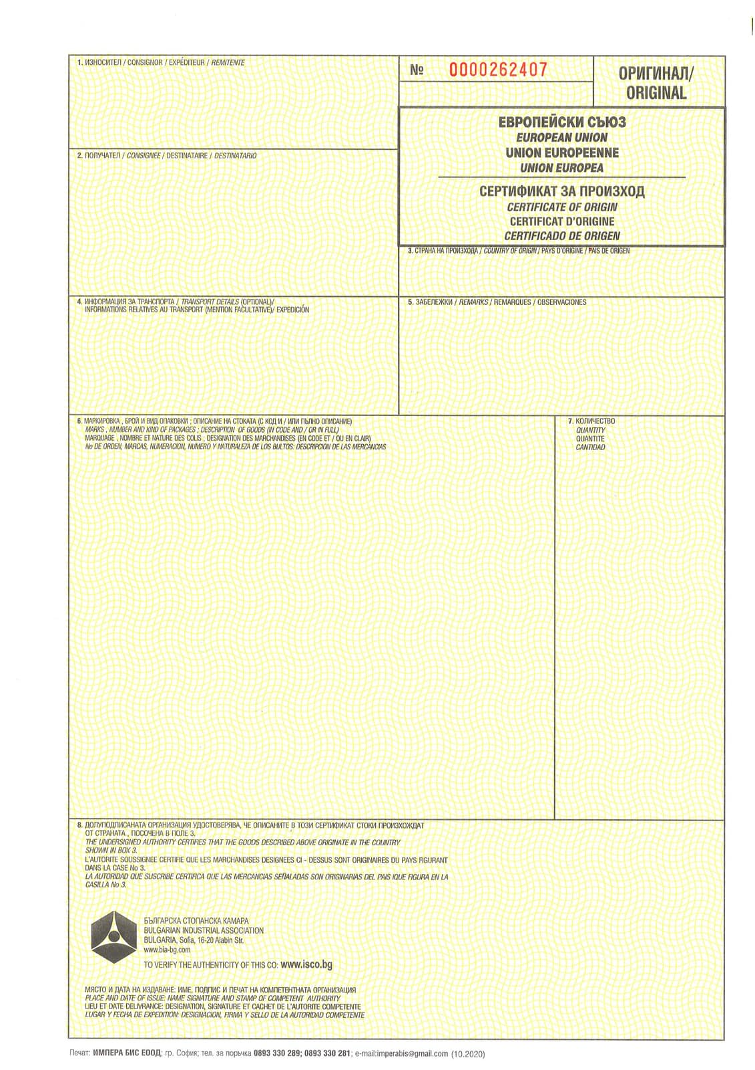
===========================================================================

{{goods_description}}

{{recipient}}

{{exporter}}

{{issue_date}}
{{country_of_origin}}
№ {{cert_number}}
{{quantity}}
{{transport}}

