Contents

Procedure 1 (Heading 1) 1

Task 1 of Procedure 1 1

Task 2 of Procedure 1 1

References 2

# Procedure 1 (Heading 1)

## Task 1 of Procedure 1

1. Steps in Task 1
2. Steps in Task 1
3. Steps in Task 1

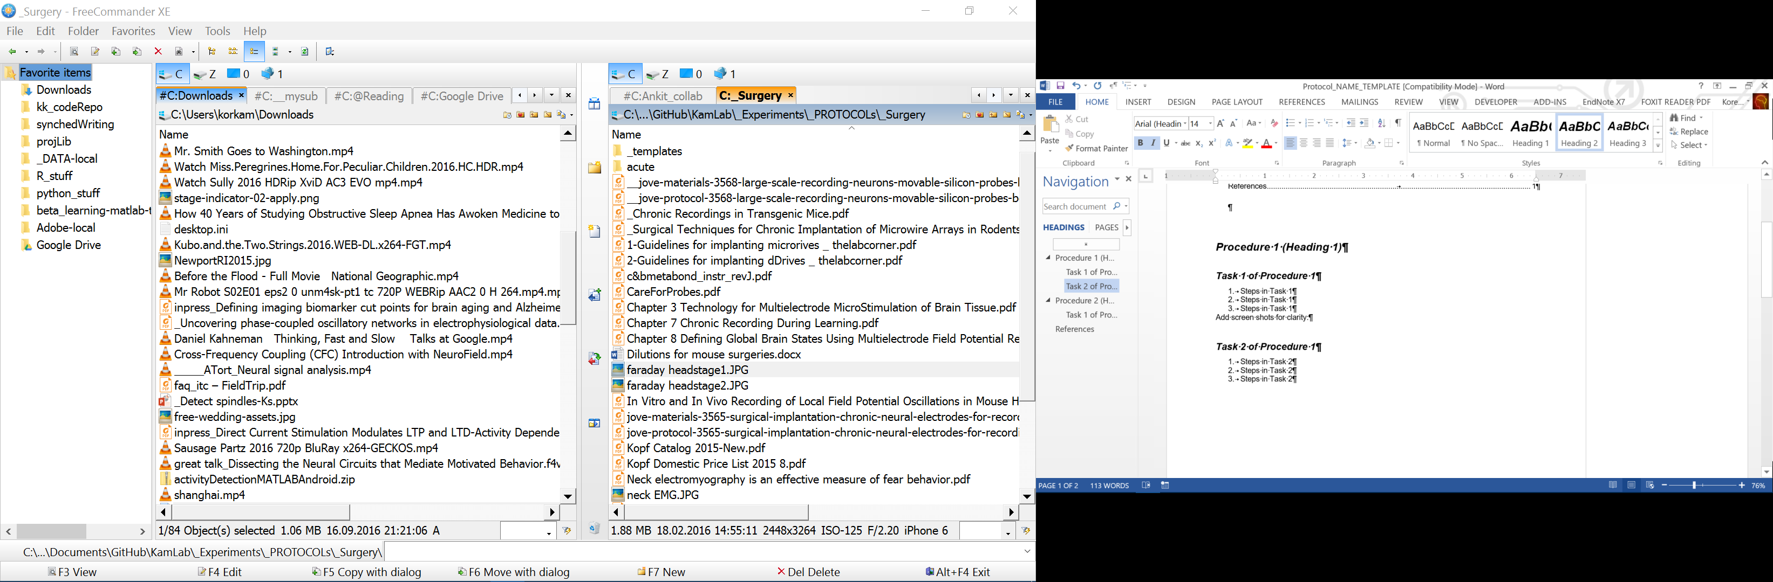

Figure - Add screen shot for clarity

## Task 2 of Procedure 1

1. Steps in Task 2
2. Steps in Task 2
3. Steps in Task 2

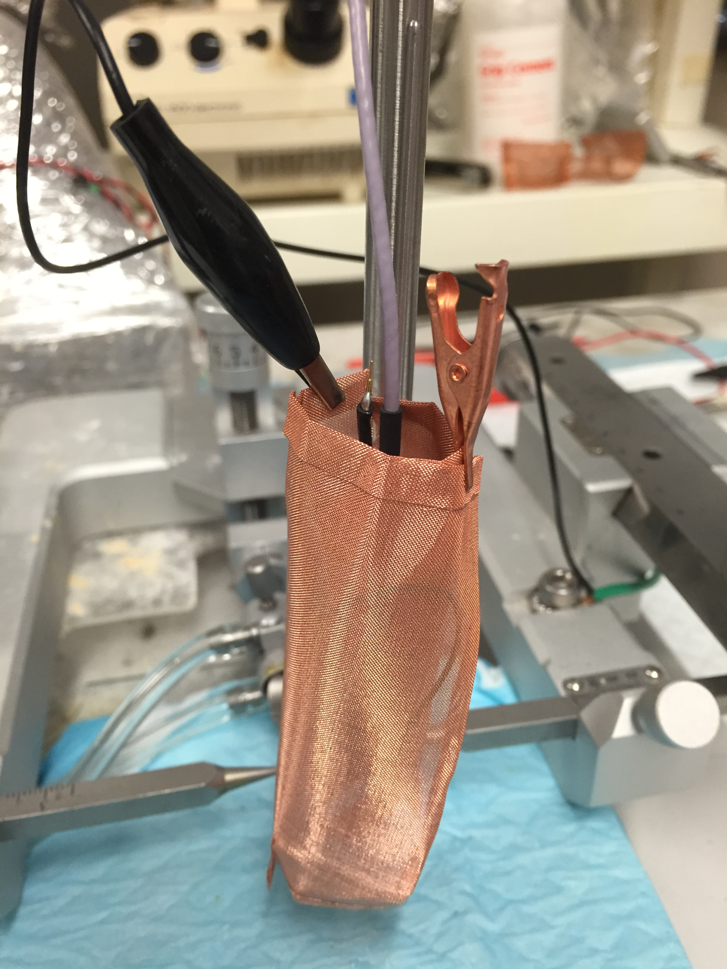

Figure - Add a cell phone picture for clarity

# Procedure 2 (Heading 1)

## Task 1 of Procedure 2

1. Steps in Task 1
2. Steps in Task 1
3. Steps in Task 1

Add screen shots for clarity:

# Comments

Design your protocol so that someone who is sleep deprived and stressed can easily follow your procedure without having to use critical reasoning skills at this step. This protocol is intended for reproducible data collection, not creative thinking.

# References

* Hyperlink or paper citation