Contents

Construct electrode components 1

Common REF block – 3 channels 1

Common REF block – 4 channels 2

For Single Wire Implants: 2

Cortical Screws 3

For Bipolar Twisted wires 3

Perform stereotactic EEG Implant Surgery 4

Prep 4

Surgery 6

References 11

# Construct electrode components

## Common REF block – 3 channels

1. Cut 4x2 block. File down edge of 4th row to make smooth. Remove silver pins from block.

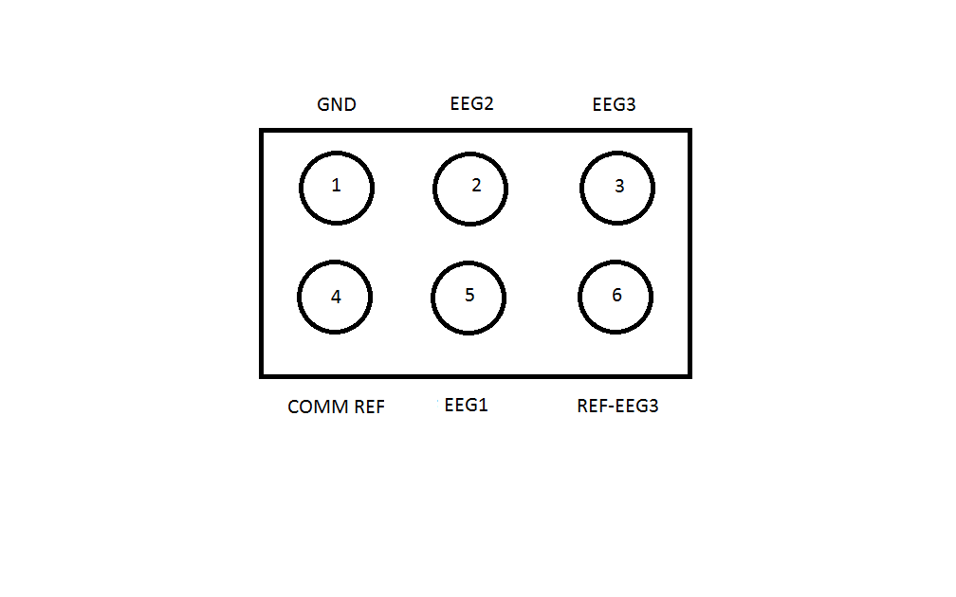

1. Cut 2.0 cm silver wire.
2. Solder one end to right angled tail of a pin
3. Solder other end to 0.10” screw
4. During surgery, insert into #1 slot.
5. Repeat for #2, #3, #5.
6. Insert two tails into #4 & #6 slots.
7. For 4-6 common reference: twist 2 silver wires and solder contact to one right angle tail. Solder end of one silver wire to 7/8 tails and the other silver wire to a 0.10” cortical screw.
8. Paint GND edge with whiteout.

## Common REF block – 4 channels

1. Make 5x2 block. Remove silver pins from block.

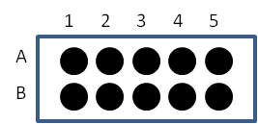

1. Cut 2.0 cm silver wire.
2. Solder one end to 0.10” screw
3. Solder other end to right angled gold tail
4. Insert into #5 slot
5. Insert two tails into #7/8 slots.
6. For 5-7-8 common reference block: twist 2 silver wires and solder contact to one right angle tail. Solder end of one silver wire to 7/8 tails and the other silver wire to a 0.10” cortical screw.

## For Single Wire Implants:

1. Cut 7 cm stainless steel wire
2. Fold in half. Insert into block to find length of coating to remove. Fold to make crease.
3. Burn off ~0.5cm from bend. This should be the depth of the micropin block.
4. Sonicate to remove coating (~5min). Verify under dissection scope.

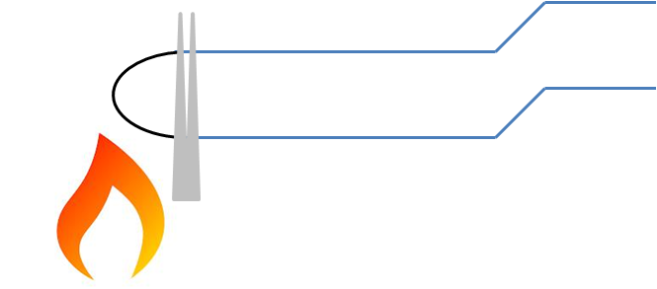

1. Check Continuity
2. Insert in block. Push tail-less pins into block to secure single wire.

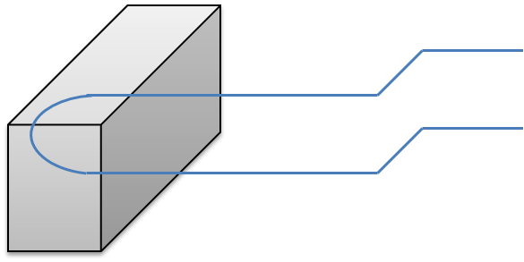

1. Use wirecutter to clip and separate wires.
2. Verify circuit with “Continuity tester” mode of multimeter.
3. For common reference PreAmp 🡪 insert tail-less pins into #7/#8 slot

## Cortical Screws

1. Clamp right angle gold pins.
2. Coat tail with flux.
3. Strip ~1mm Teflon off from silver wire.
4. Solder silver wire to tail of gold pin.
5. Cut 1.5 cm length of silver wire.
6. Strip ~2mm Teflon off from other end of silver wire.
7. Curl around cortical screw head.
8. Add flux to silver curl.
9. Solder.
10. Verify with “continuity tester”.

## For Bipolar Twisted wires

1. Specifications
   1. 0.0035” = 88.9 microns in diameter
   2. Inspect untwisted ends to ensure void of kinks.
2. Fasten wires to block
   1. Heat untwisted ends to strip coating (lacquer). Use flat forceps to strip burnt coating.
   2. Cut 2.5 cm from start of twist

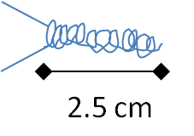

1. Make Z bend in twisted wire.
   1. Using slim flat forceps, grip at slightly above 2mm. Twist and bend to make Z.

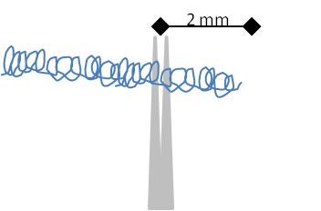

* 1. Want Z bend to be in one plane and near 90° bend

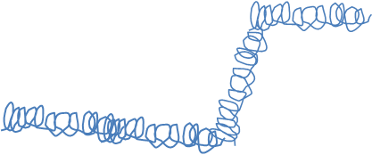

1. Verify circuit with “Continuity tester” mode of multimeter.

# Perform stereotactic EEG Implant Surgery

## Prep

1. Turn on heat sterilizer.
2. Sonicate EEG implant (2 twisted wires, #1, 2, 5, 6 bone screws)

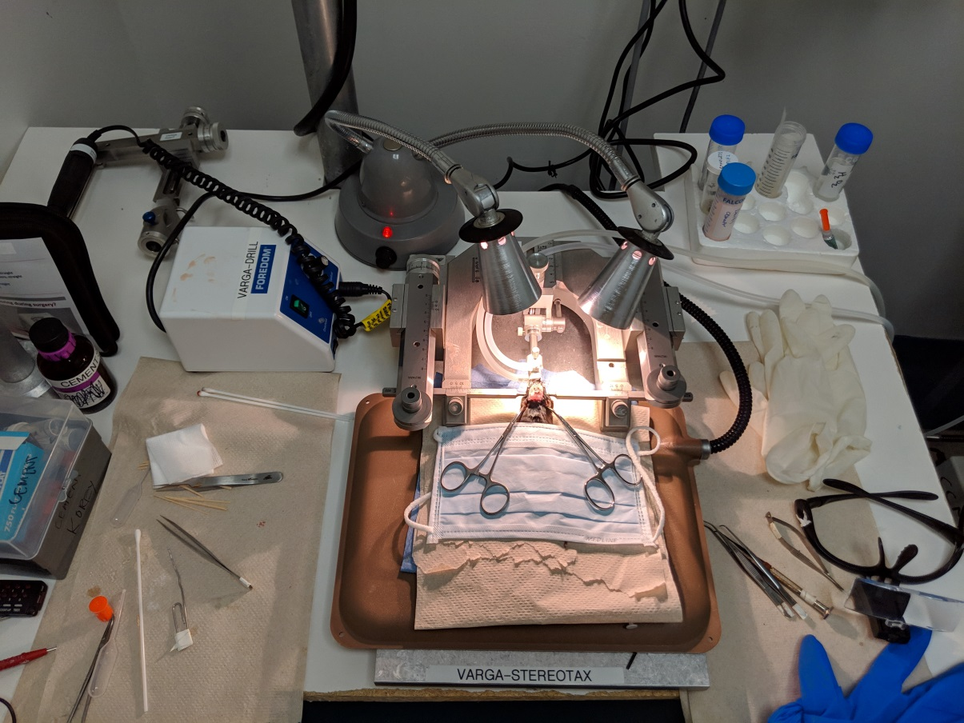

Stereotactic frame setup: mouse in frame on thermal pad. Surgical gloves, bent serrated forceps, flathead screwdriver, microscissors, and view finders. Warmed lactated ringer for post-surgical recovery (0.3 mL insulin syringe).

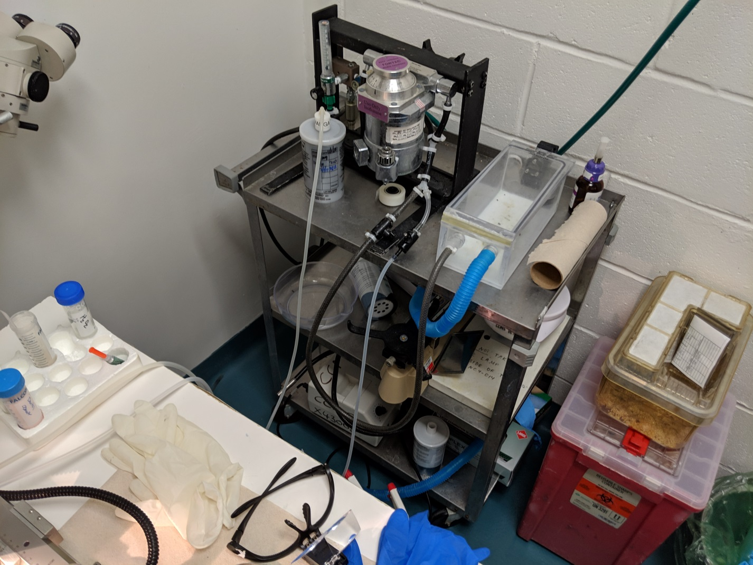

Isoflurane setup and connection to stereotaxic nose cone/bit bar

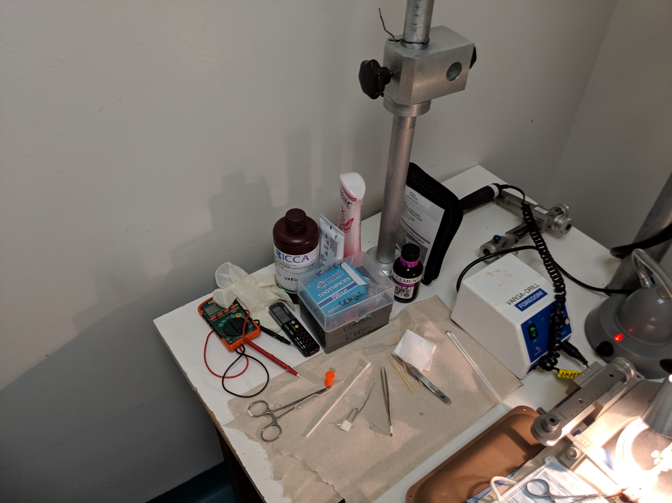

Implant build tools: right arm w/ drill, multimeter (connectivity test), drill bit, hemostat & plastic cup (mix grip cement); & straight forceps; cement applicator and short transfer pipette, sterile cotton swabs (2x), sterile gauze (2x), grip cement and solvent. Petroleum for eyes, Nair and hydrogen peroxide for midline scalp incision.

## Surgery

1. **CURRENT ANESTHESIA SETUP (changes based on OR location)**: Anesthetize animal with isoflurane inhalation. Pour isoflurane into vaporizer spigot and verify level (~3/4 full for 6 hrs at desired flow rate/concentration). Open O2 tank (verify psi). Set O2 regulator (“1” setting).

|  |  |  |
| --- | --- | --- |
|  | O2 flow setting | Isoflurane flow setting |
| Knock down Box | **“1”** | **“3”** |
| In stereotaxic frame (nose cone) | **“1”** | **“2 start”** |

1. Turn on isoflurane settings for knockdown box, then place animal inside and seal. Start timer. Verify loss of righting and slowed breathing (1/sec).
2. After ~5 min, quickly place animal in stereotaxic frame. Ensure teeth/mouth in bite bar (incisors in teeth slot and tongue flopped/exposed). Lightly clamp nose bar.

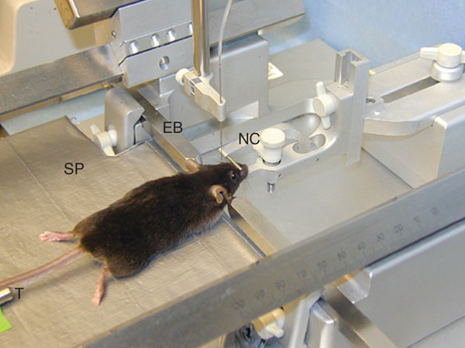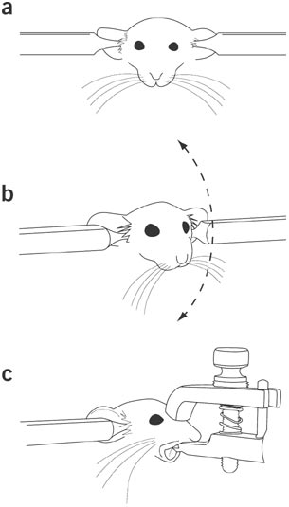

1. Evenly affix right and left ear bars (~4.5mm gap on either side aka 9mm interaural distance).
2. When in stereotaxic frame, inject buprinex (SQ): 0.1 mL (30g mouse) and ketofen (SQ): 0.1 mL.
3. Monitor breathing (want constant breathing, ie no gasping @ ~1 breath/sec). Monitor depth by tail pinch, foot pinch, and then eye blink.
4. Remove hair: Nair or Shave head with trimmer. Clean off.
5. Apply eye ointment.
6. Apply iodine to dorsal surface of head.
7. Make midline cut with forceps/scissors to expose the skull. Cut and push away the periosteum (clear film/fascia).
8. Expose skull surface w/ forceps. Use hydrogen peroxide dipped cotton swab to clean skull sutures.
9. Now that skull sutures are visible, adjust jaw/snout position to align B to L plane. Inspect behind mouse, left and right (use your V1’s straightness/parallelism detection and/or the mini-level).

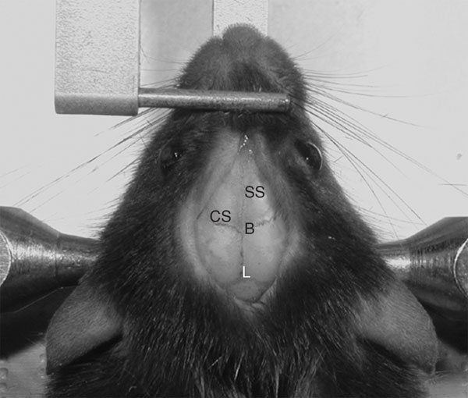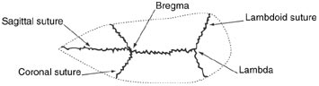

**B to L dist:**

4.21 mm per Paxinos & Franklin, Mouse Brain in Stereotactic Coordinates 2005

Rodent skull surface diagram includes the sagittal, coronal and lambdoid sutures defining the stereotaxic landmarks bregma and lambda.

1. Tighten nose bar when straightened.
2. 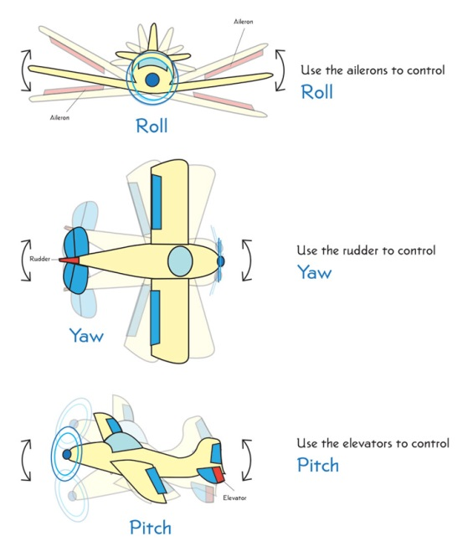**Take measurements for Implant sheet: goal is to equalize YAW (snout L-R) and PITCH (snout U-D) b/w Bregma and Lambda then Roll (head rotation) between medial to lateral axis.**

**🡨See airplane diagram for reference**

1. For Bregma and Lambda, respectively: measure X, Y and Z position as indicated on Implant sheet:

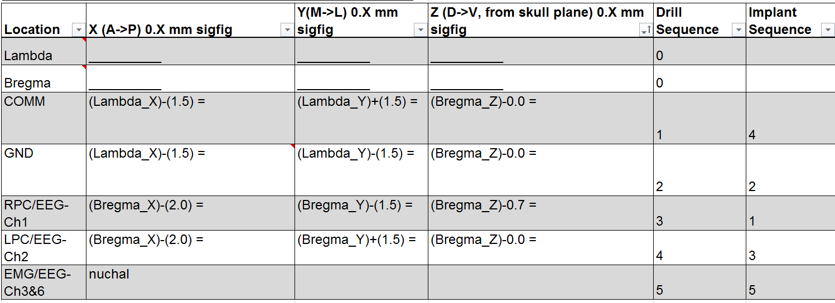

Implant sheet documents the following w/ respect to left-armed stereotaxic frame: Location (RoI), X (A to P distance), Y (M to L distance), Z (D to V distance) and drill/implant sequence.

1. To align YAW and PITCH, Verify alignment by measuring Bregma and Lambda coordinates. Y and Z coordinates should be within 0.1 mm (tolerance of frame). Adjust by ear bars and/or nose cone pitch.
2. To align ROLL, position drill bit in center of sagittal suture. Measure Z direction 2mm left and 2 mm right of center. E.g. if center = 40.0, then find Z @ 38.0 and Z @ 42.0. Proceed if Z38.0 = Z42.0. Adjust with ear bars.
3. Record final Bregma and Lambda coordinates in Implant sheet (Excel).
4. Calculate desired RoI/”Location” coordinates.
5. Drill holes according to “Drill Sequence”.
6. Dry skull if need be with gauze and cotton swab.
7. **Score skull with scalpel to improve adhesion to cement. This is important for long-term adhesion.**
8. Example Sequence of implants (follow desired Implant sheet):
   1. **#1, #4, #6 (for Right-handers with forceps using Left)**
   2. **#2, #3, #5**
   3. **For single wires: position single wires with clamp arms, both right and left**
   4. **For EMG, screw in common reference electrode then create a gap above the nuchal muscles using a curved forceps. Apply vetbond to skull/nuchal muscle/EMG wire intersection.**

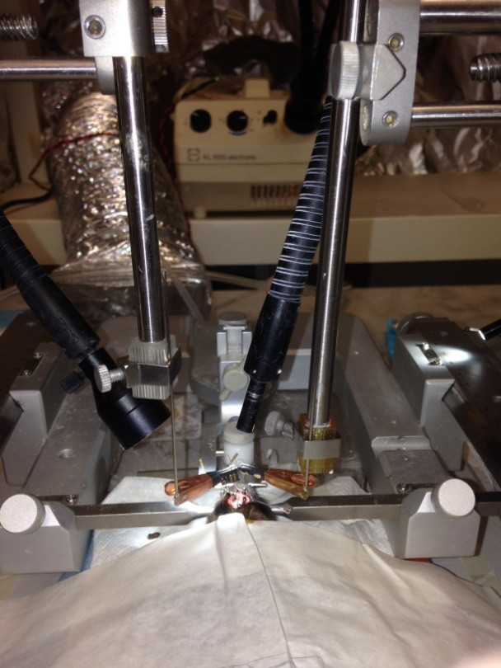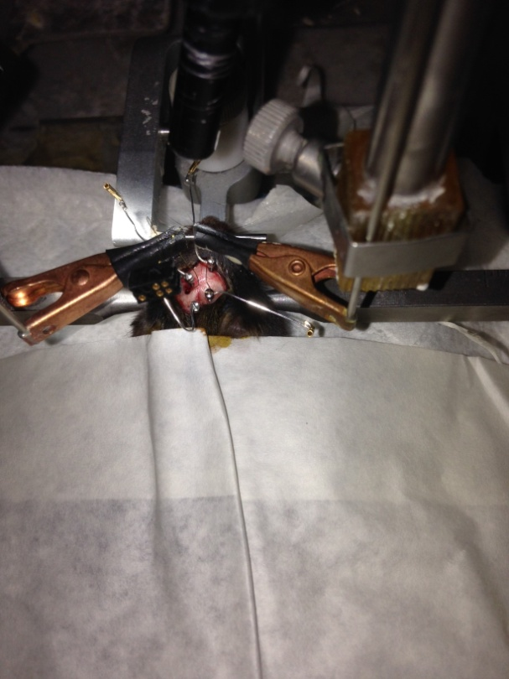

1. **After implants are positioned, apply vetbond (medical cyanoacrylate glue) to holes. Once glue has dried (~10min), proceed to applying dental cement.**
2. Cement implants into place. Cure for ~10min.

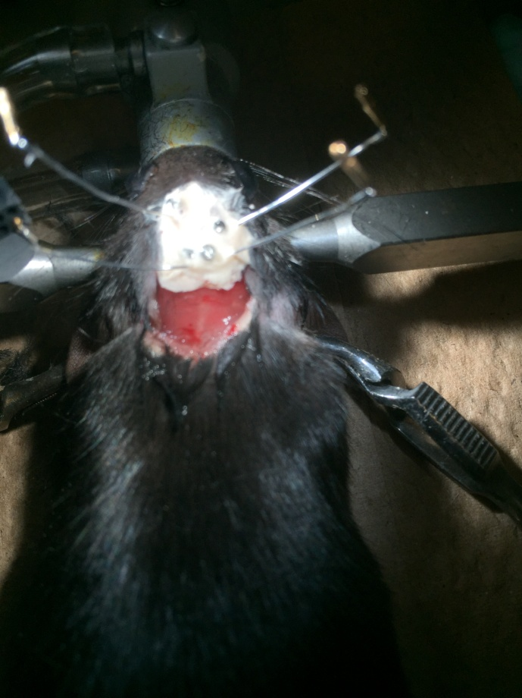

1. Insert pins into respective slots in block:

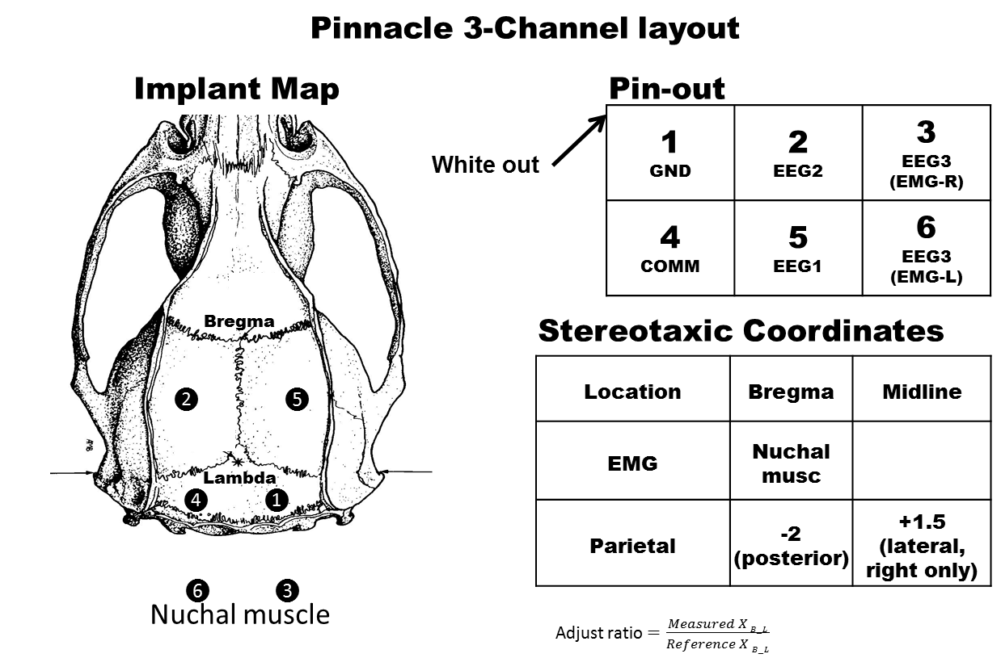

1. After electrode female pins are inserted into the microconnector: verify circuit (shorting) with “Continuity tester” mode of multimeter.
2. After each pin is mapped to correct electrode, cement headstage into final position. Allow 20 min of dry time: Using orange plastic cup, 2.5 scoops cement powder and ~25 drops of cement solvent. Mix well with paperclip for 10seconds. Apply on skull and electrode assembly with a small transfer pipette.
3. Inject lactated ringer soln for rehydration (0.75 mL/ 30g mouse).
4. Allow animal to recover in solo cage on a heated blanket (~1hr).

# References

* Kam K, Duffy AM, Moretto J, LaFrancois JJ, Scharfman HE. Interictal spikes during sleep are an early defect in the Tg2576 mouse model of β-amyloid neuropathology. Scientific reports.