Contents

Construct electrode components 1

Common REF block – 3 channels 1

Common REF block – 4 channels 2

For Single Wire Implants: 2

Cortical Screws 3

EMG Leads 3

For Bipolar Twisted wires 3

Headfixation Surgery (no implant) 4

Aluminum screw 4

Perform stereotactic EEG Implant Surgery 5

Prep 5

Surgery 7

References 12

# Construct electrode components

## Common REF block – 3 channels

1. Cut 4x2 block. File down edge of 4th row to make smooth. Remove silver pins from block.

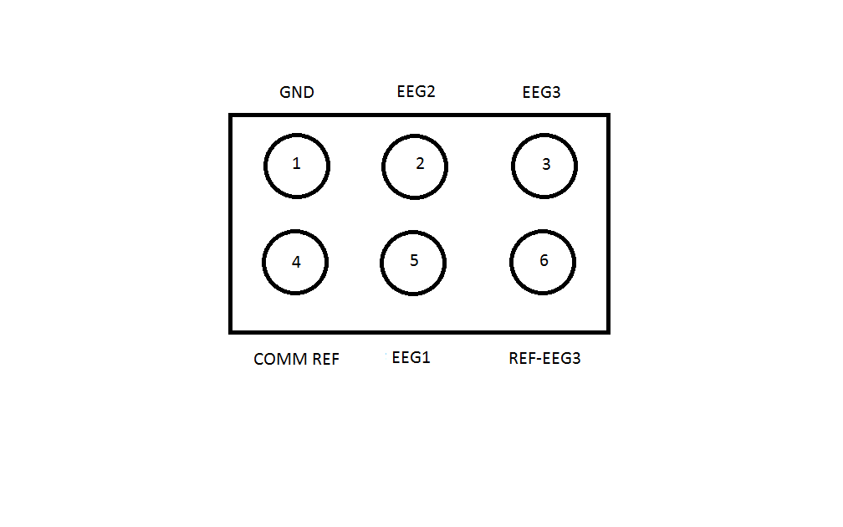

1. For comm-REF pins, twist bare end of two 2.0 cm silver wires together.
2. Paint twist and pin tails with flux.
3. Solder twisted end of silver wire to end of right angle pin #4.
4. Solder other end of first 2.0 cm silver wire to right angle pin #6.
5. Solder other end of second 2.0 cm silver wire to 0.10” screw.
6. Verify continuity.
7. On microconnector, paint GND edge with whiteout (pin #1).
8. Make electrodes for surgery: solder ends of 2.0 cm silver wire to right angle pin and 0.10” crew. Make 4x.

## Common REF block – 4 channels

1. Make 5x2 block. Remove silver pins from block.

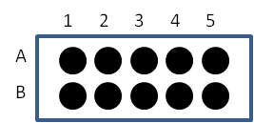

1. Cut 2.0 cm silver wire.
2. Apply flux to wrapped screw. Allow to dry 10 min.
3. Solder one end to 0.10” screw
4. Solder other end to right angled gold tail
5. Insert into #5 slot
6. Insert two tails into #7/8 slots.
7. For 5-7-8 common reference block: twist 2 silver wires and solder contact to one right angle tail. Solder end of one silver wire to 7/8 tails and the other silver wire to a 0.10” cortical screw.

## For Single Wire Implants:

1. Cut 7 cm stainless steel wire
2. Fold in half. Insert into block to find length of coating to remove. Fold to make crease.
3. Burn off ~0.5cm from bend. This should be the depth of the micropin block.
4. Sonicate to remove coating (~5min). Verify under dissection scope.

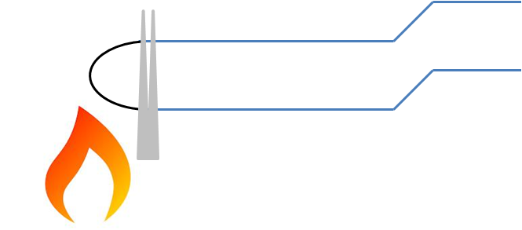

1. Check Continuity
2. Insert in block. Push tail-less pins into block to secure single wire.

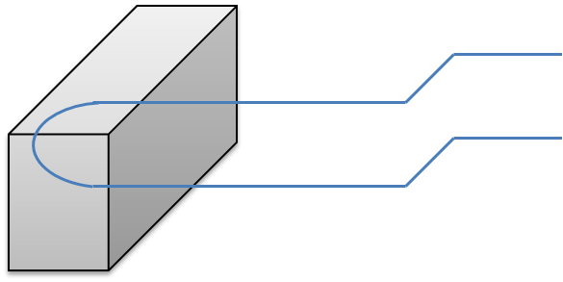

1. Use wirecutter to clip and separate wires.
2. Verify circuit with “Continuity tester” mode of multimeter.
3. For common reference PreAmp 🡪 insert tail-less pins into #7/#8 slot

## Cortical Screws

1. Clamp right angle pins.
2. Coat tail with flux. Allow to dry 10 min.
3. Strip ~1mm Teflon off from silver wire.
4. Solder silver wire to tail of gold pin.
5. Cut 2.0 cm length of silver wire.
6. Strip ~2mm Teflon off from other end of silver wire.
7. Curl around cortical screw head.
8. Add flux to silver curl. Allow to dry 10 min.
9. Solder.
10. Verify with “continuity tester”.

## EMG Leads

1. Clamp right angle pins (2x).
2. Coat tails with flux.
3. Strip ~1mm Teflon off from silver wire.
4. Solder 2.0 cm silver wire to tail of pin (2x).
5. Insert pins into slot pin #3 & #6 (3chan) or #4 & #8 (4chan).
6. Point to posterior direction (away from row B) and twist wires together but leave ends pointing away (don’t want to short).
7. Verify with “continuity tester”.

## For Bipolar Twisted wires

1. Specifications
   1. 0.0035” = 88.9 microns in diameter
   2. Inspect untwisted ends to ensure void of kinks.
2. Fasten wires to block
   1. Heat untwisted ends to strip coating (lacquer). Use flat forceps to strip burnt coating.
   2. Cut 2.5 cm from start of twist

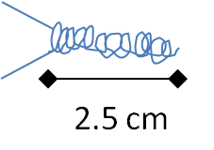

1. Make Z bend in twisted wire.
   1. Using slim flat forceps, grip at slightly above 2mm. Twist and bend to make Z.

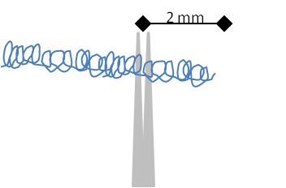

* 1. Want Z bend to be in one plane and near 90° bend

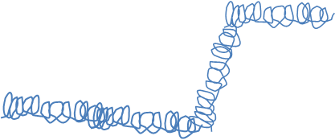

1. Verify circuit with “Continuity tester” mode of multimeter.

# Headfixation Surgery (no implant)

## Aluminum screw

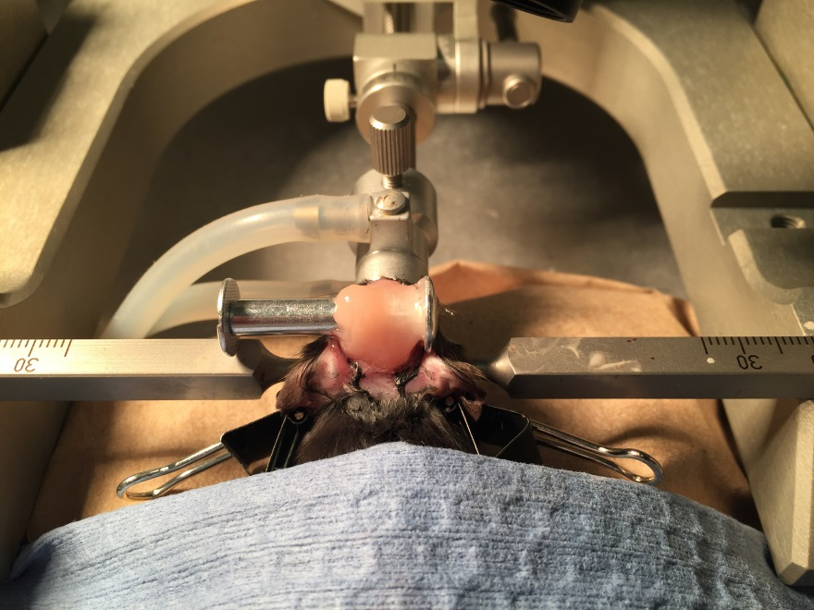

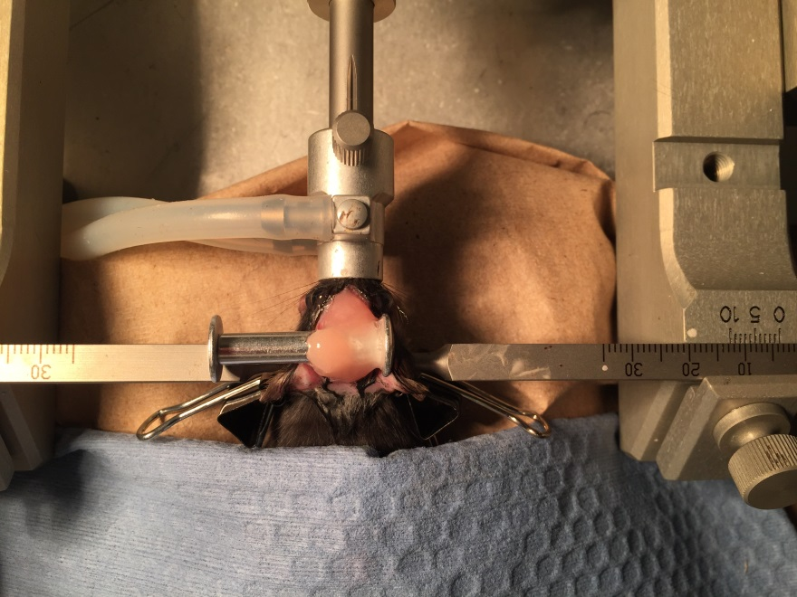

# Perform stereotactic EEG Implant Surgery

## Prep

1. Turn on heat sterilizer.
2. Sonicate EEG implant (2 twisted wires, #1, 2, 5, 6 bone screws)

Left side (bead sterilizer, eye ointment, beta-iodine)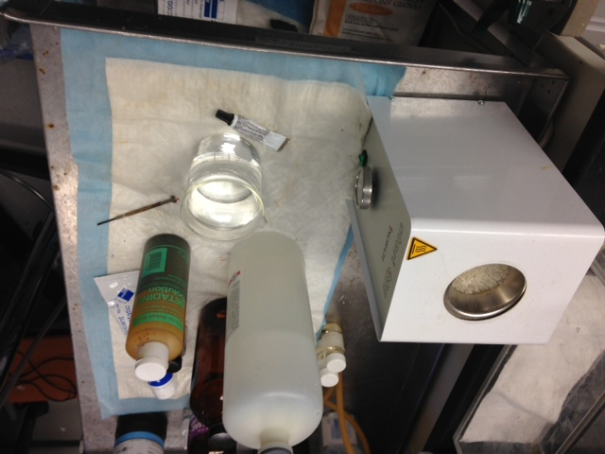

Left side: bead sterilizer, eye ointment, beta-iodine

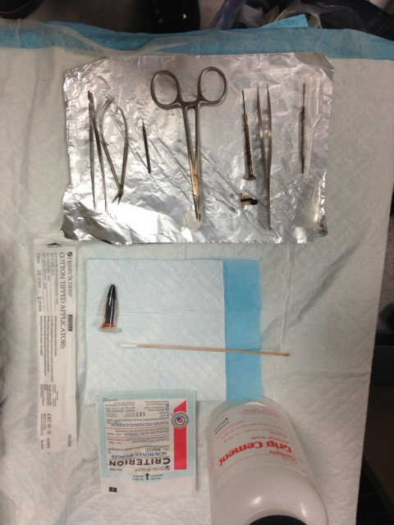

Surgical Tools: bent serrated forceps and microscissors; drill bit, hemostat & plastic cup (mix grip cement); flathead screwdriver & straight forceps; cement applicator and short transfer pipette, sterile cotton swabs (x2), sterile gauze (x2), grip cement and solvent.

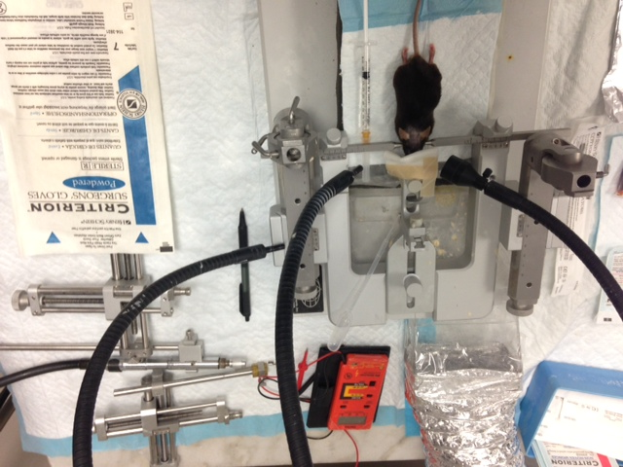

Stereotactic frame setup: mouse in frame on thermal pad. Surgical gloves, right arm w/ drill, left arm with clamp (to hold implant), multimeter (connectivity test), air vent, heated lactated ringer for post-surgical recovery.

## Surgery

1. **CURRENT ANESTHESIA**: Anesthetize animal with isoflurane inhalation. Turn on O2 tank (verify psi). Set O2 regulator (“4” setting).

|  |  |  |
| --- | --- | --- |
|  | O2 flow setting | Isoflurane flow setting |
| Knock down Box | **“2.5”** | **“3”** |
| In stereotaxic frame (nose cone) | **“1”** | **“2”** |

1. **OLD ANESTHESIA**: Anesthetize animal with chloral hydrate IP injection (26G needle, 50 mg/mL concentration in ddH2O). (110uL/10g weight dose). This equates to a dose of 5.5mg/10g = 55mg/g = **55g/kg**
2. When in stereotaxic frame, inject buprinex (SQ): 0.1 mL (30g mouse) and ketofen (SQ): 0.1 mL
3. Monitor breathing (want constant breathing, ie no gasping). Monitor depth by tail pinch, foot pinch, and then eye blink.
4. Shave head with trimmer.
5. Place in stereotaxic frame. Ensure teeth/mouth in bite bar. Lightly clamp nose bar.

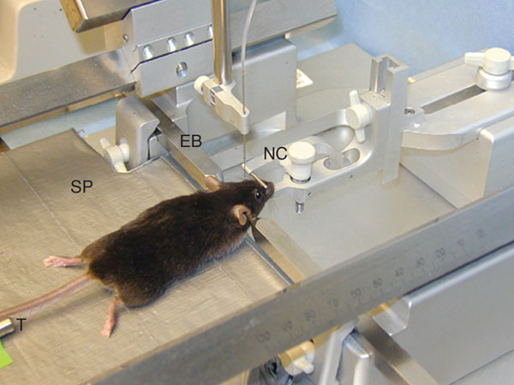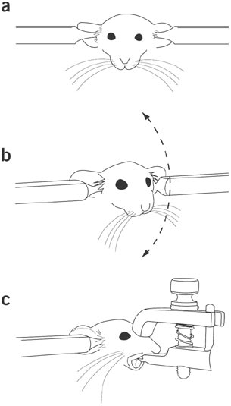

1. Evenly affix right and left ear bars.
2. Apply eye ointment.
3. Adjust jaw/snout to align L & R orbital sockets.
4. Tighten nose bar when straightened.
5. Apply iodine to dorsal surface of head.
6. Make midline cut with forceps/scissors to expose the skull. Cut and push away the periosteum (clear film/fascia).
7. Expose skull surface w/ forceps. Use clean/dry cotton swab to dry surface of skull.
8. Place gauze over the eyes & turn on
9. Align A-P plane: For Bregma and Lambda, respectively: measure X position and Z position.

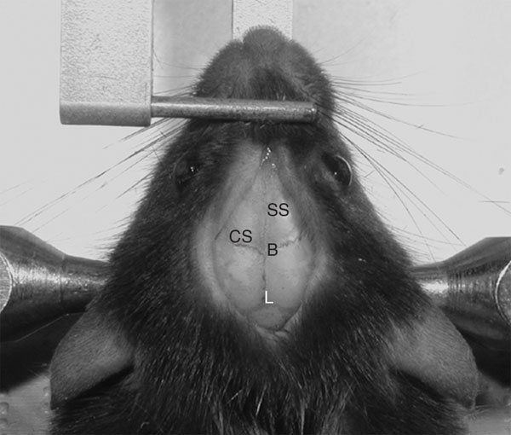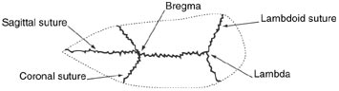

**B to L:**

4.21 mm per Paxinos & Franklin, Mouse Brain in Stereotactic Coordinates

Figure 1 - Rodent skull surface diagram includes the sagittal, coronal and lambdoid sutures defining the stereotaxic landmarks bregma and lambda.

1. Verify alignment by measuring Bregma and Lambda coordinates. Y and Z coordinates should be the same.
2. To align tilt (Y direction), position drill bit in center of B/L. Measure Z direction 2mm left and 2 mm right of center. E.g. if center = 40.0, then find Z @ 38.0 and Z @ 42.0. Proceed if Z38.0 = Z42.0.
3. Input into record sheet (Excel).
4. Drill holes according to stereotactic coordinates (Excel).
5. **Score skull with scalpel to improve adhesion to cement. This is important for long-term adhesion.**
6. Sequence of implants:
   1. **#1, #4, #6 (for Right-handers with forceps using Left)**
   2. **#2, #3, #5**
   3. **For single wires: position single wires with clamp arms, both right and left**

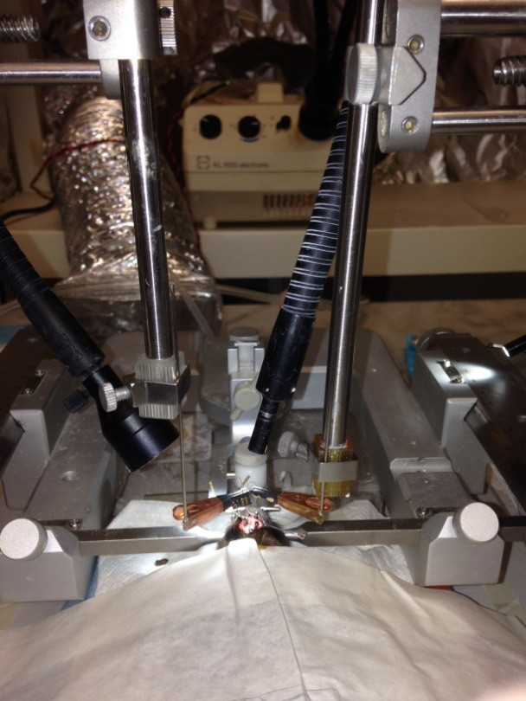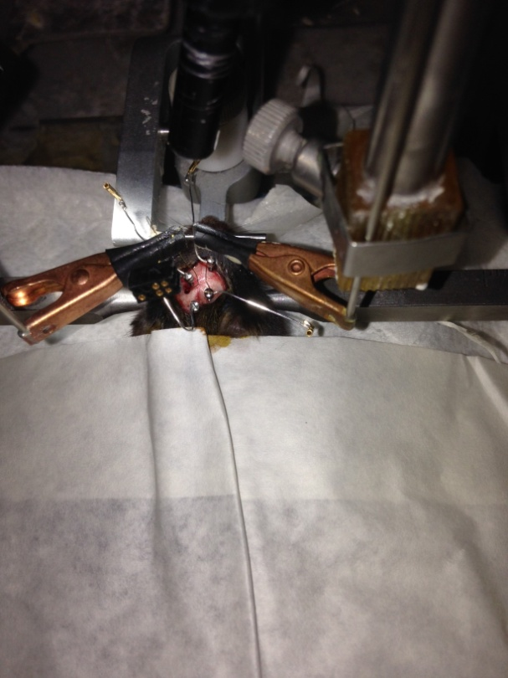

1. **After implants are positioned, apply vetbond (medical cyanoacrylate glue) to holes. Once glue has dried (~10min), proceed to applying dental cement.**
2. Cement implants into place. Cure for ~15min.
3. OPTIONAL: Implant EMG electrodes. 2cm silver wire soldered to right angle pins. Glue onto left/right nuchal (neck) muscles.

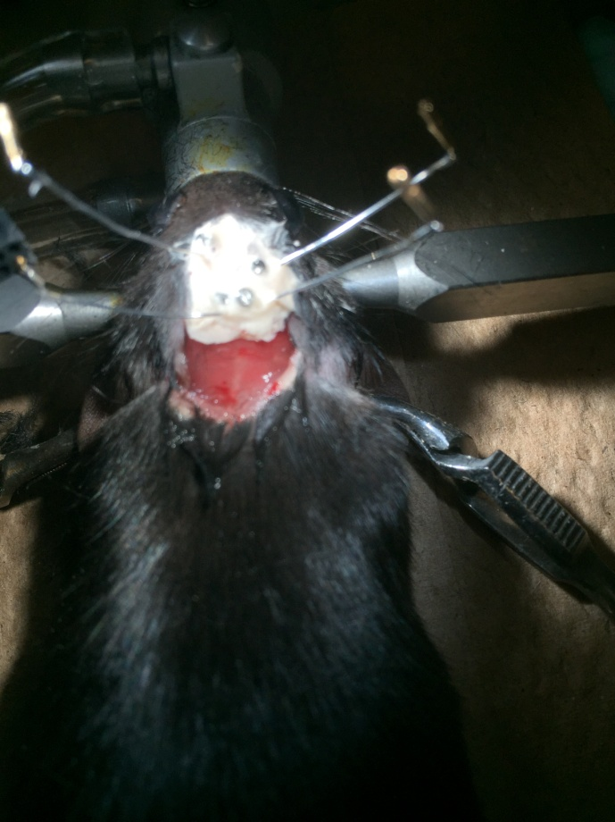

1. Insert pins into respective slots in block:

|  |  |  |  |
| --- | --- | --- | --- |
| #1 | #2 | #3 | #4 |
| #5 | #6 | #7 | #8 |

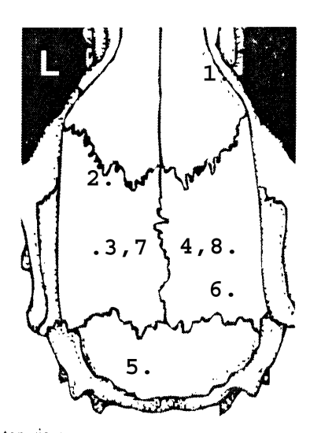

1. Raise #2 silver wire and wrap twisted wires around.
2. Apply dental cement. 2.5 scoops and 22 drops, use transfer pipette.
3. Verify circuit with “Continuity tester” mode of multimeter.
4. Cement headstage into final position. Allow 20 min of dry time.
5. Inject lactated ringer soln for rehydration (0.75 mL/ 30g mouse).

# References

* Kam K, Duffy AM, Moretto J, LaFrancois JJ, Scharfman HE. Interictal spikes during sleep are an early defect in the Tg2576 mouse model of β-amyloid neuropathology. Scientific reports.
* Nicolelis MAL, editor. Methods for Neural Ensemble Recordings. 2nd edition. Boca Raton (FL): CRC Press/Taylor & Francis; 2008. Chapter 2Surgical Techniques for Chronic Implantation of Microwire Arrays in Rodents and Primates. Laura M. O. Oliveira and Dragan Dimitrov.
* Nicolelis MAL, editor. Methods for Neural Ensemble Recordings. 2nd edition. Boca Raton (FL): CRC Press/Taylor & Francis; 2008. Chapter 5 Chronic Recordings in Transgenic Mice. Kafui Dzirasa.
* Curr Protoc Mouse Biol. 2012 Mar 1;2(1):55-74. doi: 10.1002/9780470942390.mo110126. Sleep and EEG Phenotyping in Mice. Mang GM, Franken P.
* J Neurosci Methods. 2009 Mar 15;177(2):355-60. doi: 10.1016/j.jneumeth.2008.10.020. Epub 2008 Nov 1. Neck electromyography is an effective measure of fear behavior. Steenland HW, Zhuo M.
* Methods Mol Biol. 2012;821:373-91. doi: 10.1007/978-1-61779-430-8_24.
* Video-EEG monitoring methods for characterizing rodent models of tuberous sclerosis and epilepsy. Rensing NR, Guo D, Wong M.
* Curr Protoc Mouse Biol. 2012 Sep 1;2(3):273-94. doi: 10.1002/9780470942390.mo120089. In Vitro and In Vivo Recording of Local Field Potential Oscillations in Mouse Hippocampus. Forsyth LH, Witton J, Brown JT, Randall AD, Jones MW.
* Nat Protoc. 2006;1(6):3166-73. Stereotaxic gene delivery in the rodent brain. Cetin A, Komai S, Eliava M, Seeburg PH, Osten P.
* [**A mouse model of intracerebral hemorrhage using autologous blood infusion**](http://www.nature.com.ezproxy.med.nyu.edu/nprot/journal/v3/n1/full/nprot.2007.513.html)