NAME : MADHURI EMPLOYEE ID: ACJD2416

Steps to create project in JIRA tool

Step-1: create a project with scrum template

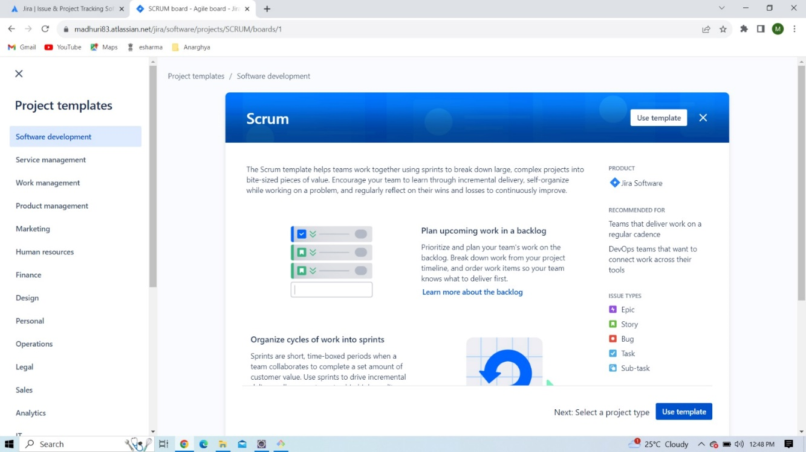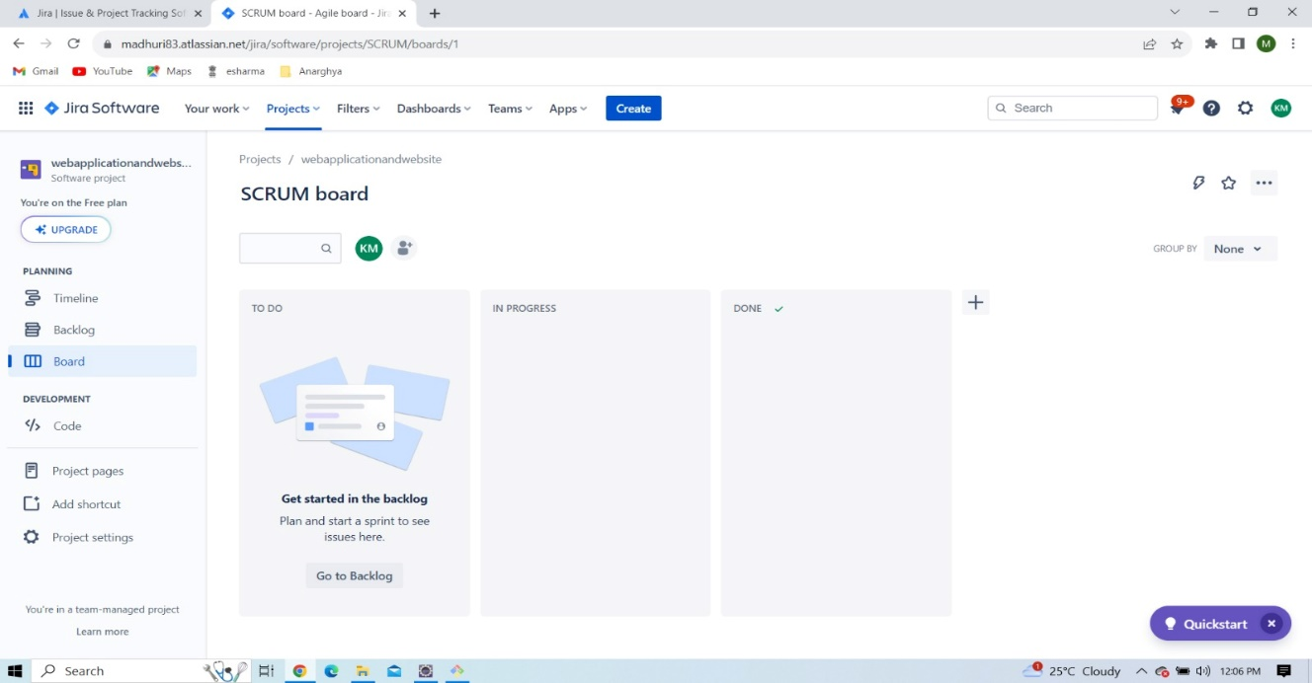

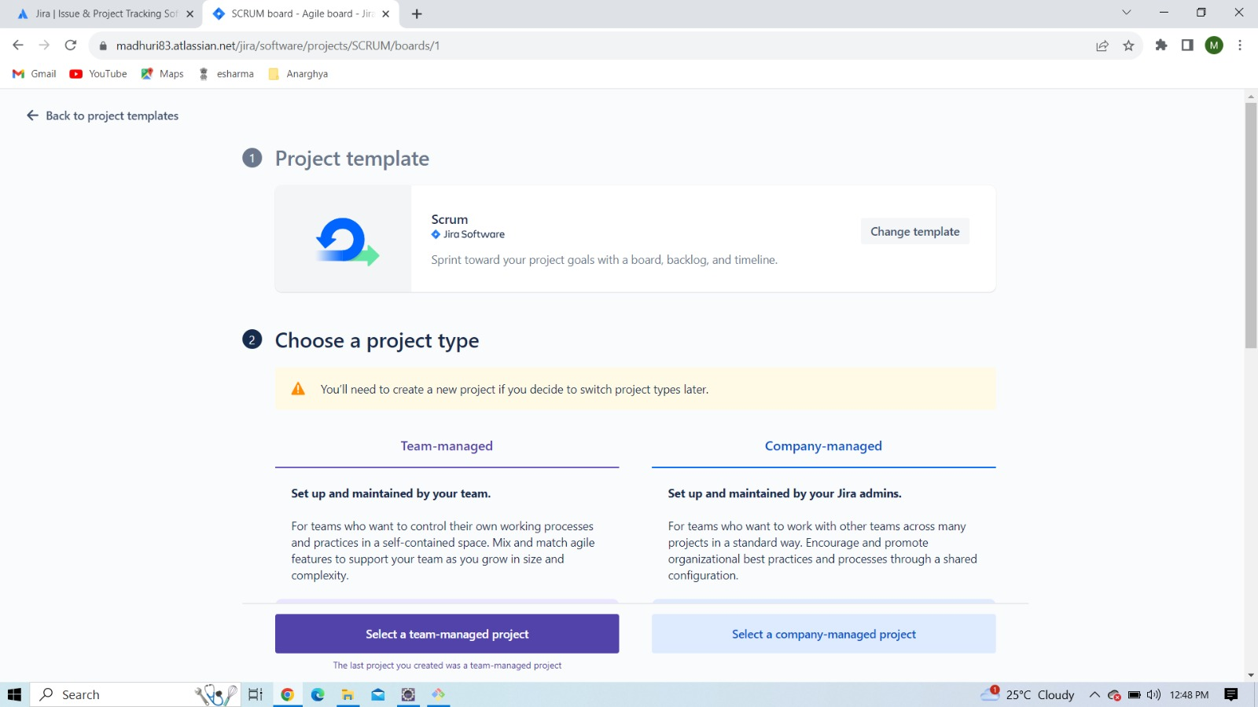NAME : MADHURI EMPLOYEE ID: ACJD2416

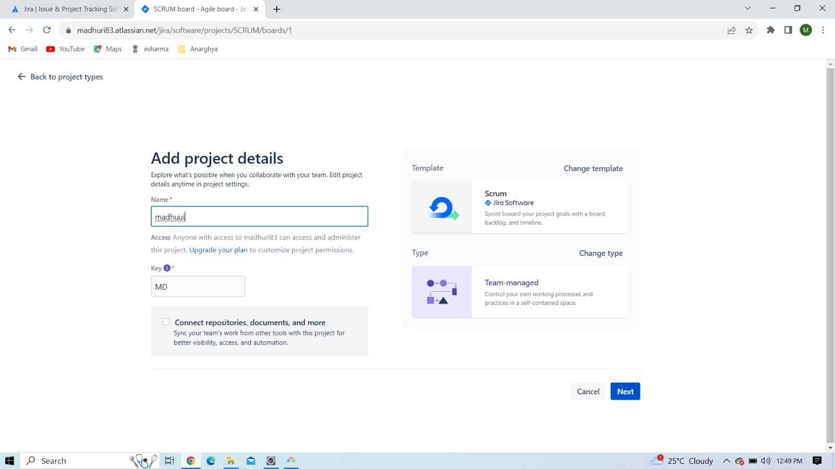

NAME : MADHURI EMPLOYEE ID: ACJD2416

Step-2: create a sprint and add the story or Tasks

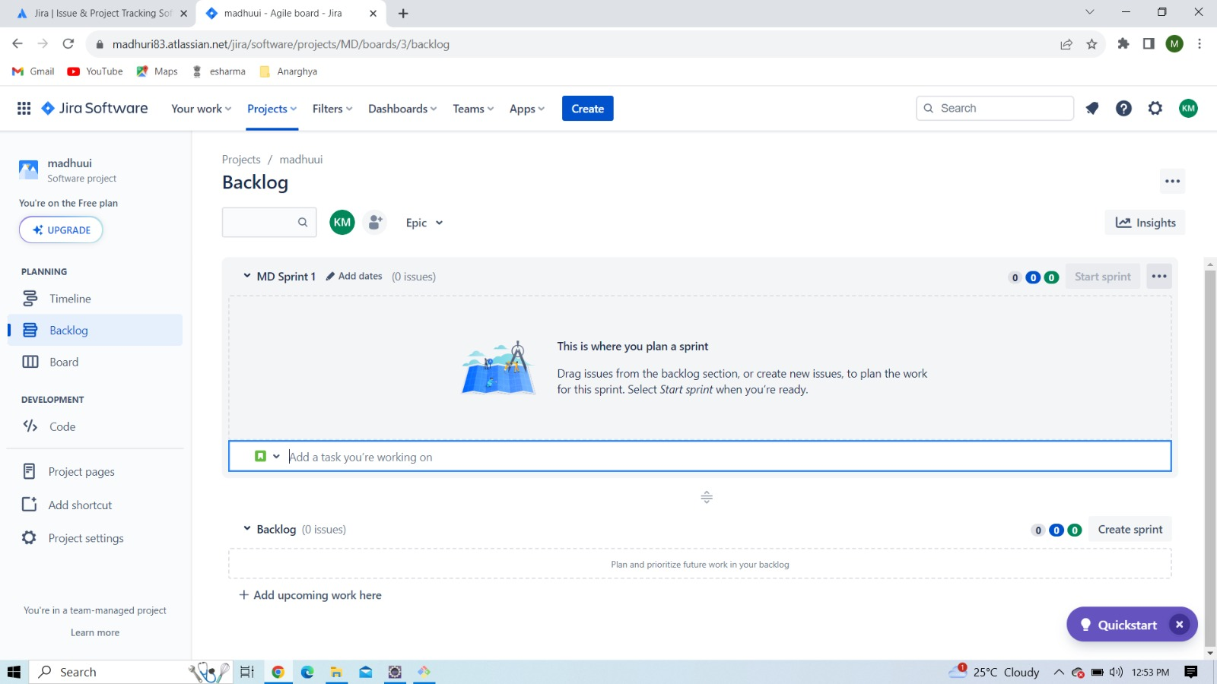

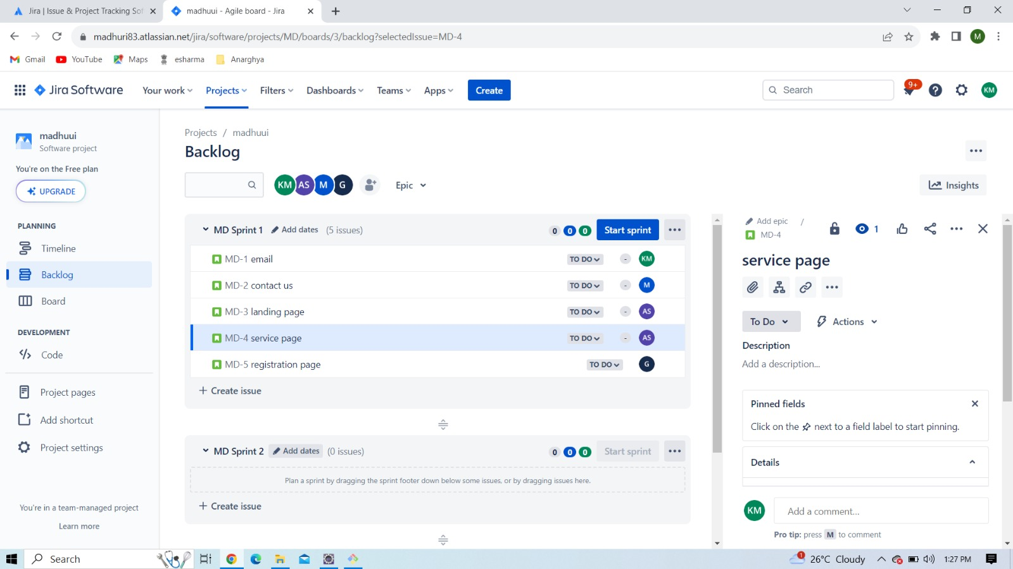

NAME : MADHURI EMPLOYEE ID: ACJD2416

Step-3: edit workflow of the sprint

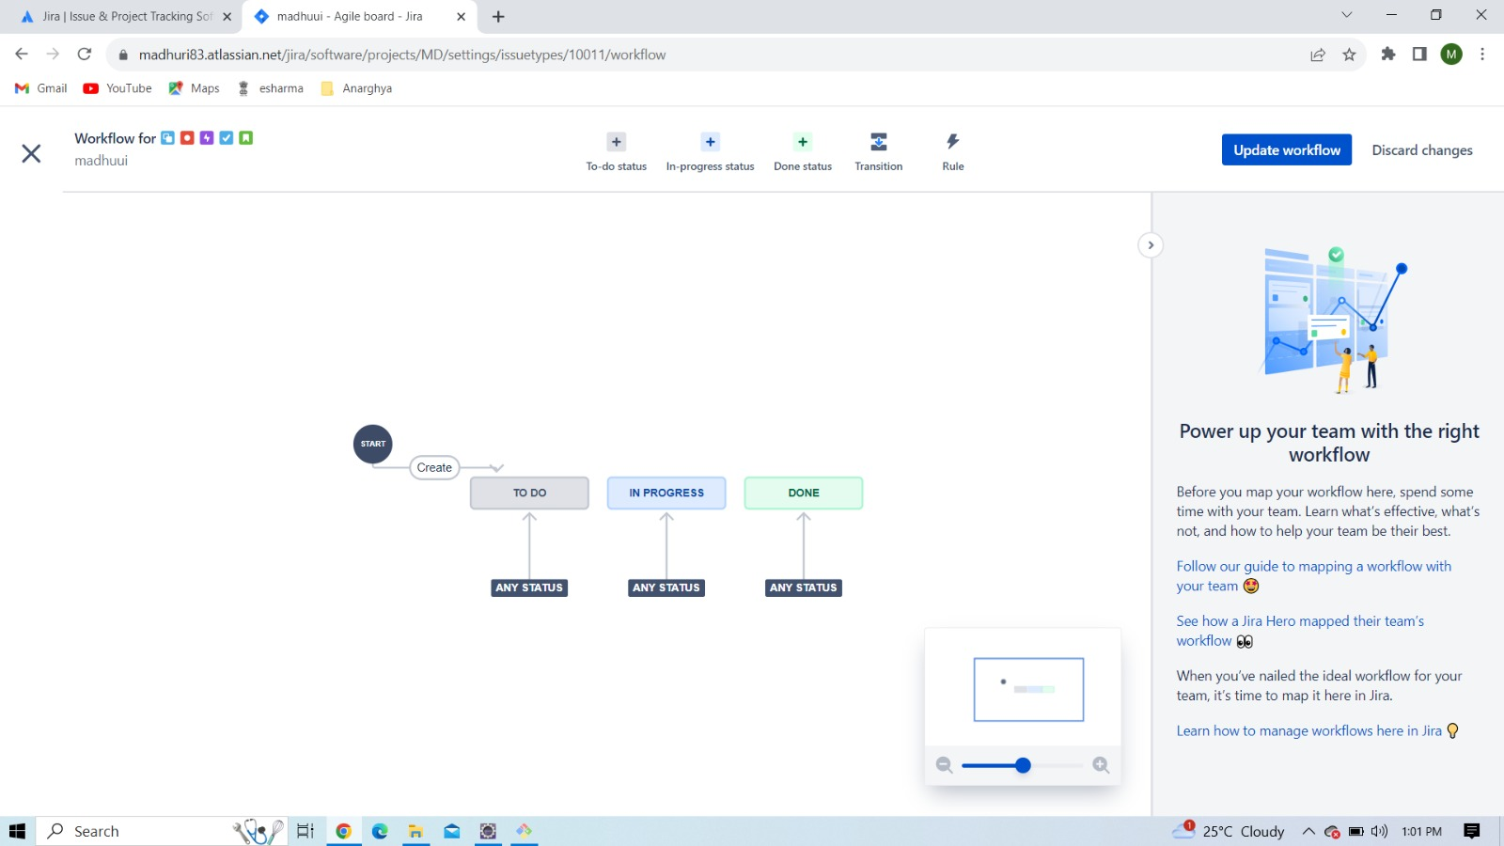

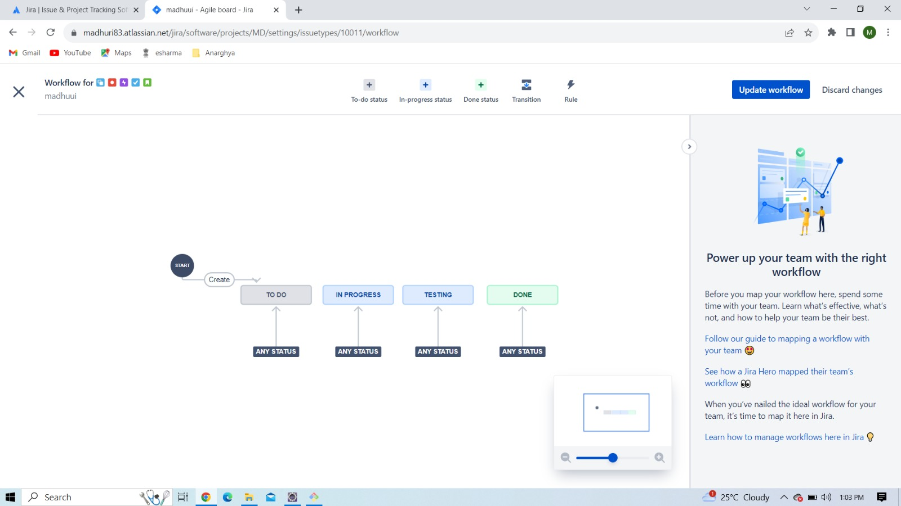

NAME : MADHURI EMPLOYEE ID: ACJD2416

Step-4: Assign the task and Start the sprint

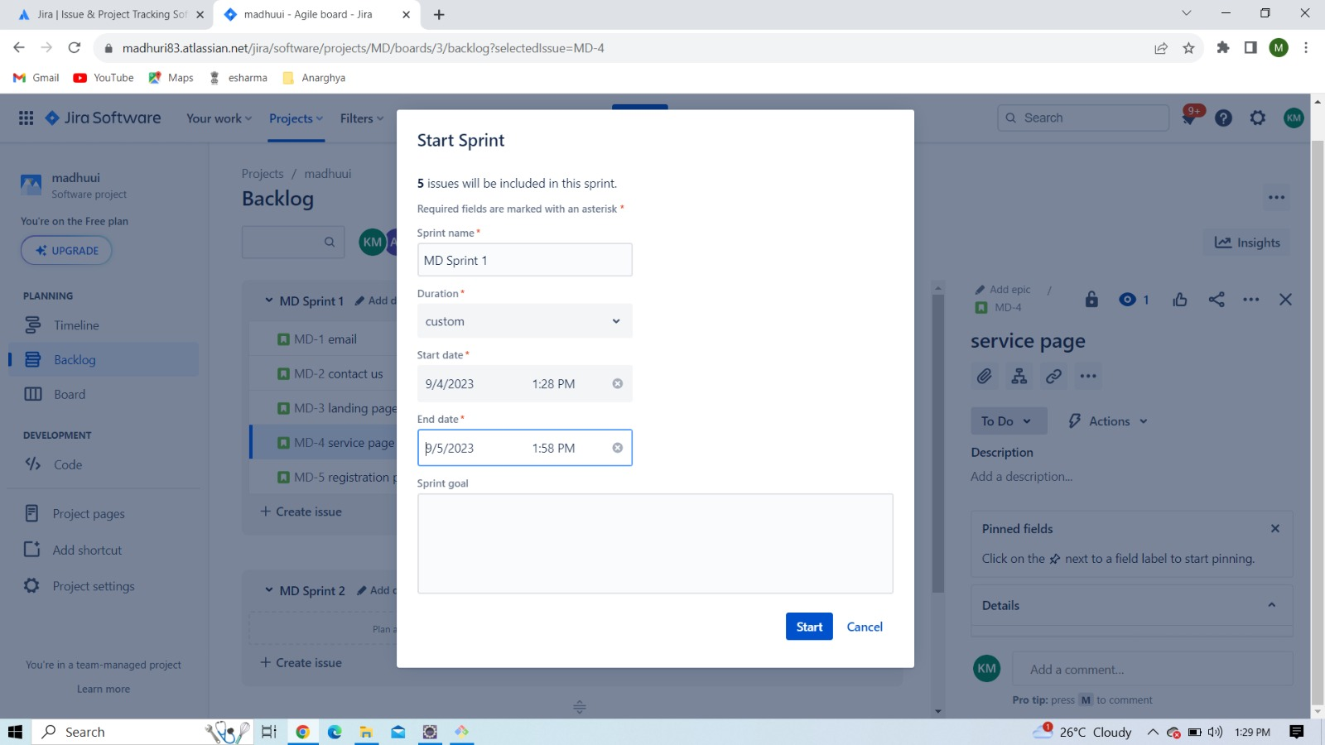

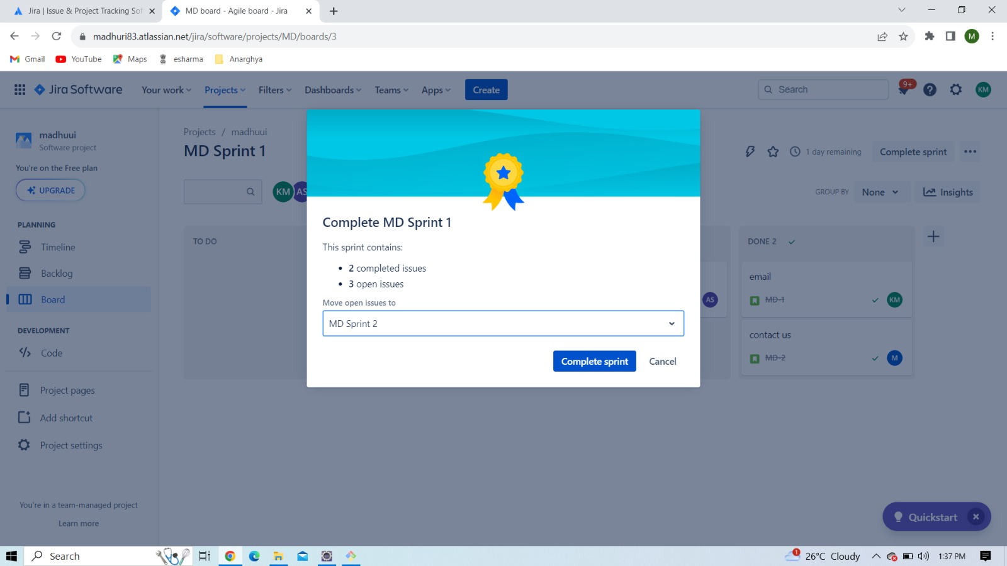

NAME : MADHURI EMPLOYEE ID: ACJD2416

Step-5: Complete the sprint

* In first sprint three issues are in progress. These issues moves into another sprint means Sprint2

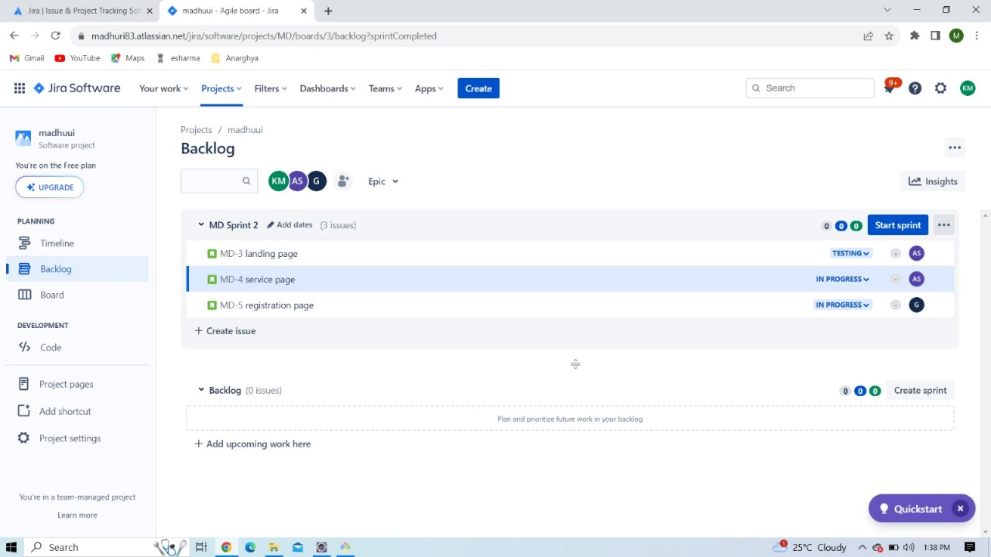

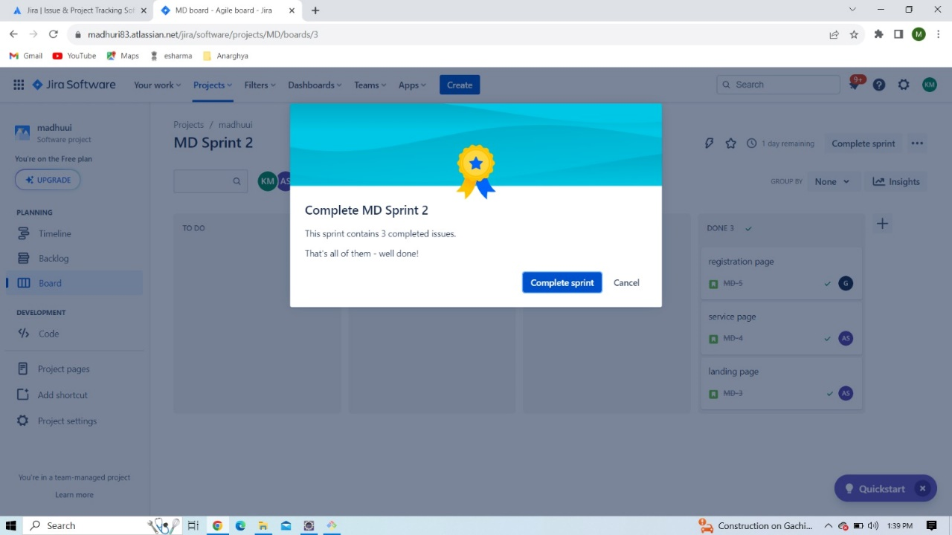

Conclusion:

Jira tool is very important in software industries to do the project more efficiently and time management purpose. We are taken requirements from the client (Project Owner), this project is designed under the scrum master. We are using scrum framework for this project and implemented project modules by team