NAME : MADHURI EMPLOYEE ID: ACJD2416

Steps to create Bugs in JIRA tool

Step-1: create a project with scrum template



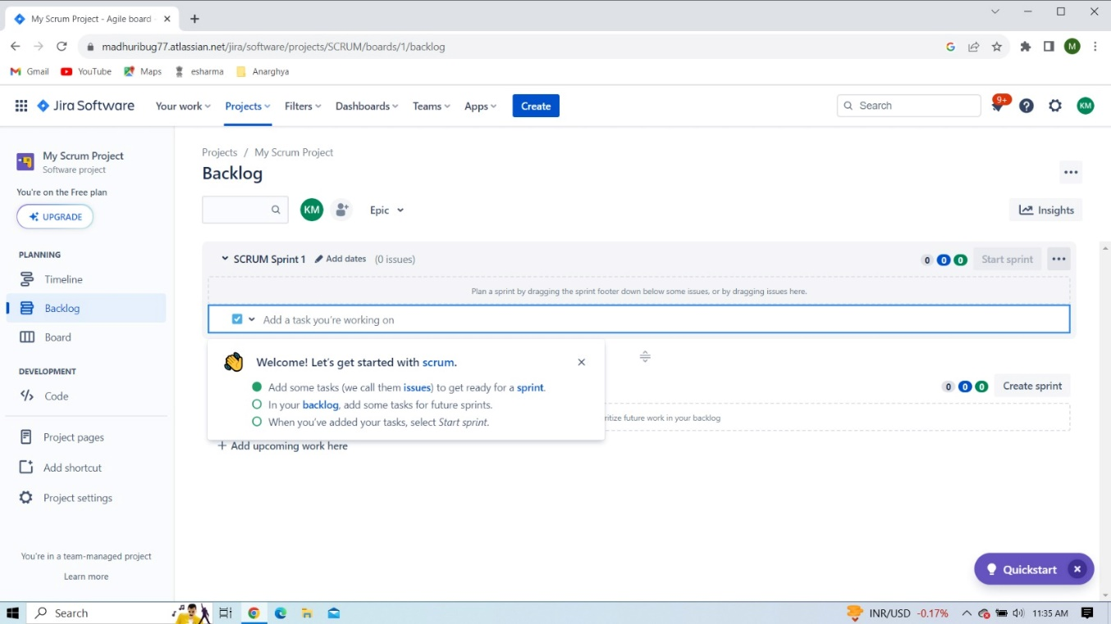NAME : MADHURI EMPLOYEE ID: ACJD2416

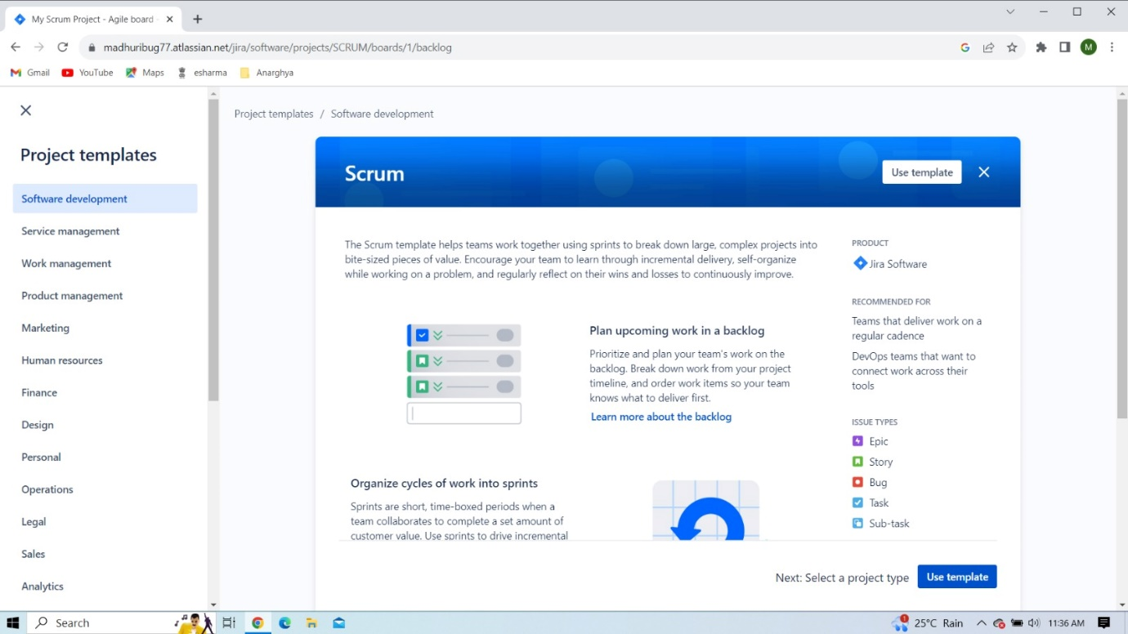

NAME : MADHURI EMPLOYEE ID: ACJD2416

Step-2: create a sprint and add the Bugs

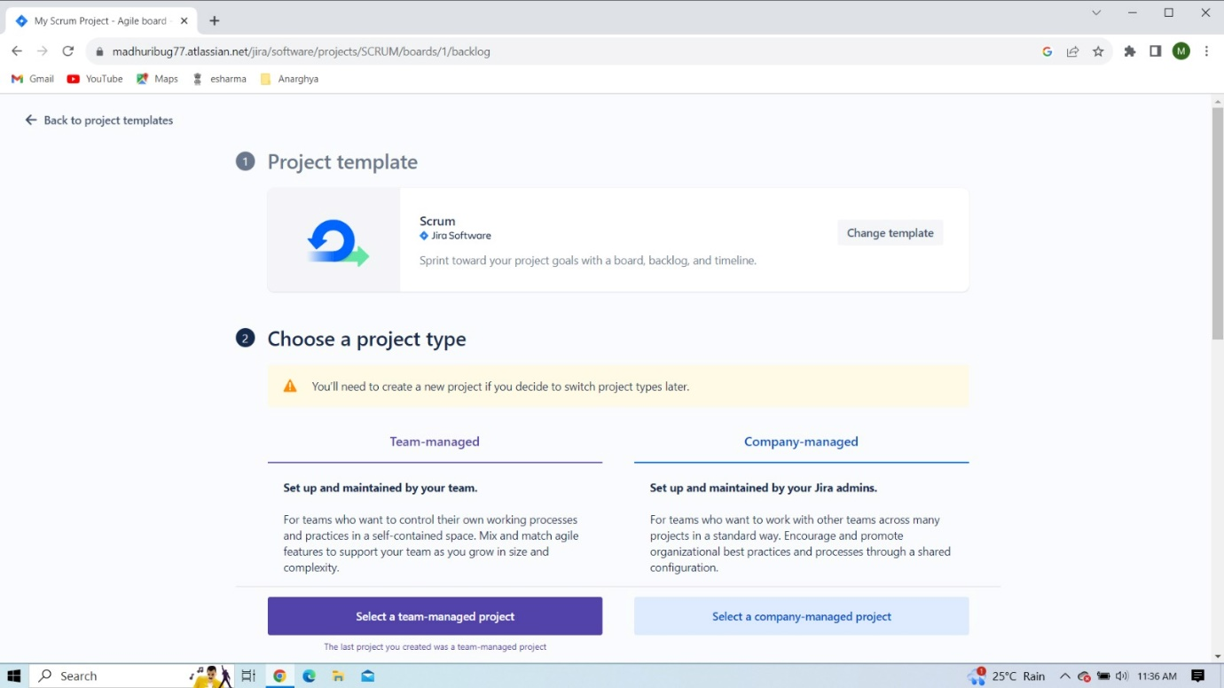

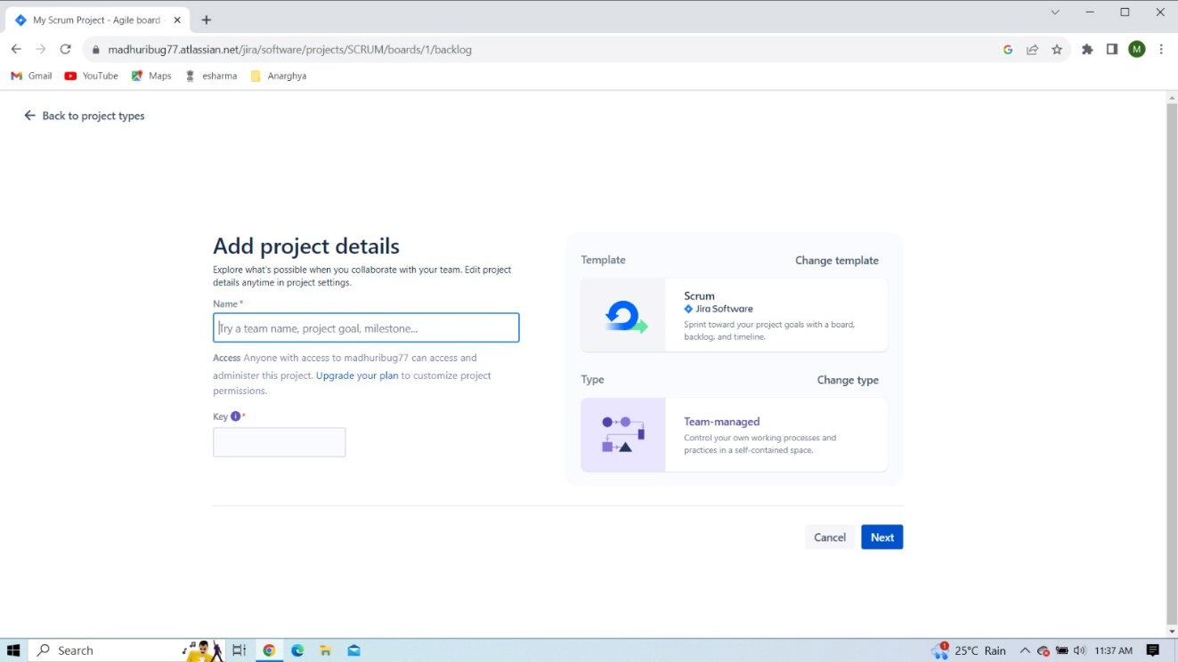

NAME : MADHURI EMPLOYEE ID: ACJD2416

Step-3: Assign the Bug and Start sprint

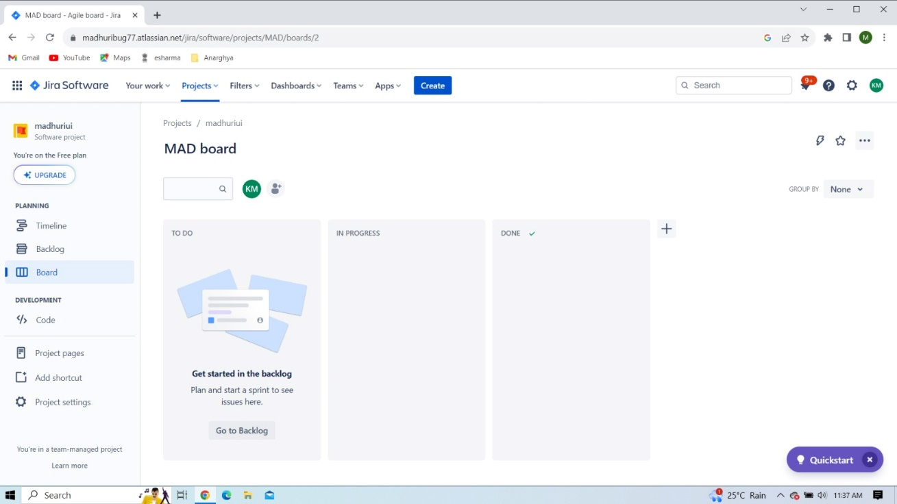

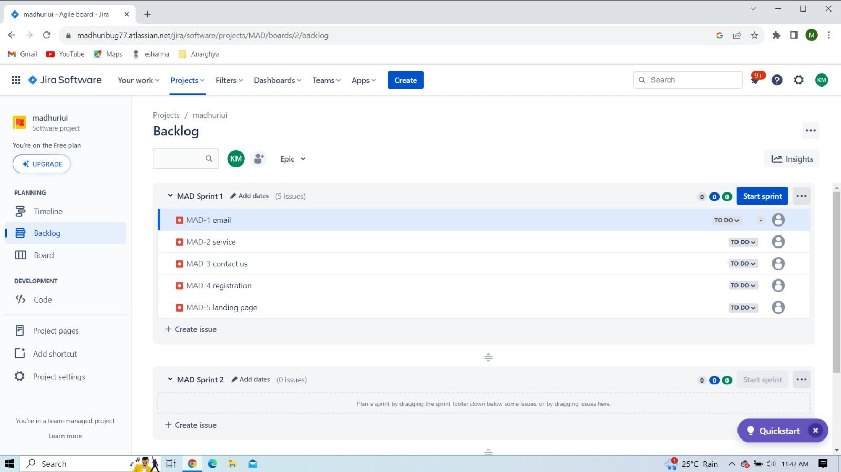

NAME : MADHURI EMPLOYEE ID: ACJD2416

Step-4: Assign the work flow

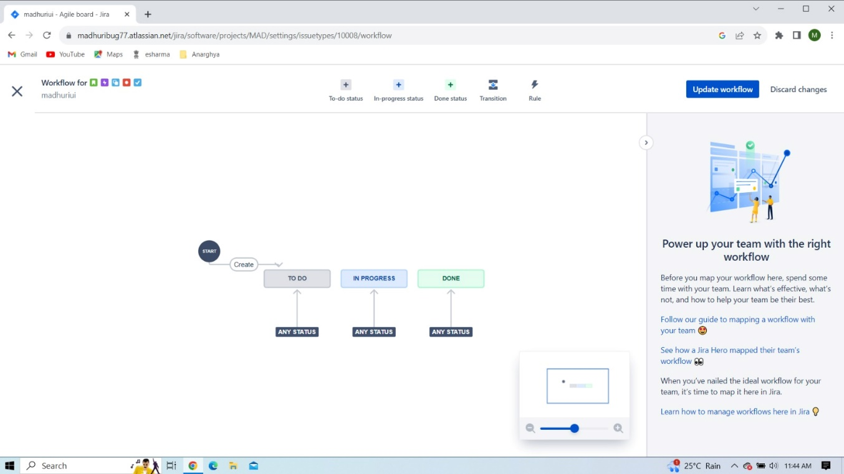

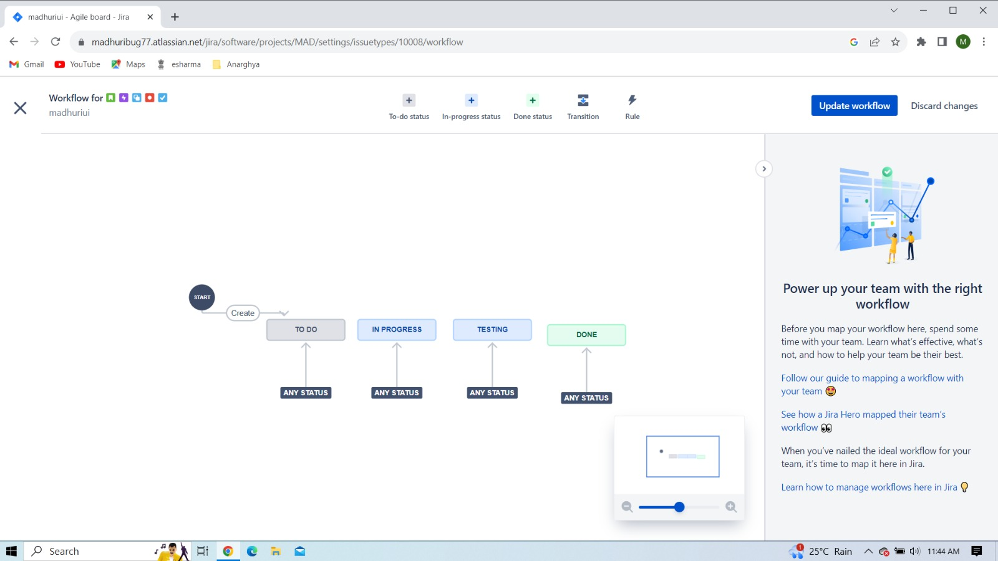

NAME : MADHURI EMPLOYEE ID: ACJD2416

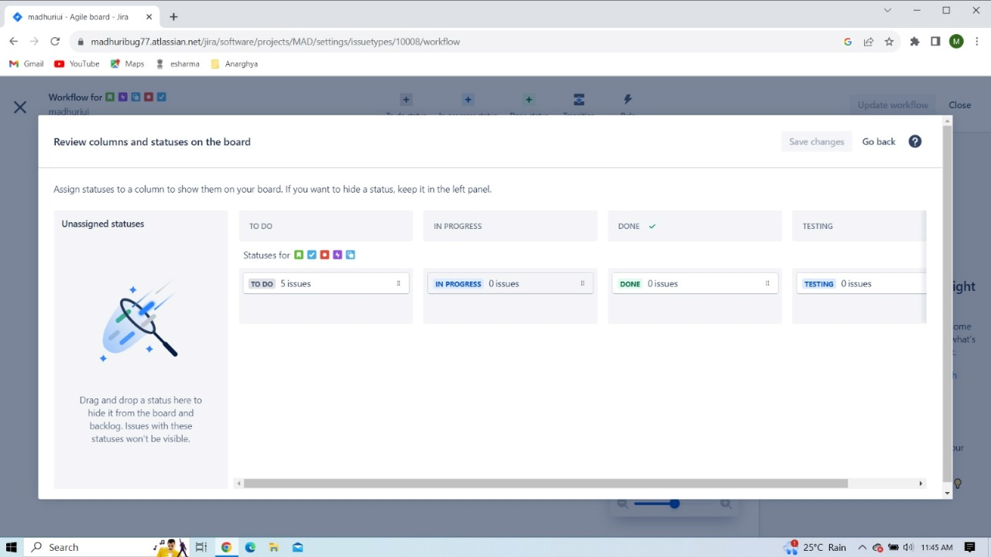



NAME : MADHURI EMPLOYEE ID: ACJD2416

Step-5: Assigning work to the team

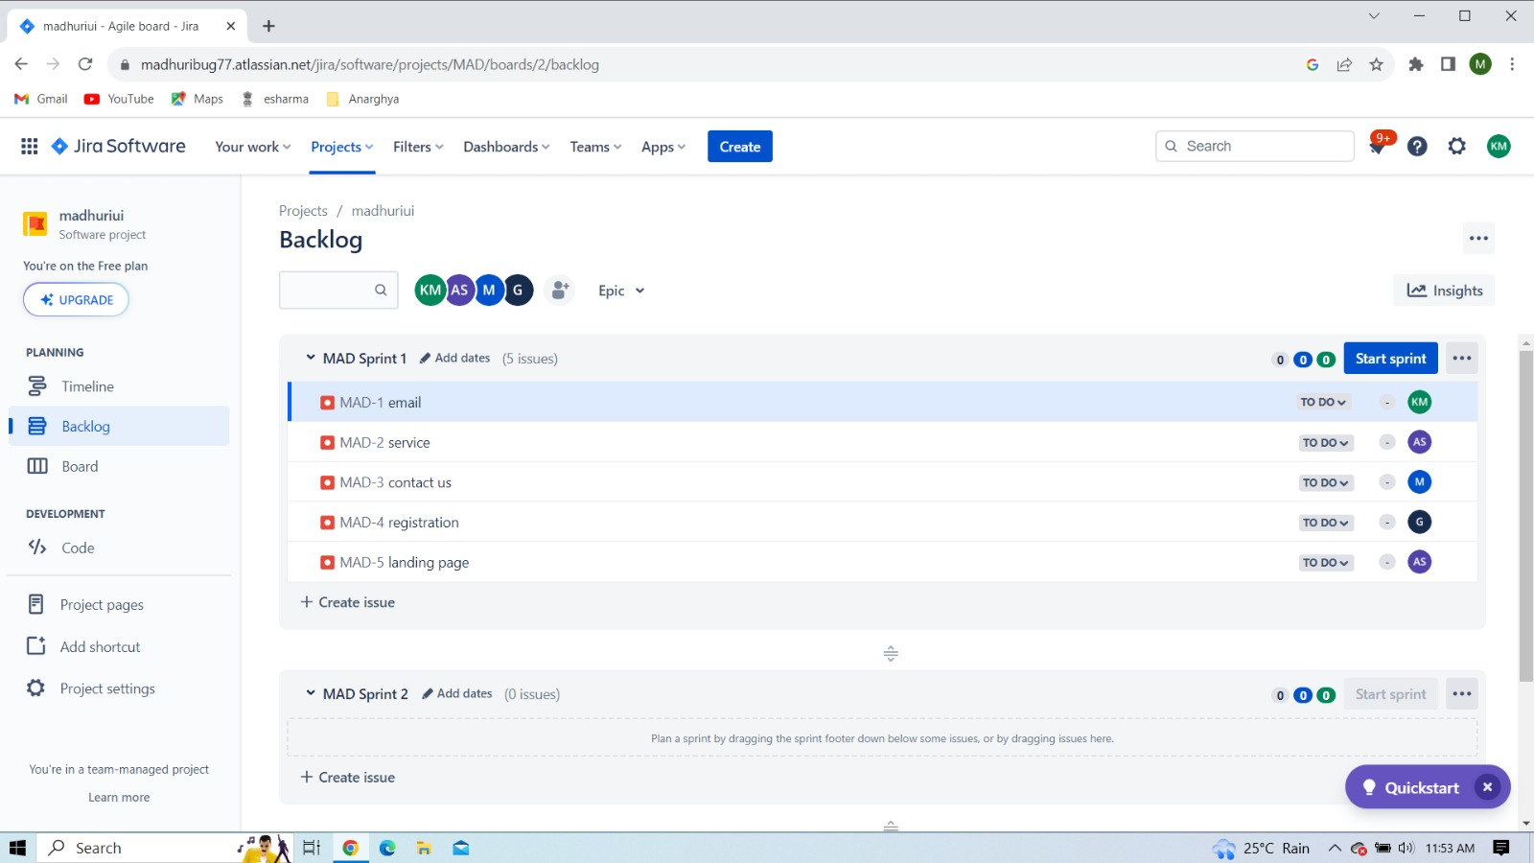

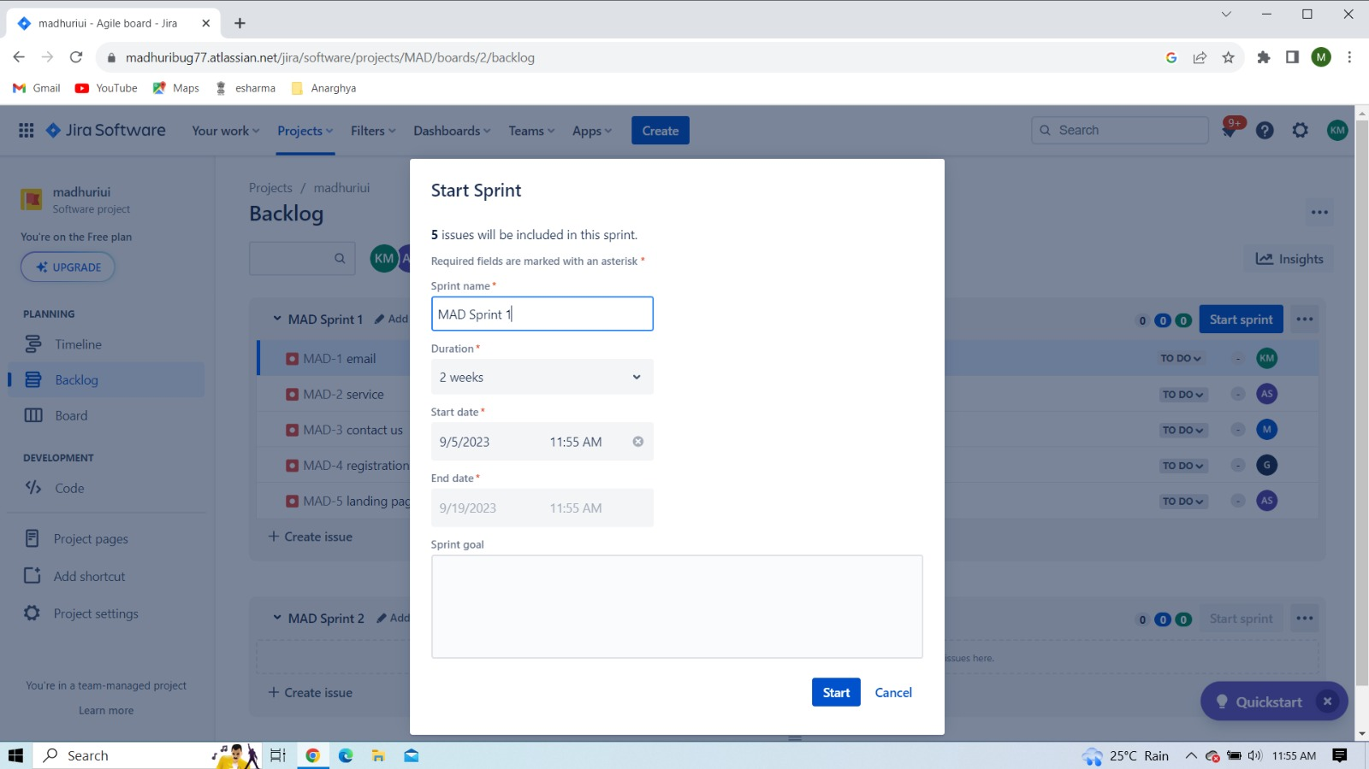

NAME : MADHURI EMPLOYEE ID: ACJD2416

Step-6: Complete the sprint1

* In first sprint three issues are in progress. These issues moves into another sprint means Sprint2

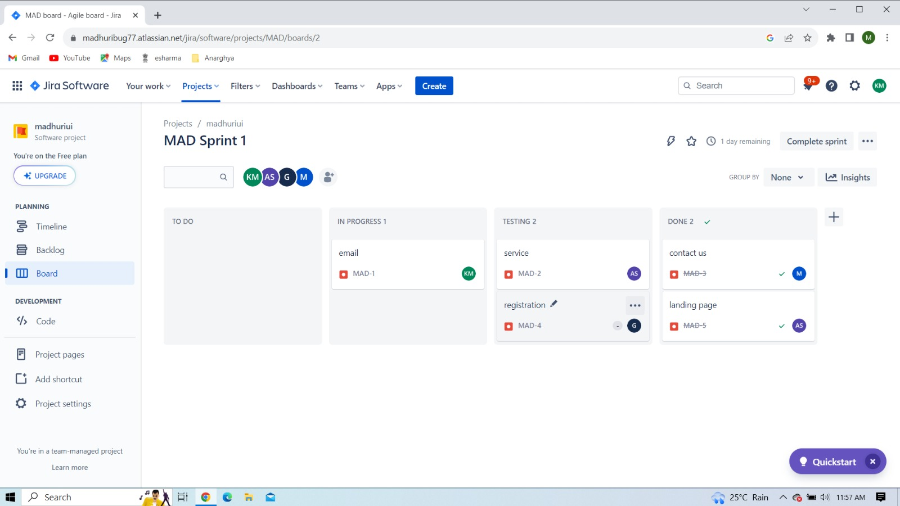

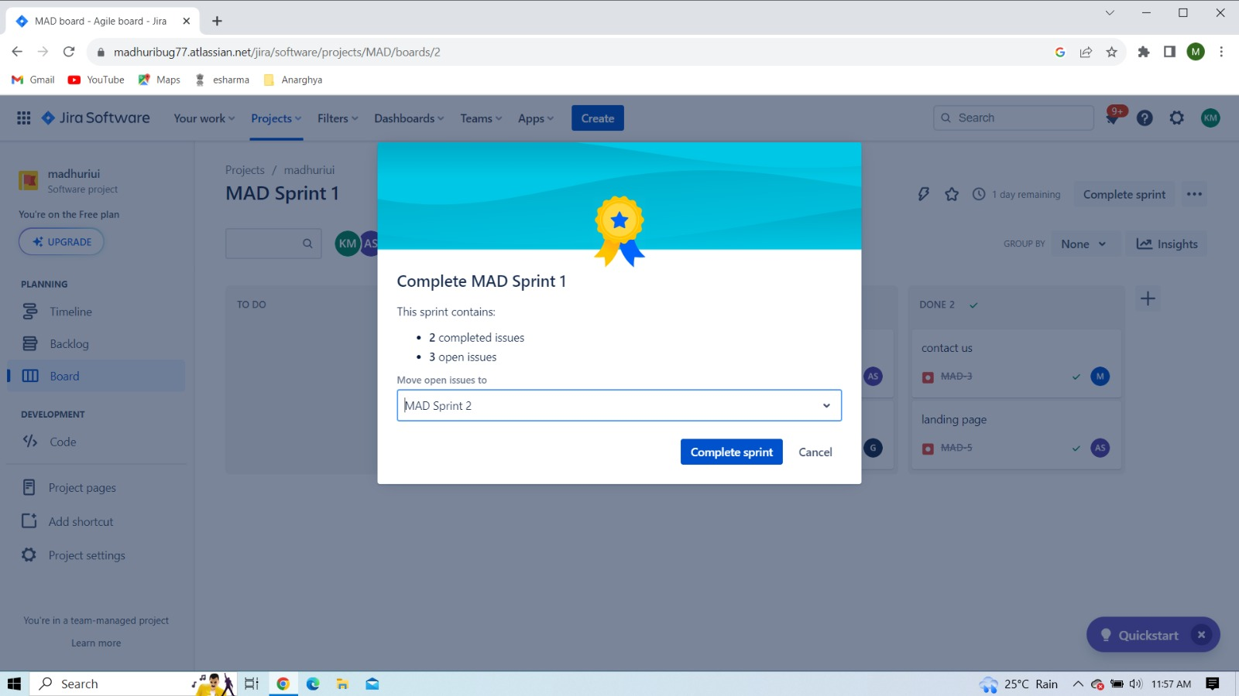

NAME : MADHURI EMPLOYEE ID: ACJD2416

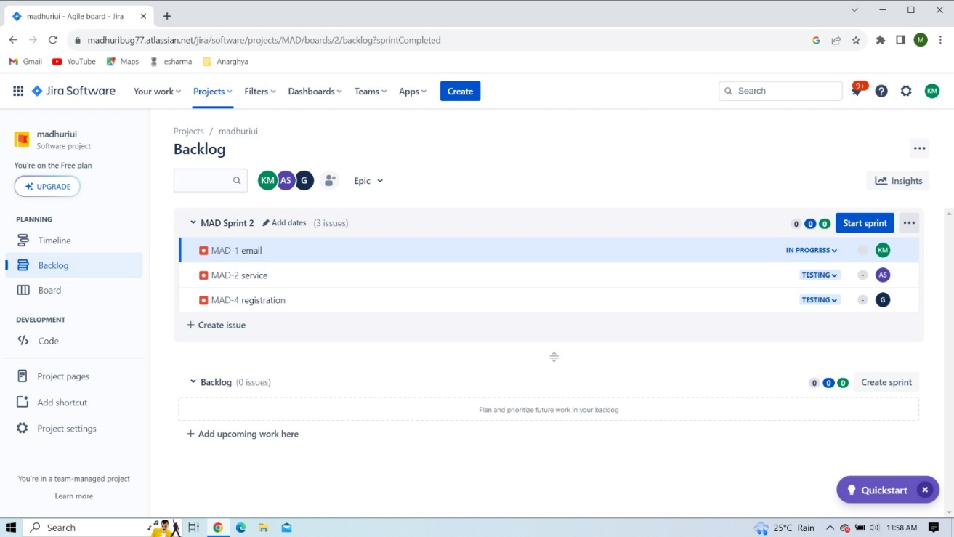

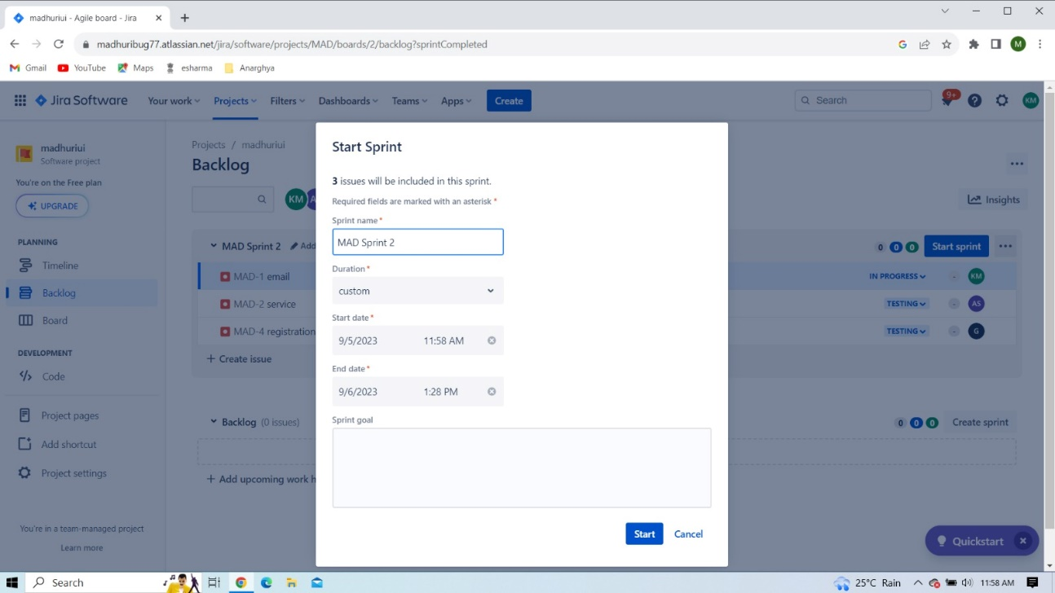

NAME : MADHURI EMPLOYEE ID: ACJD2416

Step-7: Start the sprint and complete the sprint

In this we have two sprint. After completion of sprints the project will be completed.

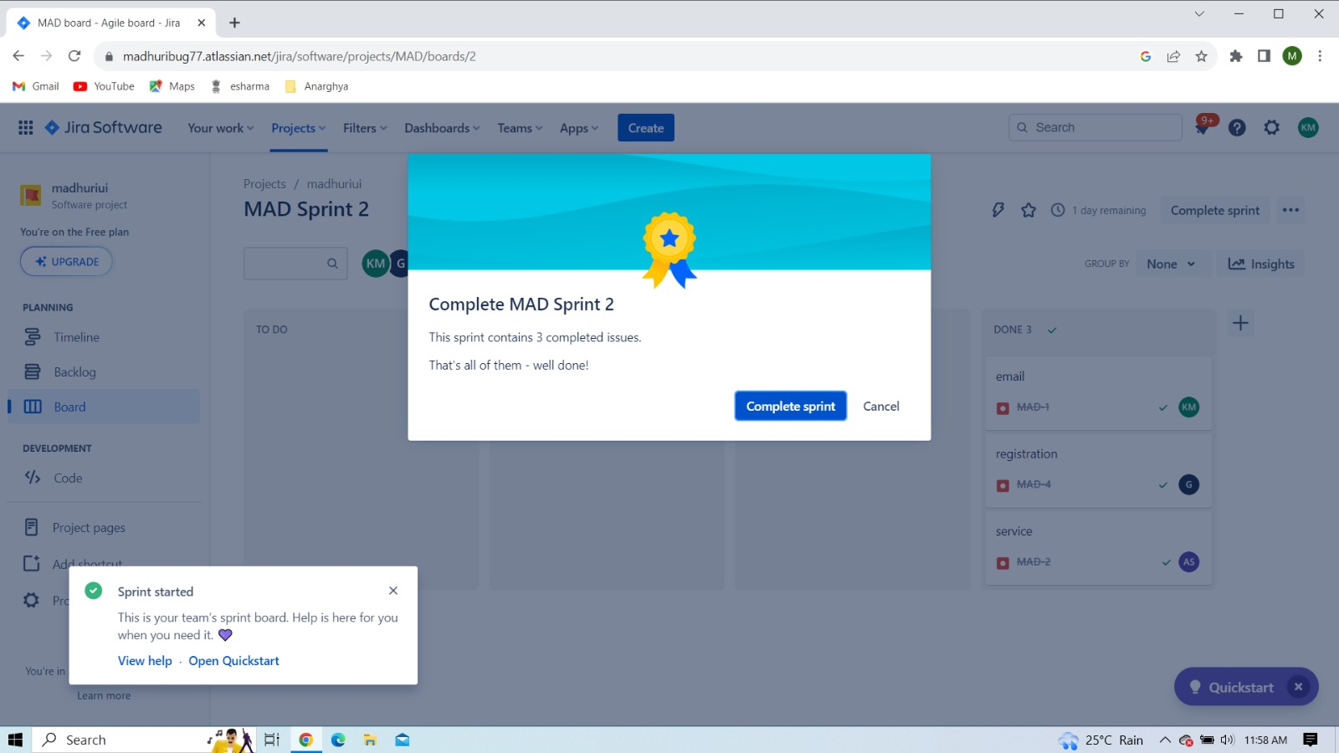

**Conclusion:**

Jira tool is very important in software industries to do the project more efficiently and time management purpose. We are taken requirements from the client (Project Owner), this project is designed under the scrum master. We are using scrum framework for this project and implemented project modules by team