COSC 519 OPERATING SYSTEM I

Project:
Secondary storage implementation

Members:

Contents

- Introduction ………………………………………………….. 3
- Structure of the disk …………………………………………. 4
- Hard disk partitions and boot sector .……………………….. 7
- Size of the hard disk …………………………………………. 9
- Read/Write to hard disk sectors ..…………………………… 12
- Conclusion………………………………………………………15

- Introduction

This objective of this project is to understand how an operating system would implement hard disk operations. The main focus of this project was to understand the physical and logical structure of the hard disk.
- To understand the physical and logical Disk structure
- Hard disk partitions
- Boot sector
- Disk size and capacity
- Read/write operation to disk sectors

The physical structure means, how does the hard disk store data electronically. The logical structure means, how this is seen by the operating system. This is explained in chapter 2.
Chapter 3 and 4 covers the hard disk partitions and the boot sector that resides in any hard disk that would finally make the computer ready to use.

Chapter 4 covers hard disk size (capacity) and BIOS translations.

Once this was complete, we had to figure out a way of writing and storing data to the hard disk. There is a small piece of code that implements the read/write operation to the hard disk which is discussed in chapter 5 of the text.

2. Structure of the disk

Primary components of the disk

The primary components of a hard-disk mechanism are the platters, head stack assembly, motor, and disk controller.

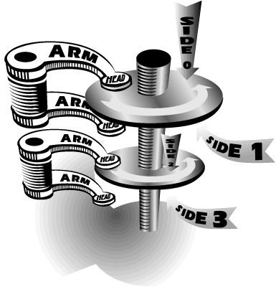
Figure 1 Hard disk components

1. Platters
Hard-disk platters are made of finely polished glass, ceramic composites, or aluminum and are coated on both sides with a very thin layer of a metal alloy. The platters are attached to a central spindle, and a brushless, direct-drive DC motor spins them at a constant speed ranging from 3600 - 7200 RPM (more recent drives are faster).

2. Read/write heads

The read/write heads, attached to the head stack assembly, are responsible for reading and writing data on the platters. Most hard drives include one read/write head on each side of a platter, although some high-performance drives have two or more read/write heads on each platter surface (so that each head servers half the platter, reducing radial travel distance required). The read/write heads don't touch the platter when the platter is spinning at full speed; instead, they float on an extremely thin cushion of air (10 millionths of an inch) to reduce the wear on the platter surface due to friction.

3. Actuator
The actuator is the motor that moves the head stack assembly between the center and outer edge of the platters. An actuator uses the force of an electromagnet pushing against fixed magnets to move to the head stack assembly across the disk platter. As the controller sends more current through the electromagnet, the head stack assembly moves closer to the edge of the platter. In case of a power loss, a spring moves the head stack assembly back to the center of the platter on a non-data storage track. Because all of the read/write heads are attached to the same head stack assembly, they move in unison.

4. Drive controller
The drive controller operates the hard disk. The controller is responsible for interpreting bus commands from the computer; sending signals to move the head stack assembly; reading and writing data; etc.

Organizing data on the disk
A physical formatting process organizes a new, blank hard-disk platter into tracks and sectors. Although most hard-disk manufacturers have their own track and sector specifications, the principles are the same.

1. Tracks
A hard-disk platter is divided into narrow, concentric circles called tracks. The read/write heads move between the outermost track on the edge of the platter and the innermost track near the center. Recent hard disks have as many as 10,000 tracks per surface (areal density of 1.74 GBits/sq.in.). The tracks are numbered as follows: track 0 is the outermost track, track 1 is the adjacent track toward the center, and so on.

2. Sectors
A byte is the smallest useful unit in discussions of memory. Hard disks store data in chunks called sectors. Most hard disks use 512-byte sectors. The hard-disk controller determines the sector size at the time the disk platter is formatted. Some hard-disk models let you specify the sector size.
Each track on the platter is divided into one or more sectors. Since the outermost tracks on a disk platter are larger than the innermost tracks, the outermost tracks contain more sectors.

3. Cylinders
The pair of tracks on opposite sides of the disk platter is called a cylinder. If the hard disk contains multiple platters (say n), a cylinder includes all pairs of tracks directly above and below each other on each disk platter (2n tracks).
Hard drives normally have one read/write head on each side of each platter. Because the read/write heads on the head stack assembly are aligned with one another, the controller can write data to all of the tracks in a cylinder without moving the head stack assembly. As a result, multi-platter disks perform slightly faster than single-platter disks since more data can be written to the platters before the read/write heads must move to a different cylinder.
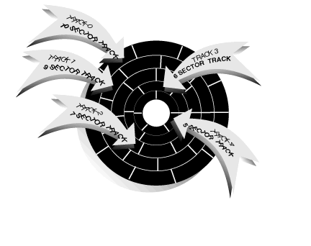
Figure 2 read/write heads on a platter

3. Hard disk partitions

Hard Disk Partitions

Let us take an example of a DOS hard disk Partition.
We recommend a hard disk with at least two partitions; one for your SYSTEM the other for your DATA. The SYSTEM partition is normally fairly stable and does not need frequent clean-ups. The DATA partition is normally heavily used and needs frequent clean-up and de-fragmentations. Here is what you should have on each partition:
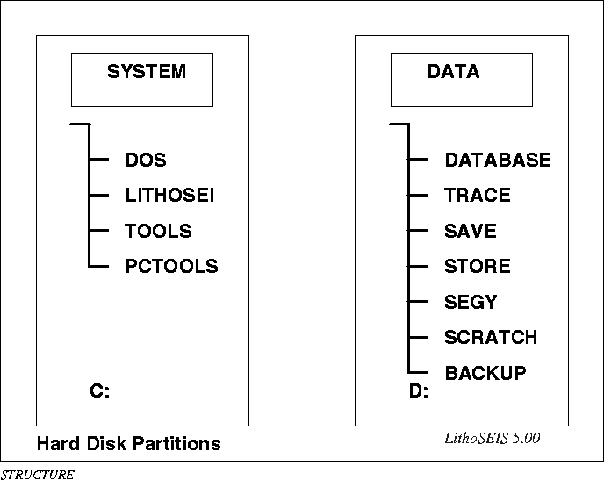
Figure 3 hard disk partition

Partitions
A hard disk can be divided into several partitions. Each partition functions as if it were a separate hard disk.

The MBR, boot sectors and partition table
The information about how a hard disk has been partitioned is stored in its first sector (that is, the first sector of the first track on the first disk surface). The first sector is the master boot record (MBR) of the disk; this is the sector that the BIOS reads in and starts when the machine is first booted. The master boot record contains a small program that reads the partition table, checks which partition is active (that is, marked bootable), and reads the first sector of that partition, the partition's boot sector (the MBR is also a boot sector, but it has a special status and therefore a special name). This boot sector contains another small program that reads the first part of the operating system stored on that partition (assuming it is bootable), and then starts it.

Extended and logical partitions
This trick allows partitioning a primary partition into sub-partitions. The primary partition thus subdivided is the extended partition; the subpartitions are logical partitions. They behave like primary partitions, but are created differently. There is no speed difference between them.
The disk is divided into three primary partitions, the second of which is divided into two logical partitions. Part of the disk is not partitioned at all. The disk as a whole and each primary partition has a boot sector.
.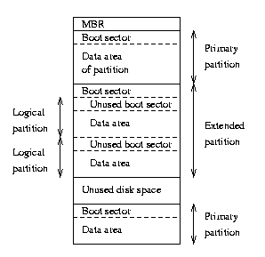
Figure 4 Sample hard disk partition

Partition types
The partition tables (the one in the MBR, and the ones for extended partitions) contain one byte per partition that identifies the type of that partition. This attempts to identify the operating system that uses the partition, or what it uses it for. The purpose is to make it possible to avoid having two operating systems accidentally using the same partition. However, in reality, operating systems do not really care about the partition type byte; e.g., Linux doesn't care at all what it is. Worse, some of them use it incorrectly; e.g., at least some versions of DR-DOS ignore the most significant bit of the byte, while others don't.

  - Size of the hard disk

Hard Disk Barriers
The most (in)famous hard disk barrier of all time was probably the 504 Mb limitation for standard IDE/ATA hard disks, which started showing up in systems starting in around 1994. As you can see, the 504 MB figure is just 1,024 * 16 * 63 * 512, which equals 528,482,304. The problem is the combination of the limitations of the two standards. Due to the 16-head limitation of IDE/ATA, no IDE hard disk is ever specified with more than 16 logical heads; they always have a large number of cylinders instead. The problem is that when you put the disk in a machine with a standard, non-translating BIOS, it can't see more than 1,024 of the cylinders.
- The 8.46 GB Barrier
This barrier, often just called the "8 GB barrier", is one of the most important in the hard disk world. Many people run into this particular barrier as they attempt to upgrade systems originally purchased in the late 1990s with hard disks of 1 GB to 8 GB or so in size.
This barrier is based on a BIOS limitation. That standard allocates 10 bits for the cylinder number (and thus a maximum of 1,024 cylinders), 8 bits for the head number (maximum of 256) and 6 bits for the sector number (maximum of 63, since the number 0 is not used). Multiplying these together, and assuming the standard of 512 bytes per sector, you get a maximum of 8,455,716,864 bytes. This is the largest hard disk size that can be addressed using the standard Int13h interface. This brings us to the question “How will BIOS handle a disk of size greater than 8 GB.
These are the four most common ways that a machine with an older BIOS will handle a hard disk larger than it supports:
- Truncation: Many BIOSes, when presented with a logical geometry containing more cylinders than they can handle, will simply truncate the total to the maximum they support. Truncation of course wastes some space on the drive, but is still far preferable to the other possibilities described below.

- Wrap-Around: Some very old BIOSes, assuming that the number of cylinders will always be 1,024 or below, only look at the bottom 10 bits of the cylinder number coming from the hard disk (2^10 = 1,024). As a result, when used with numbers over 1,023, they do the equivalent of counting up to 1,024 and then "wrapping around" to zero again and starting over. The same exact thing can happen to a BIOS that support only 4,096 cylinders: it may only look at the bottom 12 bits. This means that in some cases you can put a 2.5 GB hard disk into your system and end up with only about 400 MB of usable space showing up. This is unfortunately a common failure mode with BIOSes that don't support more than 4,096 cylinders.
- Ignorance: Some BIOSes will report the true number of logical cylinders that the drive has, making you think your system supports the full size of the hard disk. Really, the BIOS just has no clue what it is seeing. When you go to partition and format the hard disk, you will be stuck with the same limit (which can be both confusing and frustrating). This is usually seen with older BIOSes and the 1,024 cylinder limitation.

- Failure: Some BIOSes will totally lock up if you try to use them with a disk larger than they can support. These are actually pretty uncommon, fortunately.

- Read/Write to hard disk sectors

The Intel 386 Assembly code was used to read/write to the hard disk. In our code we attempted to write some text to a single sector on the hard disk. Each sector is 512 bytes. Using this code we can write to any sector of the disk. After the text was written into the sector the same sector was read and the text was displayed to the screen.
To do this we had to resolve a way for the OS to address the physical location on the disk. This was done by mapping the Physical Cylinder, head, Sector (P-CHS) format to a logical CHS format. Actually the ROM BIOS already does this translation for us which we use in our code to write to individual sectors.
For our project we used a disk with a size of 6.448 MB. With 512 bytes allocated for each sector we get a total of 12594960 sectors on the disk. The physical CHS as provided by the manufacturer shows the following data:-
13328 cylinders, 15 heads, 63 sectors per track.,6.448MB

The Logical CHS translated by BIOS gives us
255 heads,
63 sectors per track and
6448619520 bytes/(62*255*512) = 784 cylinders,

These values are used to address the sectors and the data is fed into the CX and DX registers as shown in the figure below to read and write data to each sector in the disk.

+-----------------+-----------------+-----------------+
| 7 6 5 4 3 2 1 0 | 7 6 5 4 3 2 1 0 | 7 6 5 4 3 2 1 0 |
+-----------------+-----------------+-----------------+
| H H H H H H H H | C C S S S S S S | C C C C C C C C |
+-----------------+-----------------+-----------------+
| DH | CL |CH |
+-----------------+-----------------+-----------------+

Figure 6 – CHS format

Where C: Cylinder
H: head
S: Sector

The sample code is shown below,

cseg segment para 'code'
assume cs:cseg,ds:cseg,es:cseg
org 100

begin: jmp main
readin db 512 dup(' ') ;input buffer
writeout db 'message to display : This is for 519 project!'

endcde db 0
readmsg db '****read operation failed***$'
wrtmsgerr db '****Sector not valid, Cannot write***$'
wsucc db '****write operation successfull****$'
rsucc db '****read operation successfull****$'
errorinput db '****0-9,A-Z,a-z*****$'

crlf db 0dh,0ah,'$'

main proc near

mov ax,cseg
mov ds,ax
mov es,ax

call writes ;write 'writeout' to the address you want
cmp endcde,0
jnz exit
mov ah,40h
mov bx,01
mov cx,35
lea dx,wsucc
int 21h
call inputcrlf

call reads ;read from the address you want to 'readin'
cmp endcde,0
jnz exit

mov ah,40h
mov bx,01
mov cx,34
lea dx,rsucc
int 21h
call inputcrlf

call disps
exit: mov ax,4c00h
int 21h
ret
main endp

;from write buffer to the address you want
writes proc near
mov al,01
mov ah,03
mov ch,curtrack ;track
mov cl,cursec ;sector
mov dh,head
mov dl,diskDriver
lea bx,writeout
int 13h
cmp ah,0
jz inwrt
mov endcde,01
call errinw
inwrt:
ret
writes endp

;read message from the address you want to readin buffer
reads proc near
mov al,01
mov ah,02
lea bx,readin
mov ch,curtrack ;track
mov cl,cursec ;sector
mov dh,head ;head
mov dl,diskDriver ;diskdriver
int 13h
cmp ah,0
jz incrt
mov endcde,01
call errin
incrt: ;inc curadr
ret
reads endp

;display readin buffer
disps proc near
mov ah,40h
mov bx,01
mov cx,45
lea dx,readin
int 21h
ret
disps endp

;routine for insert cr,lf
inputcrlf proc near
mov ah,40h
mov bx,01
mov cx,3
lea dx,crlf
int 21h
ret
inputcrlf endp

inputerror proc near
mov ah,40h
mov bx,01
mov cx,20
lea dx,errorinput
int 21h
call inputcrlf
ret
inputerror endp
;read message error
errin proc near
mov ah,40h
mov bx,01
mov cx,28
lea dx,readmsg
int 21h
call inputcrlf
ret
errin endp
;write message error
errinw proc near
mov ah,40h
mov bx,01
mov cx,37
lea dx,wrtmsgerr
int 21h
call inputcrlf
ret
errinw endp
cseg ends
end begin

Conclusion

As a group we are now familiar with the operating system functions of the hard disk.
We have a good idea of the way data is stored on the disk. Also this code is a general
implementation of the way the read/write operation will work on any INTEL CPU,
irrespective of operating systems.

We thank Dr. Karne for all the help rendered in the project.

