USER MANUAL FOR
MEMORY MANAGEMENT SIMULATION

This project of Memory Management Simulation is developed using java programming language. We chose Java as the programming language as it provides a very easy Graphics user interface. Without being able to display anything on the screen, it would have been very difficult to explain the working of the main memory.

STEPS TO RUN THIS CODE:

- If you don’t have java environment (JDK).

You can download latest version of java from the link given below:

http://java.sun.com/j2se/1.4.1/download.html

Save it to your harddisk(C:\).

- If you already have java environment on you machine.

Set the path for jdk(bin directory).

By writing

Set path=c:\jdk..Your version\bin;

To compile the code write:

  - javac Project.java

To run the code write:

  - java Project

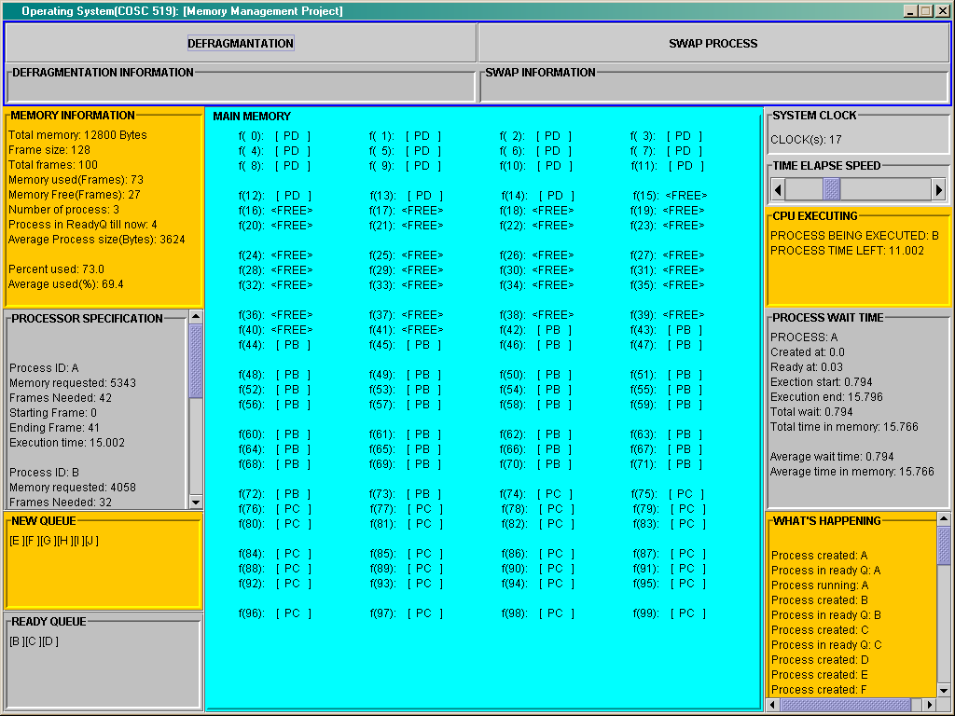

Description for the each field of the screen :

- MEMORY INFORMATION :

  - Total memory: 12800 bytes.

It displays the total size of the main memory.

  - Frame Size: 128 bytes.

It displays the size of the each frame.

  - Total Frames: 100

It displays the total No. of the frames.

  - Memory Used(Frames):

It displays the amount of main memory used at
certain time.

  - Memory Free(Frames):

It displays the available main memory (Frames) at
certain time.

  - Number of processes :

It displays the No of processes that are getting
executed in main memory at certain time.

  - Process in ReadyQ till now:

It indicates the total number of processes that
have been allocated the main memory till the
moment.

  - Average Process Size(bytes):

It displays the average size (in bytes) of the all the process generated at certain time.

  - Percent used:

It displays the percentage of the main memory used by all the processes being generated at certain time.

  - Average Percent used:

It displays the average percentage use of main memory by all the processes.

- PROCESSOR SPECIFICATION:

  - Process ID:

Process Identification number being generated.

  - Memory Requested: (in bytes)

Amount of memory required by each process being generated.

  - Frames needed:

No of frames needed by each process being generated which is calculated by process generator.

Frames needed = (Memory requested / Frame size)

  - Starting Frame:

It shows the starting frame of process when it is loaded into the main memory.

  - Ending Frame:

It shows the last frame of process when it is loaded into the main memory.

  - Execution time :

It displays the amount of time required by each
process for being executed in the main memory.

- NEW QUEUE:

All the newly produced processes are first stored into the new queue before there is enough space available for process in the ready queue.

- READY QUEUE:

All the processes which have been allocated memory and are waiting for execution are stored in ready queue.

- SYSTEM CLOCK:

Maintains the system time for all the process times.

- TIME ELAPSE SPEED:

It regulates the passage of a unit time for the system.

- CPU EXECUTING:

  - Process Being Executed:

It shows current process getting executed in main memory.

  - Process Time Left:

It shows amount of time remaining for the process to finish its execution.

- PROCESS WAIT TIME:

FOR EACH PROCESS:

1. Created at: Process creation time.
2. Ready at:
3. Execution start:
Time when execution of process starts.
4. Execution end:
Time when execution of process ends.
5. Total wait:
Time period from process generation till beginning of its execution.
6. Total time in memory:

FOR ALL PROCESS:

1. Average wait time: It displays the average waiting time for all the process waiting for its execution.

2. Average time in memory: It shows the average time of
processes they spend in the memory for execution.

- WHATS HAPPENING:

Its main purpose is to show the status of each process from being generated to the end of that particular process.

Process Created : It will show which process has
been created.
Process running: It shows which process is begin
executed.
Process in readyQ : It will show the process that
entered the ready Q.
Process Finished : It will show which process has
finished its execution.

