<Project Codename>
High-Level Design Document
v0.00

Confidential

Robosoft Technologies Pvt. Ltd.
Registered & Corporate Office
217, N.H.66, Santhekatte
New Udupi – 576 105
Karnataka, India
Tel: +91 820 2593930
Fax: +91 820 2593900

Document Revision History

Date | Version | Authors | Reviewed By | Approved By | Brief Description
<dd-Mmm-yy> | 0.01 | <Author> | <Reviewer>  (One person/ Group Review - PQAL) | - | Initial draft
<dd-Mmm-yy> | 0.02 | <Author> | Verified by | - | List the changes incorporated as per review
<dd-Mmm-yy> | 0.03 | <Author> | <Customer> | <Customer> | List the changes incorporated as per Customer feedback and sent to Customer for approval
<dd-Mmm-yy> | 1.00 |  |  |  | Approved by Customer and baselined

Contents

1. High-Level Design 3
1.1 Introduction 3
1.1.1 Purpose 3
1.1.2 Scope 3
1.1.3 Audience 3
1.1.4 References 3
1.1.5 Terms and Abbreviations 3
1.2 Software Product Overview 3
1.3 Design Considerations 3
1.3.1 Assumptions and dependencies 3
1.3.2 Development methods 3
1.3.3 General constraints 3
1.4 Architectural Strategies 3
1.5 Software Product Architecture 3
1.6 Component Architecture 3
1.7 Bibliography 3
2. Reference 3

Figures

High-Level Design

Introduction
To develop brand new application for short video sharing. The app will have the features to make and upload short videos and also to view available short videos. The app will be used for educational purpose and the short videos available are having educational contents.

Purpose

The purpose of this High-Level Design document is to layout the design plan to represent a suitable model for coding. This document can be used as reference for how modules interact at a high level. It is also aimed at providing them with a complete reference for the development process and methodologies that will be used for the project.

Scope
This document describes the structure of product, application architecture, development methodologies and application flow. This also describes design and development constraints of the product.

Audience
The application is intended for all the general population who are interested in learning by watching short videos and making educational videos.

References
Gloopt Video App requirements.pdf

Terms and Abbreviations

Swift Programming language
System Refers to the Mac system with Operating System
IDE Integrated Development Environment
SDK Software Development Kit
HTTP Hypertext Transfer Protocol
IPA iPhone Application Archive
PDD Project Definition Document
UI/UX User Interface/User Experience

Software Product Overview
This app will be available in the store for general pulation.

Design Considerations

Assumptions and dependencies
Mobile app would be published in app store as a separate application.
Application would be distributed via Apple Play Store account.
Mobile app developed for iPhone would run only on iPhones.
Minimum supported OS version to run app would be iOS 13.
Wireframe, Visual Design and assets would be provided by customer.
Build portal integration with build script would be done by customer.
App would support English language only.
App would support portrait orientation and landscape.

Development methods
The application would be developed in Agile method.

General constraints
A major change in the requirements specification during the course of project development could have an impact on both technical design and the project schedule.

Architectural Strategies

Compilers/ IDE/ Languages

XCode 11, Swift 5

Framework

iOS 13 SDK

Source code management tool

Subversion (provided by Customer)

Hardware Supported

Phones: iPhone 5 and above

Software Supported

iOS 12 and above

Dependency Management

CocoaPods

Static Code Analyzer

OCLint

Communication

HTTPS

Software Product Architecture

Different Screens and specific client as well as server side requirements

1. Login screen

Client Side
LinkedIn authentication
Email validation screen
Option to enter as guest

Server side
User authentication using email address

2.Menu
Client
Post menu API with parameter as guest or client
Based on the menu API data , load the menu list
On click of each menu item , navigate to each list detail screen

Server
Send the list of menu items based on the guest/client parameter

3.Home
Client
Fetch the list of videos base of the the category and show in list view
Load the videos using players like MPMoviePlayerCotroller
Search field - on entering the text, it will be posted to server
Once the searched results are obtained, reload the list with new data
Option to select the menu
Each video cell will have option to add video to Que, share and like and add to play list
Adding video to Que will store the video details locally
Share will open the local share view
On liking a video , post liked video details to server

Server
Send the list of video location urls based on the selected category including video details
On receiving the search API data, send the list of videos based on the search option including video details
API to take the liked video details to server and update in the server accordingly

4.Category - This screen will be shown only if the user is registered

Client
Show the list of categories using list view
Fetch the category list using API

Server
Send the category list

5.Video Details Page

Client
Fetch video detail using the selected video id
Update the details in the screen using embedded media player and text fields.
On clicking like - call the API and pass the video ID to update the like count from back end
On clicking comments button, open the list of comments and show the text field option to type comments.
On clicking post in the comments section , call post comment API with comment and video id as parameters
On done click , dismiss the presented view
On orientation change , update the video player to show in full screen

Server
API Send the video details based on the video ID
API to receive the liked action for the given video

6.Que Screen

Client
On click of Que from menu option , show the Que list screen
List the videos added to local Que variable

7.Play List

Client
Show the list of playlists created
Fetch the API and get the videos for each playlist and show in list view

Server
Send the list of videos for ay given playlist

8.Publishing Videos

Client
Show three options to :
Record(will go to video recording screen) ,
Choose Recorded (Go to the list where videos recorded through app are available)
Choose from Device Library (Go to device Library)

9.My Videos

Client
Show tabbed view to show list of published / unpublished videos
Get the list of published videos from the API
Show the unpublished videos from local storage

Server
API for getting the published video list

10.Publish
Client
On click of items in the published list - go to unpublished vide detail screen
option to enter the video details
On click of publish post the video details and upload the video

Server
API to upload the video details and Video

11.Record Video

Client
On the device camera

12.Video Editing

Client
Option to edit the video locally using video editing library

13.User Profile

Client
Show the profile details in the page
Call fetch API to receive the profile details based on the profile ID

Server
API to send the profile details

14. Contributor profile

Client
If user had uploaded any videos , this page will be shown
Call the API parsing the profile ID as the parameter to fetch the contributor details page separately for Statistics , Top Videos, Total Views

Server
API for sending the Statistics List based on the profile ID
API for Sending list of Top videos based on the profile ID
Send the image showing the total views based on profile ID

List of APIs :

1.User authentication using email address
-Parameters
-email address
-password

2.Send the list of menu items based on the guest/client parameter
-Parameters
-user type

3.Send the list of video urls based on the selected category including video details
-Parameters
- category id
- user id
-Response (list)
-video title
-video details
-share count
-comment count
-views count
-video id
- like count
- video url

4.On receiving the search API data, send the list of videos based on the search option including video details
-Parameters
      - search key word

-Response
-(list)
-video title
-video short description
-share count
-comment count
-views count
-video id
- like count
- video url

5.API to take the liked video details to server and update in the server accordingly
Parameters
      - video id
      - liked (true/false)
Response
- success/failure

6.Send the category list
Parameters
-user id
-user type
Response
-category items list

7.API Send the video details based on the video ID
Parameters
-video id

Response
-video title
-description
-view count
-share count
-like count
-comment count
-uploaded time
- video url

8.Send the list of videos for ay given playlist
Parameters
-playlist id

Response
--(list)
-video title
-video short description
-share count
-comment count
-views count
-video id
- like count
- video url

9.API for getting the published video list
Parameters
-user id
- published parameter

Response
--(list)
-video title
-video short description
-share count
-comment count
-views count
-video id
- like count
- video url

10.API to upload the video details and Video

Parameters
-video
-video title
-speaker name
-profession
-email id

Response
-success/failure

11.API to send the profile details

Parameter
-user id
Response
-name
-profession
-email id
-personal website
-profile name

12.API for sending the Statistics List based on the profile ID

Parameters
-profile id

Response
-video watched
-playlist
-total views
-visitors
-likes
-shares

13.API for Sending list of Top videos based on the profile ID

Parameters
-profile id
Response (list)
-title
-video urs
-likes count
-comments count
-views count
-share count

14.Send the image showing the total views based on profile ID

Parameters
-profile id

Response
-graph image url

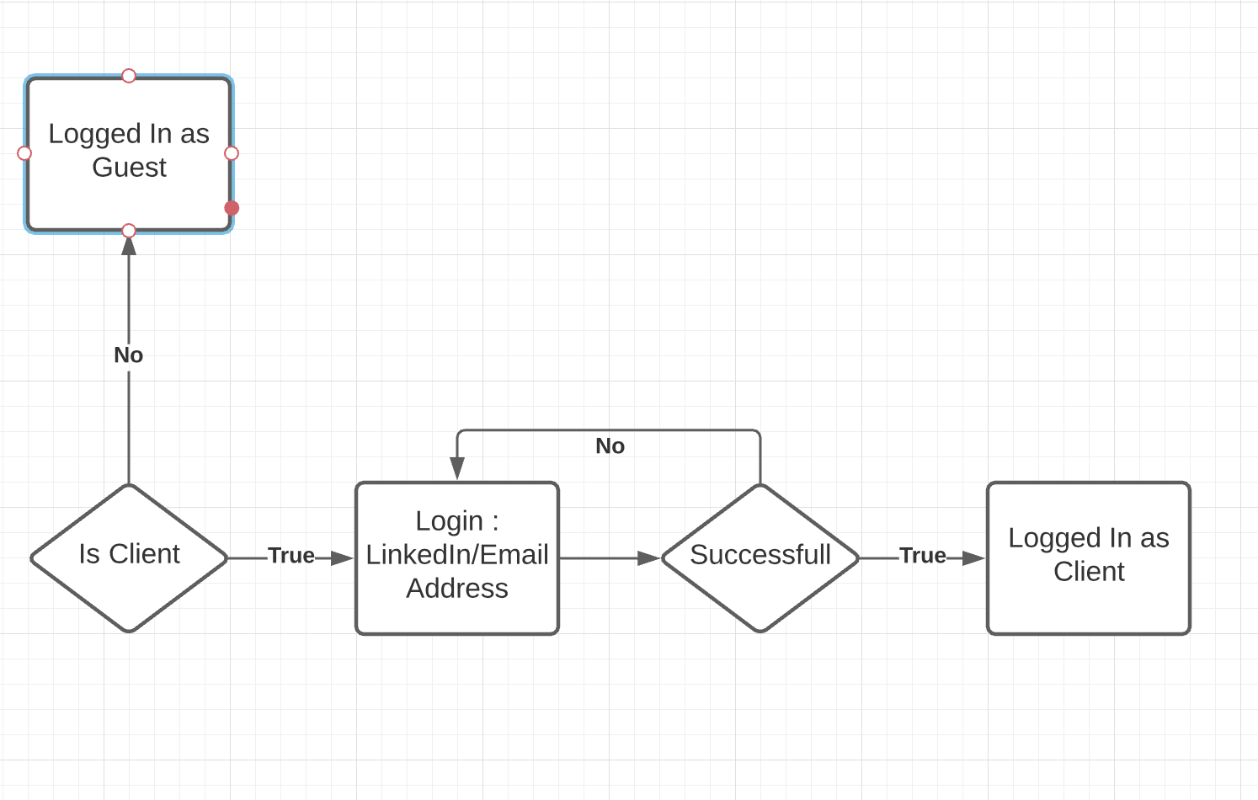

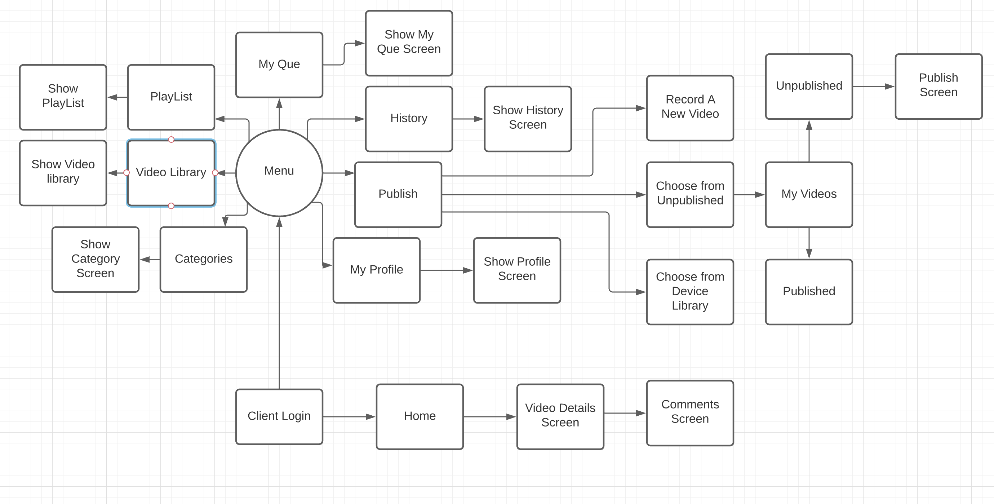

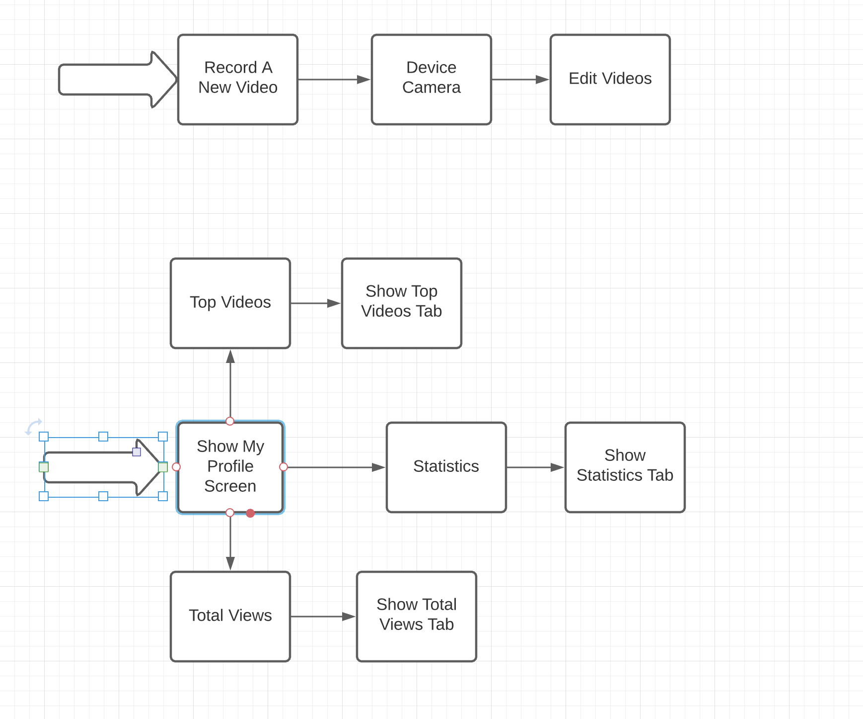
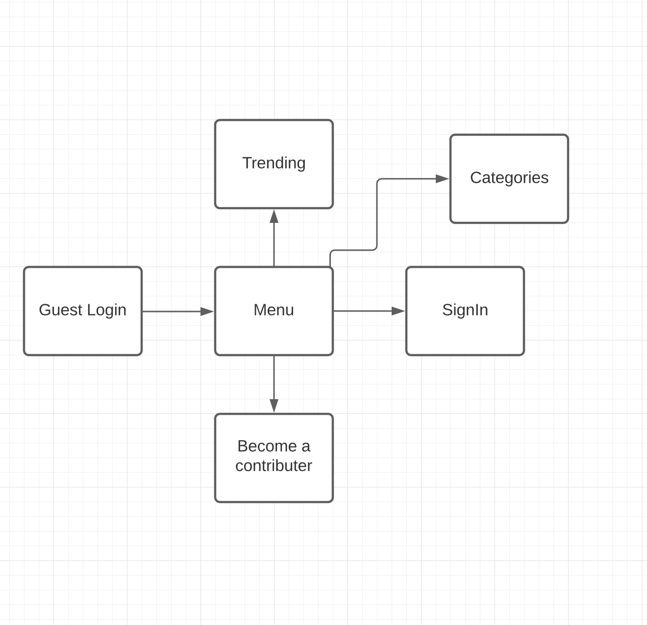

Component Architecture

Class Diagram:

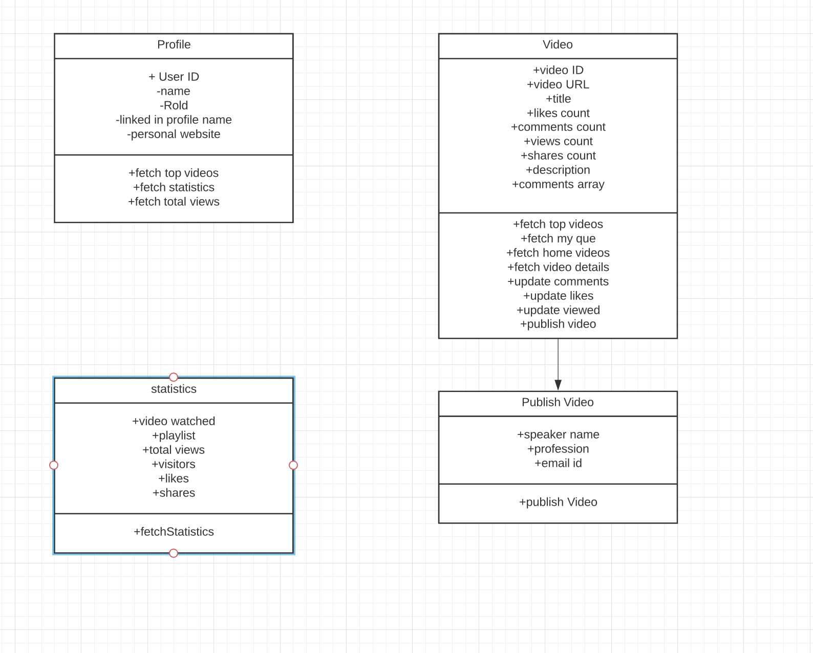

Bibliography

Reference

