**Introduction of Dataset**

I have download this dataset from Airbnb. It includes the Amsterdam ’s apartments.

**About the tables’ data:**

1. Listings:

* **id**
* **name** – Name of the apartment
* **host_id** – ID of the owner
* **host_name** – Name of the owner
* **neighbourhood_group** – Null Data
* **neighbourhood** – Location of the apartment
* **latitude**
* **longitude**
* **room_type**
* **price** –/night
* **minimum_nights**
* **number_of_reviews**
* **last_review**
* **reviews_per_month**
* **calculated_host_listings_count**
* **availability_365** – Availability of the year

1. Reviews:

* **listing_id**
* **date** – Date of the reviews

1. Neighbourhoods:

* **neighbourhood_group**
* **neighbourhood** – Location of the apartment

**Creating tables DB Schema / ER diagram:**

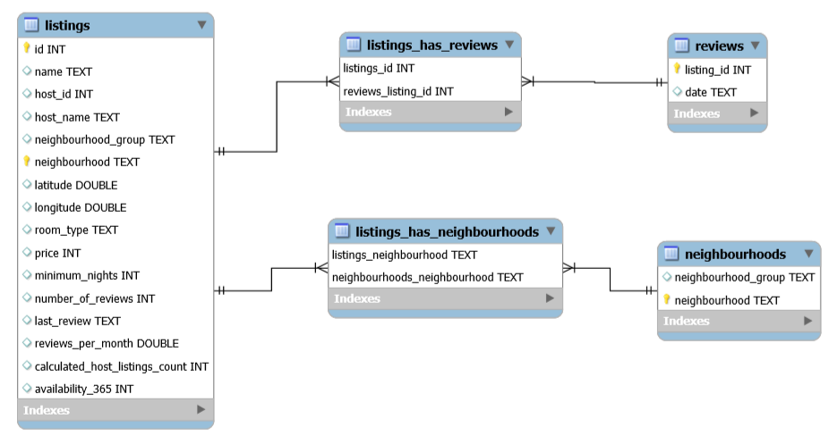

**Tasks:**

**What type of ’minimum nights’ were prefered based on the number of the reviews?**

**Code:**

SELECT

l.minimum_nights, COUNT(r.date) AS number_of_dates

FROM

listings AS l

JOIN

reviews AS r ON r.listing_id = l.id

GROUP BY l.minimum_nights

ORDER BY COUNT(r.date) DESC

LIMIT 10;

**Result:**

|  |  |  |
| --- | --- | --- |
| **Row number** | **minimum_nights** | **number_of_dates** |
| 1 | 2 | 197974 |
| 2 | 3 | 107932 |
| 3 | 1 | 104685 |
| 4 | 4 | 27720 |
| 5 | 5 | 11251 |
| 6 | 7 | 9434 |
| 7 | 6 | 3210 |
| 8 | 14 | 1056 |
| 9 | 10 | 1004 |
| 10 | 30 | 970 |

The most prefered minimum nights is the 2 nights section.

**What kind of ’room type’ was the most visited one?**

**Code:**

SELECT

l.room_type, COUNT(r.date) AS number_of_dates

FROM

listings AS l

JOIN

reviews AS r ON r.listing_id = l.id

GROUP BY l.room_type

ORDER BY COUNT(r.date) DESC

LIMIT 10;

**Result:**

|  |  |  |
| --- | --- | --- |
| **Row number** | **room_type** | **number_of_dates** |
| 1 | Entire home/apt | 233631 |
| 2 | Private room | 224881 |
| 3 | Hotel room | 7846 |
| 4 | Shared room | 2923 |

The most visited room type was the „Entire home/apt”.

**Avarage price based on the neighborhoods (with and without number of the minimum nights).**

**Code:**

SELECT

neighbourhood, avg(price) AS price_wo_nights

FROM

listings

GROUP BY neighbourhood

ORDER BY avg(price) DESC

LIMIT 1000;

SELECT

neighbourhood, avg(price)*minimum_nights AS price_w_nights

FROM

listings

GROUP BY neighbourhood

ORDER BY avg(price)*minimum_nights DESC

LIMIT 1000;

**Result:**

|  |  |  |
| --- | --- | --- |
| **Row number** | **neighbourhood** | **price_wo_nights** |
| 1 | IJburg - Zeeburgereiland | 701.5958 |
| 2 | Centrum-West | 187.1052 |
| 3 | Centrum-Oost | 179.6480 |
| 4 | Zuid | 175.6262 |
| 5 | De Pijp - Rivierenbuurt | 165.7068 |
| 6 | Oud-Noord | 165.5145 |
| 7 | De Baarsjes - Oud-West | 150.7600 |
| 8 | Westerpark | 149.1929 |
| 9 | Watergraafsmeer | 146.4568 |
| 10 | Oud-Oost | 144.6382 |
| 11 | Buitenveldert - Zuidas | 132.2296 |
| 12 | Oostelijk Havengebied - Indische Buurt | 132.1356 |
| 13 | Noord-Oost | 128.7093 |
| 14 | De Aker - Nieuw Sloten | 127.2661 |
| 15 | Bos en Lommer | 125.0697 |
| 16 | Noord-West | 124.9815 |
| 17 | Slotervaart | 116.8665 |
| 18 | Geuzenveld - Slotermeer | 113.1955 |
| 19 | Osdorp | 103.8476 |
| 20 | Bijlmer-Centrum | 97.7912 |
| 21 | Bijlmer-Oost | 92.6136 |
| 22 | Gaasperdam - Driemond | 88.4483 |

|  |  |  |
| --- | --- | --- |
| **Row number** | **neighbourhood** | **price_w_nights** |
| 1 | IJburg - Zeeburgereiland | 2305.50640953 |
| 2 | De Pijp - Rivierenbuurt | 684.04911195 |
| 3 | Centrum-Oost | 610.41695758 |
| 4 | Zuid | 601.11710140 |
| 5 | De Baarsjes - Oud-West | 559.45941104 |
| 6 | Centrum-West | 534.34822442 |
| 7 | Oud-Oost | 528.15450382 |
| 8 | Westerpark | 472.21395116 |
| 9 | Oud-Noord | 469.33127048 |
| 10 | Watergraafsmeer | 467.66324894 |
| 11 | Oostelijk Havengebied - Indische Buurt | 462.88204572 |
| 12 | Buitenveldert - Zuidas | 433.11937733 |
| 13 | Gaasperdam - Driemond | 412.50445894 |
| 14 | Noord-Oost | 409.37479864 |
| 15 | Bijlmer-Oost | 375.71668381 |
| 16 | Bos en Lommer | 368.92367433 |
| 17 | Slotervaart | 361.34973445 |
| 18 | Osdorp | 360.99410429 |
| 19 | Noord-West | 352.95696158 |
| 20 | De Aker - Nieuw Sloten | 340.93291803 |
| 21 | Geuzenveld - Slotermeer | 299.11444705 |
| 22 | Bijlmer-Centrum | 227.82127756 |

It is crystal-clean visible that, the „minimum of the nights” affect the final output, so we had better examine the avarage of the min. nights based on the neighborhood!

**Avarage min. nights based on the neighborhoods.**

**Code:**

SELECT

neighbourhood, avg(minimum_nights) AS avarage_minimum_nights

FROM

listings

GROUP BY neighbourhood

ORDER BY avg(minimum_nights) DESC

LIMIT 1000;

**Result:**

|  |  |  |
| --- | --- | --- |
| **Row number** | **neighbourhood** | **avarage_minimum_nights** |
| 1 | Gaasperdam - Driemond | 4.6638 |
| 2 | De Pijp - Rivierenbuurt | 4.1281 |
| 3 | Bijlmer-Oost | 4.0568 |
| 4 | De Baarsjes - Oud-West | 3.7109 |
| 5 | Oud-Oost | 3.6516 |
| 6 | Oostelijk Havengebied - Indische Buurt | 3.5031 |
| 7 | Osdorp | 3.4762 |
| 8 | Zuid | 3.4227 |
| 9 | Centrum-Oost | 3.3978 |
| 10 | IJburg - Zeeburgereiland | 3.2861 |
| 11 | Buitenveldert - Zuidas | 3.2755 |
| 12 | Watergraafsmeer | 3.1932 |
| 13 | Noord-Oost | 3.1806 |
| 14 | Westerpark | 3.1651 |
| 15 | Slotervaart | 3.0920 |
| 16 | Bos en Lommer | 2.9497 |
| 17 | Centrum-West | 2.8559 |
| 18 | Oud-Noord | 2.8356 |
| 19 | Noord-West | 2.8241 |
| 20 | De Aker - Nieuw Sloten | 2.6789 |
| 21 | Geuzenveld - Slotermeer | 2.6425 |
| 22 | Bijlmer-Centrum | 2.3297 |

As we can see, the number of min. nights can affect the final price based on the neighborhood.

**Final / Summarized Chart:**

|  |  |  |  |  |
| --- | --- | --- | --- | --- |
| Row number | neighbourhood | price_wo_nights | avarage_minimum_nights | price_w_nights |
| 1 | IJburg - Zeeburgereiland | 701.5958 | 3.2861 | 2305.51395838 |
| 5 | De Pijp - Rivierenbuurt | 165.7068 | 4.1281 | 684.05424108 |
| 3 | Centrum-Oost | 179.648 | 3.3978 | 610.4079744 |
| 4 | Zuid | 175.6262 | 3.4227 | 601.11579474 |
| 7 | De Baarsjes - Oud-West | 150.76 | 3.7109 | 559.455284 |
| 2 | Centrum-West | 187.1052 | 2.8559 | 534.35374068 |
| 10 | Oud-Oost | 144.6382 | 3.6516 | 528.16085112 |
| 8 | Westerpark | 149.1929 | 3.1651 | 472.21044779 |
| 6 | Oud-Noord | 165.5145 | 2.8356 | 469.3329162 |
| 9 | Watergraafsmeer | 146.4568 | 3.1932 | 467.66585376 |
| 12 | Oostelijk Havengebied - Indische Buurt | 132.1356 | 3.5031 | 462.88422036 |
| 11 | Buitenveldert - Zuidas | 132.2296 | 3.2755 | 433.1180548 |
| 22 | Gaasperdam - Driemond | 88.4483 | 4.6638 | 412.50518154 |
| 13 | Noord-Oost | 128.7093 | 3.1806 | 409.37279958 |
| 21 | Bijlmer-Oost | 92.6136 | 4.0568 | 375.71485248 |
| 15 | Bos en Lommer | 125.0697 | 2.9497 | 368.91809409 |
| 17 | Slotervaart | 116.8665 | 3.092 | 361.351218 |
| 19 | Osdorp | 103.8476 | 3.4762 | 360.99502712 |
| 16 | Noord-West | 124.9815 | 2.8241 | 352.96025415 |
| 14 | De Aker - Nieuw Sloten | 127.2661 | 2.6789 | 340.93315529 |
| 18 | Geuzenveld - Slotermeer | 113.1955 | 2.6425 | 299.11910875 |
| 20 | Bijlmer-Centrum | 97.7912 | 2.3297 | 227.82415864 |