**Лабораторна робота 2_3**

Тема: Web programming

«HTML5. CSS3»

Завдання:

Create information page about a history of windows (variant of pages given below) by using new features of html5 and css3 (like in windows-history-2013.html page). Your page must contain: header, footer, video and figure containers from HTML5 and animation, transition effects, shadows (box and text) and define new fonts (for main text and titles) from CSS3.

1. Page - 2001-2005;

Розв’язок:

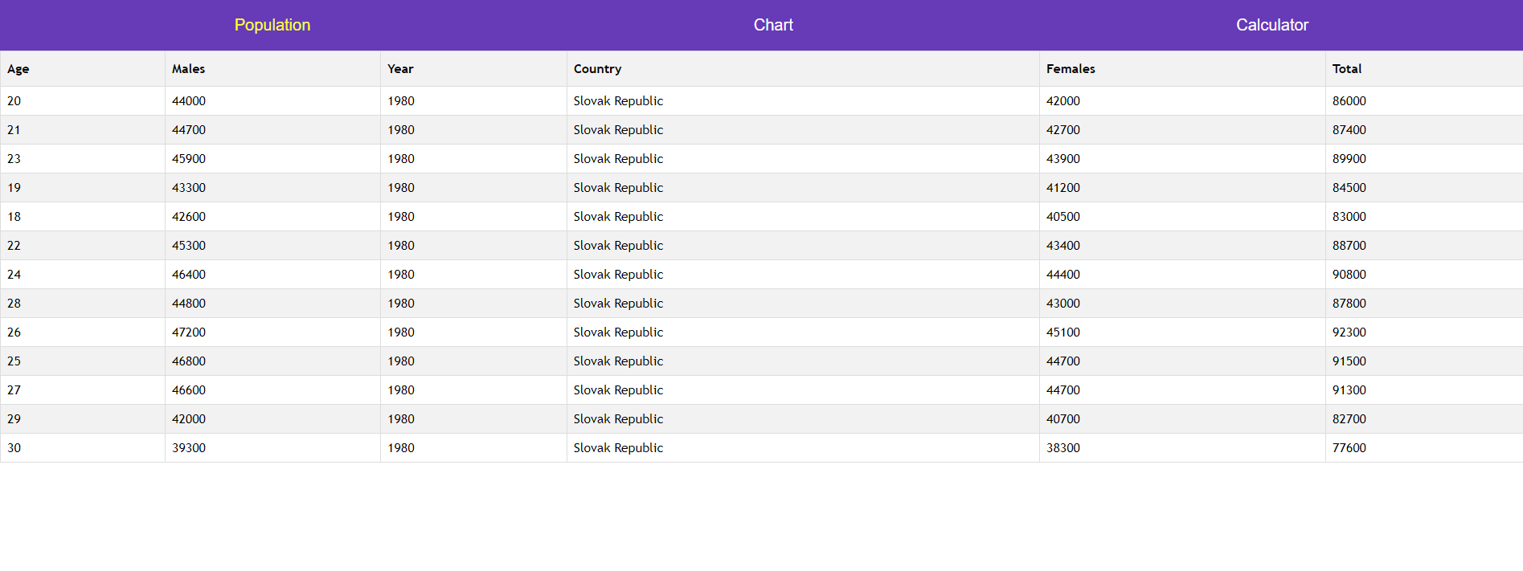

**TEST QUESTIONS**

1. **What new structural elements are show in HTML5?**
   1. **<main>, <section>, <article>, <header>, <footer>, <aside>, <nav> and <figure>;**
   2. <div>, <section>, <article>, <header>, <footer>, <aside>, <navbar> and <figure>;
   3. <main>, <article>, <footer>, <aside>, <nav> and <figure>;
   4. No right answer.
2. **Choose right syntax of animation in CSS3.**
   1. animation: <animation> [<animation>]*
   2. **animation: [animation-name] [animation-duration] [animation-timing-function] [animation-delay];**
   3. animation: h-shadow v-shadow blur-radius color|none|initial|inherit;
   4. No right answer.
3. **Select a tag that cannot be used in HTML5.**
   1. <video>;
   2. <hgroup>;
   3. <figure>;
   4. **No right answer.**