- Open Komplexiti (https://www.korovatron.co.uk/komplexiti/)
- Add the constant $a=1$ to the panel.
- Add the expression $a+\overline{a}$ to a second card.
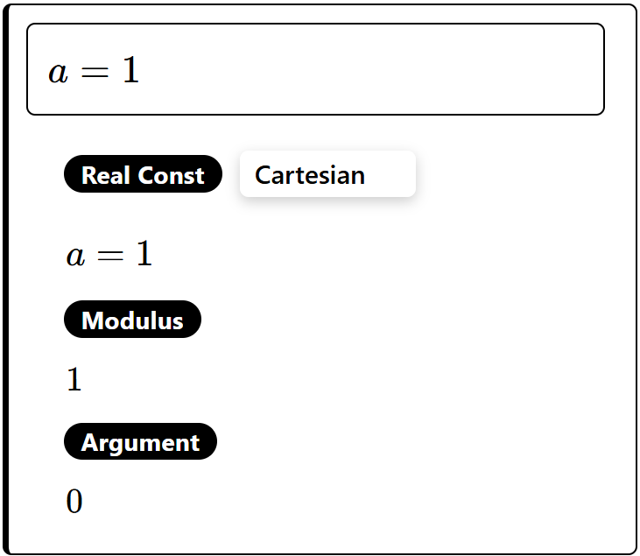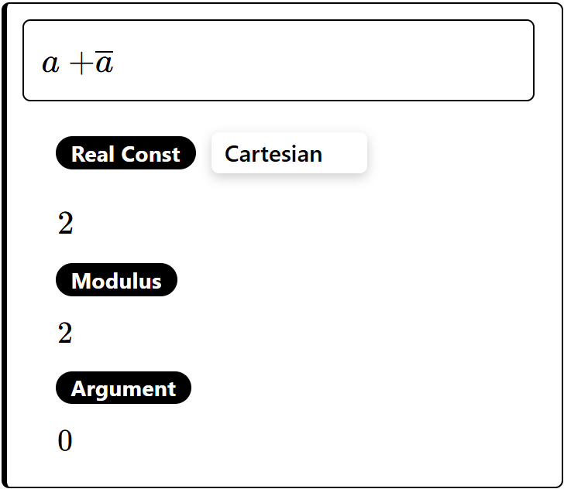
Type conj(a) to enter $\overline{a}$

For each of the following expressions use the mouse to drag the point a around the Argand diagram and observe what happens.
$$a+\overline{a}$$  Describe how $a+\overline{a}$ behaves as you drag the point $a$ around the Argand diagram.  Can you prove what you have discovered? | $$a-\overline{a}$$  Describe how $a-\overline{a}$ behaves as you drag the point $a$ around the Argand diagram.  Can you prove what you have discovered?
$$a\overline{a}$$  Describe how $a\overline{a}$ behaves as you drag the point $a$ around the Argand diagram.  Can you prove what you have discovered? | $$\frac{a}{\overline{a}}$$  Describe how $\frac{a}{\overline{a}}$ behaves as you drag the point $a$ around the Argand diagram.  Can you prove what you have discovered?

