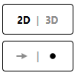
- Open Vectorama (www.korovatron.co.uk/vectorama)
- Switch to 2D, and set the vector display mode to POINT
- Click the +ADD button and add the UNIT SQUARE
from the VECTOR PRESETS.
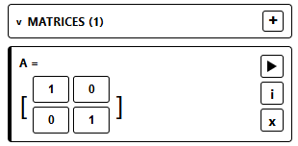
ADD A MATRIX
VIEW MATRIX INFORMATION
APPLY TRANSFORMATION
EDIT ELEMENTS

Find a 2x2 matrix that represents each of the following transformations. You may need to reset the UNIT SQUARE between transformations, by adding a new one.
Rotation 90⁰ anticlockwise about the origin | Reflection in the line x = 0 | Enlargement, scale factor 2 about the origin | Rotation 180⁰ anticlockwise about the origin
Reflection in the line y = 0 | Enlargement, scale factor 3 about the origin | Rotation 270⁰ anticlockwise about the origin | Reflection in the line y = x
Enlargement, scale factor 0.5 about the origin | Reflection in the line y = -x | Enlargement, scale factor -2 about the origin | Rotation 90⁰ clockwise about the origin

