In this activity you will explore how different vectors behave under transformations. Use Vectorama to observe patterns and describe what you notice.
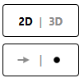
- Open Vectorama (www.korovatron.co.uk/vectorama)
- Select 2D and POINT mode
Exercise 1

- Add a 2D matrix that reflects in the x-axis.
- Add the following vectors: (2, -1), (2, 1), (2,3), (2,7)
- Apply the matrix a few times.

Describe what happens

Where does each point on the line x = 2 get mapped to under this transformation?
What might this line be called?

Exercise 2

- Change the vector display mode to ARROW
- Apply the same matrix used in exercise 1 to the same vectors.

Compare what you see now with what you observed in Exercise 1.

Exercise 3

- Switch to 3D and keep the vector display mode set to ARROW
- Add the following vectors (1, 0, 0), (0, 1, 0), (0, 0, 1), (2, 0, 0), (0, 2, 0) and (0, 0, 2).
- Add the matrix $\left(\begin{matrix}1 & 0 & 0 \\ 0 & 2 & 0 \\ 0 & 0 & 3\end{matrix}\right)$ and apply it a couple of times.

Describe fully what happens to each vector, considering direction and magnitude and orientation. Does the vector stay on the same line through the origin?

- Now delete the vectors, and replace with (2, 0, -2), (0, 4, 2) and (4, -2, -3).
- Apply the matrix.

Explain how these vectors behave differently from the first set.

Exercise 4

- Switch to 2D and keep the vector display mode set to ARROW
- Add the following vectors (1, 1), (-1, 2), (1, -2) and (-2, -2)
- Add the matrix $\left(\begin{matrix}4 & 1 \\ 2 & 3\end{matrix}\right)$ and apply it a couple of times.

Describe fully what happens to each vector, considering direction and magnitude and orientation.

- Now delete the vectors, and replace with (2, 1), (0, 2) and (-3, -1)
- Apply the matrix.

Explain how these vectors behave differently from the first set.

Exercise 5

- Using the matrix from Exercise 3, click the small blue [i] button to open the matrix information panel.
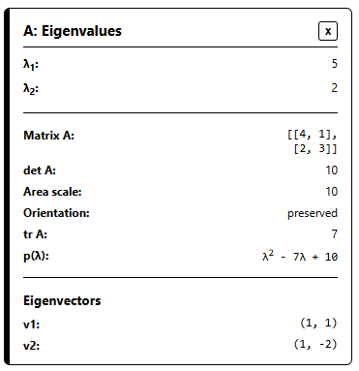
In this panel you will see things called Eigenvalues and Eigenvectors.
Use what you observed in the previous exercises to explain what these quantities must represent.

- Open the information panel for the other matrices in this exercise, to confirm your answers.

Exercise 6

- At the bottom of the matrix information panel, you can display Eigenspaces for the matrix.
How do the eigenspaces relate to the directions you observed earlier?

