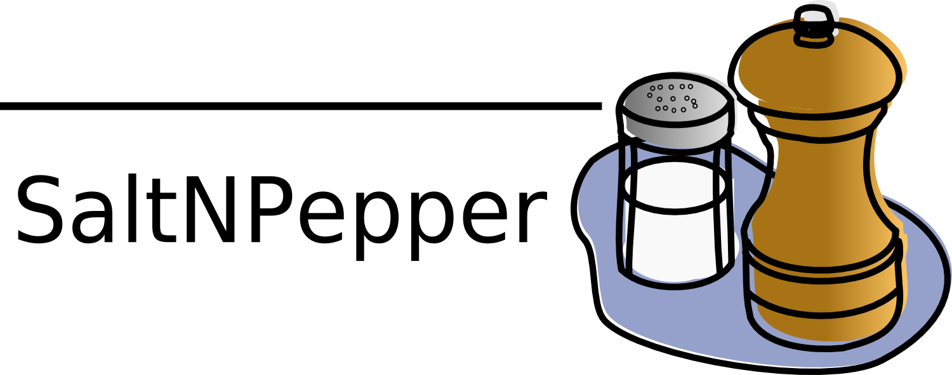
SampleModules
- the manual -

Foreword
The intention of this document is first to give a guide to the user of how to use the here mentioned pepper modules and how to utilize a mapping performed by them. Second this document shall give a closer view in the details of such a mapping in a declarative way, to give the user a chance to understand how specific data will be mapped by the presented pepper modules.

Inhaltsverzeichnis
Foreword 1

This project contains the pepper modules listed in Table 1. These modules can be identified via the coordinated also given in Table 1. You can use these coordinates in a pepper workflow description file to identify the modules in a conversion process. A description of how to model a workfloe description file can be found under https://korpling.german.hu-berlin.de/saltnpepper/.

Name of pepper modules | Type of pepper module | Formats in case of type is importer or exporter
Module01 | importer | - formats -
Module02 | manipulator | –
Module03 | Exporter | - formats -
Table 1: the pepper modules contained in this project

Pepper workflow description
In general a pepper conversion consists of three phases, 1) the import phase, 2) the manipulation phase and 3) the export phase. Each phase consists of a set of steps represented by the use of one pepper module. Phase 1 and 3 must contain between 1..n steps and phase 2 must contain between 0..n steps. To identify a pepper module to realize a step, you have have to declare that module by triggering its name. Fehler: Referenz nicht gefunden shows an excerpt of a pepper workflow description file using all types of modules.

Example 1: sample input file content
<?xml version="1.0" encoding="UTF-8"?>
<pepperParams:PepperParams xmlns:xmi="http://www.omg.org/XMI" xmlns:pepperParams="de.hu_berlin.german.korpling.saltnpepper.pepper.pepperParams" xmi:version="2.0">
<pepperJobParams id="1">
<importerParams moduleName="ImporterName" sourcePath="..."/>
<!-- ... -->
<moduleParams moduleName="ManipulatorName"/>
<!-- ... -->
<exporterParams moduleName="ExporterName" targetPath="..."/>
</pepperJobParams>
</pepperParams:PepperParams>
In case of the pepper module, you want to use is an importer or an exporter, you can also specify the module by declaring the format name and the format version of the corpus you want to im- or export. The pepper framework will search for an im- or export module handling this format. Example 2 shows the specification of an importer or exporter to be used, by mentioning the format name and format version of the corpus.

Example 2: sample input file content
<?xml version="1.0" encoding="UTF-8"?>
<pepperParams:PepperParams xmlns:xmi="http://www.omg.org/XMI" xmlns:pepperParams="de.hu_berlin.german.korpling.saltnpepper.pepper.pepperParams" xmi:version="2.0">
<pepperJobParams id="1">
<importerParams formatName="FORMAT_NAME"
formatVersion="FORMAT_VERSION"
SourcePath="..."/>
<!-- ... -->
<exporterParams formatName="FORMAT_NAME"
formatVersion="FORMAT_VERSION"
targetPath="..."/>
</pepperJobParams>
</pepperParams:PepperParams>
Please note that, the value of attribute 'sourcePath' and 'targetPath' has to follow the URI notation (see XXX). For instance for a relative path and:
for an absolute path:
file://../format1/corpus1/
A single step can be parameterized by passing a special parameter file to the corresponding pepper module. This can be done with the attribute 'specialParams' in the workflow description file. The 'specialParams' attribute can be attached to the element 'importerParams', 'exporterParams' and 'moduleParams' as shown in Example 3.
file:/C:/format1/corpus1/

Example 3: sample input file content
<?xml version="1.0" encoding="UTF-8"?>
<pepperParams:PepperParams xmlns:xmi="http://www.omg.org/XMI" xmlns:pepperParams="de.hu_berlin.german.korpling.saltnpepper.pepper.pepperParams" xmi:version="2.0">
<pepperJobParams id="1">
<importerParams moduleName="..."
sourcePath="..."
specialParams="PATH_TO_PARAMETER"/>
<!-- ... -->
<moduleParams moduleName="..."
specialParams="PATH_TO_PARAMETER"/>
<!-- ... -->
<exporterParams moduleName="ExporterName"
targetPath="..."
specialParams="PATH_TO_PARAMETER"/>
</pepperJobParams>
</pepperParams:PepperParams>
Note, that even the value of 'specialParams' has to follow the URI notation.

Module01
The pepper module Module01 imports data coming from format XXX to a salt model.

Utilize mapping by properties

Description of mapping

Module01

Module01

