**Tomato Leaf Disease Detection**

## AN END-SEMESTER PROJECT REPORT ON THE SUBJECT OF ROBOTIC OPERATING SYSTEMS AND ROBOT SIMULATION

***Submitted to***

## Amrita Vishwa Vidyapeetham

***in partial fulfillment for the award of the degree of***

## BACHELOR OF TECHNOLOGY IN COMPUTER SCIENCE ENGINEERING (AIE)

***By***

**name**

# (CH.EN.U4AIE2111x)

***Submitted to***

**DR. GOLAK BIHARI MAHANTA**



# AMRITA VISHWA VIDYAPEETHAM AMRITA SCHOOL OF COMPUTING

# CHENNAI – 601103

## May 2023

## 

## PROJECT GROUP LIST

|  |  |
| --- | --- |
| **Name** | **Registration Number** |
| Aparna S | CH.EN.U4AIE21107 |
| G V Rohan | CH.EN.U4AIE21113 |
| Harshitha M | CH.EN.U4AIE21115 |
| Korrayi Saiteja | CH.EN.U4AIE21122 |
| M Sravani | CH.EN.U4AIE21125 |



**BONAFIDE CERTIFICATE**

Certified that this project report **“ Tomato Leaf Disease Prediction”** is the bonafide work of **Name** who carried out the project work under my supervision towards his completion of the end semester project for the subject “ROBOT OPERATING SYSTEMS AND ROBOT SIMULATIONS (21AIE213)”.

|  |
| --- |
| **SIGNATURE** |
| **Dr. Golak Bihari Mahanta**  **Course Instructor**  **Assistant Professor (Sr. Gr)**  **Dept. of Mechanical Engineering Amrita School of Engineering, Amrita Vishwa Vidyapeetham, Chennai** |

## ABSTRACT

The agricultural sector plays an important role in the modern era. The main crops such as tomatoes, wheat, sugar, potatoes, etc are being affected by n number of diseases. Even though every plant has the potential to get affected by plant diseases this has become a major drawback in the agricultural sector even if pesticides are given for the infected plant. Therefore, disease prediction plays a crucial role in the prediction of plant diseases especially if the disease is known. As per our research previous papers they achieved up to 87% accuracy. Disease prediction is quite difficult because we need to understand the similar pattern of the disease.

In this paper, we implement a robot to navigate the agricultural field and monitor the health of the tomato leaves moreover, we implement disease prediction using thousands of image datasets of tomato leaves through Deep learning techniques CNN, Stochastic boosting, and SVM classifier to achieve the best accuracy rate, and percentage of the disease infected plant. We will also provide a Literature survey of nearly 50-60 disease predictions of vegetables, datasets used, and through which deep learning technique is implemented.

**Keywords:** Neural Networks, deep learning, disease prediction, Tomato leaf detection, Navigation

**TABLE OF CONTENTS**

|  |  |  |  |
| --- | --- | --- | --- |
| **CHAPTER NO.** | **TITLE** | | **PAGE NO.** |
|  | **Abstract** | | 4 |
|  | **List of Tables** | | 7 |
|  | **List of Figures** | | 8 |
| **1** | **INTRODUCTION** | | 9 |
|  | 1.1 | Background | 9 |
|  | 1.2 | Research Motivation | 9-10 |
|  | 1.3 | Outline of the Report | 11 |
| **2** | **LITERATURE REVIEW** | | 12 |
|  | 2.1 | Overview | 12-14 |
|  | 2.2 | Key Findings | 14-16 |
|  | 2.3 | Research Gap | 17 |
| **3** | **PROBLEM STATEMENT AND METHODOLOGY** | | 18 |

|  |  |  |  |  |
| --- | --- | --- | --- | --- |
|  | 3.1 | Overview | | 18 |
|  | 3.2 | Problem Statement | | 18 |
|  | 3.3 | Objective | | 18 |
|  | 3.4 | Methodology | | 18 |
| **4** | **RESULTS AND DISCUSSIONS** | | | 20 |
|  | 4.1 | Results | | 20 |
|  | 4.2 | Discussion | | 20 |
| **5** | **CONCLUSION AND FUTURE SCOPE** | | | 21 |
|  | 5.1 | | Conclusion | 21 |
|  | 5.2 | | Future scope | 21 |
|  | **REFERENCES** | | | 22-23 |

**LIST OF TABLES**

|  |  |  |
| --- | --- | --- |
| **TABLE NO.** | **TITLE** | **PAGE NO.** |
| 2.2 | Key Findings | 14-16 |
| 4.1 | Results | 20 |

**LIST OF FIGURES**

|  |  |  |
| --- | --- | --- |
| **FIGURE NO.** | **TITLE** | **PAGE NO.** |
| 4.1 | Conclusion | 21 |
| 4.1 | Conclusion | 21 |

**CHAPTER 1**

**INTRODUCTION**

* 1. **BACKGROUND**

Crop diseases are the key point of food security. In this project, we implement Robot simulation where the robot navigates around the agricultural field and detects the percentage of the disease affected. In this era, modern technologies have the capability to produce enough food to meet the needs of 8 billion people. The first crucial step in identifying the disease is efficient disease management. There is another approach for disease prediction is the traditional approach which is done by collecting samples from the local plant clinics.Moreover, it is very important to design a method that allows the farmers to quickly diagnose the disease using deep learning methods, with the best accuracy rate and better prediction.

Tomato leaf disease prediction is a field that utilizes various techniques and tools to forecast and identify diseases affecting tomato plants based on the appearance of their leaves. The health and vigor of tomato plants can be significantly impacted by diseases caused by fungi, bacteria, viruses, or other pathogens. Detecting these diseases at an early stage is crucial for implementing appropriate control measures and minimizing crop losses.

* 1. **RESEARCH MOTIVATION**

The research motivation behind tomato leaf disease prediction stems from the need to address the significant economic and agricultural challenges posed by plant diseases. Tomato plants, being widely cultivated and economically important crops, are susceptible to various diseases that can cause substantial yield losses and decrease the overall quality of the produce. Early detection and timely management of these diseases are crucial to minimizing the negative impacts on crop productivity and profitability.

1. **Disease Management:** Effective disease management strategies rely on early detection and accurate diagnosis. By developing robust prediction models for tomato leaf diseases, farmers and plant pathologists can quickly identify diseased plants, implement appropriate control measures, and prevent the further spread of diseases. This can significantly reduce yield losses, minimize the use of chemical treatments, and improve the overall sustainability of tomato cultivation.
2. **Precision Agriculture:** Precision agriculture aims to optimize crop production by using technology and data-driven approaches. By integrating disease prediction models into precision agriculture systems, farmers can monitor and manage diseases at a more localized and targeted level. This enables them to allocate resources more efficiently and apply interventions only when and where needed.
3. **Early Warning Systems:** Developing robust disease prediction models can contribute to the establishment of early warning systems for tomato leaf diseases. These systems can utilize weather data, environmental conditions, and historical disease patterns to provide timely alerts to farmers about the potential risks of disease outbreaks.
4. **Sustainable Agriculture:** Sustainable agricultural practices aim to minimize the environmental impact of crop production while ensuring long-term productivity. By accurately predicting tomato leaf diseases, farmers can adopt more targeted and environmentally friendly disease management strategies. This includes using biological control agents, optimizing cultural practices, and reducing the reliance on chemical pesticides.

Overall, research in tomato leaf disease prediction is driven by the desire to enhance disease management, optimize resource allocation, establish early warning systems, and promote sustainable agricultural practices. By developing accurate and reliable prediction models, researchers aim to assist farmers in making informed decisions and safeguarding tomato crops from the damaging effects of diseases.

**a. OUTLINE OF THE REPORT**

The structure of this thesis is summarized below.

**Chapter 1** (Introduction) briefly explains the Detection of tomato leaf diseases.

**Chapter 2** (Literature Review) deals with the details of the past literature review of Tomato Leaf Detection using deep learning algorithms.

**Chapter 3** (Problem Statements and Methodology) discusses the research methodology. It provides a brief idea about the steps that should be carried out during the research.

**Chapter 4** (Results and Discussion) deals with workflow involved in the Detection of Tomato leaf Diseases.

**Chapter 5** (Conclusion and Future Scope) draws the conclusion remarks against the stated research objective and future research scope of work

**CHAPTER 2**

**LITERATURE REVIEW**

* 1. **OVERVIEW**

Tomato leaf disease detection involves the identification and diagnosis of diseases affecting tomato plants based on the visual symptoms exhibited by their leaves. It is an essential aspect of plant pathology and plays a crucial role in effective disease management. Here is an overview of tomato leaf disease detection:

The paper “Tomato leaf disease detection using convolutional neural networks” was published in the year 2018. This paper adopts a slight variation of the convolutional neural network model called LeNet to detect and identify diseases in tomato leaves. The main aim of the proposed work is to find a solution to the problem of tomato leaf disease detection using the simplest approach while making use of monimal computing resources to achieve results comparable to state of the art techniques. Neural Network models employ automatic feature extraction to aid in the classification of the input image into respective disease classes**.[1]**

The study described in this paper consists of a method that applies gabor wavelet transform technique to extract features related to image of tomato leaf in conjuction with using Support Vector Machine with alternate kernel functions in order to detect and identify type of disease that infects tomato plant. The proposed approach can lead to tighter connection between agriculture specialists and computer system**.[2]**

This paper provides an overall review of recent work performed in the field of tomato leaf disease identification using image processing, machine learning, and deep learning approaches. And also discuss both public and private datasets available to detect tomato leaf disease**.[3]**

Overall, the paper "Deep learning precision farming Tomato leaf detection by transfer learning" contributes to the field of precision agriculture by offering a practical and efficient solution for tomato leaf detection. The use of transfer learning demonstrates the potential of leveraging pre-trained models to address specific agricultural tasks, and the experimental results validate the effectiveness of the proposed approach. This research has significant implications for the automation and optimization of tomato farming processes, ultimately leading to increased productivity and reduced resource waste**.[4]**

The paper titled "Image-Based Tomato Leaves Detection Using Deep Learning Techniques" presents a comprehensive study on the application of deep learning methods for the detection of tomato leaves in images. The authors address an important problem in agricultural automation, as accurate detection of plant leaves is crucial for various tasks such as disease diagnosis and yield estimation**.[5]**

The paper focuses on the application of deep learning techniques for the detection of leaf diseases in tomato plants. In this review, I will provide a short summary of the paper and highlight its key contributions.The objective of the paper is to develop an automated system for accurately identifying and classifying various diseases affecting tomato plants based on the analysis of leaf images. The authors propose the use of a Convolutional Neural Network (CNN), a popular deep learning architecture known for its effectiveness in image recognition tasks**.[6]**

Disease detection in tomato plants is crucial for timely intervention and effective management of plant diseases, which can significantly impact crop yield and quality. Various techniques have been employed for disease detection, including computer vision-based approaches.The use of deep learning models, such as convolutional neural networks (CNNs), has gained popularity in plant disease detection systems due to their ability to extract meaningful features from images. The term "FC-SNDPN" mentioned in the paper's title might refer to a specific model or architecture designed for this purpose, but without access to the paper, it's challenging to provide further details**.[7]**

The paper starts by addressing the importance of early disease detection in tomato plants, as diseases can significantly impact crop yield and quality. It emphasizes the need for accurate and efficient methods to detect and classify tomato leaf diseases to enable timely intervention and prevent widespread damage. The authors propose a solution based on pretrained convolutional neural networks (CNNs). They leverage the power of transfer learning by fine-tuning a preexisting CNN architecture, which is already trained on a large dataset (such as ImageNet) and has learned general image features. This approach is beneficial because it reduces the need for large annotated datasets, saves computational resources, and accelerates the training process**. [8]**

The authors describe the dataset used for training and evaluation, which consists of a large collection of tomato leaf images with various disease classes. They preprocess the images and split the dataset into training and testing sets to train and assess the performance of the AlexNet CNN model**.[9]**

The paper begins by discussing the importance of early disease detection in tomato plants, as it can help prevent significant yield losses and improve overall crop management. They highlight the potential of using computer vision and deep learning algorithms to automate the detection process**.[10]**

The paper begins by emphasizing the economic significance of tomato crops and the detrimental impact of leaf diseases on their yield and quality. It highlights the importance of timely and accurate disease diagnosis to enable effective disease management strategies. The review encompasses both traditional and modern approaches employed in disease diagnosis and severity measurement, focusing on image analysis techniques and machine learning algorithms**.[11]**

The paper introduces a smart mobile application that employs a CNN-based model for tomato leaf detection. The CNN model is trained on a large dataset of tomato leaf images to learn the distinguishing patterns and features associated with different diseases. The authors describe the architecture and configuration of the CNN, including the number of layers, filter sizes, and activation functions used**.[12]**

The authors first provide a comprehensive overview of the challenges faced in traditional tomato disease detection methods and highlight the potential of deep learning approaches in addressing these limitations. They then explain the concept of transfer learning, which involves utilizing pre-trained models trained on large-scale image datasets as a starting point for training a new model on a specific task**.[13]**

* 1. **KEY FINDINGS**

|  |  |  |  |
| --- | --- | --- | --- |
| **S.NO** | **TITLE** | **KEY FINDING** | **REFERENCE** |
| 1. | Tomato leaf disease detection using Convolutional Neural Networks | This paper focus on the detection of tomato leaf disease using simplest methods. | [1] |
| 2. | Tomato leaf detection method using support vector machines | This includes support vector machine with several kernel functions was used to test the capability of the method. | [2] |
| 3. | Artificial Intelligence in Tomato Leaf Disease Detection: A Comprehensive Review and Discussion | This article presents recent work on the field of tomato leaf research | [3] |
| 4. | Deep learning precision farming Tomato leaf detection by transfer learning | This article was published in 2019. The page is divided into 3 different types as good, fair and bad. It will give 99 percent accuracy. | [4] |
| 5. | Image based tomato leaves detection using deep learning techniques | This article was published in the year 2018. In this paper they trained convolutional neural networks to detect 5 diseases. | [5] |
| 6. | Tomato Leaf Disease Detection using Convolution Neural Network | This paper was published in the year 2019. The classification  accuracy varies from 76% to 100% with respect to classes and average accuracy of the proposed model is 91.2%. | [6] |
| 7. | Tomato leaf disease detection system based on FC-SNDPN | This paper was published on 2022.  VGG-16 model is used to segment the target crop image. The accuracy of this project is 97.59 percent. | [7] |
| 8. | Optimizing Pretrained Convolutional Neural Networks for Tomato Leaf Disease Detection | Combination of learning algorithms and various splits of training and testing and reported an accuracy of 99.35% | [8] |
| 9. | Tomato leaf disease detection and classification using AlexNet Convolutional Neural Network. | This paper was published on 2021. In this article authors implemented ALexNet on android platform to predict the disease. The overall accuracy was 98 percent. | [9] |
| 10. | Image-Based Tomato Leaves Diseases Detection Using Deep  Learning | Accuracy of 99.84% on a held-out test set, and second best model (Gray-Scale) achieved an accuracy of 95.54% | [10] |
| 11. | Tomato leaf disease diagnosis and severity measurement | This paper was proposed was proposed on July 2020. This article analysed the performance of different feature extraction including colour, texture and shape | [11] |
| 12. | Smart mobile application to recognize the tomato leaf detection using convolutional network | This paper was published in the year 2019. This paper uses tomato leaves dataset and used in smart mobile system to perform tomato disease diagnostics. | [12] |
| 13. | Deep Learning Precision Farming: Tomato Leaf Disease Detection by Transfer Learning | 99% accuracy is achieved when training percentage is increased to 85% | [13] |

**Table 2.2**

* 1. **RESEARCH GAP**
     + - 1. **Limited and Imbalanced Datasets:** Deep learning models require large and diverse datasets for effective training. However, obtaining a comprehensive dataset for tomato leaf diseases that covers a wide range of pathogens, environmental conditions, and disease severities can be challenging.
         2. **Limited Disease Coverage:** Many existing disease prediction models focus on specific diseases or groups of diseases, neglecting the comprehensive coverage of the wide range of tomato leaf diseases. There is a need for more inclusive models that can accurately predict a broader spectrum of diseases, including emerging or less common pathogens that can cause significant damage to tomato crops.
         3. **Lack of Interpretable Models:** Deep learning models, such as convolutional neural networks (CNNs), are often considered as black-box models, meaning they lack interpretability. Understanding the reasoning behind the predictions made by these models is crucial for gaining trust and acceptance from end-users, such as farmers or plant pathologists. Developing techniques to interpret and explain the decisions made by deep learning models in the context of tomato leaf disease prediction is an important research direction.
         4. **Transferability and Generalization:** Deep learning models trained on one dataset or region may not generalize well to different locations or growing conditions. Tomato leaf diseases can exhibit variations across different regions, climates, and tomato varieties. Developing transferable models that can adapt to diverse environments and accurately predict diseases in unseen datasets is a significant research challenge.
         5. **Integration of Management Recommendations:** Disease prediction models often focus on identifying the presence or absence of diseases but provide limited guidance on appropriate management strategies. Integrating actionable management recommendations into prediction models can help farmers make informed decisions and implement effective disease control measures.

**CHAPTER 3**

**PROBLEM STATEMENT AND METHODOLOGY**

* 1. **OVERVIEW**

Tomato disease prediction involves the development of models and techniques to forecast and predict the occurrence and severity of diseases affecting tomato plants. It aims to provide early detection, enable timely intervention, and enhance disease management strategies.

In this project, we are developing a method for farmers that makes the prediction of tomato leaf disease quick and easy with accurate results. This model predicts the tomato leaf diseases such as Late blight, loaf mold, bacterial spot, and early bright. It also predicts a healthy tomato leaf. The accuracy of the model 90-100% varies with the Deep learning algorithm used. Deep learning models include Convolutional Neural Network (CNN), Support Vector Machine classifier, VGG with XGBoost (Hybrid model), Resnet, and Stochastic boosting. Image datasets of tomato leaf diseases are retrieved from Kaggle, the largest resource for retrieving the datasets.

* 1. **PROBLEM STATEMENT**

Among all the vegetables tomato has the highest demand in the world. Diseases affect the health and growth of the plant. Hence, it is very important to produce in vast amounts to increase the rate of production and to ensure the quality of the tomato. Therefore, in this project, we present tomato leaf disease prediction to predict the health of the tomato leaf.

* 1. **OBJECTIVES**
* The main aim of this project is to develop a model for the prediction of tomato leaf disease using deep learning algorithms.
* To implement deep learning algorithms like Convolutional Neural Networks (CNN), Support Vector Machine (SVM), Stochastic Gradient boosting, Resnet, and VGG with XGBoost (Hybrid model).
* This system predicts the diseases of tomato leaf-like Tomato_Bacterial_spot, early_blight, late_blight, and leaf_mold.
* It also monitors the health of the tomato leaf.
  1. **METHODOLOGY**
* **Data collection**

The dataset was collected from the Kaggle website which is the largest resource for downloading the datasets. The link to the dataset is <https://www.kaggle.com/code/shakib23/tomato-leaf-disease-detection>

* **Data preprocessing**

The collected tomato leaf image datasets are processed to achieve the best accuracy rate and for better performance of the model, to analyze different types of tomato leaf diseases.

* **Train and Test**

The model was trained using an existing Deep learning algorithm for image classification. The image dataset is typically split into training and testing sets. Usually, training and testing were usually done in a 70% - 30% ratio.

* **Apply classification**

The classification was done using the below-listed models:

* + 1. SVM classifier
    2. CNN
    3. Stochastic boosting
    4. Resnet
    5. VGG with XGBoost (Hybrid model)
* **Evaluation Parameter**

To check model performance, we used evaluation metrics such as accuracy.

* **Comparative analysis**

By checking the quality of the model using the evaluation parameter (Accuracy), we made a comparative study for all five models and concluded which is the best model.

**CHAPTER 4**

**RESULTS AND DISCUSSION**

* 1. **RESULTS**

In our project, we trained our model using five different deep-learning models such as CNN, SVM, Stochastic gradient boosting, Resnet, and VGG with XGBoost.The accuracy of the trained and tested model is tabulated below:

|  |  |
| --- | --- |
| **DEEP LEARNING MODEL** | **ACCURACY** |
| CNN | 86.67% |
| SVM classifier | 18.57% |
| Stochastic gradient boosting | 100% |
| Resnet | 20.87% |
| VGG with XGBoost (Hybrid mode | 85% |

**Table 4.1**

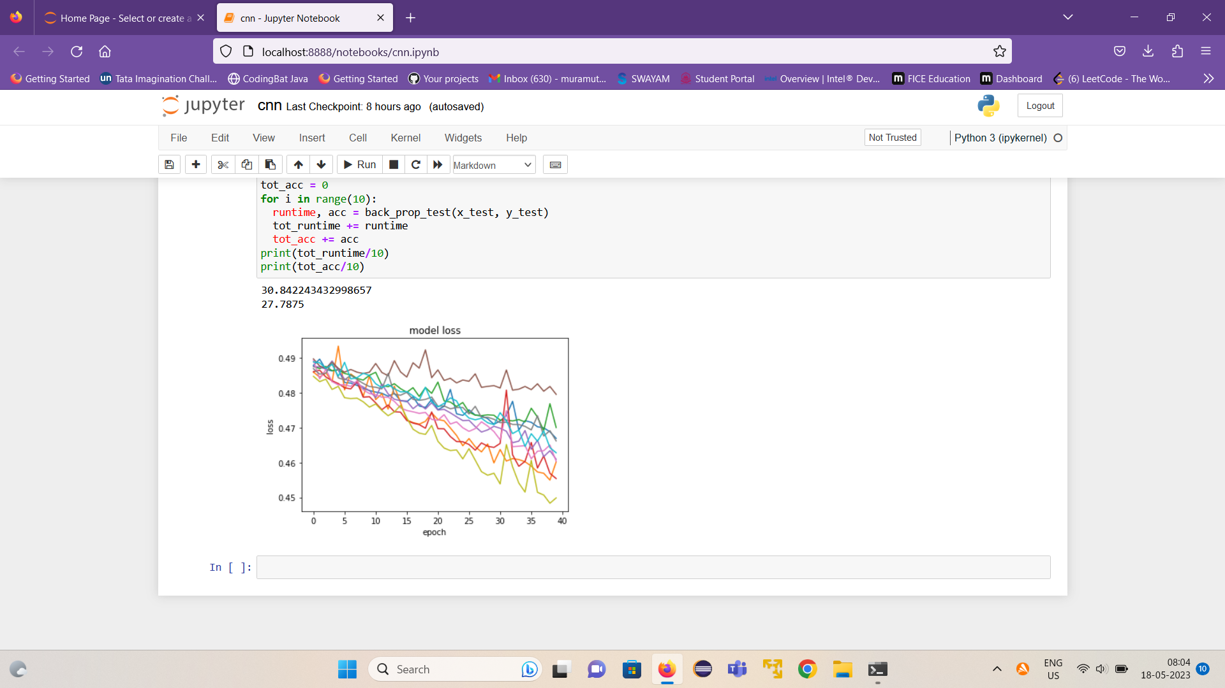 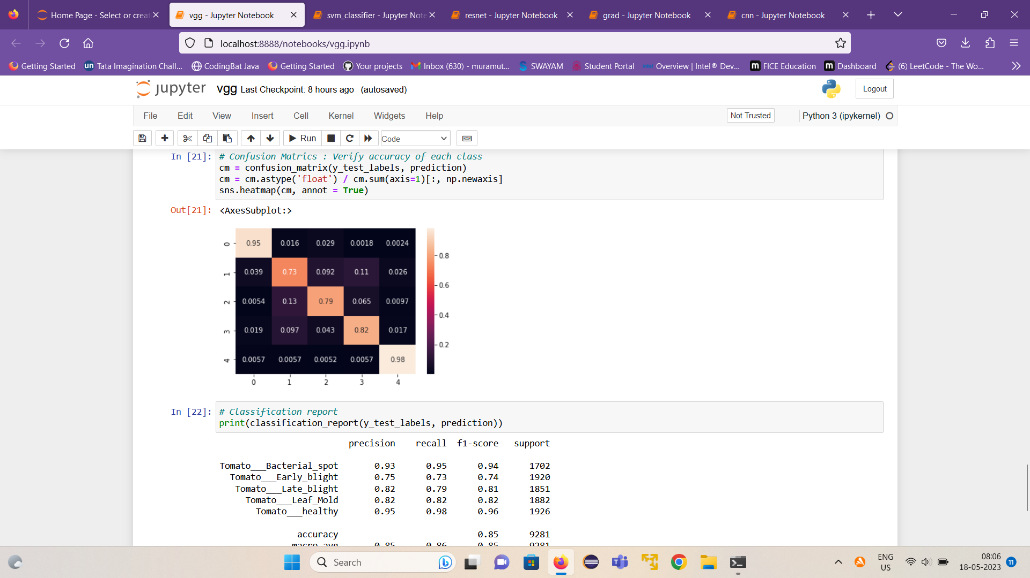

**4.1 Graph of gradient 4.1 Confusion matrix of Hybrid model**

* 1. **DISCUSSION**

This section discusses the obtained result of the proposed deep learning models for Tomato leaf disease detection. From the preprocessed dataset, 70% is used for training and 30% for testing the dataset. The proposed models are implemented in Jupyter Notebook (Anaconda). The analysis of model performance is done using performance metrics namely, accuracy.

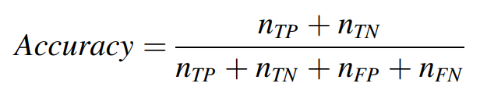

**CHAPTER 5**

**CONCLUSION AND FUTURE SCOPE**

* 1. **CONCLUSION**

Tomato leaf disease detection using deep learning can contribute to sustainable agriculture practices, reducing crop losses, optimizing resource utilization, and improving food security. The advantages of deep learning in tomato disease prediction include high accuracy, speed, and scalability. Deep learning models can quickly process and analyze vast amounts of data, enabling rapid detection and diagnosis of diseases. The conclusion of studies on tomato disease prediction using deep learning is that these models have the potential to revolutionize disease management in tomato cultivation. By training the models on extensive datasets containing images of healthy and diseased tomato plants, deep-learning algorithms can learn to recognize patterns and symptoms associated with specific diseases.

* 1. **FUTURE SCOPE**

Tomato leaf disease detection holds significant potential for advancements and improvements.

* Deep learning models can continue to be refined and optimized to achieve higher accuracy in tomato leaf disease detection. This can also involve developing more sophisticated architectures and larger and more diverse datasets.
* To develop a real-time leaf disease detection system using deep learning. This would enable farmers and researchers to quickly identify and respond to disease outbreaks, minimizing crop losses.
* The model can further be developed not only for detecting but also accurately classifying them. This would provide valuable information to farmers about the specific disease affecting their tomato plants, allowing for targeted treatments and preventive measures.
* The ability to detect multiple diseases simultaneously in tomato plants wold be beneficial.
* Developing models on mobile devices can bring the benefits of deep learning directly to farmers' hands.

**4.3 REFERENCES**

**[1]** P. Tm, A. Pranathi, K. SaiAshritha, N. B. Chittaragi and S. G. Koolagudi, "Tomato Leaf Disease Detection Using Convolutional Neural Networks," 2018 Eleventh International Conference on Contemporary Computing (IC3), Noida, India, 2018, pp. 1-5, doi: 10.1109/IC3.2018.8530532.

**[2]** U. Mokhtar, M. A. S. Ali, A. E. Hassenian and H. Hefny, "Tomato leaves diseases detection approach based on Support Vector Machines," 2015 11th International Computer Engineering Conference (ICENCO), Cairo, Egypt, 2015, pp. 246-250, doi: 10.1109/ICENCO.2015.7416356.

**[3]** Thangaraj, R., Anandamurugan, S., Pandiyan, P. *et al.* Artificial intelligence in tomato leaf disease detection: a comprehensive review and discussion. *J Plant Dis Prot* 129, 469–488 (2022). https://doi.org/10.1007/s41348-021-00500-8

**[4]** Hasan, M., Tanawala, B., & Patel, K. J. (2019, March). Deep learning precision farming: Tomato leaf disease detection by transfer learning. In *Proceedings of 2nd international conference on advanced computing and software engineering (ICACSE)*.

**[5]** Ashqar, B. A., & Abu-Naser, S. S. (2018). Image-based tomato leaves diseases detection using deep learning.

**[6]** Agarwal, M., Singh, A., Arjaria, S., Sinha, A., & Gupta, S. (2019). Tomato Leaf Disease Detection using Convolution Neural Network. In International Conference on Computational Intelligence and Data Science (ICCIDS).

**[7]** Huang, X., Chen, A., Zhou, G., Zhang, X., Wang, J., Peng, N., ... & Jiang, C. (2023). Tomato leaf disease detection system based on FC-SNDPN. Multimedia Tools and Applications, 82(2), 2121-2144.

**[8]** Ahmad, I., Hamid, M., Yousaf, S., Shah, S. T., & Ahmad, M. O. (2020). Optimizing pretrained convolutional neural networks for tomato leaf disease detection. Complexity, 2020, 1-6.

**[9]** Chen, H. C., Widodo, A. M., Wisnujati, A., Rahaman, M., Lin, J. C. W., Chen, L., & Weng, C. E. (2022). AlexNet convolutional neural network for disease detection and classification of tomato leaf. Electronics, 11(6), 951.

**[10]** Ashqar, B. A., & Abu-Naser, S. S. (2018). Image-based tomato leaves diseases detection using deep learning.

**[11]** Gadade, H. D., & Kirange, D. K. (2020, July). Tomato leaf disease diagnosis and severity measurement. In 2020 Fourth World Conference on Smart Trends in Systems, Security and Sustainability (WorldS4) (pp. 318-323). IEEE.

**[12]** Elhassouny, A., & Smarandache, F. (2019, July). Smart mobile application to recognize tomato leaf diseases using Convolutional Neural Networks. In 2019 International Conference of Computer Science and Renewable Energies (ICCSRE) (pp. 1-4). IEEE.

**[13]** Hasan, M., Tanawala, B., & Patel, K. J. (2019, March). Deep learning precision farming: Tomato leaf disease detection by transfer learning. In Proceedings of 2nd international conference on advanced computing and software engineering (ICACSE).

**Appendix 1: Individual Contribution to this project work**

**Appendix 2: Any relevant mathematics, code, etc.**