**A Novel Coal Mine Monitoring System Using Machine Learning**

**21AIE211 – INTRODUCTION TO COMPUTER NETWORKS**

**Prepared by**

Aparna S -CH.EN.U4AIE21107

G V Rohan- CH.EN.U4AIE21113

Harshitha M – CH.EN.U4AIE21115

K Saiteja-CH.EN.U4AIE21122

M Sravani-CH.EN.U4AIE21125



**COMPLETION CERTIFICATE**

**DEPARTMENT OF CSE-AI ENGINEERING CERTIFICATE OF PROJECT SUBMISSION**

This is to certify that the project titled: **SATELLITE IMAGING USING MAP REDUCE** has been submitted on 12/05/2023 to the Department of CSE-AI Engineering in partial fulfillment for the Degree of Bachelors in CSE-AI for 21AIE214-BIG DATA ANALYTICS by the following students.

|  |  |  |
| --- | --- | --- |
| **S. No.** | **ID** | **Names** |
| 1 | CH.EN.U4AIE21107 | Aparna S |
| 2 | CH.EN.UAIE21113 | G V Rohan |
| 3 | CH.EN.U4AIE21115 | Harshitha M |
| 4 | CH.EN.U4AIE21122 | K Saiteja |
| 5 | CH.EN.U4AIE21125 | M Sravani |

**I AS PER THE CDP HAS SUBMITTED THE PAPER FOR INTERNATIONAL CONFERENCE/JOURNAL AND THE SAME IS**

**SUBMITTED FOR EVALUATION**

**I AS PER THE CDP HAS NOT SUBMITTED THE PAPER FOR INTERNATIONAL CONFERENCE/JOURNAL AND THE SAME IS SUBMITTED FOR EVALUATION**

**I AS PER THE CDP HAS PREPARED THE PAPER FOR INTERNATIONAL CONFERENCE/JOURNAL AND THE SAME IS SUBMITTED FOR EVALUATION WITH PLAGARISM REPORT FOR CONSIDERATION.**

|  |  |
| --- | --- |
| Supervisor:  Dr. Sridevi  Supervisor Signature:  Department of CSE-AI | Program Head Name: Dr.R Prasanna Kumar  Program Head Signature:  Department of CSE-AI |

**ACKNOWLEDGEMENT**

We offer our sincere pranams at the lotus feet of Universal guru, **MATA** **AMRITANANDAMAYI** who blessed us with her grace to make this successful major project.

We express our deep sense of gratitude to **Dr. V Jayakumar** Principal of Amrita School of Engineering, Chennai, and **Dr. Manikandan I B** Director, of Amrita School of Engineering for their kind support. We are grateful to our guide **Dr. K Venkatraman**-Visting Faculty CSE Amrita School of Engineering for his keen interest, guidance, and constant encouragement during all stages of our work to bring this thesis to fruition.

We are also indebted to our guide **Dr. Prasanna Kumar R**, Chairperson of Computer Science (Artificial Intelligence), ASE Chennai for his guidance. We are also thankful to **Dr. Sasikala**, Class Advisor of AIE B, who helped us with this project. We are also thankful to other staff members of the Department of Sciences for their valuable help, and all our classmates who have always been a source of strength for always being there and extending their valuable support to the successful completion of this work.

**ABSTRACT**

Machine learning has numerous advantages in intelligent analysis and decision making. Our project includes a safe coal mine monitoring system using machine learning algorithms. It monitors the concentration of gas and the values of temperatures as the parameters if the values of parameter the alarm will ring. The aim of this project is to improve the safety in mines and to reduce accidents.

In this paper we are presenting machine learning based web interface which is designed on following machine learning algorithms Logistic Regression, KNearestNeighbours, SVM, Decision Tree, Random Forest, Gradient Boosting,

***Keywords-*** *Logistic Regression, KNearestNeighbours, SVM, Decision Tree, Random Forest, Gradient Boosting, Streamlit*

**1.INTRODUCTION**

A safe and secure environment in places like coal mines is a crucial aspect and is in need of the hour. There are countless accidents due to explosions of gases, release of huge dust particles and other hazards. These are caused due to the lack of a proper monitoring system. However, an efficient monitoring system and effective safety measures can minimize these risks. Thus, we created a system where Machine Learning models (7 ML Models in this project) are used to make smart decisions whether the coal mine is safe for the workers or not. With the help of data like the temperature of the surrounding and volume of gas, we developed a prediction system.

**2.PROBLEM STATEMENT**

The main goal of the project is to develop a coal mine inspection system that uses machine learning models to improve safety and security. System, temperature, fuel volume etc. parameters should be followed. By analyzing this data, the system should predict the trend and generate alarms and alerts in real time. The system should also provide historical data analysis and reporting to support decision making and improve the long-term safety and productivity of coal mining.

**3.LITERATURE REVIEW**

In the last 2020 article "Internet of Things (IoT) [1] and its impact on the mining industry", the mining industry's transition to IoT systems is back. They explore the current challenges facing the coal mining industry and make recommendations to build better models for the industry's different risks.

Recently, in 2022, Duarte J, Rodrigues developed “ Sensing Technology Applications In the Mining Industry- A Systematic Review” a technique [2] that analyzes the measured data by creating a wireless connection at the edge with the help of sensors that use less electricity.

Author Sathiskumar N developed an integrated communication and data transmission system using deep learning services in the article "Clean IoT-based coal mine safety and health monitoring using LoRaWAN" [3]. Create the graphical user interface of different underground body sensor devices with the help of visual techniques.

Yang L, Birhane GE presented “ Mining employees safety and the application of information technology in coal mining” review paper where the safety issues of the workers in the coal mines are discussed along with the significance of the information technology.[4]

The authors in [5][6] have developed several models for improving safety measures in mines. However, the need for big data management degrades physical performance.

In the year 2021 [7], a routing protocol was proposed to improve mine safety using fuzzy logic. Nevertheless, these logics increase latency and reduce the throughput and may not be the best solution for the applications in the coal mines.

Zigbee - a type of wireless technology used in the main application of wireless sensors with low-cost WPAN, is used to monitor the safety of mines. [8][9][10]

**4.OBJECTIVE**

The main goal of this project is to develop various machine learning models to make informed decisions, thus making analysis more effective. Convolutional neural network, support vector machine, XG-Boost, decision tree, logistic regression, K-nearest neighbor, gradient boosting, random forest machine learning models are used to complete the above arrangements.

**5.SYSTEM ANALYSIS**

**5.1 Functional Requirement**

The system should allow the user to upload the necessary parameters as the input according to the machine learning model and the predicted output should be displayed.

**5.2 Non- Functional Requirement**

The website should be:

* User-friendly
* Attested
* Scalable
* Compatible
* Minimizes cost

**6. METHODOLOGY**

The design and implementation of the model include data collection, data preprocessing, data labeling, splitting data, selecting the model architecture, training the model, evaluating the model, recall, testing the model, deploying the model into the web interface, and the last step is converting the model into the web interface. Figure shows the workflow of the system.

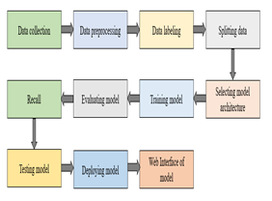

***Figure 6.1***  *Workflow of the model*

In this project we are using Streamlit to deploy the machine learning model. The trained machine learning models are deployed in Stream lit – a python framework to make it as a user-friendly web interface.

**7. ALGORITHMS**

**7.1 Logistic Regression**

Step1: Import the dataset and segregate the independent and dependent variables

Step 2: Then apply logistic regression to the dataset.

Formula: F(x) = 1/1 + e-(β0+β1x)

β0 is the slope

β1 is the y-intercept

X is an independent variable.

Step 3: Predicting the values

**7.2 KNN Algorithm**

Step 1: First fix value of K that means number of neighbors.

Step2: Then calculate the distance between the points by Euclidean distance.

Example: A(1,2) and B(3,4)

Distance = $\sqrt{{\left(3-1\right)}^{2} +}{\left(4-2\right)}^{2}$

Step3: Then calculate the Euclidean distance and group them to nearest neighbours.

Step4: Then calculate the number of k-neighbours in each Category.

Step5:Them assign the new data points to category of k neighbours which has maximum numbers of points.

**7.3 Decision Tree**

Step 1: Initialize the dataset and define the attributes

Step 2 :Calculate the entropy and the information gain of each and every attribute that present in the dataset

Formula of Entropy : E(T,X) = $\sum_{ }^{ }{C}∈p\left(c\right)E\left(c\right)$

E(C) = $\sum_{i=1}^{c}{-Pi}\log{p}i$

Pi = probability of an event of that attribute

Information Gain = Entropy(T) – Entropy(T,X)

Step 3: Select a attribute from the dataset which had high information gain or low entropy as the root node of tree.

Step 4:Split the Dataset as selected attribute to obtain the subset of the data.

Step 5: Repeat the above steps until the every attribute is selected

**7.4 Random Forest**

Step 1: First select the k random attributes from the dataset.

Step 2: Construct a decision tree for each selected attribute from dataset.

Step 3: Based on result produced by each decision tree. Based on the result voting will takes places.

Step 4:Considering the maximum voting will be selected for the predicting the data .

**7.5 Gradient Boosting**

Step 1 : Initialize the dataset and model with the constant value and apply the loss function

Step2: Calculate the Gradient and build a new decision tree based on the gradient

Step3: Then the model is ready to predict the values.

**7.6 SVM**

Step 1: Muster the dataset for test

Step 2: Pre-process the csv dataset.

Step 3: The model should be trained with the training set and should be evaluated with an F1 score.

Step 4: To predict, the feature of the new image is pulled out and passed through SVM model.

**9.RESULT**

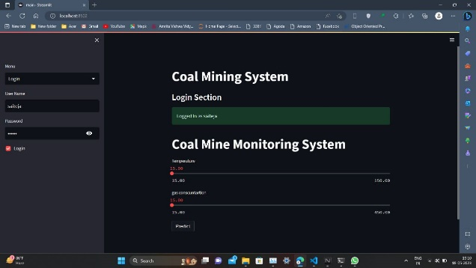

***Figure 9.1.1*** *Web page shown once the user enters their login credentials.*

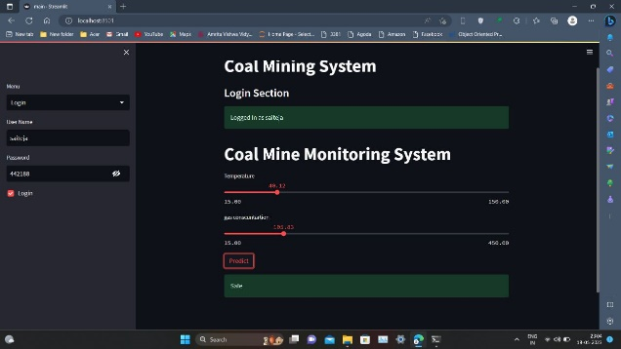

***Figure 9.1.2*** *The above figure shows the output as ‘Safe’ when the user slides the temperature and gas values which has values below the risk factor*

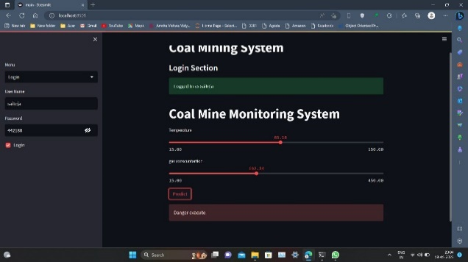

***Figure 9.1.3*** *The above figure shows the output as “ Danger, Evacuate!” once the entries cross the threshold values.*

**9.2 Achieved Accuracy for the Models**

|  |  |  |  |
| --- | --- | --- | --- |
| S.No | Algorithm | Training accuracy | Testing accuracy |
| 1. | Logistic regression | 78.86 | 85.52 |
| 2. | KNearest Neighbors | 93.20 | 94.73 |
| 3. | SVM | 80.16 | 85.52 |
| 4. | Decision Tree | 99.71 | 88.15 |
| 5. | Random Forest | 97.16 | 92.16 |
| 6. | Gradient Boosting | 99.71 | 93.42 |

***Table 9.2.1*** *The above table shows the comparison of accuracies of various machine learning models*

**10.CONCLUSION**

In conclusion, our project shed new light on making effective decisions, monitoring 24/7 and alerting the employees through sensors. Machine Learning Models such as Convolutional neural network, support vector machine, XG-Boost, decision tree, logistic regression, K-nearest neighbor, gradient boosting, random forest is compared in various aspects to obtain the most accurate prediction and consequently improve the coherence of a traditional monitoring system.

**11.FUTURE SCOPE**

In this project we are using only two parameters like concentration of gas, temperature in future we would like to add some more parameters like humidity, pressure etc. Our project improves efficiency, sustainability, safety of coal mine monitoring system. We can improve the scalability of the web interface

**12.REFERENCES**

[1] M. Fatemeh, "A comprehensive review of the Internet of Things (IoT) and its impact on the mining industry", AJEAS , 2020.

[2] Duarte J, Rodrigues F, Branco JC . IJEASPH . 2022; 19(4): 2334–2334.

[3] Sathishkumar N, "IoTbased coal mine safety and health monitoring using Lora WAN", 3rd IJEPH, 2021.  
  
[4] Geng J, Birhane GE, Zhu J, Yang L Coal My Worker Safety and Use of Information Technologies in Mines: A Review. Boundaries in Public Health. 2021;

[5] Matloob S, Li Y, Khan KZ. Safety assessment and risk assessment for the coal mining industry using artificial intelligence and machine learning. Open Business & Management Magazine. 2021; 09(03): 1198–1209.  
  
[6] Skora M , Gilerson A,, Sherikar M, Mitra R ,Stankiewicz K, Kianfar AE ,.  
Design a survey to evaluate singlewire and wireless transmission systems in the blast zone of underground mines. force. 2022; 15(2): 576–576.  
  
[7] Journal of Science and Technology. 2021; 14(3): 270–288. Rao KUM., Kumar H, Srikanth B.  
Security and QOS aware fuzzy logic based routing for underground coal mine monitoring. International Journal of Grid and Distributed Computing. 2019; 12(1):11-30.  
  
[8] Krishnan KV, Khara S, Bahubali A, Chawla V, Ashok K. Spectrum management using radio recognition for miner security.  
Indian Journal of Science thiab Technology. 2016; 9(44).  
  
[9] Rawat SKSK, Singh DA, Bharti K. WSN localization algorithm rau underground mining area. International Journal of Engineering Research Thiab Technology (IJERT).  
2021; 10(08): 10–080021.  
  
[10] Srikanth B, Kumar H, Rao K. Robust method for WSN localization for underground coal mine monitoring using modified RSSI technique. Mathematical modeling of engineering problems. 2018; 5(3): 225–231.