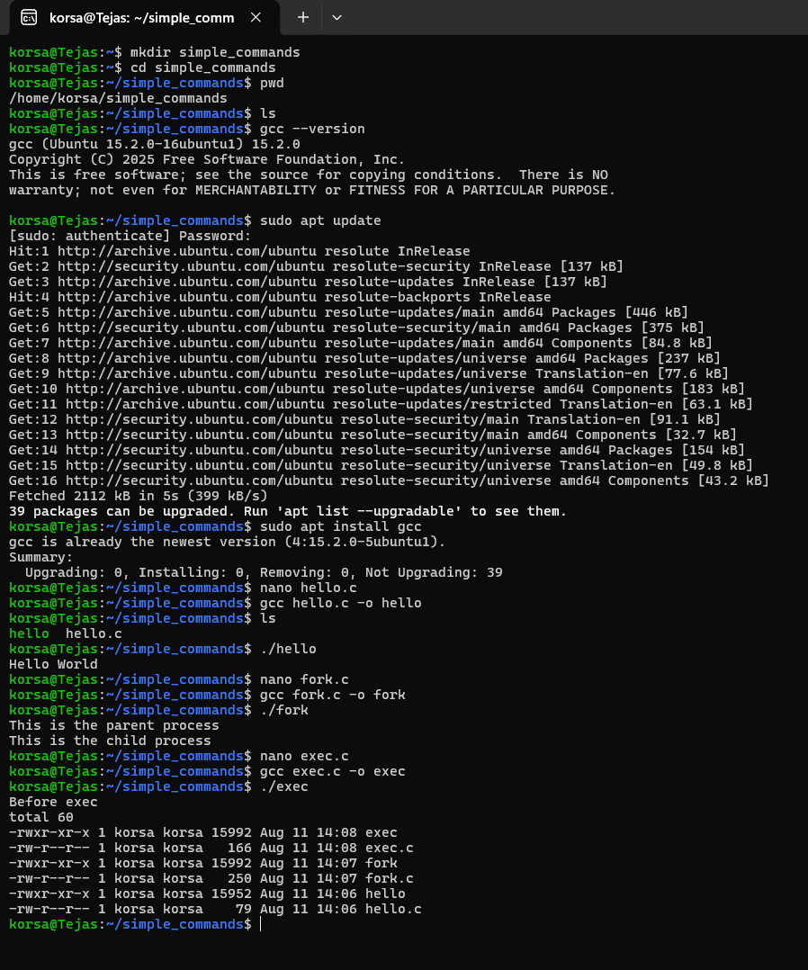
The Linux environment was successfully configured with GCC, and the required project structure was created using basic Linux commands. The fork() and exec() system calls were also understood and implemented to demonstrate process creation and command execution.

