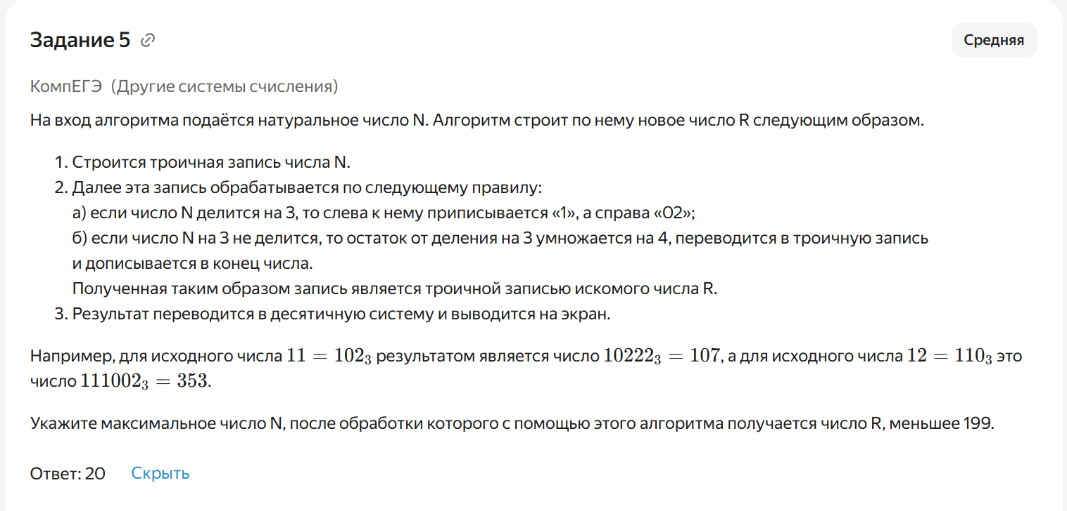
def to_base3(n):
if n == 0:
return "0"
res = ""
while n > 0:
res = str(n % 3) + res
n //= 3
return res
def f(n):
t = to_base3(n)
if n % 3 == 0:
t_new = "1" + t + "02"
else:
r = (n % 3) * 4
t_new = t + to_base3(r)
return int(t_new, 3)
max_n = 0
for n in range(1, 1000):
if f(n) < 199:
max_n = n
print(max_n)

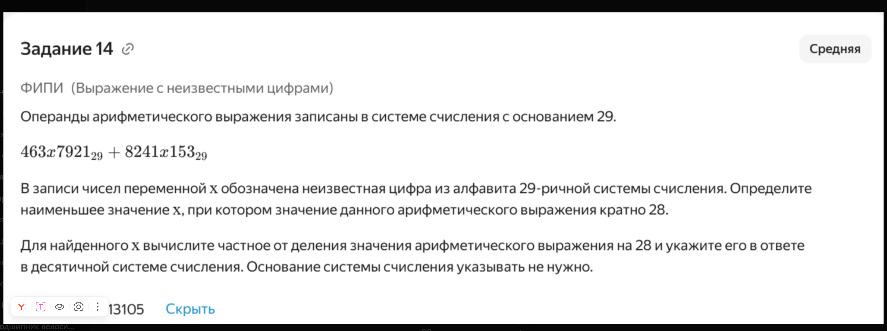

def to_decimal(s, base):
return int(s, base)

for x in range(29):
num1 = f"463{x}7921"
num2 = f"8241{x}153"

val = int(num1, 29) + int(num2, 29)

if val % 28 == 0:
print("x =", x)
print("Ответ:", val // 28)
break

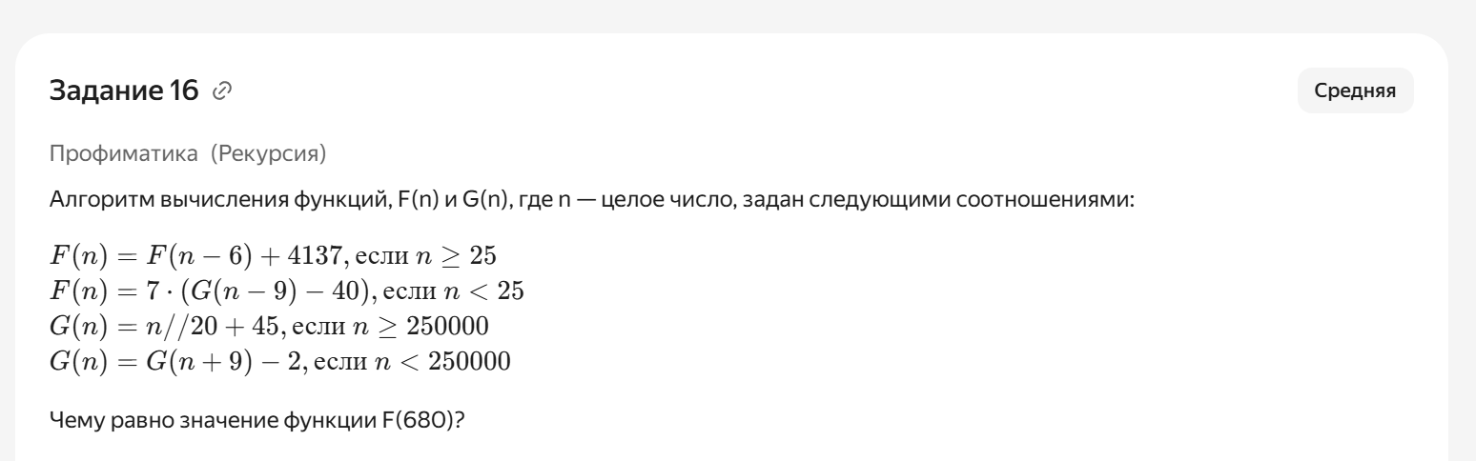
import sys
sys.setrecursionlimit(1000000)

from functools import lru_cache

def G(n):
if n >= 250000:
return n // 20 + 45
# сколько шагов нужно до >= 250000
k = (250000 - n + 8) // 9
m = n + 9 * k
return m // 20 + 45 - 2 * k
@lru_cache(None)
def F(n):
if n >= 25:
return F(n - 6) + 4137
return 7 * (G(n - 9) - 40)
print(F(680))

