# Joram 1.0.0

A Self-Sovereign Identity Lifecycle Engagement Model

By Joe Andrieu, Legendary Requirements, LLC, <[joe@legendaryrequirements.com](mailto:joe@legendaryrequirements.com)> & Bob Clint, Spiritus Partners, Inc. <[rclint@spirituspartners.com](mailto:rclint@spirituspartners.com)>

## Introduction

Joram is a 25 year-old, single male from Syria. He flees his home country, leaving behind his family, because he fears persecution. He finds his way to a refugee boat that makes its way to a beach in Greece. Joram brings only the clothes on his back: no identity papers, no technology. Joram speaks Arabic, and English[1] but not Greek.

Joram has corresponded with an aunt in France, who has promised to provide housing and help Joram find a job. Joram has some education, is a skilled welder, and is held in high regard by his community back home. He is responsible and has cared for his mother and siblings, but suffers from type 2 diabetes.

This document envisions a new way to handle identity information through the examination of the experiences of a fictional individual, Joram, as he seeks refuge in Greece on his way to resettlement in France. We use an *Information Lifecycle Engagement Model* as described at the end of this document.

### Stewards

Throughout Joram’s experience, several different individuals create and query information in a data store. These “stewards” are stewards of both the identity information and of Joram’s physical person.

**Achilles —** Greek gate officer, Camp Beta

**Alexandra —** Greek border patrol soldier working with Spiros

**Dr. Andropoli**s — Camp Doctor, Medicins Sans Frontier, Camp Alpha

**Barbra —** UNHCR outtake officer, Camp Beta

**Bohlale** — Intake Nurse, Medicins Sans Frontier, Camp Alpha

**Celine —** UNHCR intake officer, Camp Alpha

**Dion —** UNHCR transition coordinator, Camp Alpha

**François —** French resettlement case worker with France Terre d'Asile (FTDA)

**Jean-Pierre —** French immigration agent

**Markos —** Greek anti-terrorist interrogator

**Mary —** Technical administrator,Camp Beta

**Mike —** Nurse, Camp Beta

**Spiros —** Greek border patrol soldier who finds Joram and the rest of his fellow travellers

**Dr. Zeneca** — Pharmacist, Camp Beta

### Others

Two other Syrian refugees also play a role in Joram’s story.

**Fatima —** Qasim’s wife, whose arrival in Greece is a surprise to Joram

**Qasim —** A co-worker of Joram whose name Joram uses to protect his family

### Assumptions

All of the stewards in the model have a physical device with Internet access. Through this device, they are able to create and query entries in a “Distributed Self-Sovereign Data Store”. (data store). The details of how that data store work are outside the scope of this document. However, this data store is where Joram’s self-sovereign identity accretes over time as he interacts with the stewards. When interacting with stewards, Joram mediates selective disclosure of that accreted identity data.

As a strawman approach for the sake of this discussion, we make a few assumptions about this data store:

1. A QR code, a pin, and a simple biometric cryptographically secure records in the data store.
2. A semi-private ledger — governed by the UN — enables approved stewards to view and add records in the data store, independent of any centralized identity provider or service.
3. The software run by the stewards is certified to meet requirements set by the UN to assure the integrity of the consent and disclosure ceremony and subsequent data hygiene.
4. In each steward interaction, there is an initial authorization ceremony that gives permission to both query *and* create associated records. A second authorization is required to actually view the contents of any returned records.

## Stage 1 — Pre-contact

After a difficult and dangerous journey, Joram reaches the beaches of Greece. At some point during his travels, he used the last of his insulin. He is dehydrated, painfully hungry, and fatigued. He is seeking access to insulin treatment, water, food and other basic needs. He is also trying to avoid getting shot or harmed by either criminals or the military. His challenge is to find someone who can help him and his colleagues on the boat.

Spiros is a member of the Greek Border Guard. Spiros starts his shift by authenticating himself on his device, with the Border Guard. Attending his daily briefing, he receives his mission, which is to patrol the beach. The mission briefing includes a reference to the UN resolution under which they are operating. He enters a record in the data store when he begins the mission. He is on patrol when his unit responds to a report of about 20 people milling around a local beach, which also gets entered into the data store.

*Data Records: Spiros, with Border Guard authority: starting mission with agent, location, timestamp, root authority. Investigating report of unknown individuals with agent, location, timestamp.*

## Stage 2 — Contact

After avoiding the border team with the dogs, Joram sees Spiros patrolling. He recognizes that Spiros, who is in uniform, is a Greek authority, who may be able to help him. He feels there is a better chance of starting a conversation without getting hurt because Spiros doesn’t have any dogs. He waves Spiros down, calling out for assistance.

Spiros sees Joram, records contact and approaches.

*Data Records: Border Patrol: Confirmation of contact with agent, location, timestamp.*

## Stage 3 — Triage

Approaching Joram, Spiros first needs to identify if Joram poses a threat. Spiros activates the spotlight on his weapon and starts yelling at Joram to get on his knees, hands on his head. He initially speaks in Greek, then in English, which Joram understands; he complies. An initial round of questions asks for Joram’s identity, why he is there, where he is from, and where he is going.

During this triage interview, Spiros’ partner, Alexandra takes a photo of Joram and cross-checks this with a bad actor database[2].

Joram initially ignores the questions, saying “Asylum! Asylum. Help.” After some coaxing, he claims he is from Damascus, is fleeing for his life, injured, hungry, and seeking asylum with family in France. To protect his family in Syria, Joram withholds his real name, instead providing that of his co-worker, ‘Qasim’. He also tells Spiros there is a group of refugees further down the beach.

Spiros asks Joram to repeat his story a couple times, finding it generally credible. He decides to request from their supervisor that they treat Joram and his group as refugees.

Alexandra calls their supervisor for backup and a truck, explaining the refugee boat situation.

*Data Records: Contact photo with location, timestamp, agent.*

## Stage 4 — Direction

Spiros tells Joram he will be going to UNHCR refugee Camp Alpha, where he will be able to get food and shelter and deal with his diabetes.

Joram agrees to go to the refugee camp, relieved that he’s given that option instead of something far worse. He is allowed to stand up and points Spiros towards the rest of the refugee group.

When the rest of the Greek patrol shows up, Joram leads the Greeks to the other refugees, and explains to them that everything is going to be ok — that they are going to go together to a nearby UNHCR refugee camp for food, shelter, and medical care. The group cheers and appears glad to comply with directives.

After the larger group is under control, Spiros and the rest of the Greek squad take photos and names of all the refugees present, associating them with automatically generated identifiers and storing them in the data store. Spiros additionally records the details of the story told by Joram.

Joram joins the rest of the refugees in the box truck and is taken to Camp Alpha.

*Data Records: Border Patrol. Records of contact, story of origin: Joram’s false name, “Qasim”, the names given by and photos of all the refugees, claimed origin, Damascus, etc.*

## Stage 5 — Consent

At Camp Alpha, UN volunteer Celine matches Joram to the record created by Spiros and asks Joram to confirm that it is his. She explains that she is creating a new record in an isolated system that will enable Joram to securely access camp services. She explains that he will have control over who can access this data through powerful cryptography — that neither the Greek or Syrian governments will be able to access any of this information without his assistance. She asks for and receives Joram’s consent to create a profile for him.

*Data Records: Provisional ID. Contains Qasim’s name, Joram’s picture, and a Camp Alpha identifier number.*

## Stage 6 — Disclosure

Celine requests additional information and adds her notes to the data store. Joram answers more questions about who he is, but sticks with the story that he’s “Qasim”. Celine asks about Joram’s trade skills. Joram cites his work as a welder.

Afterward, Joram is given a Camp bracelet with his name and ID #, which will allow him to access records about him in the distributed data store and get access to goods and services in Camp Alpha.

Nurse Bohlale takes Joram’s vital signs (temperature, weight, pulse, blood pressure) and medical history. Joram tells her about his diabetes and Bohlale sets an appointment for him to see Dr. Andropolis.

*Data Records: Camp Record. Contains: Qasim’s name and basic information; health information; skill information. A real world quasi-permanent token (bracelet).*

## Stage 7 — Services

Joram receives a thorough medical examination from Dr. Andropolis, who confirms the diabetes diagnosis. The doctor prescribes a daily allowance for insulin and stores it in the data store, using the embedded ID in Joram’s bracelet.

Joram regularly visits the camp clinic and uses his bracelet to ask for a blood sugar check with Nurse Bohlale, who also gives him any necessary injections. Joram’s data store verifies his prescription and Bohlale records an entry of test results and any injections.

*Data Records: Diagnosis, insulin prescription, request for sugar check, test results, and disbursement.*

## Stage 8 — Enhancements

In Joram’s weekly check-in with his UNHCR transition coordinator, Dion reviews his profile with an eye to preparing Joram’s asylum application. Joram selectively shares the data she requests. She sees that he has an aunt in France and confirms that France is Joram’s first choice for immigration. She sets an appointment for Joram to meet with the French asylum specialist to begin the application process.

Seeing Joram’s skills inventory, Dion asks him if he would be interested in getting certified as a welder. Certification could be useful for his refugee application and subsequent employment. Joram thinks that’s a great idea. Dion arranges for a certification test the following week.

Dion performs a local search of the family reunification list to see if any other refugees have posted requests to find relatives matching Joram’s profile. The search turns up Qasim’s wife, Fatima, who has posted looking for Qasim, 25, from Damascus. Joram recognizes the photo of his friend’s wife and confirms the relationship. He believes they will both be better off together in the camps. Dion explains the relationship qualifies him for relocation to be with Fatima. Joram accepts. Dion confirms the relationship in the data store and arranges the relocation.

*Data Records: Welding certification, relocation.*

## Stage 9 — Updates

Upon arriving at Camp Beta, Joram goes to the clinic where Nurse Mike asks for authorization to look up Joram’s prescriptions. Unfortunately, nothing comes up. Perplexed, Joram mentions he just arrived from Camp Alpha. Mike expands the scope of the query and finds several records matching Joram and Camp Alpha. Joram selects the insulin prescription and shares it with Mike. Mike associates the prescription with Camp Beta, thereby authorizing treatment and distribution from local resources.

*Data Records: Prescription, camp assignment.*

## Stage 10 — Issues

Two days after reuniting with Fatima in Camp Beta, both are arrested and taken for interrogation. Security intelligence has named Qasim of Damascus, husband to Fatima, as a TERRORIST. Under interrogation, Joram and Fatima hold to their story, fearing reprisal for lying about Joram’s identity and claiming that Joram/Qasim has been in the camp for weeks.

Meanwhile, the real Qasim attempts to get into Camp Beta as a refugee, in search of Fatima. During intake, his background check with the Greek bad actor system comes back with a hostile designation. Security immediately arrests Qasim and takes him to interrogation.

Confronted with the real Qasim, Joram admits he lied about his name and relationship to Fatima. The interrogator, Markos, checks the two Qasims’ stories against information in the data store. He knows that the real Qasim is wanted for allegedly leading a deadly attack in Athens just days before. However, Joram — despite being on the record as Qasim — is able to share a consistently documented non-repudiable data trail of his arrival in camp Alpha and subsequent daily interactions in both Camps, including his three-times-a-day blood sugar tests. The record makes it clear that Joram could not possibly be Qasim.

*Data Records: Camp Records reviewed. Joram’s named updated to “Joram”.*

## Stage 11 — Maintenance

Sometime during Joram’s tenure at the camps, the pharmacist, Dr. Zeneca, sees an alert in the pharmacist software app that a new version of the app is available, with additional support for a new prescription data model in the data store. He reviews the new features and notes that his current version is forward compatible with the new prescriptions, although some features will be unavailable. He decides to wait until the end of the day to try the new software out. When he does so, he notices a layout bug that is obscuring patient information. He captures a screenshot and reports the bug, then rolls back to the previous version.

*Data Records: Support for new “prescription 2.0” format*

## Stage 12 — Migration

In anticipation of local regulations, records created in Greece that might contain personally identifiable information are physically stored in Greece.

As part of his asylum application, Joram works with Jean-Pierre, the French immigration agent, to export a subset of his camp records to a resettlement agency in France. This includes his aunt’s address and contact information. The information selected by Joram is transferred to a data store in France, retaining its non-repudiable characteristics and its chain of custody.

*Data Records: Aunt’s contact information, welding certificate, entry date, misc.*

## Stage 13 — Recovery

One day, after several hours welding, Joram realizes his wristband isn’t on his wrist. He searches both his sleeping area and his workplace, to no avail. When he visits Mike for his blood sugar check, Mike recognizes him and uses his authority as a nurse to provide emergency care. He then directs Joram to Mary, the Camp Beta technical administrator. Mary looks up Joram’s entry record in her database using his intake date and name, finding the record with a matching photo and QR code. She triggers an authentication ceremony with that QR code, and Joram uses his PIN and biometrics to confirm his identity. Mary then prints a new bracelet. On Joram’s next visit to the clinic, Mike associates the previous emergency treatment with Joram in the data store.

*Data records: Intake record, photos of Joram, intake date, QR code.*

## Stage 14 — Exit

After some months, Joram gets a response to his asylum application and is granted a visa to join his aunt in France. Barbra, the UNHCR outtake coordinator at Camp Beta, conducts an exit interview with Joram, double checking his name and photo, and recording his exit, his destination, the bus #, and bus driver. In turn, the driver verifies Joram’s grant of asylum, that his photo matches the record, and checks his possessions for prohibited items. Prior to leaving, camp guard Achilles also verifies Joram’s paperwork is in order. Joram’s exit is recorded in the data store and he is on his way to a new home.

*Data Records: Asylum paperwork, camp record (name, photo), exit interview notes.*

## Stage 15 — Re-engagement

Upon arrival in France, Joram is reunited with his aunt. A week later, François, a French resettlement case worker with France Terre d'Asile (FTDA), reaches out to Joram to follow up on his progress integrating into French society. Joram is doing fine, but is struggling to find work and wishes his French language skills were better.

François arranges an introduction to a local leader of the French IIW (International Institute of Welding) certification agency, Association du Soudage (AFS), and enrolls Joram in a free language class at a nearby community center.

Presenting the IIW certification earned in camp Alpha to the local AFS chapter, Joram qualifies for membership in the union and is able to stand for work as a journeyman welder.

*Data Records: IIW Certification*

## Information Lifecycle Engagement Model

The 15-stage model presented here is an instance of an Information Lifecycle Engagement Framework, as illustrated below.

Each phase in the model is a concise description of one or two interactions illustrating the phase. Rather than attempting to describe every interaction across multiple customers, the engagement model captures illustrative interactions for each phase in the lifecycle of a particular individual’s engagement with the system. The whole should be readable as a sympathetic narrative, clarifying the motivations of all parties and the viability of the described use. We use it to tease out the human requirements independent of the underlying technology.

This Information Lifecycle Engagement Model is based on the work of Joe Andrieu and Ian Henderson from The Customer-Supplier Engagement Model Quick Starter*[3].* We have re-interpreted and expanded the the 12 phases of the Customer-Supplier Engagement Model for suitability to a Syrian refugee in Greece. Our initial change shifted the language from commercial concepts to more general identity information. We also added Maintenance, Migration, and Recovery phases to address the needs of operating an ongoing system.

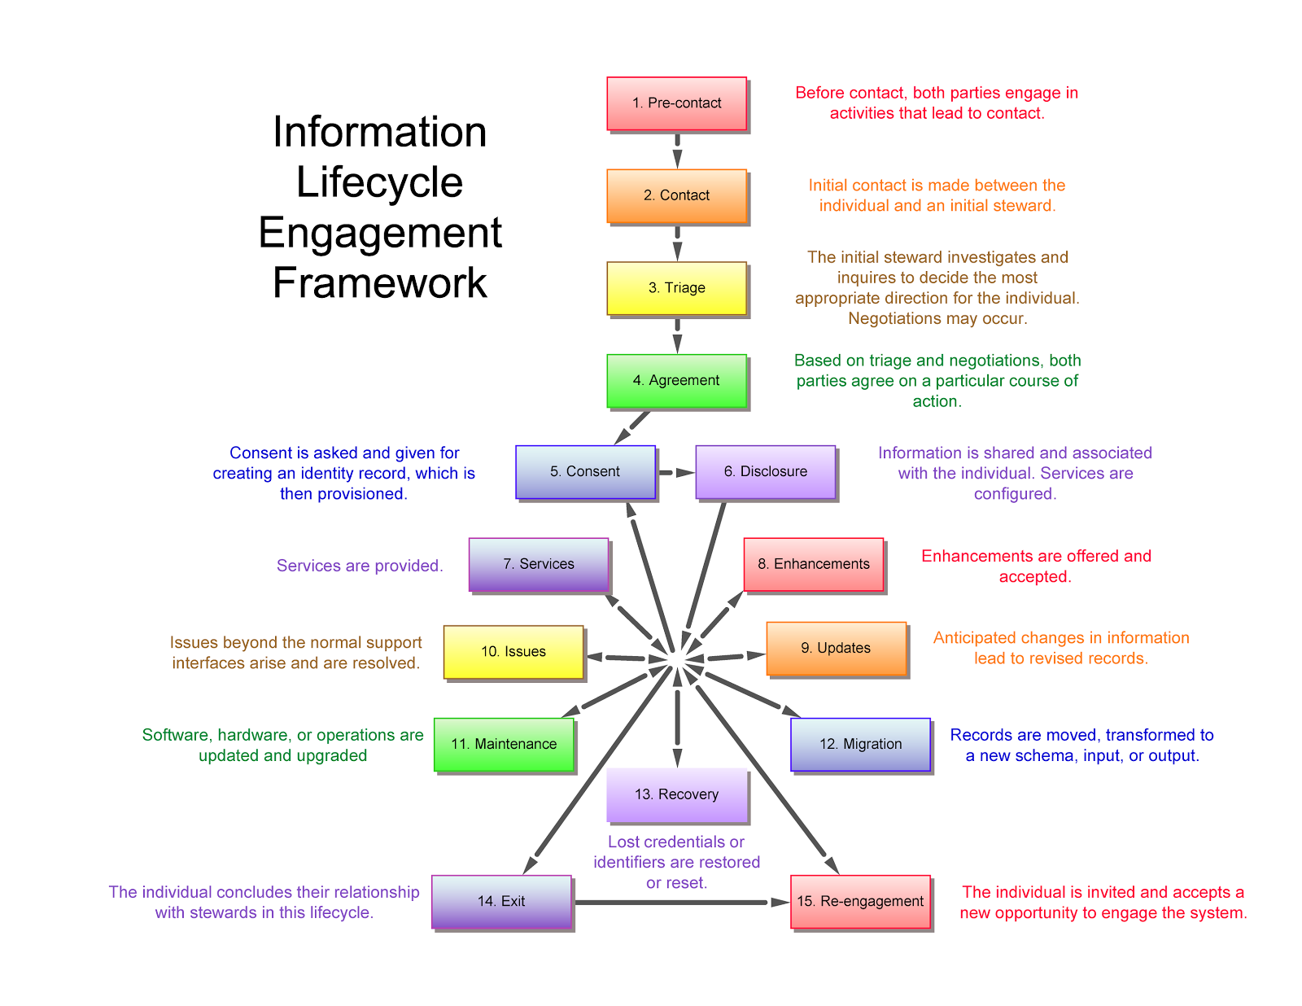

The premise remains: working through each phase in the model provides a comprehensive yet lightweight review of the necessary transactions. This can be accomplished prior to a detailed specification of the system, providing a coherent statement of functional requirements even as design and implementation details change.

### Additional Credits

**Authors:** Joe Andrieu and Bob Clint

**Additional Contributors:** Shannon Applecline, Zachary Larson, Vivian Shen, and Natalie Smolenski

### About Rebooting the Web of Trust

This paper was produced as part of the [**Rebooting the Web of Trust III**](http://weboftrust.info) design workshop. On October 19th through October 21st, 2016, over 40 tech visionaries came together in San Francisco, California to talk about the future of decentralized trust on the internet with the goal of writing 3-5 white papers and specs. This is one of them.

**Workshop Sponsors:** Blockstack, Microsoft, Netki, Protocol Labs, Tierion

**Workshop Producer:** Christopher Allen

**Workshop Facilitators:** Christopher Allen and Brian Weller, additional paper editorial & layout by Shannon Appelcline, and additional support by Kiara Robles and Marta Piekarska.

### What’s Next?

The design workshop and this paper are just starting points for Rebooting the Web of Trust. If you have any comments, thoughts, or expansions on this paper, please post them to our GitHub issues page:

<https://github.com/WebOfTrustInfo/rebooting-the-web-of-trust-fall2016/issues>

The next Rebooting the Web of Trust design workshop is scheduled for Spring 2017 in Paris, France. If you’d like to be involved or would like to help sponsor these events, email:

ChristopherA@LifeWithAlacrity.com

1. *English is chosen to make our work in this document easier.*
2. *The Greek Border Authority has its own proprietary database, outside our scope.*
3. [http://kantarainitiative.org/confluence/display/ infosharing/Customer-Supplier+Engagement +Model+Quick+Starter](http://kantarainitiative.org/confluence/display/%20infosharing/Customer-Supplier+Engagement%20+Model+Quick+Starter)