What Users Really Want

A paper of the Rebooting the Web of Trust workshop, Paris, 2017

Joe Andrieu <joe@legendaryrequirements.com>

Frederic Engel <market.engel@gmail.com>

Adam Lake <creatinglake@gmail.com>

Moses Ma <moses.ma@futurelabconsulting.com>

Olivier Maas <olivier.maas@worldline.com>

Mark van der Waal <mark.vanderwaal@sovalacc.com>

We consider five fictional personas to explore the obstacles and opportunities for self-sovereign identity. For one, Rutu Shah, we describe an illustrative day in her life.

# Five Personas, Five Opportunities

The following five individuals represent a diverse sampling of normal, everyday people whose lives could be improved by self-sovereign identity. Today, these five aren’t using enhanced digital identity. For each, we describe their current lack of engagement and provide at least one opportunity that could reframe self-sovereign identity as a clear win for them.

## Renée Moreau

Mme. Renée Moreau is a seventy-eight-year-old grandmother living in the town of Amiens, France[1]. She has a low level of understanding about information technology, but fears being hacked and losing what meager savings she has left. To the extent she has discussed it with her children, Renée Moreau feels “fancy” identity solutions are just too complicated for her to use.

Reframing: **FamilyPix** secure picture sharing enables Renee to receive photos of her grandchildren without exposing them to pedophiles or marketers.

Bonus Reframing: A friends-of-family web of trust enables support when emergencies arise. Family-of-friends and friends-of-family are discretely recruited for real-time on-demand response to minor emergencies and quality-of-life interactions such as getting locked out of the house, trip-and-fall incidents, and needing a ride to a doctor visit.

## Jack Smith

Mr. Jack Smith is the fifty-seven-year-old Chief Information Officer of a Fortune 1000 company in the United States. He lives in Portland, Oregon with his wife and ten-year-old son. He has earned a reputation as a shrewd debunker of silver bullet initiatives that promise miracle results but rarely deliver. As a rule, he has found identity solutions too burdensome for integrated deployment throughout the hundreds of applications deployed across his company. Instead, core corporate applications are managed through a centralized Active Directory service and departmental applications are free to implement their own identity approach. He underestimates his company risk for regulatory compliance and tends to avoid technical topics where his aging expertise might appear dated. Employees suffer from as much as 15 minutes/day dealing with logins at both intranet and Internet sites. Phishing is a significant, but overlooked security risk.

Reframing: **Super Sign-On** brings corporate identity data into compliance while unifying secure logins for applications across the enterprise and beyond the corporate boundary at online services like Trello, Atlassian (Jira, Confluence, etc), and Dropbox.

## Mayumi Takamasa

Miss Mayumi Takamasa is a seventeen-year-old female student in Tokyo, Japan. In conversations about privacy risk, she is dismissive and doesn’t care about advanced identity management. Online she has seen cyberbullying among her peers and goes to some effort to create boundaries between what she and her friends post for each other and what her mother can see.

Reframing: **MySociety** social game creates independent identity across social network platforms--without exposing content to uninvited eyes. The game creates pseudonymous social spaces with built-in privacy, disappearing messages, and points, levels, and badges based on social interactions.

## Joram Hadad

Mr. Joram Hadad is a twenty-five-year-old Syrian refugee from Damascus, traveling through Greece on his way to resettlement in France. He fears reprisal against his family should the Syrian government discover he made it out of the country. He has no technology to speak of and has provided authorities with a fake name. He needs health care and basic human services.

Reframing: **MyID**: a biometric + PIN secured digital datastore in a USB thumb drive gives Joram physical control over identity data that only he has the power to share.

## Rutu Shah

Ms. Rutu Shah is a thirty-eight-year-old Mayor of a modest city in India, Ahmedabad[2]. In her daily life she is wary of phishing attacks and security risks, but social and economic issues have taken priority over pushing for better identity across city services. She understands the value, but struggles to push for change when commitments to drinkable water, better education, and sustainable jobs got her elected. She is particularly concerned about online predators and children’s safety.

Reframing: **SafetyNet** creates personalized peer-to-peer, independent trust networks where parents, educators, mentors, and social workers vet and connect trusted resources for children. The same service also allows professional networks to flourish through phish-proof, trusted introductions, connecting entrepreneurs with business development, mentors, and funding sources.

# The Magic of Reframing

Reframing is a powerful tool, based on the work of George Lakoff[3], linguist, former Distinguished Professor of Cognitive Science and Linguistics at the University of California at Berkeley, and current Director of the Center for the Neural Mind & Society[4]. We use it here to avoid the common pitfall of point-by-point refutation of obstacles and misconceptions, to instead discover a transformative, indisputable win for individuals from self-sovereign identity systems.

The process of reframing is based on finding blind spots. When you detect blind spots, either in the user or in the self, you unveil the potential for flipping the system. Useful techniques include ethnography, empathy, design-thinking and design sprints. Rather than fighting existing references, create a new one, framed indisputably in terms of something individuals clearly want. Eschew obscure technical jargon for emotionally impactful and concise trigger phrases that immediately resonate. When you illuminate a blind spot with emotionally desirable terminology, listeners naturally align their mental model and find it hard to challenge the excitement and possibility. By focusing on a single win for each individual, we further simplify the message and focus positive resonance. Reframing greatly increases the possibility for substantive engagement and adoption.

# A Day in the Life of Rutu Shah

A fictional persona, Ms. Rutu Shah is the mayor of a modest city, Ahmedabad, India[5]. Here we envision a day in her live, enhanced by self-sovereign identity. 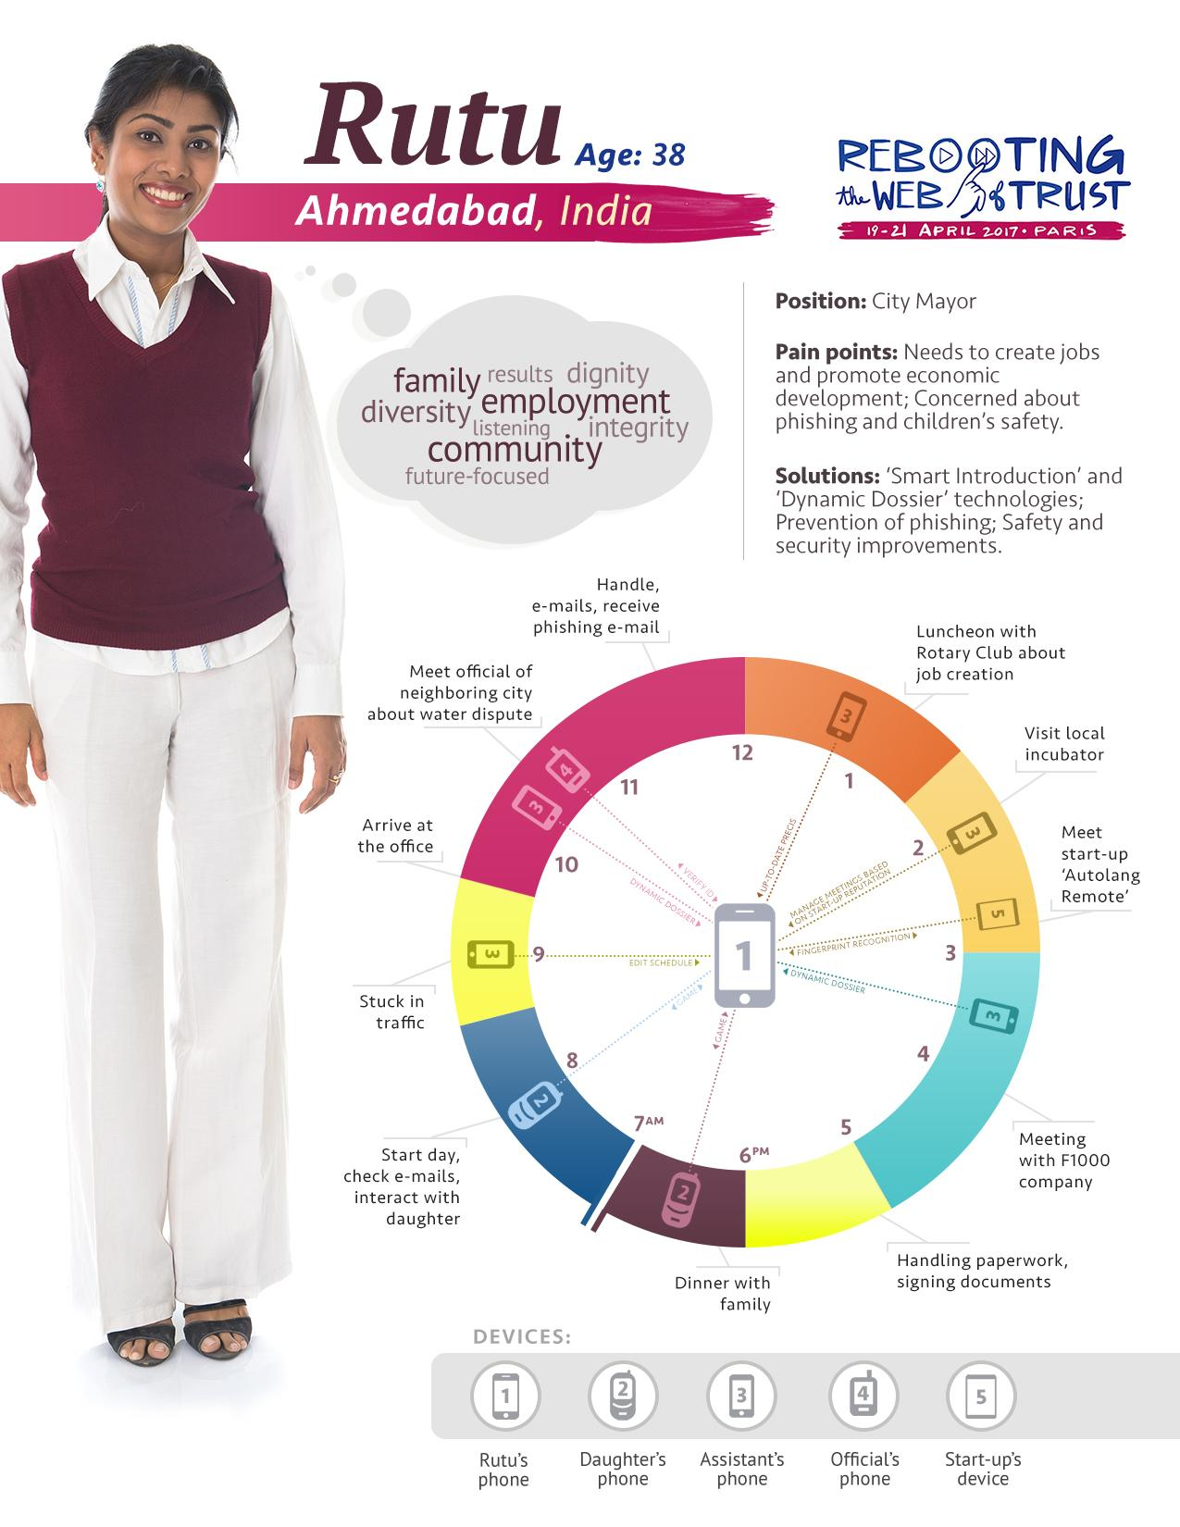

# 

# Appendix A - NOTES

Not to be published.

***Framework***

**Goal**

* recipe for reframing.

**Key concepts**

Painpoint: e.g. fear of being hacked, not knowing how to solve the problem

Trust

Identity

**Paragraph topics:**

* Person ID
* 24h day in their life
* Painpoint: why currently not interested in digital identity/WoT
* solution

Personae

**Old grandmother (Renee, F78, France)**

* **Pain Points**

**CIO (Jack, M56, USA)**

* **Paint Point**

**22yo girl (Mayoni?, F22, Japan)**

* **Paint Point**
  + Stalked by older men and wants to prevent them from seeing pictures of her

**Syrian refugee (Yorm, M25, Damascus, Syria)**

* **Paint Point**

**Medium size town city mayor (Rutu, F38)**

* **24 hour day**
  + **Devices**
    - **(1) Mayor Mobile Device, and laptop**
    - **(2) Assistant Mobile Device**
    - **(3) Kid mobile Device**
    - **(4) Start-up Incubator**
  + 6h00: Wake-up / e-mails (1), (3)
  + 8h30: Out the door / driver (1), (2)
  + 9h30: Arrive at the office (1), (2)
    - Representative from neighboring municipality requests to meet with mayor about water dispute
    - Handle e-mails; Phishing attempt → ID review: ‘Who is this guy?’
  + 12h00: Luncheon / Rotary Club, (1), (2)
    - Jobs.
  + 1h30: Visit local incubator (1), (2), (4)
    - Mentor network → reputation
    - Expedited access to mentors provided based on reputation (“intro token”) → create value through the community
    - Meeting with start-ups (‘Autolang Remote’)
  + 3h00: F1000 meeting (1), (2)
    - e.g. Microsoft, IBM
  + 5pm: signing papers
  + 6pm: Dinner with family (1), (3)

Devices

* Descriptions:
  + Mayor’s device(s)
    - Going home to family, interacting with kids’ devices
  + Neighbouring official (discussing water issue)
    - Position and ID is reflected in the phone
  + Assistant
    - Manage mayor’s schedule (calendar edits)
    - Up-to-date precis on the issue, dynamic dossier of official
  + Startup
    - Fingerprint-based recognition, automatic detection ...
* Painpoints around the clock:

|  |  |  |  |
| --- | --- | --- | --- |
| Persona | Details | Painpoint | Solution |
| **Old grandmother** | Renee  Female  78 y/o  Suburb area (Outreau), France | Very low level of understanding about IT Fear of being hacked Effort is too high to improve | Availability of secure picture-sharing with grandchildren (or other way around)  Easy & secure online banking  Easy ‘discovery’ of family’s digital identity  WoT enables network of family supporters (emergency situations) |
| **CIO (Chief Information Officer)** | Jack  Male  56 y/o  City, USA | Compliance  Too complicated - slows down innovation.  CEO phishing  Avoid the topic (his tech expertise will look dated)  Employees still suffering from fragmented sign on architecture | Developing emotional bonds quickly with …  SSO (Super Sign-On) - significant time-saving  Provides ‘magical’ compliance  Liquidated damages |
| **Female teenager** | Mayumi  Female  17 y/o  Tokyo, Japan | Immature and dismissive of risk (doesn’t care about ID management)  Cyberbullying (by peers / classmates) | Some degree of privacy from her mother  Power over her social profile and interactions across different online services  Gamification plus WoT has potential of promoting more positive engagement |
| **Syrian refugee** | Yorm  Male  25 y/o  Damascus, Syria | Fear of reprisal  Distrust of authorities  Lacks healthcare | Physical ownership and control of personal data store  Provide certification of skills / capabilities  Healthcare passport |
| **Mayor (small city)** | Rutu  Female  38 y/o  Ahmabad, India | Need to create jobs and promote economic development  phishing and security concerns  Concerns over children’s safety | ‘Smart introduction’ solution  Dynamic dossier  Security is improved with Web of Trust  Phish proof |

**Process of reframing**

The process of reframing is based on finding blind spots. When you can detect the blind spots, either in the user or in the self, it unveils the potential for flipping the system. Useful techniques are ethnography, empathy, design-thinking and design sprints, among others. Do not fight the existing reference, create a new one. Name things by what the user wants. In arguing that the user needs better identity measures, for instance, use Super Sign-On instead of DIDAUTH, and terms like Digital Dignity, Trusted Relationships ...

1. <https://en.wikipedia.org/wiki/Amiens>
2. http://en.wikipedia.org/wiki/Ahmedabad
3. <https://georgelakoff.com/>
4. <http://cnms.berkeley.edu>/  
   
5. <https://en.wikipedia.org/wiki/Ahmedabad>