# Creating the New World of Trust

### *Final Notes from Rebooting the Web of Trust*

## 

## What's Next?

On November 3rd and 4th, the Rebuilding the Web of Trust design workshop looked at the future of decentralized trust on the internet with the goal of producing 3-5 white papers and specs. Those papers were polished for release in December, leaving the question: what's next?

Our major goal is to produce something notable for the 25th anniversary of PGP, in July 2016. This should be a working proof-of-concept that can help the Web of Trust to reach a broader audience. It should be something that's both *usable* and *used* and it needs to be *compelling*.

If we can meet this goal, we can make our design ideas into reality.

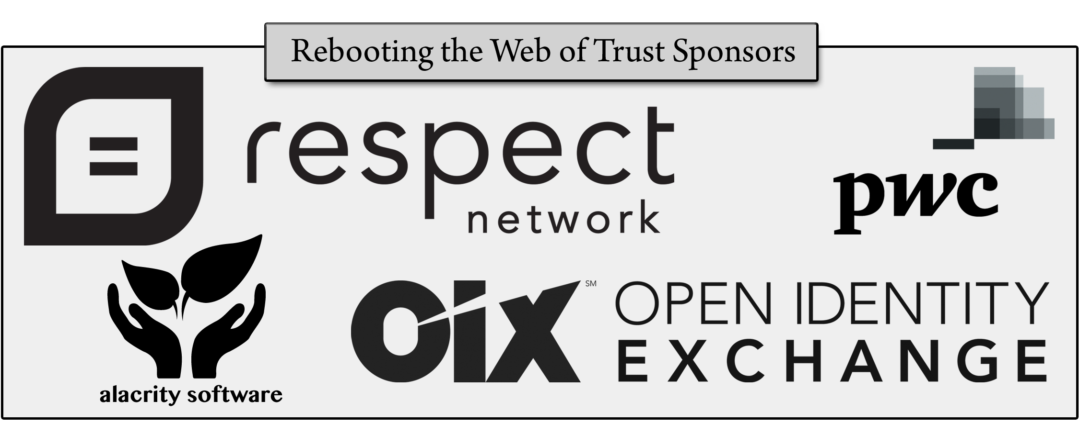

## What We're Building

The white papers and specs produced at the design workshop are the first products of our new Web of Trust, and they can be the germ of our development going forward.

For a next step, we've highlighted some additional papers that we think could draw everything together and help to tell our story. They include an article articulating the need for a new Web of Trust, explanatory introductions for some of our existing white papers, definitions of an agreed-upon language, and possibly a few more use cases.

Beyond that, our design workshop highlighted two projects that were popular and which *could* become a major emphasis for the group.

The first is DPKI, a decentralized PKI system that received an extensive white paper at the design workshop. Figuring out how to fund and ship it was the most popular suggestion for our next step among design workshop participants.

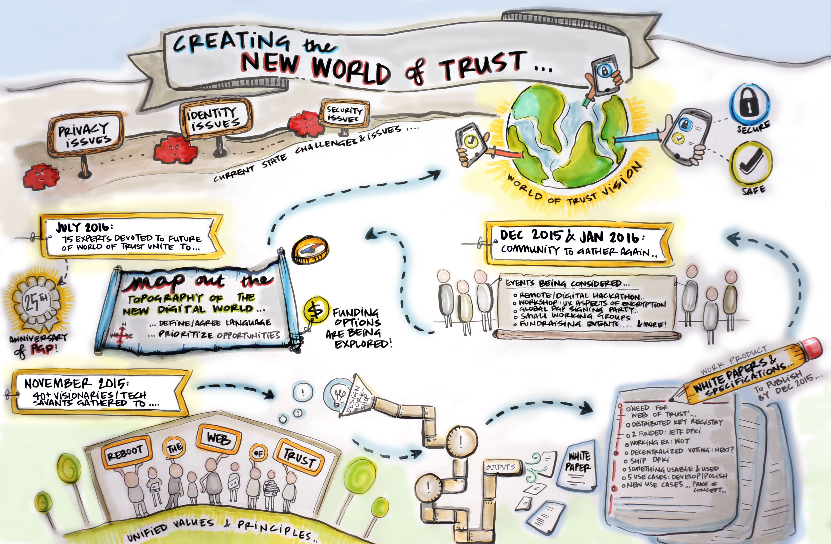The second is a solution for refugee identity as discussed in "Starting from Zero", one of five use cases in the "Opportunities Created by the Web of Trust for Controlling and Leveraging Personal Data" white paper. This use case evolved to discuss the ongoing plight of Syrian refugees but has only increased in importance since the 11/13 terrorist attacks on Paris.

It might be that neither of these projects is right for 2016. The correct answer might be a subset of one of them or something else entirely. But these were the projects that received the most attention at the design workshop, making them a good starting point for discussions.

Whatever project we decide upon, we should keep in mind the following general principles:

* Building a **platform** can be both difficult and expensive, but it's also the sort of thing that you don't want in the hands of a single company, so that might be a perfect goal for an unaffiliated group of this sort.
* However, platforms won't get the public excited. For that we need a killer **app**.
* The most successful project will probably include both a platform *and* an app, supporting the big picture *and* the public perception.

As we map out the topography of the new digital world, we hope to turn our Web of Trust into a whole World of Trust.

## The Road to 2016

The holidays make immediate movement toward 2016 goals difficult, but group hangouts in early January could support the Rebooting the Web of Trust group moving forward.

Those hangouts can also help us decide upon our next event. Possibilities include a hackathon, a workshop, another design shop, small working groups, or even fundraising events. We are committed to holding this next event in Winter 2016. As the first design workshop was held in the California Bay Area, the East Coast might be a good venue for a follow-up event, to help expand the Web of Trust group beyond the 40 or so people present in San Francisco in November.

The ultimate goal is a large get-together in July 2016, where 75 or so experts could celebrate the anniversary of PGP … and unveil the newest addition to the Web of Trust.

## Funding Questions

How to fund a winter 2016 event, any smaller events, and the creation of a compelling release for July 2016 remains an open question. VCs, donations, and grants offer the most obvious sources, but we might also be able to present pitches to the IETF, European DARPA, or even the UN.

To pursue those possibilities, we first need to decide upon our focus. Hopefully that's what the upcoming hangouts will allow. From there we can adapt and expand the early design work we've already done to create proposals or write grants … and ultimately start rebooting the Web of Trust.



### Additional Credits

***Lead Paper Editor:*** *Shannon Appelcline*

***What’s Next Support:*** *Christopher Allen, Brian Weller, Sonia Sawhney*

### About Rebooting the Web of Trust

*This paper was produced as part of the* [***Rebooting the Web of Trust***](http://weboftrust.info) *design workshop. On November 3rd and 4th 2015, over 40 tech visionaries came together in San Francisco, California to talk about the future of decentralized trust on the internet with the goal of writing 3-5 white papers and specs. This is one of them.*

***Workshop Sponsors:*** *Respect Network, PricewaterhouseCoopers, Open Identity Exchange, and Alacrity Software*

***Workshop Producer:*** *Christopher Allen*

***Workshop Facilitators:*** *Christopher Allen and Brian Weller with graphic facilitation by Sonia Sawhney and additional paper editorial & layout by Shannon Appelcline*

### What’s Next?

*The design workshop and this paper are just starting points for Rebooting the Web of Trust. If you have any comments, thoughts, or expansions on this paper, please post them to our GitHub issues page:* [*http://bit.ly/weboftrust-issues*](http://bit.ly/weboftrust-issues)*. We are also planning for more gatherings on this topic in the near future, with the object being to have something notable ready for release on the 25th anniversary of PGP, in July 2016. If you’d like to be involved or would like to help sponsor these events, email:*

*ChristopherA@LifeWithAlacrity.com*