Required Inputs for Hackathon

Use agentic AI and the GEMINI geothermal digital twin to select, size and validate a deep-geothermal system serving an annual heating and cooling load. The design must satisfy explicit thermal, hydraulic and operational constraints and explain every major engineering decision.

Objective and scope
Participants must build an agentic AI orchestration workflow that uses GEMINI for applicable subsurface/well-engineering evaluations and complementary component models for heating and cooling. The agent must interpret the provided demand profiles, generate system configurations, run engineering checks, detect violations, and iteratively improve a proposed design.
GEMINI repository (development branch):
https://github.com/GEMINI-Digital-Twin/gemini-geothermal-suite-open/tree/development
Scope clarification: the autonomous system-level design agent is to be built by participants; do not assume that GEMINI already contains an end-to-end heating-and-cooling optimizer.

Supplied annual demand profiles

Input dataset | File / format | Key figures
Heating demand | gemini_heating_demand_daily_2027.csv • date, heating_demand_MWth | 2027 daily; max 30.0 MWth; 111.67 GWhth/year
Cooling demand | gemini_cooling_demand_daily_2027.csv • date, cooling_demand_MWcool | 2027 daily; max 10.0 MWcool; 23.74 GWhcool/year
Each file contains 365 daily-average power values for 1 January to 31 December 2027. Heating peaks on 28 January; cooling peaks on 19 July. Profiles are synthetic and include seasonal variation and short demand excursions. Convert a day’s power (MW) to daily energy (MWh) by multiplying by 24 hours.
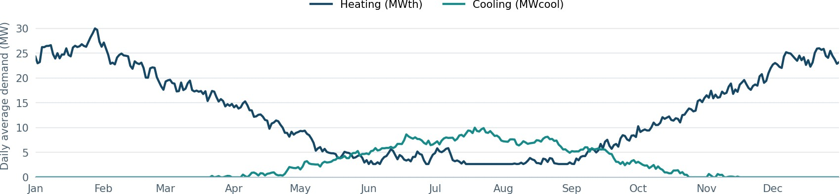

Figure 1. Daily synthetic heating and cooling demand throughout 2027. Source data are the two accompanying CSV files.

Fixed technical inputs

Geothermal reservoir

Parameter | Value | Unit / interpretation
Reservoir midpoint depth | 2,500 | m TVD
Reservoir gross thickness | 100 | m
Geothermal gradient | 30 | °C/km
Reference surface temperature | 12 | °C
Reservoir pressure | 250 | bar(g)
Permeability | 200 | mD

For selecting different geothermal well depth, you can use hydrostatic pressure for reservoir pressure and estimate reservoir temperature based on the provided geothermal gradient.

Geothermal brine and associated gas

Parameter | Specified value | Unit / note
Brine density | 1,030 | kg/m³; reference constant
Dynamic viscosity | 0.40 | mPa·s; reference constant
Gas–liquid ratio | 0.8 | Nm³ gas per m³ produced liquid
Methane fraction in produced gas | 80 | mol% CH₄
Carbon dioxide fraction in produced gas | 20 | mol% CO₂
Fluid composition | Fixed | baseline; variable PVT optional
Define normal cubic metres (Nm³) at 0 °C and 1.01325 bar(a). GLR refers to potentially liberated gas at standard conditions.

3 Design and operating constraints

Constraint | Required setting | Status / interpretation
Number of geothermal doublets | Choose 1–3 | design variable
Maximum production flow | 300 m³/h per doublet | hard challenge cap
Minimum stable flow while active | 50 m³/h per doublet | hard challenge cap
Maximum geothermal brine cooling | 40 °C | hard challenge cap; producer to injector
Pump hydraulic efficiency | 70% | simplified
Production / injection volume balance | Required | same reservoir; equal liquid volumes
Annual operation of geothermal doublet | 330 daily steps | daily power and energy balance
Supply temperature to the demand (heating) | 100 °C | fixed
Supply temperature to the demand (Cooling) | 20 °C | fixed

