Mobile Platform(The Core) Deployment Guide

Creation of Microsoft Message Queues (MSMQs)
NOTE: It is important to ensure that MSMQs is installed on the respective server.
Right click on My Computer and select Manage
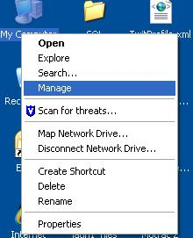

Expand Services and Applications

Expand Message Queuing

Select Private Queues

Right Click private Queues and select New / Private Queue

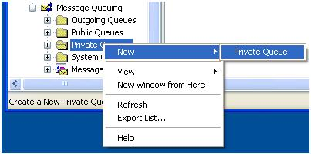

Enter the Queue name to be created

Message Queues

CIQ

COQ

DQ

SIQ

SOQ

Right click the created Queue and select properties

Click on the security tab and assign permission correctly.For development we gave given everyone full control.

Installation of The Core.

Double click on the installation files in this case we are installing the MobilePlatform and follow the following steps.

Please Note: Ensure that the installation is designated to the relevant folder. By Default it will install to the following path: c:\Program Files\Korwe\[Installation Name]

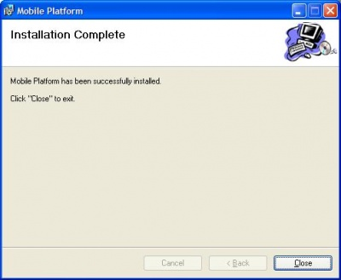

After Installing the services it is important to check if all the services are running. If not you can a check them by performing the following actions:
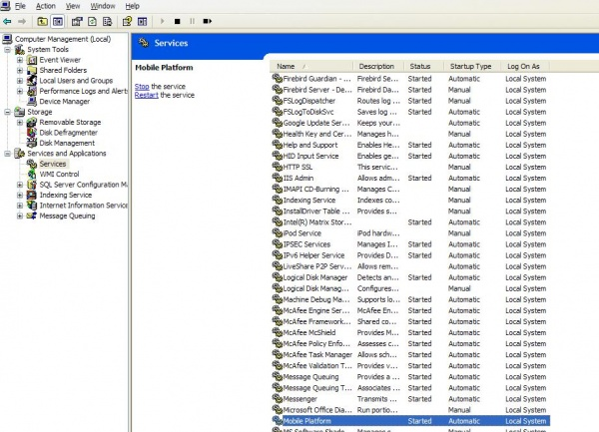

Removing / Deletion of Proxy services
Please Note: The steps below uninstalls the Email Proxy and may be used for uninstalling the rest of the proxies.

Click on start and select control panel (XP professional OS). Select Add or Remove Programs.
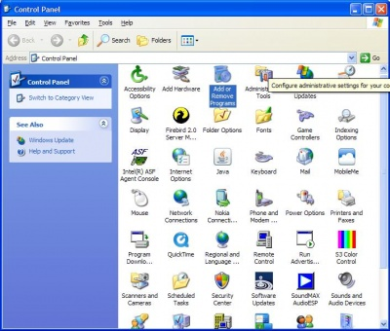

Click the Remove button.
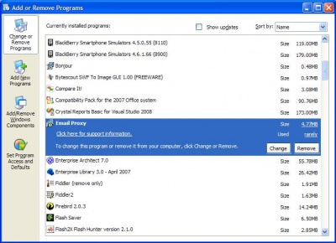
Please Note: That we do not recommend that you remove any files from the actual installed directories. Please use the built-in add remove programs utility in the windows control panel as advised in the step above.

Log File Information
All log files are stored in then c:\Temp folder. These are very important to monitor the way the application run. They are also important for troubleshooting purposes.

C:\Temp\EmailProxy.log
This Log file contains the following information:
- All messages from the SOQ and back to the SIQ and DQ
- Any errors that would have been retained by the korweEmailProxy.
- Timestamps, Procedures/Function concerned are important aspects of the documentation provided in the files.

C:\Temp\MyAccountProxy.log
This Log file contains the following information:
- All messages from the SOQ and back to the SIQ and DQ
- Any errors that would have been retained by the MyAccountProxy.
- Timestamps, Procedures/Function concerned are important aspects of the documentation provided in the files.

C:\Temp\korweFacebookClientLogs.log
This Log file contains the following information:
- All messages from the SOQ and back to the SIQ and DQ
- Any errors that would have been retained by the korweFacebookClientLogs.
- Timestamps, Procedures/Function concerned are important aspects of the documentation provided in the files.

C:\Temp\korweTwitterClientLogs.log
This Log file contains the following information:
- All messages from the SOQ and back to the SIQ and DQ
- Any errors that would have been retained by the korweTwitterClientLogs.
- Timestamps, Procedures/Function concerned are important aspects of the documentation provided in the files.

C:\Temp\MobilePlatform.log
This log file contains the following information:
- Any startup problem that might have a problem have occured during the initialization of the various threads.
- Timestamps, Procedures/Functions concerned are important aspects of the documentation provided in the files.

C:\Temp\MobilePlatformImap.log
This log files contains the following information:
- Any attempts made to connect to the imap server
- Any success/failure connections
- Types of queries made to the inbox - Quota enquiry
- Timestamp as to when such events took place are also documented.

Possible Config Changes
NB: Client operating environmentwhere client is running the application in a clustered environment, the following queue settings are important in the AppSettings section of the Config file of the front end server – Web. Config:
<!-- Queues Configuration-->
<!--add key ="RemoteServer" value ="FormatName:Direct=OS:vmdhislop\Private$\"/-->
<add key ="LocalServer" value =".\Private$\"/>

It is important to note that is this kind of architecture the Front End server requires only the COQ and Dqs . These are not required on the server where The Core will be running. This of course is different from a situation where all applications runs on the same server.

where client is running all applications on the same server the following configuration is apply:

<!-- Queues Configuration-->
<!--add key ="RemoteServer" value ="FormatName:Direct=OS:vmdhislop\Private$\"/-->
<add key ="RemoteServer" value =".\Private$\"/>
<add key ="LocalServer" value =".\Private$\"/>

Please note that these configurations are not done in The Core but in the client front end server application.

The Core configurations – AppConfig.

Please use the accompanying App.Config for your initial settings. The important sections here include logging to text files and appsettings section.

Pleas be adviced also that the XML Message that is now being transmitted between our services now incorporates the machine-name.

