Data:
- Open data from Kaggle - 2015 US Domestic Flights operated by large air carriers.
Datasets: 1.airlines.csv & 2.flights.csv
Airlines.csv
- Airline Identifier mapping - matches IATA_code with name of Airline, ie:
IATA_CODE |  | Airline
UA |  | United Air Lines
AA |  | American Airlines
US |  | US Airways
Flights.csv
- Contains airline flight information, ie Airline, Date, Departure Delay, Arrival Delay, Scheduled Time, Arrival Time etc
- Dimension: 5819079 rows, 31 columns
Preparation:
- Create 2 pandas dataframe from 2 sources, airlines.csv and flights.csv

- Clean the flights df by dropping columns which would be of no use in our analysis:
'TAIL_NUMBER', 'DIVERTED', 'CANCELLATION_REASON', 'DAY', 'MONTH', 'YEAR', 'LATE_AIRCRAFT_DELAY', 'TAXI_OUT', 'TAXI_IN', 'WHEELS_OFF', 'WHEELS_ON', 'AIR_SYSTEM_DELAY', 'FLIGHT_NUMBER', 'SCHEDULED_DEPARTURE', 'DEPARTURE_TIME', 'SCHEDULED_ARRIVAL', 'ARRIVAL_TIME', 'SECURITY_DELAY', 'AIRLINE_DELAY', 'WEATHER_DELAY'

- To make reading the flights df more user friendly when looking at dates we remove the numerical representations for ‘DAY_OF_WEEK’ and replace with the actual name of the day, for example:
7:'Monday'
1:'Tuesday'
2:'Wednesday'
3:'Thursday'
4:'Friday'
5:'Saturday'
6:'Sunday
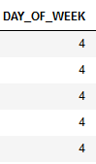 to -> 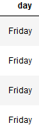

- ‘YEAR’, ‘MONTH’ and ‘DAY’ columns are dropped and combined into 1 date column using pd.to_datetime function
flights['date'] = pd.to_datetime(flights[['YEAR', 'MONTH', 'DAY']])
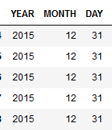 to -> 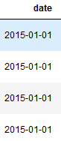

- The flights df contains the airline IATA code. To make reading the airline information easier to read we merge the airline df column ‘AIRLINE’ with the flight df and drop the original ‘AIRLINE’ column
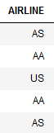 to -> 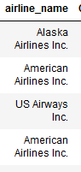

Analysis
The goal of this exercise is to determine the reliability of each airline. To achieve this we’ll take 3 measurements:
- Flown percentage
- Delayed percentage
- Mean arrival delay (minutes)
Because we’re determining statistics for each airline we’ll need to do a groupby for the airlines, this will be our index moving forward
rank_flights1.index.values.tolist()
['Alaska Airlines Inc.',
'American Airlines Inc.',
'American Eagle Airlines Inc.',
'Atlantic Southeast Airlines',
'Delta Air Lines Inc.',
'Frontier Airlines Inc.',
'Hawaiian Airlines Inc.',
'JetBlue Airways',
'Skywest Airlines Inc.',
'Southwest Airlines Co.',
'Spirit Air Lines',
'US Airways Inc.',
'United Air Lines Inc.',
'Virgin America']

- Flown percentage
-number of flights flown / scheduled flights, this should indicate operating efficiency

- Find total # of schedule flights by running a sum on column ‘SCHEDULED_TIME’
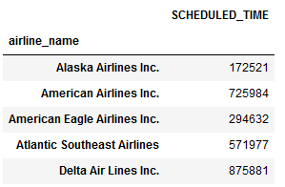

- Find total # of cancelled flights by sum’ing column ‘CANCELLED’
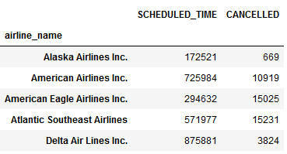

- Add new column called ‘flown’ which represents the actual number of flown flights, this is achieved by ['SCHEDULED_TIME'] - ['CANCELLED']
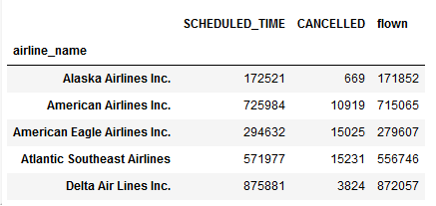

- Get the flown percentage by [‘flown’] / ['SCHEDULED_TIME'] * 100
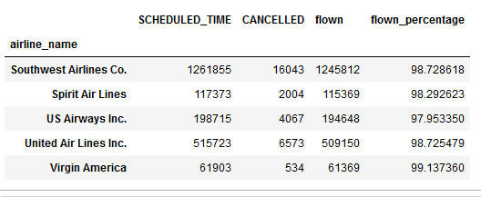

- Based on the ‘flown percentage’ we sort and rank the airlines in ascending order and graph it
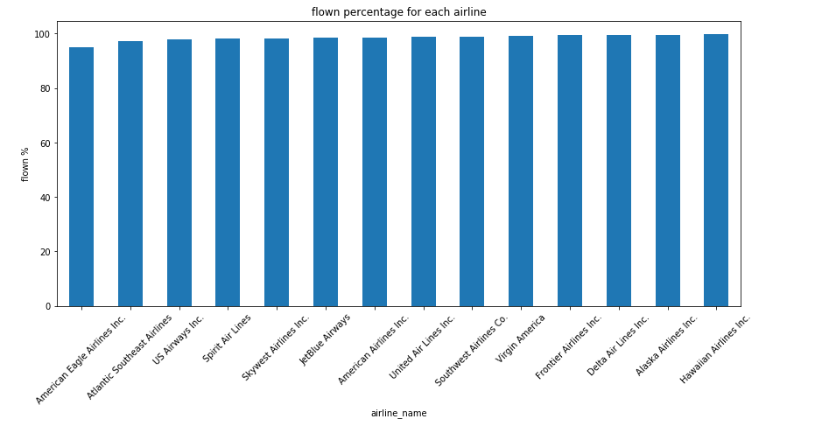

- We then assign a score of 1-14 for each airline, with 1 being the last and 14 being the first place finisher
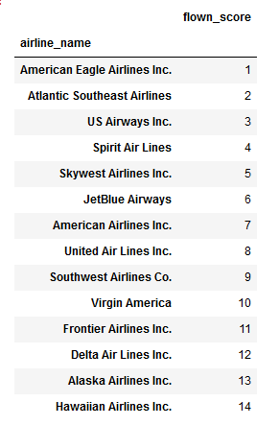

- Delayed Percentage
- Finding what percentage of flights are delayed

- Create a new column called ‘over_1min’ which flags any flights with a ‘1’ if it has been delayed by more than 1 minute

- Find total # of schedule flights by running a sum on column ‘SCHEDULED_TIME’

- Create column ‘delayed’ by adding the sum of column ['over_1min']
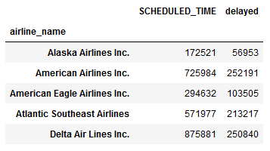

- Get the delay percentage by ['delayed'] / ['SCHEDULED_TIME']*100
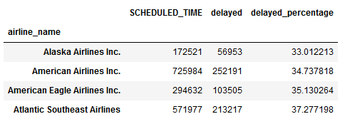

- Based on the ‘delayed_percentage’ we sort and rank the airlines in ascending order and graph it
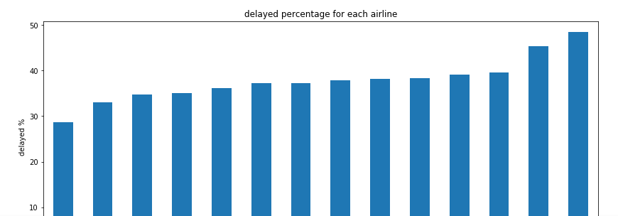

- We then assign a score of 1-14 for each airline, with 1 being the last and 14 being the first place finisher
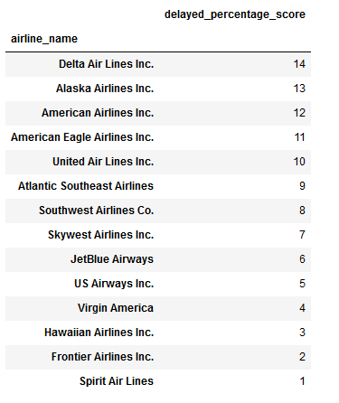

- Mean arrival delay (minutes)
- The mean delay in minutes

  - Find the mean delay in minutes by running a mean() on column ‘ARRIVAL_DELAY’
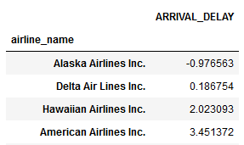

  - Based on the ‘ARRIVAL_DELAY’ we sort and rank the airlines in ascending order and graph it
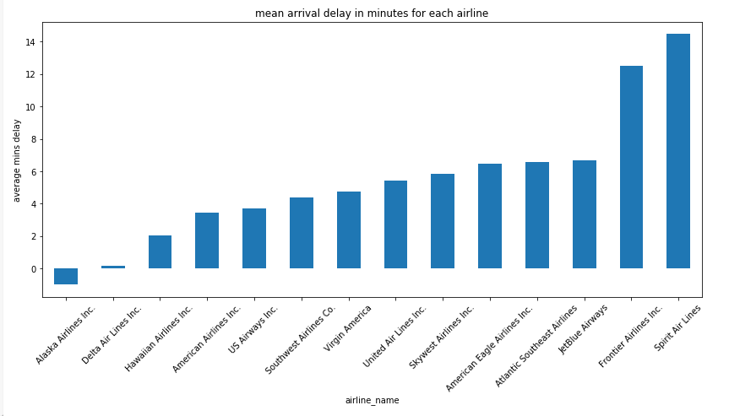
  - We then assign a score of 1-14 for each airline, with 1 being the last and 14 being the first place finisher
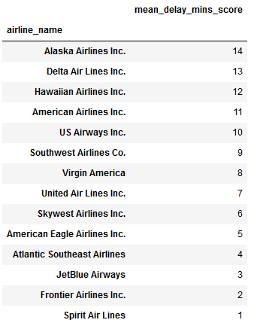
Conclusion:
We will combine the scores from previous rankings into column ‘overall_score’ to determine the best overall performer, the higher the score the better .
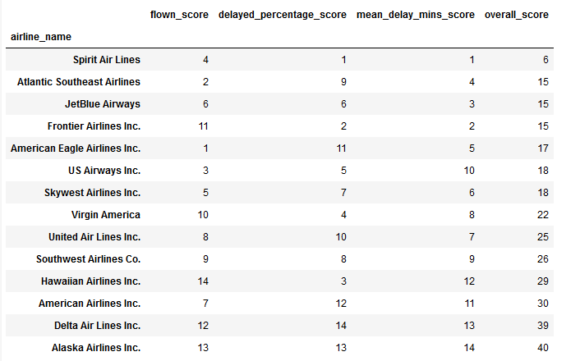

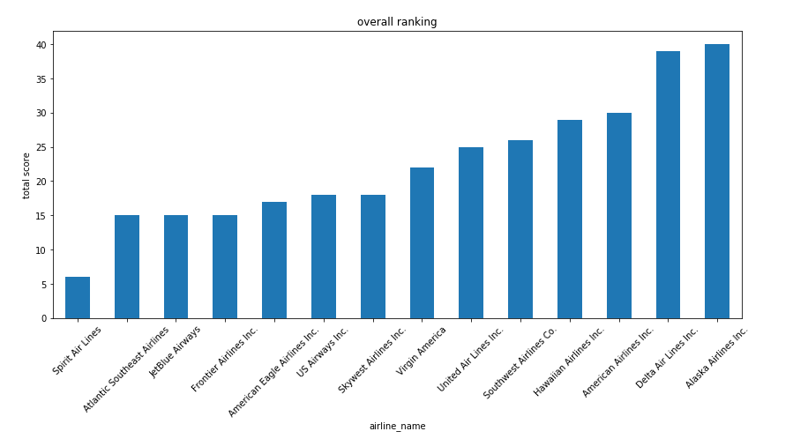
...And the winner is: Alaska Airlines
Addendum: Alaska Airlines probably has the least amount of variables when it comes to flight delays due to the relatively close distance for all its flight paths. We suspect this is why it ranks 1st

