
Jumper Squish
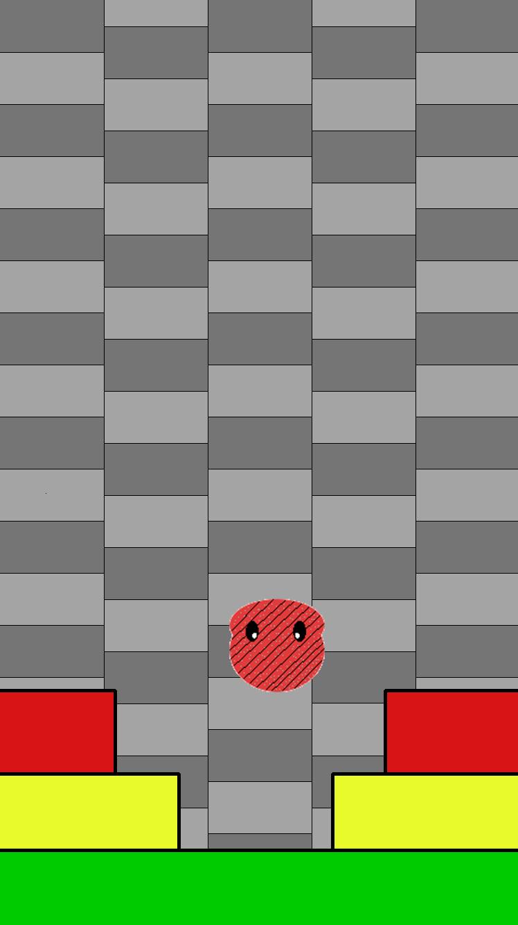
Goal:
- To get to the top of the screen without being squashed.
- The player has to jump before the level crushes them.

Assets:
- Moving background that follows the player
- Color coded blocks that tells how fast the blocks
will try to squash each player.
- Flowing UI
- Have total height traveled
- Make a mode where you go forever.

Other Ideas:
- Cool sound effects
- vibrations when blocks collide.

