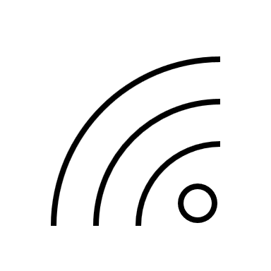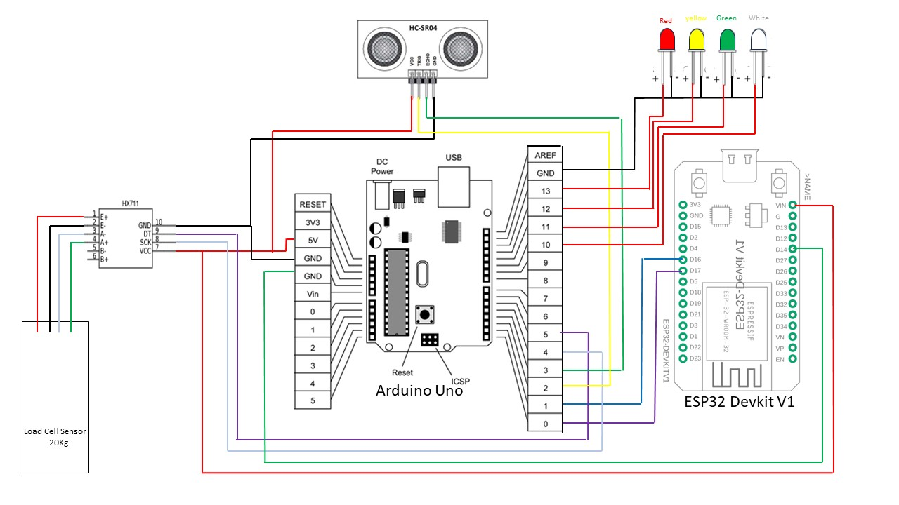

Empty bin white LED blinking

Low Level Geen LED blinking

Medium Level yellow LED blinking

Full Level Red LED blinking