Ideation Phase
Brainstorm & Idea Prioritization Template

Date | 27 September 2026
Team ID | 6ab229b877181cf94a22636a
Project Name | AI WeatherWise
Maximum Marks | 4 Marks

Brainstorm & Idea Prioritization: AI WeatherWise
Brainstorming is a creative process used to identify problems and generate possible solutions. For the AI WeatherWise project, brainstorming helps identify weather-related challenges and develop a web application that provides weather information, AI-generated summaries, and personalized recommendations.
The ideas are grouped and prioritized based on their usefulness, feasibility, and relevance to the project.
Project reference: Mural – Brainstorm and Idea Prioritization Template
.
Step-1: Team Gathering, Collaboration and Select the Problem Statement
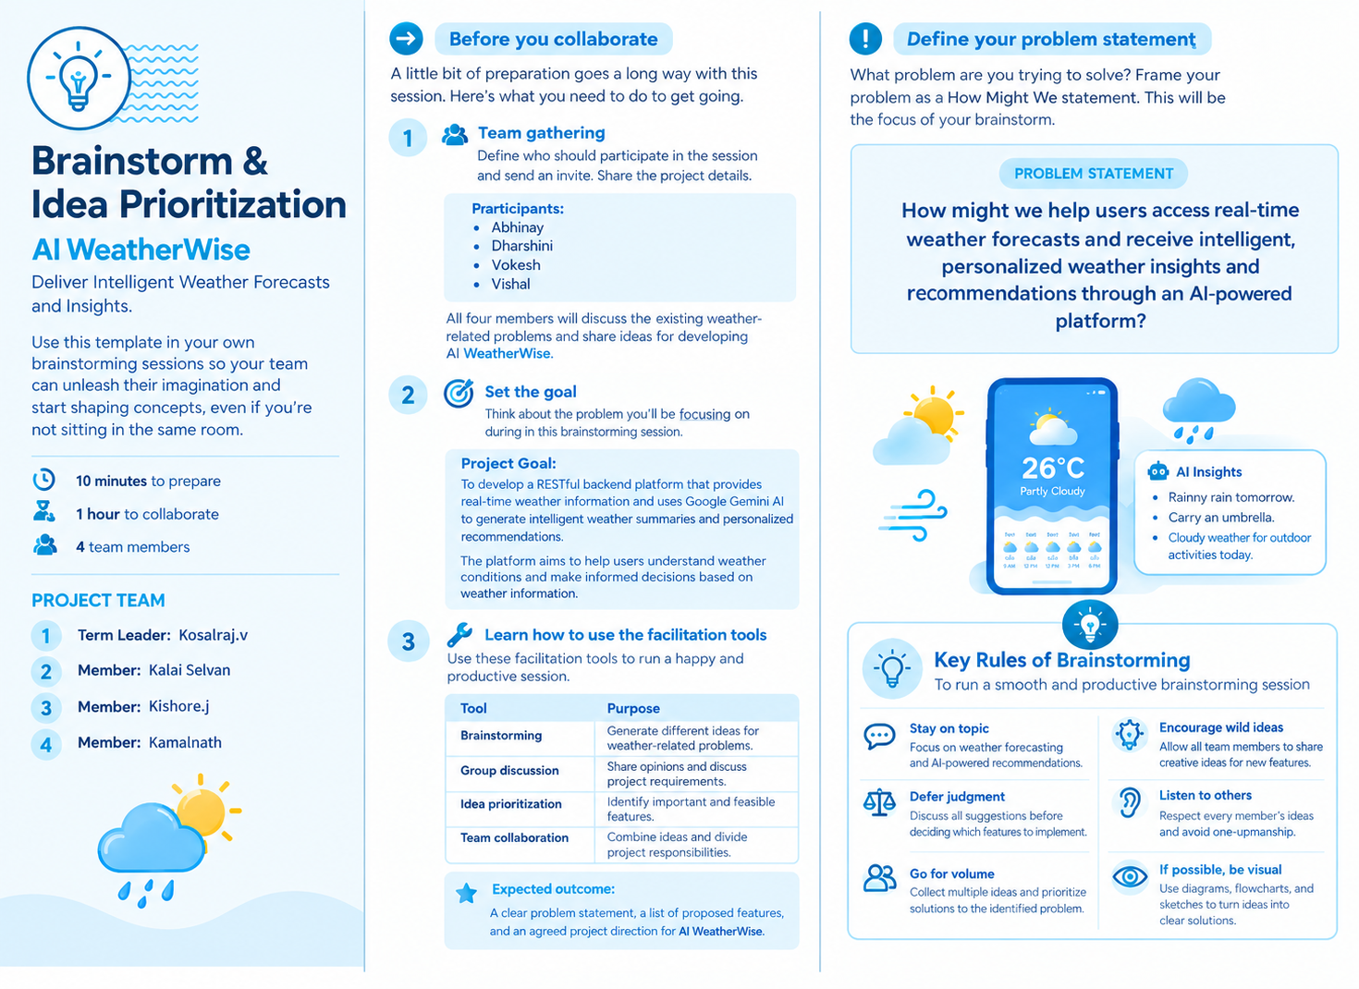

Step-2: Brainstorm, Idea Listing and Grouping
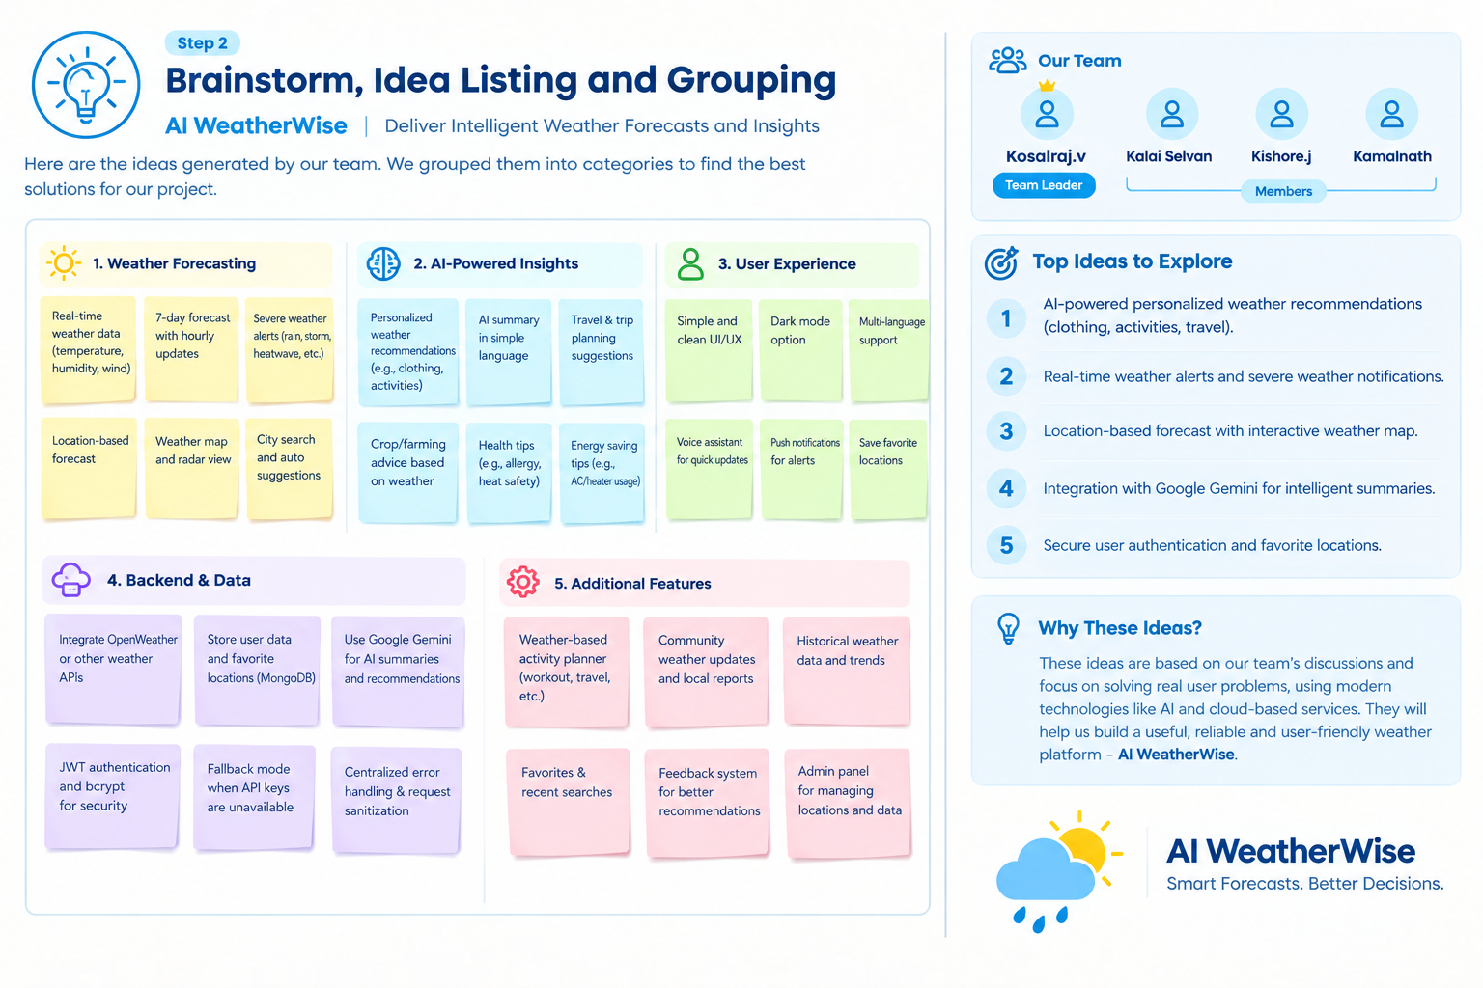
Step-3: Idea Prioritization
