AI WEATHERWISE
PROJECT DEMONSTRATION PHASE
Demonstration of the AI-Powered Weather Intelligence Backend
Node.js | Express.js | MongoDB | OpenWeatherMap | Google Gemini AI

Date | 26 September 2026
Team ID | 6ab229b877181cf94a22636a
Project Name | AI WeatherWise

1. INTRODUCTION
The Project Demonstration phase presents the completed AI WeatherWise backend and shows how the major project functions operate together. The demonstration is performed through Postman or Thunder Client because the project is implemented as a headless RESTful backend rather than a graphical frontend application.
The demonstration covers server execution, user registration and login, JWT authentication, favorite-location management, real-time weather retrieval, AI-based weather recommendations, fallback behavior, administrator operations, and database persistence.

2. DEMONSTRATION OBJECTIVES
- Show that the backend starts successfully and connects to MongoDB.
- Demonstrate secure user registration and login.
- Show JWT-protected access to private APIs.
- Demonstrate complete favorite-location management.
- Display real-time weather information from OpenWeatherMap.
- Demonstrate Gemini AI weather insights when the service is available.
- Show fallback behavior when Gemini or another external service is unavailable.
- Demonstrate administrator-only operations.
- Show that User and Location data is persisted in MongoDB.

3. DEMONSTRATION ENVIRONMENT
Component | Used for Demonstration
Development Environment | Visual Studio Code
Backend Runtime | Node.js
Web Framework | Express.js
Database | MongoDB / MongoDB Atlas
API Testing | Postman or Thunder Client
Weather Integration | OpenWeatherMap API
AI Integration | Google Gemini AI
Authentication | JWT Bearer Token

4. PRE-DEMONSTRATION SETUP
Before starting the demonstration, the following conditions must be verified:
- Required Node.js packages are installed.
- The .env file contains the required configuration values.
- MongoDB connection information is valid.
- OpenWeatherMap and Gemini API keys are configured.
- The backend server is running.
- MongoDB is successfully connected.
- A normal user account and an administrator account are available for demonstration.
Sensitive values such as API keys, JWT secrets, MongoDB credentials, passwords, and complete JWT tokens must not be exposed during the demonstration.

5. DEMONSTRATION SEQUENCE
The following sequence provides a clear end-to-end demonstration of the project without repeating unnecessary API calls.
Step | Demonstration Activity | Expected Output
1 | Start backend server | MongoDB connection and server-running messages are displayed.
2 | Register a user | User account is created successfully.
3 | Login | JWT token and user role are returned.
4 | Save a favorite location | Location is stored for the authenticated user.
5 | View saved locations | User's saved locations are returned.
6 | Update a saved location | Selected location is updated.
7 | Fetch current weather | Live OpenWeatherMap data is returned.
8 | Request AI insight | Gemini insight is returned when the service is available.
9 | Show fallback behavior | Fallback insight is returned if Gemini is unavailable.
10 | Demonstrate admin API | Admin-only user/health endpoint succeeds with an admin token.
11 | Verify MongoDB | User and Location records are visible in the database.
12 | Delete saved location | Selected location is removed successfully.

6. SERVER EXECUTION DEMONSTRATION
The demonstration begins by starting the Node.js backend. A successful start confirms that the server is running and the application can communicate with MongoDB.
Command: npm start
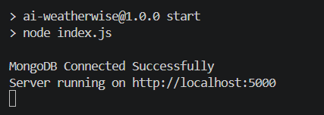

7. USER REGISTRATION DEMONSTRATION
A new user is created through the Register API. The backend validates the input, hashes the password using bcrypt, and stores the user in MongoDB.
Method | Endpoint
POST | /api/auth/register

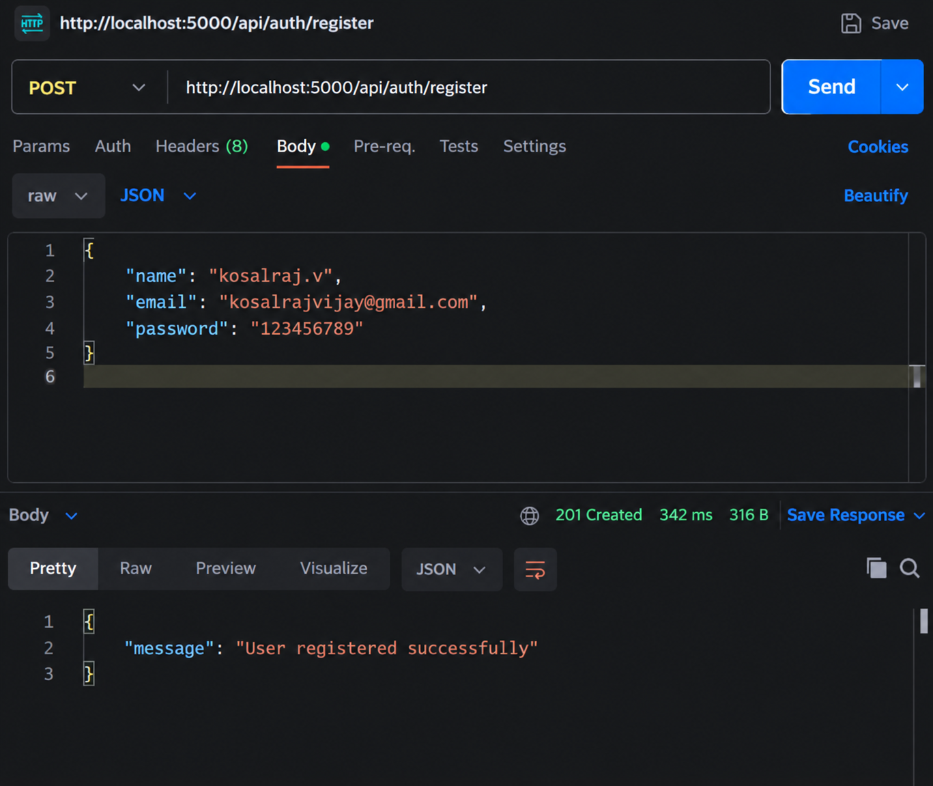

8. LOGIN AND JWT DEMONSTRATION
The registered user logs in using email and password. After successful verification, the backend returns a JWT token. This token is used as a Bearer token for protected requests.
Method | Endpoint
POST | /api/auth/login

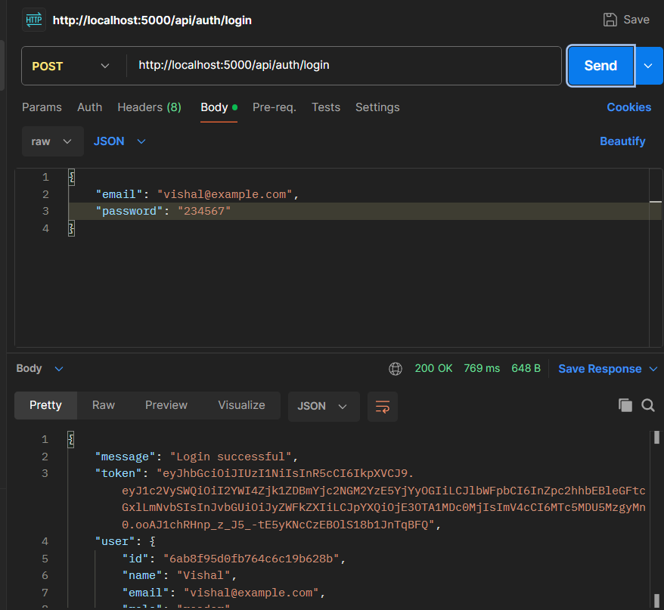

9. FAVORITE LOCATION DEMONSTRATION
The authenticated user demonstrates favorite-location CRUD operations. Each location is associated with the logged-in user's ID.
Operation | Method | Endpoint
Add Location | POST | /api/locations
View Locations | GET | /api/locations
Update Location | PUT | /api/locations/:id
Delete Location | DELETE | /api/locations/:id

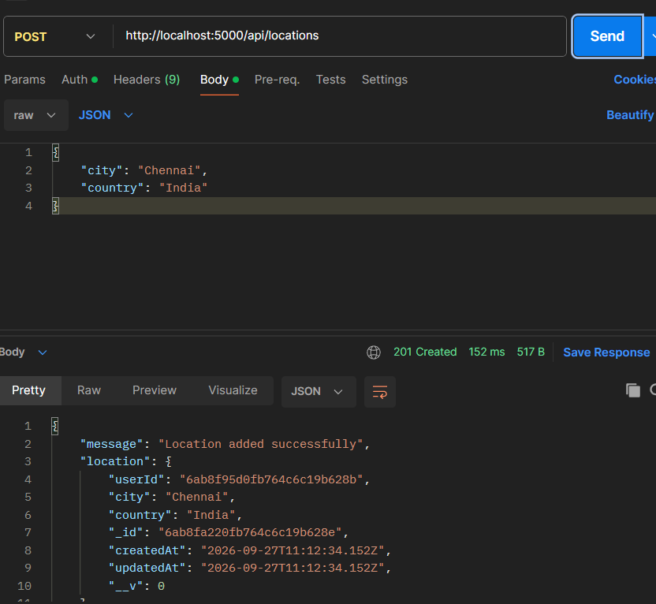

10. REAL-TIME WEATHER DEMONSTRATION
The Current Weather API is demonstrated using a city such as Chennai. The backend requests current conditions from OpenWeatherMap and returns a simplified JSON response.
Method | Endpoint
GET | /api/weather/current/Chennai

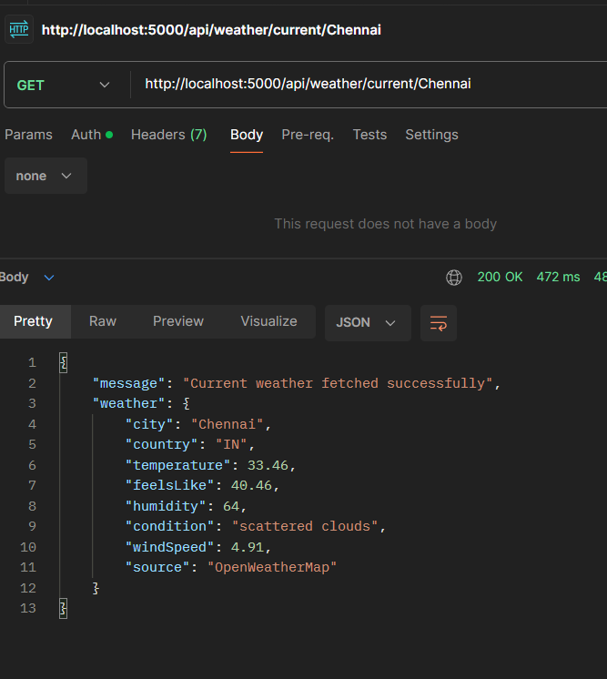
The response demonstrates city, country, temperature, feels-like temperature, humidity, condition, wind speed, and the external data source

11. GEMINI AI INSIGHT DEMONSTRATION
The AI Insight API receives the city and weather data and requests a natural-language recommendation from Google Gemini AI. When the external AI service is available, the response identifies Gemini as the source.
Method | Endpoint
POST | /api/weather/insights
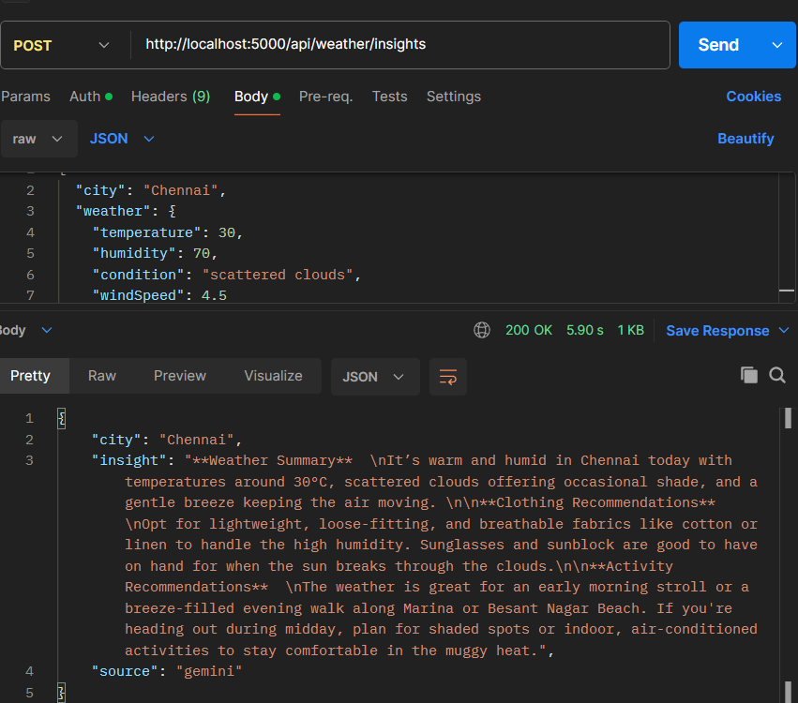

12. FALLBACK DEMONSTRATION
The fallback mechanism demonstrates the reliability of AI WeatherWise. If Gemini is temporarily unavailable or returns an external-service error, the backend catches the failure and returns a basic weather recommendation instead of terminating the request.
During project testing, Gemini returned an HTTP 503 high-demand response. The backend correctly returned a fallback recommendation with the source identified as fallback.

13. ADMIN MODULE DEMONSTRATION
Administrator functionality is demonstrated using a fresh JWT generated from an account whose role is admin. The admin middleware prevents normal reader accounts from accessing these endpoints.
Operation | Method | Endpoint
View Users | GET | /api/admin/users
Create User | POST | /api/admin/users
Delete User | DELETE | /api/admin/users/:id
Health Check | GET | /api/admin/health

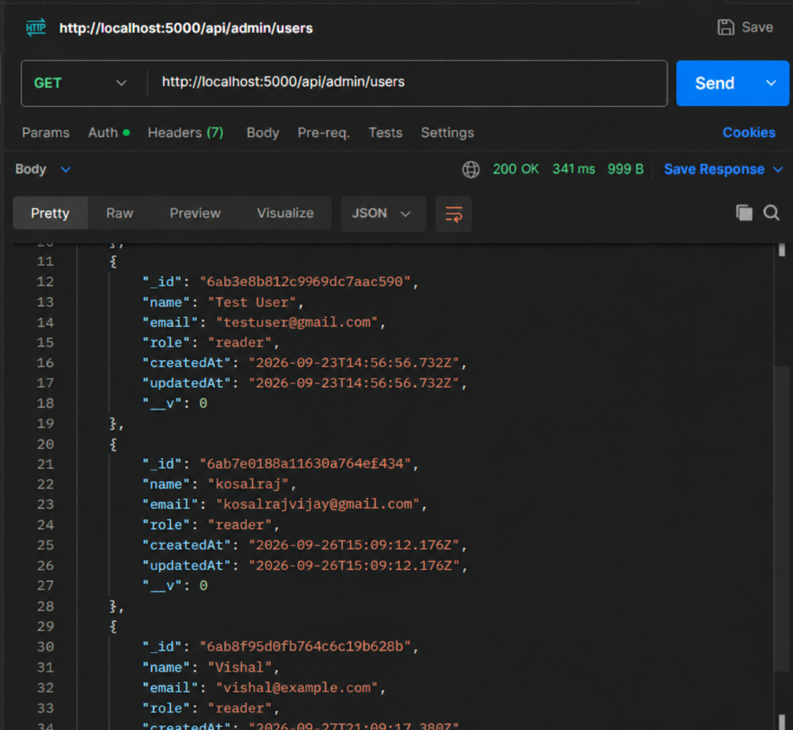

14. DATABASE DEMONSTRATION
MongoDB Atlas is used to demonstrate persistence. The users collection confirms registered accounts, while the locations collection confirms favorite locations linked through userId. 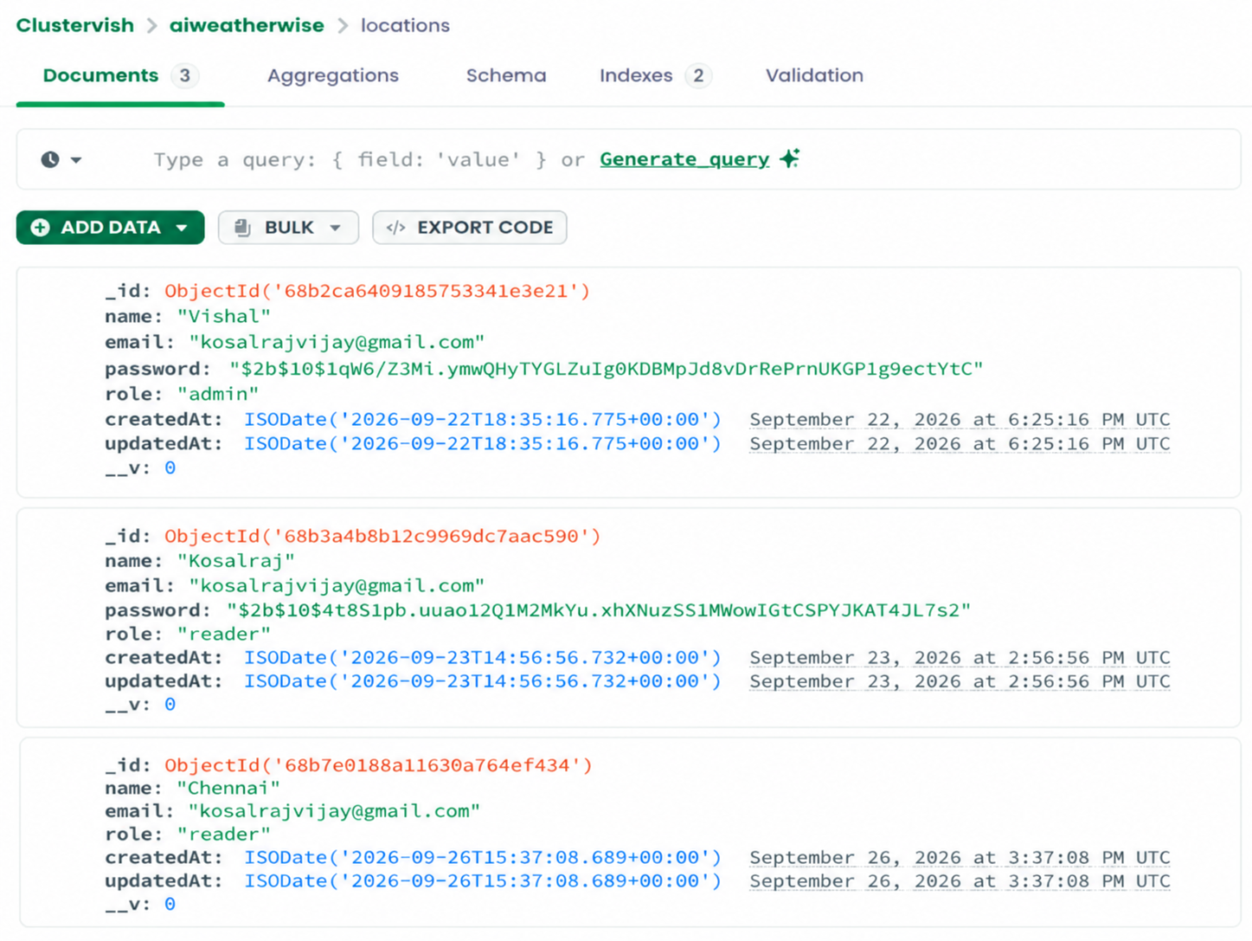

15. END-TO-END DEMONSTRATION FLOW

The complete demonstration can be explained to the evaluator using the following flow:

Start Server → Register → Login → Receive JWT → Save Location → Fetch Weather → Generate AI Insight → Fallback if Required → Admin Check → Verify MongoDB

16. DEMONSTRATION RESULT SUMMARY
Feature Demonstrated | Result
Backend execution and MongoDB connection | Working
User registration | Working
User login and JWT generation | Working
JWT-protected API access | Working
Favorite-location CRUD | Working
OpenWeatherMap live weather | Working
Gemini AI integration | Integrated; output depends on external service availability
Gemini fallback handling | Working
Admin role authorization | Working
MongoDB data persistence | Working

17. IMPORTANT DEMONSTRATION NOTES
- Use a fresh JWT before the final demonstration to avoid an expired-token response.
- For Admin APIs, log in again after confirming the account role is admin so the new token contains the correct role.
- Do not expose the .env file during the demonstration.
- Do not show full API keys, JWT secrets, MongoDB credentials, passwords, or complete JWT tokens.
- If Gemini returns HTTP 503 due to high demand, explain and demonstrate the fallback mechanism instead of treating it as a project crash.
- Keep the demonstration focused on the implemented AI WeatherWise modules; unrelated features are not required.

19. PROJECT DEMONSTRATION CONCLUSION
The Project Demonstration phase successfully presents the complete working flow of AI WeatherWise. The backend starts and connects to MongoDB, users can register and log in securely, JWT authentication protects private operations, and favorite locations can be managed through REST APIs.
The system retrieves live weather information through OpenWeatherMap and integrates Google Gemini AI for natural-language weather insights. When the AI service is temporarily unavailable, the fallback mechanism continues to provide a meaningful recommendation. Role-based authorization also protects administrator operations, while MongoDB provides persistent storage for project data.

