AI WEATHERWISE
PROJECT DESIGN PHASE
System Design for the AI-Powered Weather Intelligence Backend
Node.js | Express.js | MongoDB | OpenWeatherMap | Google Gemini AI

Date | 26 September 2026
Team ID | 6ab229b877181cf94a22636a
Project Name | AI WeatherWise

1. INTRODUCTION
The Project Design phase defines how AI WeatherWise is organized before and during implementation. It converts the functional requirements into a clear technical structure covering system architecture, modules, data storage, request flow, APIs, authentication, external-service integration, and fallback handling.
AI WeatherWise is designed as a headless RESTful backend. Users interact with the system through API clients such as Postman or Thunder Client. The backend processes authentication, saved locations, live weather requests, AI recommendations, and administrator operations.

2. DESIGN OBJECTIVES
- Separate routing, business logic, data models, and security responsibilities.
- Provide secure authentication and role-based authorization.
- Store user and favorite-location data in a structured MongoDB design.
- Integrate live weather information through OpenWeatherMap.
- Integrate Google Gemini AI for weather summaries and recommendations.
- Provide a fallback response when an external AI or weather service is unavailable.
- Keep the backend modular so that individual modules can be maintained independently.

3. SYSTEM ARCHITECTURE DESIGN
The application follows a modular MVC-style backend architecture. API requests first reach the Express server and route layer. Protected requests pass through authentication or administrator middleware. Controllers execute the required business logic and communicate with MongoDB or external APIs.
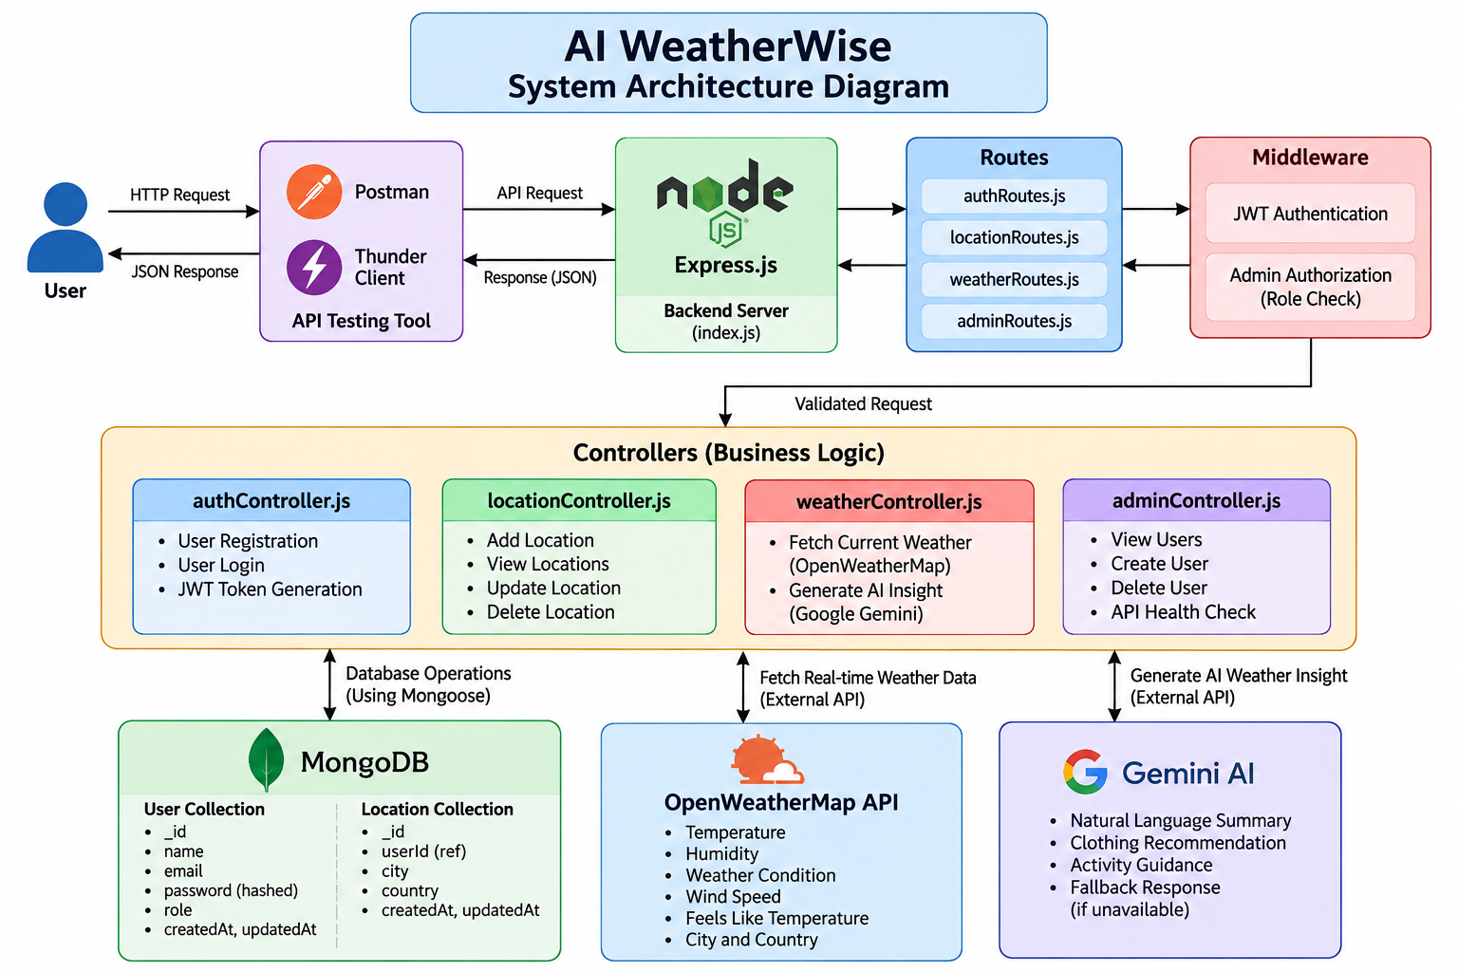
Figure 1: AI WeatherWise System Architecture

4. ARCHITECTURAL COMPONENTS
Component | Design Responsibility
API Client | Postman or Thunder Client sends HTTP requests and receives JSON responses.
Express Server | Receives requests, parses JSON, enables middleware, and maps API routes.
Routes | Direct requests to authentication, location, weather, and admin controllers.
Middleware | Validates JWT tokens and checks the admin role for protected operations.
Controllers | Contain the application business logic and prepare API responses.
Mongoose Models | Define User and Location data structures and communicate with MongoDB.
MongoDB | Stores registered users and their saved locations.
OpenWeatherMap | Provides current weather information for requested cities.
Gemini AI | Generates natural-language weather insights and recommendations.
Fallback Logic | Returns a meaningful response when an external service is unavailable.

5. MODULE DESIGN

5.1 Authentication Module
The Authentication module manages account creation and login.
Function | Design
Register | Accept name, email, and password; hash the password using bcrypt; store the user in MongoDB.
Login | Verify email and password; generate a JWT containing user identity and role.
Token Validation | Protected routes require a valid Bearer token.

5.2 Favorite Location Module
The Location module allows an authenticated user to manage favorite cities.
Operation | Method | Design
Create | POST | Store a city and country with the authenticated user's ID.
Read | GET | Return locations belonging to the authenticated user.
Update | PUT | Update a location only when its ID and owner match.
Delete | DELETE | Delete a location only when its ID and owner match.

5.3 Weather Module
The Weather module receives a city name, requests current conditions from OpenWeatherMap, converts the external response into a simplified JSON structure, and returns it to the client.
- City and country
- Temperature
- Feels-like temperature
- Humidity
- Weather condition
- Wind speed
- Data source

5.4 AI Recommendation Module
The AI Recommendation module accepts the city and weather data and sends a prompt to Google Gemini AI. The generated response is returned as a natural-language weather summary and recommendation. If Gemini is temporarily unavailable, fallback logic produces a basic recommendation from the supplied weather data.

5.5 Admin Module
The Admin module is protected by both JWT authentication and an administrator role check.
Operation | Purpose
View Users | Retrieve registered users without exposing stored passwords.
Create User | Create a user account with a selected role.
Delete User | Remove a selected user account.
Health Check | Verify that the backend API is running.

6. DATABASE DESIGN
MongoDB is used as the persistence layer. Mongoose schemas define the structure and validation rules for the two core entities: User and Location.

6.1 User Entity
Field | Type | Constraint / Purpose
_id | ObjectId | Primary identifier generated by MongoDB
name | String | Required user name
email | String | Required and unique login email
password | String | Required hashed password
role | String | Defaults to "reader"; "admin" enables administrator access
createdAt | Date | Automatically generated timestamp
updatedAt | Date | Automatically generated timestamp

6.2 Location Entity
Field | Type | Constraint / Purpose
_id | ObjectId | Primary identifier generated by MongoDB
userId | ObjectId | Reference to the User who owns the location
city | String | Required city name
country | String | Required country name
createdAt | Date | Automatically generated timestamp
updatedAt | Date | Automatically generated timestamp

6.3 Entity Relationship Design
The relationship is one-to-many: one User can own multiple Location records, while each Location belongs to one User.
+------------------+ 1 M +------------------+
| USER |---------------------------->| LOCATION |
+------------------+ +------------------+
| _id | | _id |
| name | | userId (ref) |
| email | | city |
| password | | country |
| role | | timestamps |
+------------------+ +------------------+

7. DATA FLOW DESIGN

7.1 Authentication Flow
User
|
| Register / Login Request
v
Auth Route
|
v
Auth Controller
|
+----> bcrypt password processing
|
+----> MongoDB User Collection
|
`----> JWT Token on successful login

7.2 Weather and AI Insight Flow
User / API Client
|
| City Request
v
Weather Route
|
v
Weather Controller
|
+------> OpenWeatherMap API ------> Live Weather JSON
|
| Weather Data
v
Gemini AI
|
+------> AI Insight
|
`------> Fallback Insight if Gemini is unavailable

7.3 Saved Location Flow
Authenticated User
|
| Bearer JWT
v
Location Route
|
v
Auth Middleware
|
v
Location Controller
|
v
MongoDB Location Collection
|
v
JSON Response

8. API DESIGN
Module | Method | Endpoint | Protection
Register | POST | /api/auth/register | Public
Login | POST | /api/auth/login | Public
Current Weather | GET | /api/weather/current/:city | Public
AI Insight | POST | /api/weather/insights | JWT
Add Location | POST | /api/locations | JWT
View Locations | GET | /api/locations | JWT
Update Location | PUT | /api/locations/:id | JWT
Delete Location | DELETE | /api/locations/:id | JWT
View Users | GET | /api/admin/users | Admin
Create User | POST | /api/admin/users | Admin
Delete User | DELETE | /api/admin/users/:id | Admin
Health Check | GET | /api/admin/health | Admin

9. SECURITY DESIGN
Security Control | Design
Password Protection | bcrypt hashes passwords before database storage.
JWT Authentication | Protected requests must contain a valid Bearer token.
Role Authorization | Admin middleware permits administrator APIs only when role is admin.
Data Ownership | Location operations use both location ID and authenticated user ID.
Secret Management | MongoDB URI, JWT secret, Gemini key, and Weather API key are stored in .env.
Public Repository Safety | .env is excluded using .gitignore.

10. EXTERNAL API INTEGRATION DESIGN
Service | Input | Output | Failure Handling
OpenWeatherMap | City name | Current weather metrics | Return fallback weather information when live retrieval fails.
Google Gemini AI | City + weather data | Natural-language summary and recommendations | Return locally generated fallback insight when Gemini fails or is unavailable.

11. ERROR AND FALLBACK DESIGN
The backend is designed to return controlled JSON responses instead of terminating when expected errors occur. Validation errors return suitable messages, authentication failures reject protected requests, missing resources return a not-found response, and external-service failures are handled by fallback logic.
Situation | Designed Response
Missing required fields | 400-level validation response
Invalid login credentials | Authentication error response
Missing / invalid JWT | Unauthorized response
Non-admin accesses admin API | Forbidden / admin access required response
Location ID not found | Location not found response
OpenWeatherMap unavailable | Fallback weather response
Gemini unavailable / high demand | Fallback weather recommendation

12. REQUEST SEQUENCE DESIGN
Typical registered-user sequence:
1. User registers an account.
2. User logs in.
3. Server verifies credentials and returns a JWT.
4. User sends the JWT with protected requests.
5. User saves one or more favorite locations.
6. User requests current weather for a city.
7. Backend obtains live weather from OpenWeatherMap.
8. User sends weather data to the AI Insight endpoint.
9. Gemini generates a recommendation when available.
10. If Gemini is unavailable, the fallback recommendation is returned.

13. DESIGN VALIDATION
The design is validated by mapping every implemented feature to a module, route, controller, security rule, and data source. The design covers the complete basic project scope without requiring a frontend.
Requirement | Design Component
Registration and Login | Authentication module + User model
Secure Access | JWT middleware
Favorite Locations | Location controller + Location model
Real-time Weather | Weather controller + OpenWeatherMap
AI Recommendation | Weather controller + Gemini AI
Fallback Response | Controller error/fallback logic
Administrator Access | Admin controller + admin middleware
Persistent Storage | MongoDB + Mongoose

14. DESIGN PHASE OUTPUT
The Project Design phase establishes the complete technical blueprint for AI WeatherWise. The architecture, module responsibilities, database entities, one-to-many relationship, request flows, API endpoints, authentication controls, external integrations, and fallback behavior are defined before final execution and testing.
This design directly supports the implemented backend and can be used by evaluators to understand how each project requirement is represented in the system.

