Project Design Phase-II
Data Flow Diagram & User Stories
Date | 27 September 2026
Team ID | 6ab229b877181cf94a22636a
Project Name | AI WeatherWise
Maximum Marks | 4 Marks
Data Flow Diagrams:
A Data Flow Diagram (DFD) shows how data moves through AI WeatherWise: how it enters the system, what processes transform it, where it is stored, and how it leaves the system towards the user, the OpenWeatherMap API, and the Google Gemini API.

Level 0 DFD (Context Diagram):
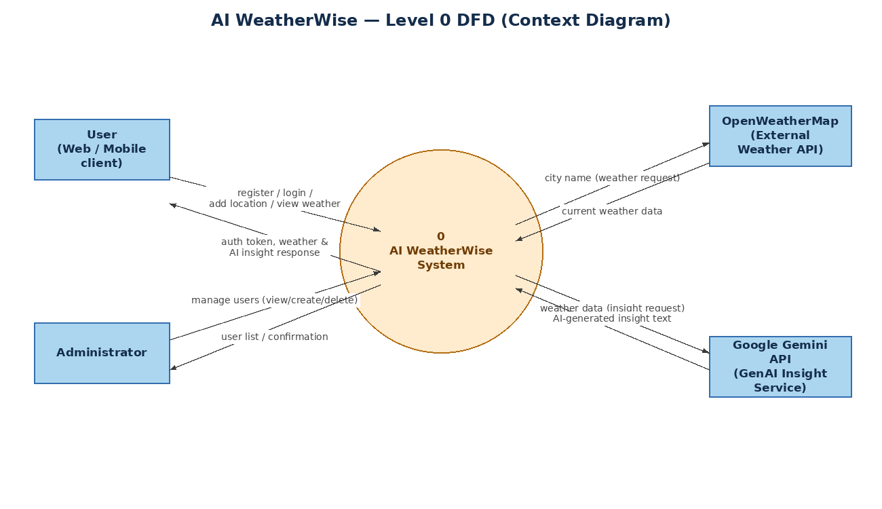
Level 1 DFD:
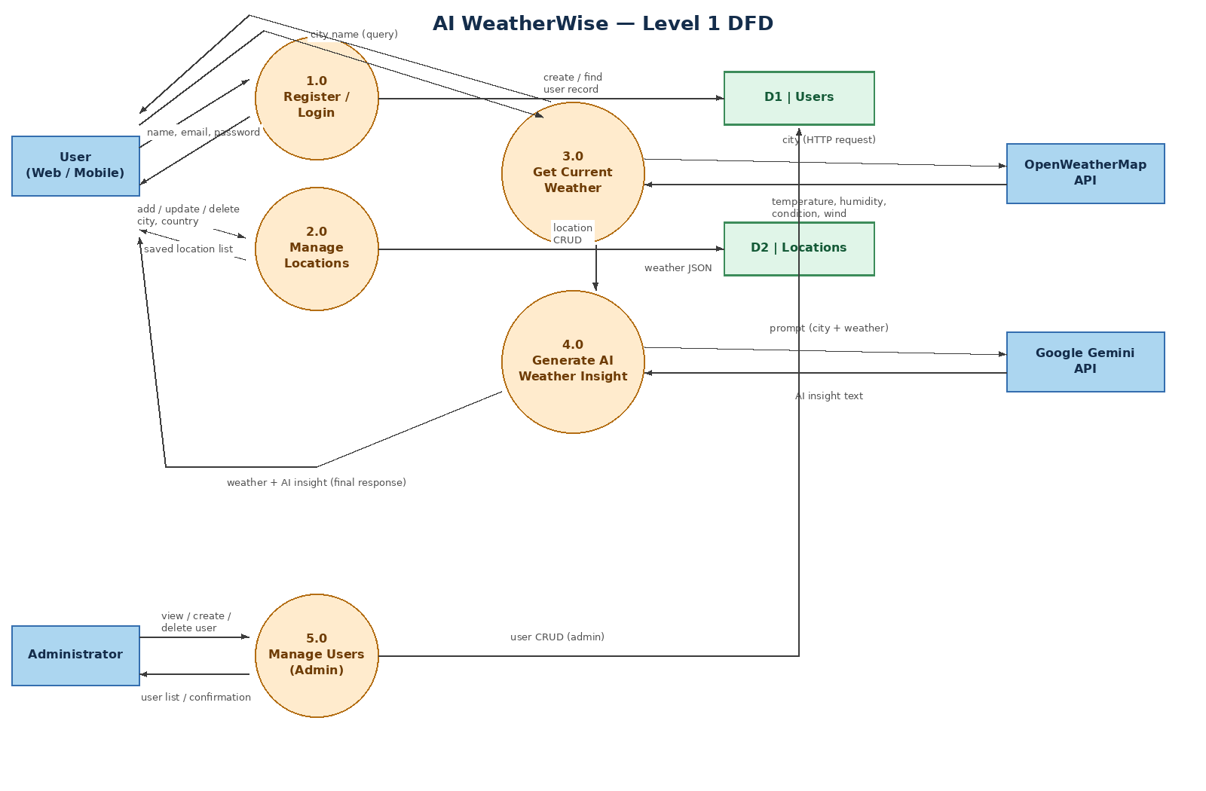
User Stories
User stories for AI WeatherWise, grouped by user type and functional requirement (epic):
User Type | Functional Requirement (Epic) | User Story Number | User Story / Task | Acceptance criteria | Priority | Release
Customer  (Web / Mobile user) | Registration | USN-1 | As a user, I can register for the application by entering my name, email, and password. | I can access my account / dashboard after registering. | High | Sprint-1
Customer  (Web / Mobile user) | Registration | USN-2 | As a user, I want my password stored securely so my account stays protected. | Password is hashed (bcrypt) before being saved to the database. | High | Sprint-1
Customer  (Web / Mobile user) | Login | USN-3 | As a user, I can log into the application using my registered email and password. | I receive a JWT token and can access protected endpoints. | High | Sprint-1
Customer  (Web / Mobile user) | Login | USN-4 | As a user, I want to stay logged in for a reasonable session so I don't have to log in repeatedly. | JWT token remains valid for 1 day from login. | Medium | Sprint-1
Customer  (Web / Mobile user) | Location Management | USN-5 | As a user, I can add a city and country as one of my saved locations. | The new location is saved and linked to my account. | High | Sprint-1
Customer  (Web / Mobile user) | Location Management | USN-6 | As a user, I can view all of my saved locations. | I can see the list of locations I have saved. | High | Sprint-1
Customer  (Web / Mobile user) | Location Management | USN-7 | As a user, I can update the city/country of a saved location. | The updated location details are reflected immediately. | Medium | Sprint-2
Customer  (Web / Mobile user) | Location Management | USN-8 | As a user, I can delete a saved location I no longer need. | The location is removed from my saved list. | Medium | Sprint-2
Customer  (Web / Mobile user) | Weather Dashboard | USN-9 | As a user, I can view current weather (temperature, humidity, condition, wind) for any city. | Weather details for the requested city are displayed. | High | Sprint-1
Customer  (Web / Mobile user) | Weather Dashboard | USN-10 | As a user, I still want to see basic weather info even if the live weather service is unreachable. | Fallback weather data is shown when the external API fails. | Medium | Sprint-2
Customer  (Web / Mobile user) | Weather Dashboard | USN-11 | As a user, I can request an AI-generated summary and activity/clothing recommendation based on current weather. | An AI-generated insight is displayed for the selected city. | High | Sprint-2
Customer  (Web / Mobile user) | Weather Dashboard | USN-12 | As a user, I want a sensible recommendation even when the AI service is unavailable. | A rule-based fallback insight is shown when Gemini is unreachable. | Low | Sprint-2
Customer  (Web / Mobile user) | Weather Dashboard | USN-13 | As a user, after logging in I want a dashboard showing my saved locations for quick access. | Dashboard lists saved locations with a way to check weather for each. | Medium | Sprint-2
Customer Care Executive | — | — | Not applicable — this project does not define a Customer Care Executive role in the current scope. | — | — | —
Administrator | User Administration | USN-14 | As an admin, I can view a list of all registered users. | Admin sees the full user list with passwords excluded. | High | Sprint-2
Administrator | User Administration | USN-15 | As an admin, I can create a new user account directly, optionally setting its role. | New user is created and stored in the database. | Medium | Sprint-2
Administrator | User Administration | USN-16 | As an admin, I can delete a user account. | The user is removed from the system. | Medium | Sprint-2
Administrator | User Administration | USN-17 | As an admin, I can check that the API/service is healthy. | Admin health-check endpoint confirms the API is running. | Low | Sprint-2

