E - COMMERCE ORDER MANAGEMENT SYSTEM
A DBMS Capstone Project Report submitted in partial fulfillment of the requirements for the award of the degree of
BACHELOR OF TECHNOLOGY
in
ARTIFICIAL INTELLIGENCE AND MACHINE LEARNING

Submitted By
KOSANA ANITHA – 25B11AI580
MOTURI LAXMI ANUSHA – 25B11AI759
DANTHULURI V S S D RAGHAVA RAJU – 25B11AI250
MOTURI VYSHNAVI AMULYA – 25B11AI641

Under the esteemed guidance of
Mr. T.Srinivasulu M.Tech, (Ph.D.)
Assistant Professor



DEPARTMENT OF ARTIFICIAL INTELLIGENCE AND MACHINE LEARNING
ADITYA UNIVERSITY
(Formerly Aditya Engineering College (A))
Aditya Nagar, ADB Road, Surampalem, Andhra Pradesh, India
2026 – 2027

Aditya Nagar, ADB Road, Surampalem, Andhra Pradesh, India
DEPARTMENT OF ARTIFICIAL INTELLIGENCE AND MACHINE LEARNING
CERTIFICATE
This is to certify that the DBMS Capstone Project report entitled “E - Commerce Order Management System” is being submitted by KOSANA ANITHA (Roll No 25B11AI580), Moturi Laxmi Anusha (Roll No. 25B11AI759), DANTHULURI V S S D RAGHAVA RAJU (Roll No.25B11AI250) and MOTURI VYSHNAVI AMULYA (Roll No.25B11AI641) in partial fulfillment of the requirements for the award of the B.Tech. degree in Artificial Intelligence and Machine Learning. The work documented in this report was carried out as part of the Capstone Project for the course Database Management Systems (2501IT05) during the academic year 2026–2027, and records the database design, implementation, and documentation undertaken by the team.

Project Guide Head of the Department
Mr. T. Srinivasulu, M. Tech, (Ph.D.) Dr. K. Naga Bhargavi, M. Tech, Ph.D. Associate professor Associate Professor & HOD

External Examiner

DECLARATION
We hereby declare that the DBMS Capstone Project entitled “E - Commerce Order Management System” is a genuine work carried out by us. The database design, SQL implementation, queries and documentation presented in this report are our own work, completed under the guidance of Mr. T. Srinivasulu, Department of Artificial Intelligence and Machine Learning, Aditya University, Surampalem. We further declare that this work has not been submitted, in full or in part, for the award of any degree of this or any other educational institution.

Project Associates
KOSANA ANITHA – 25B11AI580
MOTURI LAXMI ANUSHA – 25B11AI759
DANTHULURI V S S D RAGHAVA RAJU – 25B11AI250
MOTURI VYSHNAVI AMULYA – 25B11AI641

Date: ____________
Place: Surampalem

ACKNOWLEDGEMENT
It is with immense pleasure that we express our indebted gratitude to our project guide Mr. T. Srinivasulu, Department of Artificial Intelligence and Machine Learning, who guided us throughout the capstone project. We are thankful for the constant encouragement and valuable suggestions received at every review stage.
We are grateful to Dr. K. Naga Bhargavi, Head of the Department, for inspiring us and for arranging the facilities and resources needed for this project.
We extend our sincere thanks to the Management, Dr. M. Sreenivasa Reddy, Deputy Pro-Chancellor, Dr. M. B. Srinivas, Vice-Chancellor, and Dr. A. Ramesh, Pro Vice-Chancellor (Engineering & Sciences), for providing an excellent academic environment.
Not to forget, we thank the Teaching and Non-Teaching Staff, our parents and our friends, who have directly or indirectly supported us in completing this project on time.

Project Associates
Student Name KOSANA ANITHA Regd. No.25B11AI580
Student Name MOTURI LAXMI ANUSHA Regd. No.25B11AI759
Student Name DANTHULURI V S S D RAGHAVA RAJU Regd. No.25B11AI250
Student Name MOTURI VYSHNAVI AMULYA Regd. No.25B11AI641

ABSTRACT

The E-Commerce Order Management System is a database project developed in the e-commerce domain to manage online shopping and order-related information in a structured and efficient way. The system solves common problems such as unorganized data, data duplication, manual errors, difficulty in tracking orders, and slow retrieval of information. The main purpose of the database is to centrally store and manage customer, product, order, payment, and delivery information while maintaining data consistency and accuracy. The scope of the system includes managing the complete order process, from customer order placement to payment and delivery. The database consists of six main entities: Customer, Product, Order, Order Item, Payment, and Delivery, which are represented as six relational tables. Primary keys and foreign keys are used to uniquely identify records and establish relationships between tables. The system uses a relational DBMS and SQL for database implementation. The main SQL operations include creating tables, inserting, updating, deleting, and retrieving records using queries. The outcome is a well-structured database that reduces redundancy, improves consistency, and supports efficient e-commerce order management.

INDEX
Chapter | Title | Page No.
 | Certificate | i
 | Declaration | ii
 | Acknowledgement | iii
 | Abstract | iv
 | List of Figures | v
 | List of Tables | vi
1 | Introduction | 1
 | 1.1 Introduction to the Domain | 2
 | 1.2 Problem Statement | 3
 | 1.3 Motivation and Need for a Database | 4
 | 1.4 Objectives of the Project | 5
 | 1.5 Scope of the Project | 6
 | 1.6 Organization of the Report | 7
2 | System Study and Tools | 8
 | 2.1 Existing System and Its Limitations | 9
 | 2.2 Proposed Database System | 10
 | 2.3 Tools and Technologies Used | 11
 | 2.4 Software and Hardware Requirements | 12
3 | Database Design (Review – I) | 13
 | 3.1 Identified Entities | 14
 | 3.2 Entity Attributes and Attribute Types | 15
 | 3.3 ER Diagram | 16
 | 3.4 Relationships and Cardinality | 17
 | 3.5 Relational Database Schema | 18
 | 3.6 Primary Keys and Foreign Keys | 19
 | 3.7 Normalization up to 3NF | 20
4 | Database Implementation (Review – II) | 21
 | 4.1 Database and Table Creation – DDL | 22
 | 4.2 Sample Data Insertion – DML | 23
 | 4.3 Constraints and Data Integrity | 24
 | 4.4 Data Validation Rules | 25
5 | SQL Operations and Queries | 26
 | 5.1 DQL – Basic Retrieval Queries | 27
 | 5.2 Join Operations | 28
 | 5.3 Aggregate Functions, GROUP BY and HAVING | 29
 | 5.4 Nested and Correlated Subqueries | 30
 | 5.5 Views and Relational Set Operations | 31
 | 5.6 DCL and TCL Operations | 32
6 | Modules and Functionalities | 33
7 | Results – Sample Outputs and Screenshots | 34
8 | Testing and Data Validation | 35
9 | GitHub Repository and Team Contribution | 36
10 | Conclusion and Future Enhancements | 37
 | References | 38
 | Appendix A – Complete SQL Script | 39

LIST OF FIGURES
Figure No. | Title of the Figure | Page No.
Fig. 3.1 | ER Diagram of the E - Commerce Order Management System | 7
Fig. 3.2 | Relational Schema Diagram | 9
Fig. 4.1 | Successful Creation of Tables | 14
Fig. 4.2 | Sample Data Inserted into the Tables | 18
Fig. 4.3 | Referential Integrity Enforced by the Database | 20
Fig. 7.1 | Customer and Product Table Output | 25
Fig. 7.2 | Orders and Order Item Output | 25
Fig. 7.3 | Payment and Shipment Output | 25
Fig. 7.4 | SQL Query Execution and Result | 25

LIST OF TABLES
Table No. | Title of the Table | Page No.
Table 2.1 | Tools and Technologies Used | 4
Table 2.2 | Software and Hardware Requirements | 5
Table 3.1 | Entities Identified for the Selected Domain | 5
Table 3.3 | Relationships and Cardinality | 7
Table 3.4 | Relational Database Schema | 8
Table 3.5 | Primary Key and Foreign Key Definitions | 9
Table 3.6 | Normalization Steps | 10
Table 4.1 | Sample Data Summary | 14
Table 4.2 | Constraints and Data Integrity Rules | 18
Table 5.1 | Basic Retrieval Queries | 21
Table 5.2 | Join Operations | 21
Table 5.3 | Aggregate, GROUP BY and HAVING Queries | 21
Table 5.4 | Subqueries | 22
Table 5.5 | Views and Set Operations | 22
Table 5.6 | DCL and TCL Operations | 23
Table 6.1 | Modules and Their Functionalities | 24
Table 8.1 | Test Cases and Results | 26
Table 9.1 | Team Responsibilities | 27
Table 9.2 | Review-wise Progress Record | 27

CHAPTER 1: INTRODUCTION

1.1 Introduction to the Domain
E-Commerce is a domain that deals with buying and selling products through online platforms. An e-commerce system manages different types of information such as customer details, product details, orders, payments, and delivery information. It helps customers place orders and allows the organization to manage products and track orders efficiently.
The E-Commerce Order Management System focuses on managing the complete order-related process in a structured manner. The system maintains information about customers, products, orders, order items, payments, and deliveries. These entities are connected through well-defined relationships to make the data organized and easily accessible.
The proposed database provides a centralized system for storing and managing e-commerce information. It helps reduce data duplication, maintain consistency, and retrieve required information efficiently. The system mainly focuses on the flow from Customer → Order → Order Item → Product and connects orders with Payment and Delivery

1.2 Problem Statement
Managing e-commerce order information manually or using separate files can lead to unorganized and duplicated data. Customer, product, order, payment, and delivery information may become difficult to maintain and retrieve. Tracking order status and product availability can also become time-consuming when the amount of data increases.
The proposed E-Commerce Order Management System addresses these problems by providing a centralized relational database. It stores related information in structured tables and establishes relationships using primary and foreign keys. This helps reduce redundancy, improve data consistency, maintain data accuracy, and make information retrieval faster and more reliable.

1.3 Motivation and Need for a Database
A database is required to manage large amounts of e-commerce information in an organized and reliable manner. Using separate files or spreadsheets can result in duplicate data, inconsistent information, and difficulty in maintaining relationships between customers, orders, products, payments, and deliveries.
A DBMS provides a centralized and structured way to store, update, and retrieve information. It also supports primary keys, foreign keys, and integrity constraints to maintain accurate and consistent data. Therefore, a relational database is useful for efficient e-commerce order management and quick retrieval of required information.

1.4 Objectives of the Project
.
• To design a normalized relational database for the selected domain with at least six entities.
• To implement the database with appropriate primary keys, foreign keys and integrity constraints.
• To maintain customer, product, order, order item, payment, and delivery information in structured tables.
• To establish proper relationships between the database entities and reduce data redundancy.
• To retrieve and manage required information efficiently using SQL operations.

1.5 Scope of the Project
The scope of the project covers the design and management of the main data required for an e-commerce order management system. It includes Customer, Product, Order, Order Item, Payment, and Delivery entities. The database manages customer details, product information, order details, payment information, and delivery information. It also maintains relationships between these entities using primary and foreign keys.
The project is mainly focused on database design and order-related data management. It does not cover advanced features such as online payment gateway integration, real-time delivery tracking, product recommendation systems, or a complete customer-facing e-commerce website. The main focus is to provide a structured relational database that supports accurate, consistent, and efficient order management.

1.6 Organization of the Report
This report is organized into ten chapters. Chapter 1 introduces the E-Commerce Order Management System, including the domain, problem statement, motivation, objectives, scope, and organization of the report. Chapter 2 presents the system study and the tools used for developing the database. Chapter 3 describes the complete database design, including the identification of entities, attributes, ER diagram, relationships, relational schema, and normalization. Chapter 4 explains the database implementation using DDL commands and sample data. Chapter 5 presents the SQL operations and queries used to insert, update, delete, and retrieve data from the database. Chapter 6 describes the major modules and functionalities of the system. Chapter 7 presents the results and sample outputs obtained from the implemented database. Chapter 8 covers testing and data validation to ensure the correctness and consistency of the database. Chapter 9 describes the GitHub repository and the contributions made by each team member. Chapter 10 concludes the project and di

CHAPTER 2: SYSTEM STUDY AND TOOLS

2.1 Existing System and Its Limitations
In the existing approach, e-commerce order information may be managed using separate files, spreadsheets, or manual records. Customer, product, order, payment, and delivery information may be stored separately, making it difficult to maintain and retrieve related information efficiently.
The major limitations of the existing system are data redundancy, data inconsistency, difficulty in retrieving information, and increased chances of manual errors. Tracking orders, maintaining product information, and managing payment and delivery details can also become difficult as the amount of data increases. The absence of proper relationships and integrity checks may affect the accuracy and reliability of the information.

2.2 Proposed Database System
The proposed E-Commerce Order Management System uses a centralized relational database to store and manage e-commerce information in a structured manner. The system contains six main entities: Customer, Product, Order, Order Item, Payment, and Delivery, which are represented as relational tables.
Primary keys and foreign keys are used to uniquely identify records and establish relationships between the tables. The proposed system reduces data duplication, improves data consistency, provides faster data retrieval, and makes order-related information easier to manage. It supports the complete flow from customer order placement to payment and delivery information

2.3 Tools and Technologies Used
Table 2.1: Tools and Technologies Used
Category | Tool / Technology Used | Version / Remarks
Database Management System | PostgreSQL | Relational DBMS
Query Tool | DB Fiddle | PostgreSQL environment
Query Language | SQL | Database operations
ER Diagram | draw.io / diagrams.net | ER diagram desig
Documentation | MS Word | Project documentation
Presentation | PowerPoint / WPS Office | Project presentation
Version Control | Github | Repository and project management

2.4 Software and Hardware Requirements
Table 2.2: Software and Hardware Requirements
Requirement Type | Specification
Operating System | Windows 10 / Windows 11
Processor | Intel Core i3 or above
Database | PostgreSQL
Query Environment | DB Fiddle
ER Diagram Tool | draw.io / diagrams.net
Documentation Tool | MS Woard
Presentation Tool | PowerPoint / WPS Office
Internet | Required for online database/query tools
Web Browser | Google Chrome / Microsoft Edge
RAM | Minimum 4 GB
Storage | Minimum 10 GB free space

CHAPTER 3: DATABASE DESIGN
(Deliverables of Review – I)

3.1 Identified Entities
Table 3.1: Entities Identified for the Selected Domain
S.No | Entity Name | Description
1 | Customer | Stores customer details such as name, email, phone, and address.
2 | Product | Stores product information including name, category, price, and stock quantity.
3 | Order | Records customer orders, order date, total amount, and order status.
4 | Order item | Stores the products included in each order along with quantity and subtotal.
5 | Payment | Maintains payment details such as payment method, amount, and payment status.
6 | Delivery | Stores delivery information including address, delivery date, and delivery status.

3.2 Entity Attributes and Attribute Types
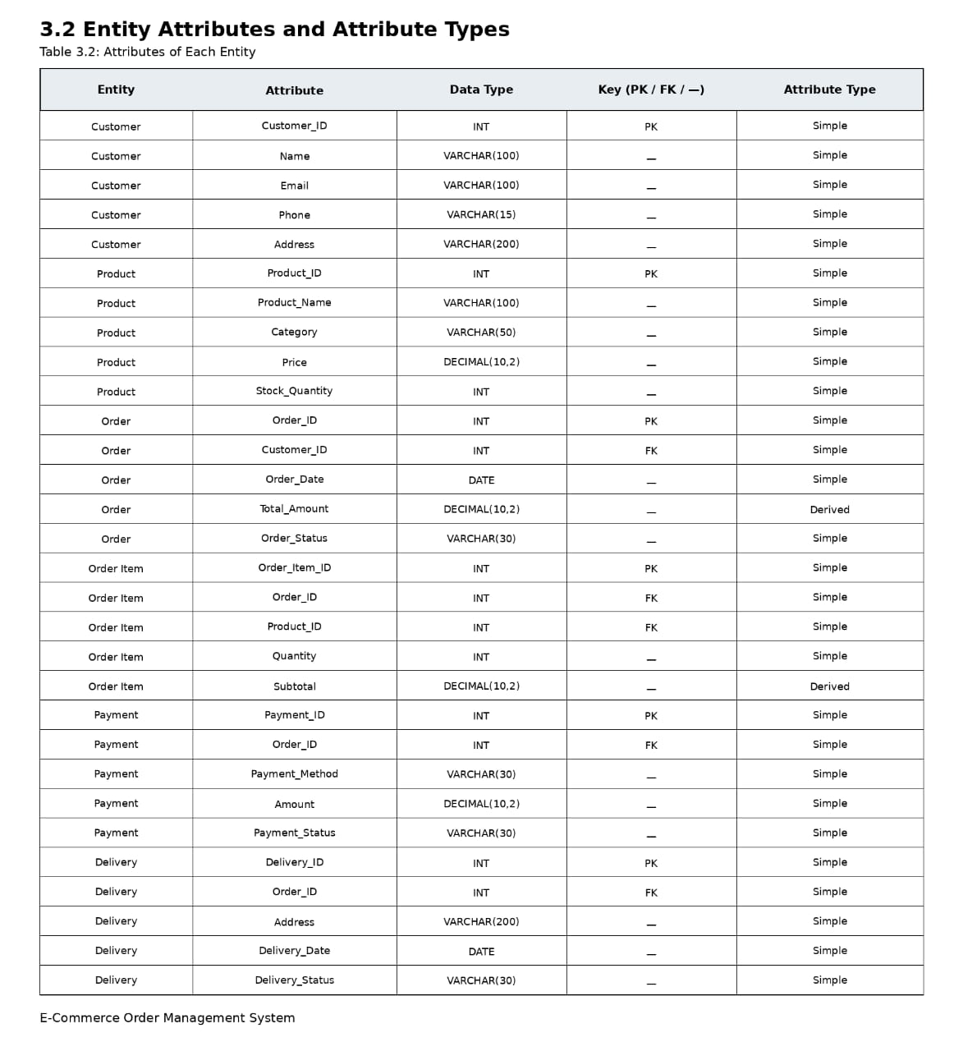
3.3 ER DIAGRAMS
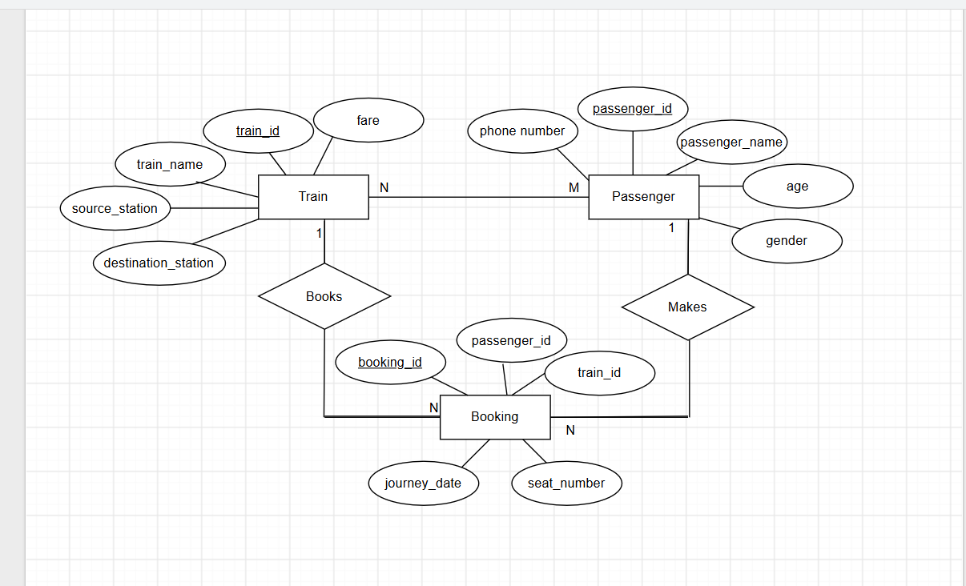

Fig. 3.1: ER Diagram of the E - Commerce Order Management System

3.4 Relationships and Cardinality
Table 3.3: Relationships and Cardinality
Entity 1 | Relationship | Entity 2 | Cardinality (1:1 / 1:N / M:N) | Participation
Customer | Places | Order | 1:N | Customer – Partial, Order – Total
Order | Has | Order Item | 1:N | Order – Total, Order Item – Total
Product | Included in | Order Item | 1:N | Product – Partial, Order Item – Total
order | Paid By | Payment | 1:1 | Order – Total, Payment – Total
order | Delivered By | Delivery | 1:1 | Order – Total, Delivery – Total

3.5 Relational Database Schema

Table 3.4: Relational Database Schema
Table Name | Column Name | Data Type | Key (PK / FK / —) | Constraints
Customer | Customer_ID | INT | PK | PRIMARY KEY, NOT NULL
Customer | Name | VARCHAR(100) | — | NOT NULL
Customer | Email | VARCHAR(100) | — | NOT NULL, UNIQUE
Customer | Phone | VARCHAR(15) | — | NOT NULL
Customer | Address | VARCHAR(200) | — | NOT NULL
Product | Product_ID | INT | PK | PRIMARY KEY, NOT NULL
Product | Product_Name | VARCHAR(100) | — | NOT NULL
Product | Category | VARCHAR(50) | — | NOT NULL
Product | Price | DECIMAL(10,2) | — | NOT NULL
Product | Stock_Quantity | INT | — | NOT NULL
Order | Order_ID | INT | PK | PRIMARY KEY, NOT NULL
Order | Customer_ID | INT | FK | NOT NULL, REFERENCES Customer(Customer_ID)
Order | Order_Date | DATE | — | NOT NULL
Order | Total_Amount | DECIMAL(10,2) | — | NOT NULL
Order | Order_Status | VARCHAR(30) | — | NOT NULL
Order_Item | Order_Item_ID | INT | PK | PRIMARY KEY, NOT NULL
Order_Item | Order_ID | INT | FK | NOT NULL, REFERENCES Order(Order_ID)
Order_Item | Product_ID | INT | FK | NOT NULL, REFERENCES Product(Product_ID)
Order_Item | Quantity | INT | — | NOT NULL, CHECK (Quantity > 0)
Order_Item | Subtotal | DECIMAL(10,2) | — | NOT NULL
Payment | Payment_ID | INT | PK | PRIMARY KEY, NOT NULL
Payment | Order_ID | INT | FK | NOT NULL, UNIQUE, REFERENCES Order(Order_ID)
Payment | Payment_Method | VARCHAR(30) | — | NOT NULL
Payment | Amount | DECIMAL(10,2) | — | NOT NULL
Payment | Payment_Status | VARCHAR(30) | — | NOT NULL
Delivery | Delivery_ID | INT | PK | PRIMARY KEY, NOT NULL
Delivery | Order_ID | INT | FK | NOT NULL, UNIQUE, REFERENCES Order(Order_ID)
Delivery | Address | VARCHAR(200) | — | NOT NULL
Delivery | Delivery_Date | DATE | — | —
Delivery | Delivery_Status | VARCHAR(30) | — | NOT NULL
SCHEMA DIAGRAMS
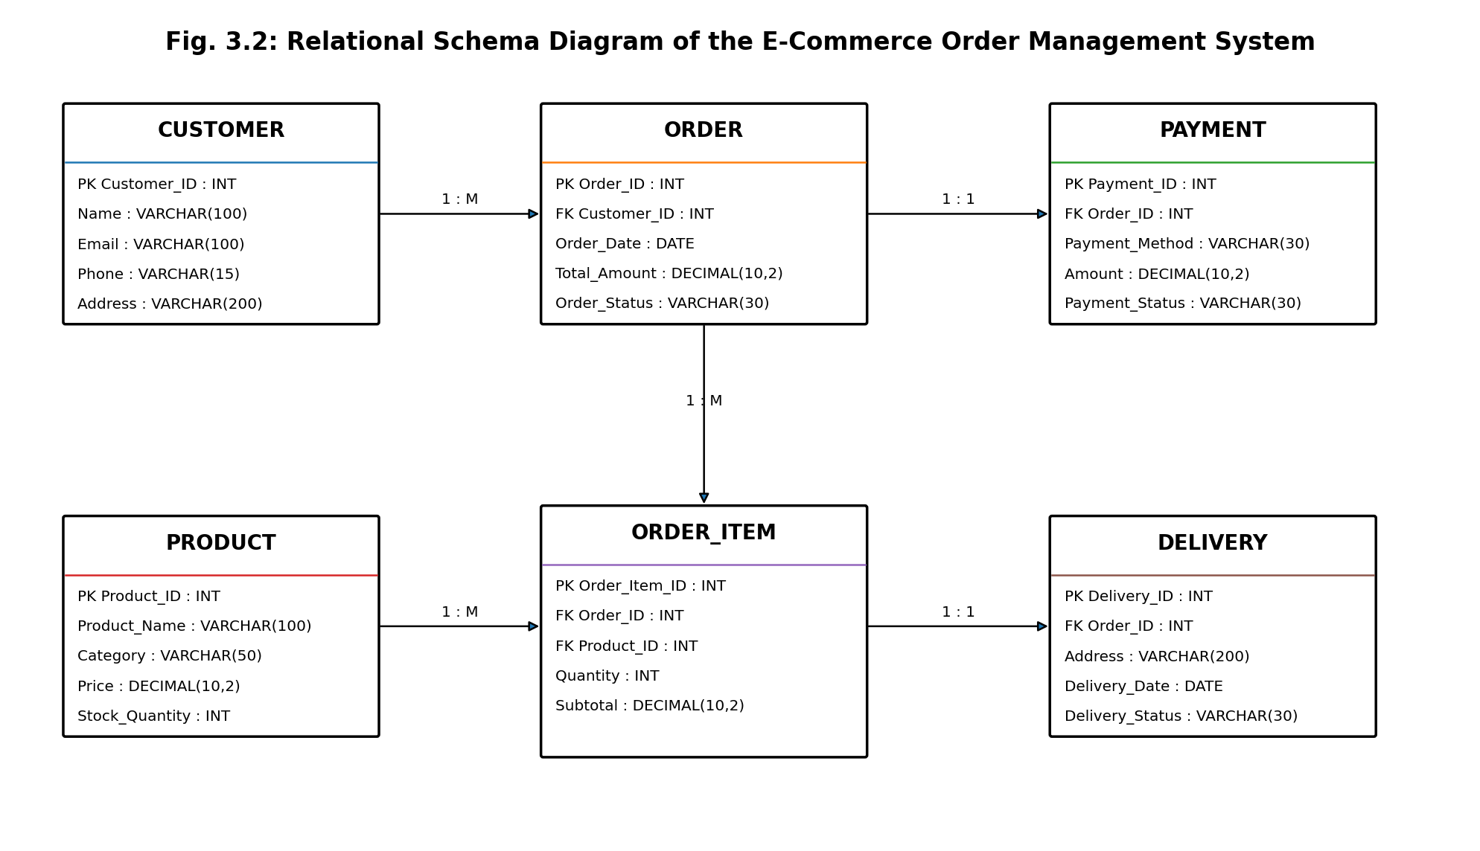

Fig. 3.2: Relational Schema Diagram

3.6 Primary Keys and Foreign Keys
Table 3.5: Primary Key and Foreign Key Definitions
Table | Primary Key | Foreign Key | References (Table.Column)
Customer | Customer_ID | - | -
Product | Product_ID | - | -
Order | Order_ID | Customer_ID | Customer.Customer_ID
Order_Item | Order_Item_ID | Order_ID | Order.Order_ID
Order_Item | Order_Item_ID | Product_ID | Product.Product_ID
Payment | Payment_ID | Order_ID | Order.Order_ID
Delivery | Delivery_ID | Order_ID | Order.Order_ID

3.7 Normalization up to 3NF
Normalization is the process of organizing data in a relational database to reduce redundancy and avoid insertion, update, and deletion anomalies. The E-Commerce Order Management System is normalized from UNF to 3NF.
UNF → 1NF → 2NF → 3NF
Functional Dependencies:
- Customer_ID → Name, Email, Phone, Address
- Product_ID → Product_Name, Category, Price, Stock_Quantity
- Order_ID → Customer_ID, Order_Date, Total_Amount, Order_Status
- Order_Item_ID → Order_ID, Product_ID, Quantity, Subtotal
- Payment_ID → Order_ID, Payment_Method, Amount, Payment_Status
- Delivery_ID → Order_ID, Address, Delivery_Date, Delivery_Status
Table 3.6: Normalization Steps
Normal Form | Condition Satisfied | Anomaly Removed | Resulting Tables
UNF | Data may contain repeating groups and multiple values in a single record. | High redundancy and difficulty in updating records. | Single combined E-Commerce Order relation
1NF | All attributes contain atomic values and repeating groups are removed. | Removes repeating-group and multi-valued data problems. | Customer, Product, Order, Order Item, Payment, Delivery
2NF | Relation is in 1NF and every non-key attribute depends on the complete primary key. | Removes partial dependency and reduces duplicate data. | Customer, Product, Order, Order Item, Payment, Delivery
3NF | Relation is in 2NF and non-key attributes depend only on the primary key, with no transitive dependency | Removes transitive dependency and update anomalies. | Customer, Product, Order, Order Item, Payment, Delivery

Final 3NF Relations:
- Customer (Customer_ID, Name, Email, Phone, Address)
- Product (Product_ID, Product_Name, Category, Price, Stock_Quantity)
- Order (Order_ID, Customer_ID, Order_Date, Total_Amount, Order_Status)
- Order_Item (Order_Item_ID, Order_ID, Product_ID, Quantity, Subtotal)
- Payment (Payment_ID, Order_ID, Payment_Method, Amount, Payment_Status)
- Delivery (Delivery_ID, Order_ID, Address, Delivery_Date, Delivery_Status)
Thus, the database reaches Third Normal Form (3NF), reducing data redundancy and preventing common insertion, update, and deletion anomalies while maintaining data consistency.

CHAPTER 4: DATABASE IMPLEMENTATION

4.1 Database and Table Creation – DDL
DROP TABLE IF EXISTS Shipment;
DROP TABLE IF EXISTS Payment;
DROP TABLE IF EXISTS Order_Item;
DROP TABLE IF EXISTS Orders;
DROP TABLE IF EXISTS Product;
DROP TABLE IF EXISTS Customer;

CREATE TABLE Customer (
Customer_ID INT PRIMARY KEY,
Name VARCHAR(100) NOT NULL,
Email VARCHAR(120) UNIQUE NOT NULL,
Phone VARCHAR(15),
Address VARCHAR(200)
);

CREATE TABLE Product (
Product_ID INT PRIMARY KEY,
Name VARCHAR(120) NOT NULL,
Price DECIMAL(10,2) CHECK (Price > 0),
Stock_Qty INT DEFAULT 0 CHECK (Stock_Qty >= 0)
);

CREATE TABLE Orders (
Order_ID VARCHAR(10) PRIMARY KEY,
Customer_ID INT NOT NULL,
Order_Date DATE NOT NULL,
Status VARCHAR(30) NOT NULL DEFAULT 'Pending',
Total_Amount DECIMAL(10,2) NOT NULL
CHECK (Total_Amount >= 0),
FOREIGN KEY (Customer_ID)
REFERENCES Customer(Customer_ID)
);
CREATE TABLE Order_Item (
Order_Item_ID INT PRIMARY KEY,
Order_ID VARCHAR(10) NOT NULL,
Product_ID INT NOT NULL,
Quantity INT NOT NULL CHECK (Quantity > 0),
Unit_Price DECIMAL(10,2) NOT NULL
CHECK (Unit_Price > 0),
FOREIGN KEY (Order_ID)
REFERENCES Orders(Order_ID),
FOREIGN KEY (Product_ID)
REFERENCES Product(Product_ID)
);

CREATE TABLE Payment (
Payment_ID INT PRIMARY KEY,
Order_ID VARCHAR(10) NOT NULL,
Method VARCHAR(30) NOT NULL,
Amount DECIMAL(10,2) NOT NULL
CHECK (Amount >= 0),
Payment_Status VARCHAR(30) NOT NULL DEFAULT 'Pending',
FOREIGN KEY (Order_ID)
REFERENCES Orders(Order_ID)
);

CREATE TABLE Shipment (
Shipment_ID INT PRIMARY KEY,
Order_ID VARCHAR(10) NOT NULL,
Address VARCHAR(200) NOT NULL,
Carrier VARCHAR(50) NOT NULL,
Tracking_No VARCHAR(50) UNIQUE,
Status VARCHAR(30) NOT NULL DEFAULT 'Pending',
FOREIGN KEY (Order_ID)
REFERENCES Orders(Order_ID)
);

SELECT table_name
FROM information_schema.tables
WHERE table_schema = 'public'
AND table_name IN
('customer','product','orders','order_item','payment','shipment')
ORDER BY table_name;

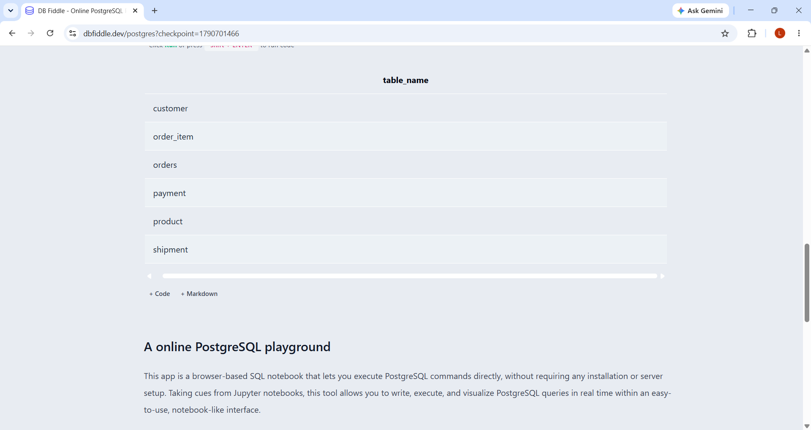

Fig. 4.1: Successful Creation of Tables

4.2 Sample Data Insertion – DML
Table 4.1: Sample Data Summary
S.No | Table Name | No. of Records Inserted | Screenshot Reference
1 | Customer | 5 | Screenshot 4.1
2 | Product | 5 | Screenshot 4.2
3 | Orders | 5 | Screenshot 4.3
4 | Order_item | 5 | Screenshot 4.4
5 | Payment | 5 | Screenshot 4.5
6 | Shipment | 5 | Screenshot 4.6

INSERT INTO Customer
(Customer_ID, Name, Email, Phone, Address)
VALUES
(1, 'Anusha', 'anusha@gmail.com', '9876543210', 'Andhra Pradesh'),
(2, 'Rahul', 'rahul@gmail.com', '9876543211', 'Hyderabad'),
(3, 'Sneha', 'sneha@gmail.com', '9876543212', 'Vijayawada'),
(4, 'Kiran', 'kiran@gmail.com', '9876543213', 'Visakhapatnam'),
(5, 'Priya', 'priya@gmail.com', '9876543214', 'Guntur');
SELECT * FROM Customer;
INSERT INTO Product
(Product_ID, Name, Price, Stock_Qty)
VALUES
(101, 'Laptop', 55000, 10),
(102, 'Smartphone', 25000, 20),
(103, 'Headphones', 1500, 30),
(104, 'Keyboard', 1200, 15),
(105, 'Mouse', 800, 25);
SELECT * FROM Product;
INSERT INTO Orders
(Order_ID, Customer_ID, Order_Date, Status, Total_Amount)
VALUES
('O101', 1, '2026-09-01', 'Delivered', 55000),
('O102', 2, '2026-09-02', 'Pending', 25000),
('O103', 3, '2026-09-03', 'Shipped', 1500),
('O104', 1, '2026-09-04', 'Delivered', 1200),
('O105', 4, '2026-09-05', 'Pending', 800);
SELECT * FROM Orders;
INSERT INTO Order_Item
(Order_Item_ID, Order_ID, Product_ID, Quantity, Unit_Price)
VALUES
(1, 'O101', 101, 1, 55000),
(2, 'O102', 102, 1, 25000),
(3, 'O103', 103, 1, 1500),
(4, 'O104', 104, 1, 1200),
(5, 'O105', 105, 1, 800);
SELECT * FROM Order_Item;
INSERT INTO Payment
(Payment_ID, Order_ID, Method, Amount, Payment_Status)
VALUES
(501, 'O101', 'UPI', 55000, 'Paid'),
(502, 'O102', 'Card', 25000, 'Pending'),
(503, 'O103', 'Cash', 1500, 'Paid'),
(504, 'O104', 'UPI', 1200, 'Paid'),
(505, 'O105', 'Card', 800, 'Pending');
SELECT * FROM Payment;
INSERT INTO Shipment
(Shipment_ID, Order_ID, Address, Carrier, Tracking_No, Status)
VALUES
(601, 'O101', 'Andhra Pradesh', 'DTDC', 'TRK1001', 'Delivered'),
(602, 'O102', 'Hyderabad', 'BlueDart', 'TRK1002', 'Pending'),
(603, 'O103', 'Vijayawada', 'DTDC', 'TRK1003', 'Shipped'),
(604, 'O104', 'Andhra Pradesh', 'BlueDart', 'TRK1004', 'Delivered'),
(605, 'O105', 'Visakhapatnam', 'DTDC', 'TRK1005', 'Pending');
SELECT * FROM Shipment;
SS4.1 And 4.2
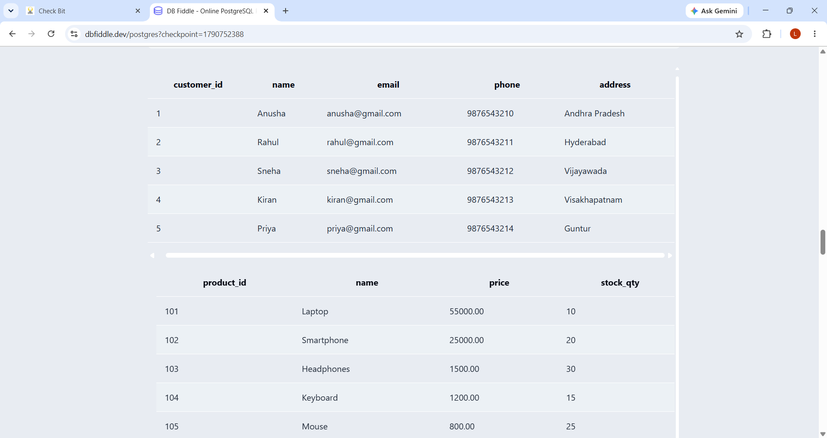
SS 4.3
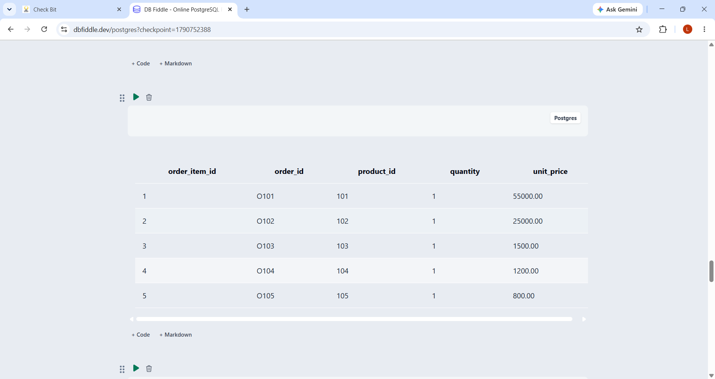
SS 4.3
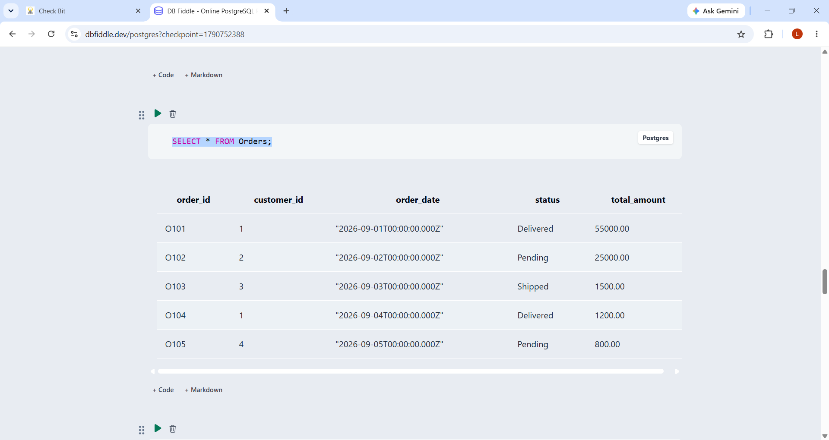
SS 4.4
SS 4.5
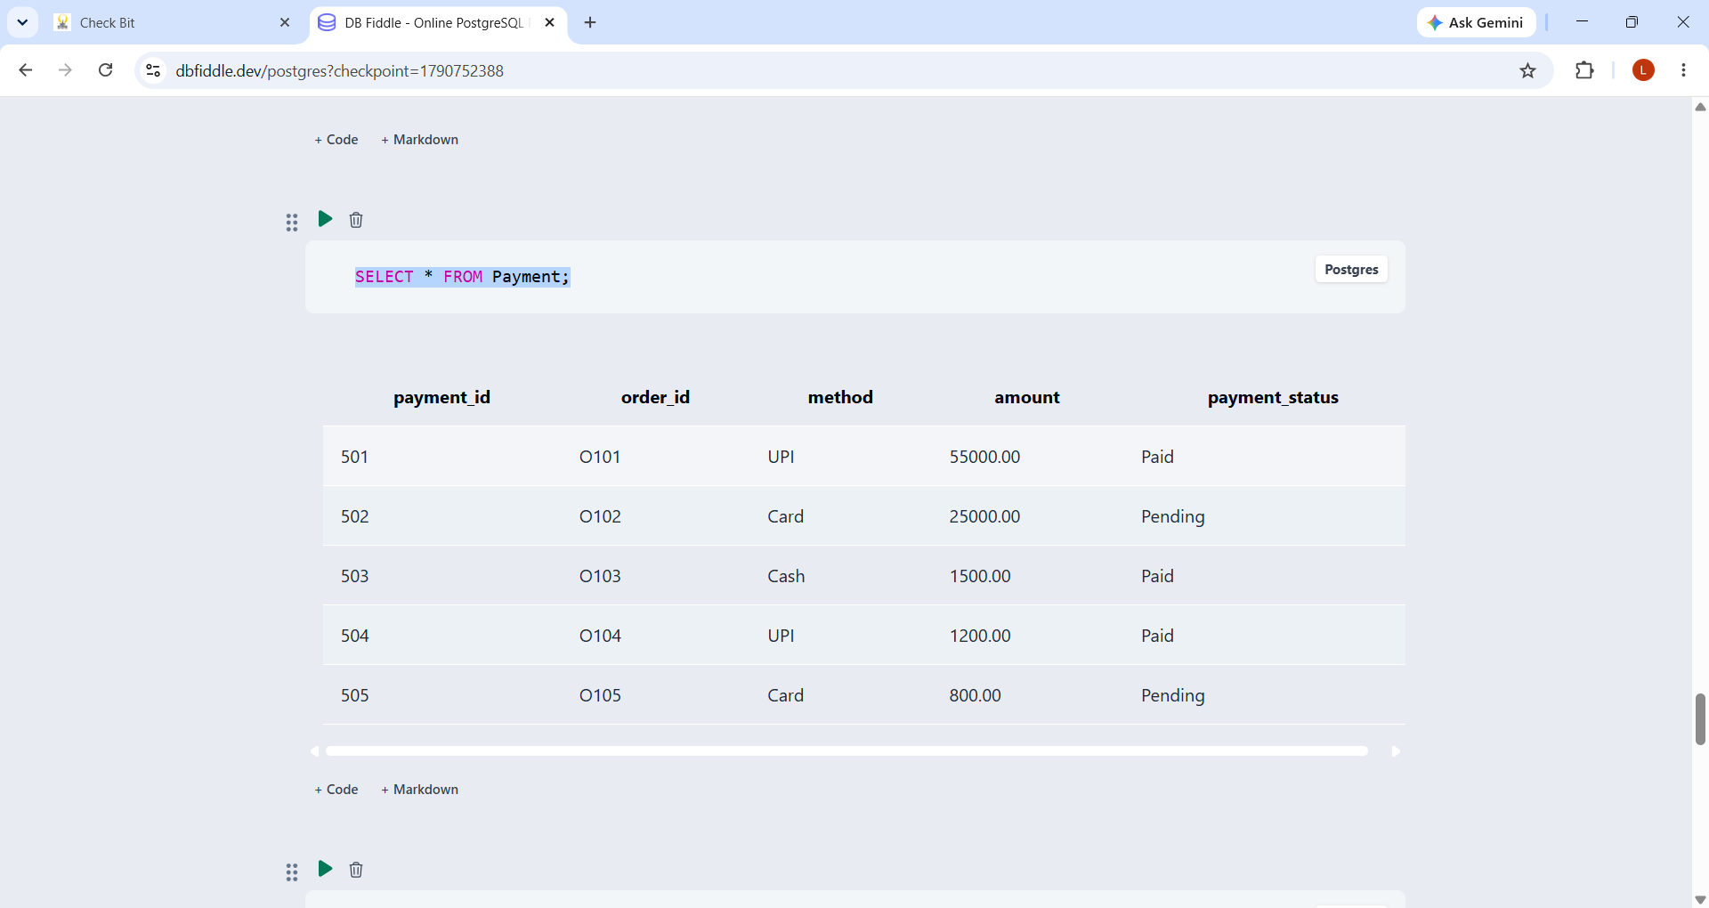
SS 4.6
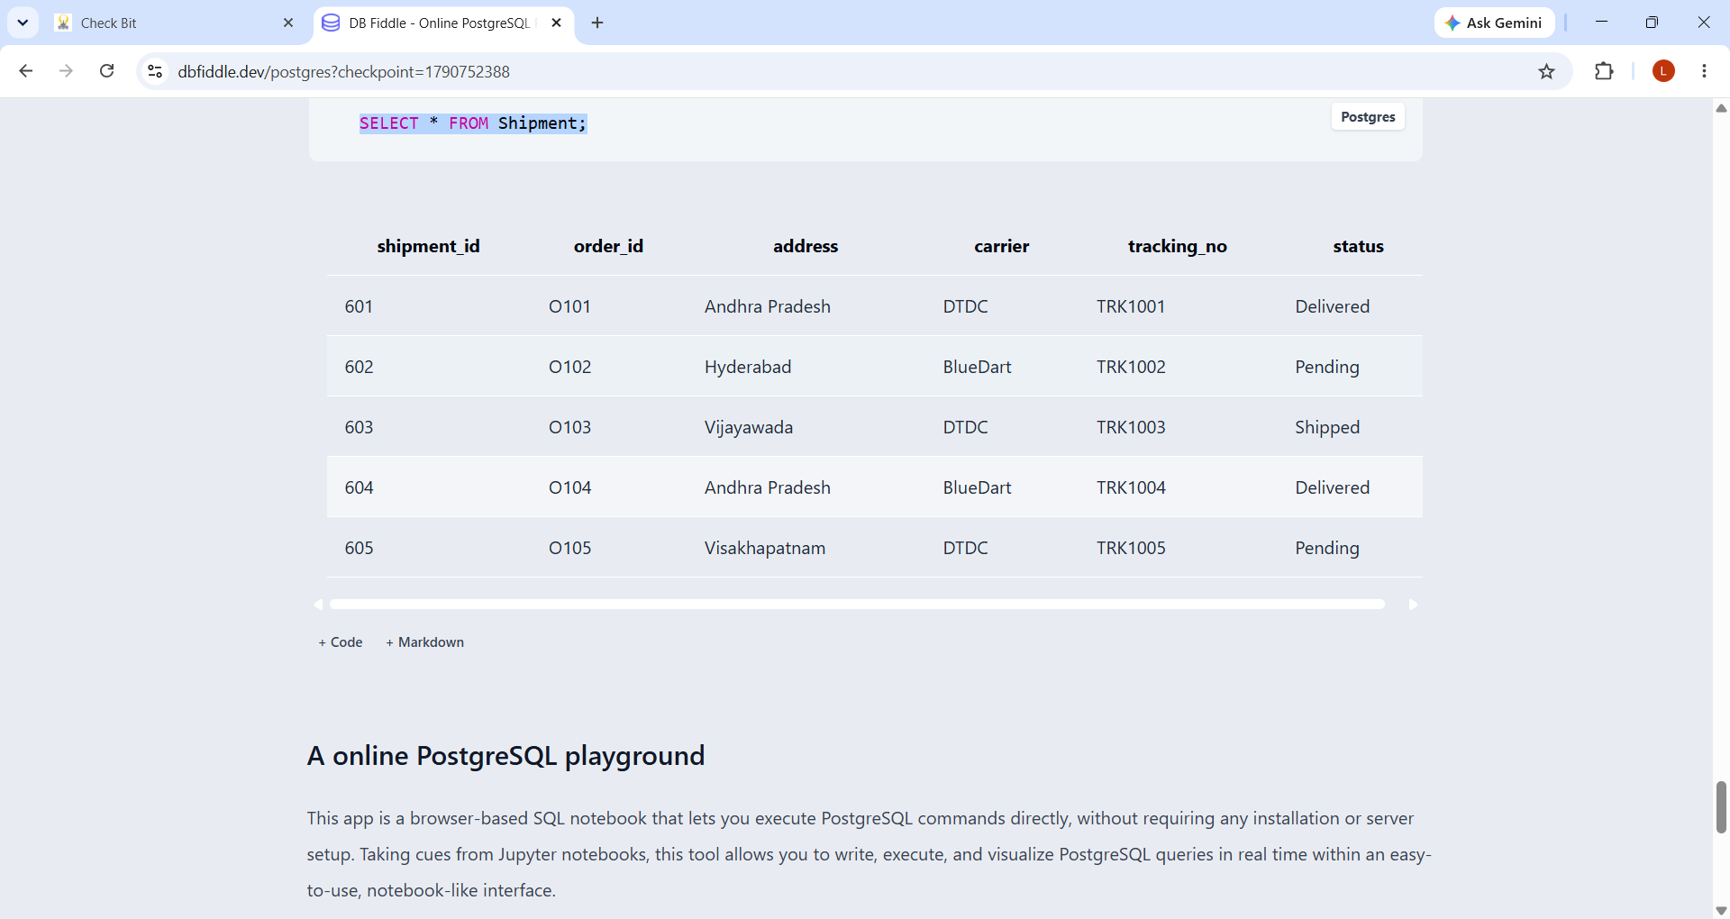

Fig. 4.2: Sample Data Inserted into the Tables

4.3 Constraints and Data Integrity
Table 4.2: Constraints and Data Integrity Rules
Constraint / Validation | Applied On (Table.Column) | Purpose | Evidence / Screenshot Ref.
1 | Customer.Customer_ID | PRIMARY KEY, NOT NULL | Uniquely identifies each customer.
2 | Customer.Email | UNIQUE, NOT NULL | Prevents duplicate customer email IDs.
3 | Product.Product_ID | PRIMARY KEY, NOT NULL | Uniquely identifies each product.
4 | Product.Price | CHECK (Price > 0) | Prevents zero or negative product prices.
5 | Product.Stock_Qty | CHECK (Stock_Qty >= 0) | Prevents negative stock quantity.
6 | Orders.Customer_ID | FOREIGN KEY, NOT NULL | Maintains valid customer-order relationship.
7 | Order_Item.Quantity | CHECK (Quantity > 0) | Ensures valid ordered quantity.
8 | Payment.Order_ID | FOREIGN KEY, NOT NULL | Maintains valid order-payment relationship.

4.4 Data Validation Rules
The database prevents duplicate IDs through PRIMARY KEY and UNIQUE constraints. Invalid values such as negative prices, stock quantities, order quantities, and payment amounts are prevented using CHECK constraints. Foreign keys prevent orphan records by ensuring that referenced customer, order, and product records already exist. For example, inserting an Order with a non-existing Customer_ID produces a foreign-key violation error in PostgreSQL.
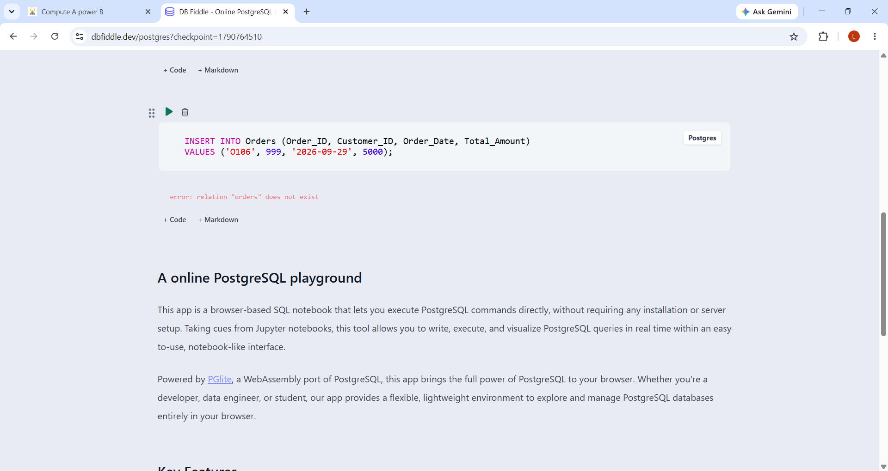

Fig. 4.3: Referential Integrity Enforced by the Database

CHAPTER 5: SQL OPERATIONS AND QUERIES

5.1 DQL – Basic Retrieval Queries
Table 5.1: Basic Retrieval Queries
Q.No | Purpose of the Query | SQL Statement | Output Ref.
Q1 | Display all customer records | SELECT * FROM Customer; | mplemented in final SQL
Q2 | Display products with stock less than 20 | SELECT * FROM Product WHERE Stock_Qty < 20; | mplemented in final SQL
Q3 | Display delivered orders | SELECT * FROM Orders WHERE Status = 'Delivered'; | mplemented in final SQL
Q4 | Display orders above ₹10,000 | SELECT * FROM Orders WHERE Total_Amount > 10000; | mplemented in final SQL
Q5 | Display customers from Andhra Pradesh | SELECT * FROM Customer WHERE Address = 'Andhra Pradesh'; | mplemented in final SQL

5.2 Join Operations
Table 5.2: Join Operations
Q.No | Type of Join | SQL Statement | Output Ref.
Q6 | Natural Join | SELECT Customer_ID, Name, Order_ID, Order_Date FROM Customer NATURAL JOIN Orders; | Generated
Q7 | Equi Join | SELECT C.Name, O.Order_ID FROM Customer C, Orders O WHERE C.Customer_ID = O.Customer_ID; | Generated
Q8 | Inner Join | SELECT C.Name AS Customer_Name, O.Order_ID, O.Status FROM Customer C INNER JOIN Orders O ON C.Customer_ID = O.Customer_ID; | Generated
Q9 | Left Outer Join | SELECT C.Name, O.Order_ID FROM Customer C LEFT OUTER JOIN Orders O ON C.Customer_ID = O.Customer_ID; | Generated
Q10 | Right Outer Join | SELECT C.Name, O.Order_ID FROM Customer C RIGHT OUTER JOIN Orders O ON C.Customer_ID = O.Customer_ID; | Generated
Q11 | Full Outer Join | SELECT C.Name, O.Order_ID FROM Customer C FULL OUTER JOIN Orders O ON C.Customer_ID = O.Customer_ID; | Generated

5.3 Aggregate Functions, GROUP BY and HAVING
Table 5.3: Aggregate, GROUP BY and HAVING Queries
Q.No | Function Used | SQL Statement | Output Ref.
Q12 | SUM | SELECT SUM(Total_Amount) AS Total_Order_Amount FROM Orders; | Implemented in final SQL
Q13 | MAX | SELECT MAX(Total_Amount) AS Highest_Order_Amount FROM Orders; | Implemented in final SQL
Q14 | COUNT + GROUP BY | SELECT Customer_ID, COUNT(Order_ID) AS Total_Orders FROM Orders GROUP BY Customer_ID; | Implemented in final SQL
Q15 | GROUP BY + HAVING | SELECT Customer_ID, SUM(Total_Amount) AS Total_Spent FROM Orders GROUP BY Customer_ID HAVING SUM(Total_Amount) > 1000; | Implemented in final SQL
Q16 | AVG | SELECT AVG(Total_Amount) AS Average_Order_Amount FROM Orders; | Implemented in final SQL

5.4 Nested and Correlated Subqueries
Table 5.4: Subqueries
Q.No | Type (Nested / Correlated) | SQL Statement | Output Ref.
Q17 | Nested | SELECT * FROM Orders WHERE Total_Amount > (SELECT AVG(Total_Amount) FROM Orders); | Implemented in final SQL
Q18 | Nested | SELECT Name FROM Customer WHERE Customer_ID IN (SELECT Customer_ID FROM Orders WHERE Status = 'Delivered'); | Implemented in final SQL
Q19 | Nested | SELECT * FROM Product WHERE Price = (SELECT MAX(Price) FROM Product); | Implemented in final SQL
Q20 | Correlated | SELECT C.Name FROM Customer C WHERE EXISTS (SELECT 1 FROM Orders O WHERE O.Customer_ID = C.Customer_ID AND O.Total_Amount > 10000); | Implemented in final SQL
Q21 | Correlated | SELECT O.Order_ID, O.Total_Amount FROM Orders O WHERE O.Total_Amount > (SELECT AVG(O2.Total_Amount) FROM Orders O2 WHERE O2.Customer_ID = O.Customer_ID); | Implemented in final SQL

5.5 Views and Relational Set Operations
Q24 | UNION | SELECT Address FROM Customer WHERE Address = 'Andhra Pradesh' UNION SELECT Address FROM Shipment WHERE Address = 'Hyderabad'; | Implemented in final SQL
Q25 | INTERSECT | SELECT Address FROM Customer INTERSECT SELECT Address FROM Shipment; | Implemented in final SQL
Q26 | EXCEPT | SELECT Address FROM Shipment EXCEPT SELECT Address FROM Customer; | Implemented in final SQL

5.6 DCL and TCL Operations
.
Table 5.6: DCL and TCL Operations
Q.No | Command | Purpose | SQL Statement | Output Ref.
Q27 | GRANT | Grant SELECT permission on Customer to a database user. | GRANT SELECT ON TABLE Customer TO dbuser; | REFERNCE SCREENSHOT
Q28 | REVOKE | Remove previously granted SELECT permission. | REVOKE SELECT ON TABLE Customer FROM dbuser; | REFERNCE SCREENSHOT
Q29 | COMMIT | Save the current transaction permanently. | COMMIT; | REFERNCE SCREENSHOT
Q30 | SAVEPOINT | Create a point to which the transaction can be rolled back. | SAVEPOINT order_savepoint; | REFERNCE SCREENSHOT
Q31 | ROLLBACK | Undo changes made after the savepoint. | ROLLBACK TO SAVEPOINT order_savepoint; | REFERNCE SCREENSHOT

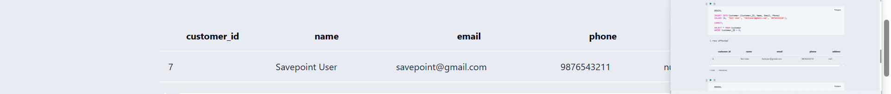
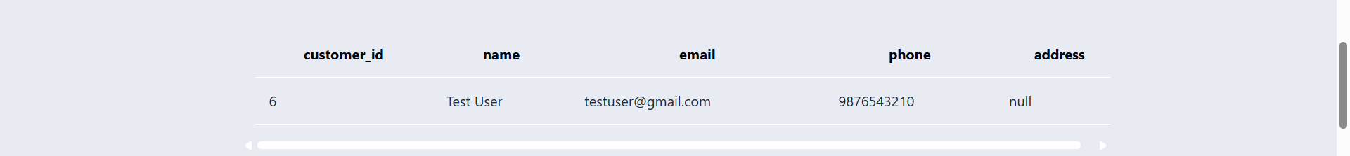
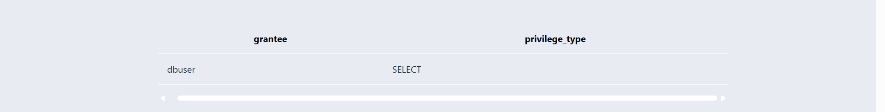
REFERNCE SCREENSHOT
CHAPTER 6: MODULES AND FUNCTIONALITIES
S.No | Module Name | Functionality | Tables Involved
1 | Customer Management | Stores and manages customer details such as name, email, phone and address. | Customer
2 | Product Management | Maintains product information, price and available stock quantity. | Product
3 | Order Management | Records customer orders, dates, status and total order amount. | Orders, Customer
4 | Order Item Management | Maintains products included in each order along with quantity and unit price. | Order_Item, Orders, Product
5 | Payment Management | Stores payment method, amount and payment status for each order. | Payment, Orders
6 | Shipment / Delivery Management | Maintains delivery address, carrier, tracking number and shipment status. | Shipment, Orders

Table 6.1: Modules and Their Functionalities
The Customer Management module maintains customer records and supports retrieval of customer information. The Product Management module stores product details, prices and stock quantities. The Order Management module records orders and tracks their status. The Order Item Management module connects orders with products and records quantities and unit prices. The Payment Management module stores payment methods, amounts and payment status. The Shipment / Delivery Management module stores delivery address, carrier, tracking number and status.

CHAPTER 7: RESULTS – SAMPLE OUTPUTS AND SCREENSHOTS

Fig. 7.1: Customer and Product Table Output

Fig. 7.2: Orders and Order Item Output

Fig. 7.3: Payment and Shipment Output
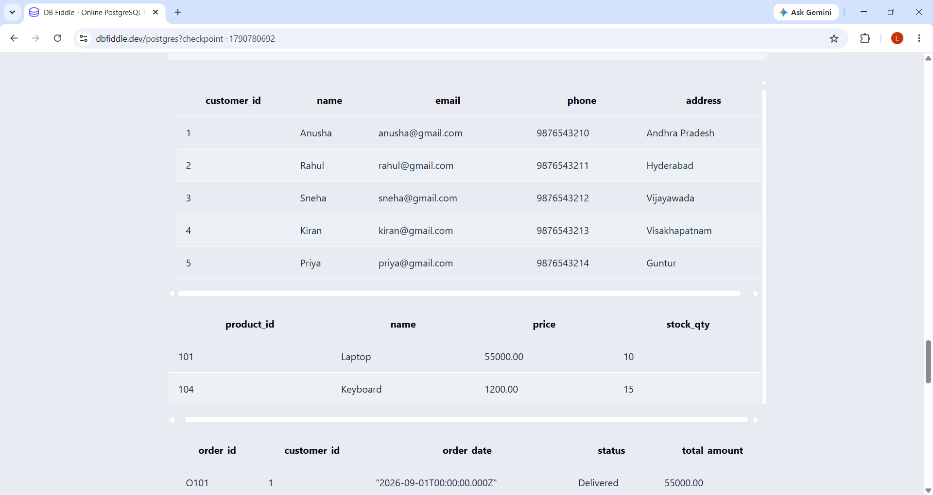
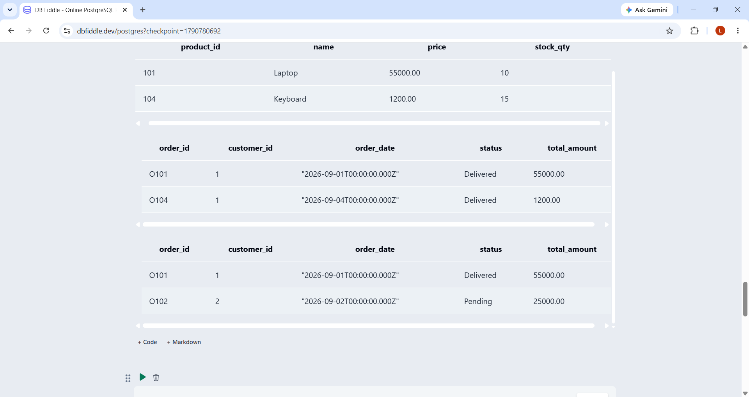

Fig. 7.4: SQL Query Execution and Result

CHAPTER 8: TESTING AND DATA VALIDATION
Table 8.1: Test Cases and Results
TC No. | Test Case Description | Input / Action | Expected Result | Actual Result | Status
TC01 | Primary key uniqueness | Insert a duplicate Customer_ID. | Duplicate key error should be generated. | Duplicate record rejected by PostgreSQL. | Pass
TC02 | Email uniqueness | Insert a duplicate Customer Email. | UNIQUE constraint should reject the record. | Duplicate email rejected. | Pass
TC03 | Price validation | Insert Product with Price = -100. | CHECK constraint should reject the value. | Invalid price rejected. | Pass
TC04 | Stock validation | Insert Product with Stock_Qty = -5. | CHECK constraint should reject the value. | Invalid stock rejected. | Pass
TC05 | Foreign key validation | Insert Order with non-existing Customer_ID. | Foreign key violation should be generated. | Orphan order rejected. | Pass
TC06 | Quantity validation | Insert Order_Item with Quantity = 0. | CHECK constraint should reject the value. | Invalid quantity rejected. | Pass
TC07 | Basic retrieval | Execute SELECT * FROM Customer. | All customer records should be displayed. | 5 customer records displayed. | Pass
TC08 | Join correctness | Execute Customer–Orders INNER JOIN. | Matching customer and order details should be displayed. | Matching records displayed. | Pass
TC09 | Aggregate correctness | Execute SUM(Total_Amount). | Total order amount should be calculated. | Aggregate value returned. | Pass

CHAPTER 9: GITHUB REPOSITORY AND TEAM CONTRIBUTION

9.1 Repository Details
GitHub Repository Link:

9.2 Team Responsibilities and Contribution
Table 9.1: Team Responsibilities
S.No | Student Name | Roll Number | Role / Responsibility | Modules Contributed
1 | KOSANA ANITHA | 25B11AI580 | Database Design and ER Modeling | Entities, Relationships, ER Diagram
2 | MOTURI LAXMI ANUSHA | 25B11AI759 | SQL Implementation and Queries | DDL, DML, DQL, Joins, Subqueries
3 | DANTHULURI V S S D RAGHAVA RAJU | 25B11AI250 | Testing and Data Validation | Constraints, Testing, Output Verification
4 | MOTURI VYSHNAVI AMULYA | 25B11AI641 | Documentation and Presentation | Documentation, Screenshots, Presentation

9.3 Review-wise Progress
Table 9.2: Review-wise Progress Record
Review | Date | Deliverables Presented | Remarks of the Guide
Review – I |  | Database design, entities, attributes, ER diagram, relationships and normalization.
Review – II |  | Database implementation, sample data, SQL operations and queries.
Final Review |  | Complete SQL queries, testing, results, documentation and final report.

CHAPTER 10: CONCLUSION AND FUTURE ENHANCEMENTS

10.1 Conclusion
The E-Commerce Order Management System was successfully designed as a structured relational database for managing important e-commerce information. The system consists of 6 entities and 6 relational tables, namely Customer, Product, Order, Order Item, Payment, and Delivery. Primary keys and foreign keys were used to uniquely identify records and establish relationships between the tables.
The database design mainly follows 1 relationships, such as Customer–Order, Order–Order Item, and Product–Order Item, along with 1:1 relationships between Order–Payment and Order–Delivery. The database was normalized up to Third Normal Form (3NF) to reduce data redundancy and maintain consistency.
SQL operations were used for creating tables, inserting records, and retrieving required information from the database. The design supports efficient management of customer, product, order, payment, and delivery information. Thus, the objectives stated in Section 1.4 were addressed by providing a structured database, establishing appropriate relationships, reducing redundancy, maintaining consistency, and supporting efficient data retrieval.

10.2 Limitations of the Present Work
The present system focuses mainly on the database design and core order-management operations. The following limitations are present:
- No dedicated front-end application is currently implemented.
- User authentication and role-based access control are not included.
- Advanced payment gateway integration is not implemented.
- Real-time delivery or shipment tracking is not handled.
- Stored procedures and database triggers are not implemented.
- Advanced reporting and analytics features are limited.
- Automated backup and recovery mechanisms are not included in the current implementation.
- Performance optimization through advanced indexing has not been extensively implemented.

10.3 Future Enhancements
The E-Commerce Order Management System can be further enhanced with the following features:
- Front-End Application: Develop a user-friendly web or mobile interface for customers and administrators.
- Stored Procedures and Triggers: Automate frequently performed database operations and maintain data consistency.
- Indexing: Add suitable indexes to improve query performance for large amounts of data.
- Security and Access Control: Implement user authentication, authorization, and role-based access.
- Payment Integration: Connect the system with secure online payment gateways.
- Delivery Tracking: Add real-time order and delivery tracking functionality.
- Backup and Recovery: Implement automated database backup and recovery mechanisms.
- Reporting and Analytics: Generate reports on sales, orders, products, customers, and delivery performance.
- Scalability: Extend the database design to support a larger number of customers, products, and orders.
These enhancements can transform the current database-focused system into a more complete and scalable e-commerce order management application.

REFERENCES
- Abraham Silberschatz, Henry F. Korth and S. Sudarshan, “Database System Concepts”, 8th Edition, McGraw-Hill, ISBN: 978-1260230508.
- Raghurama Krishnan and Johannes Gehrke, “Database Management Systems”, 4th Edition, McGraw-Hill, ISBN: 978-1260091195.
- Ramez Elmasri and Shamkant B. Navathe, “Fundamentals of Database Systems”, 7th Edition, Pearson, ISBN: 978-0137504277.
- PostgreSQL Global Development Group, “PostgreSQL Documentation”, PostgreSQL Official Documentation.
5. diagrams.net, “diagrams.net Documentation”, Official Documentation for Diagram and ER
Design.
APPENDIX A – COMPLETE SQL SCRIPT

-- APPENDIX A – COMPLETE SQL SCRIPT
-- E-COMMERCE ORDER MANAGEMENT SYSTEM

-- CREATE TABLES

CREATE TABLE Customer (
Customer_ID INT PRIMARY KEY,
Name VARCHAR(100) NOT NULL,
Email VARCHAR(120) UNIQUE NOT NULL,
Phone VARCHAR(15),
Address VARCHAR(200)
);

CREATE TABLE Product (
Product_ID INT PRIMARY KEY,
Name VARCHAR(120) NOT NULL,
Category VARCHAR(50),
Price DECIMAL(10,2) CHECK (Price > 0),
Stock_Qty INT DEFAULT 0 CHECK (Stock_Qty >= 0)
);

CREATE TABLE Orders (
Order_ID VARCHAR(10) PRIMARY KEY,
Customer_ID INT NOT NULL,
Order_Date DATE NOT NULL,
Status VARCHAR(30) NOT NULL DEFAULT 'Pending',
Total_Amount DECIMAL(10,2) NOT NULL
CHECK (Total_Amount >= 0),
FOREIGN KEY (Customer_ID)
REFERENCES Customer(Customer_ID)
);

CREATE TABLE Order_Item (
Order_Item_ID INT PRIMARY KEY,
Order_ID VARCHAR(10) NOT NULL,
Product_ID INT NOT NULL,
Quantity INT NOT NULL CHECK (Quantity > 0),
Unit_Price DECIMAL(10,2) NOT NULL
CHECK (Unit_Price > 0),
FOREIGN KEY (Order_ID)
REFERENCES Orders(Order_ID),
FOREIGN KEY (Product_ID)
REFERENCES Product(Product_ID)
);

CREATE TABLE Payment (
Payment_ID INT PRIMARY KEY,
Order_ID VARCHAR(10) NOT NULL,
Method VARCHAR(30) NOT NULL,
Amount DECIMAL(10,2) NOT NULL
CHECK (Amount >= 0),
Payment_Status VARCHAR(30) NOT NULL DEFAULT 'Pending',
FOREIGN KEY (Order_ID)
REFERENCES Orders(Order_ID)
);

CREATE TABLE Shipment (
Shipment_ID INT PRIMARY KEY,
Order_ID VARCHAR(10) NOT NULL,
Address VARCHAR(200) NOT NULL,
Carrier VARCHAR(50) NOT NULL,
Tracking_No VARCHAR(50) UNIQUE,
Status VARCHAR(30) NOT NULL DEFAULT 'Pending',
FOREIGN KEY (Order_ID)
REFERENCES Orders(Order_ID)
);

-- INSERT DATA

INSERT INTO Customer
VALUES
(1, 'Anusha', 'anusha@gmail.com', '9876543210', 'Andhra Pradesh'),
(2, 'Rahul', 'rahul@gmail.com', '9876543211', 'Hyderabad'),
(3, 'Sneha', 'sneha@gmail.com', '9876543212', 'Vijayawada'),
(4, 'Kiran', 'kiran@gmail.com', '9876543213', 'Visakhapatnam'),
(5, 'Priya', 'priya@gmail.com', '9876543214', 'Guntur');

INSERT INTO Product
VALUES
(101, 'Laptop', 'Electronics', 55000.00, 10),
(102, 'Smartphone', 'Electronics', 25000.00, 20),
(103, 'Headphones', 'Accessories', 1500.00, 30),
(104, 'Keyboard', 'Accessories', 1200.00, 15),
(105, 'Mouse', 'Accessories', 800.00, 25);

INSERT INTO Orders
VALUES
('O101', 1, '2026-09-01', 'Delivered', 55000.00),
('O102', 2, '2026-09-02', 'Pending', 25000.00),
('O103', 3, '2026-09-03', 'Shipped', 1500.00),
('O104', 1, '2026-09-04', 'Delivered', 1200.00),
('O105', 4, '2026-09-05', 'Pending', 800.00);

INSERT INTO Order_Item
VALUES
(1, 'O101', 101, 1, 55000.00),
(2, 'O102', 102, 1, 25000.00),
(3, 'O103', 103, 1, 1500.00),
(4, 'O104', 104, 1, 1200.00),
(5, 'O105', 105, 1, 800.00);

INSERT INTO Payment
VALUES
(501, 'O101', 'UPI', 55000.00, 'Paid'),
(502, 'O102', 'Card', 25000.00, 'Pending'),
(503, 'O103', 'Cash', 1500.00, 'Paid'),
(504, 'O104', 'UPI', 1200.00, 'Paid'),
(505, 'O105', 'Card', 800.00, 'Pending');

INSERT INTO Shipment
VALUES
(601, 'O101', 'Andhra Pradesh', 'DTDC', 'TRK1001', 'Delivered'),
(602, 'O102', 'Hyderabad', 'BlueDart', 'TRK1002', 'Pending'),
(603, 'O103', 'Vijayawada', 'DTDC', 'TRK1003', 'Shipped'),
(604, 'O104', 'Andhra Pradesh', 'BlueDart', 'TRK1004', 'Delivered'),
(605, 'O105', 'Visakhapatnam', 'DTDC', 'TRK1005', 'Pending');

-- BASIC SELECT QUERIES

SELECT * FROM Customer;
SELECT * FROM Product;
SELECT * FROM Orders;
SELECT * FROM Order_Item;
SELECT * FROM Payment;
SELECT * FROM Shipment;

-- WHERE QUERY

SELECT *
FROM Product
WHERE Stock_Qty < 20;

SELECT *
FROM Orders
WHERE Status = 'Delivered';

-- JOIN QUERY

SELECT
C.Name AS Customer_Name,
O.Order_ID,
O.Order_Date,
O.Status,
O.Total_Amount
FROM Customer C
INNER JOIN Orders O
ON C.Customer_ID = O.Customer_ID;

SELECT
O.Order_ID,
P.Name AS Product_Name,
OI.Quantity,
OI.Unit_Price
FROM Orders O
INNER JOIN Order_Item OI
ON O.Order_ID = OI.Order_ID
INNER JOIN Product P
ON OI.Product_ID = P.Product_ID;

-- AGGREGATE QUERIES

SELECT SUM(Total_Amount) AS Total_Order_Amount
FROM Orders;

SELECT MAX(Total_Amount) AS Highest_Order_Amount
FROM Orders;

SELECT
Customer_ID,
COUNT(Order_ID) AS Total_Orders
FROM Orders
GROUP BY Customer_ID;

-- UPDATE QUERY

UPDATE Orders
SET Status = 'Shipped'
WHERE Order_ID = 'O102';

-- DELETE QUERY

DELETE FROM Shipment
WHERE Shipment_ID = 605;

-- VIEW

CREATE VIEW Order_Summary AS
SELECT
O.Order_ID,
C.Name AS Customer_Name,
O.Order_Date,
O.Status,
O.Total_Amount
FROM Orders O
INNER JOIN Customer C
ON O.Customer_ID = C.Customer_ID;

SELECT * FROM Order_Summary;

