Git
src: https://www.youtube.com/watch?v=RGOj5yH7evk

Platforms that facilitate Git:




Terms

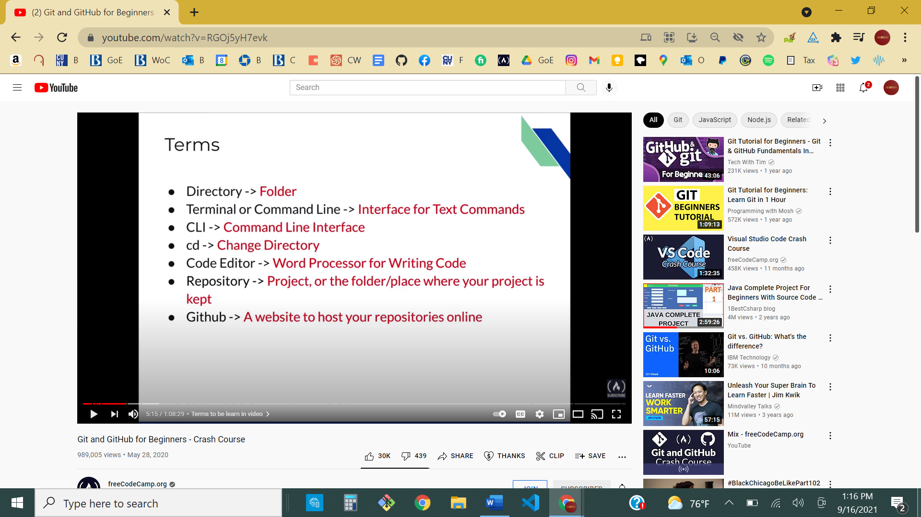

Commands

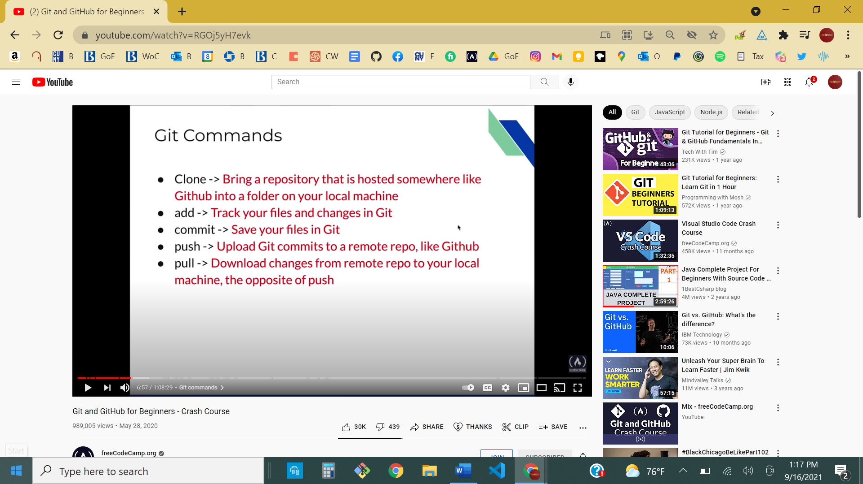

You can use a specific file when usine ‘git add’:
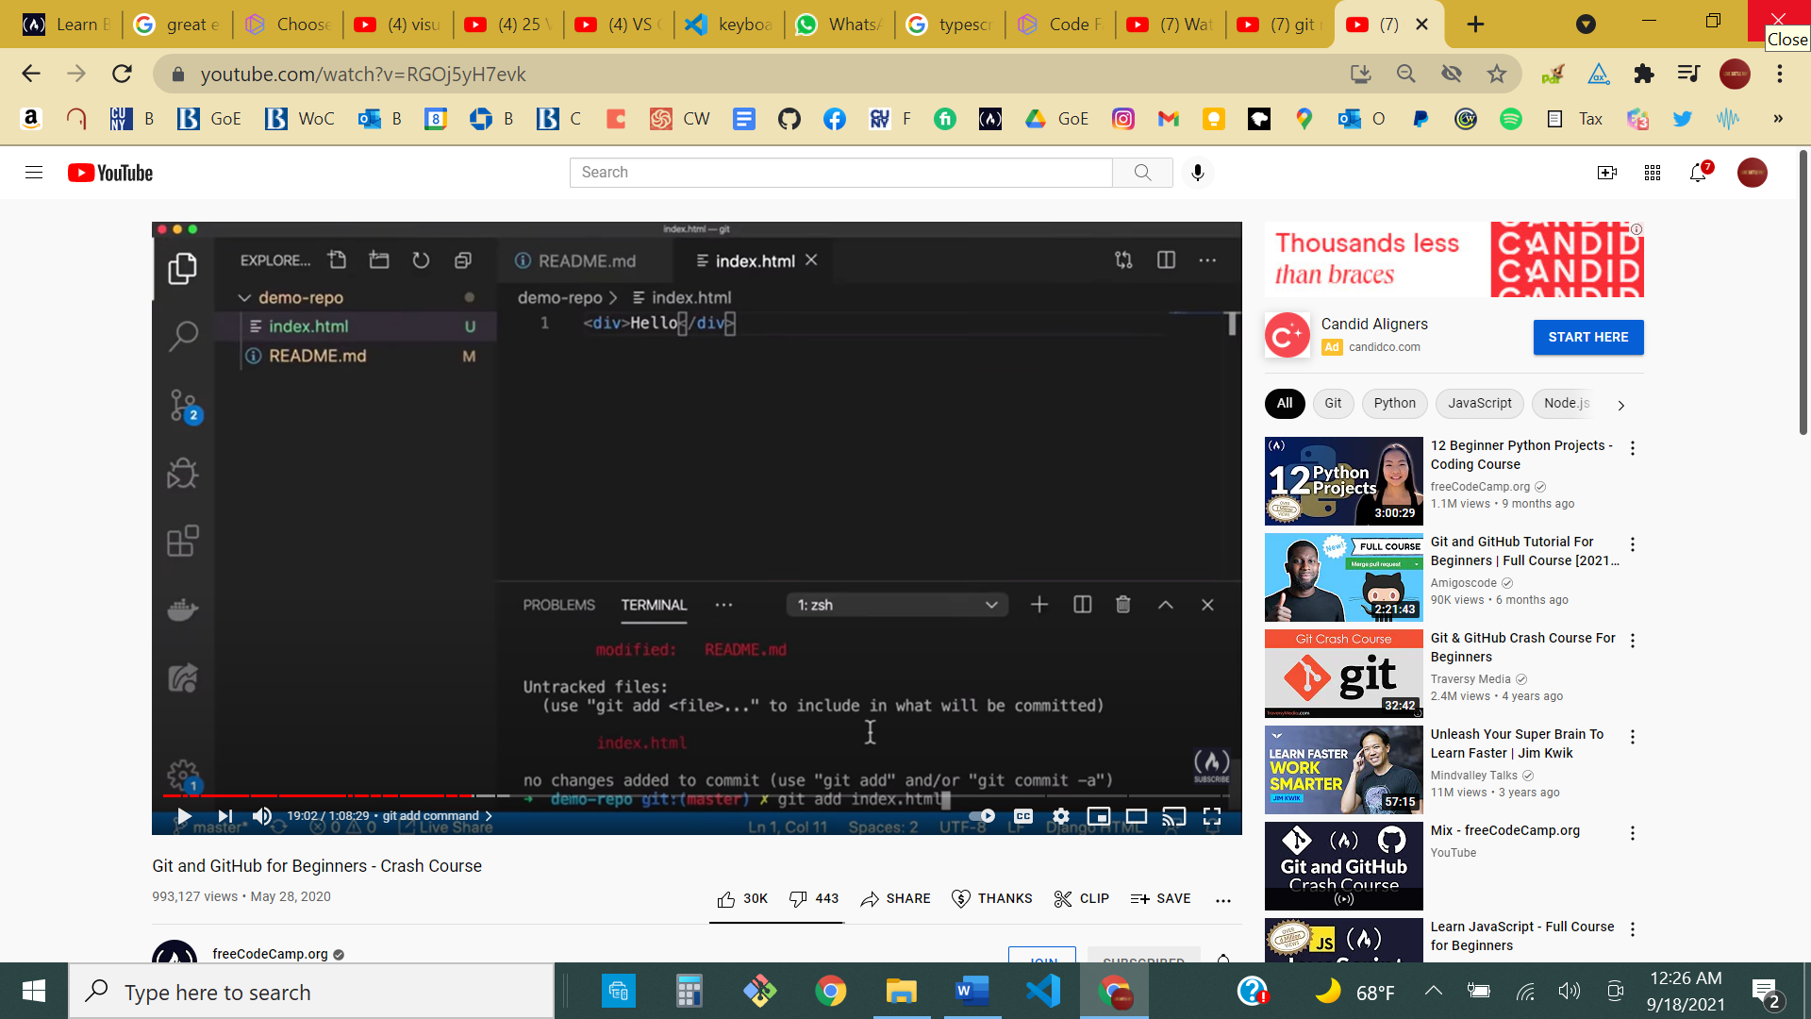

git status: checks the nature/status of current git repo

- It is important to set up ssh keys by generating a key locally:
  - Ssh-keygen -t rsa -b 4096 -C email@example.com

MAKE A REGULAR FOLDER A GIT REPO
- use ‘git init’ while in folder
- ‘git add’ any or all of the contents that you will be saving locally
- ‘git commit -m’ in git bash or terminal
- Create a new empty repo on the git website, under my username: add README.md file if necessary.
- Copy the SSH link to that particular git repo folder (usually found under the ‘Code’ button on the upper right)
- ‘git remote add origin + [paste SSH link]’ in git bash or terminal
- Git push -u origin master (use -u to set it up as a default for future pushes; afterwards, you can just type ‘git push’.

The “fatal: refusing to merge unrelated histories” Git error
Edpresso Team
The “fatal: refusing to merge unrelated histories” Git error occurs when two unrelated projects are merged (i.e., projects that are not aware of each other’s existence and have mismatching commit histories).

Consider the following two cases that throw this error:
- You have cloned a project and, somehow, the .git directory got deleted or corrupted. This leads Git to be unaware of your local history and will, therefore, cause it to throw this error when you try to push to or pull from the remote repository.
- You have created a new repository, added a few commits to it, and now you are trying to pull from a remote repository that already has some commits of its own. Git will also throw the error in this case, since it has no idea how the two projects are related.
Solution
The error is resolved by toggling the allow-unrelated-histories switch. After a git pull or git merge command, add the following tag:

git pull origin master --allow-unrelated-histories

More information can be found here, ​ on Git’s official documentation.

