Haifa University

Computer Science Department

The Account Program’s Bug

Software Testing Course

Dr. Shmuel Ur

Submitted by:

Zoya Shaham 17259045
Maya Maimon 40600595

Contents

Contents 3
A.Overview 4
B. Synchronization 4
C. Inputs and outputs of the program 5
Example of a buggy interleaving 6
D. Dictionary of all possible tuples 7
Remark: 7
E. The Bonus 7
Running 8
Discussion 9
1st Lab – 9
Figure 1: 10
2nd Lab – 11
Figure 2: 12
Conclusion 13

A. Overview

This program manages accounts, in the following aspects:
- Deposits – Adds a sum of money to an account.
- Withdrawals – Subtracts a sum of money from an account.
- Transfers – Subtracts a sum of money from one account and adds the same amount of money to another account. The transfers are in a cyclic order.

The implementation of the program constructed from three classes: Account, ManageAccount and Main.
Each account is managed by a thread. The thread is an instance of ManageAccount class. The Manager creates the account and performs operations on it. Executing this Manager thread will perform the following operations:
Adding 300, subtracting 100 from its account and transferring 99 to another account.
The class ManageAccount consists a static array of all the accounts. The random function, which was chosen for transferring the money, is the cyclic order that the accounts are organized in.
In the Main function, Thread Managers are created and being started. The number of Thread Managers may be 2,5 or 10 in accordance with the user input.

B. Synchronization

To avoid non-deterministic results, each account’s operation is a synchronized function, e.g. at the same time only one operation may be executed on account A (for example). Trying to execute another operation on Account A will start after the completion of the first operation on account A.
The problem in this synchronization is that it didn’t eliminate the non-deterministic results.
The Bug is as follows:
- We are using lock for each account, BUT if there is a transfer between account A to account B, then account's B lock will never be require()-ed by account A, and the meaning is that the amount in account B will not always be as it is supposed to be.

The bug can be found in line 25 in class Account (and between lines 28-31 in Class ManageAccount).

The bug pattern it conforms is a weak reality principle [Wrong Lock/No Lock].

The involved variables in the bug are the variable amount in every account. This variable is one of the fields in class Account.

C. Inputs and outputs of the program

The program receives as an input two parameters:
- The name of the output file.
- Optional parameter of concurrency, {little, average, lot}, which will determine the number of Manager threads.
  - little concurrency -> 2 threads (default).
  - average concurrency -> 5 threads.
  - lot concurrency -> 10 threads.

The program outputs into the output file tuples of the form <program name, result, bug-pattern-indicated>. The possible tuples are elaborated in the dictionary below. The output tuple is in accordance with the actual running of the program.

The program prints the final amounts as a result. There are too many options for the program output. For example if we have two threads:
A-300 B-300,
A-300 B-99,
A-300 B-101,
A-300 B-199,
A-300 B-201,
A-300 B-299,
A-300 B-399,
A-300 B-400,
A-300 B-499,
A-201 B-199.

As mentioned above, there are too many options and we did not calculate/elaborate all of them. We also skipped the possibilities of 5 threads (A-E) or 10 threads (A-J). In general, the idea is that the buggy line may be updated in any time of the other thread execution.

Example of a buggy interleaving
time

First, we will assign numbers to the operations:
1. Initial (100)
2. Deposit (300)
3. Withdraw (100)
4. Transfer to the other account (99):
a. Subtract 99
b. Read the other balance
c. Add 99 to it
d. Update the amount in other account

The interleaving will show the operations that were executed and then the variable(s) that was (were) changed at the end of the operation. The variables are amount and local_amount for each account (A or B) .We need the local variable in accordance with how java executes the operations.

The only way to get a buggy interleaving in our program is to have a context switch in the transfer operation (line 25), which was not protected properly. We will see in the bonus part that noise between lines 24-25 will increase the probability to have a buggy interleaving.
Thread A
1. amountA=100

2. amountA=400
3. amountA=300
4a. amountA=201
4b. local_amountB=100
4c. local_amountB=199

4d. amountB=199

Thread B

1. amountB=100

2. amountB=400
3. amountB=300
4a. amountB=201
4b. local_amountA=201
4c. local_amountA=300
4d. amountA=300

time
D. Dictionary of all possible tuples

One of the following elements will be in the output file:

<Account program, All amounts are 300, None>
< Account program, There is an amount with more than 300 and
there is amount with less than 300, No Lock>
<Account program, There is amount with more than 300, No
Lock>
<Account program, There is amount with less than 300, No
Lock >

Remark:
Usually there is a case when the right results are calculated, but the interleaving was not as it was supposed to be. In our thread.run code this is not possible. (It might be a section which was not atomic, although it was suppose to be, but it did not affect the amount’s value. Such cases can be identified if the trace is available).

E. The Bonus

The tool uses different heuristics to find bugs in a concurrent program. Each heuristic includes some input parameters. The better heuristic will find bugs in a higher probability. The goal of this testing is to run our program repeatedly with different parameters and to find which heuristic works better.

The parameters are as follows:
- The first parameter: <little, average, lot>
- Number of times to run
- In the noise table we have:
  - Size of variable subset we have the following parameters:
    - White noise – random noise
    - Subset and its size
    - Single variable
For each one of the above three parameters we can choose also:
i. Escape analysis
ii. Noise before event
iii. Noise after event
  - Type of noise applied. We can choose from the following:
    - Take lock before
    - Take lock after
    - Yield – requires setting the loop probability and setting the yield probability.
    - Barrier – we need to determine the barrier probability and the barrier time (milliseconds)
    - Variables – We can choose one or more of the following variables (to replace the random choice).

Running

We ran the program 200 times for every test.
Attached is a table of the results (excel file). For each test we checked how many times (out of 200) we had a buggy run. In the last column, we wrote the result.
Because of technical problems, we ran the program in two different places. This is the reason for two kinds of the control tests, one for every lab of the tests.
The tests in the 1st lab were run on all levels of concurrency (little, average and lot). We continued the testing in the 2nd lab with average concurrency. All the tests were run with noises before and after the events.
As for the size of the variable subset we chose the following parameters:
  - Subsets – we ran it on two, four and six randomly chosen variables.
  - Single Variable – we chose the most common variables, and the least common variables and we checked to see the reaction for the combination: E.g. we ran a test with the most common variable, then with two most common. We did the same for the least common, and then we combined the most common one with the least common one.
We applied the following types of noise:
  - Yield and Loop Probability – we set the yield and the loop probability to various possibilities, in order to try and find the point when more buggy runs appear. We especially did it for the tests in the 1st lab. In the 2nd lab we took the probabilities of 90%, 60%, and 30%. The percentages were the same for both the yield and the loop probabilities, in the two labs.
  - Taking Lock Before and After, Barrier – because of technical problems we did not check the program under these types of noise.

Discussion

1st Lab –
- We ran six tests concerning the little concurrency. The differences in the tests were the loop & yield probabilities. If we compare the two results, where the loop & yield probabilities are 90% and where the loop & yield probabilities are 66%, we can see that the amount of buggy runs found in both of these tests is almost identical. This is what brought us to try the 75% probability of the loop & yield, in order to see what is the amount of buggy runs found in these levels of probabilities. We can see that if we make more noise we can find more buggy runs up to a level, where making more noise means we are going to find less buggy runs. We assume that where you have “too much” noise, is eventually “disturbing” the bugs to appear and we reach to the correct runs just by chance.
- We can see that running the tests in higher levels of concurrency is giving us the same graphical behavior like the test we ran in the little concurrency.
- Differences between the concurrencies: We can see that the higher the concurrency was, the higher was the curve of the buggy runs we found in the tests.

Figure 1:
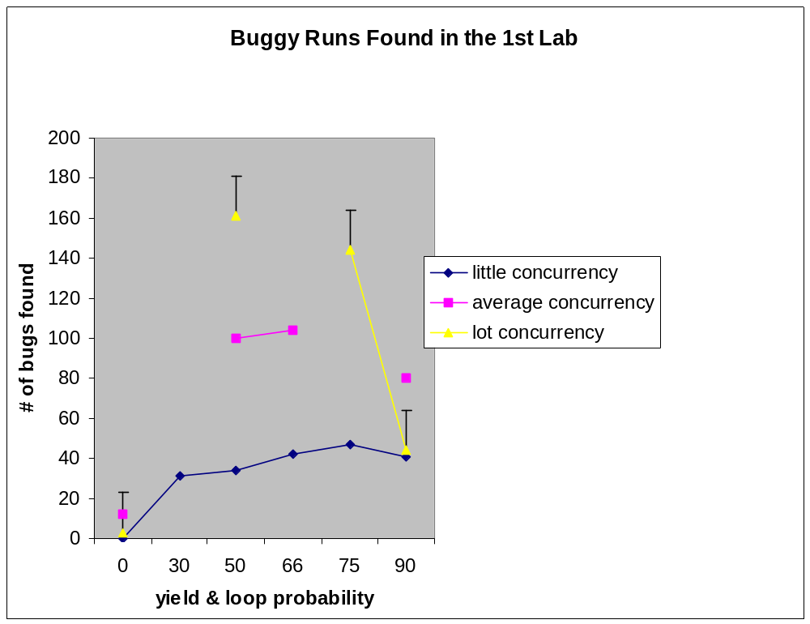

2nd Lab –
- Random variables: If we make noise on more random variables the more buggy runs we find. We think it is due to the fact that in our program there is race only on one variable, and the question is if we chose it or not. This is also the reason for the next two results.
- Appearance of variables:
  - The uncommon variable and two uncommon variables: Two of the lowest levels of buggy runs found during the tests we ran with it.
  - The most common variable: it has the best levels of buggy runs found during the tests we ran with it.
  - Two most common variables: the amount of buggy runs found during these tests are lower than that of one most common variable, we believe it is due to the fact that “too much” noise, is eventually “disturbing” the buggy runs to appear and we reach to more correct runs just by chance. We also know that in our program we have race only on one variable, so the noise on the other variable might decrease the number of buggy runs found in the test.
  - Mixture of two – Most common with most uncommon: it has the 2nd highest level of buggy runs, which were found during the tests. On one hand it is making noise on the most common variable, and this, we believe, is the reason for the many buggy runs, which were found during the tests. On the other hand we were also making noise on the uncommon variable, and as written above, “too much” noise is eventually disturbing. We can see clearly that taking the mixture is less disturbing than taking two most common variables, because we can find more buggy runs in the mixture, we think it is because making noise on the uncommon variable is less “disturbing” than making noise on the 2nd most common.
  - Comparing the noise made on random variables to the noise made on specific variables: It is clearly seen that the best choice is to make noise on the most common variable, and preferably only on it. The second best choice is to make noise on many random variables, because, as seen on the graph – making noise on six random variables gives better results than making noise on two random variables. The worst choice is to make noise on the uncommon variable/s. We assume that it is more likely that the most common variable will have race on it. Looking closely on the program reveals that there is only one variable that has race on it, and probably it is better to have the noise on it.

Figure 2:
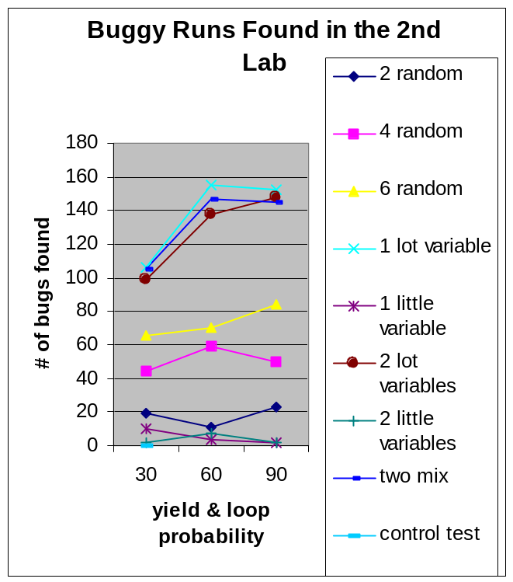

Conclusion

It is very hard or even impossible to find the best heuristic for all the programs, which exist. The goal of these tests was to check which heuristic works better for our program and to derive why one heuristic was better than the other. We described the tests, environment, and results. Our findings are elaborated in the discussion above.

The number of accounts depends on the concurrency we want to achieve in this program: for higher concurrency we will have more accounts.
The accounts we have defined in our program.
This is a random way, which was implemented in our program.
Will be explained below
We assigned numbers only to the relevant operations. Operations like 4a, which subtract 99, are protected with the lock, so we assume it was atomic. The initialization also cannot be disturbed due to the way the code is written.
The tests were chosen according to the assumptions we wanted to check. The results are analyzed in the discussion.
The first tests were run in the 2nd degree’s Labs (we will call it the 1st lab), and the last tests were run in Yosi Ben Asher’s Cluster computers’ lab (we will call it the 2nd lab). Yosi Ben Asher’s computers are much faster than the 2nd degree lab’s computers.
That is because we know that for our program we have race only on that variable, in random choice the program might not make any noise on that variable or make noise on other variables and “disturb” the buggy runs from appearing,
The reason is again, the chance of making noise on the right variable.

