LEAFLET

(tag line)

**Appendix**

App Description –

“**Leafy**” application provides an attractive and user-friendly experience to people who are fond of plants and enjoy gardening. The main goal of designing the application will focus more on following the **“KISS”** approach and keeping the flow simple but attractive which will enable more people to access different varieties of plants. Leafy is a unique idea and very rarely being implemented till now. Like there are many websites like www.nurserygide.com but not many applications being designed which would fulfill the purpose of delivering plants right to the customer. Key features about the application will be integrating a marketplace where people can connect and sell their plants.

Group Number, Group Members Full Names –

|  |  |  |
| --- | --- | --- |
| Student Name | Student ID | Contribution |
| Kosha Paresh Raval | 300324116 | 33.33% |
| Rebecca Moses Demllo | 300322984 | 33.33% |

Link to Video Presentation:

Individual member contribution percentage towards group project (must total to 100% in all giving percentage for each person) Video Presentation (clickable link should be given in report): 8 Min Video – Video must detail group number, app name, app justinmind demo highlighting interesting, important features, and must provide key insights from requirements gathering and evaluation user studies – Everyone must participate in the video presentation • Percentage contribution (should be in report) – A three member project can have 33.3% each or – Student 1 – 25%, Student 2 – 35%, Student 3 – 40%

Introduction – Name, motto, metaphors – Broad Motivation of Utility – What your app does – high level – Identify PACT elements – Outline personas and scenarios to motivate your app

NAME: – Name for your app and motto (and logo if you like) – Capture the essence, communicate a metaphor •

**Market Competitors**

“My Garden: Inspiration To Grow” is an android application which provides users with the tutorial of how they could plant and nurture their garden. The application was just focused mainly on providing tutorials whereas in most scenarios there are cases where people might not have sufficient time to start planting from the basic i.e with seeds. There may be some circumstances where people would prefer to have small roses or lily plants around them rather than waiting for long to see plants grow. In such cases the success of downloading the app will fall apart.

“House indoor plants” app provides information and sells plants that can be grown inside the house for decorative purposes. This application has a plain and simple design where all the plant information is shown in a scrollable list. Whereas our application will focus on buying and selling of plants in form of seeds to a grown christmas tree. “Florist One Flower Delivery app” is an app that has a restrictive scope of selling only bouquets of flowers. The theme used for  the application is not at all attractive and the colors used are quite dull.

**Novel Idea**

There are many applications in the market which provide delivery service to users but they mainly focus on Grocery or other products like electronics. The application which we are planning to design will mainly focus on “**delivery of plants”** to the user. Additional feature which will be incorporated in our application will be “**Marketplace”** which will provide flexibility to the user in case they would like to sell some plants from their own garden. We will also try to add more small functional components to the design like Points which could be redeemed by the user while purchase or something similar to it.

**Requirements**

User Personas:

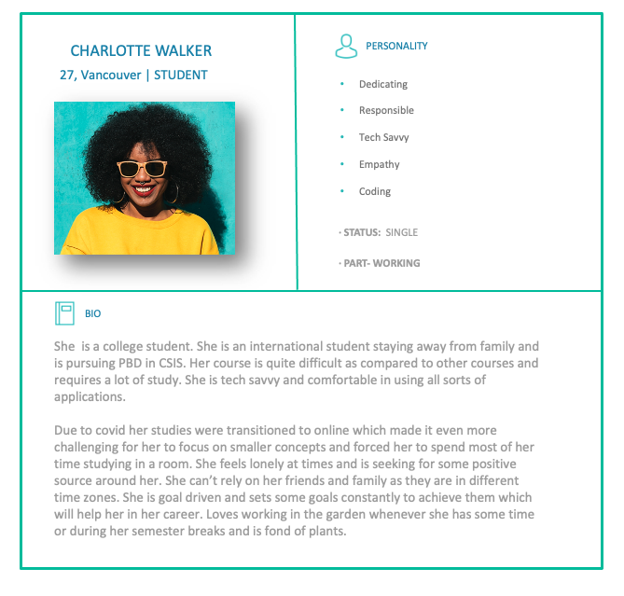

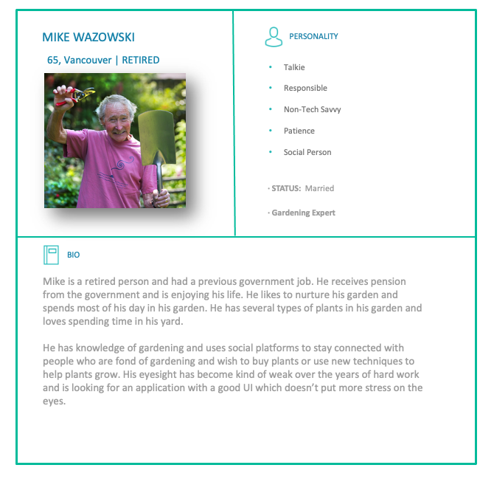

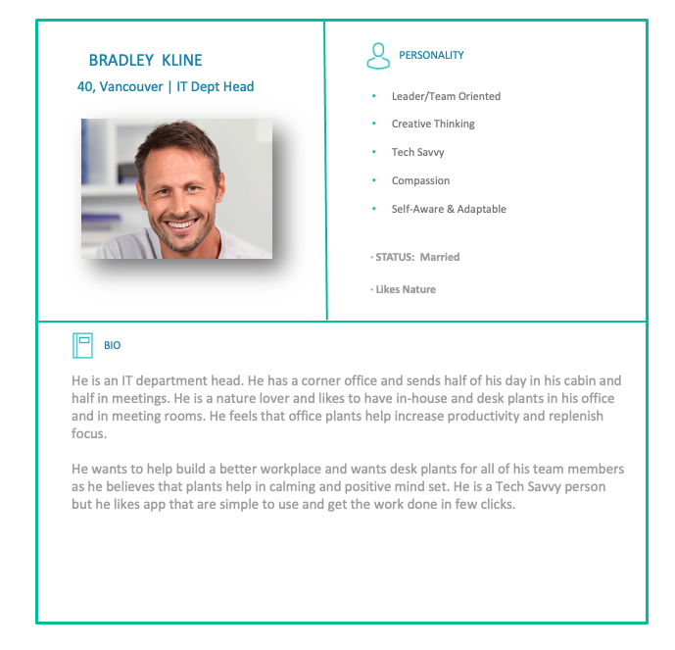

Requirements gathering and evaluation using user personas:

PACT: Identify PACT elements for your app.

• Understanding: – Stories/Scenarios, Storyboards,

Stories/Scenarios, Storyboards or mood boards that reflect your insights

Moodboards and use cases –

Identify problem and solution space • Requirements Gathering and generation – Must involve evaluation/user studies – List of requirements • Functional vs. non-functional • Must haves and more optional functions

Mock-up sketches or prototypes on paper (need not be included in the report) • Actual wireframing and prototyping (justinmind) •

Navigation Maps

Evaluation of created prototypes – Designer based evaluation – User studies of prototype evaluation – Improve prototype based on feedback

**Design**

User Studies – How did you do requirements gathering, understanding? – How did you evaluate your design? – What methods did you use? – What were the results of your requirements gathering and evaluation? – Total of 5 participants each for Requirements gathering and evaluation

Design – What are the main screens, their broad functions, individual features you have designed – Envisionment and task analysis for your app – What will be a typical interaction flow when using your app? – Include screenshots of all your main screens

**Conclusion**

–Did you think your design achieved your goals? If yes, how? If not, why not? – Broad insights or lessons learned from the design project • What are your broad take-aways or learned insights from doing this design project?

**Reference**