TrustFed-Health: A Privacy-Preserving, Explainable and Fairness-Audited Hierarchical Federated Learning Framework for Multi-Hospital Heart-Disease Risk Prediction
Vikram R  Department of CSE,  IFET College of Engineering,  Villupuram, India.  rmvikram05@gmail.com | [Co-author 2 name]  Department of CSE,  [Institution],  [City, Country].  [email] | [Guide name, Dr.]  Department of CSE,  [Institution],  [City, Country].  [email]

Abstract—Hospitals cannot pool patient records, yet single-site models generalise poorly. We present TrustFed-Health, a hierarchical federated learning (FL) framework for heart-disease risk prediction that combines record-level differential privacy (local DP-SGD with a Rényi accountant), additive-secret-sharing secure aggregation inside regional hubs, an optional Paillier tier between hubs and the global server, exact Shapley explanations, and a fairness audit that compares subgroup accuracy and SHAP-importance profiles. All components run in a tested, dependency-light Python engine behind a role-based FastAPI service and React dashboard. We evaluate on a synthetic Cleveland-schema cohort (the real data could not be downloaded in the build environment) (297 patients) split over 5 non-IID hospitals using 10×5-fold cross-validation. Secure aggregation is numerically exact (max accuracy difference 0.000). Local DP at σ=2 (worst-case ε=8.1, δ=10⁻⁵) lowers accuracy from 86.1 ± 4.1% to 83.9 ± 4.4% and reduces a loss-threshold membership-inference attack from AUC 0.533 to 0.516 (paired Δ=0.017, 95% CI [0.009, 0.025]). Federation beats isolated hospitals by 8.8 accuracy points. We report overheads, limitations and a reproducible protocol.
Keywords—federated learning, differential privacy, secure aggregation, SHAP, algorithmic fairness, membership inference, healthcare AI

I. Introduction
Machine-learning models for cardiovascular risk are only as good as the data behind them, but patient records are protected by law and institutional policy and cannot be centralised [1]. Federated learning (FL) trains a shared model by exchanging model updates instead of records [2], [3]. FL alone is not a privacy guarantee: updates can leak membership and attributes, clinical users need to know why a model flags a patient, and a model that is accurate on average may still underperform for particular sexes, age bands or hospitals.
Recent healthcare-FL work addresses pieces of this problem—hierarchical aggregation with DP and secure multi-party computation [4], wearable prognostics [5], key distribution for patient authentication [6], XGBoost-based federated transfer [7], cyber-threat detection [8] and blockchain-backed services [9]—but among the works we reviewed none jointly (i) measures privacy empirically with a membership-inference attack, (ii) explains each prediction with exact attributions and (iii) audits subgroup fairness inside the federation. TrustFed-Health targets that gap.
The contributions of this paper are:
• a two-tier federation (hospital → regional hub → global server) with local record-level DP-SGD, exact additive-share secure aggregation and an optional packed-Paillier tier;
• an auditable privacy pipeline: a Rényi-DP accountant for the Poisson-sampled Gaussian mechanism (checked against a published benchmark) plus an empirical membership-inference test;
• exact Shapley explanations (all 2¹³ coalitions) and a fairness audit combining subgroup accuracy with a permutation test on SHAP-importance divergence;
• an open, tested implementation (unit tests for gradients, accountant, secure sums, Paillier, SHAP efficiency and fairness detection) and a one-command reproduction of every number in this paper.

II. Related Work
Federated learning in healthcare. FedAvg [2] remains the baseline; surveys emphasise statistical heterogeneity and privacy as open problems [3], [1]. Hierarchical designs reduce cross-silo communication and allow regional trust domains; Singh et al. [4] combine them with DP and SMPC. We adopt that structure but add exact accounting and empirical attack testing.
Differential privacy. DP-SGD clips per-example gradients and adds Gaussian noise [10]. Privacy loss is tracked with Rényi DP; for Poisson-sampled Gaussian steps there is a closed form at integer orders [11], converted to (ε, δ) with the tight rule of Balle et al. [12]. We implement this accountant directly.
Secure aggregation. Additive secret sharing hides individual updates from the aggregator [13]; additively homomorphic Paillier encryption [14] lets an untrusted server add ciphertexts. We use both, at different tiers.
Explainability and fairness. Shapley values [15] underlie SHAP [16]; with 13 features we compute them exactly. Group-fairness criteria such as equalised odds [17] compare error rates across subgroups; we additionally compare how the model uses features per subgroup using Jensen–Shannon divergence [18].
Privacy auditing. Membership-inference attacks [19], [20] estimate leakage empirically; stronger likelihood-ratio attacks exist [21] and are left for future work.

III. Problem Statement and Objectives
Given K hospitals, each holding a private, differently distributed tabular cohort, train a global risk model such that (O1) no site's raw data or individual update is revealed, (O2) the privacy cost is quantified formally (ε, δ) and tested empirically, (O3) every prediction carries a faithful explanation, and (O4) performance and feature-use disparities across sex, age band and hospital are detected and reported. The system should run end-to-end in a web application with role-based access and a tamper-evident audit trail.

IV. System Design

A. Architecture
Fig. 1 shows the architecture. Hospitals train locally; the 5 sites are grouped into 2 regional hubs (sizes 3, 2). Inside a hub, updates are combined by secure summation; hub totals are optionally encrypted under a key held by a separate authority and summed by the global server, which never sees an individual hub total in the clear. After training, the explanation, fairness and privacy audits run on the global model and are exposed through a FastAPI service with JWT roles (hospital staff, regional admin, global admin) and a hash-chained audit log.
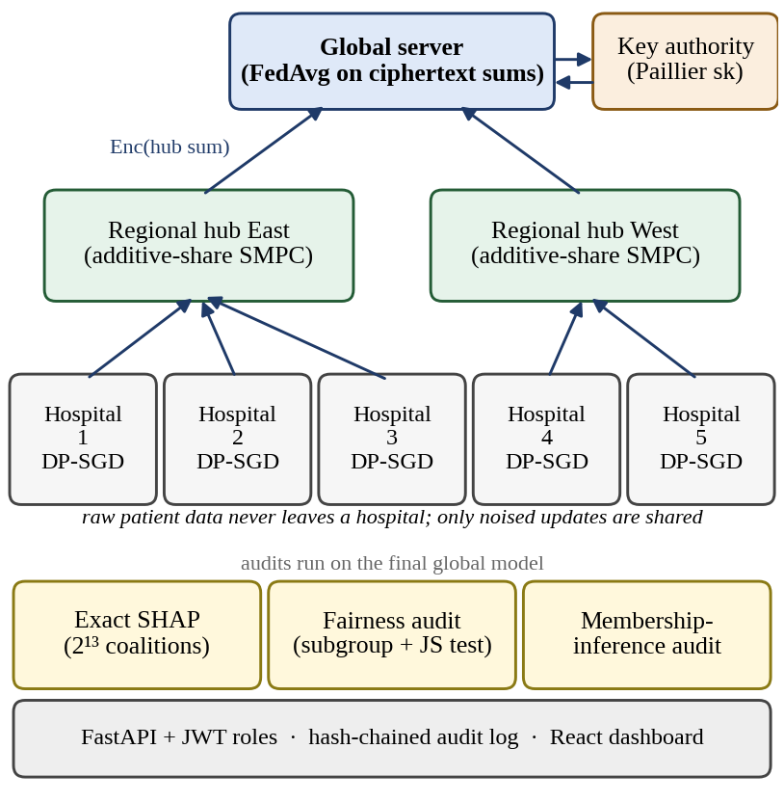
Fig. 1. TrustFed-Health architecture: two-tier federation with local DP-SGD, SMPC in hubs, optional Paillier tier and post-hoc audits.

B. Model and Federated Optimisation
The predictor is a 13–32–16–2 ReLU network (1010 parameters) over the 13 Cleveland attributes, standardised with public normalisation constants. Each round every hospital runs local SGD from the global weights and the server forms the sample-weighted average
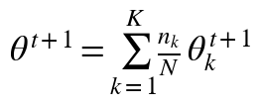 (1)
where nₖ is hospital k's training-set size and N=Σnₖ. Weights nₖθₖ and the count nₖ are aggregated together so the weighting itself is computed securely.

C. Local Differential Privacy
Each local step samples a Poisson mini-batch (rate q=B/nₖ), clips every per-example gradient to L2 norm C and adds Gaussian noise:
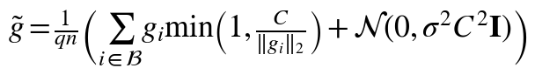 (2)
We implement per-example gradients analytically (verified against finite differences). The guarantee is record-level for each hospital over all T=rounds×steps local steps. The accountant evaluates, for integer orders α∈[2, 256],
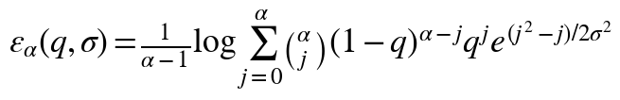 (3)
composes T steps linearly, and converts to (ε, δ)-DP:
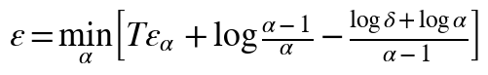 (4)
As a correctness check our code reproduces ε≈2.6 for the standard MNIST benchmark (N=60 000, B=256, σ=1.1, 60 epochs, δ=10⁻⁵), and the older, looser conversion gives ≈3.0, the value commonly quoted for this benchmark. We report the maximum ε over hospitals, which is governed by the smallest site.

D. Secure Aggregation
Tier 1 (SMPC). A hospital encodes its vector in fixed point (2⁻²⁴ resolution) and splits it into one random share per member of its hub:
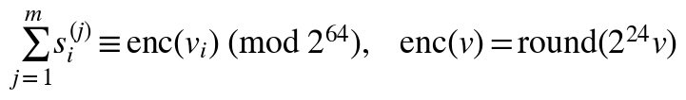 (5)
Member j adds the shares it receives and the hub adds the partial sums, so only the total is ever formed; any single share or partial sum is uniform on ℤ₂⁶⁴. Exactness is tested: the aggregate equals the plain sum to 10⁻⁶. Tier 2 (HE). Hub totals are encrypted with Paillier [14] (g=n+1) using slot packing—19 values of 52 bits per 1024-bit plaintext—so a 1011-element vector needs 54 ciphertexts; the global server multiplies ciphertexts and a key authority decrypts only the sum. A hub of two sites cannot hide a member's update from the other member once the hub total is known; this inherent limit is discussed in Section VII.

E. Explainability
For a standardised patient x and reference b (the population mean after standardisation), the Shapley value of feature j for the logit margin f=z₁−z₀ is
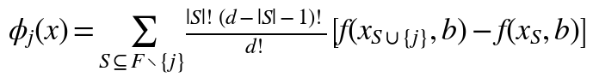 (6)
Because d=13 we enumerate all 8 192 coalitions, so values are exact and satisfy efficiency, Σφⱼ=f(x)−f(b) (unit-tested). An LLM can optionally verbalise the top attributions, constrained to those numbers; a deterministic template is used when no key is configured.

F. Fairness Audit
On held-out predictions we report, per subgroup (sex, age <55/55–64/≥65, hospital site), accuracy, TPR and FPR. To test whether the model uses features differently for a group g we compute normalised mean-|SHAP| profiles and
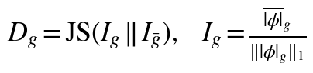 (7)
with p-values from 500 label-permutation draws. A subgroup with n≥15 is flagged if its accuracy deviates from overall by >10 points or p<0.05. The fairness score is 1−max accuracy gap. A SHAP flag signals a different feature profile—often reflecting covariate differences—and is a prompt for clinical review, not proof of bias.

G. Empirical Privacy Test
We run a loss-threshold membership-inference attack [20] with members = training records and non-members = held-out records:
(8)
AUC 0.5 means no leakage. This is a weak attack; a low AUC does not prove privacy, which is why the formal ε is reported alongside it.

V. Experimental Setup

A. Data and Federation
Data disclosure. The sandbox used to build this version had no internet access, so the UCI Cleveland file [22], [23] could not be fetched. All reported numbers therefore come from a synthetic cohort with the same 13-attribute schema, 297 patients and prevalence 40.4%, generated from approximate class-conditional marginals. These results validate the pipeline, not clinical performance. Running python -m tefl.run_experiments --data cleveland and rebuilding this paper replaces every number with real-data results.
Patients are assigned to K=5 hospitals with label skew (Dirichlet α=0.5 [24]) and age skew, guaranteeing ≥5 patients per class per site; mean training sizes are 37, 52, 48, 45, 55. The same mechanism assigns held-out patients to sites so each hospital has a site-specific test slice.

B. Protocol and Baselines
We use 10 repetitions of stratified 5-fold cross-validation (50 runs per method, identical splits across methods). Normalisation constants come from the training fold. Methods: centralised pooled training (upper bound), local-only training, FedAvg on IID and non-IID partitions, FedAvg+SMPC, FedAvg with 150 rounds (to expose overfitting leakage), and TEFL (local DP-SGD + SMPC) at σ∈{1, 2, 4, 8}. Table I lists the shared settings.
TABLE I
EXPERIMENTAL CONFIGURATION
Parameter | Value
Network / parameters | 13–32–16–2 ReLU / 1010
Rounds × local epochs | 20 × 1
Expected batch B / lr (SGD) | 8 / 0.1
Clip norm C | 1.0
Noise multiplier σ | 1, 2, 4, 8
δ / RDP orders | 10⁻⁵ / 2…256
Hospitals / hubs | 5 / 2 (3+2)
Partition | Dirichlet α=0.5, age skew 0.5
Evaluation | 10×5-fold CV

VI. Results and Discussion

A. Utility and Privacy
TABLE II
TEST RESULTS, MEAN ± SD OVER 50 RUNS
Method | Acc. (%) | ROC-AUC | MIA AUC | ε
Centralised (pooled) | 85.9 ± 3.9 | 0.930 | 0.557 | —
Local-only (mean) | 77.3 ± 4.2 | 0.883 | — | —
FedAvg, IID | 86.1 ± 4.1 | 0.939 | 0.531 | —
FedAvg, non-IID | 86.1 ± 4.1 | 0.937 | 0.533 | —
FedAvg + SMPC | 86.1 ± 4.1 | 0.937 | 0.533 | —
FedAvg, 150 rounds | 85.8 ± 4.3 | 0.930 | 0.555 | —
TEFL σ=1 | 84.6 ± 4.0 | 0.926 | 0.518 | 22.3
TEFL σ=2 | 83.9 ± 4.4 | 0.916 | 0.516 | 8.1
TEFL σ=4 | 78.8 ± 5.8 | 0.866 | 0.510 | 3.4
TEFL σ=8 | 67.1 ± 8.7 | 0.717 | 0.499 | 1.5
MIA AUC: loss-threshold attack (0.5 = chance). ε: worst hospital, δ=10⁻⁵.
Table II and Fig. 2 summarise utility. Federation is clearly worthwhile: non-IID FedAvg exceeds isolated hospitals by 8.8 accuracy points (paired 95% CI [7.6, 10.1]) and is within 0.2 points of centralised training. Non-IID skew changes accuracy by +0.0 points relative to IID (CI [-0.8, +0.8]). Secure aggregation is exact: FedAvg and FedAvg+SMPC differ by at most 0.000 accuracy in any run, because the ring arithmetic is lossless up to 2⁻²⁴ quantisation.
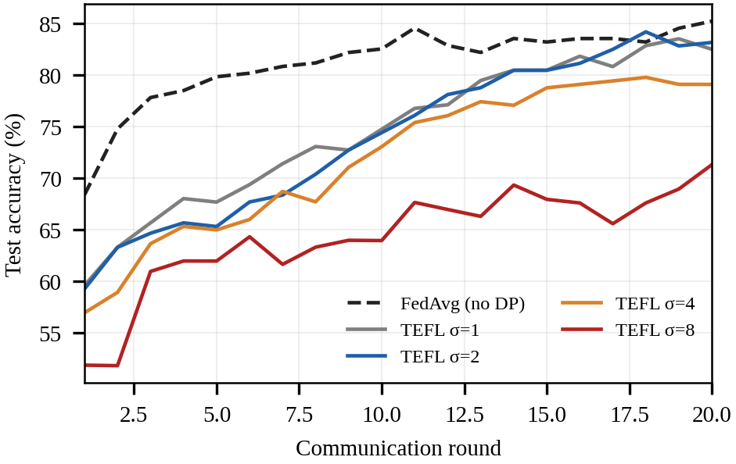
Fig. 2. Test accuracy per round (mean of the five folds of repetition 1). Higher noise slows convergence.
Local DP trades accuracy for privacy smoothly: σ=1 / 2 / 4 / 8 give worst-case ε≈22.3 / 8.1 / 3.4 / 1.5 and accuracy 84.6 ± 4.0 / 83.9 ± 4.4 / 78.8 ± 5.8 / 67.1 ± 8.7%. The paired accuracy cost relative to non-private FedAvg is 2.2 points at σ=2 (CI [1.0, 3.3]). These ε values are large by deployment standards: they are set by the smallest hospital (37 training records on average), where each record is sampled in a large fraction of the steps. More data per site, fewer rounds or larger σ shrink ε, at the utility cost in Fig. 3.
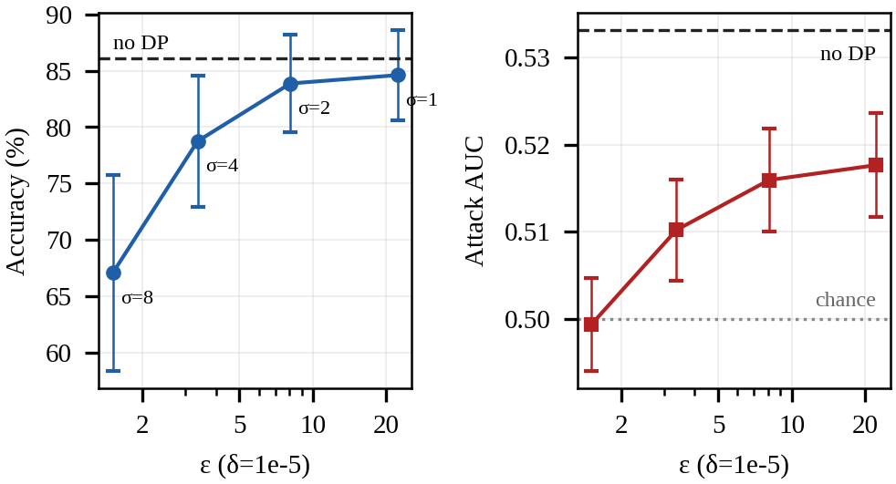
Fig. 3. Privacy–utility trade-off. Left: accuracy (±SD). Right: membership-inference AUC (±SE); dashed = non-private FedAvg, dotted = chance.
Empirical leakage. Even without DP the attack is weak here (AUC 0.533 at 20 rounds; 0.555 after 150 rounds; 0.557 for the pooled model), because a 1 010-parameter network trained briefly on ~240 records barely overfits. DP still reduces the AUC monotonically towards 0.5 (σ=8: 0.499); the paired reduction at σ=2 is 0.017 (95% CI [0.009, 0.025]). This effect is statistically detectable but small in absolute terms, and the CI treats repeated-CV runs as independent, so it is optimistic. We therefore do not claim that DP 'eliminates' leakage; the formal ε is the guarantee, the attack is a sanity check.

B. Explainability
Fig. 4 shows global importance (mean |SHAP|, pooled out-of-fold predictions of repetition 1). The three most influential features are vessels (ca), exercise angina, chest-pain type for non-private FedAvg and thalassemia, vessels (ca), exercise angina with DP; the Spearman rank correlation of the two importance vectors is 0.79, i.e. DP noise largely preserves which features drive predictions. Rankings on synthetic data reflect the generator, not clinical knowledge.
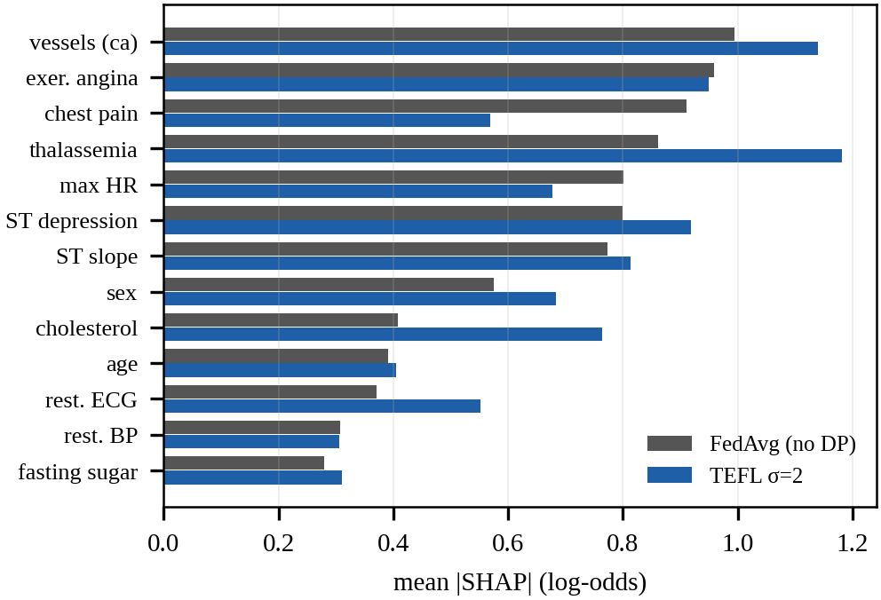
Fig. 4. Global feature importance for non-private FedAvg and TEFL σ=2.

C. Fairness Audit
TABLE III
SUBGROUP AUDIT (POOLED OUT-OF-FOLD TEST PREDICTIONS)
Subgroup | n | Acc. FedAvg | Acc. TEFL σ=2 | JS div. | p
Female | 100 | 88.0 | 87.0 | 0.138 | 0.002*
Male | 197 | 83.8 | 81.2 | 0.138 | 0.002*
Age <55 | 161 | 83.9 | 82.6 | 0.042 | 0.653
Age 55-64 | 100 | 85.0 | 83.0 | 0.060 | 0.164
Age ≥65 | 36 | 91.7 | 86.1 | 0.105 | 0.032*
Hosp. 1 | 44 | 81.8 | 79.5 | 0.078 | 0.206
Hosp. 2 | 63 | 93.7 | 90.5 | 0.091 | 0.016*
Hosp. 3 | 66 | 84.8 | 83.3 | 0.037 | 0.942
Hosp. 4 | 54 | 85.2 | 79.6 | 0.046 | 0.816
Hosp. 5 | 70 | 80.0 | 81.4 | 0.059 | 0.347
p<0.05 (500 permutations). Overall accuracy: FedAvg 85.2%, TEFL 83.2%
Fairness scores are 0.915 (FedAvg) and 0.927 (TEFL σ=2), i.e. the largest subgroup accuracy gap is 8.5 and 7.3 points. The audit raised 4 and 4 flags respectively. Subgroup sizes are small (smallest: 36 patients), so per-group accuracies have wide uncertainty (a binomial 95% interval at that size is roughly ±9 points); the flags are best read as review prompts. Fig. 5 shows that, relative to non-private FedAvg, DP changes subgroup accuracies by between -5.6 and +1.4 points.
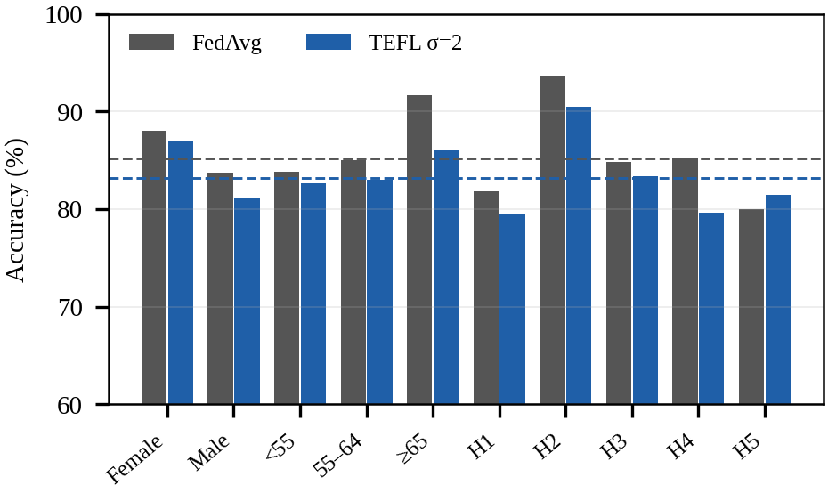
Fig. 5. Subgroup accuracy; dashed lines mark overall accuracy.

D. Overhead
TABLE IV
AGGREGATION COST PER ROUND (5 HOSPITALS, 1 011 VALUES)
Protocol | Time
Plain sum | 7 µs
SMPC (additive shares) | 0.11 ms
SMPC + Paillier-1024 (packed) | 1.84 s
SMPC + Paillier-2048 (packed) | 6.49 s
Single-threaded pure-Python Paillier; key generation is excluded.
Additive-share SMPC is negligible; Paillier dominates (about 1.8 s per round at 1 024 bits and 6.5 s at 2 048 bits even with packing), which is acceptable for cross-hospital rounds that take minutes but is why HE is optional in the dashboard. Optimised big-integer libraries would reduce this substantially.

VII. Limitations and Threats to Validity
Data. Results use a synthetic cohort and must be regenerated on real data before any scientific claim; the 'hospitals' are simulated partitions.
Privacy. DP is record-level per hospital, assumes honest Poisson sampling and ignores privacy spent on hyper-parameter selection and on normalisation constants (treated as public). The attack is weak; stronger attacks may recover more. Secure summation inside a two-site hub reveals the other member's update to a member who learns the hub total, and neither SMPC nor HE defends against malicious or colluding parties.
Fairness. Small subgroups yield noisy estimates; SHAP-profile divergence is partly driven by covariate differences and is a review signal, not a bias test. Multiple comparisons are not corrected.
Scope. The model is a small MLP on 13 tabular attributes; it is decision support, not a diagnostic device. Differences across partitions and seeds are reported as SD, and confidence intervals from repeated CV are optimistic.

VIII. Conclusion and Future Work
TrustFed-Health shows that formal DP accounting, exact secure aggregation, exact explanations and subgroup auditing can be combined in one small, fully tested federated pipeline. On the synthetic cohort, federation outperformed isolated hospitals, secure aggregation cost no accuracy, and DP traded a few accuracy points for a lower—but not zero—empirical leakage. Future work includes evaluation on multi-institution clinical data, likelihood-ratio membership attacks [21], secure aggregation with dropout tolerance and malicious-security guarantees, client-level DP, fairness-aware training, and native Flower/Opacus back-ends.

Reproducibility
Code, tests and the paper builder are in the project archive: python tests/test_tefl.py, python -m tefl.run_experiments --data cleveland, then python paper/make_figures.py results/results.json && python paper/build_paper.py results/results.json.

References
[1] N. Rieke et al., "The future of digital health with federated learning," npj Digit. Med., vol. 3, art. 119, 2020.
[2] B. McMahan, E. Moore, D. Ramage, S. Hampson, and B. A. y Arcas, "Communication-efficient learning of deep networks from decentralized data," in Proc. AISTATS, 2017, pp. 1273–1282.
[3] P. Kairouz et al., "Advances and open problems in federated learning," Found. Trends Mach. Learn., vol. 14, no. 1–2, pp. 1–210, 2021.
[4] J. P. Singh et al., "Privacy-aware hierarchical federated learning in healthcare: Integrating DP and SMPC," Future Internet, 2025.
[5] A. Jain and S. Bhullar, "AI-driven wearable health devices with health-aware control and secure prognostics," Array, 2025.
[6] O. AbuAlghanam et al., "A novel key distribution for mobile patient authentication inspired by federated learning," Sensors, 2025.
[7] L. Tightiz et al., "XG-FedAIT: XGBoost-based federated adaptive interpolation transfer learning for post-TAVR outcome prediction," Blockchain: Res. Appl., 2025.
[8] A. Ikegwu et al., "Advancing federated learning frameworks for privacy-preserving cyber threat detection in healthcare systems," Int. J. Comput. Intell. Syst., 2026.
[9] D. K. Murala et al., "MedLedgerFL: A hybrid blockchain–federated learning framework for secure remote healthcare services," Sci. Rep., 2026.
[10] M. Abadi et al., "Deep learning with differential privacy," in Proc. ACM CCS, 2016, pp. 308–318.
[11] I. Mironov, K. Talwar, and L. Zhang, "Rényi differential privacy of the sampled Gaussian mechanism," arXiv:1908.10530, 2019.
[12] B. Balle, G. Barthe, M. Gaboardi, J. Hsu, and T. Sato, "Hypothesis testing interpretations and Rényi differential privacy," in Proc. AISTATS, 2020, pp. 2496–2506.
[13] K. Bonawitz et al., "Practical secure aggregation for privacy-preserving machine learning," in Proc. ACM CCS, 2017, pp. 1175–1191.
[14] P. Paillier, "Public-key cryptosystems based on composite degree residuosity classes," in Proc. EUROCRYPT, 1999, pp. 223–238.
[15] L. S. Shapley, "A value for n-person games," in Contributions to the Theory of Games II, Princeton Univ. Press, 1953, pp. 307–317.
[16] S. M. Lundberg and S.-I. Lee, "A unified approach to interpreting model predictions," in Proc. NeurIPS, 2017, pp. 4765–4774.
[17] M. Hardt, E. Price, and N. Srebro, "Equality of opportunity in supervised learning," in Proc. NeurIPS, 2016, pp. 3315–3323.
[18] J. Lin, "Divergence measures based on the Shannon entropy," IEEE Trans. Inf. Theory, vol. 37, no. 1, pp. 145–151, 1991.
[19] R. Shokri, M. Stronati, C. Song, and V. Shmatikov, "Membership inference attacks against machine learning models," in Proc. IEEE S&P, 2017, pp. 3–18.
[20] S. Yeom, I. Giacomelli, M. Fredrikson, and S. Jha, "Privacy risk in machine learning: Analyzing the connection to overfitting," in Proc. IEEE CSF, 2018, pp. 268–282.
[21] N. Carlini, S. Chien, M. Nasr, S. Song, A. Terzis, and F. Tramèr, "Membership inference attacks from first principles," in Proc. IEEE S&P, 2022, pp. 1897–1914.
[22] R. Detrano et al., "International application of a new probability algorithm for the diagnosis of coronary artery disease," Am. J. Cardiol., vol. 64, no. 5, pp. 304–310, 1989.
[23] D. Dua and C. Graff, "UCI Machine Learning Repository," Univ. California, Irvine, 2019. [Online]. Available: https://archive.ics.uci.edu
[24] T.-M. H. Hsu, H. Qi, and M. Brown, "Measuring the effects of non-identical data distribution for federated visual classification," arXiv:1909.06335, 2019.

