SECURECORP INC.
SECURITY ASSESSMENT REPORT

Name: Koshik T
Date : 16-08-2026

EXECUTIVE SUMMARY:
SecureCorp Inc. commissioned a security assessment to evaluate its security posture, identify weaknesses, investigate suspicious activity and recommend practical improvements. The assessment was performed in a controlled laboratory environment representing SecureCorp's customer-facing web application and Ubuntu web server.

The laboratory environment used an Ubuntu Server virtual machine hosting DVWA (Damn Vulnerable Web Application), a separate Wazuh server for centralized security monitoring, with WSL serving as the primary attacker/analyst environment. Network and application discovery were followed by controlled demonstrations of brute force, SQL injection, reflected crosssite scripting (XSS), and command injection.

The same activities were then reviewed from a defender's perspective using Wazuh. The assessment demonstrated that insecure authentication, unsanitized input and unsafe handling of operating-system commands can expose applications and systems to unauthorized access or data disclosure. It also demonstrated that centralized monitoring is essential because some activity may be automatically detected while other application attacks may require manual log searches and SIEM tuning.

The highest-priority improvements are stronger authentication and password controls, multi-factor authentication, strict input validation, parameterized database queries, safe command handling, improved Wazuh detection coverage, patch management and security awareness.

SCOPE AND RULES OF ENGAGEMENT :

Component | Role | Status
Ubuntu Server VM | Target server; hosts DVWA | Configured
DVWA | Vulnerable web application under assessment | Configured
WSL 2 | Primary attacker/analyst environment | Configured
Wazuh | Centralized logging / SIEM | Configured
Nmap | Network/service discovery | Used
Hydra | Controlled brute-force testing | Used where applicable
Wireshark | Packet capture / traffic analysis | Project tool
Rules Followed :

• Only systems inside the student's own lab are assessed.
• No public website, public IP, shared network device, or another student's machine is targeted.
• Password attacks are limited to accounts created by the student inside the lab.
• Every finding is supported by a screenshot, terminal output or log evidence.
• If the lab network cannot reach the target, use the documented lab fallback rather than an uncontrolled network workaround.
ASSET INVENTORY :
Asset | Type | Owner / Department | Why It Matters
Employee laptops / Windows workstations | Hardware | Employees / IT | Used for daily business operations and may contain sensitive company information.
Ubuntu Web Server | Hardware / Software | IT / Engineering | Hosts the customer-facing web application represented by DVWA and provides the main server environment
Customer Portal / Web Application | Data | Engineering / Customer Support / HR | Contains important business, customer and employee information that must be protected.
Employee Accounts & Credentials | Data | HR / IT / Employees | Credentials provide access to systems and can be abused for unauthorized access if compromised.
Internet-facing Network Connection | Connectivity | IT / Network Administration | Provides access to externally reachable services and therefore forms part of the attack surface.
CIA ANALYSIS :
Asset | Confidentiality | Integrity | Availability
Customer & Employee Database | Customer and employee information must remain private and accessible only to authorized users. | Records must not be modified, deleted or corrupted without authorization. | Authorized staff must be able to access required records when needed.
Ubuntu Web Server | Server credentials, configuration and sensitive system information must be protected from unauthorized disclosure. | System files, configurations and services must not be modified by unauthorized users. | The server must remain operational so the customer portal can be accessed.
Customer Portal / Web Application | Customer/account information handled by the application must not be exposed to unauthorized users. | Application data and transactions must not be manipulated through malicious input or unauthorized actions. | Customers and staff must have reliable access to the portal.
Employee Accounts & Credentials | Passwords and authentication information must remain secret. | Account permissions and authentication settings must not be changed without authorization. | Employees must be able to authenticate and access the systems required for their work.
Employee Laptops / Windows Workstations | Employee and business information stored or accessed on workstations must be protected. | Files, configurations and security settings must remain trustworthy and unaltered. | Employees need their workstations available to perform normal business activities.
Internet-facing Network Connection | Network access and communication should not expose sensitive information to unauthorized parties. | Network configuration and traffic paths must not be manipulated without authorization. | Required network connectivity must remain available for legitimate services and users.
RISK ASSESSMENT :

Asset | Threat | Vulnerability / Weakness | Business Impact | Risk | Recommended Security Control
Customer Portal | Brute Force | Weak authentication and unlimited/repeated login attempts | Unauthorized account access and possible account compromise | High | Strong password policy, MFA, rate limiting and account lockout
Customer Database | SQL Injection | Unsanitized user input reaches database queries | Unauthorized disclosure or manipulation of customer data | Critical | Parameterized queries, input validation and least-privilege database access
Customer Portal | Reflected XSS | User input is not properly validated/encoded | Malicious script execution in a user's browser and possible session/data exposure | High | Context-aware output encoding and strict input validation
Ubuntu Web Server | Command Injection | User input can reach operating-system command execution | Possible unauthorized command execution and server compromise | Critical | Avoid direct shell execution; use allow-lists and safe APIs
Ubuntu SSH Account | Credential Attack / Brute Force | Weak password or insufficient authentication controls | Unauthorized access to the server | High | Strong passwords, MFA where possible, rate limiting and SSH monitoring
Security Monitoring | Undetected Web Attacks | Default SIEM rules may not detect every application-level attack | Delayed detection and incident response | High | Custom Wazuh rules, improved application log collection and SIEM tuning
METHODOLOGY :
Assessment Approach
The security assessment was conducted using a structured approach consisting of environment discovery, vulnerability testing, attack simulation, centralized monitoring, and security investigation.
The assessment was performed in a controlled laboratory environment representing SecureCorp's customer portal. The objective was to identify security weaknesses, demonstrate their impact through controlled attack simulations, and determine whether the activities could be detected through centralized monitoring.
The assessment followed these general stages:
- Environment and network discovery
- Asset and service identification
- Vulnerability and security testing
- Controlled attack simulation
- Wazuh-based monitoring and log collection
- Detection and investigation of security events
- Analysis of findings and preparation of recommendations

Assessment Environment
The assessment environment consisted of an Ubuntu virtual machine hosting the DVWA application and a WSL-based Linux environment used as the attacker/analyst environment.
DVWA represented SecureCorp's vulnerable customer portal, while the Ubuntu system represented the target server. The assessment environment was configured so that the attacker/analyst environment could communicate with the target system.
The project handbook specifies that the Ubuntu VM acts as the target, DVWA runs on the Ubuntu server, and WSL represents the consulting/attacker environment.

Environment Components :

Component | Role
Ubuntu VM | Target server and DVWA host
DVWA | Vulnerable web application
WSL/Linux environment | Attacker and security analyst environment
Wazuh Manager | Centralized security monitoring
Wazuh Dashboard | Security event visualization and investigation
Wazuh Agent | Collection of target-system logs

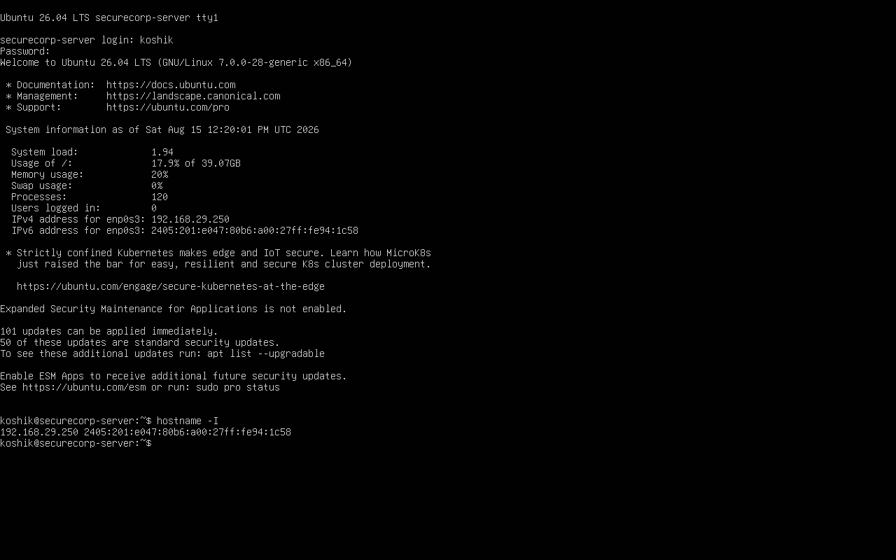

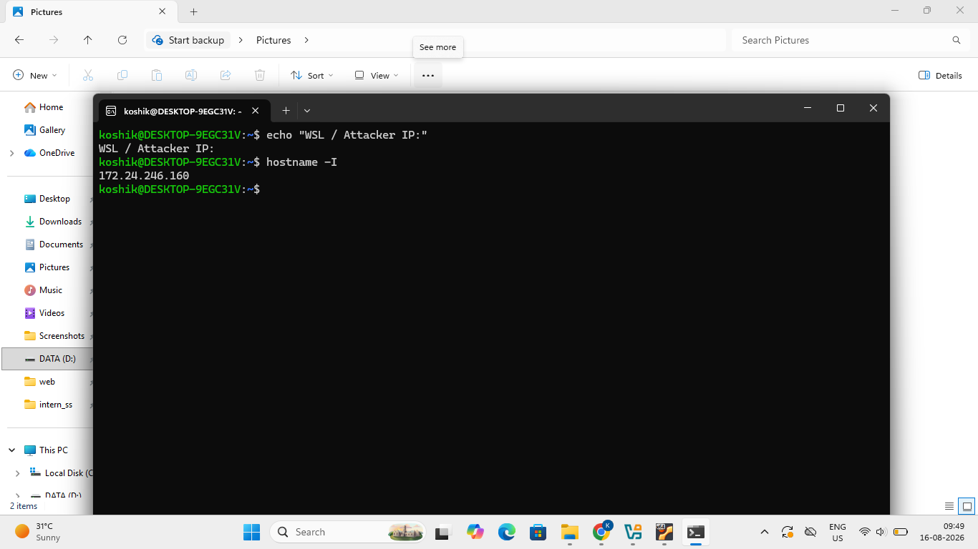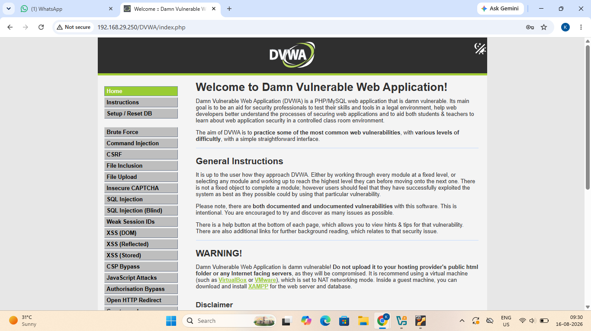
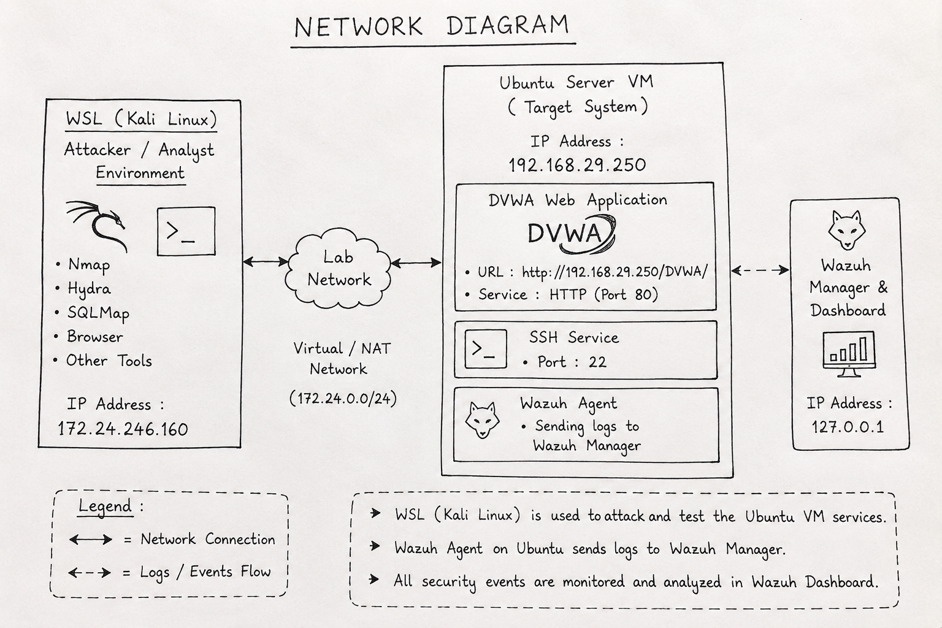
Discovery and Enumeration
Initial discovery was performed before the attack simulations to identify the target system and the services exposed by it.
Nmap was used to identify reachable services and open ports on the Ubuntu target. The scan identified services including:
- SSH — TCP/22
- HTTP — TCP/80
Service/version detection was also performed to identify the software versions associated with the discovered services.

Port | Service | Observation
22 | SSH | Remote SSH access is enabled.
80 | HTTP | Web server / DVWA is accessible.
Nmap Evidence
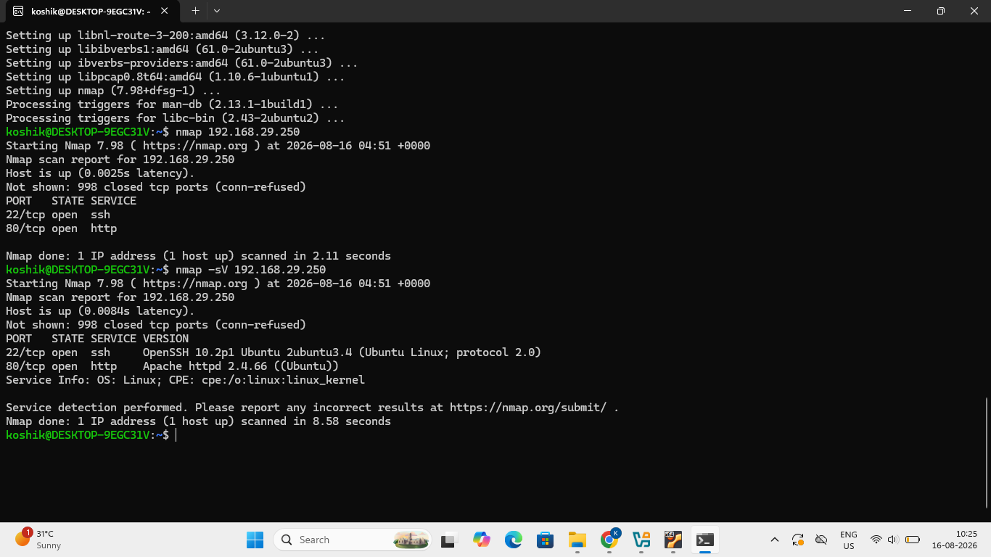
Observation: The Nmap scan confirmed that the target Ubuntu server is reachable. TCP port 22 (SSH) and TCP port 80 (HTTP) were identified as open. Service detection further identified OpenSSH 10.2p1 and Apache HTTP Server 2.4.66 running on Ubuntu Linux.
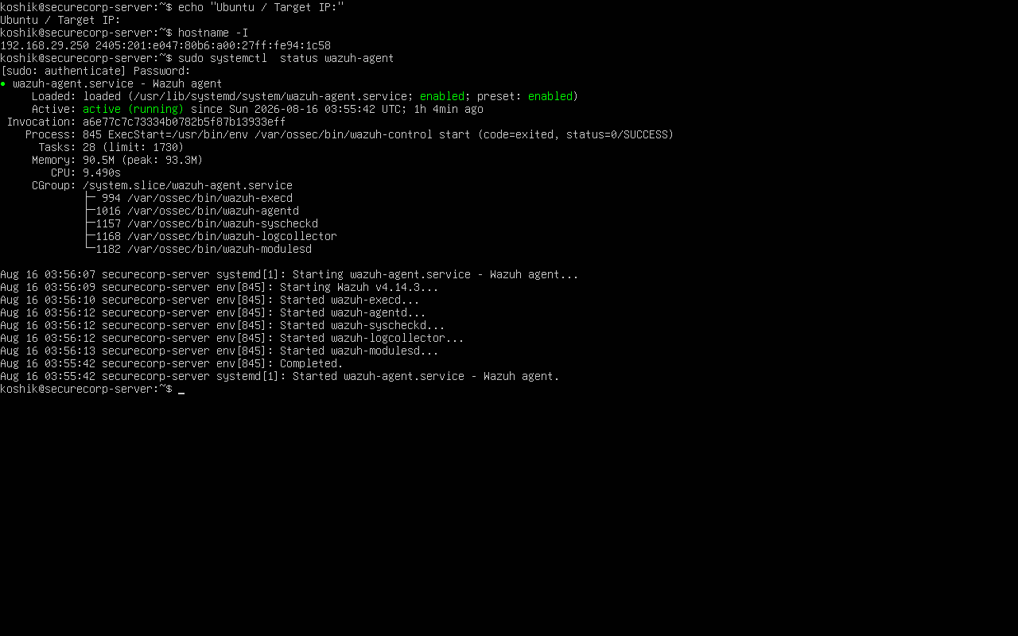
Wazuh Agent Registration and Connection Status
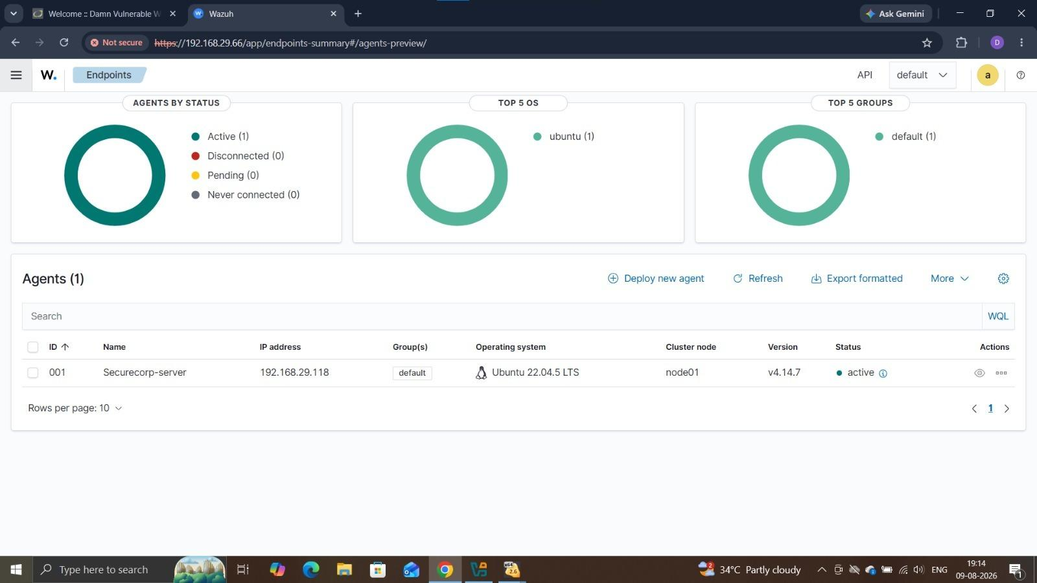
DVWA Module | Purpose / What it does | Input Accepted
Brute Force | Tests the application's resistance to repeated username and password login attempts. | Username and Password
SQL Injection | Tests whether user-supplied input can manipulate database queries and disclose additional records. | User ID
Reflected XSS | Tests whether user-supplied input can be reflected and executed as client-side JavaScript in the browser. | Name / Text Input
Command Injection | Tests whether application input can be used to execute operating-system commands through the vulnerable application. | IP Address / Command Input
Attack Simulation Evidence
Attack Simulation Findings

Attack Simulation 1 — Brute Force
Target / Module: DVWA Brute Force / Lab SSH Account
Wordlist: [welcome,hello,test123,hello@123,test@123,12345]
Attempts: [6]
Start Timestamp: 15 Aug 2026, approximately 22:47
End Timestamp: 15 Aug 2026, approximately 22:49
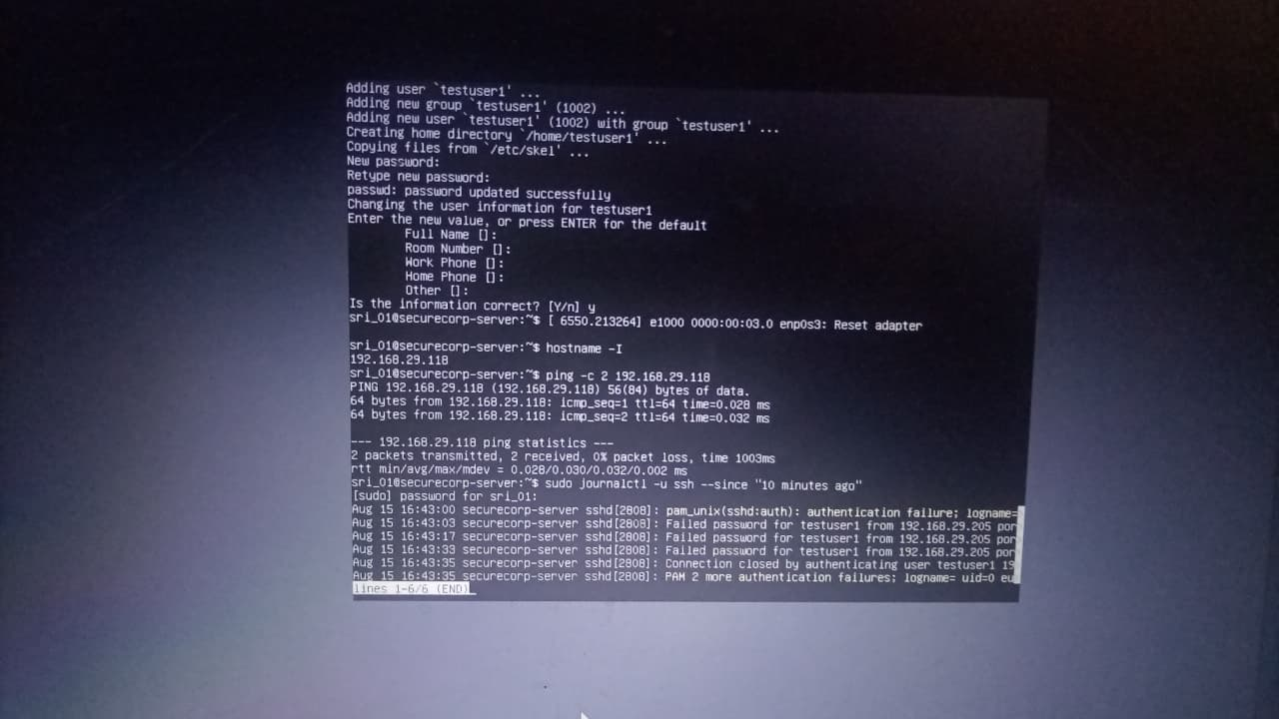
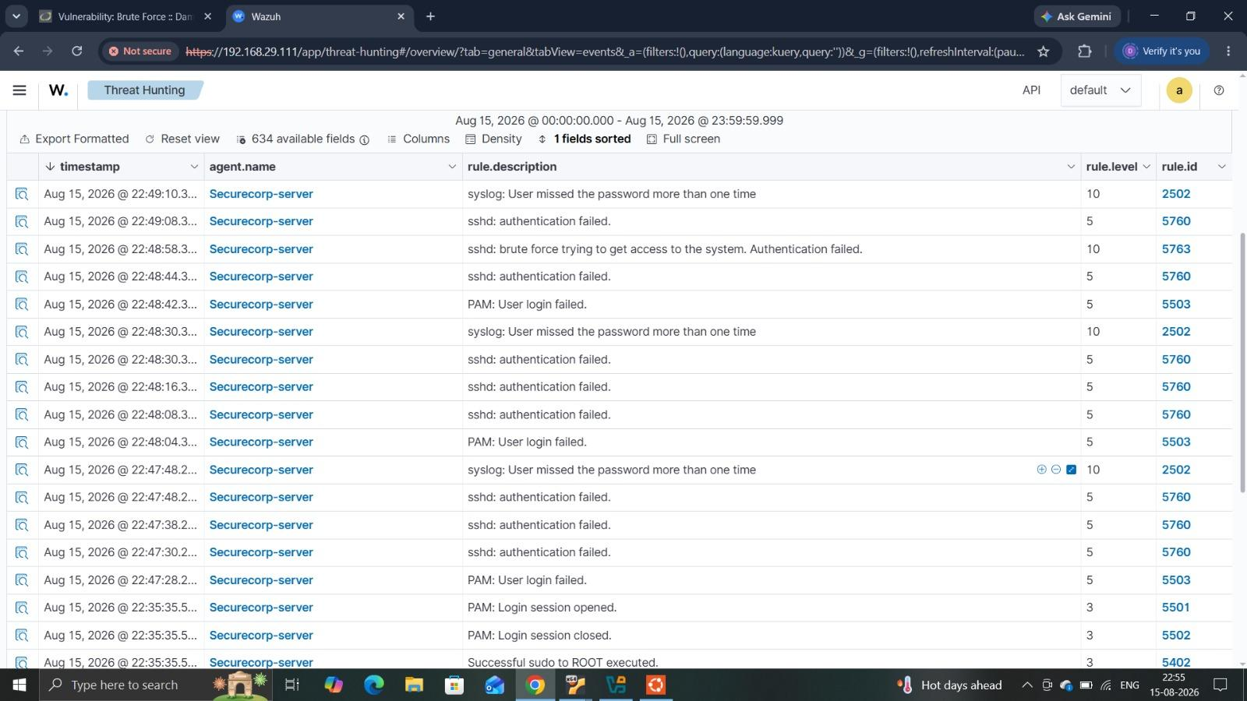
Result:
Multiple failed SSH authentication attempts were generated against the controlled lab account. Wazuh detected repeated authentication failures and identified the activity as a brute-force attempt.
Attack Simulation 2 — SQL Injection
Target / Module: DVWA SQL Injection
Security Level: Low
Input Field: User ID
Exact Payload Used:
' OR '1'='1
Timestamp: 15 Aug 2026 @ 23:13:46
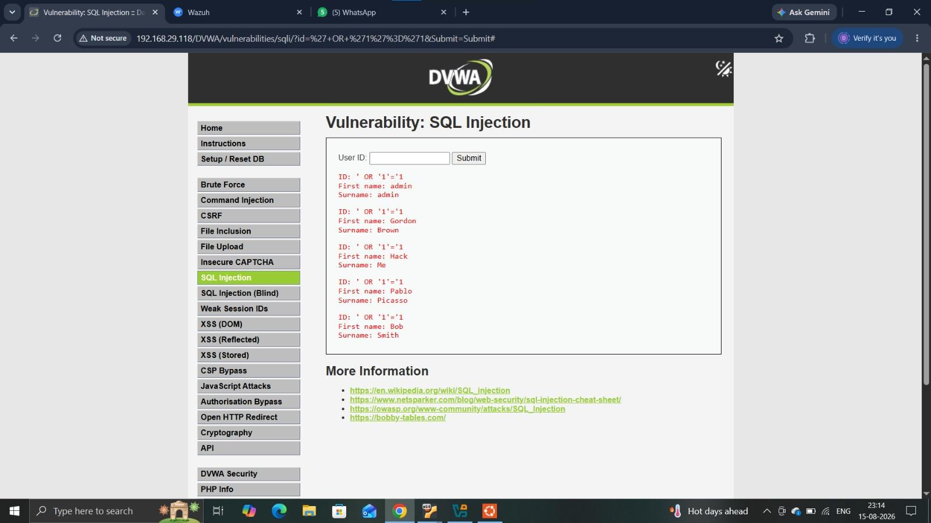
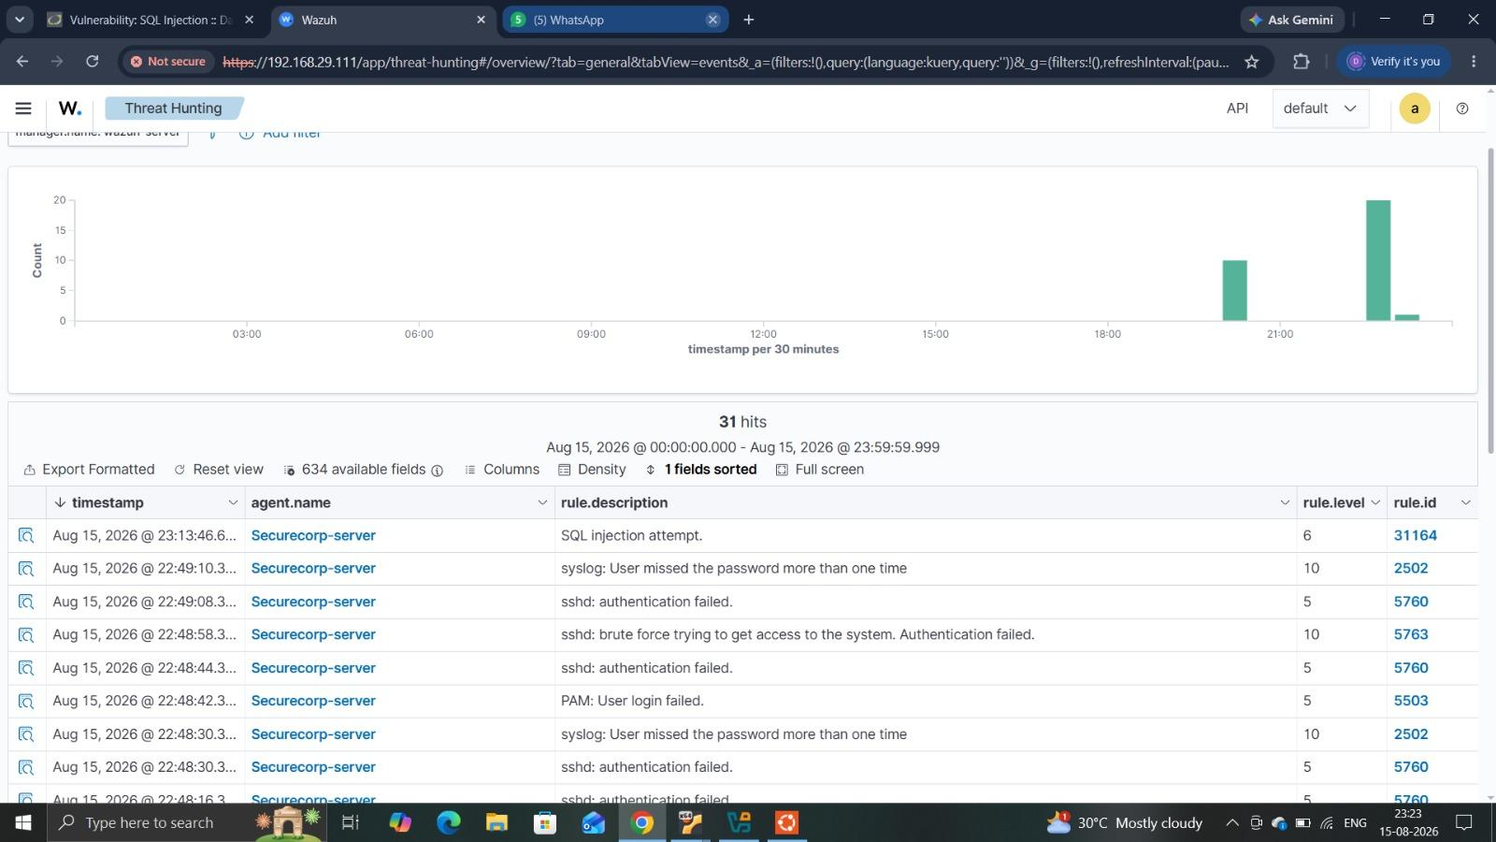
Result:
The SQL injection attack was successful. The application returned multiple database records instead of a single user record, demonstrating unauthorized data disclosure through unsanitized input.
Attack Simulation 3 — Reflected XSS
Target / Module: DVWA XSS (Reflected)
Input Field: Name
Exact Payload Used:
<script>alert('XSS')</script>
Timestamp: 15 Aug 2026 @ 23:31:39
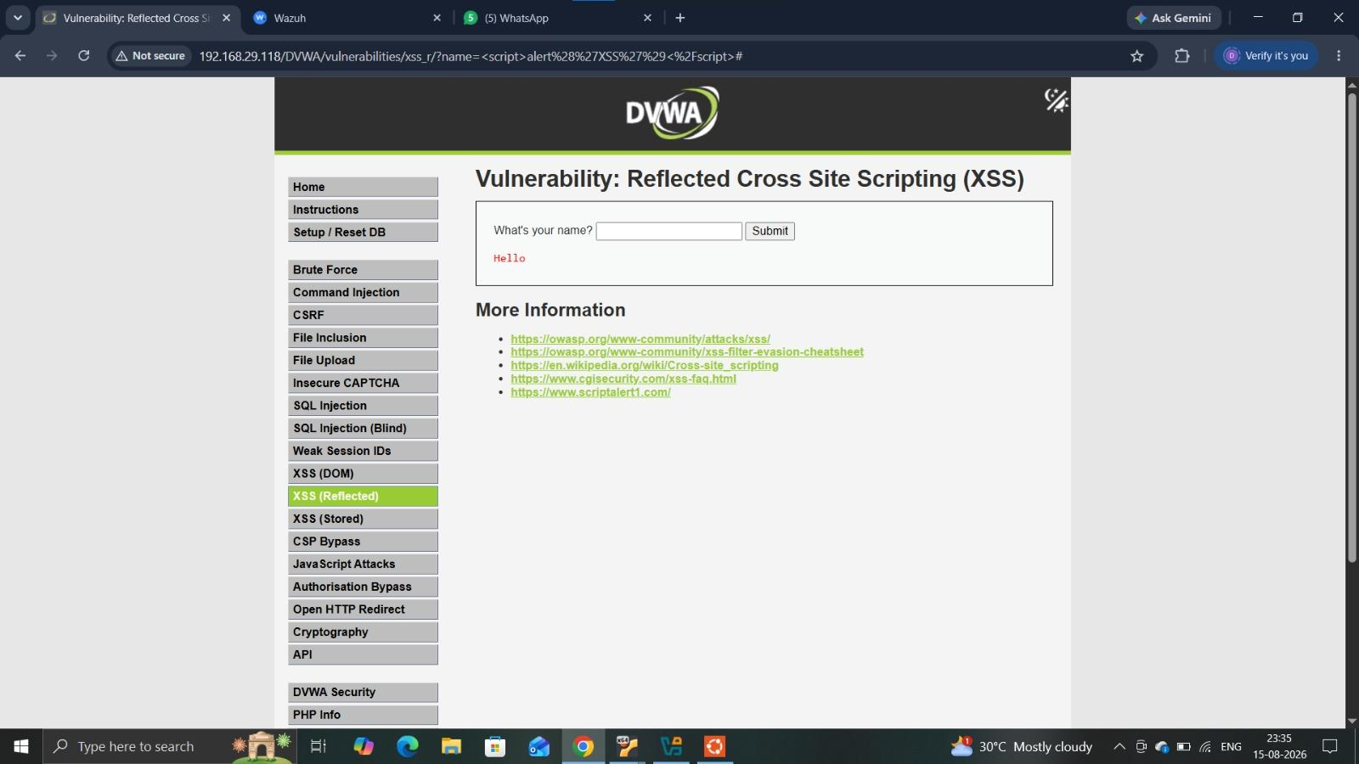
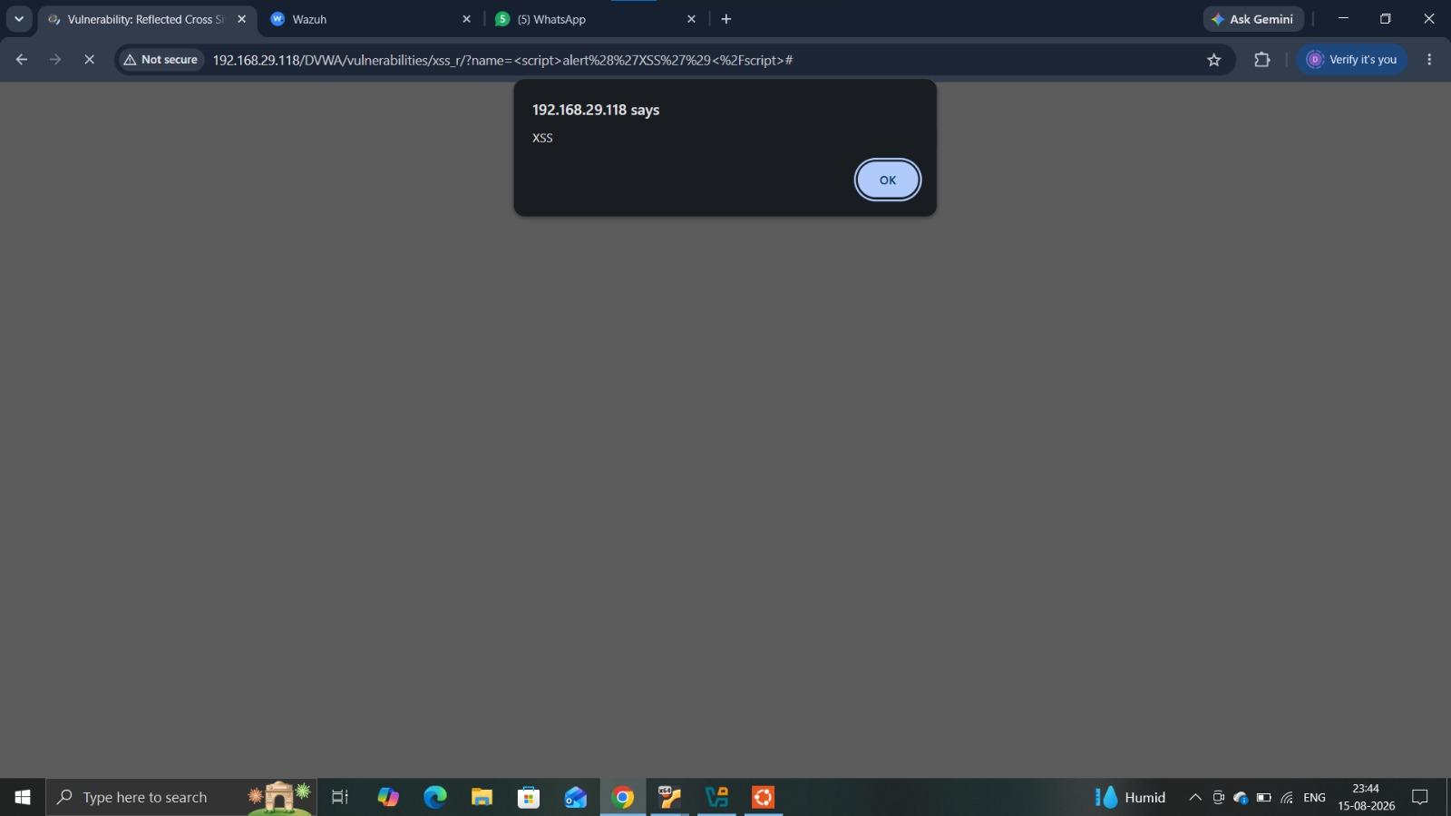
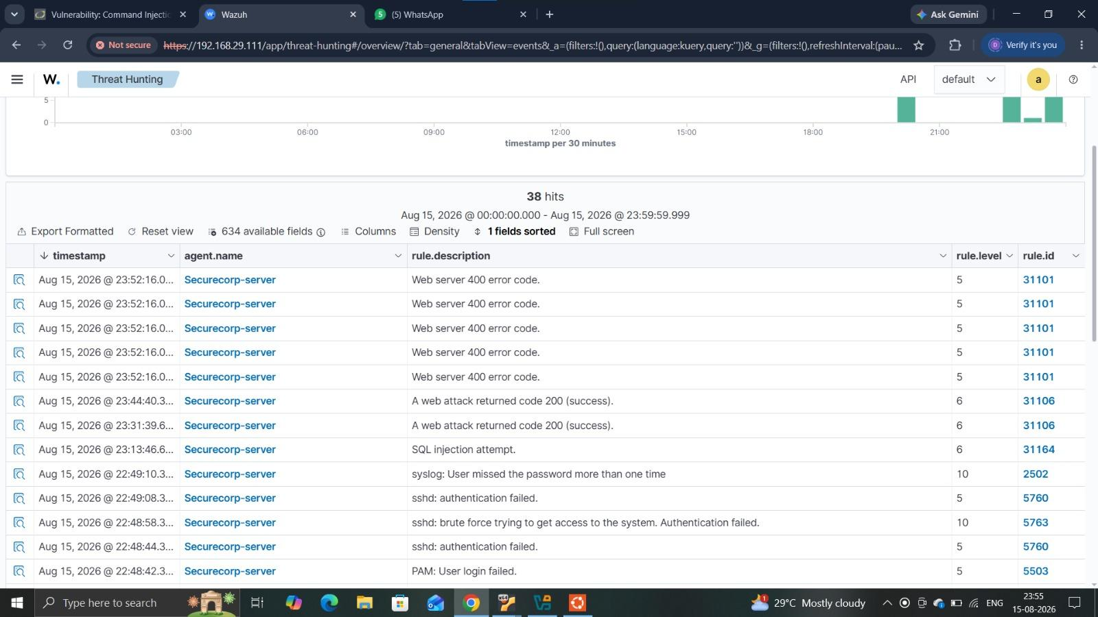
Result:
The reflected XSS attack was successful. The injected JavaScript was reflected by the application and executed in the browser, producing an alert popup displaying “XSS”.

Attack Simulation 4 — Command Injection
Target / Module: DVWA Command Injection
Input Field: IP Address
Exact Payload Used: 127.0.0.1;whoami
Timestamp: 15 Aug 2026 @ 23:44:40
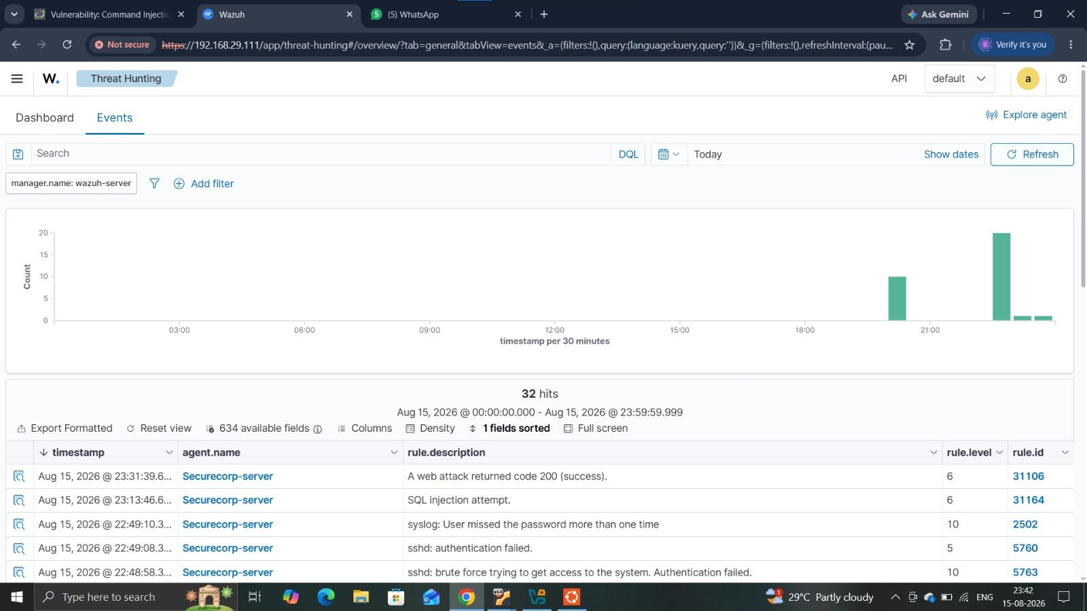
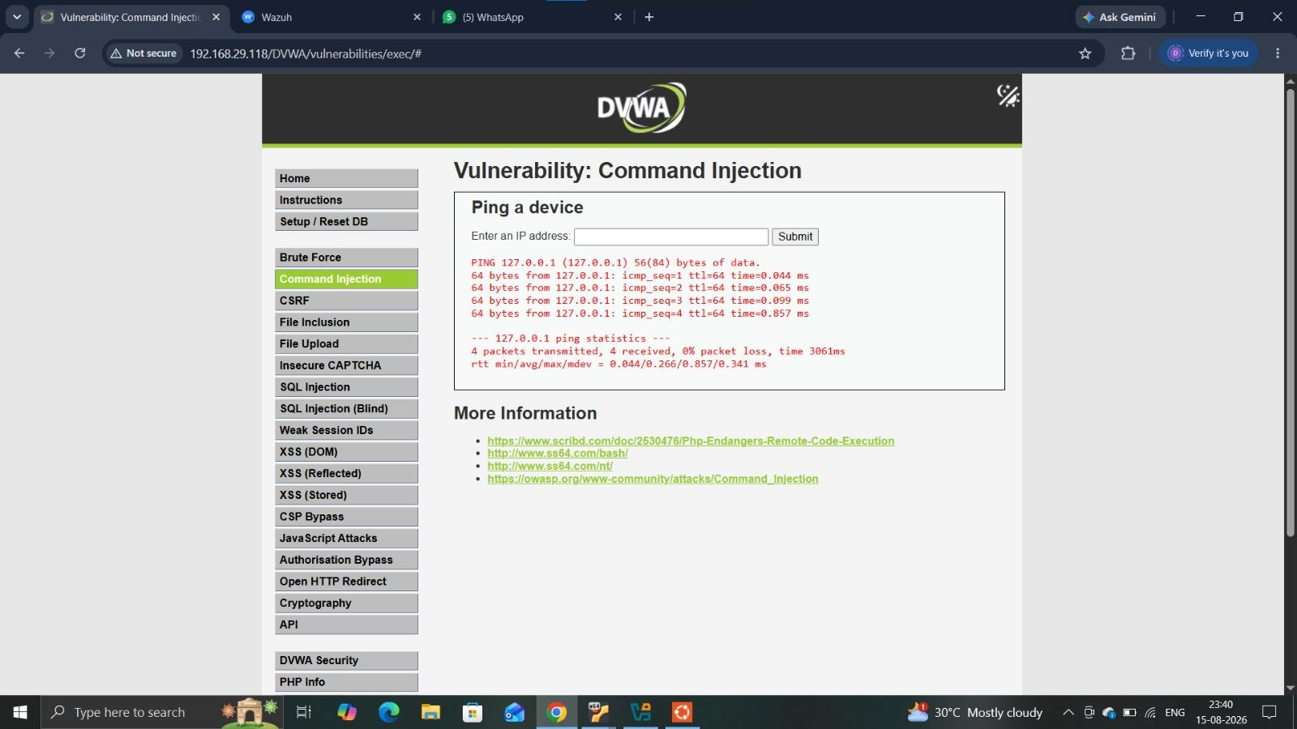
Result:
The command injection test was successfully processed by the DVWA application. The application returned operating-system command output for the supplied input, demonstrating command execution through the vulnerable input.

Wazuh Detection Summary
Wazuh successfully collected and displayed security events generated during the controlled attack simulations. The monitoring dashboard recorded repeated SSH authentication failures and identified brute-force activity. It also detected SQL injection attempts and successful web attack responses. These events provided centralized evidence that the simulated attacks were visible to the security monitoring system.

Attack | Wazuh Evidence | Rule ID | Level
Brute Force | SSH brute-force attempt / authentication failed | 5763 | 10
SQL Injection | SQL injection attempt | 31164 | 6
XSS / Web attack | A web attack returned code 200 (success) | 31106 | 6
Command Injection | Web attack returned code 200 / application response | 31106 | 6
Wazuh Monitoring Evidence
Detection Evidence
Wazuh successfully collected and displayed security events generated during the testing activities. The Events view shows detected authentication failures, web attack events and other security-related alerts with corresponding rule levels and rule IDs.
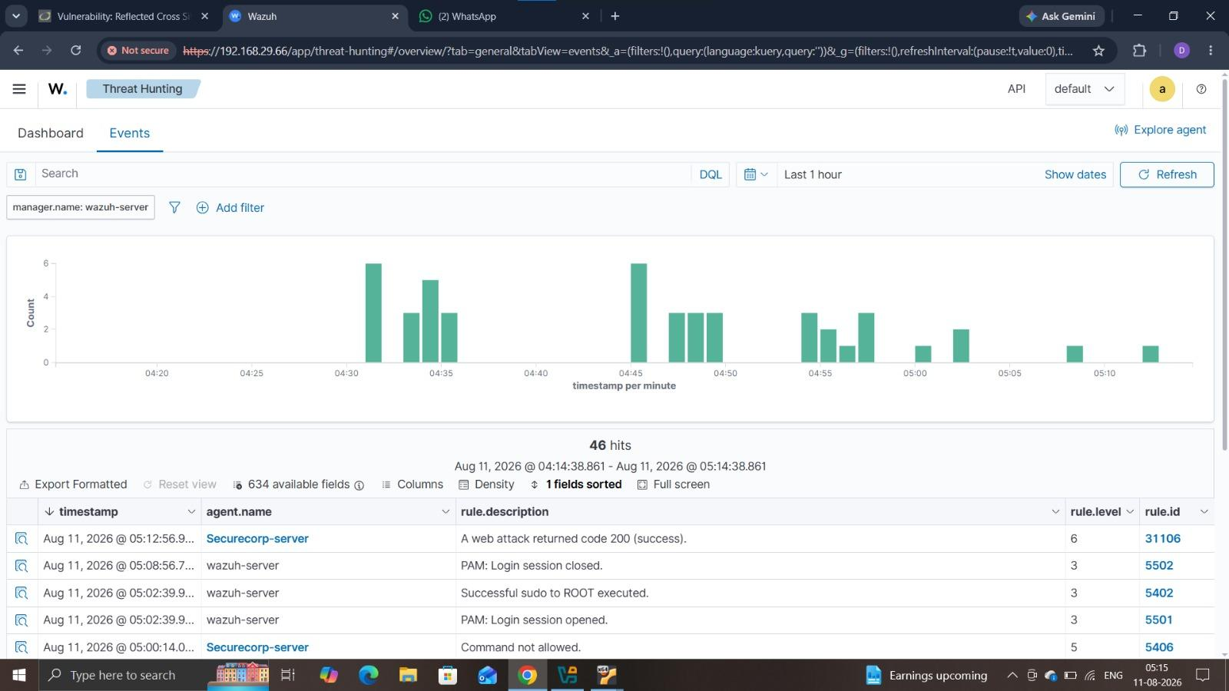
Additional Evidence:
Wazuh Dashboard showing overall alert and authentication statistics.
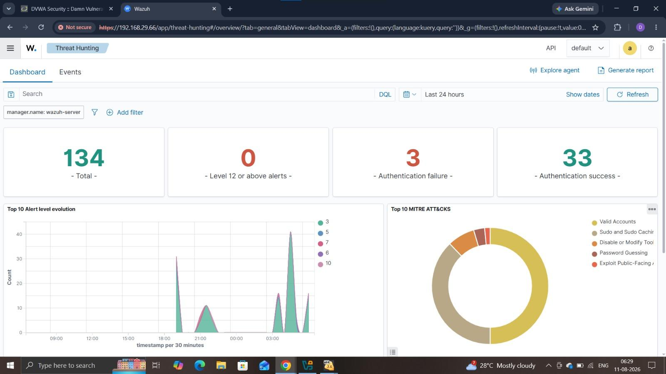
Time | Event | Source | Evidence / Notes
Attack timestamp | Brute Force | Wazuh / SSH log | Authentication failures detected
Attack timestamp | SQL Injection | Wazuh / Apache log | SQL injection attempt identified
Attack timestamp | XSS | Wazuh / Apache log | Reflected XSS activity identified
Attack timestamp | Command Injection | Wazuh / Apache log | Command injection activity identified
Incident Investigation Evidence
Incident Investigation Report

Incident Overview
During the security assessment of the SecureCorp customer portal, multiple suspicious activities were identified against the DVWA web application hosted on the Ubuntu server. The investigation was performed using the Wazuh monitoring platform and the logs generated by the DVWA/Apache web server and Linux authentication services.
Four simulated attack activities were investigated: Brute Force, SQL Injection, Reflected Cross-Site Scripting (XSS), and Command Injection.
The investigation confirmed that the activities generated observable security events in the monitored environment. Brute-force activity was identified through repeated SSH authentication failures and Wazuh alerts, while the web application attacks were identified through Wazuh event data and corresponding DVWA test results.

Affected System
Primary affected asset: SecureCorp Customer Portal / DVWA Web Application
Server: Ubuntu Server
DVWA IP Address: 192.168.29.118
Monitoring Platform: Wazuh
Attacker/Analyst Environment: WSL
Purpose of Investigation: To determine whether the simulated attacks were visible to the centralized monitoring system and to assess the resulting security impact.

Investigation Method
The investigation was conducted by reviewing the Wazuh Events dashboard and correlating the observed events with the attack activities performed during the security assessment.
The investigation process included:
- Reviewing recent Wazuh events generated by the monitored environment.
- Identifying authentication-related events associated with the brute-force activity.
- Searching for web attack indicators related to SQL Injection, XSS, and Command Injection.
- Comparing Wazuh event timestamps with the timestamps recorded during the attack simulations.
- Reviewing the corresponding DVWA screenshots as supporting evidence.
- Determining whether each activity was automatically detected by Wazuh or required manual log investigation.
The handbook specifically notes that brute-force attempts are likely to be automatically flagged through repeated authentication failures, whereas SQL Injection, XSS, and Command Injection may require direct searching of the ingested DVWA/Apache logs.

Investigation Findings

1. Brute Force Attack
The investigation identified multiple unsuccessful SSH authentication attempts against the monitored Ubuntu system. Wazuh recorded repeated authentication failures, PAM login failures, and a brute-force-related alert.
The repeated authentication failures indicate an attempt to gain unauthorized access through password guessing. Wazuh provided automatic detection through its authentication-related rules, making this activity easier to identify during investigation.
Evidence: Wazuh dashboard screenshot showing repeated SSH authentication failures and brute-force detection.
Assessment: The activity represents a significant authentication security risk because successful password guessing could result in unauthorized system access.

2. SQL Injection
The SQL Injection test was performed against the DVWA application. The application returned multiple database records after the SQL Injection input was submitted, demonstrating that the input was processed by the vulnerable application.
During the Wazuh investigation, an event with the description “SQL injection attempt.” was identified.
Evidence:
- DVWA SQL Injection successful-result screenshot.
- Wazuh event showing the SQL Injection attempt.
Assessment: The vulnerability could allow an attacker to manipulate database queries and potentially access or modify application data if the vulnerable behaviour existed in a production application.

3. Reflected Cross-Site Scripting (XSS)
A Reflected XSS test was performed against the DVWA application. The injected JavaScript was reflected by the application and successfully generated a browser alert displaying “XSS”, confirming that the input was executed in the browser.
The corresponding activity was investigated using the Wazuh monitoring environment and web log evidence.
Evidence:
- DVWA Reflected XSS browser-alert screenshot.
- Corresponding Wazuh/web-log evidence screenshot.
Assessment: Reflected XSS could allow malicious scripts to execute in a victim's browser when vulnerable input is reflected without appropriate validation and output encoding.

4. Command Injection
The Command Injection test was performed through the DVWA command-injection functionality. The application successfully processed the supplied input and displayed the resulting command output, confirming the presence of command-injection behaviour in the deliberately vulnerable DVWA environment.
The activity was then correlated with the monitoring evidence available in Wazuh.
Evidence:
- DVWA Command Injection result screenshot.
- Corresponding Wazuh/web-log evidence screenshot.
Assessment: Command Injection represents a high-impact vulnerability because successful exploitation may allow an attacker to execute operating-system commands through a vulnerable application.

Overall Incident Assessment
The investigation demonstrated that the monitored environment was capable of recording and exposing security-relevant activity generated during the assessment. The Wazuh dashboard provided particularly useful automatic visibility into authentication failures and brute-force behaviour.
The investigation also demonstrated an important limitation: not every web application attack is necessarily detected automatically by default. SQL Injection, XSS, and Command Injection may require manual investigation of the relevant web-server logs and correlation with the timestamps and attack indicators recorded during testing. This is consistent with the assessment methodology specified in the project handbook.
Overall, the incident investigation confirms the importance of centralized logging, continuous monitoring, appropriate Wazuh rule coverage, and manual log analysis for events that are not automatically classified as security alerts.

Immediate Actions Recommended
- Strengthen authentication controls by enforcing strong passwords and account lockout/rate-limiting mechanisms.
- Use parameterized SQL queries and proper input validation to prevent SQL Injection.
- Implement output encoding and input validation to prevent XSS.
- Restrict operating-system command execution from web applications and validate all user-supplied input.
- Improve Wazuh detection coverage for web application attacks.
- Continue centralized collection of Apache/DVWA and Linux authentication logs.
- Investigate high-severity authentication events promptly and preserve relevant logs as evidence.
- Apply regular security testing and vulnerability assessment to identify similar weaknesses before deployment.
Security Recommendations :
Area | Current State | Recommendation | Priority
Password Policy | Brute-force testing identified repeated authentication failures. | Enforce strong password requirements, account lockout/rate limiting, and password-guessing protection. | High
Multi-Factor Authentication (MFA) | Authentication currently relies primarily on username/password credentials. | Implement MFA for administrative and sensitive accounts to reduce the impact of compromised passwords. | High
SQL Injection Prevention | DVWA SQL Injection testing demonstrated that crafted input could return multiple database records. | Use parameterized queries/prepared statements and validate all user-supplied database input. | Critical
Cross-Site Scripting (XSS) Prevention | Reflected XSS testing successfully executed injected JavaScript in the browser. | Apply strict input validation and context-appropriate output encoding; implement a suitable Content Security Policy (CSP). | High
Command Injection Prevention | Command Injection testing demonstrated that application input could result in operating-system command output. | Avoid direct OS command execution where possible; validate and restrict input and use safe APIs instead of shell commands. | Critical
Firewall / Network Security | The assessment environment exposed services including SSH and HTTP. | Restrict unnecessary network services and allow only required ports through firewall rules. | High
Patch Management | The assessment identified services and web application components that require regular security maintenance. | Maintain a regular patching process for the operating system, web server, application and security tools. | High
Logging & Monitoring | Wazuh successfully collected authentication and web-related security events, but some web attacks required manual investigation. | Maintain centralized logging and improve Wazuh detection rules for SQL Injection, XSS and Command Injection. | High
Backup Strategy | No specific backup control was demonstrated during the assessment. | Maintain regular tested backups of critical application and business data and protect backups from unauthorized access. | Medium
User Security Awareness | Social-engineering/user-awareness controls were not directly assessed during this engagement. | Provide regular security awareness training covering phishing, password security, suspicious activity reporting and safe handling of credentials. | Medium
10. APPENDICES
Appendix A — Raw Nmap / Network Discovery Evidence
The raw Nmap scan evidence is included with the Nmap Network Discovery section in the report.
Appendix B — Attack Simulation Evidence
The supporting evidence for Brute Force, SQL Injection, Reflected XSS and Command Injection is included with the Attack Simulation Findings.
Appendix C — Wazuh Monitoring Evidence
The Wazuh Agent, Dashboard, Events and detection evidence are included with the Wazuh Monitoring and Detection sections.

