SOFTWARE DEVELOPMENT CASE STUDIES
Assignment 4

Product Thinking & MVP Development
Student: Koshikov Alimzhan
Group: CSE-2501M
Project repository link: https://github.com/koshikovme/socratesai

Part 1 – MVP Definition (30%)

MVP Hypothesis (10%)
Field | Your Answer
The problem you are solving | Frequently a first-year computer science students gets stucked on some mistakes in code during an assignment, and he/she need a quick hint inside the code editor so he/she can solve and learn without waiting for a teacher or copying an entire solution into ChatGPT.
Your riskiest assumption | Importance of the project lies in short and appropriate feedback bounded with pedagogical policies, which as assumed should help to learn and improve understanding. However, if students ignore the hints and feedback or prefer a full answer from a general AI tools like ChatGPT, Claude without thinking and learning, then it will be useless and my project then has no value.
My MVP hypothesis | If I build a real time mentor that analyzes code (C/C++/Java) of novice learners, provides appropriate feedback (code highlight, conceptual hint, guiding question, or no feedback) gradually considering mistakes and habits of a student and bounded by the pedagogical policies and working in real time, which prevents cheating and promotes thinking and learning, then I think that first year computer science students will use it during problem solving, because of immediate help while they solving problems and learning some topics and it definetely more helpful than coding with no help or using general chatbots without any restrictions.
What the MVP is NOT | I want to make a project with a specific purpose (real-time programming mentor for first year CS students with feedback bounded by a pedagogoical methodologies) instead of trying to implement generic platforms such as tutoring platforms, online compiler, grading system, general AI chatbot.
How you will test it | The project must work in one specific and simple business process/loop - student open a task, writes code in editor, submit the code, gets a quick response and marks whether the feedback helped or not. In my implementation it works using several components and modules: TaskSolveView (Vue 3 JS Frontend component which is main panel where students write code), then after clicking submit button manually or using websocket (real-time) it sends to a backend - POST /api/mentor/analyze-feedback or for websocket the WebSocket path /app/code.update, then all the context information processing through policy layer and then finally it saves the interaction log in DB and sends final feedback for student on UI

1.2 Product-Market Fit Signal (10%)
Question | Your Answer
Who is your primary user? | My primary user is a first year computer science student who is currently taking an introductory courses related to C/C++/Java programming. Especially it suitable for students who understands a task in general (it also helpful if student does not fully understand the problem), but can’t reflect their ideas in code because of syntax, logic and etc common problems during assignments and labs.
What retention signal will you track? | My main retention signal is usage of virtual mentor for the whole month. Particularly, how many students use the mentor and how many students use it again for next problems and their feedback about the project
Distribution risk | The main risk is that coding platforms such as LeetCode, HackerRank could add similar features such as “explain my bug” or “provide hint” while users code. However, the Socrates AI is not just generic AI chatbot, the main idea lies in combination of real-time help with bounded and appropriate feedback based on pedogogical policies. Also, it was intended as a plugin or web project for university courses, with opportunity for teaching staff intervention.

1.3 Product Debt Awareness (10%)
Debt Risk | How It Could Appear in Your Product | How You Will Avoid It
Feature creep | It is very easy to keep adding attractive features: full AI chat, teacher analytics, code execution, plagiarism checks, class dashboards, multi-language support, rankings, and assignment authoring. I already have side features like task management and LeetCode fetching, so this risk is real. | I should focus on main purpose of my project, instead of implementing side features that do not related to my core functionalities. Main question should be considered while developing and maintaining the mentor: does real-time immediate feedback help novice programmers solve and learn faster?  If some functionality does not improve my main business process, then it should wait until the main process team complete it
Wrong early-adopter assumption | If I conduct experiements on the students with already strong fundamentals in DSA and LeetCode, who already know how to solve problems and debug code, then I may conlude that the abstract and vague hints such as “good enough” or “almost optimized” may mislead novice learners. | I should largely consider the main group, for whome it specificially designed - first-year students in intro programming, not only advanced in terms of DSA and problem solving.
North star metric misalignment | If I unrestrict the number of requests for hints, total session time, it may eventually lead to confusion, because when students asking for 15–20 hints it is not a good sign. | The best way to evaluate a performance of student I should consider metrics such as: resolved-after-fix, time-to-fix which is added to track whether student understood and learnt or not. It is better rather than tracking just raw statistics related to trials.

Part 2 – Ethics & Privacy (20%)

2.1 Privacy by Design (10%)

Principle | How Your Product Applies It
Data minimisation – collect only what you use | For mentor interactions, our system holds code analyzer metadata, feedback action and code itself in InteractionLog entity.  Regarding the user profile, it necessary to hold basic data such as email, password, full name and a role. Additionally, we it important to hold university and group, to track performance of students in each university.
Purpose limitation – data collected for one feature cannot be reused for another | Firstly, interaction data should indicate a process of learning (feedback actions, coding history, user feedback), rather than grading and evaluating or marketing data metric.  Also, a data from InteractionLog entity which is related to users should be anonymized and processed in order to protect private policy of users
Default = private – users opt in to sharing, not out | The application protects user activities and considered as private by default, all the REST routes are protected using JWT auth including user data under /api/users/me and mentor responses from queue under /user/queue/feedback endpoints.
Right to erasure (GDPR Art. 17) – full deletion including logs and backups | Honestly, now I didn’t implement deletion functionality for all modules of my project. Further, when I bring my project to the production-ready level, I would add a delete account flow that removes the user profile, active student task sessions, interaction logs.

2.2 Ethical Risk Analysis (10%)
Risk | EAD Principle | Who Is Affected | Your Mitigation
Risk 1: SocratesAI could allow cheating | Awareness of Misuse | Students, instructors, and the course itself | The main risk lies in academic dishonesty and cheating during coding session by asking for numerous hints or asking for full solution from LLM. My project implies that learning, knowledge and academic integrity the most important things. So in order to align with these goals, our system is based on the pedagogical policies with bounded help, rather than unrestricted help with full solutions. The system offers four types of feedback actions and the feedback system is designed to provide not full solution, but hints, guiding questions or highlights.
Risk 2:  Vague and too generic feedback | Transparency | Mostly beginner students, because they do not yet have strong debugging judgment | The risk lies in misleading help, when students may trust for vague and incorrect hints or questions which can easily mislead them. I think the best solution is to build responses short and precise and connect it with current code and also consider coding history within session so it will be specific and precise for a user.

Part 3 – MVP Prototype (40%)

3.1 Prototype Requirements
My prototype already covers one full end-to-end workflow that directly tests the hypothesis.
Core workflow
- The student logs in or sign up, then he/she opens a desired task from the dashboard.
- The student writes some code on C/C++/Java in the editor.
- Student chooses whether he want to real time help (/app/code.update) or manually click the “Ask Mentor” button (POST /api/mentor/analyze-feedback) and then all metadata and code combined into one request and goes through this endpoints
- The server logic creates or reuses a StudentTaskSession from the database, then it analyze the code, select an appropriate feedvack action and based on them generates short and precise feedback text and finally returns the feedback to the UI.
- In the end of the process, the student can mark the feedback as It helped or Still stuck, which is saved through /api/interactions/{interactionId}/result which also persists user coding history and eventually serves as dataset for my policy ML service.

User interface
1) login/register pages
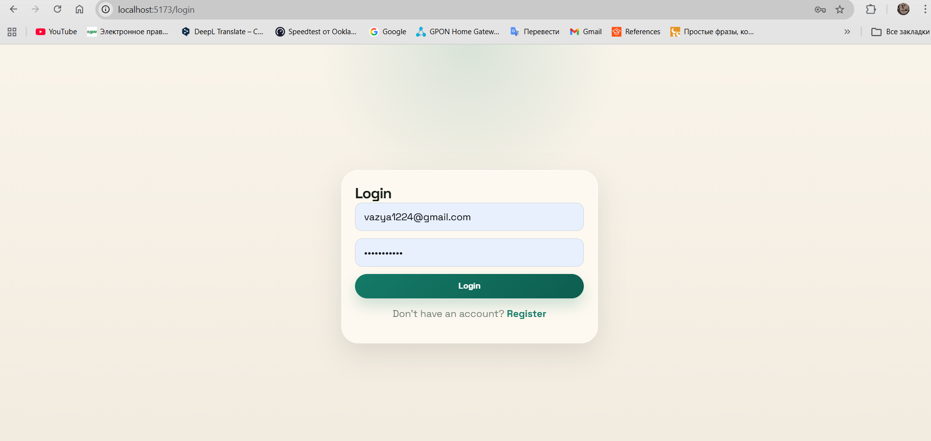
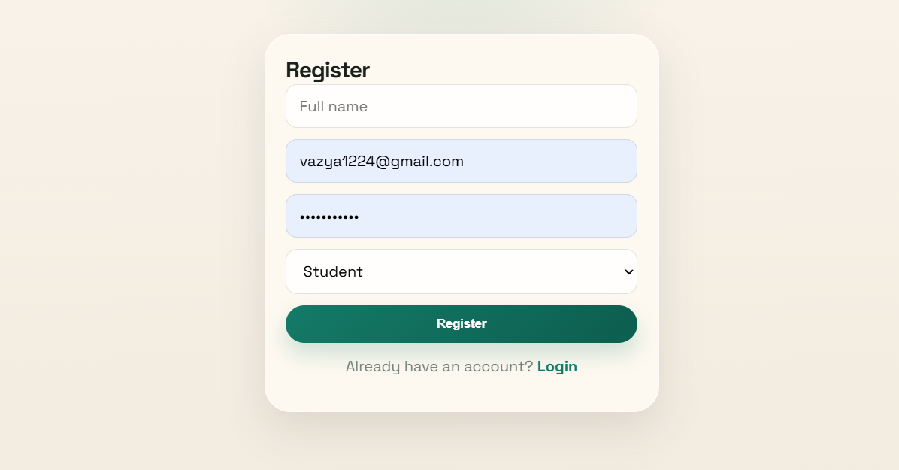

2) dashboard
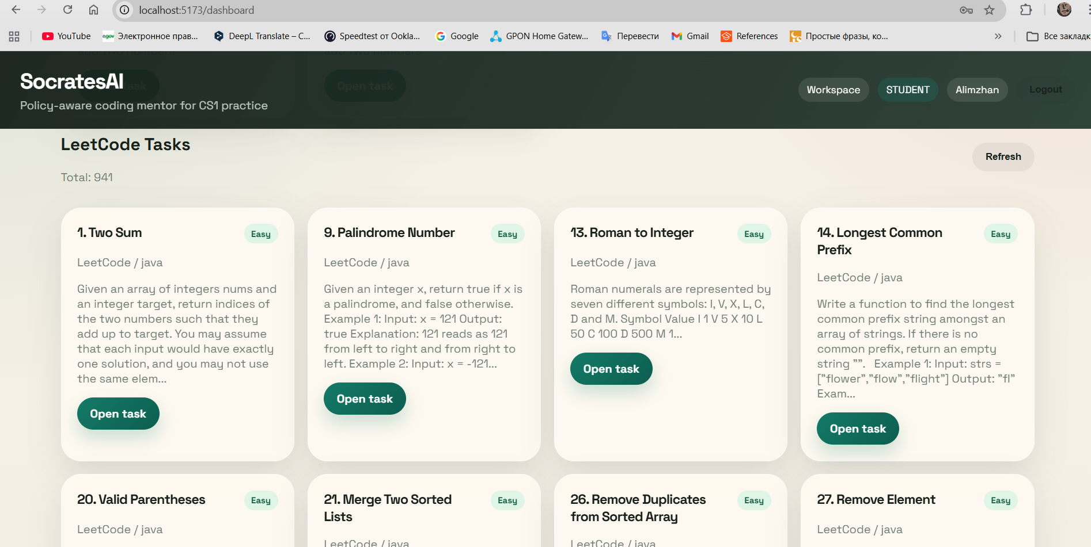

3) task solving panel with feedback panel
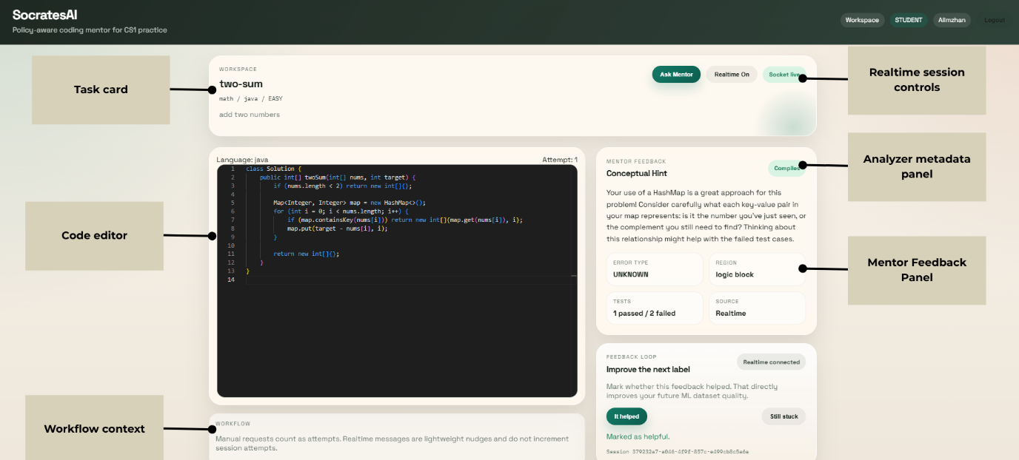

Data flow
In the proposed mentor assistant, the data changes based on student input (code, feedback, modes), so there are no hardcodes and mockups. Different code generates different feedback, analyzer results. The system handles basic misconceptions and logic mistakes such as empty editor, syntax failures, loop errors or wrong condition.

3.2 Hypothesis Test Report

Question | Your Answer
Did the prototype test your MVP hypothesis? | Yes, definetely. Pilot testing was conducted and during this testing 570 event interactions was created with a solid ~0.8 seconds end-to-end latency for a feedback production whenever user actively coding. Also, mentor help quality was solid and with resolution rate at 70%.
What did you learn that you did not know before building? | The biggest thing I learned is that the hard problem is not "generate an explanation." The harder product problem is deciding how much help to give. Once I implemented the policy layer, it became obvious that beginners do not always need the same kind of feedback. I also learned that my analyzer is much narrower than I first imagined. Right now it is enough implemented for a focused CS1 debugging assistant, but it is nowhere near a general-purpose code tutor yet.
What product debt did you introduce, and why? | I introduced several kinds of deliberate debt. First, the analyzer still relies on simple basic and string patterns, which is fast for prototyping but too vague and superficial. Second, I now have both REST and realtime flows using the same mentor workflow, which is useful for testing but adds duplication of logic. Third, some prototype configuration is still too local and not production-ready.
What is the next hypothesis to test? | The next dangerous and compromising aspect is about retention, not latency. My next hypothesis is: If first-year students find the feedback useful on one task, they will come back and use SocratesAI again on a second task within the same week without being forced to ask for help the instructor. To test that, I need a small real classroom pilot with repeated tasks, not just isolated prototype sessions.

Part 4 – Reading Connection (10%)
Source (title, author, year) | Key idea you applied | Where it appears in your work
The Lean Startup - Eric Ries (2011) | An MVP is not a smaller copy of the final product. It is the smallest version that lets you build, measure, and learn from real user behavior. | This key idea helped me properly test my MVP hypothesis, because I fully focused developing my core functionality loop, rather than implementing vague and general ides such as general tutoring system or full AI chatbot. I focused one my main business workflow: the student writes code, gets feedback, and then marks whether the feedback helped or not.

