Final Project
Course | Software Development Case Studies
Format | YouTube video (Unlisted) + delivery report
Team Size | 1 student: Koshikov Alimzhan
Group | CSE-2501M

Part 1 - Video Submission (50%)
Submit one YouTube video set to Unlisted. Eight minutes maximum. Demo runs first; presentation follows in the same recording.
https://www.youtube.com/watch?v=-xNOuWMWyYU

Part 2 - Delivery Report (50%)

Section 1 - Product Summary (ungraded)
SocratesAI is a real time programming mentor assistant designed for introductory C/C++/Java students with pedagogically and timely bounded. It helps freshmen to learn programming faster and ensure deep engagement and academic integrity. Frequently teaching staff is overloaded and they are not able to help each student and as result many of them get stucked on some topic and eventually give up, so this project should become a individual programming teacher for each student and it also assumed that it will be an assistant for teaching staff. As you understood, the main user is a first year computer science student.

Section 2 - Requirements Delivery (10%)

ID | Requirement | Type | Final Status | Evidence / Note | Sprint
FR-01 | Monitor code changes in real time | Functional | Implemented | TaskSolveView.vue watches for code changes, then it updates context and sends user coding session context using WebSocket messages or using REST CodeRealtimeController.java handles /app/code.update and returns feedback to /user/queue/feedback. | Sprint 3
FR-02 | Detect syntax, beginner, and simple logic errors | Functional | Partial | AnalyzerService, SyntaxCheckEngine, and PatternDetectionEngine detect basic errors such as syntax errors, logic errors, but the analyzer is still primitive and narrow | Sprint 2
FR-03 | Tracking student coding session data | Functional | Implemented | InteractionLogService tracks repeated errors, last feedback action, last feedback success, and total session feedback count. | Sprint 1-2
FR-04 | Generate feedback | Functional | Implemented | MentorPolicyService selects one of four actions and FeedbackGenerationService returns either a template response or LLM phrasing | Sprint 4
FR-05 | Avoid giving full solutions | Functional | Partial | The defined feedback actions set and the Gemini prompt is configured to prevent full solutions and corrected code | Sprint 4
FR-06 | Log all interactions for future improvement | Functional | Implemented | InteractionLogService.saveInteraction() stores each mentor interaction and /api/interactions/policy-dataset exports a CSV dataset for later policy training. | Sprint 1-6
NFR-01 | Scalability: support many users | Non-functional | Partial | The architecture is modular and StudentTaskSessionServiceConcurrencyTest tests for case when only one active session per student-task is possible, but I didn’t run a large load test unfortunately | Sprint 5-6
NFR-02 | Security and privacy of interaction data | Non-functional | Partial | JWT protects authenticated APIs, passwords are hashed and WebSocket connections use token-based auth. Also interaction logs stores a code hash instead of raw code, but dataset export still contains student and task metadata, which is unsafe. | Sprint 1-6

Section 3 - MVP Hypothesis Outcome (10%)
Question | Your Answer
State the original hypothesis (from Assignment 4) | If I build a real time mentor that analyzes code (C/C++/Java) of novice learners, provides appropriate feedback (code highlight, conceptual hint, guiding question, or no feedback) gradually considering mistakes and habits of a student and bounded by the pedagogical policies and working in real time, which prevents cheating and promotes thinking and learning, then I think that first year computer science students will use it during problem solving, because of immediate help while they solving problems and learning some topics and it definetely more helpful than coding with no help or using general chatbots without any restrictions.
What evidence supports it? | The main evidence is that the whole mentoring worflow works and tested, it is not implemented only in design. A student can open a task, then writes code, request mentor for a feedback manually or using realtime updates implemented by WebSocket, and then mark whether the feedback helped or not. Pilot testing was conducted and during this testing 570 event interactions was created with a solid 0.8-1 seconds end-to-end latency for a feedback production whenever user actively coding. Also, mentor help quality was solid and with resolution rate at 70%.
What did not validate? | I still don’t know whether first-year students will return and use SocratesAI again on a second task within the same period without being forced by an instructor and deadlines, in other words, is it was really enjoying and helpful.
What changed as a result? | I implemented some restrictions related to boundaries in terms of granularity of feedback, by implementing the four bounded feedback actions and detailed logging, user feedback, and policy control and abandoned from too general ideas such as AI chat, tutoring platform, etc.

Section 4 - Development Process (10%)

Item | What to include
Methodology | I used Scrum that I selected in Assignment 2. In practice, I applied it as a process with six planned sprints: firstly, requirements and architecture, then backend mentoring logic, then frontend implementation, feedback refinement, ML service extension and finally testing with documentation
Github | There are multiple commits instead of one single push which confirms that development process was steady and consistent:  Main history: https://github.com/koshikovme/socratesai/commits/main. (https://github.com/koshikovme/socratesai/commit/3a164a8c354761350a6e1a314cc5f5d9233491ed), test and integration expansion 90958c3 (https://github.com/koshikovme/socratesai/commit/90958c3207bba6d6118ba6a93762e8810f43a72a), validation and E2E quality gates 9a5cfb1 (https://github.com/koshikovme/socratesai/commit/9a5cfb17d4aabeb1fd52a1a71ae22fa80dd1b998), and analyzer/feedback test growth 20cf6d3 (https://github.com/koshikovme/socratesai/commit/20cf6d3770c0b02d441c8d03286e64adee038bd1).
Ceremonies/artefacts | Because this was a solo project, I used the sprint plan and requirement traceability table as the main artefacts. I conducted Sprint planning and review and I worked in the six sprint plan and checked progress looking on requirements that I set before.
What you learned | Scrum helped the most by setting priorities by separating the core mentoring workflow from the side features. If I do this again, I would more precisely defined phases when it feasible to implement side features instead putting of them on the last phases, in other words, I would save more time.

Screenshot of commits (with CI pipeline):
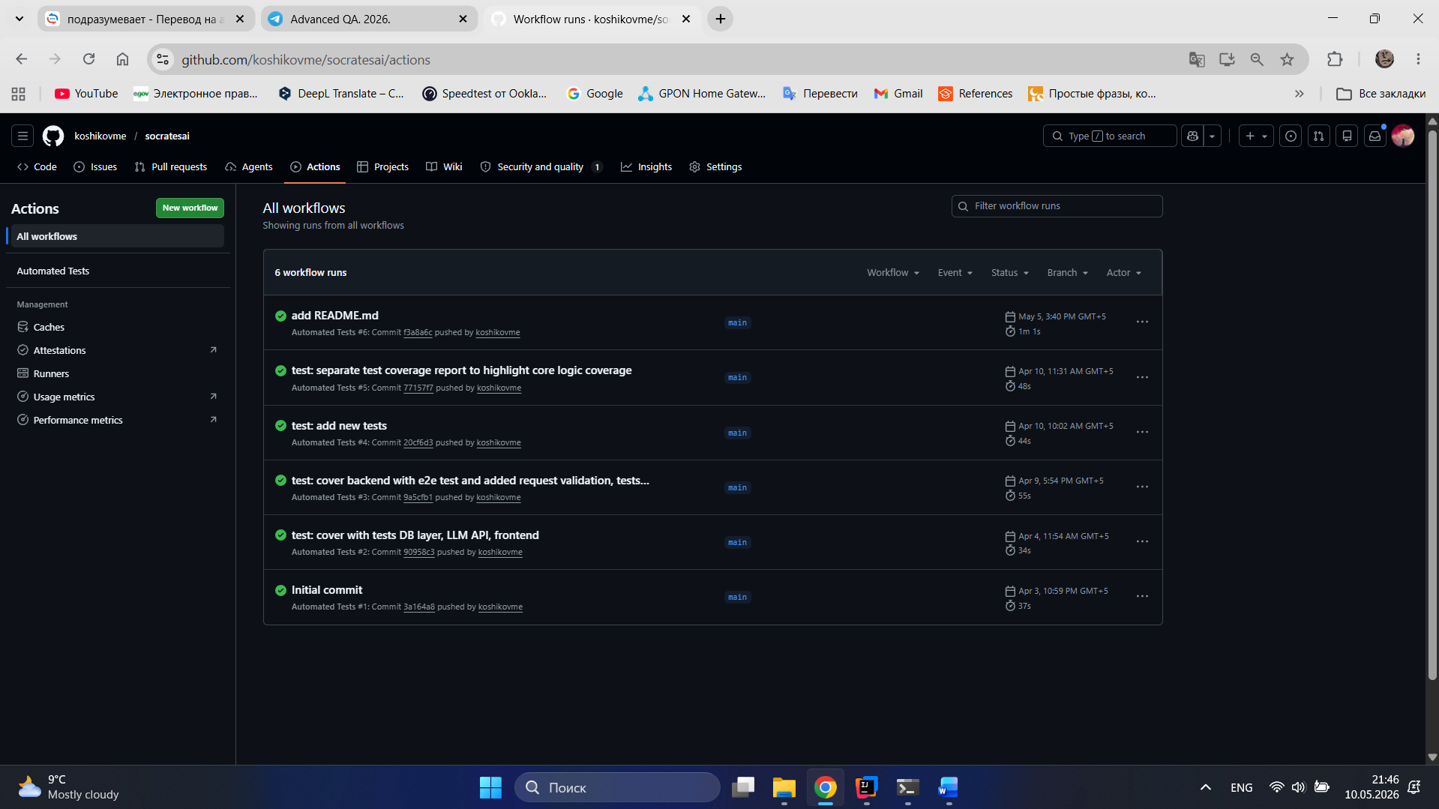

Section 5 - Theory in Practice (10%)
Identify one concept from the assigned course reading that is directly visible in a decision or problem you encountered during development. Cite the source by author, title, and page or chapter.

Item | Required content
Concept | Innovation accounting from Eric Ries, The Lean Startup, p. 18 and Chapter 7. Ries says that startup progress should be meausured using only learning based metricss, not superficial metrics related to results of an user activity
Where it appeared | I aligned with this concept by implementing the interaction logging and feedback review functionality. Instead of measuring success by raw mentor request count or time spent in the editor, I added fields such as same_error_count , resolved_after_feedback , fixed_after_ms , last_feedback_action , and total_feedback_count_in_session to InteractionLog , and I added the "It helped” and “Still stuck" feedback buttons in the UI
Outcome | This idea is useful because because it provides more precise and honest approach to evaluate whether the mentor helper or not.

General claims - "we followed agile principles", "we applied software engineering best practices" - score zero. The concept must be named, the source cited, and a specific project moment described.

Section 6 - Architecture Delta (10%)
Document only the components or decisions that diverged from the original design submitted in earlier assignments. If the implementation matches the original design exactly, state that in one sentence.

Component / Decision | Original Design | Final Implementation
LLM feedback provider | Earlier the main LLM for phrasing functionality was only OpenAI API | Currently, it was replaced by Gemini API because of cheaper pricing and now OpenAI API Client integration used only for local development.  Now FeedbackGenerationService has two implementations using OpenAI and Gemini APIs, but for testing and production environment only Gemini used.
Database | H2 Database | I switched to PostgreSQL as soon as I implemented and tested all the core functionality. Also, it is important to collect data in interaction log table in order to train my ML model.

