Lab Exercise 1:

* 1. Create a PHP script display “Hello World” on the screen

<html>

<head>

<title>Hello World</title>

</head>

<body>

<?php echo "Hello, World!";?>

</body>

</html>

OUTPUT

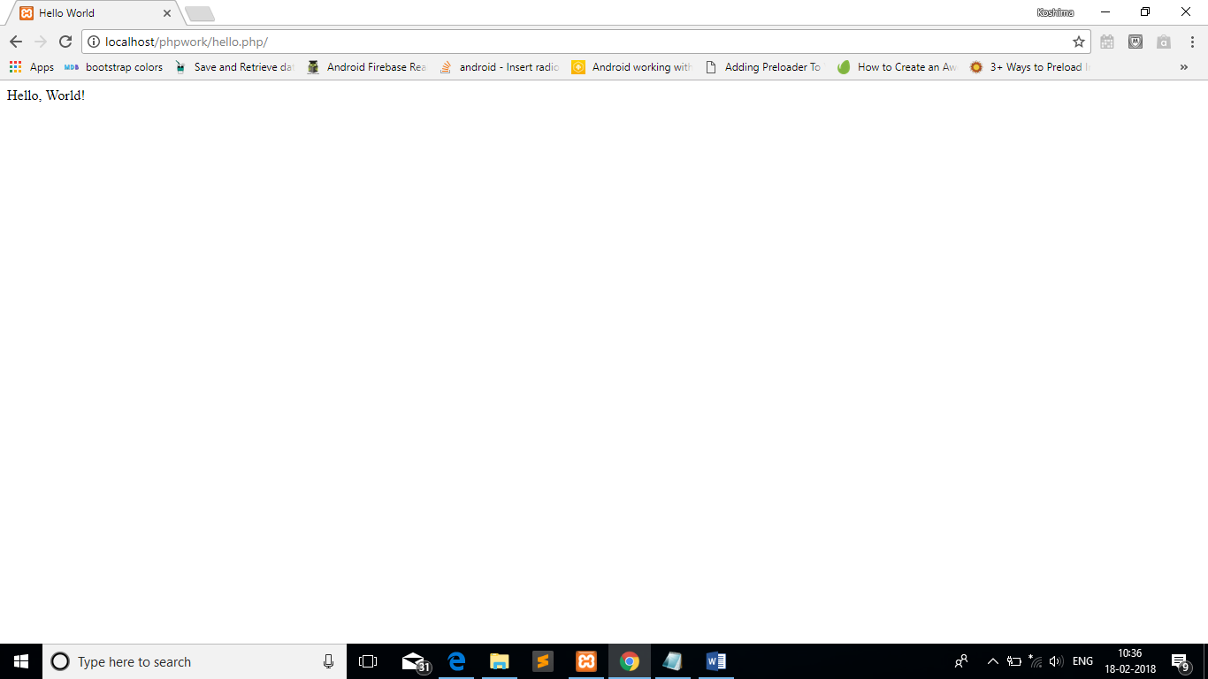

* 1. WAS to perform the following operations on the strings

1. Reverse a String

<html>

<head>

<title>Reverse of String</title>

</head>

<body>

<?php

echo "Original String is Hello World";

?><br><?php

echo "Reverse of String is ";

echo strrev("Hello World");

?>

</body>

</html>

OUTPUT

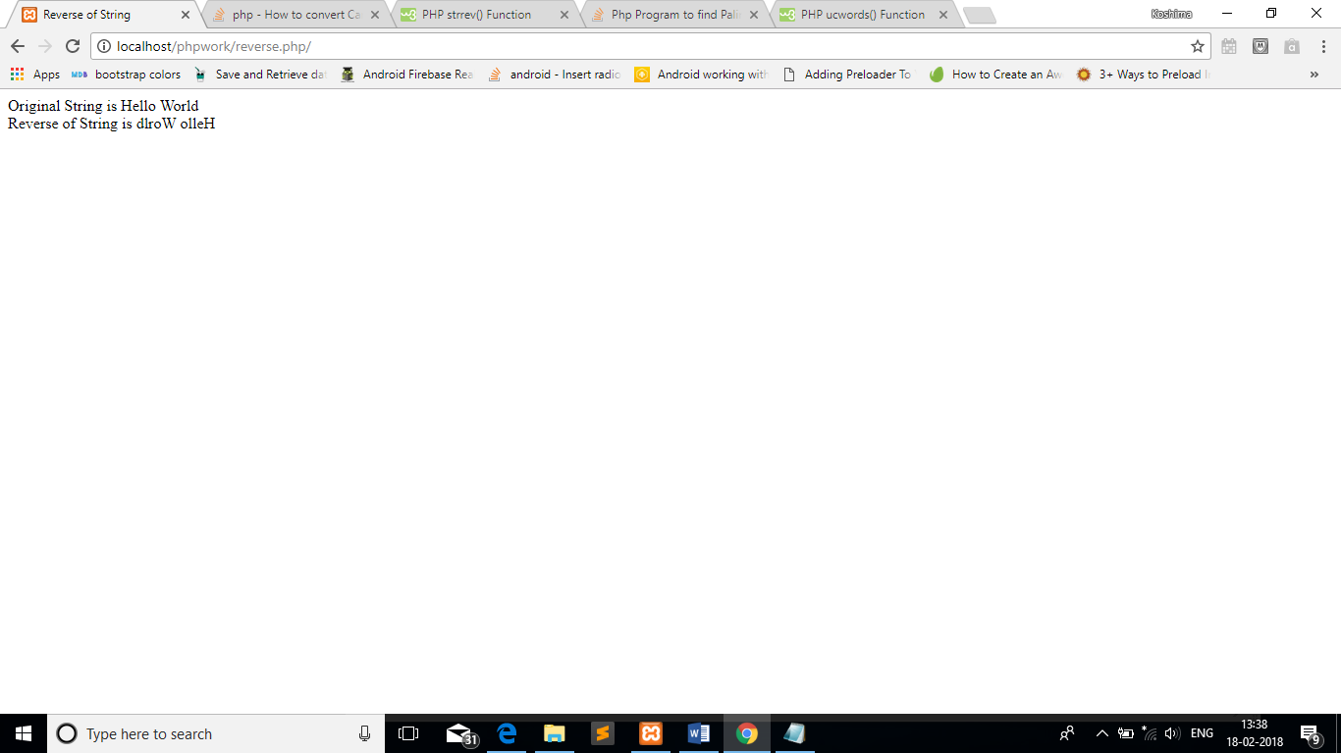

1. Pallindrome

<html>

<head>

<title>Pallindrome of String</title>

</head>

<body>

<?php

$a="mallayallam";

$b=strrev($a);

echo "Original String is ".$a;

?><br><?php

echo "Reverse of String is ".$b;

if($a==$b)

{

echo "<br>Pallindrome";

}

else

{

echo "<br>Not Pallindrome";

}

?>

</body>

</html>

OUTPUT

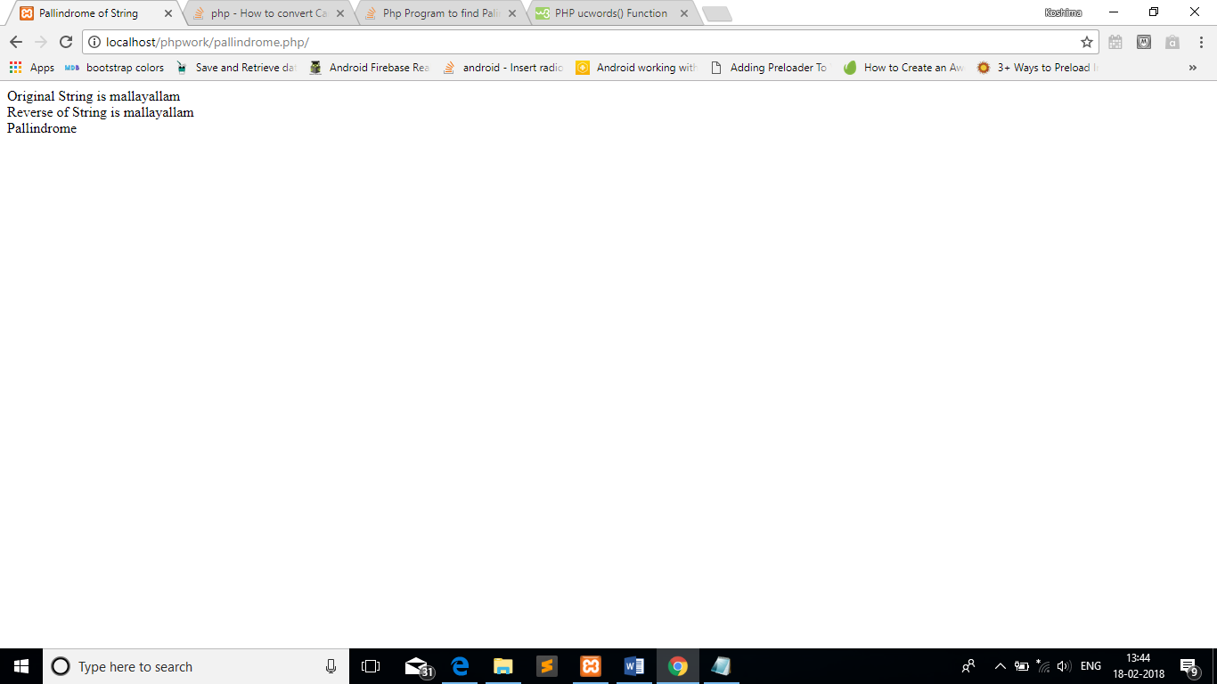

1. CamilCase Display of String input through keyboard

<html>

<head>

<title>CamelCase Display</title>

</head>

<body>

<?php

$a="hello world";

$b=ucwords($a);

echo "Original String is ".$a;

?><br><?php

echo "CamelCase Display is ".$b;

?>

</body>

</html>

OUTPUT

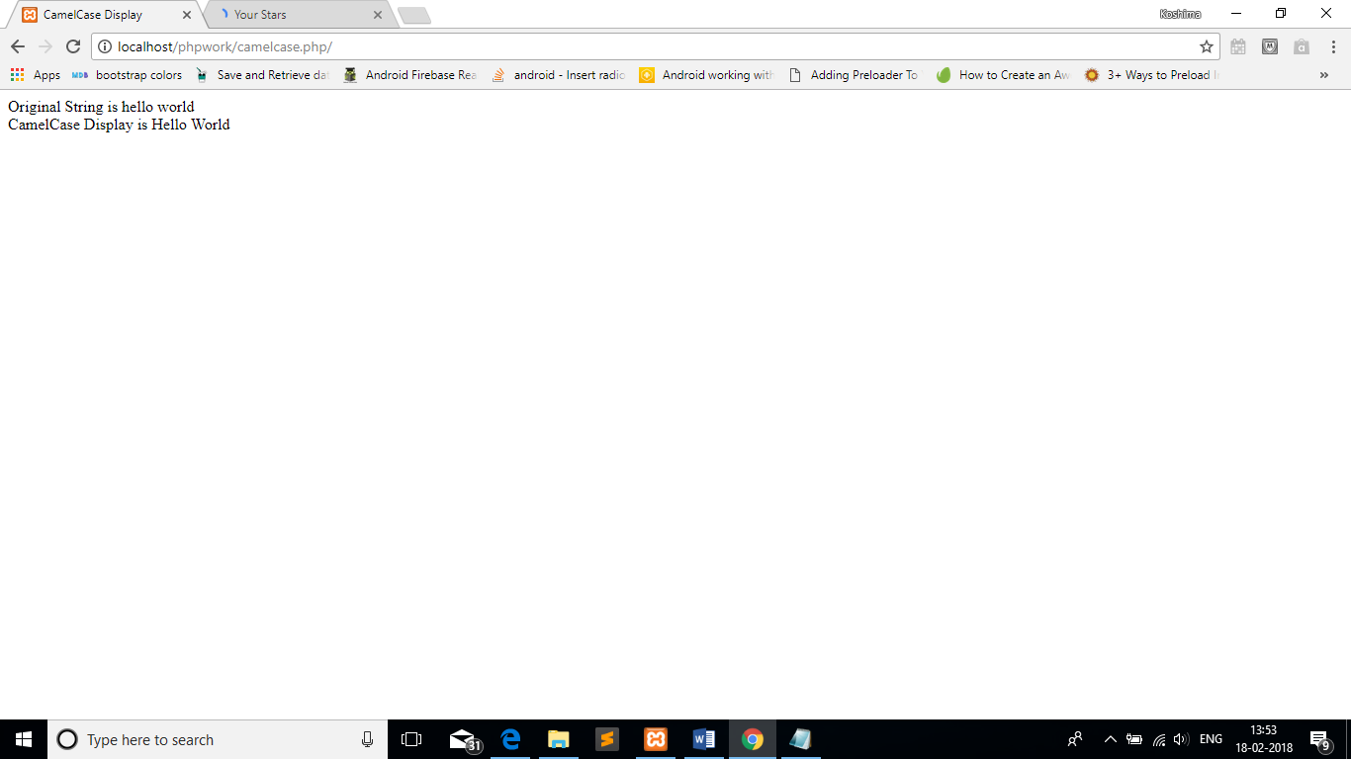

Lab Exercise 2:

1. WAS to create function in php and call that function in the page.

<html>

<head>

<title>Function</title>

</head>

<body>

<?php

function add($num1,$num2)

{

$sum=$num1+$num2;

echo "Sum of $num1 and $num2 is $sum";

}

add(10,20);

?>

</body>

</html>

OUTPUT

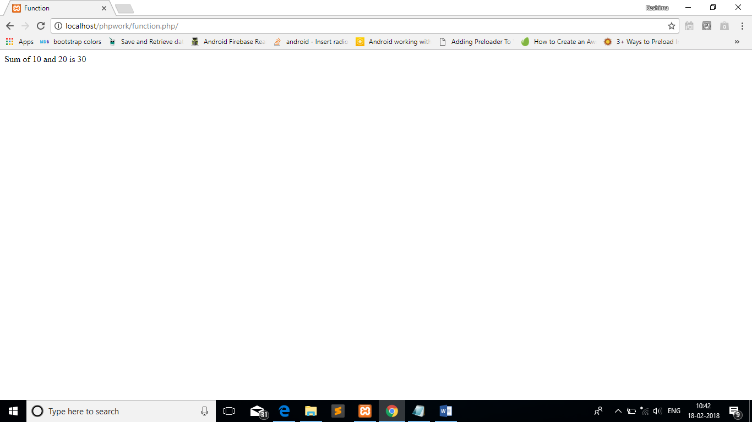

1. WAS to create 5 different classes and include them in one file. Create objects of the class and execute something using their constructors.

Class 1

<html>

<head>

<title>Class 1</title>

</head>

<body>

<?php

class person

{

var $name;

var $age;

function set_name($nam)

{

$this->name=$nam;

}

function set_age($age)

{

$this->age=$age;

}

function get_name()

{

return $this->name;

}

function get_age()

{

return $this->age;

}

}

?>

</body>

</html>

Class 2

<html>

<head>

<title>Class 2</title>

</head>

<body>

<?php

class book

{

var $name;

var $price;

function set_details($name,$price)

{

$this->name=$name;

$this->price=$price;

}

function get_bname(){

return $this->name;

}

function get_bprice(){

return $this->price;

}

}

?>

</body>

</html>

Class 3

<html>

<head>

<title>Class 3</title>

</head>

<body>

<?php

class pet

{

var $name;

function __construct( $par1)

{

$this->name = $par1;

}

function get_pet()

{

return $this->name;

}

}

?>

</body>

</html>

Class 4

<html>

<head>

<title>Class 4</title>

</head>

<body>

<?php

class place

{

var $name;

var $place;

function __construct( $par1,$par2)

{

$this->name = $par1;

$this->place=$par2;

}

function get_name()

{

return $this->name;

}

function get_place()

{

return $this->place;

}

}

?>

</body>

</html>

Class 5

<html>

<head>

<title>Class 5</title>

</head>

<body>

<?php

class sibling

{

var $bro;

var $sis;

function __construct( $bro,$sis)

{

$this->bro = $bro;

$this->sis = $sis;

}

function get_bro()

{

return $this->bro;

}

function get_sis()

{

return $this->sis;

}

}

?>

</body>

</html>

Objetcs

<html>

<head>

<title>Classes & Objects</title>

</head>

<body>

<?php

include("class1.php");

include("class2.php");

include("class3.php");

include("class4.php");

include("class5.php");

$ob1=new person();

$ob1->set_name("garima");

$ob1->set_age(18);

echo "person name is ".$ob1->get_name();

echo "\n and age is ".$ob1->get_age();

?><br><?php

$ob2=new book();

$ob2->set_details("php tutorial",180);

echo "book name is ".$ob2->get_bname();

echo "\n and price is ".$ob2->get_bprice();

?><br><?php

$ob3=new pet("dog");

echo "my pet is ".$ob3->get_pet();

?><br><?php

$ob4=new place("garima","market");

echo $ob4->get_name();

echo "\n is going to ".$ob4->get_place();

?><br><?php

$ob5=new sibling("rahul","rita");

echo "my brother is ".$ob5->get_bro();

echo "\n and my sister is ".$ob5->get_sis();

?>

</body>

</html>

OUTPUT

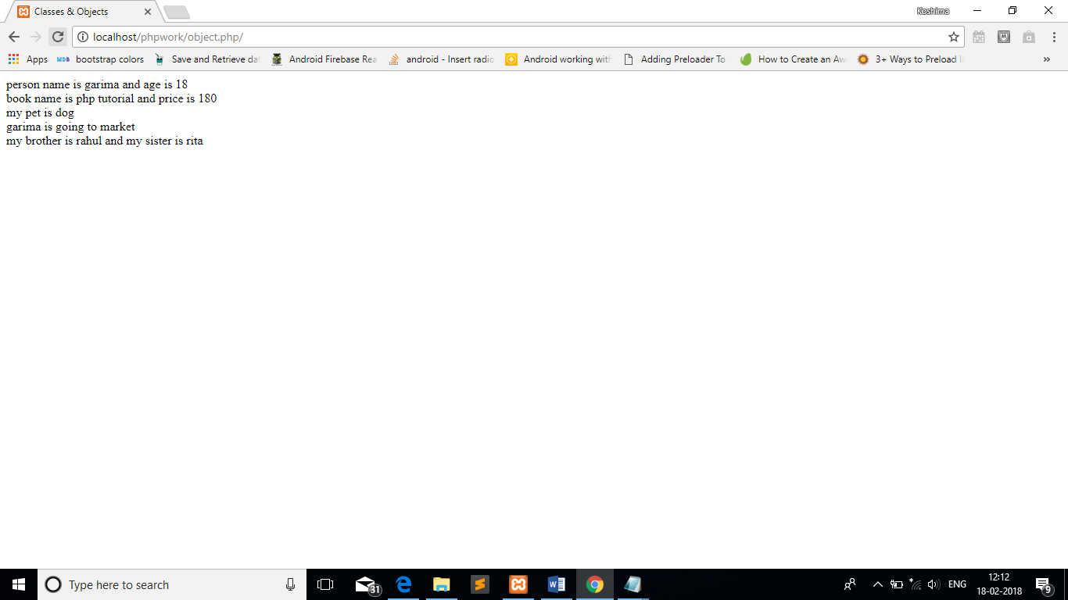

1. WAS to create an Associative Array in php and display the same.

Lab Exercise 3:

1. WAS to create a simple login form in php and post the information on another page for display.

LoginForm.html

<html>

<head>

<title>Login Form</title>

</head>

<body>

<form action="data1.php" method="post">

NAME : <input type="text" name="name"/>

<br><br>

EMAIL : <input type="email" name="gmail"/>

<br><br>

<input type="submit">

</form>

</body>

</html>

Data1.php

<html>

<body>

WELCOME <?php echo $_POST["name"] ?>

<br>

Your email address is <?php echo $_POST["gmail"] ?>

</body>

</html>

OUTPUT

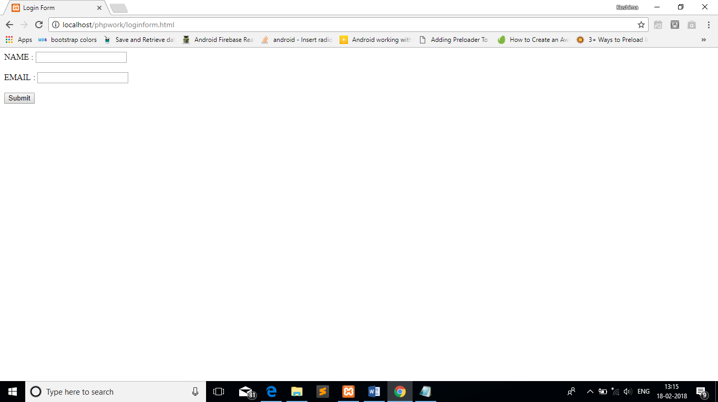

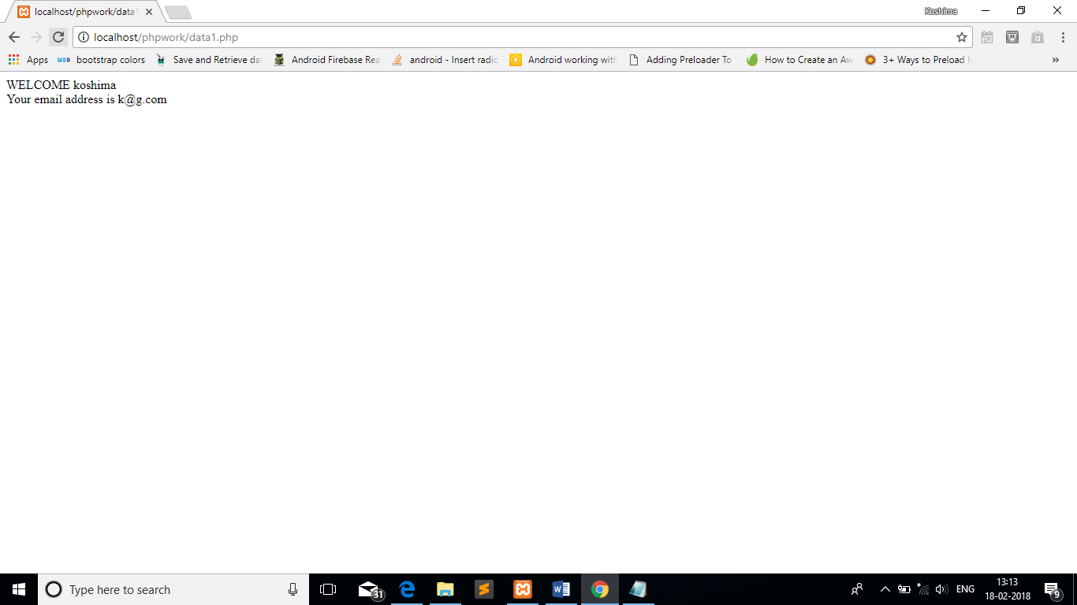

1. WAS to validate and encrypt the information posted through form.

<html>

<body>

<form name="form" method="post" action="self.php">

Name: <input type="text" value="username" name="username">

<br><br>

<input type="submit" name="submit" value="login">

</form>

<?php

if(isset($_POST["submit"]))

{

$username=$_POST["username"];

if($username=="Hello")

{

echo "You have entered";

}

else

{

echo "try again";

}

}

?>

</body>

</html>

OUTPUT

