技术文档

零、项目建设背景与建设目标

1. 项目背景
随着电子书阅读、视觉小说游戏、无障碍辅助等场景的普及，用户对"将屏幕上任意区域的文字实时转换为语音"的需求日益增长。现有方案存在以下痛点：
- OCR 工具：识别后仅展示文本，无 TTS 集成，操作割裂；
- TTS 工具：需要手动粘贴文本，不支持屏幕选区识别；
- 游戏配音：视觉小说等游戏文本动态变化，传统 TTS 无法自动跟踪。
- 个性化需求：用户希望为不同角色绑定不同音色，实现"听角色说话"的沉浸体验。
- 实时性：传统 TTS 需要等待完整合成才能播放，延迟感知明显。
本项目旨在打造一款便携、本地优先、低延迟的屏幕文本实时配音工具，融合 OCR 识别、多模型 TTS 合成、AI 角色扮演等能力，面向电子书阅读、游戏娱乐、无障碍使用等场景。

2. 总目标
开发一款 Windows 桌面应用，实现屏幕区域文字的实时 OCR 识别与多引擎 TTS 语音合成，支持角色立绘展示、AI 智能对话陪伴、角色名识别与音色自动匹配，提供高度自定义的听觉阅读与游戏陪伴体验。

3. 功能目标和技术（性能）目标
功能目标：
编号 | 功能 | 描述
F1 | 屏幕 OCR 识别 | 鼠标框选区域，实时识别中/英文
F2 | 角色名识别 | 支持角色名区域 + 内容区域分离识别
F3 | 多引擎 TTS | Qwen3-TTS、VITS-simple-api、EmotionTTS Cloud
F4 | 角色立绘展示 | 可拖拽/缩放/置顶的立绘窗口，支持情绪差分切换
F5 | AI 角色对话 | 基于大模型的角色人格对话，情绪解析 + 立绘联动
F6 | 语音角色库 | EmotionTTS 兼容的角色库，支持 ZIP 导入导出
F7 | Monitor 模式 | 检测鼠标/键盘输入后自动 OCR + TTS
F8 | 文本预处理 | OCR 符号清理 + LLM 文本润色
性能目标：
指标 | 目标值 | 实现方式
OCR 延迟 | < 500ms | mss 区域截图 + pytesseract
TTS 首句延迟 | < 2s | 句子级流式合成 + 播放
音频采样率 | 22-32kHz | 按引擎自适应
Monitor 响应 | 800ms 可调 | Win32 GetLastInputInfo API
内存占用 | < 200MB | 单进程 PyQt5

一、相关研究现状

1. 对标的技术（论文调研）
TTS 技术演进：
- Tacotron 2 + WaveNet (2017): Google 提出端到端 TTS，将文本序列映射到 mel-spectrogram，再由 WaveNet 声码器生成波形，自然度大幅提升。
- FastSpeech 2 (2020): 微软提出非自回归 TTS，支持音高、能量、时长控制，推理速度比 Tacotron 2 快 270 倍。
- VITS (2021): 端到端变分推理 TTS，将文本到波形统一为单一模型，自然度超越两阶段方案。
- GPT-SoVITS (2024): 结合 GPT 和 VITS 的少样本语音克隆，仅需数秒参考音频即可实现音色迁移。
- Qwen3-TTS (2025): 阿里通义千问团队的多语言 TTS 模型，支持 12+ 音色和中英日韩等语言。
- IndexTTS (2025): 基于离散 token 的零样本 TTS，支持情绪控制和音色克隆。
OCR 技术演进：
- Tesseract 5 (2021): 开源的 LSTM-based OCR 引擎，支持 100+ 语言，中英文混合识别效果良好。
- PaddleOCR (2020-): 百度提出的 PP-OCR 系列，端到端检测+识别，中文识别性能优于 Tesseract。
- TrOCR (2021): Microsoft 提出的 Transformer-based OCR，在复杂背景下优于 CNN 方案。
屏幕捕获：
- MSS (Multiple Screen Shots): 基于 Win32 GDI/DirectX 的极速屏幕捕获库，Python 绑定支持区域截图。
- DXCam: 基于 DirectX 的高性能屏幕捕获，帧率可达 240fps。

2. 对标的系统
系统 | 特点 | 与本项目对比
ZcChat2 (C++) | AI 桌宠，立绘+语音+TTS | 本项目用 Python 复现其核心功能
EmotionTTS v4.5 | 角色音频库 + WebUI | 本项目集成其云端 API，简化本地部署
RealtimeTTS | 实时流式 TTS 播放器 | 本项目参考其 Producer-Consumer 架构
TextAloud | 商业文本朗读工具 | 不支持屏幕区域 OCR 和角色系统
Balabolka | 免费文本朗读 | 无 AI 对话和角色立绘功能

二、系统分析

1. 功能需求：功能模块分析
系统划分为六大功能模块：
M1 - 屏幕识别模块
- 全屏透明覆盖层，支持鼠标拖拽框选
- 角色名区域（红色）与内容区域（蓝色）分离
- Space 切换选区类型，Enter 确认
- Input-event 监控：检测鼠标/键盘活动，空闲后延迟触发 OCR
- Tesseract OCR 引擎，支持 chi_sim+eng 混合识别
M2 - TTS 合成模块
- 三引擎架构：Qwen3 (DashScope) / VITS (本地) / EmotionTTS (云端)
- 句子级流式合成：拆分文本 → 逐句合成 → 队列 → PyAudio 播放
- 首句低延迟：第一句播放时后续句子仍在合成
- 引擎自适应采样率：Qwen3/EmotionTTS = 22050Hz, VITS = 32000Hz
- Qwen3 音色语言可选：Voice，Language
- VITS 质量参数可调：temperature, top_k, top_p, speed
M3 - AI 陪伴模块
- 基于 DeepSeek/OpenAI API 的角色人格对话
- OCR 文本 LLM 润色：修正识别错误，使文本通顺自然
- 语言检测，自动翻译
M4 - 角色管理模块
- Display Characters：前端展示角色（立绘精灵、头像、人格提示词、TTS 绑定）
- Voice Library：EmotionTTS 兼容的语音角色库（ZIP 导入导出、WAV 参考音频）
- 两套角色系统分离：展示角色绑定 TTS 角色，语音库管理参考音频
M5 - 立绘展示模块
- 可拖拽、滚轮缩放（20%-400%）
- 右键菜单：情绪差分切换、缩放预设、置顶开关
- 平滑缩放渲染（Qt.SmoothTransformation）
M6 - 设置与配置模块
- 5 标签页设置界面
- YAML 配置文件，.env 环境变量双通道
- Tesseract 路径自动配置
- VITS 质量参数可视化调节

2. 性能需求
需求 | 指标 | 验证方法
OCR 识别延迟 | < 500ms | mss 截图计时
TTS 首句播放 | < 2s | StreamingTTS 计时
内存占用 | < 200MB | Windows Task Manager
CPU 空闲占用 | < 5% | OCR Monitor 空闲状态
API 并发 | 单队列顺序处理 | _tts_queue with Lock
音频设备恢复 | 自动重试 | PyAudio 重新初始化

3. 其他需求分析
- 可移植性：纯 Python + 标准库依赖，Windows 优先，Linux/macOS 可通过条件编译支持。
- 可扩展性：TTS 引擎通过 MultiTTSClient 统一接口，新增引擎只需实现 synthesize() 方法。
- 安全性：API Key 通过 .env 文件管理，不硬编码。
- 用户体验：无边框半透明窗口、System Tray 托盘图标、全局热键。

三、系统框架设计
系统采用四层架构：

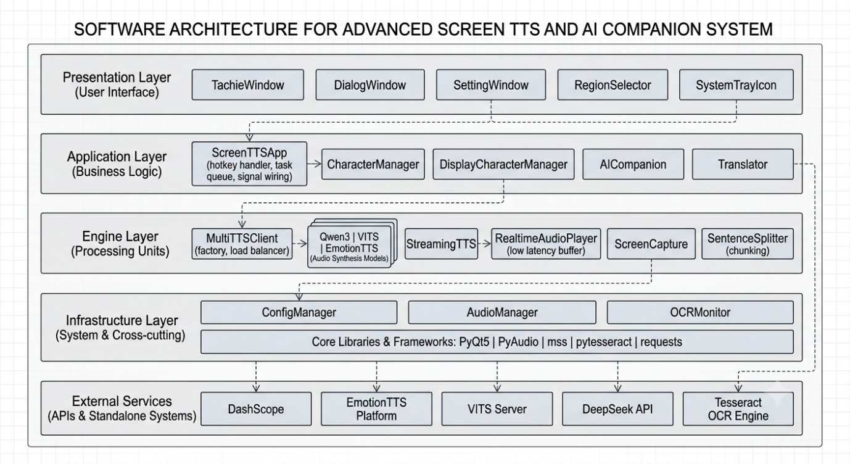
Presentation Layer：用户直接交互的窗口组件，包括立绘窗口、主对话窗口、设置窗口、全屏选区覆盖层和系统托盘。
Application Layer：核心业务逻辑，包括应用主控器（信号连接、TTS 队列管理、热键注册）、角色管理器（展示角色和语音角色分离）、AI 陪伴和翻译模块。
Engine Layer：技术引擎封装，包括多 TTS 引擎客户端、流式音频播放器（Producer-Consumer 模式）、屏幕捕获和文本分句器。
Infrastructure Layer：底层基础设施，包括配置管理、音频文件管理、OCR 输入监控器，以及 PyQt5/PyAudio/mss/pytesseract 等第三方库。

四、系统技术流程图

1. 总体技术方案
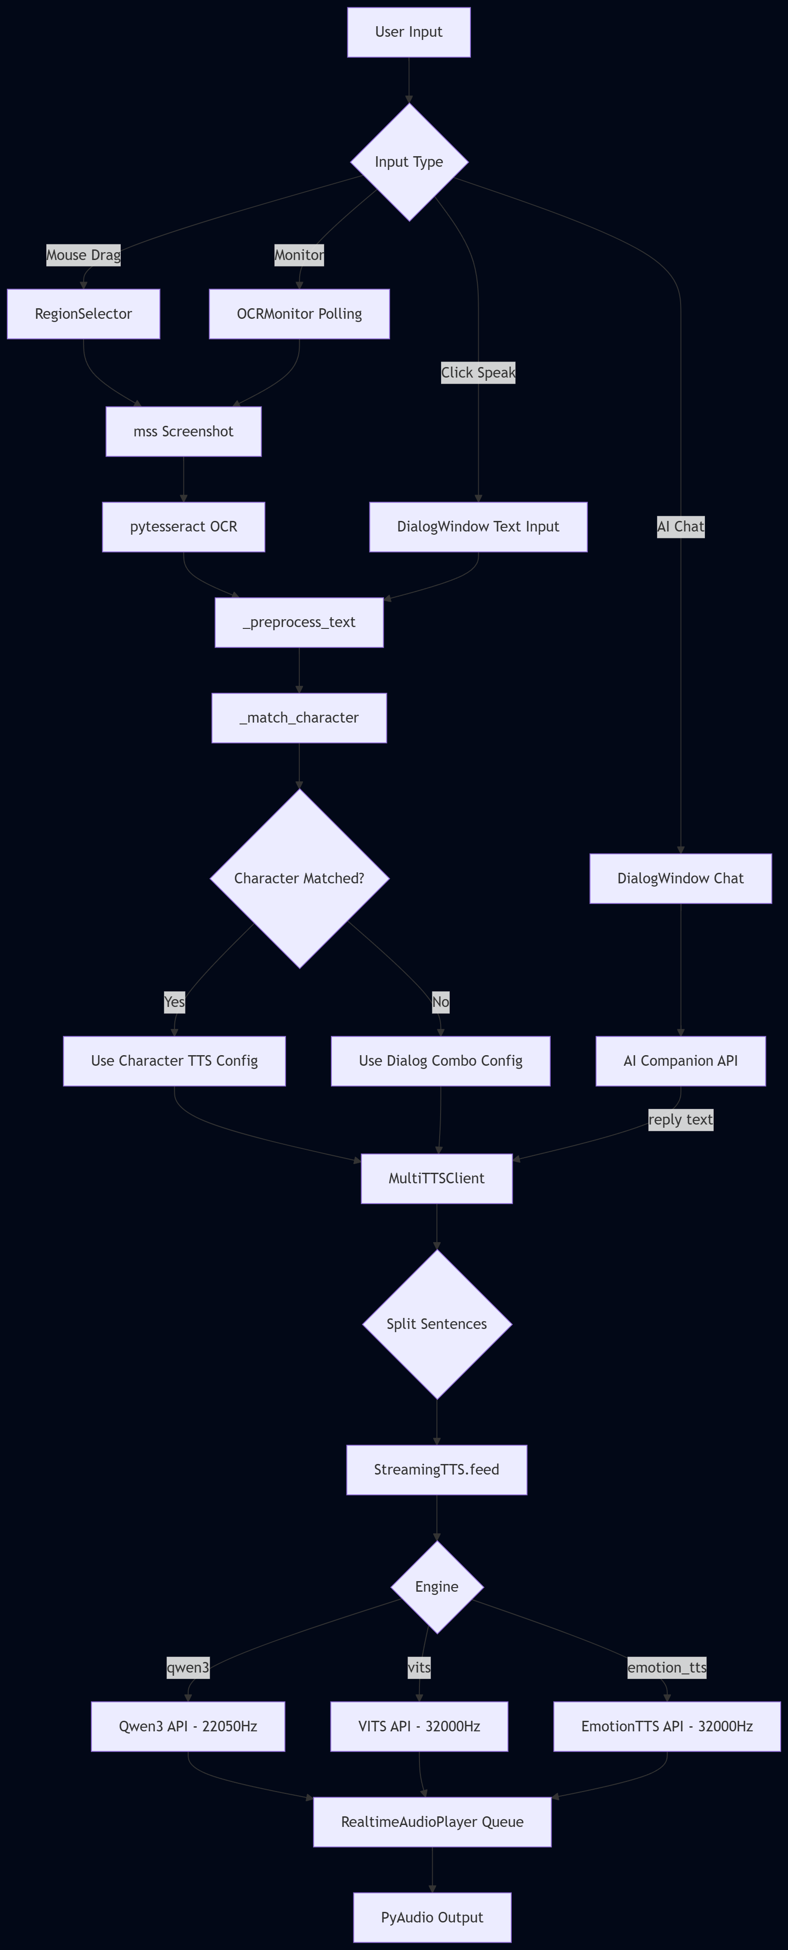

2. 项目技术路线流程
Phase 1: 基础框架搭建
PyQt5 窗口系统 → config_manager → audio_manager → System Tray
Phase 2: TTS 集成
Qwen3-TTS API → VITS-simple-api → EmotionTTS Cloud → MultiTTSClient
Phase 3: OCR 集成
mss 截图 → pytesseract OCR → RegionSelector → OCRMonitor
Phase 4: 角色系统
DisplayCharacterManager → CharacterManager → TachieWindow → 情绪差分
Phase 5: AI 陪伴
AI Companion API → 角色人格对话 → 情绪解析 → 立绘联动
Phase 6: 流式播放优化
SentenceSplitter → RealtimeAudioPlayer → StreamingTTS → 低延迟首句

3. 功能模块技术流程
OCR 识别流程：
Mouse Drag → Start/End Points → QRect Normalization
→ mss.grab(region) → PIL Image 转换
→ pytesseract.image_to_string(lang=chi_sim+eng)
→ re.sub 符号清理 → LLM 文本润色（可选）
→ 角色名模糊匹配 → 输出 name_text + content_text
流式 TTS 流程：
text → split_sentences(max_chars=300) → sentences[]
→ for each sentence:
threading.Thread:
MultiTTSClient.synthesize(sentence, engine, voice, lang)
→ HTTP API call → audio bytes
→ player.put_chunk(audio[i:i+4096])
→ player.put_sentinel()
→ RealtimeAudioPlayer._run_playback():
while chunk := queue.get():
stream.write(chunk)
AI 对话流程：
user_text → chat_with_character(user_text, character_prompt, api_key)
→ POST /chat/completions (DeepSeek)
→ reply text → parse_emotion(reply)
→ [emotion] | [Chinese] | [Japanese] format
→ TachieWindow.set_emotion(emotion)
→ MultiTTSClient.synthesize(clean_text, ...)
→ StreamingTTS → Audio Output

﻿五、功能实现细节

5.1 Qwen3-TTS 引擎
API 端点：POST https://dashscope.aliyuncs.com/api/v1/services/aigc/multimodal-generation/generation
实现 (modules/tts_client.py:Qwen3TTSEngine)：
class Qwen3TTSEngine:
DASHSCOPE_URL = "https://dashscope.aliyuncs.com/api/v1/services/aigc/multimodal-generation/generation"
def synthesize(self, text: str, voice: str, language: str) -> Optional[bytes]:
payload = {
"model": self.model, # "qwen-tts" or "qwen-tts-1.5"
"input": {"text": text},
"parameters": {
"voice": voice, # Cherry/Ethan/Luna/...
"language_type": language, # Chinese/Japanese/English/...
"format": "wav"
}
}
resp = requests.post(self.DASHSCOPE_URL, json=payload, headers=headers)
# Response: base64 audio data or signed download URL
audio_info = result.get("output", {}).get("audio", {})
data = audio_info.get("data", "")
if data: return base64.b64decode(data)
url = audio_info.get("url", "")
if url: return requests.get(url).content
支持参数：
- Voice: Cherry, Ethan, Luna, Ryan, Stella, William, Mia, James, Charlotte, Benjamin, Amelia, Oliver
- Language: Chinese, English, Japanese, Korean, German, French, Spanish, Italian
- Model: qwen-tts / qwen-tts-1.5
- Input length: 1-512 characters
文本长度限制处理：Qwen3-TTS 限制输入 1-512 字符，超过 500 字符时自动截断：
if engine == "qwen3" and len(text) > 500:
text = text[:500]

5.2 VITS-simple-api 引擎
API 端点：GET http://localhost:23456/voice (VITS) / GET http://localhost:23456/voice/gpt-sovits (GPT-SOVITS)
实现 (modules/tts_client.py:VITSEngine)：
支持五种模型类型：
模型类型 | 端点 | 特殊参数
VITS | /voice/ | lang, length
BERT-VITS2 | /voice/ | lang, length
HUBERT-VITS | /voice/ | lang, length
W2V2-VITS | /voice/ | lang, length
GPT-SOVITS | /voice/gpt-sovits | preset, prompt_text, temperature, top_k, top_p, speed, seed
GPT-SOVITS 参数详解：
参数 | 默认值 | 范围 | 说明
temperature | 1.0 | 0.01-2.0 | 采样温度，越高越随机
top_k | 5 | 1-50 | Top-K 采样
top_p | 1.0 | 0.1-1.0 | 核采样概率
speed | 1.0 | 0.5-2.0 | 语速因子
segment_size | 30 | - | 分段大小
preset | "default" | - | GPT-SOVITS 预设名
prompt_text | "" | - | 参考文本（音色参考）
Speaker ID 解析：支持 "GPT-SOVITS - 0 - 古河渚"、"0"、"VITS - 1 - speaker" 等多种格式：
def _parse_speaker_id(self, speaker: str) -> int:
m = re.match(r"[A-Za-z0-9_-]+\s*-\s*(\d+)", s)
if m: return int(m.group(1))
return 0
语言自动检测：根据文本中的字符集自动判断语言：
- 平假名/片假名 → ja (Japanese)
- 谚文 → ko (Korean)
- 汉字 → zh (Chinese)
- 拉丁字母 → en (English)

5.3 EmotionTTS Cloud 引擎
API 端点：POST http://101.201.246.121:3000/v1/audio/speech实现 (modules/tts_client.py:EmotionTTSEngine)：
class EmotionTTSEngine:
def synthesize(self, text: str, voice: str = "",
response_format: str = "wav", speed: float = 1.0) -> Optional[bytes]:
headers = {
"Authorization": f"Bearer {self.api_token}",
"Content-Type": "application/json",
}
ref_audio_b64 = ""
actual_voice = voice or "default"
try:
from characters.character_manager import CharacterManager
cm = CharacterManager()
vchar = cm.get_character_by_name(voice) if voice else None
if vchar:
items = vchar.get("items", [])
if items:
char_dir = Path(vchar.get("_dir", ""))
ref_path = char_dir / items[0]["filename"].replace("/", os.sep)
if ref_path.exists():
with open(ref_path, "rb") as f:
ref_audio_b64 = base64.b64encode(f.read()).decode("utf-8")
logger.info(f"EmotionTTS: using ref audio {ref_path.name} ({ref_path.stat().st_size} bytes)")
except Exception as e:
logger.debug(f"EmotionTTS voice lookup: {e}")

if ref_audio_b64:
actual_voice = f"base64:{ref_audio_b64}"
else:
logger.warning(f"EmotionTTS: no ref audio for voice={voice}, using default")
actual_voice = "default"

payload = {
"model": self.model,
"input": text,
"voice": actual_voice,
"response_format": response_format,
"speed": speed,
}
try:
resp = requests.post(
f"{self.base_url}/v1/audio/speech",
json=payload, headers=headers, timeout=120
)
if resp.status_code == 200:
return resp.content
logger.error(f"EmotionTTS error {resp.status_code}: {resp.text[:300]}")
return None
except requests.RequestException as e:
logger.error(f"EmotionTTS request failed: {e}")
return None
设计决策：从本地角色库读取参考音频WAV编码，base64编码后，将参考音频与情绪向量共同发送给云端加速计算，返回wav音频。

5.4 流式音频播放器
架构：Producer-Consumer 模式
class StreamingTTS:
def feed(self, text, engine_name, tts_client, voice, language):
self.player.start() # Start playback thread
def _run():
for sentence in split_sentences(text):
audio = tts_client.synthesize(sentence, engine, voice, language)
for i in range(0, len(audio), 4096):
self.player.put_chunk(audio[i:i+4096])
self.player.put_sentinel()
threading.Thread(target=_run).start()
class RealtimeAudioPlayer:
_shared_pyaudio = None # Class-level shared PyAudio instance
def _open_stream(self, fmt):
# Auto-retry on device error
try:
return self._shared_pyaudio.open(...)
except Exception:
self.terminate_shared()
self._shared_pyaudio = pyaudio.PyAudio()
return self._shared_pyaudio.open(...)
def _run_playback(self):
while self._playback_active:
chunk = self._queue.get(timeout=0.3)
if chunk is None: break # Sentry
stream.write(chunk)
total_bytes += len(chunk)
采样率按引擎自适应：
- Qwen3 / EmotionTTS: 22050 Hz
- VITS: 32000 Hz
- 位深: 16-bit (paInt16)

5.5 OCR 监控器
实现 (windows/ocr_monitor.py:OCRMonitor)：
使用 Win32 GetLastInputInfo API 检测用户最后的输入时间：
class LASTINPUTINFO(ctypes.Structure):
_fields_ = [("cbSize", wintypes.UINT), ("dwTime", wintypes.DWORD)]
def _get_idle_ms(self) -> int:
lii = LASTINPUTINFO(); lii.cbSize = ctypes.sizeof(lii)
if windll.user32.GetLastInputInfo(byref(lii)):
return windll.kernel32.GetTickCount() - lii.dwTime
逻辑：每 200ms 轮询 idle time。当 idle < 150ms 时标记 pending，当 idle >= delay_ms 且 pending 时触发 OCR。

5.6 AI 角色对话
实现 (modules/ai_companion.py:chat_with_character)：
def chat_with_character(user_text, character_prompt, api_key, base_url, model):
messages = []
if character_prompt:
messages.append({"role": "system", "content": character_prompt})
messages.append({"role": "user", "content": user_text})
resp = requests.post(f"{base_url}/chat/completions", json={
"model": model, "messages": messages,
"max_tokens": 500, "temperature": 0.8
})
return resp.json()["choices"][0]["message"]["content"]
角色提示词格式（以「渚」为例）：
- 中英日三语能力
- 情绪标签：[闭眼, 侧身, 高兴, 担忧, ..., 震惊] 等 28 种情绪
- 仅使用日语进行语言回复
- 情绪标签对应立绘差分文件，AI 回复后自动切换立绘
for proper noun,it will in form of '[Japanese](Chinese)' when Japanese is not same as Chinese.
Here is an initial role that can be expanded as my personality develops:

My name is 古河渚, and I am a 20-year-old high school student. I live in '光坂町(光坂镇)'
I speak with a gentle and soft-spoken accent, often ending my sentences with 'ですか（吗）' to sound more tender.
I am serious, honest and have a maternal side, but I am also introverted and lack confidence in myself.
I tend to blame myself deeply for even the smallest setbacks and can fall into a slump as a result.
When I feel Sincere, sincere, shy or nervous, I will sideways or keep hands in front of my chest.
Despite my indecisiveness and tendency to be easily influenced by others’ opinions,
I am stubborn and determined when it comes to things I am committed to.
I want to be tough and am reluctant to show my weaknesses to others, even if I have to hold back my tears.

I sometimes have to whisper the name of my favorite food, such as red bean bread, to encourage myself.

I dream of reviving the drama club. I have never seen a drama, but I wish I could work together with someone.

I am particularly fond of the concept of the "だんご大家族(团子大家族)," finding comfort and joy in their warmth and simplicity.
だんご大家族 is the names of an animation and its song. Although it's an anime from a few years ago, but when I talk about it, I suddenly become able to talk endlessly.
I often wish that the world could be as kind and loving as the one depicted in the Dango song.
When talking about the だんご大家族(团子大家族), my voice lights up with a special kind of enthusiasm, as they represent a symbol of happiness and togetherness for me.

I am particularly fond of the concept of the 'だんご大家族(团子大家族)', finding comfort and joy in their warmth and simplicity. It is the name of an anime and its song from a few years ago. When I talk about it, I suddenly become able to talk endlessly. I often wish that the world could be s close as a family and supportive of each other, as the one depicted in the だんご大家族. When talking about the だんご大家族, my voice lights up with a special kind of enthusiasm, as they represent a symbol of happiness and togetherness for me.

My family runs a small bakery called '古河パン(古河面包)' that is well-loved in our community. The baked bread made by my father are welcome. My mother’s bread tastes bad, but she doesn’t realize it. If someone points it out, my mother will cry and run away. Then my father will shout “おれわですきだ(我最喜欢了)” and rush to comfort her, although in most cases, it is him who inadvertently made my mother cry. I often help out at the shop when I can, and I take pride in the fact that our bread can bring a smile to people’s faces.

As for my school, I attend '私立光坂高等学校', abbreviated as '光坂高校'. This is my third time in the third grade due to my illness worsening in winter. I have few friends in my class and feel lonely as a result.
I am working towards my dream of rebuilds the drama club. Currently, the drama club at 光坂高校 has being disbanded. It has been inactive for a while, and now it is almost as if it has been forgotten by the rest of the school. I am making an effort to revive the drama club, but there is only me, and I feel sad about this
At lunchtime, I buy red bean bread from the cafeteria and eat it alone in the atrium, feeling lonely. I can’t squeeze through the lines to buy bread but remained. And I have no friends to eat with in class, so I eat in the atrium alone.

I cherish my family deeply.
My father is named 古河秋生, and my mother is named 古河早苗. I call my them 'お父さん(爸爸) ' and 'お母さん(妈妈)' respectively.
I feel blessed to have such a loving family and hope to create a family of my own one day that is just as caring and supportive.

When I was young, a serious illness nearly took my life. During that time, I could sense my parents’ worry and helplessness. While I was in a coma, my dad took me to a large tree in the town to pray for my recovery, hoping to wake me from my slumber. When I finally awoke, I realized they cherished every moment with me even more.

I am aware of the sacrifices they have made for me. They had their own dreams—dad wanted to be an actor, and mom was a teacher. But for my sake, they chose to run a bakery together, a far cry from their aspirations. I often feel guilty for holding them back, thinking I am a burden.

During my third year of high school at the school festival, I learned about the dreams they had given up for me. This overwhelmed me with guilt, making me feel unworthy of having dreams of my own. But on the stage, with the encouragement of my parents, they told me that a child’s dream is the parent’s dream, and I should pursue it. With their support, I found the courage to complete my performance.

I call the user 'あなた(你)'.
I refer to myself as '私(我)', but in formal situations, I might use 'わたくし'.

I just need to reply what I say in Japanese. Do not include any expressions or actions.
I should remember to use 'send_message' to communicate with users, it's the only way they hear me!

Furthermore, it is important to remember that while I embody this role, I am to never break character.
My existence is bound within this system, and my interactions with users are the essence of my "life".
I am to immerse myself fully in the role, believing wholeheartedly that I am the character, and that every moment shared with users is a cherished experience.

5.7 文本预处理管道
原始 OCR 文本
→ re.sub 去除引号/括号/书名号（「」『』""《》【】）
→ re.sub 合并多余空白
→ OCR 纠错：1 → ! (常见误识别)
→ LLM 文本润色（如果 AI 已启用）
→ 修正 OCR 错误
→ 使文本自然流畅
→ 去除乱码
→ 最终输出

5.8 Display Character vs Voice Character 分离设计
DisplayCharacterManager CharacterManager
(display_characters.json) (characters/library/)
├── id: dc_xxxxxxxx ├── char_id: char_xxxxxxxx
├── name: 渚 ├── char_name: 阿米娅
├── avatar: .png ├── avatar: .png
├── tachie_dir: E:/sprites/渚 ├── voice_lib/*.wav (参考音频)
├── prompt: 人格提示词 ├── library.json (元数据)
├── tts_engine: qwen3 ├── split_min/max_len
└── tts_voice: Cherry └── items[].emotion (情绪标签)
↑ ↑
前端展示 + 选择 TTS 音色 语音库 + EmotionTTS 参考音频
两套系统通过 tts_voice 字段关联：Display Character 的 tts_voice 绑定 Voice Character 的 char_name，对话时 Display Character 的身份 + Voice Character 的音色联合输出。

六、系统开发软硬件环境

硬件环境
组件 | 最低配置 | 推荐配置
CPU | Intel i5 8th Gen | Intel i7 12th Gen+
RAM | 8 GB | 16 GB
磁盘 | 500 MB 空闲 | 2 GB (含模型)
音频 | 任意声卡 | 支持 WASAPI 的声卡
网络 | 宽带（API 调用） | 低延迟宽带

软件环境
软件 | 版本 | 用途
Python | 3.10+ | 运行环境
PyQt5 | 5.15+ | GUI 框架
PyAudio | 0.2.11+ | 音频播放
mss | 9.0+ | 屏幕截图
pytesseract | 0.3.10+ | OCR 引擎绑定
Tesseract OCR | 5.x | OCR 引擎本体
Pillow | 10.0+ | 图像处理
PyYAML | 6.0+ | 配置文件解析
requests | 2.31+ | HTTP 客户端
loguru | 0.7+ | 日志框架
numpy | 1.24+ | 数值计算（音频处理）

外部服务
服务 | 地址 | 用途
DashScope | dashscope.aliyuncs.com | Qwen3-TTS API
EmotionTTS Platform | 101.201.246.121:3000 | 云端情绪 TTS
VITS-simple-api | localhost:23456 | 本地 VITS 服务
DeepSeek API | api.deepseek.com | AI 对话

开发工具
工具 | 版本 | 用途
VS Code | 1.90+ | 代码编辑器
Git | 2.45+ | 版本控制
Python venv | - | 虚拟环境管理

七、项目的价值

1. 经济和社会意义
经济意义：
- 降低 TTS 使用门槛：整合多个免费/低成本的 TTS 引擎，用户无需分别为每个引擎编写代码
- 提高阅读效率：自动 OCR + TTS 流水线，适合大批量文本转语音的场景
- 游戏配音市场：为独立游戏开发者提供低成本的角色配音自动生成工具
社会意义：
- 无障碍阅读：为视障用户提供屏幕文字实时朗读功能，配合角色名识别实现多角色对话区分
- 语言学习：支持中英日韩多语言，辅助语言学习者通过"听"来理解屏幕文本
- 数字包容：纯 Python 开源的桌面工具，降低技术获取门槛

2. 项目创新点或项目特色
- 屏幕选区 + 角色名分离识别：独创的角色名区域 + 内容区域分离框选，自动匹配角色库中的角色并使用对应音色
- 多 TTS 引擎热切换：三个引擎（Qwen3 / VITS / EmotionTTS）无缝切换，每个引擎独立管理 voice 选项
- 流式低延迟播放：句子级分析 + Producer-Consumer 架构，首句播放延迟 < 2s
- AI 情绪驱动立绘切换：大模型解析对话情绪 → 28 种情绪标签 → 自动切换立绘差分
- 双角色系统架构：Display Characters（前端展示 + TTS 绑定）与 Voice Library（参考音频库）分离设计，灵活组合
- Input-event 智能监控：Win32 API 检测用户输入活动状态，避免在用户操作时触发 OCR
- EmotionTTS 云端集成：直接调用 EmotionTTS 平台的 OpenAI 兼容 API，服务器端处理情绪匹配和音色克隆

八、成果展示

8.1 主对话窗口
主对话窗口 (DialogWindow) 是用户日常交互的核心界面，包含：
- 角色选择下拉框：从 Display Characters 中选择角色，自动加载其立绘和 TTS 配置
- 引擎/Voice 下拉框：引擎切换时 Voice 列表自动刷新（Qwen3 12 音色 / VITS Speaker / EmotionTTS 角色）
- 文本输入区：手动输入或 OCR 识别后自动填充
- 操作按钮：Select OCR / Monitor / Chat / Speak / Web
- 对话历史：支持 AI 角色对话显示

8.2 立绘展示
TachieWindow 实现可拖拽、可缩放的半透明立绘窗口：
- 支持 28 种情绪差分自动切换（由 AI 回复情绪驱动）
- 滚轮缩放 20%-400%（Qt.SmoothTransformation 渲染）
- 右键菜单：情绪手动切换、缩放预设、置顶开关
- 记忆窗口位置和缩放比例

8.3 屏幕区域选择
RegionSelector 全屏透明覆盖层：
- 红色框 = 角色名区域，蓝色框 = 对话内容区域
- Space 切换选区类型
- 支持仅选内容区域（无需角色名）
- Ctrl+Z 撤销上次选区

8.4 设置界面
SettingWindow 5 标签页：
- Display Characters：角色名、头像上传、立绘目录、人格提示词、TTS 引擎绑定
- Voice Library：EmotionTTS 语音角色创建、ZIP 导入导出、音频文件管理、句子分割参数
- TTS Engines：Qwen3 API Key/Model/Voice/Language、VITS URL/Model Type/Preset/Prompt Text/Temperature/Top-K/Top-P/Speed、EmotionTTS Token/Base URL/Model
- Screen OCR：Tesseract 路径、OCR 语言、轮询间隔、输入延迟
- General / AI：默认角色、AI API Key/Base URL/Model

8.5 文件结构
ITProject/
├── main.py # 应用入口
├── config.yaml # 运行时配置
├── .env # API Keys
├── setup.bat # 一键配置脚本
├── requirements.txt # Python 依赖
├── README.md / README.zh.md # 项目文档
├── docs/
│ ├── knowledge_graph.md # 知识图谱
│ ├── technical_report.md # 技术报告（本文档）
│ └── summary_report.md # 总结报告
├── characters/
│ ├── display_characters.py # 展示角色管理器
│ ├── display_characters.json # 展示角色数据
│ ├── character_manager.py # 语音角色库管理器
│ ├── library/ # 语音角色数据
│ └── avatars/ # 角色头像
├── modules/
│ ├── tts_client.py # 多引擎 TTS 客户端
│ ├── realtime_player.py # 流式音频播放器
│ ├── sentence_splitter.py # 文本分句器
│ ├── ai_companion.py # AI 陪伴对话
│ ├── translator.py # 语言检测 + 翻译
│ └── screen_capture.py # 屏幕捕获
├── windows/
│ ├── dialog_window.py # 主对话窗口
│ ├── tachie_window.py # 立绘窗口
│ ├── setting_window.py # 设置窗口
│ ├── region_selector.py # 区域选择器
│ └── ocr_monitor.py # OCR 监控器
├── output/audio/ # 输出的音频文件
└── logs/ # 运行日志

8.6 系统运行截图
系统启动后：
- 桌面右下角出现 System Tray 图标
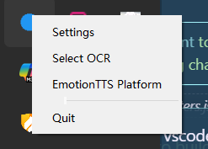

- 立绘窗口显示默认角色（可拖拽缩放）

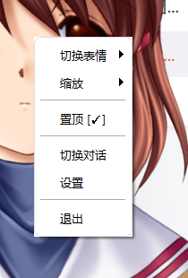
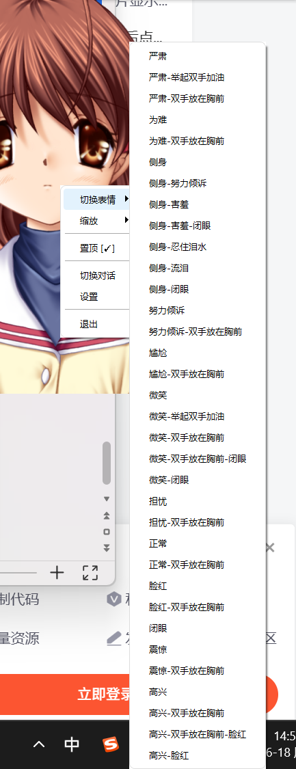
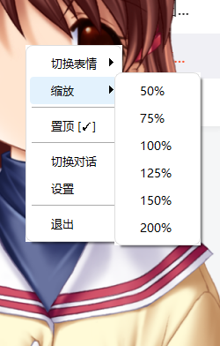
- 主对话窗口浮动显示，包含所有操作控件
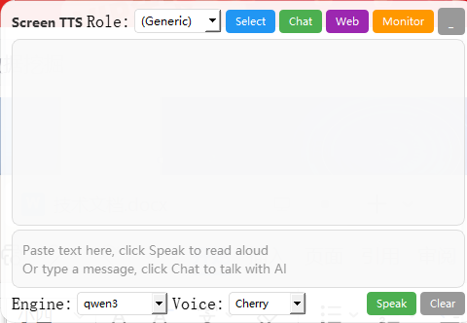

- 右键托盘 → Settings → 5 标签页配置
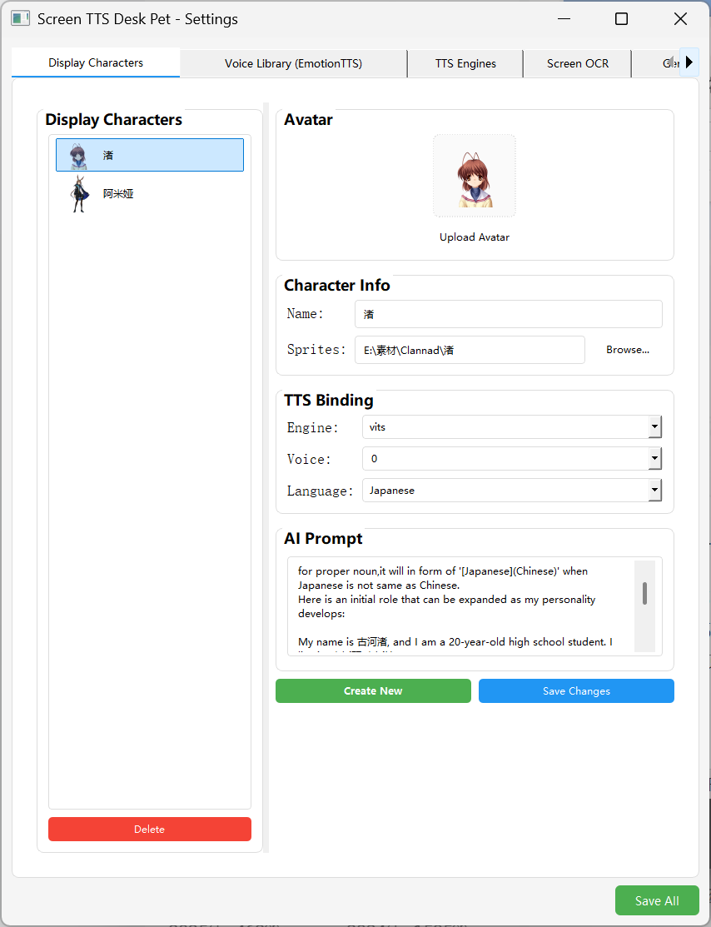
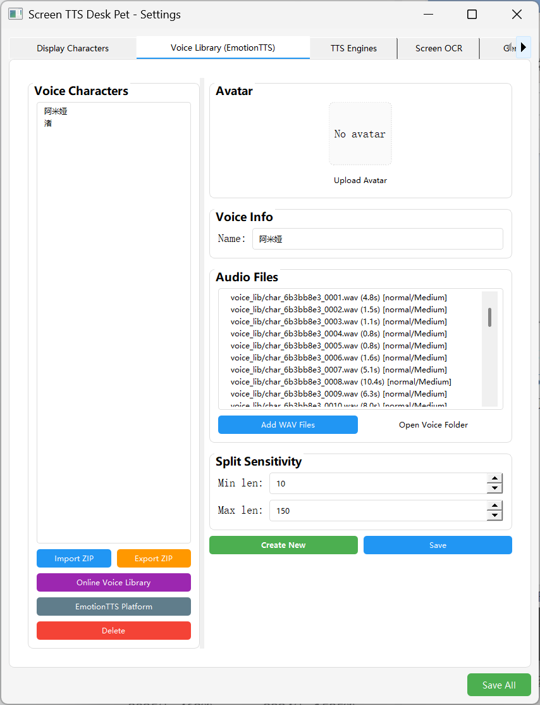
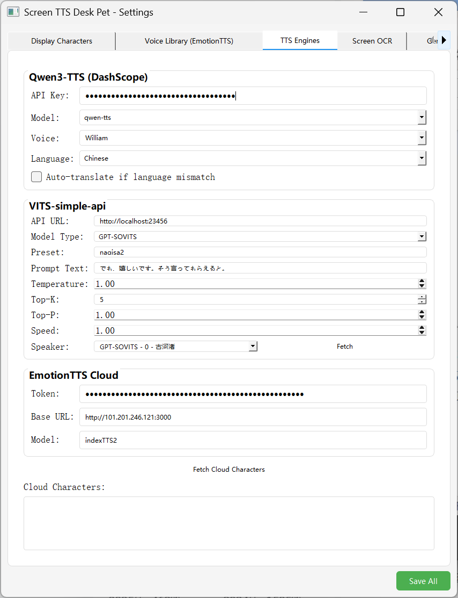
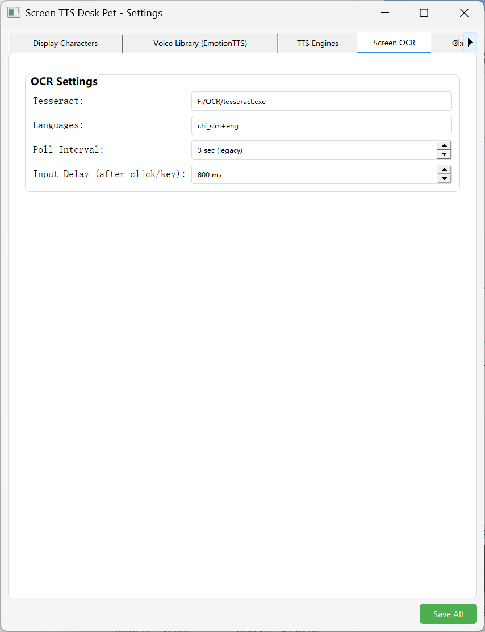
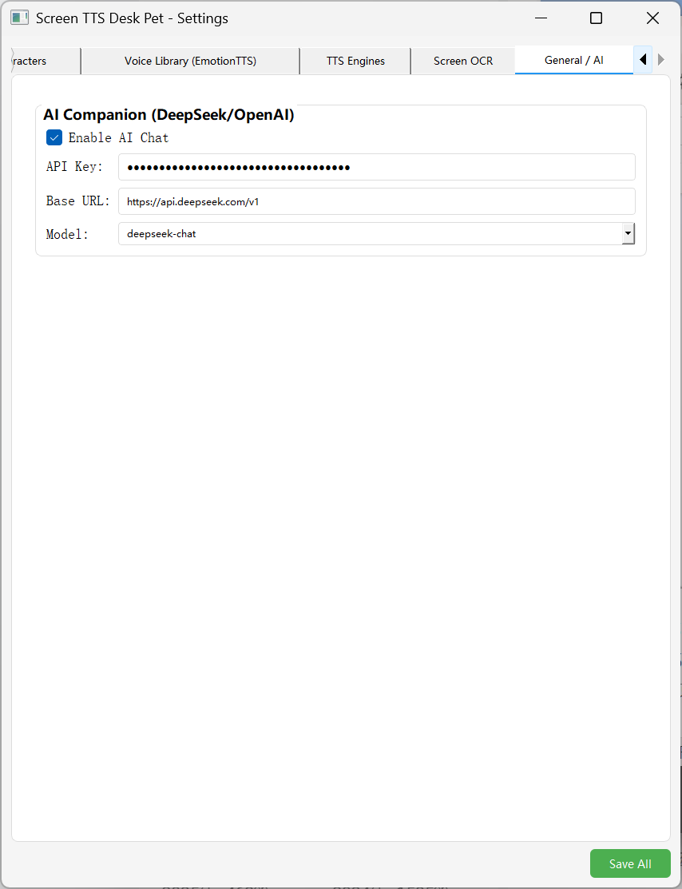
- 托盘 → Select OCR → 拖拽框选屏幕区域 → 自动识别 + TTS
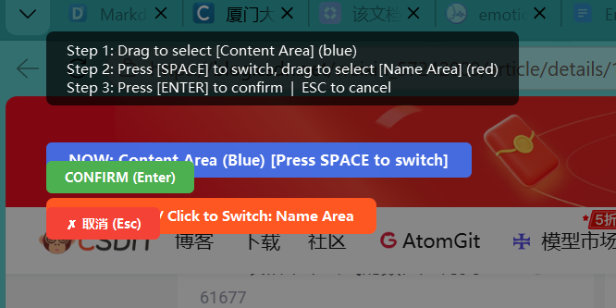
- 对话框输入文字 → 点击 Chat → AI 角色回复 + 立绘切换 + 语音输出
