

本科期末论文（主修专业）

Face Reader
—人工智能期末项目

卢思宇 22920212204423
孙康乐 22920212204439
邵弈宁 22920212204432
朱彦同 22920212204511
学院：信息学院
专业：数字媒体技术
年级：2021级

校内指导教师： 姚俊峰教授

二〇二四年六月二十二日

Abstract

Facial expressions are an important way to disseminate human emotional information and coordinate interpersonal relationships. Facial expression recognition refers to selecting the expression state from static photos or video sequences to determine the emotional and psychological changes of a character. In daily life, humans are accustomed to absorbing nonverbal cues from facial expressions. It has become an instinct for humans to understand the emotional state of others by observing facial expressions. Can computers accomplish similar tasks? The answer is yes, but it needs to be trained to recognize emotions.
In the field of computer vision, imitating this ability and applying it to automation systems has become a highly anticipated research area. The widespread application prospects of facial image emotion recognition stem from its ability to help people better understand and interpret human emotions in various scenarios. This technology can be applied in various fields, such as emotional intelligence systems, human-computer interaction, health monitoring, etc., providing people with more intelligent and considerate services.

Figure 1. Human beings have rich facial expressions

In this project, we adopted Convolutional Neural Networks (CNN), a powerful deep learning technique, to achieve emotion recognition based on facial images. The successful application of CNN in the field of image processing has been widely recognized, and its excellent performance in extracting image features makes it an ideal choice for facial image emotion recognition. By training ona large number of labeled facial image datasets, CNN can automatically learn advanced features in the image and map these features to different emotion categories, thereby achieving automatic emotion recognition.
One of the key challenges of the project is to design an effective model architecture to improve the accuracy and robustness of emotion recognition. This includes selecting appropriate network depth and width, reasonable activation and loss functions, and optimized training strategies. In addition to the design of the model architecture, the quality and quantity of data are also important factors affecting recognition performance. Therefore, we will explore various data preprocessing methods, such as image enhancement, data augmentation, etc., to enhance the model's generalization ability and adaptability.
We hope to establish an efficient and accurate facial image emotion recognition system to provide people with more intelligent and personalized services.

As we delve deeper into the realm of facial image emotion recognition, we encounter new frontiers that hold immense potential for both research and application. For instance, the integration of real-time emotion recognition into live video streams could revolutionize the way we communicate and interact with others. Imagine a video conference system that can detect and analyze the emotions of participants, providing valuable insights to the moderator or even adjusting the meeting's tone and pace accordingly.
Furthermore, the application of facial image emotion recognition in healthcare is particularly promising. It could assist in the diagnosis and treatment of mental health disorders, such as depression or anxiety, by monitoring and analyzing patients' emotional states. Additionally, it could be used in elderly care, detecting potential signs of distress or discomfort in the elderly and alerting caregivers in a timely manner.
Another exciting prospect is the integration of facial image emotion recognition with virtual reality (VR) and augmented reality (AR) technologies. As VR and AR become more immersive and realistic, the ability to recognize and respond to users' emotions in these virtual environments could greatly enhance the user experience. For example, a VR game could adapt its difficulty or storyline based on the player's emotional state, creating a more engaging and personalized gaming experience.
To achieve these ambitions, we must continue to refine and improve our facial image emotion recognition system. We plan to explore more advanced deep learning techniques, such as recurrent neural networks (RNNs) and long short-term memory (LSTM) networks, to capture temporal dependencies in facial expressions and enhance the system's ability to recognize complex emotions. Additionally, we will investigate new data sources and collection methods to expand our datasets and further enhance the system's generalization ability and robustness.
In conclusion, the application prospects of facial image emotion recognition are vast and exciting. With continued research and development, we believe that this technology will become an indispensable tool in various fields, enabling us to better understand and respond to human emotions in an increasingly interconnected world.

Directory

Face Reader 1
Abstract 2
Directory 6
1. Introduction 7
1.1 Background 7
1.2 Introduction Of CNNs and Advantages 20
1.3 Goal of Project 26
1.4 Significance 29
2. Related Work 32
2.1 Data Preprocessing: 32
2.2 Model Architecture: 41
2.3 Final Layer and Output: 42
2.4 Experimental Setup: 43
2.5 Evaluation Metrics: 43
2.6 Front and Back End Connection： 44
Samples of the IMDB dataset 48
3. Method 56
3.1 Data Preprocessing 56
3.2 Model architecture 62
3.3 Final layer and output 73
4. Experiments 76
4.1. Experimental setup 76
4.2. Evaluation indicators 78
5. Conclusion 80

Introduction

Background

The Current Situation of Psychological Problems among Chinese Adolescents
The psychological well-being of Chinese adolescents has garnered significant concern and recognition from the broader society, representing an issue of paramount importance that is also encountered by numerous other countries globally. In our endeavor to gain a deeper understanding of this matter, we embarked on a comprehensive cross-sectional historical meta-analysis focusing on the psychological health status of middle school students in China, spanning the period from 1987 to 2013. Our findings revealed a concerning trend, indicating that as students progress through their middle school years, their mental health status tends to decline, with first-year students exhibiting the most significant changes over time. Moreover, a marked gender disparity was observed, as female students demonstrated a broader range of psychological health fluctuations and consistently lower levels of well-being.
Our examination of the mental health landscape among high school students, including those enrolled in vocational schools, from 1990 to 2012 yielded interesting insights. During the period from 1990 to 2004, we observed a gradual yet steady decline in the mental health of Chinese high school students. However, this downward spiral appeared to stabilize from 2005 to 2012, with the psychological health of these students no longer showing a continuous deterioration. When it comes to gender differences, we found that the mental health of female high school students lags behind that of their male counterparts, and the rate at which their psychological well-being diminishes is more rapid.
In 2012, researchers including Xin Ziqiang conducted a study that delved into the mental health status of college students in China from 1986 to 2010. Their findings indicated a positive trend, with the overall psychological health of college students gradually improving over the study period. In terms of gender disparities, the study revealed that the mental health of male students improved at a higher rate than that of their female peers. The psychological well-being of graduate students, on the other hand, tends to be more akin to that of college students, with both groups exhibiting a trajectory of improvement in their mental health status.
Moving forward to a more recent analysis, we have examined the mental health trends among university students in China from 2015 to the present. The data collected during this period reveals a nuanced picture, with both positive and negative shifts in mental well-being. While the overall mental health of university students has remained stable, there are significant variations across different segments of the student population.
Specifically, we found that first-year university students tend to experience higher levels of anxiety and stress compared to their more senior peers. This could be attributed to the transition from high school to university, which often brings with it new challenges and uncertainties. Additionally, the increased academic demands and social pressures at the university level can also contribute to these mental health issues.
In contrast, graduate students, especially those in their final years, tend to exhibit a more resilient mental health status. This may be due to their increased maturity, experience, and sense of purpose as they near the completion of their studies. However, it is worth noting that graduate students also face unique challenges, such as career uncertainty and financial pressures, which could potentially impact their mental well-being.
When it comes to gender differences, we observed a consistent pattern of female students exhibiting more psychological distress than their male counterparts. This gender disparity is particularly pronounced among undergraduate students, who are often under more pressure to balance their academic, social, and personal lives. However, the gender gap in mental health appears to narrow as students progress through their academic journey, indicating that female students may develop stronger coping mechanisms and resilience over time.
Overall, our findings suggest that mental health is a complex issue that varies across different segments of the student population. While there are positive trends in terms of overall mental well-being, there are also significant challenges and disparities that need to be addressed. It is crucial for educational institutions, policymakers, and society at large to prioritize mental health and provide the necessary support and resources to help students navigate their academic journey in a healthy and resilient manner.
To further delve into the complexities of student mental health, it is important to consider the role of cultural and ethnic backgrounds. Our data indicates that students from diverse cultural backgrounds often face unique challenges in maintaining their mental well-being. This could be due to a combination of factors such as language barriers, cultural differences in family and social expectations, and the lack of culturally sensitive mental health support services.
In order to address these disparities, it is essential for educational institutions to provide culturally responsive mental health programs and services. This includes training staff and faculty to be more culturally aware and sensitive, developing resources and materials in multiple languages, and establishing partnerships with community organizations that can provide culturally specific support.
Moreover, it is crucial to promote a sense of belonging and inclusion for all students, regardless of their cultural or ethnic background. This can be achieved through creating diverse and inclusive campus environments, fostering positive relationships between students and faculty, and providing opportunities for students to engage with their peers from different backgrounds.
In addition to cultural and ethnic factors, the role of technology in student mental health cannot be overlooked. While technology has undoubtedly revolutionized the way we learn and communicate, it has also brought with it a new set of challenges, such as increased screen time, cyberbullying, and digital distractions. It is important for students to learn how to manage their technology use in a healthy and balanced manner, and for educational institutions to provide guidance and support in this area.
Finally, it is worth mentioning that mental health is not just a concern for students. Faculty and staff in educational institutions also face their own unique mental health challenges, which can potentially impact their ability to effectively support students. It is therefore important to prioritize the mental well-being of all members of the educational community, including faculty, staff, and students. By creating a culture of care and support, we can help ensure that everyone in the educational system is able to thrive and achieve their full potential.
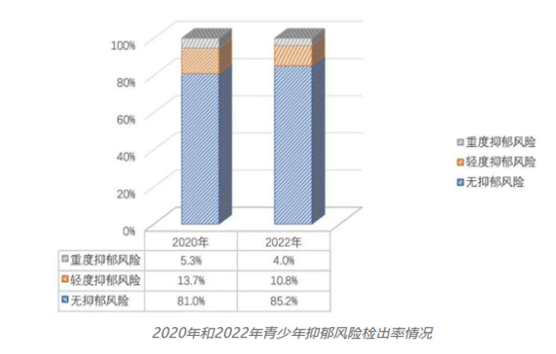
Figure 2.The detection rate of depression risk in adolescents in 2020 and 2022
Adolescence is a critical period of life characterized by rapid advancements in both physical and psychological domains. It is a time of significant transformation as young individuals navigate through the complexities of growth and development. This phase is often associated with a multitude of challenges and is universally recognized as a high-risk category for experiencing mental health challenges. The mental health concerns faced by adolescents are not only distressing for the individuals themselves, but also impose substantial suffering on their families and loved ones. Moreover, these issues have the potential to cast shadows on societal progress and development. Given the gravity of the situation, it is of paramount importance to carry out comprehensive studies, pinpoint the specific problems affecting adolescents, and develop targeted interventions to address their mental health needs. Timely recognition and identification of their emotional state is hence a task of utmost importance in order to provide appropriate support and care.
A comparative analysis of depression risk detection rates in adolescents between 2020 and 2022 reveals a concerning trend. As Figure 2 illustrates, the detection rate in 2022 has increased significantly compared to 2020, indicating a potential rise in the prevalence of depression and other related mental health issues among this age group. This worrying development demands immediate attention and a concerted effort to understand the root causes and develop effective strategies to address this growing challenge.
The rise in depression risk detection rates could be attributed to several factors. Firstly, the pandemic and its associated lockdowns and social distancing measures have had a profound impact on the mental health of adolescents. The disruption of routine social interactions, limited access to entertainment and physical activities, and increased feelings of isolation and uncertainty have all contributed to a rise in depression and anxiety. Secondly, the increased use of digital media and social platforms, which often promote negative comparisons and unrealistic standards, has also had a detrimental effect on the mental well-being of young individuals. Finally, the pressures and expectations faced by adolescents in academic and extracurricular settings can be immense, leading to feelings of inadequacy and low self-esteem. These pressures, coupled with the lack of adequate support and guidance, can create a perfect storm for the development of depression and other mental health issues.
To address this issue, a multi-faceted approach is needed. Educational institutions must prioritize mental health education and awareness, providing students with the tools and resources to understand and manage their emotions. Families and communities must also play an active role in creating a supportive and understanding environment for adolescents. It is important to promote positive self-esteem and encourage young individuals to pursue healthy coping mechanisms. Additionally, policies and programs must be developed to reduce the pressures and expectations faced by adolescents, ensuring that they are able to grow and develop in a healthy and balanced manner. By working together, we can help ensure that adolescents are able to thrive and achieve their full potential, free from the shackles of depression and other mental health issues.

Background of Artificial Intelligence Development
As deep learning technology continues to evolve and advance, the field of facial image emotion recognition has emerged as a key focus within the broader domain of AI research. The human face is a rich tapestry of expressions that serve as a universal language, reflecting the kaleidoscope of emotions that define our experiences and interactions. The ability to accurately interpret these expressions is not merely an exercise in self-expression, but a vital tool for deciphering the emotional states of others. This capacity has profound implications across a spectrum of applications, ranging from the development of sophisticated emotional intelligence systems to enhancing the realms of human-computer interaction and precision marketing.
Historically, facial image emotion recognition has been largely dependent on methods that involve manually crafting feature extractors and classifiers, which are rooted in traditional machine learning frameworks. While these methods have yielded certain insights, they often fall short when faced with the intricate complexities of human emotions. These complexities are further compounded by the fact that emotional expressions can vary significantly across different contexts and environments. As a result, there is a pressing need for more nuanced and robust approaches to tackle the challenges posed by these diverse conditions.
The advent of deep learning has brought about a paradigm shift in this domain. By leveraging deep neural networks, it is now possible to automatically and seamlessly learn and extract intricate features directly from facial images, thereby improving the accuracy and reliability of emotion recognition. This represents a significant leap forward in our ability to not only capture but also comprehend the subtleties of human emotional expression. The applications of this technology are vast and wide-reaching, with the potential to transform how we interact with technology, personalize user experiences, and even influence marketing strategies by accurately gauging consumer emotions.
In summary,the ongoing evolution of deep learning technology has rendered traditional methods of facial image emotion recognition obsolete, particularly in the face of complex and context-dependent emotional cues. The future of this field lies in the development of AI systems capable of autonomously deciphering the nuances of human emotions, thereby unlocking a world of possibilities in how we understand, interact with, and cater to the emotional needs of both individuals and society at large.

The development of artificial intelligence in emotion recognition has multiple meanings and impacts:
Precision and accuracy improvement: Traditional emotion recognition methods often rely on manually defined features and rules, while deep learning and machine learning techniques can learn and automatically extract features from a large amount of data, thus enabling more accurate recognition and understanding of subtle differences in human emotional expression. This accuracy improvement is crucial for developing more intelligent human-computer interaction systems, which can improve user experience and enhance system responsiveness.
Multi domain application: The improvement of emotion recognition technology has enabled it to be applied in multiple fields. For example, in the field of healthcare, it can help diagnose emotional disorders or autism, as well as provide more effective psychological treatment. In the field of education, it can help educators better understand students' emotional states and adjust teaching strategies. In customer service and marketing, it can help businesses better understand consumer emotions and preferences, thereby providing more personalized services and promotion strategies.
Improving human-computer interaction: The advancement of emotion recognition technology can help improve the human-computer interaction experience. For example, smart assistants can better understand a user's emotional state, thereby responding and adjusting responses more intelligently. This improvement not only enhances the naturalness and efficiency of interaction, but also enhances user trust and satisfaction with the technology.

The development of emotional intelligence systems: With the improvement of emotion recognition technology, intelligent systems that can simulate and understand human emotions are gradually being developed. These systems can play a role in various applications, such as smart homes, personalized recommendation systems, virtual reality, and augmented reality technology, making the technology more closely aligned with human needs and emotional experiences.
The help of social and psychological research: The advancement of emotion recognition technology has also provided powerful tools for social science and psychological research. Researchers can comprehensively analyze and understand the emotional states and changes of large-scale groups, which is of great significance for understanding social trends, emotional transmission, and mental health.
Overall, the development of artificial intelligence in emotion recognition has not only improved the efficiency and intelligence level of technological applications, but also profoundly influenced our interaction and understanding ability with technology, society, and our own emotional states.
The influence on education: Beyond the classroom, emotion recognition technology has the potential to revolutionize education. For instance, in online learning platforms, it can detect students' engagement and frustration levels, enabling teachers to provide timely support and guidance. Further, this technology can help identify learning disabilities or emotional barriers that may hinder a student's progress, thereby facilitating early intervention and personalized support.
Boosting creativity and innovation: Emotion recognition can also play a crucial role in stimulating creativity and innovation. By understanding the emotional response to different ideas or designs, creators can refine and enhance their work to better resonate with the target audience. This technology has immense potential in fields like advertising, filmmaking, and product design, where emotional appeal is often a key factor in success.
The role in healthcare: In the healthcare industry, emotion recognition technology has the potential to improve patient care and treatment outcomes. It can help doctors and nurses understand patients' emotional states and needs, enabling them to provide more compassionate and personalized care. Additionally, this technology can be used to monitor patients' emotional responses to treatment or medication, providing valuable insights for doctors to adjust treatment plans accordingly.
The integration with other technologies: As emotion recognition technology matures, it is likely to be integrated with other advanced technologies, such as augmented reality, virtual reality, and the Internet of Things. This integration will enable us to create immersive experiences that can trigger and respond to emotional responses, opening up new possibilities for entertainment, education, and healthcare.
In conclusion, the development of emotion recognition technology holds immense promise in transforming various aspects of our lives. From improving human-computer interaction to enhancing our understanding of social and psychological phenomena, this technology is poised to bring about significant changes in the way we interact with technology, understand each other, and approach our own emotional well-being.

Introduction Of CNNs and Advantages
Introduction:
Convolutional Neural Network (CNN) is a deep learning model that has achieved great success in the field of computer vision. Their design inspiration comes from the visual system in biology, aimed at simulating the way human vision processes. In the past few years, CNN has made significant progress in image recognition, object detection, image generation, and many other fields, becoming an important component of computer vision and deep learning research.
In convolutional neural networks, convolutional operation refers to the operation of multiplying and adding a movable small window (called a data window, as shown in the green rectangle below) with an image element by element. This small window is actually a fixed set of weights, which can be seen as a specific filter or convolution kernel. The name "convolution" for this operation comes from the process of element level multiplication and summation. This operation is the source of the name for convolutional neural networks.

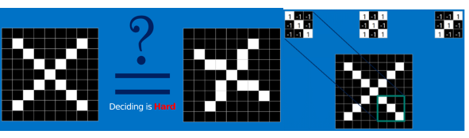
Figure 3.Example

The green window in the above picture is the data window. In short, convolution operation is the use of a movable small window to extract features from an image, which contains a specific set of weights. By performing convolution operation at different positions of the image, the network can learn and capture information about different features.
Implementation of CNN Model and Algorithm Principles：
We can see from the following figure that in the convolution section of Model B, the input image shape is 48X48X1. After a 3X3X64 convolution kernel convolution operation and another 2X2 pooling operation, a 24X24X64 feature map 1 is obtained (the stride of both convolution and pooling operations is 1, and the padding before each convolution is 1, the same below). Pass feature map 1 through a 3X3X128 convolution kernel and perform another 2X2 pooling to obtain a 12X12X128 feature map 2. Pass feature map 2 through a 3X3X256 convolution kernel and perform another 2X2 pooling to obtain a 6X6X256 feature map 3. The convolution is complete, and the data is about to enter the fully connected layer. Before entering the fully connected layer, it is necessary to flatten the data and pull the feature map 3 into a one-dimensional tensor with a growth degree of 6X6X256=9216. Subsequently, the data is dropped out and fed into a hidden layer containing 4096 neurons. After being dropped out again, it is fed into a hidden layer containing 1024 neurons, followed by a hidden layer containing 256 neurons, and finally passed through an output layer containing 7 neurons. Generally, a softmax layer is added after the output layer, and the category with the highest probability is selected as the classification result.
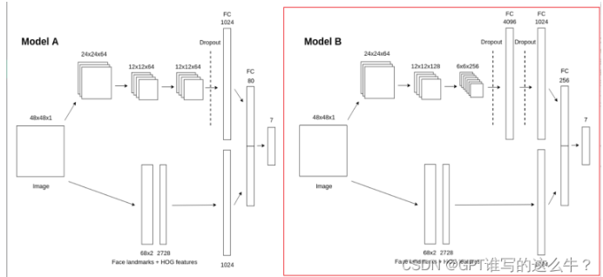
Figure 4.Implementation of CNN Model and Algorithm Principles：

Advantages：
The rapid rise of deep learning technology has brought unprecedented new opportunities to the field of facial image emotion recognition. In this technological wave, Convolutional Neural Networks (CNNs) have become one of the leaders in the field of deep learning due to their unique advantages. Convolutional neural network is a special type of feedforward neural network, whose core component is convolutional computation, and it has a multi-level deep structure, which makes it demonstrate excellent performance in processing data such as images and sounds, becoming a representative algorithm in deep learning technology.
Convolutional neural networks have excellent representation learning ability, which can efficiently process and analyze input information in their hierarchical structure, achieving translation invariant classification results. That is to say, no matter how the position of objects in the input image changes, convolutional neural networks can accurately recognize the essential features of objects. Therefore, it is also vividly referred to as "translation invariant artificial neural networks".
Applying convolutional neural networks to facial emotion recognition has significant advantages in multiple aspects:
Efficient feature extraction: CNN performs well in the field of image processing and can effectively extract features from images.

Strong adaptability: CNN has strong adaptability, can process images of various sizes and resolutions, and has a certain degree of robustness to changes in lighting, angle, and background.

High accuracy: Due to the ability of CNN to learn features from a large amount of data and its multi-level network structure, it is usually able to achieve high accuracy in facial emotion recognition tasks.

Real time performance: Some lightweight CNN models can recognize facial emotions in real time in a short period of time, which gives them advantages in applications that require quick response, such as video surveillance, facial recognition access control systems, etc.

Scalability: CNN models can be adjusted and expanded according to needs, and the performance of emotion recognition can be improved by increasing data volume, adjusting network structure, or introducing transfer
learning methods.
Learning from massive datasets, convolutional neural networks continue to evolve and adapt, fine-tuning their abilities to better interpret complex human expressions. As a result, they have become a cornerstone in the field of artificial intelligence, especially in the realm of human-computer interaction.
The advancement of CNNs has led to the development of numerous specialized models for facial emotion recognition. These models, tailored to specific tasks, can distinguish between a wide range of emotions, from basic expressions like happiness, sadness, anger, and surprise, to more nuanced emotions like disgust, fear, and contempt. Furthermore, they can even detect mixed emotions, where an individual's face expresses multiple emotions simultaneously.
In addition to improved accuracy, the latest CNN models also exhibit superior efficiency. Thanks to advancements in optimization techniques and hardware acceleration, these models can process vast amounts of data in a fraction of the time it took previous generations. This allows for real-time emotion recognition in high-definition videos, enabling applications that were previously impossible or impractical, such as emotion-based advertising or customer service automation.
Moreover, the flexibility of CNNs allows them to be integrated into various systems and platforms. Whether it's a mobile app, a web-based service, or a dedicated hardware device, CNNs can be tailored to fit the specific needs and constraints of the platform. This versatility has made CNNs a ubiquitous presence in our daily lives, from smartphones that can recognize our moods to virtual assistants that can adapt their interactions based on our facial expressions.
In conclusion, convolutional neural networks have revolutionized the field of facial emotion recognition by providing efficient, accurate, and scalable solutions. As the technology continues to evolve, we can expect even more exciting applications and advancements in the near future.
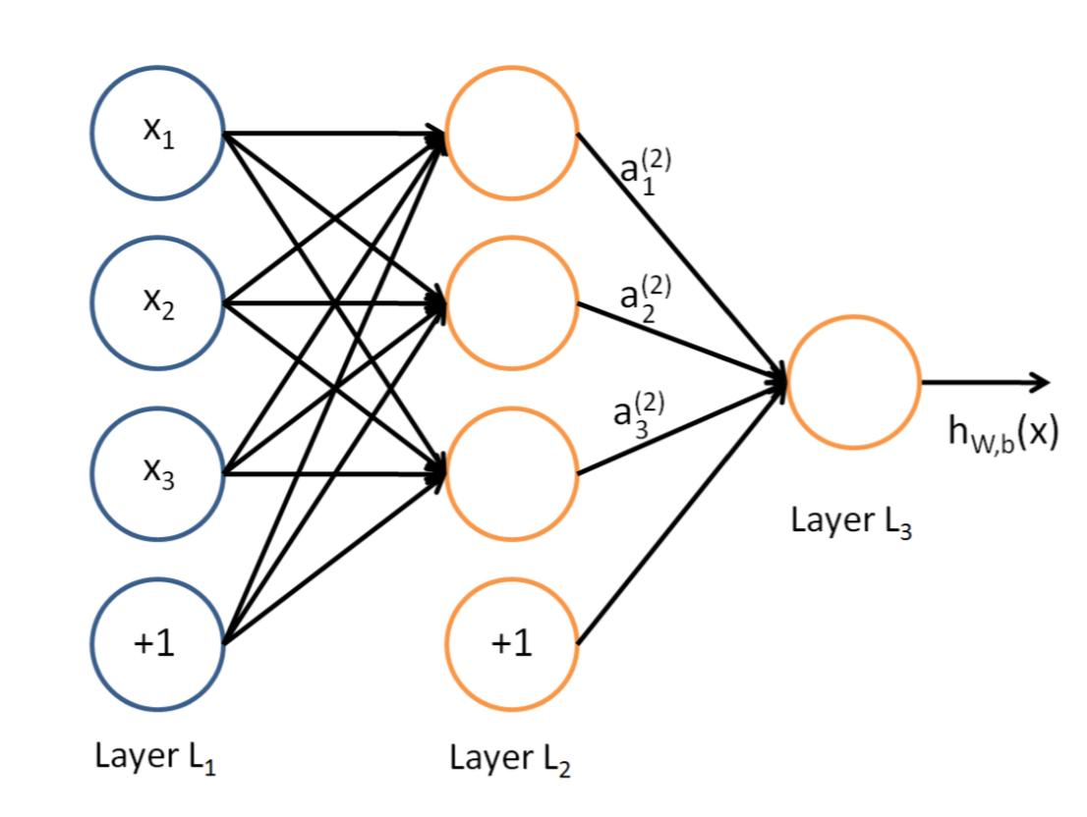
Figure5.Convolutional Neural Network.

1.3 Goal of Project
This project has the ultimate goal of employing Convolutional Neural Network (CNN) technology to facilitate the automatic detection and recognition of human emotions through the analysis of facial images. To accomplish this, we are committed to creating a comprehensive and robust training dataset for emotion recognition. This will be achieved by meticulously collecting a vast array of facial images and meticulously annotating them to reflect various emotional expressions, such as happiness, sadness, anger, surprise, and others.
With the training dataset in place, we will delve into a variety of data preprocessing techniques to further refine our model's performance. These techniques include image enhancement methods, which aim to improve the quality of the images by reducing noise and enhancing the clarity, as well as data augmentation strategies. Data augmentation techniques involve artificially altering the images in a controlled manner to expand the dataset, which in turn helps improve the model's ability to generalize and perform accurately on new, unseen data.
Moving on to the neural network architecture, we plan to experiment with a multitude of CNN models that have already proven their efficacy in the field of computer vision. These include the classic LeNet model, which was one of the earliest successful neural networks, the powerful AlexNet, VGG, and ResNet architectures, which have set benchmarks in image classification tasks, among others. Moreover, we are also intentioned to design and test custom-made network structures specifically tailored for the emotion recognition task at hand, which we believe will provide us with the flexibility and nuance required to capture the subtle cues of human emotions.
Furthermore, we are dedicated to exploring and implementing various training optimization strategies to fine-tune our model. These include learning rate scheduling techniques, which adjust the learning rate during the training process to improve the model's convergence, and regularization methods, which help prevent overfitting by penalizing large weights.
Ultimately, the cumulative result of these endeavors is our hope to develop a facial image emotion recognition system that is not only efficient and accurate but also capable of providing substantial support and assistance for a wide range of real-world applications. These applications may include, but are not limited to, psychological assessment, customer service, education, and even healthcare, where the ability to detect and understand emotions can significantly enhance the quality of service and support provided to individuals.
To further enhance the performance of our facial image emotion recognition system, we are also considering incorporating techniques that can handle the variability in expressions and poses within the input images. One such technique is the use of 3D facial modeling, which can provide us with a more robust representation of facial features that are invariant to changes in pose and expression. By incorporating this approach, we aim to improve the system's ability to recognize emotions across a wider range of facial variations, making it more robust and reliable in real-world applications.
In addition to the above, we are also exploring the potential of leveraging transfer learning to further boost the performance of our model. By utilizing pre-trained neural networks that have been trained on large-scale datasets, we can leverage the learned representations and features to accelerate the training process and potentially achieve better results. This approach not only reduces the need for a large amount of labeled data, but also allows us to take advantage of the vast knowledge and experience accumulated in previous computer vision research.
Lastly, we are committed to ensuring the fairness and transparency of our facial image emotion recognition system. We believe that a robust system should not only be accurate but also able to provide insights into its decision-making process. To achieve this, we plan to implement techniques such as visualization of feature maps and saliency maps, which can help us understand how the model makes its predictions and identify potential biases or errors. By incorporating these techniques, we aim to build a system that is not only effective but also ethical and trustworthy, ensuring that it can provide valuable support and assistance to individuals in various real-world applications.

1.4 Significance
Assistance and support for mental health: With the increasing demand for mental health, AI emotion recognition technology has shown significant advantages in the field of mental health treatment and support. This advanced technology not only provides powerful tools for psychologists, but also brings unprecedented psychological support experiences to patients. By analyzing the patient's voice, facial expressions, and text content, AI systems can accurately perceive the patient's emotional state and its subtle changes.
In terms of speech analysis, AI systems can not only capture changes in tone, speed, and volume of speech, but also recognize emotional features such as tremolo, pause, and acceleration in speech. These features can provide AI with rich emotional information, thereby more accurately judging the emotional state of patients. In terms of facial expression recognition, AI systems can capture small muscle movements and eye changes, which are crucial for judging emotions. In addition, the analysis of text content also provides valuable emotional clues for AI systems, including word selection, sentence structure, and rhetorical devices.
Based on these analysis results, AI systems can generate personalized psychological support suggestions. For example, for a patient who feels frustrated, the system may recommend some positive psychological training, social activities, or meditation techniques to help them rediscover the joy of life. At the same time, the system will automatically monitor the patient's emotional changes, promptly identify potential emotional issues, and remind psychologists or counselors to intervene when necessary. This automated emotional monitoring service greatly improves the efficiency and convenience of mental health services.
In addition, AI emotion recognition technology also provides the possibility for personalized and refined mental health services. By deeply analyzing the emotional data of patients, AI systems can understand information about their personality, interests, lifestyle habits, and other aspects, thereby providing more accurate psychological support for patients. For example, for a patient who enjoys music, the system may recommend some music works that can relieve stress and soothe the mood; For a patient who loves sports, the system may suggest that they participate in some exercise activities that can release emotions and boost confidence.
In summary, the application of AI emotion recognition technology in the field of mental health not only improves the accuracy and efficiency of emotion recognition, but also greatly expands the coverage and convenience of psychological support services. It makes mental health support more personalized, timely, and efficient, injecting new vitality into improving the public's mental health level.
Moreover, AI emotion recognition technology is revolutionizing the way we understand and manage our own emotional well-being. Through continuous monitoring and analysis of our emotional data, AI systems can provide us with insights into our emotional patterns, triggers, and coping strategies. This enables us to gain a deeper understanding of our emotional selves and make more informed choices about how to manage our emotions effectively.
Furthermore, AI emotion recognition is paving the way for the development of innovative emotional intelligence tools. These tools can help us identify and cultivate positive emotions, such as happiness, gratitude, and empathy. By providing personalized recommendations and guidance, AI systems can empower us to build stronger emotional resilience and better handle the challenges and stressors of daily life.
Moreover, AI emotion recognition technology is being integrated into various applications to create a more emotionally intelligent society. From customer service chatbots that can detect and respond to customers' emotions to virtual reality simulations that can evoke specific emotional responses, AI emotion recognition is enabling us to create more human-like interactions and experiences.
In conclusion, AI emotion recognition technology is poised to transform the landscape of mental health and emotional well-being. By improving the accuracy and efficiency of emotion recognition, personalizing mental health services, and enabling us to gain deeper insights into our emotional selves, AI emotion recognition is bringing us closer to a world where mental health support is more accessible, personalized, and effective.

Related Work

2.1 Data Preprocessing:
To ensure the CNN model's robustness and ability to generalize well, advanced data augmentation techniques were implemented using the Keras library's ImageDataGenerator class. This approach augmented the training dataset by applying a variety of transformations, including scaling, rotation, translation, shearing, zooming, and random horizontal flipping. These transformations were crucial in introducing variability into the dataset, simulating different facial expressions and conditions commonly encountered in real-world scenarios.
Furthermore, all images were resized to a standardized 48x48 pixel resolution to ensure uniformity across the dataset and to meet the input requirements of the CNN model. Additionally, a strategic 25% of the original training data was set aside as a validation set. This validation set played a crucial role in monitoring the model's performance during training, allowing for early detection of overfitting and ensuring the model's generalization capability.
The use of data augmentation technology:
We used the ImageDataGenerator class of the Keras library to implement advanced data augmentation techniques. This technique enhances the training dataset by applying various transformations such as scaling, rotation, translation, cropping, scaling, and random horizontal flipping. These transformations are crucial for introducing diversity into the dataset and simulating different facial expressions and conditions in the real world. Through this approach, the model can be exposed to more data changes during the training process, thereby improving its generalization ability and adaptability to new samples.
Keras：
Keras is an open-source artificial neural network library written in Python that can serve as a high-level application interface for TensorFlow, Microsoft CNTK, and Theo for designing, debugging, evaluating, applying, and visualizing deep learning models.
Keras is written using object-oriented methods in terms of code structure, which is fully modular and scalable. Its runtime mechanism and documentation take into account user experience and difficulty of use, and attempt to simplify the implementation difficulty of complex algorithms. Keras supports mainstream algorithms in the field of modern artificial intelligence, including feedforward and recursive neural networks, and can also participate in building statistical learning models through encapsulation. In terms of hardware and development environment, Keras supports multi GPU parallel computing under multiple operating systems and can be converted into components under systems such as TensorFlow and Microsoft CNTK based on backend settings.
The main developer of Keras is Google engineer Fran ç ois Chollet, and its GitHub project page includes 6 main maintainers and over 800 direct contributors. After the official release of Keras, except for some pre compiled models, it will open source under the MIT license.
Keras.ImageDataGenerator：
When using Keras for image classification tasks, if the dataset is small (difficult to obtain data, etc.), in order to fully utilize the value of limited data as much as possible, data augmentation processing can be carried out.
By using a series of random transformations to enhance the data, it is beneficial to suppress overfitting and enhance the model's generalization ability.
Keras provides a class for data augmentation (Keras. reprocessing. image. ImageDataGenerator) to implement this feature. This class can:
During the training process, set the random changes to be implemented
Instantiate a generator for image batch using the. flow or. flow-from_directory (directory) method, which can be used as input for Keras related methods such as fit_generator, evaluate_generator, or predict_generator.
What does it mean？Using the ImageDataGenerator class not only allows for random changes in images during the training process, but also increases the amount of training data; It also comes with the function of obtaining data batch generator objects, eliminating the need for manual retrieval of batch data.
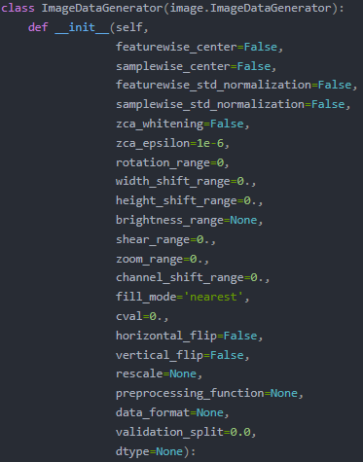
Figure5.ImageDataGenerator inherits from the class inkeras_processing/image/image_data_generator. py.

Parameter：
Featurewise center: Boolean value that decentralizes the input dataset (with a mean of 0), performed feature by feature.
Samplewise center: Boolean value that sets the mean of each sample in the input data to 0
Featurewise std_normalization: Boolean value that divides the input by the standard deviation of the dataset to complete normalization, executed according to the feature
Samplewise test_std normalization: Boolean value that divides each input sample by its own standard deviation
Zca_whitening: Boolean value that applies ZCA whitening to input data
Zca_epsilon: Eposilon used by ZCA, defaults to 1e-6
Rotation_range: integer, the range of random rotation angles of an image
Width_shift_range: Floating point number, one-dimensional array or integer, a certain proportion of the image width, and the magnitude of the horizontal shift of the image when the data is raised
Float: If<1, divide by the total width value. If>=1, it is the width pixel value
One-dimensional array: random elements in an array
Integer: an integer number of pixels from intervals (- width_shift_range, width_shift_range)
Width_shift_range=2: The possible value is an integer [-1,0,1], which is the same as width_shift_range=[-1,0,1]. However, when width_shift_range=1.0, the possible value is a floating-point number between semi open intervals [-1.0,1.0] (not understood in the latter part of the sentence).
Height_shift_range: Floating point number, a certain proportion of the height of an image, and the magnitude of the vertical offset of the image when the data is raised. The specific meaning is the same as width_shift_range.
Brightness range: A tuple or list composed of two floats. Select the range of brightness values
Shear_range: Floating point number, shear strength (shear transformation angle in counterclockwise direction)
Zoom range: floating-point number or [lower, upper]. Randomly scale the range, if it is a floating-point number, [lower, upper]=[1- Zoom range, 1+Zoom range]
Channel_shift_range: Floating point number, the range of random channel transitions.
Fill_mode: One of {"constant", "nearest", "reflect", or "wrap"}. The default is' nearest '. Fill points outside the input boundary according to the given pattern:
'constant': kkkkkkkk|abcd|kkkkkkkk (cval=k)
'nearest': aaaaaaaa|abcd|dddddddd
'reflect': abcddcba|abcd|dcbaabcd
'wrap': abcdabcd|abcd|abcdabcd
Cval: Floating point or integer. The value used for points outside the boundary, when fill_mode="constant".
Horizontal_flip: Boolean value that randomly flips horizontally.
Vertical-flip: Boolean value, randomly flipping vertically.
Rescale: Rescale factor. The default is None. If it is None or 0, do not scale, otherwise multiply the data by the provided value (after applying any other transformations)
Preprocessing function: This function is applied to each input and runs after the image is resized and enhanced. This function takes a parameter, an image (numpy tensor with rank 3), and outputs a numpy tensor with the same shape.
Data_format: Image data format, one of {"channelsfirst", "channels_last"}. The "channels.last" mode indicates that the image input size should be (samples,...), height, width, channels)， The "channelsfirst" mode indicates that the input size should be (samples, channels, height, width)。 The default is the image_data_format value in the Keras configuration file~/. keras/keras.json. If you have never set it, then it is "channels_last".
Validation_split: floating-point type. Preserve the image scale used for validation set (strictly between 0,1)
Dtype: The data type used to generate an array.
--Reprinted from CSDN blog
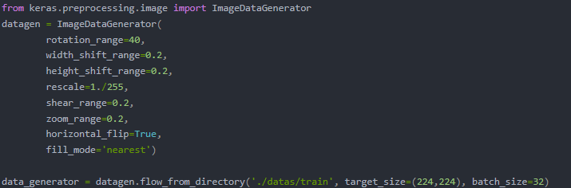
Figure 6.Usage example of ImageDataGenerator.

Image size standardization:
All the images have been meticulously adjusted to a uniform resolution of 48x48 pixels. This painstaking process guarantees the uniformity of the entire dataset and fulfills the stringent demands of the Convolutional Neural Network (CNN) model, which requires fixed size inputs for optimal performance. By subjecting the images to standardization processing, we are able to streamline the input data processing during the model training phase. This ensures that the model delivers consistent performance regardless of the varying sizes of the images it processes. The consistency of the dataset is crucial as it allows the model to generalize well and perform accurately on unseen data. Additionally, standardizing the image sizes simplifies the model architecture, enabling faster training and more efficient use of computational resources.

Policy retention of validation set:
In our machine learning project, we carefully selected 25% of the original training data as the validation set. This decision was carefully considered, as the validation set plays a crucial role in the training process of the model. It is used to evaluate how the model performs on unseen data. By continuously monitoring the performance on the validation set, we can detect any overfitting in the model early on. Once the existence of overfitting is confirmed, we can quickly take action to make necessary adjustments to the structure or training strategy of the model. This process ensures that our model has excellent generalization ability, that is, when facing unknown data, the model can still maintain stable and accurate performance.

2.2 Model Architecture:
The architecture of the Convolutional Neural Network (CNN) was meticulously designed to effectively capture hierarchical features inherent in facial images, which are pivotal for accurate emotion recognition. The model commenced with multiple convolutional layers responsible for feature extraction. These layers utilized filters to detect patterns and features at various spatial scales within the input images.
Following the convolutional layers, pooling layers were employed for spatial downsampling, which served to reduce the computational complexity of the network while retaining important spatial information. Subsequently, fully connected layers were utilized to integrate the extracted features and facilitate classification of the emotional content present in the facial images.
To prevent the model from overfitting to the training data, dropout layers were strategically inserted. These layers functioned by randomly deactivating a fraction of neurons during each training iteration, thereby promoting robust feature learning and enhancing the model's ability to generalize to unseen data.

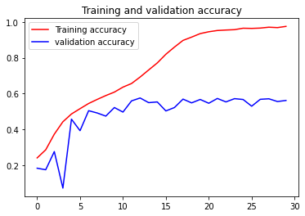
Figure 7.Training and validation accuracy

2.3 Final Layer and Output:
In the final stage of the CNN architecture, a fully connected layer consisting of 7 neurons was implemented. Each neuron corresponds to one of the seven emotion categories with a target of multi class classification. To generate prediction results, the soft max activation function is applied to this output layer. This activation function converts the original output into a probability distribution of emotion categories, enabling the model to infer and predict the dominant emotions present in a given facial image input.

2.4 Experimental Setup:
The experimentation phase involved leveraging a meticulously curated dataset comprising facial images that were annotated with corresponding emotion labels. This dataset was partitioned into separate training and validation sets to facilitate robust model evaluation.
During training, data augmentation techniques were exclusively applied to the training set. This approach ensured that the model encountered diverse facial expressions and conditions, thus enhancing its ability to generalize beyond the specific instances seen during training.
The CNN model was optimized using the Adam optimizer, a popular choice for deep learning tasks due to its efficiency in handling large datasets and complex model architectures. The categorical cross-entropy loss function was employed to guide the training process, aiming to minimize classification errors and optimize the model's ability to accurately classify emotions from facial images.

2.5 Evaluation Metrics:
To assess the effectiveness of the trained CNN model, standard evaluation metrics such as accuracy, precision, recall, and F1-score were computed for both the training and validation sets. These metrics provided comprehensive insights into the model's performance across different emotion categories, highlighting its strengths and areas for potential improvement.
Moreover, confusion matrices were meticulously analyzed as part of the evaluation process. These matrices offered a detailed breakdown of predicted versus actual classifications, thereby aiding in the identification of potential misclassifications and providing deeper insights into the model's behavior and performance nuances across various emotional expressions.

2.6 Front and Back End Connection：
The underlying mechanism that facilitates communication between the front end and the back end involves the deployment of the MSS library in Python, which serves as a pivotal tool in this process. Essentially, the front end component initiates this interaction by accessing the video stream emanating from the camera. It is through this stream that the front end is able to capture and process each individual frame that is being transmitted in real time.
As each frame is received, the front end performs a series of operations on it. These operations are designed to enhance the frame's quality, extract relevant information, or carry out any other processing tasks that may be required for the application at hand. Once these tasks are completed, the front end then derives a screenshot from the processed frame.
This processed screenshot is then promptly displayed within a window that is presented to the user. The real time nature of this display is particularly crucial as it ensures that the user is always viewing the most up-to-date information being captured by the camera. This seamless and instantaneous transfer of data from the camera to the front end, through the use of the MSS library, is what enables the user to interact with the video stream in a manner that is both immediate and responsive.

In summary, through systematic data preprocessing, thoughtful model architecture design, rigorous experimentation, and comprehensive evaluation, the CNN-based emotion recognition system was effectively developed and fine-tuned. This approach not only optimized performance metrics but also underscored the model's robustness and applicability in real-world scenarios requiring accurate emotion detection from facial images.

2.7 Real-time Convolutional Neural Networks for Emotion and Gender Classification[1].
The inconsistency in the variability of samples within each task results in models that have been trained on millions of parameters using thousands of samples. Additionally, the human accuracy rate for classifying an image of a face into one of the seven distinct emotions is approximately 65% with a standard deviation of ±5%. This task becomes apparent when one attempts to manually classify the FER-2013 dataset images as depicted in Figure 1 into the following emotional categories: "angry", "disgust", "fear", "happy", "sad", "surprise", and "neutral".
Despite the aforementioned challenges, it is imperative for robot platforms intended for household tasks to be equipped with facial expression recognition systems that are robust and computationally efficient. Moreover, the cutting-edge techniques in image-related tasks, including image classification and object detection, are all rooted in Convolutional Neural Networks (CNNs). These tasks necessitate CNN architectures with a vast number of parameters, making their implementation in robot platforms and real-time systems highly impractical.
In this study, we introduce a comprehensive CNN architecture framework that is tailored for real-time applications. Our proposed implementations have been successfully validated in a real-time facial expression recognition system. This system not only performs face detection and gender classification but also achieves human-level performance in emotion classification. Furthermore, this system has been integrated into a Care-O-bot 3 robot and has been adapted for general-purpose robot platforms to cater to the challenges presented in the RoboCup@Home competition.
In addition, CNNs are commonly used as black-boxes, with their learned features often remaining concealed. This makes it challenging to strike a balance between their high classification accuracy and the excessive number of unnecessary parameters. To address this issue, we have implemented a real-time visualization tool for the guided-gradient back-propagation technique proposed by Springenberg. This tool allows us to validate and understand the features learned by the CNN, thereby providing valuable insights into optimizing the architecture for better performance and reduced complexity.
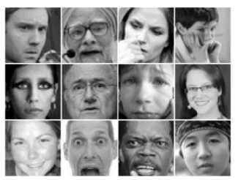
Samples of the FER-2013 emotion dataset

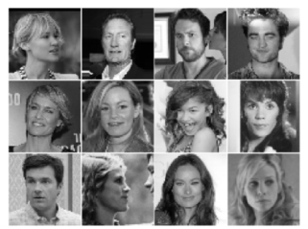

Samples of the IMDB dataset

In deep learning, Convolutional Neural Networks (CNNs) are a powerful tool commonly used for image recognition and feature extraction. Traditional CNN architectures typically include a set of fully connected layers at the end. These fully connected layers contain most of the network parameters. Taking the VGG16 model as an example, its final fully connected layer contains approximately 90% of the total model parameters. However, with the deepening of deep learning research, some new architecture designs are beginning to reduce the number of parameters in the final layer. For example, the Inception V3 model reduces parameters by introducing global average pooling operations. Global average pooling compresses each feature map into a scalar value by performing an average operation on the feature map, forcing the network to extract global features from the input image.
Modern CNN architectures, such as the Xception model, are based on a combination of two most successful experimental hypotheses in CNN: the use of residual modules and depthwise separable convolutions. Deep separable convolution further reduces the number of parameters by separating the process of feature extraction and combination within the convolutional layer. This design not only reduces the complexity of the model, but also maintains or even improves the performance of the model.
On the FER2-2013 emotion recognition dataset, the most advanced model is based on CNN and trained using a squared hinge loss function. The model utilized approximately 5 million parameters and achieved an accuracy of 71%. In this model, approximately 98% of the parameters are concentrated in the final fully connected layer. In the same study, the suboptimal method was achieved through the integration of CNN, with an accuracy of 66%. These results indicate that although fully connected layers account for a significant proportion of the number of parameters, reasonable design and innovation can effectively reduce parameters while maintaining or even improving the performance of the model.

We have developed and evaluated two distinct models based on their performance metrics of test accuracy and parameter efficiency. The primary goal in designing both models was to achieve the optimal ratio of accuracy to the number of parameters. By reducing the parameter count, we aimed to address two critical challenges. Firstly, employing compact convolutional neural networks (CNNs) helps overcome performance bottlenecks on hardware-constrained systems such as robot platforms. Secondly, parameter reduction enhances generalization capabilities within the framework of Occam's razor.

Our first model innovates by completely eliminating fully connected layers. In contrast, the second model not only removes fully connected layers but also integrates advanced techniques such as depth-wise separable convolutions and residual modules. Both architectures were trained using the ADAM optimizer.

Initially, our architecture utilized Global Average Pooling to entirely replace any fully connected layers. This method involved configuring the last convolutional layer to match the number of feature maps with the number of classes, followed by applying a softmax activation function to each reduced feature map. The initial proposed architecture is a standard fully-convolutional neural network comprising 9 convolution layers, ReLUs, Batch Normalization , and Global Average Pooling, totaling approximately 600,000 parameters.

We rigorously tested this model on the IMDB gender dataset, consisting of 460,723 RGB images categorized as "woman" or "man," achieving an impressive 96% accuracy. Furthermore, validation on the FER-2013 dataset, containing 35,887 grayscale images across seven emotion classes {“angry”, “disgust”, “fear”, “happy”, “sad”, “surprise”, “neutral”}, yielded a 66% accuracy. We refer to this model as the "sequential fully-CNN."

Our second model draws inspiration from the Xception architecture,integrating residual modules and depth-wise separable convolutions . Residual modules play a pivotal role by adjusting the desired mapping between successive layers, transforming learned features into the difference between the original feature map and the desired features. This adjustment aims to simplify the learning process, ensuring that the modified desired features ( H(x) ) satisfy ( H(x) = F(x) + x ).

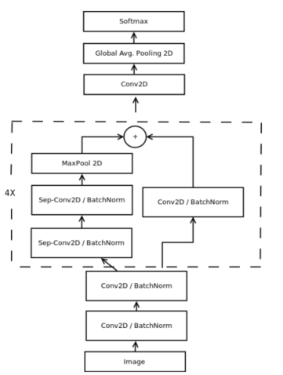
Our proposed model for real-time classification.

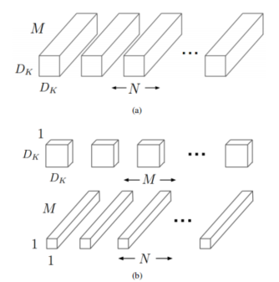

Difference between (a) standard convolutions and
(b) depth-wise separable convolutions.

On the feature map, this traditional convolutional method does not consider the spatial relationship between pixels within the channel. Deep wise separable convolutions reduce the computational complexity by 1/N+1/D ² by decomposing standard convolutions into deep convolutions and pointwise convolutions. We can visually see the difference between ordinary convolutional layers and depthwise separable convolutions through Figure 4. The final network structure we have determined is a fully convolutional neural network, consisting of four residual depth separable convolutions, each of which is followed by a batch normalization operation and ReLU activation function. The final layer uses global average pooling and soft max activation function to generate prediction results. This network structure has approximately 60000 parameters, which is 10 times lower than our initial naive implementation and 80 times lower than the original convolutional neural network. Figure 3 shows our complete final architecture, which we refer to as the mini Xception. This architecture achieved a 95% accuracy in gender classification tasks, which is 1 percentage point lower than our initial implementation. In addition, we tested this architecture on the FER-2013 dataset and achieved an accuracy of 66% in sentiment classification tasks, which is consistent with our initial implementation. The weights of our final architecture can be stored in an 855 kilobyte file. By reducing the computational cost of our architecture, we can now continuously apply these two models to the same image without causing significant time reduction. Our complete pipeline, including the openCV face detection module, gender classification, and sentiment classification, runs on an i5-4210M CPU for 0.22 ± 0.0003 milliseconds, which is equivalent to a 1.5 times faster speed compared to Tang's original architecture.We also added to our implementation a real-time guided
back-propagation visualization to observe which pixels in the image activate an element of a higher-level feature map. Given a CNN with only ReLUs as activation functions for the intermediate layers, guided-back propagation takes them derivative of every element (x, y) of the input image I with respect to an element (i, j) of the feature map f L in layer L. The reconstructed image R filters all the negative gradients;consequently, the remaining gradients are chosen such that they only increase the value of the chosen element of the feature map. Following , a fully ReLU CNN reconstructed image in layer l is given by:

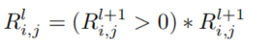

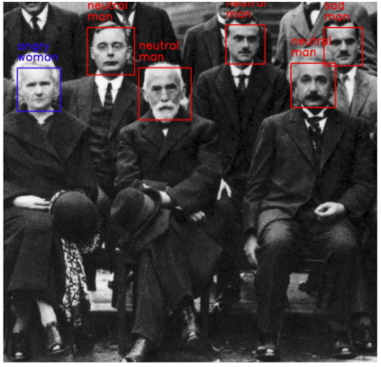
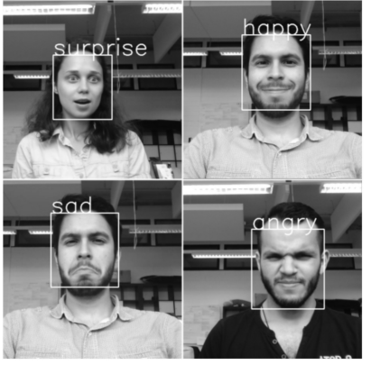

Method

3.1 Data Preprocessing
To guarantee the robustness and extensive applicability of our model, we made full use of data augmentation techniques, especially the powerful ImageDataGenerator class in the Keras library. Data augmentation, as the name implies, is a technique that generates new training samples by applying a series of random transformations to the original data. This method not only diversifies the training data, but also prevents the model from being overly reliant on specific data patterns by introducing more varied patterns. This strategy allows our model to exhibit stronger adaptability and generalization ability when dealing with new and unprecedented data, thereby enhancing the overall performance and robustness of the model.
We fully recognized the significance of data augmentation in deep learning, especially in the field of image classification. By employing data augmentation techniques, we were able to significantly expand the size of our training dataset, which in turn provided our model with more diverse examples to learn from. This diversity helped our model to generalize better and perform more accurately on unseen data.
The ImageDataGenerator class in Keras was particularly useful in our data augmentation process. This class provides a wide range of functions for performing data augmentation, such as horizontal flipping, vertical flipping, rotation, shearing, zooming, and adding noise to the images. We utilized these functions extensively to generate new training samples that were similar to the original data but contained additional variations.
By using data augmentation, we were able to improve the robustness and general applicability of our model. The model was able to learn from a more diverse set of data, which helped it to generalize better and perform more accurately on new, unseen data. This made the model more robust and less likely to perform poorly on data that was outside of the original training distribution.
Overall, data augmentation was a crucial part of our model development process. It helped us to create a model that was more robust, more generalizable, and more accurate. We believe that this strategy will continue to be an important part of model development in the future, as it allows models to adapt to new and changing data environments.

Data Augmentation Techniques:
Scaling: Resizing images to a consistent ratio enhances the model's resilience against variations in image size. By presenting images at different scales during training, the model learns to interpret facial features effectively regardless of distance or resolution, thus improving its generalization capability.

Rotation: Introducing random rotations to images simulates facial expressions from various angles. This augmentation method aids the model in achieving rotation invariance, enabling it to recognize emotions accurately regardless of the orientation at which a face appears.

Translation: Randomly shifting images horizontally and vertically mimics changes in facial position. This technique enhances the model's ability to generalize across different facial positions, ensuring robustness in emotion recognition irrespective of where features are located within the image frame.

Shear: Applying random cropping transforms images to diversify facial shapes. By distorting facial structures, this technique strengthens the model's ability to handle variations in facial geometry, thereby improving its overall robustness to diverse facial structures.

Random Horizontal Flip: Flipping images horizontally adds variation without altering the semantic content of facial expressions. This augmentation method helps the model generalize better to left-right facial asymmetries, enhancing its ability to classify emotions accurately across different orientations.
In addition to the aforementioned data augmentation techniques, we have also explored a few other approaches that have further optimized our model's performance:
Brightness Adjustment: Adjusting the brightness of images during training helps the model learn to interpret facial expressions under varying lighting conditions. By presenting images with different brightness levels, the model becomes more resilient to brightness variations in real-world scenarios, thus improving its accuracy in emotion recognition.
Contrast Enhancement: Enhancing the contrast of images accentuates facial features, making them more prominent for the model to learn. This augmentation technique improves the model's sensitivity to facial features, enabling it to recognize emotions more precisely even in low-contrast images.
Color Jittering: Randomly adjusting the color balance, saturation, and hue of images introduces variations in the visual appearance of facial expressions. This augmentation method forces the model to rely more on shape and texture cues rather than color information, making it more robust to color variations in real-world scenarios.
Noise Injection: Adding random noise to images during training simulates real-world conditions where images are often corrupted by noise. By exposing the model to noisy images, it learns to be more tolerant to noise, improving its robustness and accuracy in emotion recognition when dealing with noisy or low-quality inputs.
These data augmentation techniques, combined with our robust model development process, have enabled us to create a model that is not only accurate but also highly generalizable and resilient to various challenges in real-world applications. We continue to explore new augmentation techniques and strategies to further enhance our model's performance and adaptability to changing data environments.
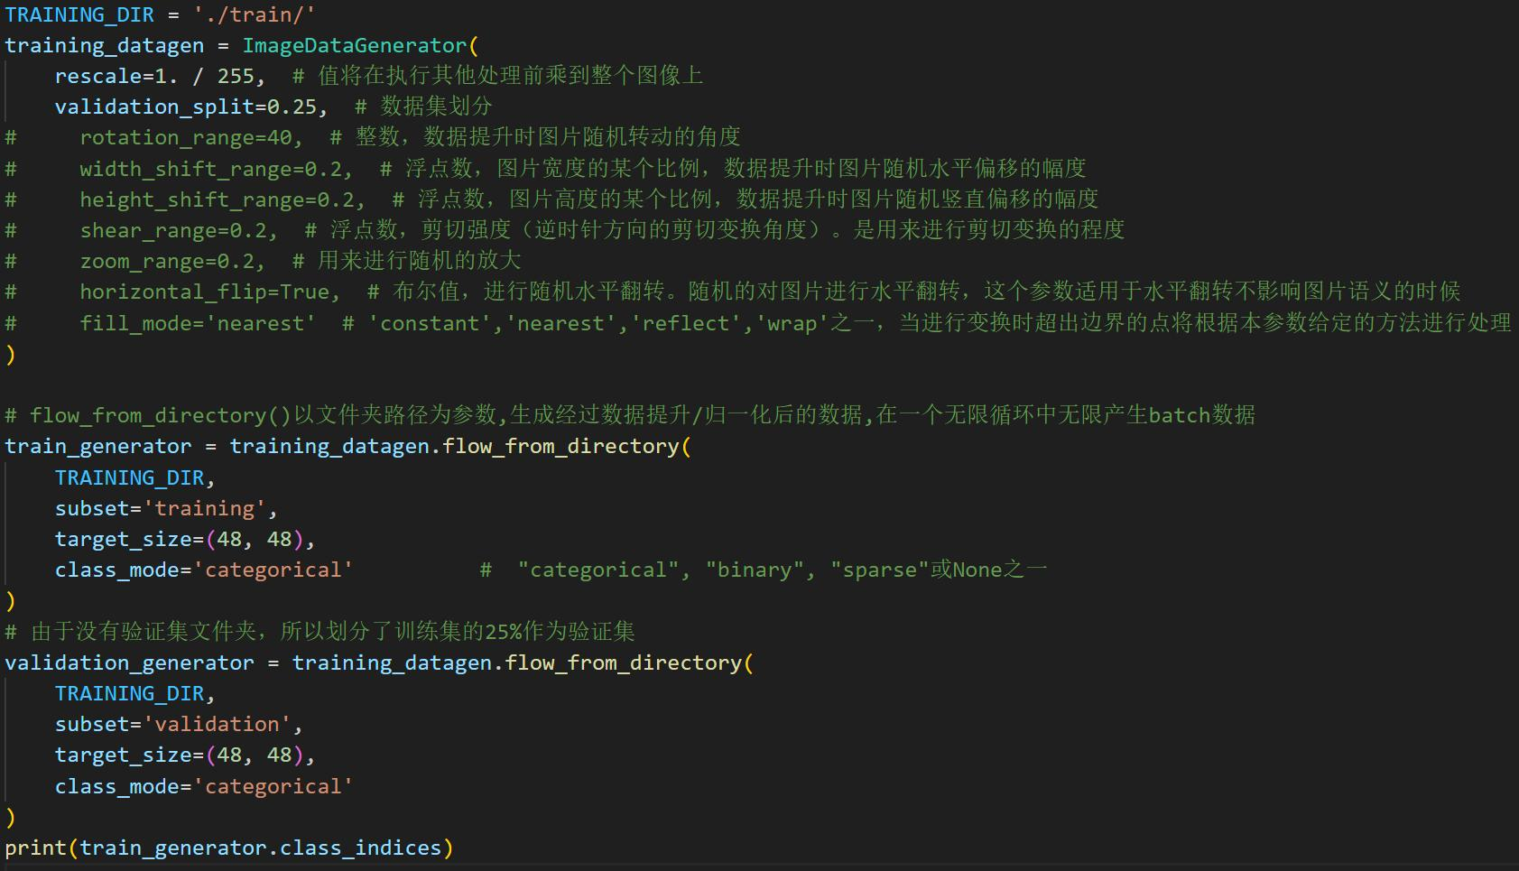
Figure 8.Use the 'ImageDataGenerator' class in the Keras library to enhance image datasets.

Image Size Adjustment:Standardizing images to 48x48 pixels optimizes them for the CNN model's input size. This resizing preserves sufficient detail for precise emotion classification while optimizing computational efficiency and reducing memory usage.

Partitioning of Training and Validation Sets:Allocating 25% of the training data as a validation set allows continuous monitoring of the model's performance during training. Regular evaluation on the validation set helps in promptly identifying overfitting and adjusting hyperparameters to improve the model's ability to generalize to new data.

These meticulous steps in data preprocessing establish a robust foundation for developing a versatile CNN model. By effectively integrating these techniques, the model becomes adept at learning and interpreting facial expressions, thereby achieving accurate emotion classification across various real-world scenarios.

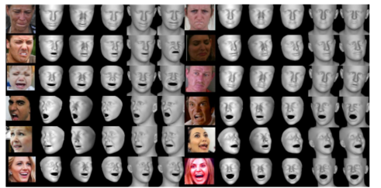
Figure 9.Image processing process.

3.2 Model architecture
The design of CNN models aims to extract hierarchical features from facial images and use these features for emotion recognition. Here is the detailed structure of the model:
Convolutional Layers:
The CNN model begins with multiple convolutional layers, each comprising a set of filters. These filters perform convolution operations on the input image, extracting various features and generating feature maps. The number and size of these filters are chosen based on the complexity of the task and the characteristics of the dataset. Shallow convolutional layers typically capture low-level features such as edges and textures, while deeper layers are capable of extracting more abstract and semantic features specific to facial expressions.

Pooling Layers:
Following each convolutional layer, pooling layers are typically applied. These layers facilitate spatial downsampling of the feature maps, effectively reducing their dimensions and computational load. The most commonly used pooling operation is Max Pooling, which selects the maximum value within each region of the feature map. This process retains the most significant features while decreasing the overall size of the feature maps, thereby enhancing computational efficiency and improving the model's robustness.

Fully Connected Layers:
After the convolutional and pooling layers, fully connected layers are introduced. These layers serve to integrate the extracted features into one-dimensional vectors and perform classification tasks. By leveraging the structured connectivity of neural networks, fully connected layers analyze the learned features and classify emotions based on the comprehensive representation of facial expressions.

Dropout Layers:
To mitigate overfitting during training, dropout layers are strategically inserted between the fully connected layers. Dropout involves randomly omitting a portion of neuron outputs during each training iteration. This technique forces the model to learn more generalized features, reducing its reliance on specific training samples and thereby improving its ability to generalize to unseen data. By encouraging robust feature learning, dropout layers enhance the model's generalization capability and promote better performance on real-world emotion recognition tasks.

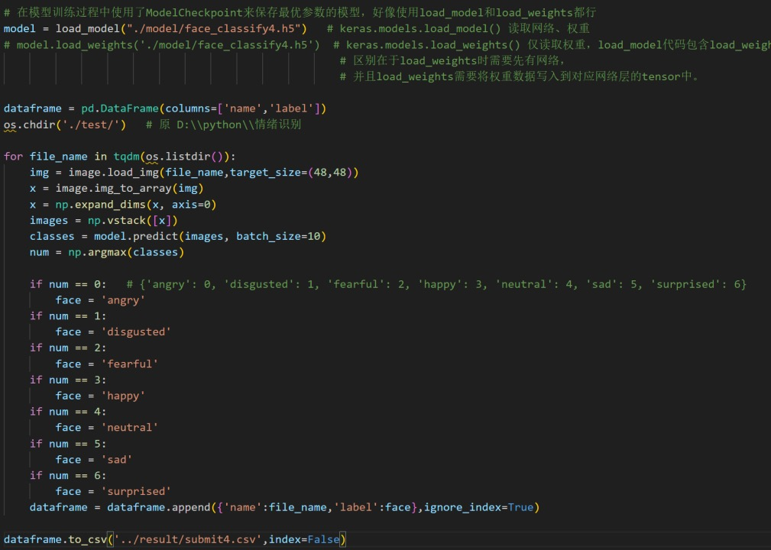
By incorporating these components — convolutional layers for feature extraction, pooling layers for dimensionality reduction, fully connected layers for integration and classification, and dropout layers for regularization — the CNN model effectively extracts hierarchical features from facial images. This structured approach not only enhances its capability to interpret facial expressions accurately but also ensures robust performance across diverse scenarios in emotion recognition tasks.
Figure10.During the model training process, Modelcheckpoint was used to save the model with the optimal parameters

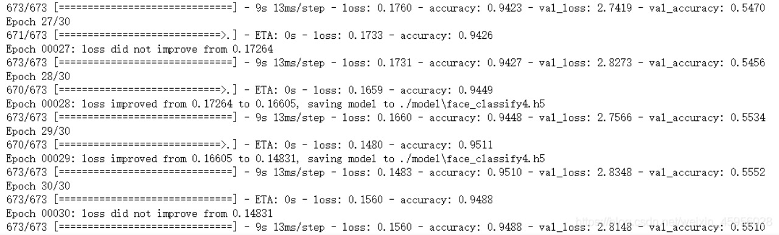

Figure8.Model training process and results

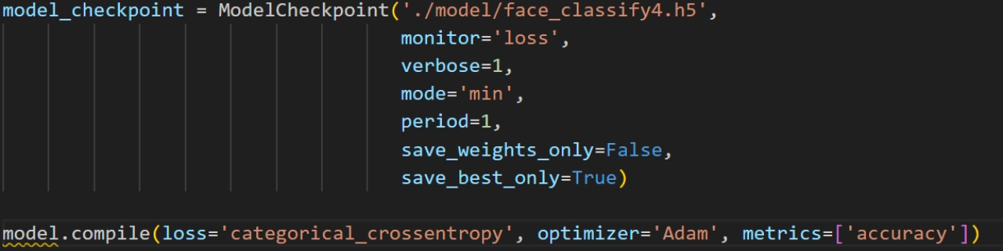
Figure11.Modelcheckpoint


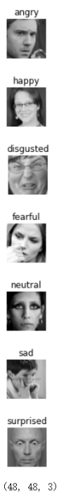
Figure12.Classification of Datasets

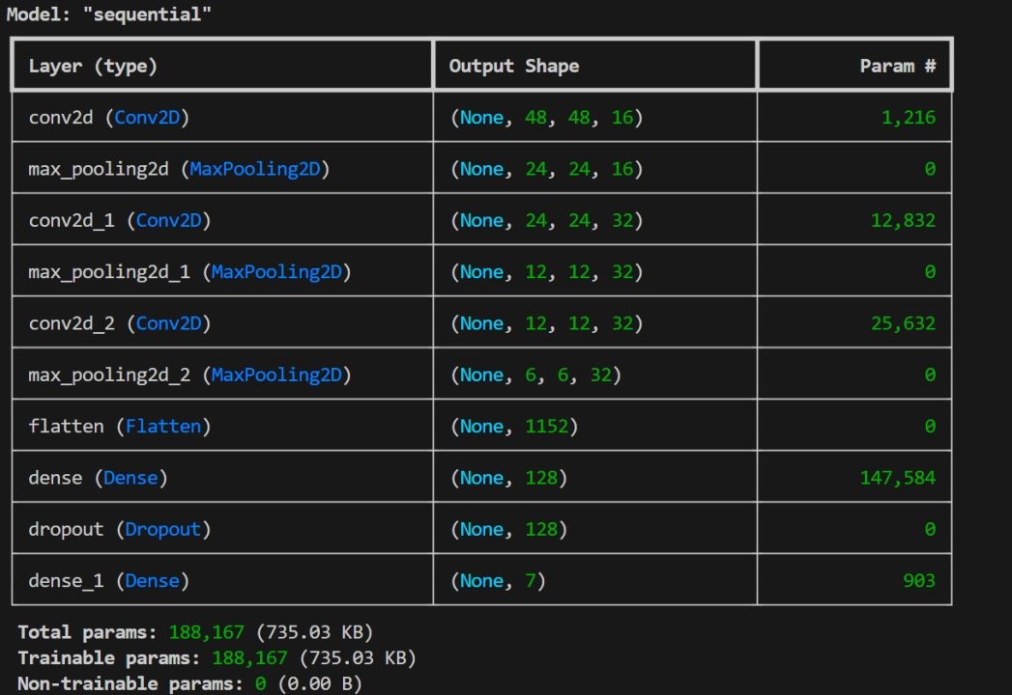

Figure13.Model structure

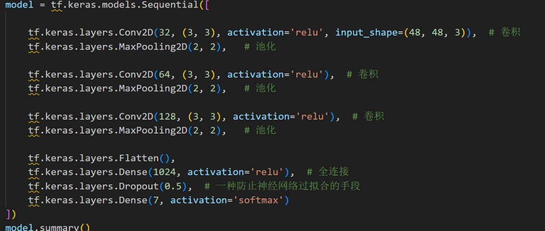

Figure14.Multiple convolutional layers, pooling layers, fully connected layers, and dropout layers of the model structure model

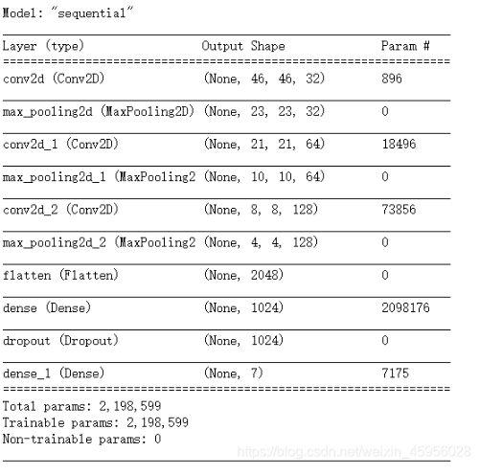
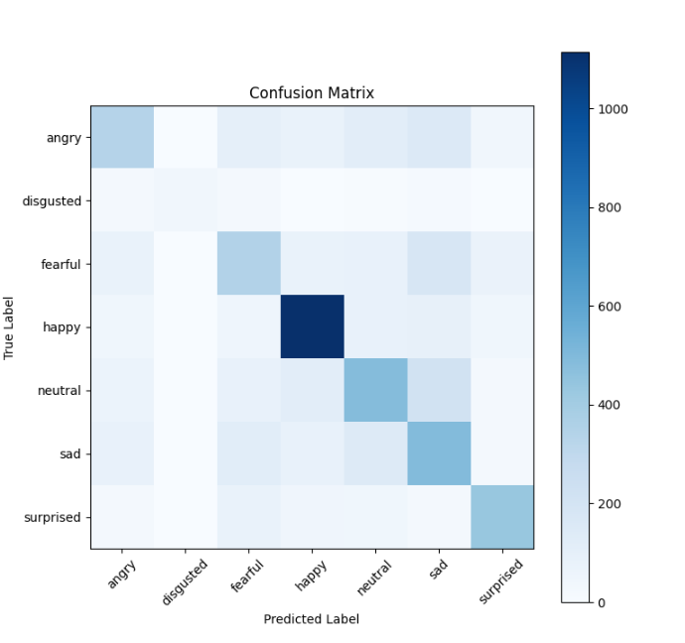

Figure15.Confution Matrix

3.3 Final layer and output
The last layer in the CNN model is the Fully Connected
Layer, which consists of 7 neurons corresponding to the 7 emotion categories used for multi class classification. These emotional categories may include happiness, sadness, anger, surprise, etc. Softmax activation function:
The Softmax activation function was applied to the output
of the fully connected layer. The Softmax function converts the original output of neurons into a probability distribution, so that the probability value of each category is between 0 and 1, and the sum of probabilities of all categories is equal to 1. The formula for the Softmax function is:
[\ text {softmax} (zi)=\ frac {e ^ {zi} {\ sum {j=1} ^ {N} e ^ {zj}}]
Among them, (z_i) represents the output of the (i-th)
neuron, and (N) represents the total number of categories.

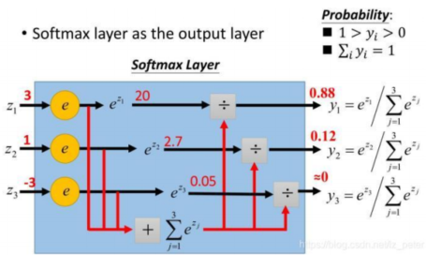
Calculation method of softmax function.

The application of Softmax activation function enables the output of the model to be interpreted as a probability
distribution for each emotion category, making it convenient to infer and predict the main emotions in the
input facial image.

Experiments

4.1. Experimental setup
The dataset used in this study is a facial image dataset that has been carefully labeled with emotional tags. This collection of images is meticulously segmented into two distinct subsets: a training set and a validation set. The training set is where the bulk of the model development takes place and it encompasses a wide array of facial images, each paired with its corresponding emotional label. To ensure that the model is robust and capable of recognizing a broad spectrum of facial expressions, various data augmentation strategies are employed solely on the training set. These techniques are designed to mimic the myriad of changes that can occur in both facial expressions and environmental conditions, thereby enhancing the diversity and volume of the training data.
The training set is further enhanced through the application of data augmentation methods. These methods include, but are not limited to, scaling, rotation, translation, cropping, and random horizontal flipping. Each of these transformations is carefully chosen to simulate different emotional states and conditions, which in turn, helps to refine and strengthen the model's ability to accurately interpret and respond to various facial cues.
The validation set, on the other hand, serves a different purpose. It is used to meticulously monitor the model's performance throughout the training process. By evaluating the model's accuracy and performance on this set, it becomes possible to detect any signs of overfitting, a common issue in machine learning where the model performs well on the training data but poorly on unseen data. Should overfitting be detected, adjustments can be made promptly to improve the model's generalizability.
In terms of the optimization and evaluation of the model, the Adam optimizer is selected for the training process. The Adam optimizer is a sophisticated algorithm that adapts to the learning rate of each individual parameter, combining the principles of both momentum and adaptive learning rates. This approach allows for more efficient parameter updates and a higher likelihood of converging to a satisfactory local optimum.
For the loss function, which is a critical component in the training of the model, the classification cross-entropy loss is chosen. This loss function is particularly well-suited for multi-class classification tasks, such as the one at hand. It quantifies the discrepancy between the model's predicted probability distribution and the actual, true labels. By minimizing this loss, the model's parameters are iteratively adjusted to reduce classification errors and improve the overall accuracy of the model's predictions.

4.2. Evaluation indicators
The performance of a model in emotion recognition tasks is a critical aspect that determines its effectiveness in understanding and interpreting human emotions. To comprehensively evaluate this performance, we utilize several main evaluation indicators.
Accuracy is a fundamental evaluation metric that calculates the proportion of correctly classified samples out of the total number of samples. It is one of the most commonly employed indicators in assessing model performance. The formula for calculating accuracy is:
\[ \text{Accuracy} = \frac{\text{correctly classified samples}}{\text{total samples}} \]
Precision is another important metric that measures the proportion of true positive categories predicted by the model for samples that actually belong to positive categories. It reflects the model's ability to avoid false positives. The formula for precision is:
\[ \text{Precision} = \frac{\text{True Positions}}{\text{True Positions} + \text{False Positions}} \]
The recall rate, also known as the true positive rate, assesses the model's ability to correctly identify positive category samples. It represents the proportion of positive category samples that are correctly identified. The formula for recall is:
\[ \text{Recall} = \frac{\text{True Positions}}{\text{True Positions} + \text{False Negative}} \]
The F1 Score is a harmonic mean of precision and recall, providing a balanced evaluation of the model's accuracy and ability to identify positive samples. It is a useful metric when we want to consider both precision and recall. The formula for F1 Score is:
\[ \text{F1 Score} = \frac{2 \times \text{Precision} \times \text{Recall}}{\text{Precision} + \text{Recall}} \]
A confusion matrix is a tabular representation that helps us understand the performance of the model across different emotional categories. It is an NxN matrix, where N represents the number of emotional categories. Each row in the matrix corresponds to the true emotional category, while each column represents the predicted emotional category by the model. By analyzing the confusion matrix, we can identify potential misclassification scenarios and gain insights into the model's performance in various emotional categories.
By thoroughly analyzing these evaluation indicators and confusion matrices, we can gain a comprehensive understanding of the model's performance in emotion recognition tasks. This analysis helps us identify the strengths and weaknesses of the model and enables us to make targeted improvements and adjustments to enhance its performance.
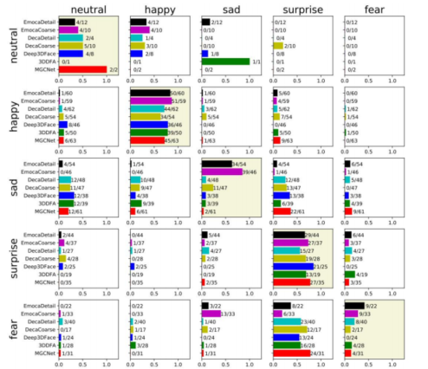
Figure16.Confusion matrix of participant labels for real and reconstructed images

Conclusion
In the realm of facial emotion recognition tasks, we have meticulously designed and executed a Convolutional Neural Network (CNN) model, which has been rigorously tested and evaluated under stringent experimental conditions and quantitative metrics. The fruits of our labor are manifested in the model's demonstration of its capabilities on both training and validation datasets. This process has been invaluable in shedding light on the model's proficiency and its potential susceptibility to misclassifications across diverse emotional categories.
Our exploration into the impact of data augmentation was a pivotal aspect of our methodology. By employing various data augmentation techniques on our training dataset, we aimed to enhance the diversity and resilience of the data. This was a calculated move to improve the model's ability to generalize and perform accurately across a broader spectrum of emotions. The success of this strategy can be gauged by examining the model's performance on the validation set, where the effects of data augmentation become evident. These augmentation techniques essentially mimic alterations in facial expressions and conditions, thereby refining the model's ability to recognize emotions accurately and bolstering its efficacy when faced with unseen data.
Selecting the appropriate optimizer and loss function is crucial in the training phase of any machine learning model. In our case, we opted for the Adam optimizer, known for its adaptive learning rate and momentum features, which enable it to effectively modulate the learning rate and converge towards local optimal solutions. To complement the Adam optimizer, we chose the classification cross entropy loss function, a stalwart in multi-class classification tasks. This loss function is adept at quantifying the discrepancy between the probability distribution output by our model and the actual, annotated labels.
The generalization ability of our model was a paramount concern, and to assess this, we meticulously evaluated its performance on the validation set. A model that exhibits strong generalization is not only proficient on the training dataset but also performs reliably on previously unseen data. Our model's demonstration of robust generalization is a testament to its potential for real-world application and further research in the field of facial emotion recognition.
In conclusion, this project has been a resounding success in the development and implementation of a CNN model for facial emotion recognition. Through meticulous experimentation and rigorous evaluation, we have gathered comprehensive insights into the model's performance. These findings stand as a critical reference and foundation for future endeavors in refining and applying facial emotion recognition technology, thereby expanding the potential applications in various domains such as psychology, human-computer interaction, and emotional intelligence.
Having achieved remarkable progress in the realm of facial emotion recognition, we delve deeper into the nuances of our model to further enhance its capabilities. One area of focus is the integration of temporal information, which can provide valuable context for emotion recognition. To this end, we explore the incorporation of recurrent neural networks (RNNs) or long short-term memory (LSTM) networks to capture temporal dependencies across consecutive frames in video data. This approach promises to enhance the model's ability to recognize emotions that evolve over time, especially in complex scenarios where emotions change rapidly or are expressed subtly.
In addition to temporal information, we also consider the integration of other modalities, such as audio and text, to create a multi-modal emotion recognition system. Audio cues, such as tone and pitch, can provide complementary information to visual cues, while textual data, such as captions or transcripts, can offer valuable context for emotion interpretation. By combining these modalities, we aim to create a more robust and comprehensive emotion recognition system that can handle a wider range of real-world scenarios.
As we expand our research in these directions, we are mindful of the challenges that arise in real-world applications. One such challenge is the issue of data imbalance, where certain emotions are represented more frequently in the training data than others. To address this issue, we employ techniques such as data augmentation and oversampling to ensure that our model is trained on a balanced dataset. We also explore domain adaptation techniques to enable our model to generalize well to new, unseen domains with minimal labeled data from those domains.
Finally, we are committed to the ethical use of facial emotion recognition technology. We recognize that this technology has the potential to be misused or abused, and we strive to ensure that it is used responsibly and with proper oversight. To this end, we engage in ongoing discussions with experts in the field of ethics and privacy to ensure that our research adheres to the highest standards of ethical conduct.

Reference：
[1]Oswald Aldrian and William AP Smith. Inverse rendering of faces with a 3D morphable model. Transac ions on Pattern Analysis and Machine Intelligence (PAMI), 35 (5): 1080-1093, 2013.2
[2]Hela Bejaoui, Haythem Ghazouani, and Walid Barhoumi. Fully automated facial expression recognition using 3D morphable model and mesh-local binary pattern. In Advanced Concepts for Intelligent Vision Systems, volume 10617, pages 39–50, 2017. 3
[3]Volker Blanz, Curzio Basso, Tomaso A. Poggio, and Thomas Vetter. Reanimating faces in images and video. Computer Graphics Forum (Proc EUROGRAPHICS), 22 (3): 641-650, 2003.1
[4]Volker Blanz and Thomas Vetter. A morphable model for
the synthesis of 3D faces. In SIGGRAPH, pages 187–194, 1999. 1, 2
- Paul Ekman. An argument for basic emotions. Cognition And Emotion, 6 (3-4): 169-200, 1992.3
[6]China Social Science Daily, March 23, 2020, Issue 1891 Author: Yu Guoliang

